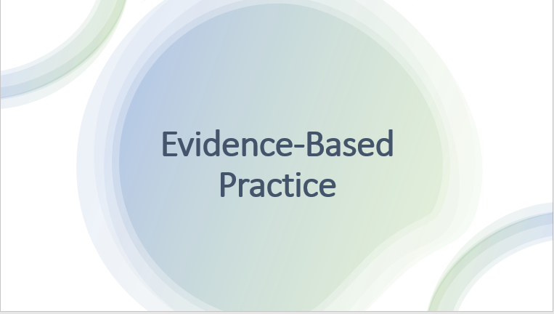
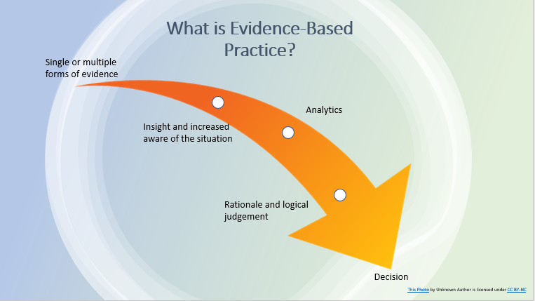

According to Young (2021) evidence based practice is the process of making decisions by analysing available evidence guided by critical thinking.
Evidence-based practice progresses towards critical thinking about what works and what doesn’t work within an organisation for decision-making.
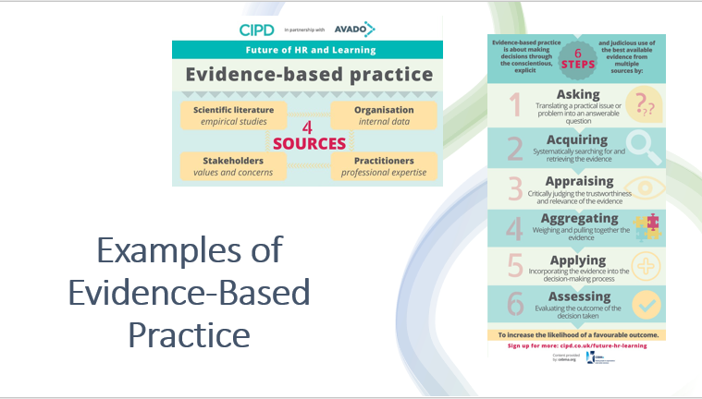
Evidence-based practice approach came from the field of medicine. Medical practitioners started relying on evidence to increase their skills for added certainty in their clinical decision-making. Since then, evidence-based practice has spread into other areas such as education and HR.

There are 4 sources of evidence-based practice, as seen in the slide:
- Scientific Literature - Scientific literature research can help support decisions with all kinds of data such as common factors that cause employees to leave, recruitment methods that predict strong performance and average absence rates in similar industries. This can provide a general idea of the current studies in a particular area.
- Organisational Internal Data - Internal data can help you review what approaches or initiatives have worked in the past and what ones have failed. Collating the different types in internal data can help solve problems within the organisation and provide insight into potential solutions. Organisational data may relate to people management metrics, such as sick absence data or employee turnover data.
- Stakeholders - Stakeholders can include employees, managers, applicants and customers. Teaming up with stakeholders can have an effect on your conclusion and can improve perception and reception of the decision.
- Practitioners - Professional practitioners expertise offer input acquired knowledge of processes or outcomes from historic similar circumstances.
There are 6 steps to evidence-based decision making:
- Asking
- Acquiring
- Appraising
- Aggregating
- Applying
- Assessing
“Assessing and using a wide variety of data helps us to develop factual knowledge and understanding on a wide range of organisational and people issues. In turn, this helps the people function and the organisation to support:
- a positive organisational culture and to maintain employee satisfaction and engagement;
- recognition of issues illuminated through data;
- employee and organisational performance and rewards levels;
- positive internal and external perceptions of the organisation.” (Waite et al., 2021).
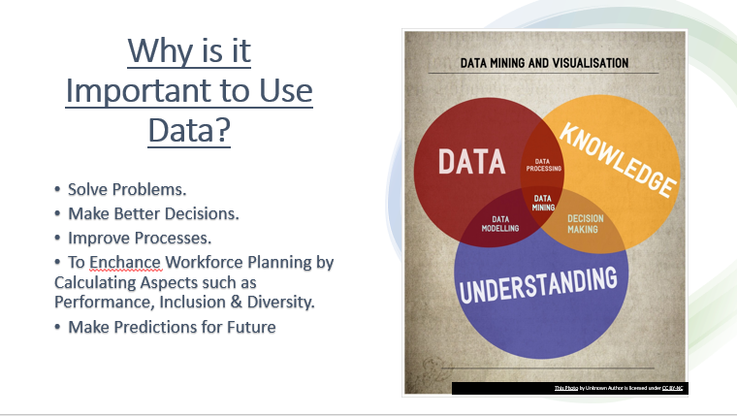

“A Forbes article discussing a survey from Deloitte, notes that “49 percent of respondents said analytics helps them make better decisions, 16 percent say that it better enables key strategic initiatives, and 10 percent say it helps them improve relationships with both customers and business partners.” But to take full advantage of data and analytics, you need to know how to get the most value from your data.” (Why Is Data Important for Your Business? | Grow.com, 2020).
Data helps the organisation understand and improve businesses processes and to make better decisions. Data allows organisations to measure the successfulness of a strategy. When strategies are put into place, collating the data will allow the organisation to determine how successful the solution is performing, and determines if the approach needs to be changed. Data will also help the organisation to explain decisions to stakeholders, and that approach has been based on data to back the organisation up.
When looking at data, organisations need to make sure that it is accurate, reliable and timely. If the data isn’t accurate, reliable and timely, the organisations will make bad decisions. The higher the quality of data, the increased chance of the organisation thriving.

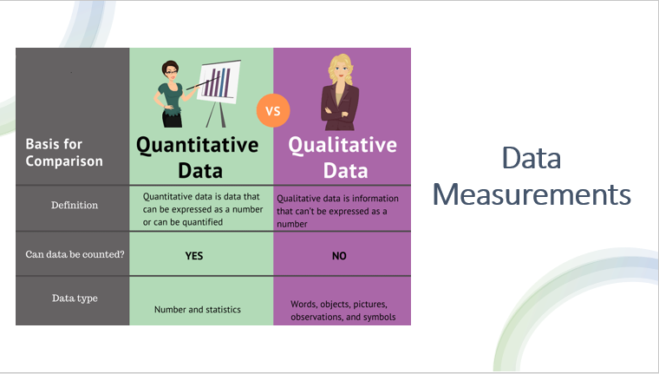
There are 2 types of data; quantitative and qualitative data.
Quantitative data is data that can be counted and measured in numerical values. The main way to collect quantitative data is through surveys. In surveys, close-ended questions have to be used. Once the data has been collected and analysed, it can be used to explore patterns. This can help make predictions about the future.
“Qualitative data is non-statistical and based on meanings that come from words” (Waite et al., 2021). This type can also be known as categorical data. There are many ways you can collect qualitative data; exit interviews, focus groups, performance appraisals and employee engagement.
Gupta (2015) wrote about how Black Hills Corporation uses HR analytics to address a turnover catastrophe in the future by calculating how many employees would retire per year, the types of employees needed as replacements and the source of possible new employees.

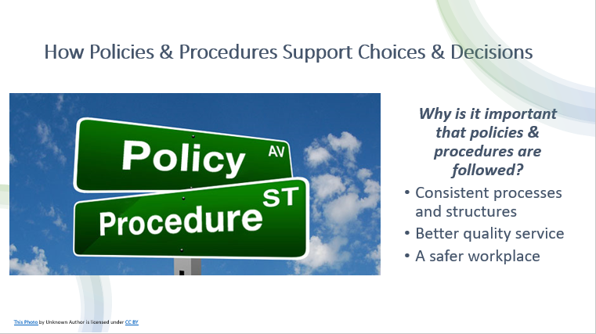
Policies and procedures are a crucial part of any organisation. Policies help in maintaining consistency in decision making. It is important that employees follow policies and procedures. Policies and procedures act as a guide for daily operations, to ensure compliance, streamline internal processes and assist in decision-making.
“When everyone is following policies and procedures, your organization can run smoothly. Management structures and teams operate as they’re meant to. And mistakes and hiccups in processes can be quickly identified and addressed.” (Following policies and procedures, and why it’s important, 2018).

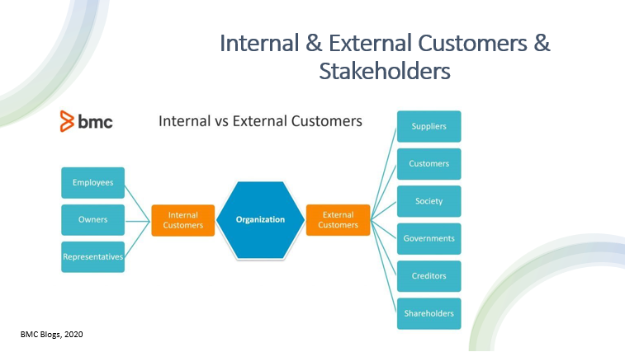
In all organisations, people professionals work with both internal and external customers.
Internal customers are within an organisation. This could be through employment or partners. Internal customers provides the product or service to the external customers and are important in playing a part in the success of an organisation. Shareholders and stakeholders are also seen as internal customers.
When the needs of the internal customers are being met, such as systems, then this has an impact on external customers. If systems and processes are out of date then this will have a negative impact on the internal customers which affects the experience of the external customers who seek assistance from the organisation.
External customers are the people who use and pay for the services or products that an organisation provides. External customers could be someone who has purchased a product once or someone who keeps purchasing on a long-term basis.
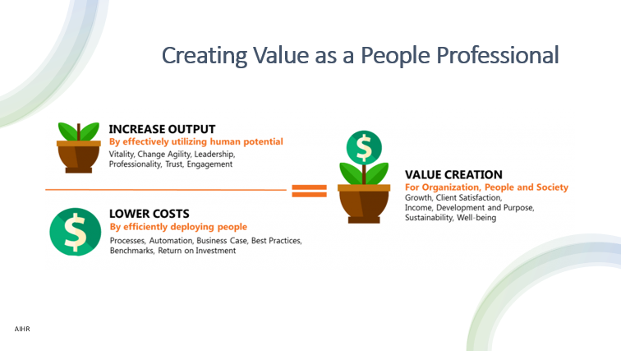
“A stakeholder is a party that has an interest in a company and can either affect or be affected by the business. The primary stakeholders in a typical corporation are its investors, employees, customers, and suppliers.” (Fernando, 2021).
According to Dijk, Human Resources exists to reduce personnel costs and to keep people happy and productive. The purpose of people management is to create value for the organisation and employees.
Creation of value could contribute to business growth, having a return on investment, customer satisfaction and maximizing benefits with an acceptable price.
In relation to employees within an organisation, the creation of value is often created by income and development, as well as a sense of purpose.
“Creating value for customers means providing useful products and services that customers consider worthy of their time, energy and money.” (Indeed Editorial Team, 2021).

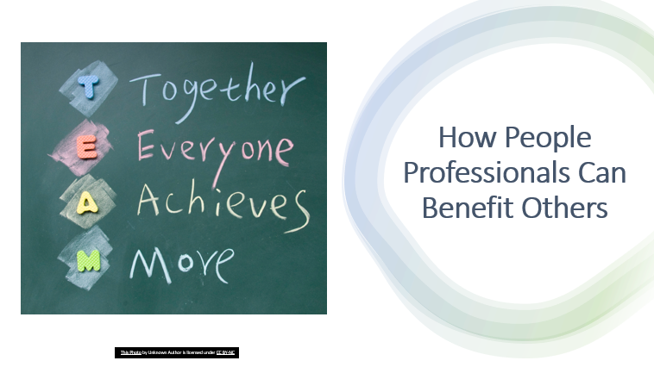
People professionals play an essential role in any organisation. They influence both internal and external customers.
In relation to internal, people professionals benefit employees by promoting an open culture. Employees create an open culture by being approachable and are open to suggestions from all employees.
“When HR organizes a charity benefit, for example, or a program by which employees can donate unused sick or vacation days for employees in need, it also helps employees feel that they are valued and promotes a team spirit throughout the company.” (Norman, n.d.).
People professionals also benefit others by showing commitment or trust within an organisation by role modelling and demonstrating a high standard of integrity in their behaviour and in their work.

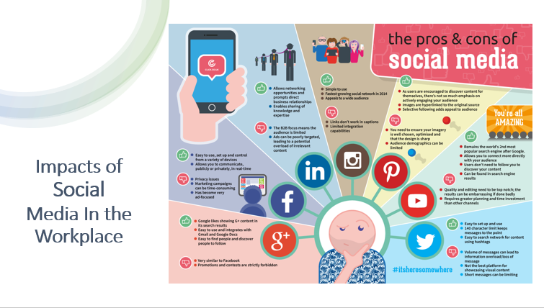
Within an organisation, there is two ways of communicating; internal and external. Some of the social media platforms that are used in the workplace are Facebook, Twitter, Instagram, YouTube and LinkedIn.
Internal communication happens amongst the organisation and employees. Internal communication also happens between employees and management.
External communication happens between the organisation and the customers.
Some of the positive impacts of using social media are:
- Employees can connect with colleagues to discuss ideas and ask questions.
- Improves business reputation and clientele.
- Promotes diversity and inclusion.
Although there are many positives from using social media, there is also the risk, which include:
- Potential outlet for cyberbullying via negative comments from employees or customers.
- Legal consequences if employees use social media incorrectly.
- Possibility of hackers committing fraud and launching viruses.

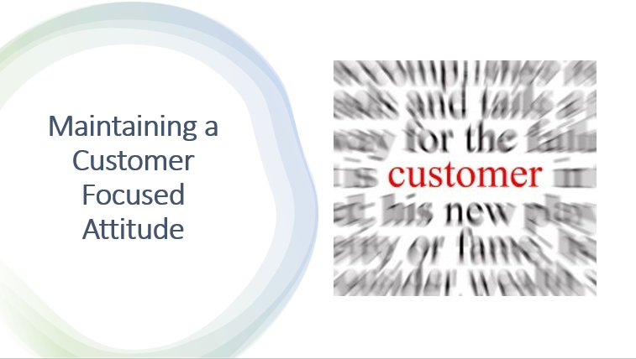
Customers are the priority of customer-focused organisations. Creating relationships, supporting customers and increasing customer satisfaction are all part of the process of becoming a customer-focused organisation.
“To be truly customer-focused, businesses need to work toward building a complete 360-degree customer view. In doing so, they will be able to deliver unified cross-channel customer engagement.” (Afshar, 2021).
Some ways of achieving and maintain a positive customer-focused attitude are:
- Listen to the customers.
- Supporting the employees and having an open culture.
- Approaching problems with an open mind.
- Celebrate the small wins.
- Create opportunities for learning.

Reference List – TASK ONE
- Afshar, V., 2021. How To Improve Customer Focus: 6 Tips and Strategies. [online] The 360 Blog from Salesforce. Available at: <https://www.salesforce.com/blog/customer-focus/> [Accessed 17 June 2022].
- Arshad, S., 2020. What Is The Role Of A Stakeholder? - Why So Important? - TBW. [online] TheBalanceWork. Available at: <https://thebalancework.com/what-is-the-role-of-a-stakeholder/#:~:text=%20Other%20Role%20And%20Responsibility%20Of%20Stakeholder%3A%20,all%20major%20social%20and%20environmental%20decisions..%20More%20> [Accessed 15 June 2022].
- Boatman, A., n.d. What is Evidence-Based HR? Examples, Benefits, and Process - AIHR. [online] AIHR. Available at: <https://www.aihr.com/blog/evidence-based-hr/#What> [Accessed 1 June 2022].
- CIPD People Profession. n.d. Evidence-based practice | CIPD Profession Map. [online] Available at: <https://peopleprofession.cipd.org/profession-map/core-knowledge/analytics-creating-value#:~:text=Using%20evidence%20and%20data%20to%20create%20insight%2C%20problem,as%20professional%20expertise%20to%20deliver%20work%20that%E2%80%99s%20impactful.> [Accessed 2 June 2022].
- Dijk, R. and Brugman, T., n.d. Creating Value With Fact-Based HR - AIHR. [online] AIHR. Available at: <https://www.aihr.com/blog/creating-value-fact-based-hr/> [Accessed 17 June 2022].
- dsim.in. 2019. 5 Reasons Why Data Accuracy Matters For Your Business. [online] Available at: <https://dsim.in/blog/2019/08/08/5-reasons-data-accuracy-matters-business/#Five_Reasons_Why_Data_Accuracy_is_so_Important_to_Businesses> [Accessed 6 June 2022].
- Eslake, S., 2006. The Importance of Accurate, Reliable and Timely Data. [online] Anz.com. Available at: <https://www.anz.com/documents/economics/The_Importance_of_Data.pdf#:~:text=In%20the%20absence%20of%20accurate%2C%20reliable%20and%20timely,that%20could%20have%20been%20made%20at%20the%20time.> [Accessed 4 June 2022].Grow.com. 2020. Why Is Data Important for Your Business? | Grow.com. [online] Available at: <https://www.grow.com/blog/data-important-business#:~:text=Data%20helps%20you%20understand%20and%20improve%20business%20processes,squanders%20time%2C%20and%20ultimately%20impacts%20the%20bottom%20line.> [Accessed 3 June 2022].
- Fernando, J., 2021. Learn What Stakeholders Are and the Roles That They Play. [online] Investopedia. Available at: <https://www.investopedia.com/terms/s/stakeholder.asp> [Accessed 15 June 2022].
- Fullstory.com. 2022. [online] Available at: <https://www.fullstory.com/quantitative-data/> [Accessed 5 June 2022].
- Gupta, B. (2015). Analytics in HR – Data Driven Decision Making in Human Resources. [online] Analytics India Magazine. Available at: https://analyticsindiamag.com/analytics-in-hr-data-driven-decision-making-in-human-resources/ [Accessed 10 June 2022].
- Indeed Career Guide. 2021. 14 Effective Tips for Creating Value for Your Customers. [online] Available at: <https://www.indeed.com/career-advice/career-development/creating-value-for-customers> [Accessed 17 June 2022].
- Kapur, R., 2020. Human Resources Policies and Procedures. [online] Available at: <https://www.researchgate.net/publication/339711840_Human_Resources_Policies_and_Procedures> [Accessed 12 June 2022].
- Kemp, A., 2018. UK perspective on evidence based policy planning. [online] GOV.UK. Available at: <https://www.gov.uk/government/speeches/uk-perspective-on-evidence-based-policy-planning> [Accessed 10 June 2022].
- Kidd, C. and McLatchie, H., 2020. Internal vs External Customers: How Are They Different?. [online] BMC Blogs. Available at: <https://www.bmc.com/blogs/internal-vs-external-customers/> [Accessed 15 June 2022].
- Miller, B., 2018. [online] Available at: <https://hrdailyadvisor.blr.com/2017/09/29/evidence-based-hr/> [Accessed 1 June 2022].
- Mohdzaini, H. (2021). People Analytics | Factsheets. [online] CIPD. Available at: https://www.cipd.co.uk/knowledge/strategy/analytics/factsheet#gref. [Accessed 13 June 2022]
- Moitra, T., 2017. An Overview of Evidence Based Management in HR: Moving from Suppositions to Data. [Blog] Available at: <https://blog.sage.hr/overview-evidence-based-management-hr-moving-suppositions-data/> [Accessed 31 May 2022].
- Norman, L., n.d. The Role of HR in Workplace Culture. [online] Small Business - Chron.com. Available at: <https://smallbusiness.chron.com/role-hr-workplace-culture-10206.html> [Accessed 18 June 2022].
- Powerdms.com. 2018. Following policies and procedures, and why it’s important. [online] Available at: <https://www.powerdms.com/policy-learning-center/following-policies-and-procedures-and-why-its-important> [Accessed 19 June 2022].
- QuestionPro. n.d. Qualitative Data: Definition, Types, Analysis and Examples. [online] Available at: <https://www.questionpro.com/blog/qualitative-data/> [Accessed 9 June 2022].
- Russell, T. and Green, M., 2022. Ethical Practice and the Role of People Professionals | Factsheets | CIPD. [online] CIPD. Available at: <https://www.cipd.co.uk/knowledge/culture/ethics/role-hr-factsheet> [Accessed 19 June 2022].
- The Council on Quality and Leadership. n.d. 12 Reasons Why Data Is Important - The Council on Quality and Leadership. [online] Available at: <https://www.c-q-l.org/resources/guides/12-reasons-why-data-is-important/> [Accessed 3 June 2022].
- tawk.to. 2019. 9 tips to maintain a positive attitude in customer service. [online] Available at: <https://www.tawk.to/customer-happiness/9-tips-to-maintain-a-positive-attitude-in-customer-service/#:~:text=%209%20tips%20to%20maintain%20a%20positive%20attitude,you%20have%20with%20your%20boss%20and...%20More%20> [Accessed 19 June 2022].
- The Oxford Review. 2022. The Essential Guide to Evidence-Based Practice – 2022. [online] Available at: <https://oxford-review.com/evidence-based-practice-essential-guide/#:~:text=In%20essence%20organisational%20evidence-based%20practice%20%28EBP%29%20refers%20to,activities%20are%20undertaken%20using%20the%20best%20evidence%20available.> [Accessed 31 May 2022].
- SHRM. n.d. Managing and Leveraging Workplace Use of Social Media. [online] Available at: <https://www.shrm.org/ResourcesAndTools/tools-and-samples/toolkits/Pages/managingsocialmedia.aspx> [Accessed 17 June 2022].
- Waite, K., Beevers, K., Small, N., Tomlinson, K. and Hussain, S., 2021. People Practice: A Complete Guide. KoganPage, p.47.
- Young, J. (2021). Evidence-based Practice for Effective Decision-Making | Factsheets. [online] CIPD. Available at: https://www.cipd.co.uk/knowledge/strategy/analytics/evidence-based-practice-factsheet#gref.

TASK TWO - Example of analysis of data to inform practice

From the data above, you can see that majority of the department agree that they have scope to use their own initiative and the opportunity to develop their skills.
Again, you can see that majority of the department agree that they are expected to complete outside of work hours, which could mean that employees are not under pressure to meet deadlines. Coming work outside of contracted hours could lead to burnout and stress, which could then lead to staff being off sick. Although they are completing work outside of work hours, 36.65% of the department still manage to fulfil commitments outside of work, but 45.40% find it difficult. This could lead to people not having a work life balance. Not having a work life balance could instigate staff seeking other jobs where they would have a work life balance and being able to complete their work in their contracted hours.

Within the administration department, you can see that 89.20% of the department find it difficult to fulfil commitments outside of work, which is due to them being expected to complete work outside of their contracted hours.
Compared to the Research & Design department, administration department aren’t provided with flexi time or the option to work from home.
53.84% of the department also believe they don’t have the opportunity to develop skills. Often if staff can’t develop their skills in a job, they will seek jobs elsewhere in an organisation where they can develop their skills. this will decrease retention in the department.
89.23% of the department disagree that the absence rates are low. I believe this could be a link between staff having to complete work outside the contracted hours and not being able to fulfil commitments outside of work. This can lead to stress and work burnout, which is causing sick to be off sick.

The marketing department is small compared to Research & Design and Administration.
Same as Administration, Marketing aren’t allowed to work from home. If one department is allowed to work from home but other departments aren’t, then this could cause disputes within the organisation.
Marketing is the only department where majority isn’t expected to work outside of work hours, but also the only department where they are aware that the organisation has the opportunity to job share. By looking at the data, this has an impact on work life balance, as they don’t work over their contracted hours and can fulfil commitments outside of work.

Department | Days lost through absence – 3 Month Period | Projected Average Loss of Working Days – 12 Month Period | Costs of Pay (Full Pay) Whilst off Sick - 3 Month Period
Research and Design | 250 days | 1,000 days | £65,660
Administration | 32 days | 128 days | £2,962.50
Marketing | 3 days | 12 days | £560

