Selection in C (3) – if…else (including multiple conditions) (SOLUTIONS)

1. Write a program to allow the user to enter their age. If their age is between 18-30, print a message on the screen. If they are outside this age group, print a different message.

Don't forget to test your program on the boundaries!

Sample output:

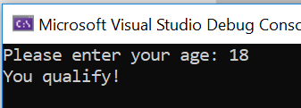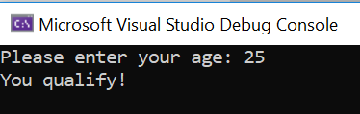

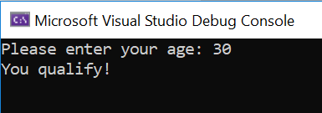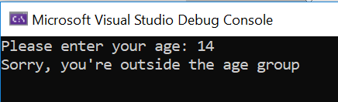

Solution:

#define _CRT_SECURE_NO_WARNINGS
#include <stdio.h>

void main()
{
int userAge;

printf("Please enter your age: ");
scanf("%d", &userAge);

if (userAge >= 18 && userAge <= 30)
{
printf("You qualify!\n\n");
}
else
{
printf("Sorry, you're outside the age group\n\n");
}

}

OR

#define _CRT_SECURE_NO_WARNINGS
#include <stdio.h>

void main()
{
int userAge;

printf("Please enter your age: ");
scanf("%d", &userAge);

if (userAge < 18 || userAge > 30)
{
printf("Sorry, you're outside the age group\n\n");
}
else
{
printf("You qualify!\n\n");
}

}

2a. Write a program which allows the user to input a date in a form similar to the following:

9 February 2021

Print the date on the screen, using statements/conditions to show the contraction for the day (eg 1st 4th 22nd)

Sample output:

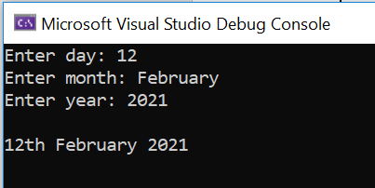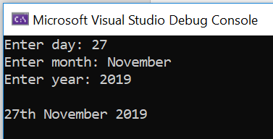

Solution:

#define _CRT_SECURE_NO_WARNINGS
#include <stdio.h>

void main()
{
int day;
char month[10];
int year;

printf("Enter day: ");
scanf("%d", &day);
printf("Enter month: ");
scanf("%s", &month);
printf("Enter year: ");
scanf("%d", &year);

if (day == 1 || day == 21 || day == 31)
{
printf("\n%dst %s %d\n\n", day, month, year);
}
else if (day == 2 || day == 22)
{
printf("\n%dnd %s %d\n\n", day, month, year);
}
else if (day == 3 || day == 23)
{
printf("\n%drd %s %d\n\n", day, month, year);
}
else
{
printf("\n%dth %s %d\n\n", day, month, year);
}

}

2b Extension (harder): Extend your code to warn the user that (for example) the date 31 April does not exist. Test with both valid dates (eg 29th April 2021) and invalid dates (31st April 2021) to make sure the code is working for all dates.

Sample output:

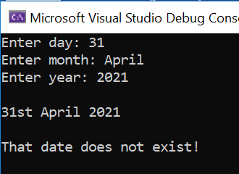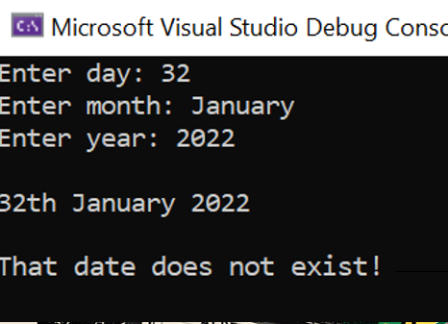

Solution:

#define _CRT_SECURE_NO_WARNINGS
#include <stdio.h>
#include <string.h>

void main()
{
int day;
char month[10]; //Note: longest month is September – 9 letters plus 1
int year;

printf("Enter day: ");
scanf("%d", &day);
printf("Enter month: ");
scanf("%s", &month);
printf("Enter year: ");
scanf("%d", &year);

if (day == 1 || day == 21 || day == 31)
{
printf("\n%dst %s %d\n\n", day, month, year);
}
else if (day == 2 || day == 22)
{
printf("\n%dnd %s %d\n\n", day, month, year);
}
else if (day == 3 || day == 23)
{
printf("\n%drd %s %d\n\n", day, month, year);
}
else
{
printf("\n%dth %s %d\n\n", day, month, year);
}

if ((strcmp(month, "April") == 0 || strcmp(month, "June") == 0 || strcmp(month, "September") == 0 || strcmp(month, "November") == 0) && day > 30)
{
printf("That date does not exist!\n\n");
}
else if (strcmp(month, "February") == 0 && day > 29)
{
printf("That date does not exist!\n\n");
}

}

3. Write a calculator which looks something like the below. Think about the variable types in advance and decide on the types.

Sample output:
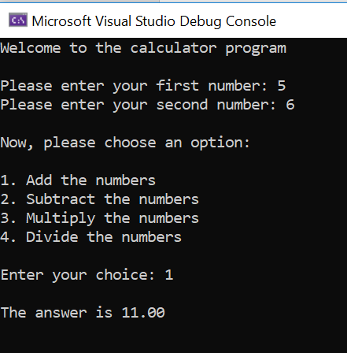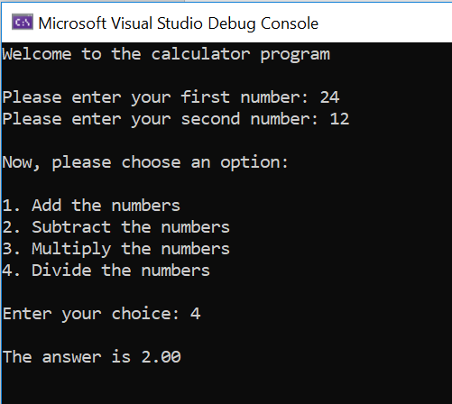

Remember to test your calculator thoroughly, making sure it works for all options (and invalid ones too!)

Solution:

#define _CRT_SECURE_NO_WARNINGS
#include <stdio.h>

void main()
{
float first, second, total = 0;
int choice;

printf("Welcome to the calculator program\n\n");

printf("Please enter your first number: ");
scanf("%f", &first);
printf("Please enter your second number: ");
scanf("%f", &second);

printf("\nNow, please choose an option:\n\n");

printf("1. Add the numbers\n");
printf("2. Subtract the numbers\n");
printf("3. Multiply the numbers\n");
printf("4. Divide the numbers\n");

printf("\nEnter your choice: ");
scanf("%d", &choice);

if (choice == 1)
{
total = first + second;
}
else if (choice == 2)
{
total = first - second;
}
else if (choice == 3)
{
total = first * second;
}
else if (choice == 4)
{
total = first / second;
}
else
{
printf("Sorry, invalid option");
}

printf("\nThe answer is %.2f\n\n", total);
}

4. Write a program that allows the user to enter two pizza toppings. Print a message on the screen to state whether the user has chosen Hawaiian pizza (ham and pineapple!) or not. (Note: the user should enter everything in lower case)

Remember, the user could enter pineapple first and then ham, or vice versa, so you will need to check both combinations.

Sample output:

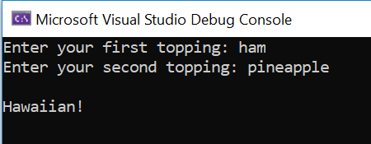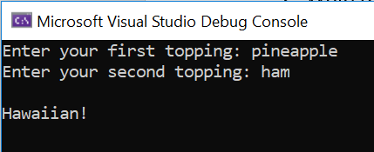

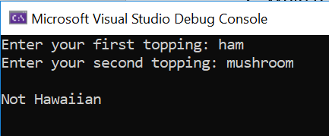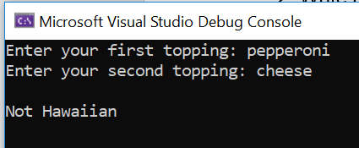

Solution:

#define _CRT_SECURE_NO_WARNINGS
#include <stdio.h>
#include <string.h>

void main()
{
char topping1[15];
char topping2[15];

printf("Enter your first topping: ");
scanf("%s", &topping1);

printf("Enter your second topping: ");
scanf("%s", &topping2);

if (strcmp(topping1, "ham") == 0 && strcmp(topping2, "pineapple") == 0)
{
printf("\nHawaiian!\n\n");
}
else if (strcmp(topping1, "pineapple") == 0 && strcmp(topping2, "ham") == 0)
{
printf("\nHawaiian!\n\n");
}
else
{
printf("\nNot Hawaiian\n\n");
}

}

5a. Ask the user to guess what my favourite number is (for the purposes of this program, my favourite number is 15) Tell the user whether they guessed right or wrong.

(Note: one guess only, but the user can re-run the program to try again if they want)

Sample output:
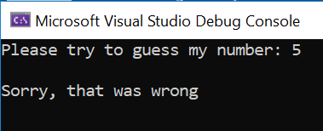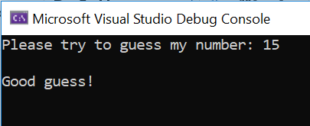

Solution:

#define _CRT_SECURE_NO_WARNINGS
#include <stdio.h>

void main()
{
int faveNumber = 15;
int myGuess;

printf("Please try to guess my number: ");
scanf("%d", &myGuess);

if (myGuess == faveNumber)
{
printf("\nGood guess!\n\n");
}
else
{
printf("\nSorry, that was wrong\n\n");
}

}

5b Extend the game from 5a so that instead of the player being told they are wrong, they get told if they are warm or cold. You can consider "warm" to be a guess within 5 of my favourite number.

Sample output:
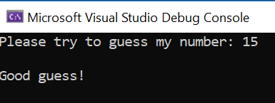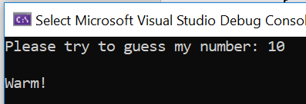

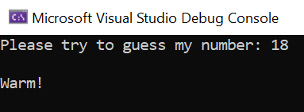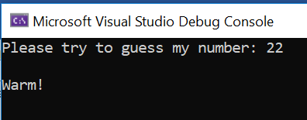

Solution:

#define _CRT_SECURE_NO_WARNINGS
#include <stdio.h>

void main()
{
int faveNumber = 15;
int myGuess;

printf("Please try to guess my number: ");
scanf("%d", &myGuess);

if (myGuess == faveNumber)
{
printf("\nGood guess!\n\n");
}
else if (myGuess >= 10 || myGuess <= 20)
{
printf("\nWarm!\n\n");
}
else
{
printf("\nCold!\n\n");
}

}

