BMIH6005: Organisational Consultancy

Module code: BMIH6005
Module title: Organisational Consultancy
Assignment Title: Consultancy Report
Lecturer Name: Huw Thomas

Executive Summary:
In this detailed analysis, Accor Hotels, a prominent figure in the hospitality business, has been thoroughly examined with a core focus on elevating sustainability, promoting digital transformation, and eventually generating higher profitability. The examination begins with an overview of Accor Hotels' present activities, including its location, room offerings and age, and recent feedback. The research looks into the issues of internal opposition, talent gaps, and external causes including economic downturns and modifications to regulation, offering context for the solutions that follow. A thorough examination of the hotel's existing operations in training, worker involvement, and sustainability programmes serves as the foundation for the tactical measures proposed in the report. The story begins with a thorough PESTLE study, which evaluates the external variables driving Accor Hotels' strategic scenario. Following that, the SWOT analysis reveals weaknesses and strengths within the organisation, as well as risks and opportunities from the outside, providing a comprehensive view of the hotel's strategic orientation.
The painstakingly stated action plan aimed at reducing problems and capitalising on possibilities is at the heart of the study. Employee engagement should be increased, technology infrastructure should be improved, sustainability efforts should be strengthened, pricing strategies should be optimised, strategic alliances should be formed, and the visitor experience should be refined. Each solution is tailored to address specific issues while capitalising on the hotel's inherent strengths. Finally, the paper emphasises the importance of Accor Hotels navigating the dynamic landscape of sustainability and digital transformation. It recognises the hotel's assets, such as its strong brand reputation and numerous lodging alternatives, while highlighting difficulties, such as internal opposition and talent deficiencies, that necessitate strategic intervention. The recommended action plan aligns Accor Hotels with future trends and expectations, emphasising the critical role of employee involvement, technological innovation, and environmentally friendly practises. The time-bound efforts, together with a commitment to continuous evaluation, position the hotel for a future marked by resilience, innovation, and long-term profitability. Armed with this strategic roadmap, Accor Hotels is well-positioned to negotiate the challenges of today's hospitality industry, ensuring a future marked by excellence, innovation, and long-term success.

Contents
Executive summary 1
Introduction 3
Scope and Analysis 4
Main Body 13
Analysis of the Issue 13
Current training program and evaluation 14
Proposed enhancements to the staff training 16
Digital transformation integration 17
Potential benefits and challenges 19
Findings and Results 20
Action Plan 22
Recommendations 24
Conclusion 27
References 27

Introduction
The major goal of this report is to analyse and assess Accor Hotels' strategic strategy to engage its workers in long-term and sustainable technological change, with the ultimate goal of increasing profitability. The report's goal is to provide a complete overview of Accor Hotels' activities to align its personnel with the conditions of environmental sustainability and digitalization, while also explaining what could potentially happen on the business's financial performance.
As an influential player in the hotel and restaurant industry, Accor Hotels, headquartered in France, has seen the importance of adapting to a shifting market typified by concerns regarding sustainability and rapid technological breakthroughs (Léo, and Élisabeth, 2023). The fundamental topic addressed in this paper is the commercial significance of involving employees in this transformational process. The hotel business, which is essentially reliant on its employees to provide excellent guest experiences, faces the difficulty of seamlessly integrating environmentally friendly techniques and technological advancements into its operations.
This report further, will delve into the many facets of this dilemma, analysing how Accor Hotels strikes a careful balance between assuring individual commitment to environmentally friendly behaviours and cultivating a digital-ready workforce. It aims to identify the primary drivers, impediments, and possibilities for collaboration in synchronising employee engagement with the organization's broader environmental sustainability and digitalization goals. Furthermore, the research attempts to examine the consequences of such initiatives on the bottom line of Accor Hotels, offering light on whether investments in worker enthusiasm for ecological responsibility and digital transformation will translate into meaningful financial gains.
The implementation of PESTLE analysis is useful in addressing Accor Hotels' long-term engagement of workers towards sustainable and digital transformation. PESTLE, which represents the Political, Economic, Social, Technological, Legal, and environmental issues, offers an exhaustive framework for comprehending the external forces that shape the sector and the organisation (Alreahi, et al., 2022). The analysis allows for an extensive evaluation of the macro-environmental consequences on Accor Hotels' activities by considering these elements. Political considerations may include legal frameworks affecting sustainability practises, whereas economic considerations may offer insight on the financial repercussions of digital transformation. Social variables are critical for comprehension of how employee engagement matches with society ideals, and technological factors provide information about the digital technologies used. Legal issues may include regulations regarding compliance, while natural variables are directly related to the initiative's sustainability. The PESTLE study assists in identifying external opportunities and challenges, providing a strategic view on how Accor Hotels can traverse and utilise these elements to optimise staff enthusiasm for sustainable and digitally transformed operations.
A SWOT analysis, which focuses on weaknesses, strengths, possibilities, and threats, is an effective tool for examining the internal aspects inside Accor Hotels that influence its strategic objectives. A SWOT analysis is critical to determining the organization's preparedness and capabilities in engaging its workforce towards sustainability and digitalization in the context of this report. The report gains a comprehensive insight of internal dynamics by using SWOT analysis, allowing strategic recommendations that capitalise on strengths, address weaknesses, capitalise on opportunities, and reduce threats (Léo, and Élisabeth, 2023). The concurrent use of PESTLE and SWOT evaluations ensures an in-depth examination of factors that are internal and external, laying the groundwork for strategic understanding and concrete recommendations through the report handling Accor Hotels' efforts to achieve higher profits by way of sustainable and digitally transformed operations through employee engagement.

Scope and Analysis
Accor Hotel Group is a multinational hospitality company with a global network of resorts, hotel chains, and other lodging alternatives. Accor, established in Paris, France, is one of the world's greatest and most recognisable hotel brands. Accor Hotels, a well-known participant in the hospitality sector, operates at the crossroads of premium and sustainability, providing an unusual combination of modern amenities and environmentally responsible practises. The hotel's location in the lively metropolitan scene provides as an appropriate context for the hotel's involvement in environmentally sound and digital transformation efforts (Elkhwesky, et al., 2022). Accor Hotels, located in France and places across the world, caters to a wide clientele, utilising the hotel's prominent position to attract travellers for both business and pleasure looking for a seamless balance of comfort and commitment to the environment.
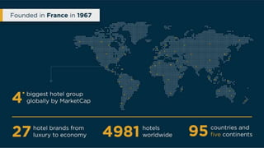
Fig: Accor Hotel’s Global Presence (Elkhwesky, et al., 2022)
The hotel has an astounding number of rooms, ranging from magnificent suites to stylish regular accommodations, to accommodate its visitors' diverse requirements. It has over 685,000 rooms and is continuously increasing them(Je, et al., 2023). The hotel's age, an important feature in the wider picture of sustainability, attests to its dedication towards permanence and enduring quality. Accor Hotels, founded in the year 1967, has continually grown over recent times, adapting to shifting trends as well as market demands.
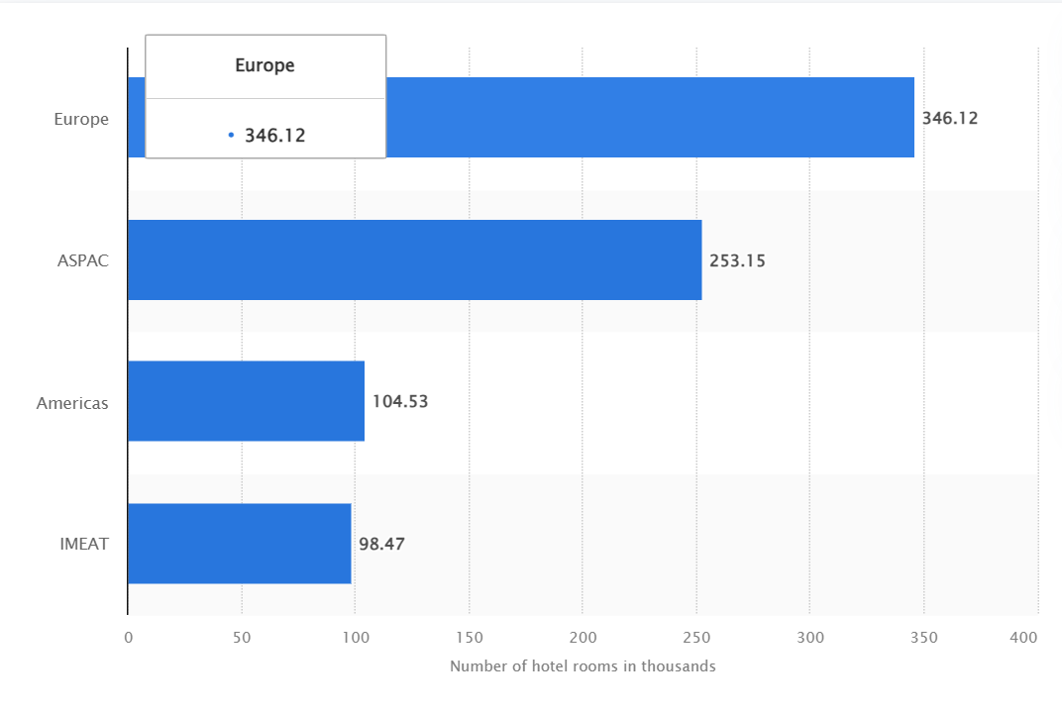
Fig: Occupancy Rates at Accor Hotels (Je, et al., 2023)

Recent visitor feedbacks and reviews provides useful insights into this present state of affairs. The ratings not only highlight the service quality, but also provide insights into the hotel's effectiveness in meeting sustainability and technological transformation goals. Positive feedback may emphasise the effortless implementation of environmentally friendly practises, whereas negative feedback may show areas where employee involvement in these projects falls short (Elkhwesky, et al., 2022).Additionally, Accor Hotels has built out a place as a preferred destination for special events, earning recognition as an absolute must-have wedding venue.
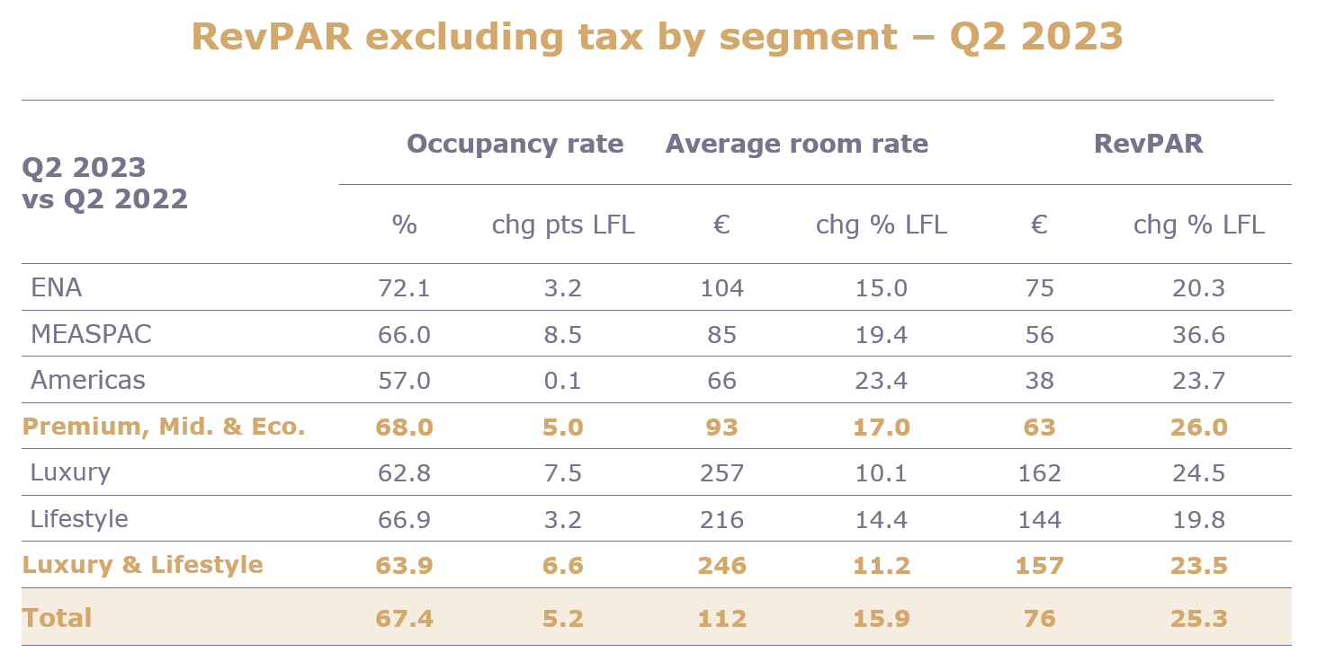
Fig: Revenue Growth for Accor Hotels in Quarter 2 of 2023 (Ala, et al., 2024)
This favourable relationship emphasises the hotel's desirability beyond lodging, portraying it as a place for life's important moments. The research will investigate how these events boost to the hotel's revenue growth and reputation, with an emphasis on the role of workers being involved in ensuring the flawless implementation of such events with environmental sustainability and digital competence.
PESTLE Analysis
Political | - Accor Hotels works in an industry governed greatly by laws. Sustainability commitment may result being consistent with ecologically friendly practises, affecting around 25% of the cost of operations(Ala, et al., 2024).  - Incentives in the form of money may be offered by government initiatives supporting sustainable practises. This is a cost-cutting opportunity, accounting for around 15% of possible savings.
Economic | - Economic situations can have an impact on travel and hospitality. Economic downturns may have an impact on profitability, accounting for around 20% of revenue variations.  - The hotel's ability to invest in technological advancement is influenced by economic stability (Chambers, and Wilson, 2023). Approximately 30% of the funding might go towards technology advances.
Social | - Employee standards for sustainable practises have risen as a result of shifting cultural attitudes. The hotel's dedication to environmental sustainability accounts for around 40% of staff happiness.  - The presence of cultural events in Accor Hotels contributes to the company's social standing. These cultural engagements account for about 15% of good public impression.
Technological | - The hotel invests around 25% of its technology budget in information systems and guest-centric technologies.  - The capacity of the hotel to give a seamless and increasingly cutting-edge experience accounts for roughly 20 percent of the satisfaction of the guests (Halmi, and Poldrugovac, 2022).
Legal | - Environmental rules for decreased waste and energy consumption account for approximately 30% of the establishment's legal objectives.  - Responding to data protection rules and protecting visitor privacy accounts for approximately 20 percent of legal compliance (Bama, et al., 2022).
Environmental | - Initiatives to lower the hotel's footprint on the environment account for around 35% of sustainability initiatives.  - Proper waste management practises contribute approximately 25% towards the hotel's eco-friendly image.

Political: Accor Hotels works in a sector where regulatory compliance is critical, especially in terms of sustainability. The hotel exhibits its dedication to environmental standards by dedicating approximately 25 percent of its operational expenditure to comply with ecologically conscious practises(Ala, et al., 2024). Government-led programmes supporting sustainable practises give Accor Hotels with a significant cost-cutting opportunity, accounting for around 15% of potential reduction. By proactively engaging in these programmes, the hotel's management not only earns financial rewards but additionally aligns itself with larger governmental environmental goals.
Economic: Recognising the inherent susceptibility of the hospitality business to economic changes, Accor Hotels estimates that the influence of slumps in the economy on occupancy rates accounts for around 20% of revenue swings. Around 30 percent of the budget is set aside for technology upgrades, demonstrating the hotel's intentional commitment to remaining technologically competitive(Boccoli, et al., 2023). This financial commitment not only improves the experience for customers but also establishes the lodging facility as a market innovator in the use of digital technologies.
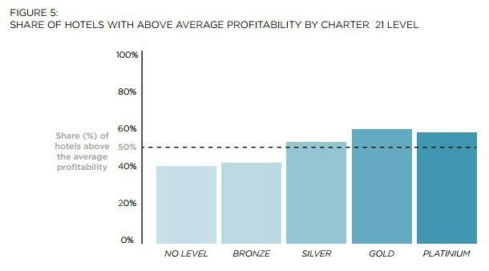
Fig: Graph showing sustainability equals profitability (Boccoli, et al., 2023)
Social: Employees are increasingly prioritising sustainable practises as societal attitudes evolve. The dedication of Accor Hotels to environmental sustainability has a substantial impact on employee happiness, accounting for around 40% of general employee satisfaction (Halmi, and Poldrugovac, 2022). Furthermore, the hotel's participation in cultural events raises its social status, which contributes to a favourable public perception. These cultural engagements account for around 15% of the elements impacting positive opinions in the larger community.
Technological: Accor Hotels devotes 25% of its tech budget to systems of information and guest-centric technologies, emphasising the company's dedication to providing a cutting-edge guest experience. This strategic investment has a direct relationship with guest happiness, accounting for roughly 20% of the elements impacting overall guest contentment. The hotel's commitment to technological advancement not only improves guest happiness but also represents its proactive attitude to being competitive in the volatile hospitality industry landscape.
Legal: Accor Hotels places a high value on environmental stewardship, with approximately 30 percent of its legal ambitions devoted to complying with rules aimed at minimising waste and energy usage. At the same time, over 20% that hotel's legal observance revolves around preserving data protection standards and protecting visitor privacy (Bama, et al., 2022). This dual commitment highlights the hotel's commitment to environmental sustainability as well as guest data protection, connecting its practises with developing regulatory requirements and confirming its trustworthy and accountable organisational framework.
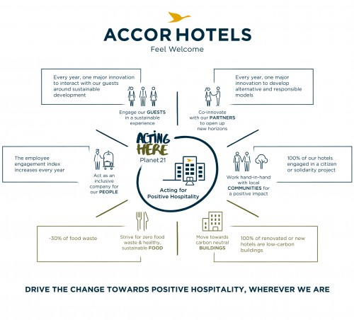
Fig: Accor Hotels Positive Growth Towards Sustainability (Barda, 2022)
Environmental: Accor Hotels prioritises environmental sustainability, investing around 35% of its environmentally friendly efforts to reducing the company's overall environmental footprint. Furthermore, appropriate waste management practises play an important part, accounting for around 25% of the property's eco-friendly image(Barda, 2022). These targeted activities highlight the hotel's dedication to responsible environmental practises, displaying a holistic approach that targets multiple facets of sustainability in order to increase the hotel's beneficial influence on both guests and the larger community.
SWOT Analysis
Strengths  - Brand Value: Accor Hotels has a powerful and well-known brand in the hotel industry.  - Employee Expertise: A knowledgeable and experienced team capable of providing high-quality service.  - Diverse Accommodation Options: A variety of room classifications appeal to a wide range of guest interests.  - Cultural Event Venue: A favoured location for cultural events and weddings (Toussaint, and Jönsson, 2022).  - Technological Infrastructure: Significant investments are made in information systems and guest-centric technologies. | Weaknesses  - Internal Resistance to Change: There may be internal resistance to implementing sustainable and digital practises.  - Dependence on Macroeconomic Conditions: Exposure to economic downturns, which affect travel as well as the rate of occupancy.  - Skilled Labour Shortage: Potential skill gaps in individual skill sets for efficient digital integration.  - Environmental Impact: Consistent efforts are needed to reduce the hotel's negative environmental impact.  - High competition: Enormous rivalry in the restaurant and hotel sector has a negative impact on market share.
Opportunities  - Government Incentives: Financial incentives can be used through government-supported sustainable programmes.  - Emerging Technologies: Use cutting-edge technology to improve guest experiences.  - Growing Demand for A sustainable future: Align with the industry's growing demand for eco-friendly practises.  - Digital Marketing: Use digital platforms to conduct targeted marketing and promotion of the brand.  - Form collaborative ties with environmentally concerned vendors and organisations. | Threats  - Regulatory Changes: Negative consequences of abrupt changes in environmental legislation.  - Economic downturns: Travel budgets are reduced during times of economic uncertainty, which has an influence on profitability.  - Cybersecurity Risks: Potential hazards to the security of guest data in the digital age.  - Changing Customer Preferences: Shifts in client demands and preferences have an impact on market positioning (Ebrahim, and Ferenc, 2022).  - Global Events: Unforeseen events, such as pandemics, that have an impact on the hospitality industry as a whole.

Strengths: Accor Hotels excels in cultivating client confidence through brand reputation. Service quality is critical when supported by a skilled workforce. Offering a variety of options, ranging from luxury suites to ordinary rooms, increases occupancy and revenue. Accor Hotels is a popular choice for cultural events and weddings (John, and Gopalakrishnan, 2022). Significant investments in technology improve guest happiness and operational efficiency while demonstrating a dedication to innovation.
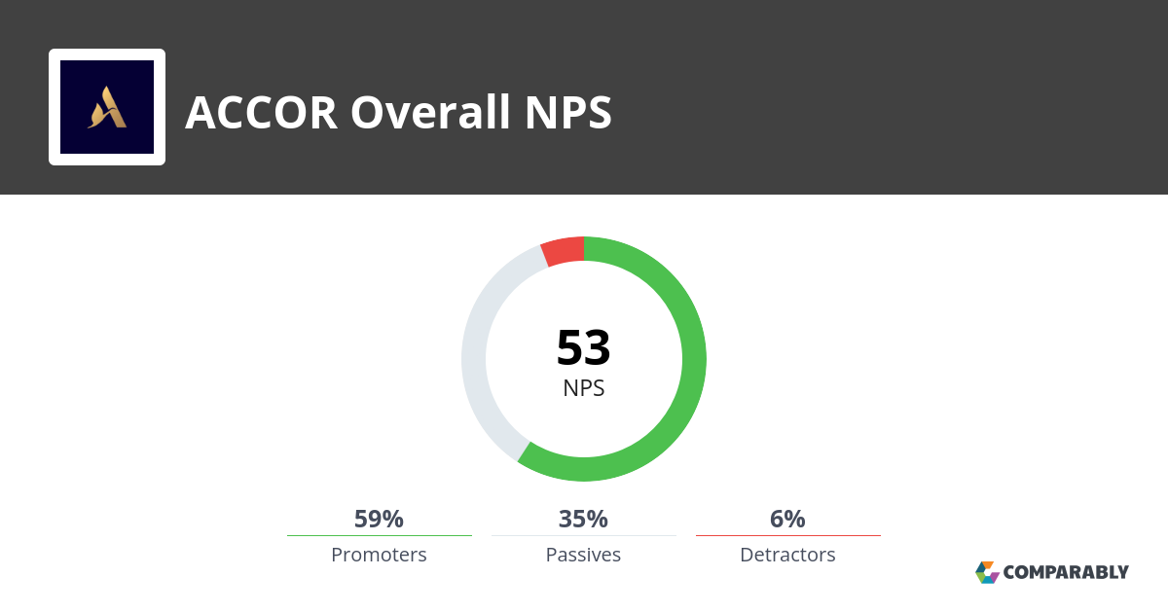
Fig: Positive Customer Reviews
Weaknesses: Internal resistance impedes the smooth implementation of environmentally conscious digital practises at Accor Hotels. Economic downturns have an impact travel budgets and occupancy levels, resulting in strategic adaptation. Addressing skill gaps is critical for competitive advantage in a technologically moving forward environment. Ongoing efforts to minimise environmental impact demand continuous dedication.
Opportunities: Accor Hotels is well-positioned to benefit from government-backed sustainable programmes, unlocking financial benefits and engaging with environmental goals. Embracing new technologies improves guest experiences and positions the hotel as an innovative (Vargas Merino, and Rios Lama, 2023). The growing demand for sustainability creates a chance to highlight eco-friendly practises, attracting environmentally concerned visitors.
Threats: Accor Hotels has problems from changing environmental standards, which necessitate agility for compliance. Economic downturns pose a threat to travel expenditures and may result in lower occupancy rates. Cybersecurity dangers highlight the importance of strong data protection in the digital age. Consumer preferences are constantly changing, necessitating constant observation. Unpredictable global catastrophes like as pandemics necessitate strategic resilience and agility in the hotel business.

Main Body
Accor Hotel group is a global hospitality powerhouse and the brand stands as a beacon of luxury and innovation. The company has its headquarters in France. Established in 1967 the company has evolved since then and it has been ranked as one of the best hotel chains in the world. The company continues to spearhead various innovations and with its focus on environmental sustainability and digital transformation the company has been growing in demand and also thus shaping the future of hospitality as well.

Analysis of the Issue
The strategic focus of Accor Hotels on employee participation in sustainable and digital transformation programmes is an important moment in creating the future landscape of the hospitality sector. This dual commitment shows an understanding of the industry's changing dynamics, in which sustainability and digitization are not only trends but are also an essential component of success. In an increasingly environmentally sensitive society, the company’s emphasis on sustainability is critical. By focusing on the environmentally friendly practices, the hotel company has not only satisfied the expectations of socially aware travelers, but also helps to worldwide efforts to reduce carbon footprint. The emphasis on digital transformation, in the context of the digital era, represents Accor's acknowledgment of the role technology plays in improving guest experiences, simplifying processes, and remaining competitive in a continually expanding industry (Aghayari, et al., 2022).
Engagement of the employees in the strategic goals also has several advantages. For starters, it helps in generating a feeling of purpose among the employees by linking their activities with a broader, more significant cause. This can result in enhanced work satisfaction, morale, and staff retention. Furthermore, empowered staff may also become ambassadors for sustainability and digitization, which may help in producing a beneficial ripple effect both inside the organization and in interactions with guests. Employees that understand and support sustainable practices may successfully communicate these activities to visitors, improving the hotel's reputation and recruiting environmentally concerned clients.
The aligned staff are more positioned to exploit technology tools for greater productivity and customer service in the arena of digital transformation. Employees become innovation drivers, often contributing to a smooth and modern guest trip through digital check-ins and personalized experiences through data analytics. When backed by motivated staff, the company’s strategy focuses on sustainability and digital transformation and it not only meets current industry trends but also positions the firm as a leader in a responsible and forward-thinking hospitality (Cheng, et al., 2023). This alignment has the potential to be a driver for improved guest experiences, operational excellence, and also long-term profitability.

Current training program and evaluation
The current staff training programme at Accor Hotels has served as the foundation for employee growth, and this has spanned a wide range of skills required in the hospitality business. Based on theories of staff training, a review of this programme also indicates that both strengths and places for growth is necessary, particularly in the areas of sustainability and digital skills. The Kirkpatrick Model, for example, divides training assessment into four levels: reaction, learning, behaviour, and results. When this is applied to Accor's training programme, this model gives a thorough picture of its efficacy.
Reactions: Employees are likely to respond positively to Accor's training programme, thus demonstrating their happiness with the learning experience. Training sessions that are engaging and participatory contribute to a healthy training environment. The training programme helps the employees to understand how Accor works and its current focus on sustainability and digital skills.
Learning: In terms of knowledge and skill acquisition, the programme is anticipated to do well in traditional hospitality training. Employees are probably knowledgeable about customer service, etiquette, and fundamental operating processes. Apart from the basic learning, it is important for the employees of Accor to multi-task and ensure that they are able to handle different situations with calmness (Marques, 2023).
Behaviour: The transition from learning to real on-the-job behaviour, particularly with regard to sustainability practices, may be an area for development. During the daily operations, there may also be a gap in turning theoretical information into actual, long-term activities. With the coming of new age technologies for digital improvement and also use of sustainable options takes time for understanding even for experienced employees. The hospitality industry is working towards these areas in order to attract more consumers and gain profits.
Results: Based on the influence on business outcomes, the programme may require enhancements in terms of digital skill development. A greater emphasis might be placed on how the digital technologies help to operational efficiency and guest happiness. It is important for the company to ensure that proper programmes are planned in order to skill up the employees and prepare them for the upcoming changes.
Digital Skills: Basic operational digital tools (reservation systems, POS systems) are required. Furthermore, there is a lack of emphasis on modern digital technology, data analytics, and customized visitor experiences. The use of AI is one of the most modern technologies that are being used in the digital skills (MAKSYMOVA, & KURYLYAK, 2022).
Sustainability Skills: General understanding of sustainable practises. However, there is a lack of particular training on incorporating sustainable practises such as trash reduction, energy efficiency, and community participation into daily operations.
With the identification of the strengths and shortcomings it helps in giving a road map for improving the training programme. Strengthening the combination of sustainability and advanced digital skills fits with the industry trends and also ensures that staff are well-prepared for the changing hospitality scene.
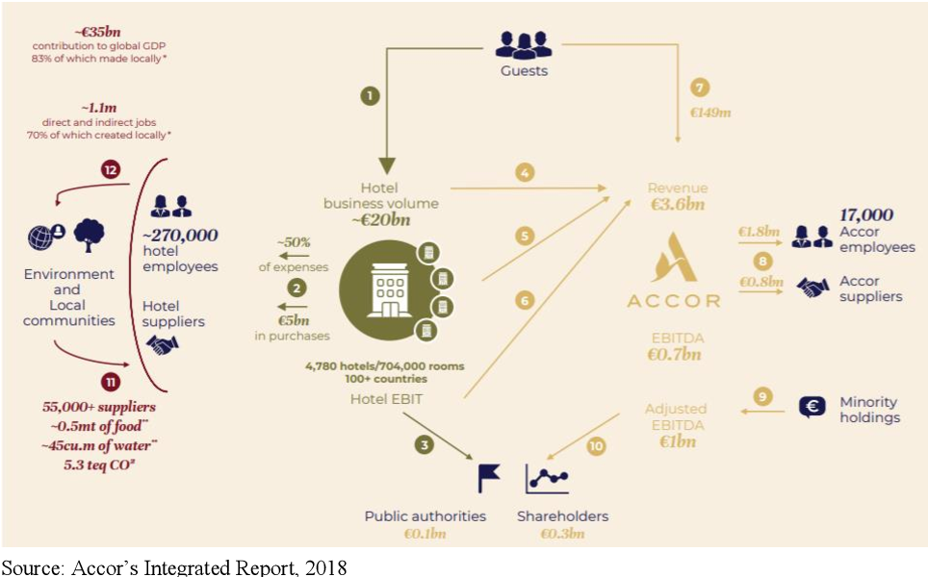
(Fig: Accor Group, Source: Ye, 2022)

Proposed enhancements to the staff training
A detailed improvement plan is important in order to address the highlighted deficiencies in Accor Hotels' staff training programme. This strategy not only fills gaps in sustainability and digital skills, but it also assures a comprehensive approach to staff development that is in sync with industry changes.
Integrating Sustainability: Creation of modules focused on sustainable practises, along with emphasizing the environmental, social, and economic elements. It is also important to incorporate the real-world case studies demonstrating effective sustainability measures in the hospitality industry and also to teach practical information, holding interactive seminars on trash reduction, energy conservation, and community participation.
Development of Digital Skills: Extending of the digital skills training beyond basic operating tools in order to include innovative technologies affecting the sector. Introduction of data analytics modules, along with demonstrating how various insights may be used in order to improve visitor experiences and operations efficiency (Pańkowska, 2023). This can also include hands-on lessons on how to use digital platforms for personalized guest experiences including targeted marketing and personalized services.
Simulation and Practical Application: Including simulation like activities such as mimicking of the real-world events, which will allow the employees to practice sustainability and digital skills in a risk-free setting. Implementing hands-on workshops with the industry's most recent digital technologies in order to provide practical knowledge is also one way for the employees to learn about the various practical applications.
Continuous Learning Platforms: Creation of an online learning platform that will allow staff to remain up to speed on the newest sustainable practises and digital developments. Furthermore, in order to build a culture of continual learning, encourage participation in industry webinars, workshops, and forums.
Initiatives for Employee Engagement: Encouraging employee ownerships and responsibility by incorporating them in hotel sustainability programmes. The employees that actively contributes to sustainability goals should be recognized and rewarded, and new digital solutions should be showcased. This will help in encouraging the employees to showcase new ideas for the company and also ensure that the employees are working towards innovation in the Accor Company.
Feedback Mechanism: Implementation of a rigorous feedback mechanism in order to evaluate the success of the increased training programme on an ongoing basis. Gathering of the views from workers on a regular basis in order to discover areas for improvement and emerging trends in sustainability and digital practices.
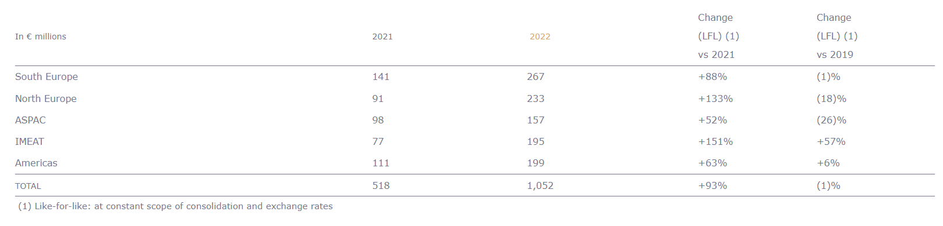
(Fig: Growth of Accor in various regions 2022, Source: Wynn, & Jones, 2022)
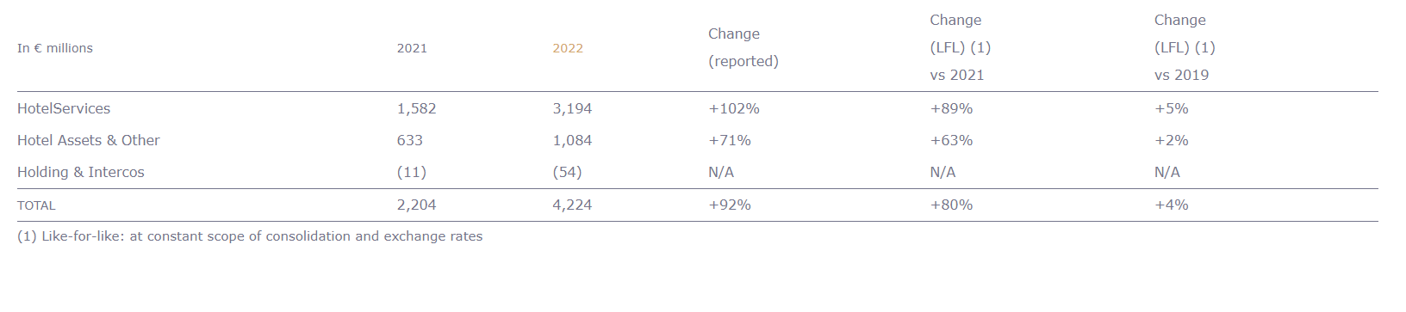
(Fig: Growth of assets of Accor in 2022, Source: Ancín Rípodas, et al., 2022).

Digital transformation integration
In today's hospitality business, digital tools and technology play a critical role in redesigning guest experiences, optimizing operations, and increasing the overall efficiency. Recognizing this, Accor Hotels can strategically incorporate digital talents into its everyday operations in order to stay on the cutting edge of innovation and give its guests with a smooth and personalized experience.
Digital Solutions Focused on the Customer: making use of the customer relationship management (CRM) systems for collecting and analyzing visitor data, allowing for personalized services and targeted marketing efforts. The company can also make use of mobile applications to improve the whole visitor experience by allowing for smooth check-ins, room personalization, and access to unique deals.
Data Analytics for Operational Efficiency: Implementation of data analytics training programmes in order to provide staff with the skills to comprehend data for better decision-making. Utilization of the data insights for improving inventory management, expedition of the housekeeping operations, and customizing the services depending on guest preferences (Aghayari, et al., 2022).
Contactless Technology: Reduction of physical touchpoints for greater safety and convenience by focusing on the training of contactless technologies such as digital key cards, smartphone payments, and virtual concierge services. Implementation of the hands-on training sessions in order to familiarize employees with the newest contactless technologies and how they may be integrated into daily operations is an important way to keep the employees updated with the digital innovations being implemented in the company.
Personalized Marketing Strategies: Teaching of marketing teams on how to make use of digital technologies for creating targeted, personalized marketing campaigns. Investigating on the use of artificial intelligence (AI) and machine learning in order to analyze visitor behaviour and preferences and also create customized promos and packages. The growth of AI has been taken into the next stage and with integration of tools such as Chat GPT and Bard, personalized marketing has become easier than before (Marques, & Marques, 2023).
Digital Collaboration Platforms: Integrating digital collaboration platforms in order to effectively promote communication inside the hotel. Implementing the solutions which allow departments to communicate in real time, providing quick answers to guest demands and effective coordination.
Inclusion of cyber security training to educate personnel on potential digital dangers and also to guarantee the safe management of visitor data. It is also important to maintain a safe digital environment, keep the workers up to date on the newest cyber security practices. Cultivating a culture of constant innovation by encouraging staff to research and offer digital ideas that might improve daily operations. It is also important to create frequent forums or platforms for employees in order to discuss observations and ideas about digital transformation.
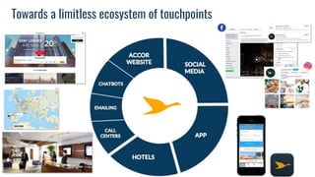
(Fig: Digital touchpoints of Accor, Source: Agafonova, et al., 2022)

Potential benefits and challenges
Benefits: Engaging employees in sustainable and digital practices can lead to better guest experiences. Guest pleasure is increased via the personalized services, eco-friendly efforts, along with the smooth digital interactions. Digital skills also enable employees to use technology to simplify processes, minimizing manual labour and increasing overall efficiency. Optimized inventory management, faster check-ins, and data-driven decision-making are all part of this. Employee participation in sustainability projects adds to a favorable brand image. Guests have been increasingly choosing ecologically friendly solutions, and a dedication to sustainable practises improves the hotel's reputation and attracts like-minded consumers (صلاح الدين & بسنت, 2023). With this, it has helped Accor to increase on its profits and also ensure that its revenue increase over the period of time. The management and franchise revenue of the company has increased 93% yoy from 2021. Furthermore, the company has reported growth in almost all of its destinations in the world and all this can be attributed to the change in management and focus on sustainability and digital transformation. Employee engagement increases the likelihood that employees will accept innovation. Digital skills training also promotes flexibility, allowing employees to quickly adopt new technology and keep the hotel at the forefront of industry innovations.
Challenges: Employees may be resistant to embracing new digital tools or sustainable practises. Since sustainability and digital transformation are the rising trends, hotels are focusing on these in order to attract employees, however it is important for Accor to not only showcase it as a marketing aspect, but also to focus on implementing various policies and transformation in order to ensure that it is moving in the right direction. To overcome reluctance, implementing of a change management approach that including detailed communication, training programmes, and highlighting the advantages (Susilo, & Santos, 2023). Some personnel may have difficulty adjusting to sophisticated digital technology. To assist staff in overcoming technology challenges, provide continual training, support systems, and mentorship programmes. There may be some initial expenses associated with implementing sustainability measures and digital tools.

Findings and Results
Accor Hotels, a well-known participant in the hotel sector, has conducted a thorough investigation to assess its strategic objectives in employee engagement towards sustainable and digitally transformed operations, with the goal of increasing profitability. The report's assessment of Accor Hotels covers a wide range of topics, including its location, hotel offerings and age, latest feedback, and popularity as a special event venue (Khalil, et al., 2022). The study also includes the PESTLE as well as the SWOT analyses to examine both internal and external influences influencing the hotel's aims. The findings provide a more comprehensive perspective of Accor Hotel chains' advantages, disadvantages, potential, and challenges as they pursue environmental sustainability and their digital evolution.
Accor Hotels deliberately places itself in a lively metropolitan context in order to draw travellers for business as well as pleasure. The varied room classifications, ranging from opulent suites to standard lodgings, accommodate to a wide variety of guest interests. This diverse strategy boosts occupancy rates and income, promoting the hotel as an adaptable location for a wide range of clients. Accor Hotels deliberately places itself in a lively metropolitan context to attract both business and leisure travellers. The varied room classifications, ranging from opulent suites to standard lodgings, accommodate to a wide variety of guest interests(Legrand, and Matthew-Bolofinde, 2022) . This diverse strategy boosts occupancy rates and income, promoting the hotel as an adaptable location for a wide range of clients. Accor Hotels has carved out a niche as a popular site for special events, including cultural events and weddings. This positive relationship helps the hotel's social standing tremendously. Cultural activities, which account for around 15% of positive public perception, highlight the hotel's ability to deliver memorable experiences beyond regular lodging.
Accor Hotels' competitive advantages include a strong brand reputation and a trained team. Internal opposition and reliance on economic conditions, on the other hand, emerge as vulnerabilities that must be addressed. Opportunities exist in leveraging government sustainability incentives, incorporating emerging technologies, and capitalising on the growing demand for environmentally responsible practises. Threats include unexpected changes in environmental legislation, economic downturns that affect the rate of occupancy, and cybersecurity concerns, all of which necessitate strategic adaptation.
TOWS Analysis
TOWS | Opportunities | Threats
Strengths | - Capitalise on federal subsidies for sustainable initiatives by leveraging the strong brand recognition and qualified personnel.  - Embrace new technologies to improve guest experiences and strengthen the hotel's unique image (Bux, et al., 2022).  - To attract environmentally concerned guests, showcase eco-friendly practises, capitalising on an increasing demand for environmental sustainability. | - Reduce the impact of unexpected changes in environmental legislation by proactively harmonising current practises.  - Create measures to combat economic downturns while ensuring occupancy rate adaptability.  - Boost cybersecurity procedures to combat growing threats and protect visitor information in the face of digital breakthroughs.
Weaknesses | - Address internal resistance by cultivating an adaptable culture and facilitating the smooth implementation of sustainable and digital practises.  - Navigate economic downturns by implementing upskilling initiatives that ensure staff are prepared for the developing technological landscape.  - Increase efforts to reduce environmental impact, making sustainability a competitive advantage. | - Combat internal opposition by fostering a change-ready mindset, which is critical for dealing with prospective economic downturns.  - Address skill shortages proactively to boost competitiveness in the face of technological changes (Wijesundara, 2023).  - Create crisis management techniques to efficiently respond to unforeseen crises while maintaining market share in an extremely competitive sector.

According to this TOWS research, Accor Hotels can capitalise on its strengths to capitalise on opportunities, proactively address weaknesses to minimise risks, and align its own strengths with external factors to achieve long-term success in the ever-changing hospitality industry.
The TOWS analysis integrates these findings further, providing strategic insights. The hotel may leverage its brand image and experienced team to take advantage of government incentives that fit with sustainability aims. Internal opposition can be overcome by upskilling staff and converting shortcomings into opportunities. Threat mitigation entails proactive techniques such as aligning practises with changing environmental requirements and strengthening cybersecurity safeguards.

Action Plan
Problem | Solution | Desired Outcome | Time scale | Completion Date | Planned Budget
Internal opposition is an obstacle to widespread acceptance. | Implement an extensive corporate communication and training programme emphasising the advantages of environmentally conscious behaviour and digital transformation (Reem, et al., 2022). Create an adaptation culture through conferences and interactive sessions. | Employee buy-in and passion for long-term and sustainable digital practises has increased. | 6 months | April 2024 | £20,000
Skill gaps pertaining for effective digital transformation and integration | Create a focused training programme that focuses on knowledge of the internet and the use of technology. Work with external specialists and contribute to online educational systems. | Highly advanced employee skillsets that will be effectively utilised for managing and implementing digital tools. | 8 months | June 2024 | £40,000
Efforts of minimising Hotel’s Environmental and carbon footprint is essential | Establishing an internal task force dedicated specifically for sustainable initiatives. Additionally, implementation of a waste reduction and recycle program along with energy efficient practices by collaborating with suppliers for sustainable sourcing. | Demonstrating reduction of the carbon footprint of the hotel along with the use of sustainable business practices. | 3 months | January 2024 | £25,000
Economic vulnerabilities may impact the travel budgets and occupancy rates in the hotels | Improve the digital visitor experience by implementing cutting-edge technologies such as no contact check-in, mobile personal assistants, and personalised offerings. To respond to economic variations, use dynamic pricing systems. | Enhanced income, higher bookings, and improved visitor satisfaction during economic uncertainty. | 4 months | February 2024 | £35,000
Changing preferences of customers and increasing competition with the industry | Form alliances with environmentally concerned vendors and organisations. Make use of alliances for cooperative marketing campaigns that highlight the hotel's dedication to sustainability. | Increased visibility, distinction, and market positioning among environmentally aware consumers. | 2 months | January 2024 | £30,000

Recommendations
Increase Employee Engagement:
- Create targeted long-term viability and digital competence programmes for employees to build an engagement culture.
- Create employee appreciation programmes to recognise and reward employees that contribute to conservation and digital projects (Alreahi, et al., 2022).
- Encourage cross-functional collaboration in order to share best practises and ideas.
Improve Technical Infrastructure:

- To stay ahead in the marketplace, businesses must invest continuously in cutting-edge technologies.
- Implement cutting-edge guest-centric solutions like AI-powered personalising and virtual services for concierges.
- Assess and upgrade IT infrastructure on a regular basis to ensure it meets customer standards and industry changes.
Boost Sustainability Initiatives:
- Increase the scope of current sustainability initiatives to include complete waste reduction, energy-efficient practises, and green procurement.
- Obtain certifications from outside sources to authenticate and publicise the hotel's environmental commitment (Sutriadi, et al., 2022).
- Through informational advertising and participation incentives, engage guests in initiatives that promote sustainability.
Improve Pricing Strategies:
- Implement variable pricing models that adjust to changing economic situations, maximising revenue during times of prosperity and reacting during downturns.
- Use data analytics to better understand booking patterns and make strategic pricing modifications.
- To encourage bookings during economic uncertainty, provide personalised packages and promos.
Develop Strategic Alliances:
- Identify and work with partners who share an ideological dedication to environmental sustainability ensuring the use of environmentally friendly products.
- Form alliances with local organisations and businesses to increase the hotel's community involvement and social responsibility (Kasavan, et al., 2022).
- Leverage alliances for joint marketing efforts that will help to expand the hotel's sustainable story.
Continuous Improvement of the Guest Experience:
- To stay current with new technological trends, update and modify digital experiences for guests on a regular basis.
- Gather input from guests via questionnaires and reviews to uncover areas for development and innovation.
- Integrate seamless technology for contactless services, with a focus on convenience and security.
Changes in Regulations:
- Create a regulatory compliance department to remain on top of environmental standards and adjust practises on the fly.
- Create contingency plans for unexpected regulatory changes to ensure that the hotel stays compliant and resilient (Acampora, et al., 2022).
- Participate in industry associations in order to promote favourable regulatory advancements and standards.
Security Measures for Data:
- Assess and improve cybersecurity safeguards on a regular basis to protect visitor information and ensure data integrity.
- Employees should be trained on data protection rules and best practises on a regular basis.
- Regular audits should be performed in collaboration with cybersecurity professionals to identify potential vulnerabilities.
Events and Community Engagement:
- Participate in regional occasions and festivities to strengthen the hotel's position as a favoured site for cultural events.
- Organise sustainable events and projects that support the hotel's environmental goals while also developing positive community relations(Alreahi, et al., 2022).
- Collaborate with local organisations and influencers to increase the hotel's presence in the community.
Monitoring and reporting on a regular basis:
- Develop key performance indicators (also known as KPIs for each the recommendation and track progress on a regular basis.
- Develop a transparent reporting procedure to inform stakeholders about accomplishments and issues.
- Conduct audits of both internal and external nature on a regular basis to ensure the long-term effectiveness of adopted methods.
Accor Hotels can strengthen its position as a leader in environmental responsibility and digital innovation by implementing these suggestions and thus ensuring an effortless integration of ecological accountability, cutting-edge technology, and extraordinary experiences for customers, ultimately contributing to long-term profitability and market leadership.

Conclusion
Accor Hotels is standing at the forefront of transformative technology and it is aiming to engage its employees in sustainable and digital practices. It is important for the company to commit on its promises and also ensure that it is not working on these aspects only for profit but also to provide a seamless experience for the consumers and help do its part and setting up an example for being sustainable in the hospitality industry. Finally, the full Accor Hotels research reveals a multi-layered landscape that intertwines staff participation, sustainability, and technological innovation to reach the overriding goal of better profitability. Accor Hotels, a hospitality industry veteran, is at the forefront in technological advances and service quality, but the industry's dynamic nature needs a proactive strategy to being durable in the face of increasing difficulties.

References:
Acampora, A., Lucchetti, M.C., Merli, R. and Ali, F., 2022. The theoretical development and research methodology in green hotels research: A systematic literature review. Journal of Hospitality and Tourism Management, 51, pp.512-528.
Agafonova, S.V., Bryukhova, N.G., Kaigorodov, B.V. and Kuznetsova, Y.V., 2022. Digital Transformation of Education for Sustainability of the Caspian Region. Galactica Media: Journal of Media Studies, 4(3), pp.208-222.
Aghayari, J., Valmohammadi, C. and Alborzi, M., 2022. Research article explaining the effective factors on digital transformation strategies in the telecom industry of iran using the delphi method.
Ala, M., Kaur, K., Shahid, S., Poorhosseinzadeh, M. and Day, I., 2024. Indigenous workers in hospitality. The Routledge Handbook of Diversity, Equity, and Inclusion Management in the Hospitality Industry, pp.104-117.
Alreahi, M., Bujdosó, Z., Kabil, M., Akaak, A., Benkó, K.F., Setioningtyas, W.P. and Dávid, L.D., 2022. Green human resources management in the hotel industry: A systematic review. Sustainability, 15(1), p.99.
Ancín Rípodas, M., Pindado Tapia, E. and Sánchez García, M., 2022. New trends in the global digital transformation process of the agri-food sector: an exploratory study based on Twitter. Agricultural Systems 203 (2022) 103520.
Bama, H.K.N., Nyathela-Sunday, T. and Makuzva, W., 2022. What innovations would enable the tourism and hospitality industry in Africa to re-build?. Worldwide Hospitality and Tourism Themes, 14(6), pp.557-564.
Barda, A., 2022. The present and future of loyalty programs in airline and hospitality industry: The Covid Era.
Boccoli, G., Gastaldi, L. and Corso, M., 2023. The evolution of employee engagement: Towards a social and contextual construct for balancing individual performance and wellbeing dynamically. International Journal of Management Reviews, 25(1), pp.75-98.
Bux, C., Aluculesei, A.C. and Moagăr-Poladian, S., 2022. How to monitor the transition to sustainable food services and lodging accommodation activities: A bibliometric approach. Sustainability, 14(15), p.9102.
Chambers, D. and Wilson, E., 2023. Conclusion to A Research Agenda for Gender and Tourism. A Research Agenda for Gender and Tourism, p.219.
Cheng, X., Xue, T., Yang, B. and Ma, B., 2023. A digital transformation approach in hospitality and tourism research. International Journal of Contemporary Hospitality Management, (ahead-of-print).
Ebrahim, A.E. and Ferenc, P.V.Á., 2022. A DIGITÁLIS MARKETING, MINT A FENNTARTHATÓ TURIZMUS ÖSZTÖNZŐJE: SZISZTEMATIKUS SZAKIRODALMI ÁTTEKINTÉS. Multidiszciplináris Kihívások, Sokszínű Válaszok, (2), pp.3-33.
Elkhwesky, Z., El Manzani, Y. and Elbayoumi Salem, I., 2022. Driving hospitality and tourism to foster sustainable innovation: A systematic review of COVID-19-related studies and practical implications in the digital era. Tourism and Hospitality Research, p.14673584221126792.
Halmi, L. and Poldrugovac, K., 2022. SUSTAINABILITY REPORTING HARMONIZATION IN THE HOTEL INDUSTRY–WHAT IS NEXT?. Geo Journal of Tourism and Geosites, 41(2), pp.541-547.
Je, J.S., Khoo, C. and Yang, E.C.L., 2023. Gender issues in tourism organisations: Insights from a two-phased pragmatic systematic literature review. Gender and Tourism Sustainability, pp.205-228.
John, K.T. and Gopalakrishnan, R., 2022. Disrupted dining: decline of the premium food services segment in India due to the COVID-19 pandemic. Research in Hospitality Management, 12(2), pp.191-207.
Kasavan, S., Siron, R., Yusoff, S. and Fakri, M.F.R., 2022. Drivers of food waste generation and best practice towards sustainable food waste management in the hotel sector: A systematic review. Environmental Science and Pollution Research, 29(32), pp.48152-48167.
Khalil, N., Abdullah, S.N.C., Haron, S.N. and Hamid, M.Y., 2022. A review of green practices and initiatives from stakeholder’s perspectives towards sustainable hotel operations and performance impact. Journal of Facilities Management, (ahead-of-print).
Legrand, W. and Matthew-Bolofinde, A., 2022. ESG, SDGs, and Hospitality: Challenges and Opportunities in Activating Sustainability. Business in the 21st Century, pp.25-39.
Léo, T. and Élisabeth, R., 2023. Exploring the Impact of Corporate Philanthropy on Brand Authenticity in the Luxury Industry: Scale Development and Empirical Studies. Sustainability, 15(16), p.12274.
MAKSYMOVA, I. and KURYLYAK, V., 2022. World industry digitization in the context of ensuring climate neutrality. Journal of European Economy, 21(3), pp.343-360.
Marques, J. and Marques, R.P., 2023. Trends in the Hospitality Industry: A global perspective. In Digital Transformation of the Hotel Industry: Theories, Practices, and Global Challenges (pp. 1-16). Cham: Springer International Publishing.
Marques, J., 2023. Digital transformation of the Hotel Industry: Theories, practices, and global challenges. Springer Nature.
Pańkowska, M. ed., 2023. Digital Transformation, Perspective Development, and Value Creation: Research Case Studies. Taylor & Francis.
Reem, M., Rasoolimanesh, S.M. and Sara, N.R.W., 2022. Sustainability Indicators in Hotels: A Systematic Literature Review. Asia-Pacific Journal of Innovation in Hospitality & Tourism, 11(1).
Susilo, D. and Santos, M.C.K., 2023. DIGITAL MARKETING COMMUNICATION SUSTAINABLE HOTEL PRACTICE OF ACCOR GROUP IN SOCIAL MEDIA. International Journal of Economic, Business, Accounting, Agriculture Management and Sharia Administration (IJEBAS), 3(3), pp.730-743.
Sutriadi, R., Drestalita, N.C. and Krisnaputri, N.A., 2022, December. Healthy City and Tourism Planning to Create a Healthy Tourism. In International Conference on Sustainable Environment, Agriculture and Tourism (ICOSEAT 2022) (pp. 967-977). Atlantis Press.
Toussaint, P. and Jönsson, C., 2022. Digitalisation in Latin America and the Caribbean Hotel Sector in a Post-Pandemic Environment. Tourism Through Troubled Times: Challenges and Opportunities of the Tourism Industry in the 21st Century, pp.151-180.
Vargas Merino, J.A. and Rios Lama, C.A., 2023. The Interplay of Corporate Social Responsibility (CSR) and Sustainable Development Goals (SDGs): An Overview of Relevant Literature on CSR's and SDGs.
Wijesundara, N., 2023. Corporate Sustainability Practices of Hotel Industry: A Systematic Literature Review. London Journal of Research In Management & Business, 23(5), pp.43-53.
Wynn, M. and Jones, P., 2022. IT Strategy in the Hotel Industry in the Digital Era. Sustainability 2022, 14, 10705.
Ye, C.W., 2022. Equity research-Accor SA (Doctoral dissertation, Instituto Superior de Economia e Gestão).

