ACDA5025A
Engineering and project management
Level 5
Electrical and electronic engineering
Conner Kinsey

2415170



Contents

- Introduction Page 3
- Project planning and assessment Page 4
2.1 Needs assessment Page 4
2.2 Site assessment Page 4
2.3 Project planning Page 5
2.4 Budget Page 6
2.4.1 Grants Page 6
2.4.2 Hardware costs Page 6
2.4.2.1 Groundworks installation Page 7
2.4.2.2 Electrical installation Page 7
2.5 Procurement Page 8
2.5.1 Deliveries Page 8
2.6 Permitting Page 9
3. Risk assessment Page 10
3.1 Groundwork installation Page 10
3.2 Electrical installation Page 10
4 Ethics and environmental impact Page 11
4.1 Ethics Page 11
4.1 Environmental Page 11
5 Conclusion Page 11
6. References Page 12/13

- Introduction
With global awareness and concerns over climate change and carbon emissions ever growing, the demand for greener more efficient transport has become more prevalent, this coming in the form of electric vehicles (EVs). In the United Kingdom, the governments commitment to banning the sale of diesel and petrol cars by 2030 underlines the urgency of the matter.
Even though publics adoption of electric vehicles is ever expanding, there is still growing concerns with key factors such as milage range of batteries and recharging infrastructure [1]. This proposal aims to address these challenges by giving an outlined, detailed plan for the installation of EV charging stations.
The project will include site assessments, risk assessments and mitigations, environmental and ethical considerations. Also, whilst ensuring the installation meets the standard practices necessary so the adoption of electric vehicles can be furthermore promoted.

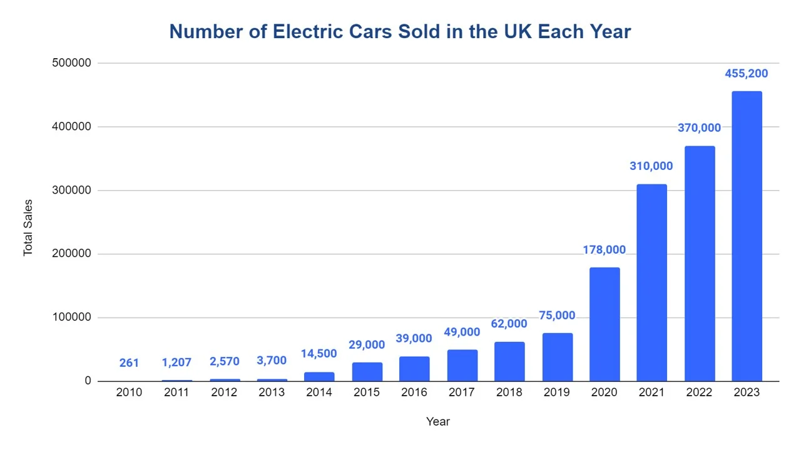

Figure 1: This chart shows the rapidly per year the UK publics adoption of EVs is increasing from 2010 up until 2023 [2].

2. Project planning and assessment
2.1 Needs assessment
Due to an increased number of employees in General Dynamics UK Merthyr adopting the use of Electric vehicle (EVs). A proposal was made to facilitate charging the employees’ cars whilst at work. With the ever-evolving world moving towards clean energy transport, it has been discussed as a good idea and supports the governments zero emissions vehicles (ZEV) mandate [3]. The proposal of four charging stations was put forward to facilitate the demand whilst also still being within budget.

2.2 Site assessment
The proposed site is in a car park on General Dynamics UK Merthyr to facilitate four electrical charging points. After assessing and surveying, the northeast corner of the main car park has been selected for the installation as there is a main distribution board already installed which could be used to power the charging stations. Also, there is a minimal need for major groundworks as the cable runs are under grass, which has been surveyed and assessed. This proposal encourages and allows employees to adopt the idea of driving an electric vehicle.

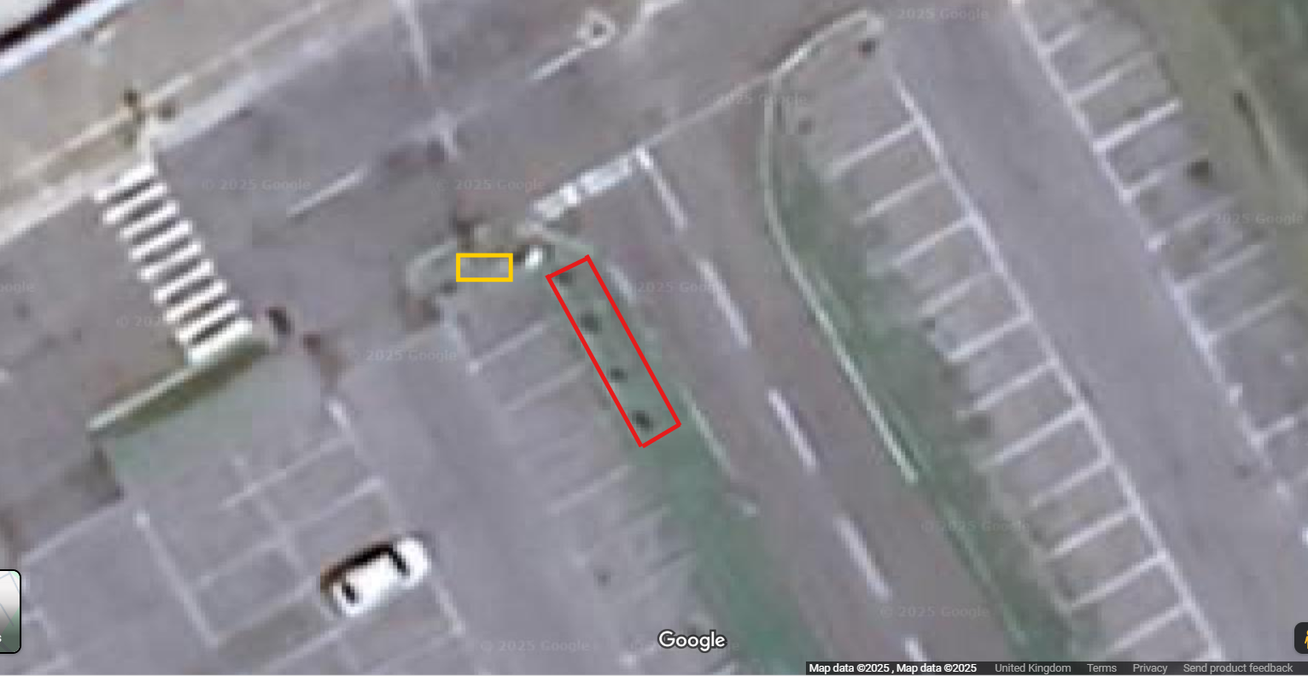
Figure 2: This image shows the proposed site of installation. The red box showing where the Electric charging stations will be installed. The yellow box showing the where electrical distribution box is situated [4].

2.3 Project planning
The installation of electric vehicle chargers in General dynamics UK Merthyr car park will follow a structured timeline spanning three months. The process starts with a planning and design stage, ensuring installation aligns with both technical and regulatory standard practices.
Following planning, the Permitting & Approvals stage involves submitting applications for necessary permits and awaiting their approval. The UK government has allowed a smoother process of installing the charging stations.
The Groundwork installation involves excavation, trenching, cable routing, and foundation preparation. This stage is critical for ensuring the infrastructure supports the hardware and meets safety standards.
The Electrical Installation phase involves installing the armoured cabling through the ducting, mounting the chargers and connecting the board in the panel and charging stations.
The Testing & Commissioning phase includes system testing, safety checks, and final inspections to verify that the installation operates correctly and complies with all regulations.
Finally, the Handover phase involves providing necessary documentation and officially completing the project. This ensures that the end-users are equipped to operate and maintain the EV charging infrastructure effectively.
Throughout each phase, compliance to health and safety standards is critical to avoid risks associated with excavation, electrical work, and equipment handling. By following this structured timeline, shown in figure 3, the installation of EV chargers can be completed efficiently, safely, and in compliance with all applicable regulations.

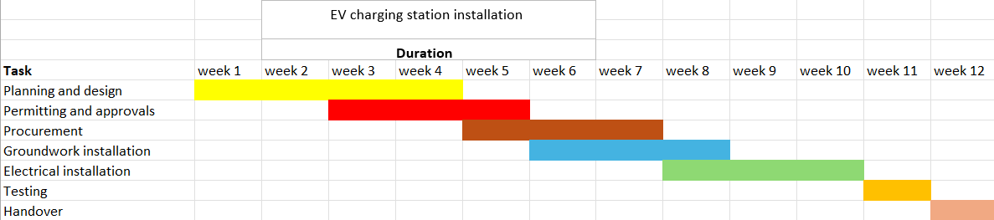Figure 3: This Gantt chart shows the planned tasks and the timelines of the electric vehicle charging station installation.

2.4 Budget
2.4.1 Grants
As the Uk is moving towards a greener future, the UK government offers a workplace incentive to work towards transitioning to Electric Vehicles. The workplace charging scheme (WCS) offers to cover 75% installation costs of charging points, capped at £350 [5]. This would give a £1,750 saving on hardware costs of the proposal. This allowing the company to future proof itself towards government sustainability goals as well as being cost effective.
Also, in conjunction with the workplace charging scheme (WCS), the UK government also runs an electric vehicle infrastructure grant for staff and fleet which covers the cost of 75% of the work. This includes £350 per charging station and up to £500 per car parking space [6]. Factoring in all these numbers, a further saving of £4,250 can be made on this proposal.
With these two government schemes, a saving of around £6,000 could be made.
2.4.2 Hardware costs
The Hardware that has been selected is the 7kW AC charger. This type of charger has been chosen as it requires lower installation costs and is also less damaging on car batteries, even if the charge time is longer [7]. The 7kW charger wouldn’t require any upgrades to the existing distribution box, as it only requires a single-phase power transfer [8]. It also has lower operational costs in comparison to a DC charger. An EV charger can range from £500-£1,200. Calculating the cost for the hardware for five EV charging stations on the higher end on the range gives a price of £6000. Also, the selected EV charger must come under the WCS and the electric vehicle infrastructure grant. In future, if the demand for charging stations keeps growing. There will be potential to transfer or incorporate both AC and DC charging stations.
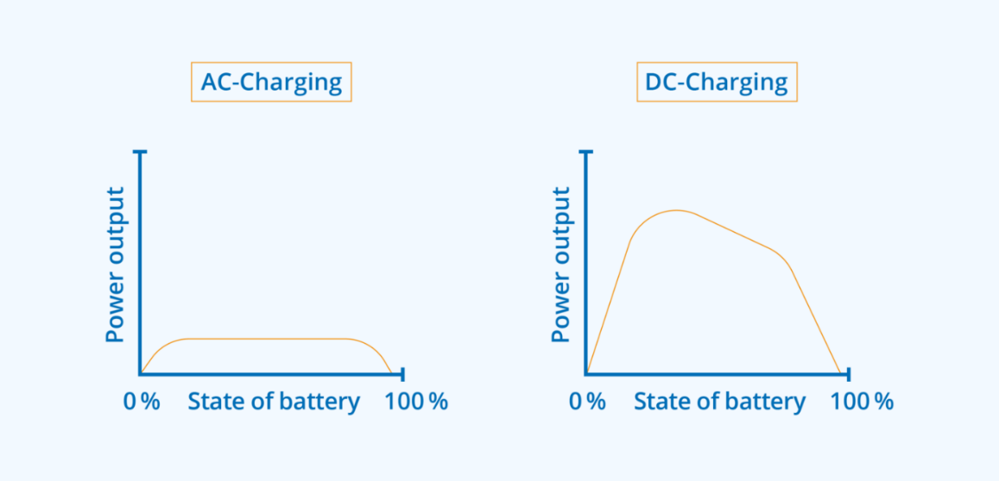
Figure 3: The AC charger power stays at a steady state of power delivered as in comparison to the DC charging state, due to on board charger and limited power. This being less damaging to the car's batteries [9].
2.4.2.1 Groundwork Installation
The groundwork installation of electric vehicle chargers is a critical part of installation, that ensures the infrastructure is both safe and efficient. This process begins with a site assessment to determine the best placement of charging units, considering factors like accessibility, distance to electrical supply, and compliance with local regulations. The groundwork installation involves tasks such as excavation, trenching for cable routing, and laying foundations for the chargers. The calculations for the installation for five EV chargers are as shown below in table 1.
Additionally, obtaining the required permits and adhering to safety standards, such as the health and safety at work act 1974, to prevent workplace accidents. Experienced installation teams typically handle these tasks with minimal disruption and in compliance with all legal and safety requirements
Item | Cost per unit | Total cost (5 units) Inc. VAT
Trenching and backfilling | £25/m | £1,250.00
Ducting installation | £15/m | £750.00
Concrete pads | £500.00 | £2,500.00
Total |  | £4,500.00
Table 1: This shows the calculations for groundwork installation for five EV units.
2.4.2.2 Electrical installation
Following the survey, the selected installer will design an installation plan that includes necessary electrical upgrades, cable routing, and safety measures such as surge protection and grounding. The installation phase involves mounting the chargers, connecting them to the electrical system, and configuring any smart features.
The installer will be selected from a registered WCS company, meaning they will have to comply with the Office for Zero Emission Vehicles (OZEV) standards and to qualify for available grants like the Workplace Charging Scheme.
The installation must comply with the UK Wiring Regulations (BS 7671), particularly the 18th Edition of the IET Wiring Regulations. This includes ensuring appropriate earthing, overcurrent protection, and cable sizing to handle the electrical load.
Once installed, the system will undergo testing to ensure functionality and safety. The final step is commissioning the chargers, which includes user training.
Item | Cost per unit | Total cost (5 units) Inc. VAT
Installation labour | £40/hr x 8 hrs | £1,600.00
EV charging unit | £1,085.50 | £6,513.00
Wiring and cabling | £50/m x 10m | £500.00
Permits and inspections | £50-£200 | £200.00
Total |  | £2,300
Table 2: This shows the calculations for electrical installation for five EV units.
2.5. Procurement
The Rolec EV Basic Charge Smart EV Charging Pedestal has been selected as the EV station hardware as it is a cost-effective and government approved for installing EV charging points in workplaces and commercial settings. It is eligible for both the WCS and EV Infrastructure Grant makes it a good option for the business which is aiming to support the transition to electric vehicles. [10].

Figure 4: This shows the EV charger that has been selected for this project [10].

2.5.1 Deliveries
Managing deliveries is a key component of coordinating an EV charging station installation. Organising delivery of materials such as EV chargers, cabling, ducting and groundwork materials is essential to keep the project on schedule and avoid costly delays. Deliveries will be planned in line with the installation, ensuring that hardware with long waits are ordered early and delivered just in time to reduce hold ups. All deliveries must be checked against purchase orders and inspected for damage upon arrival.

2.6 Permitting
Even though the EV charging stations on being installed on private land, getting the correct electrical permits and ground working permits is essential to ensure the project complies with safety and construction regulations.
An electrical permit is required for all installations involving new wiring and circuit modifications. They must also be issued by the local authority or building control. This permit ensures the work meets working standards (BS 7671) and is typically carried out by a licensed electrician.
A ground working permit is necessary if the project involves excavation, trenching, or any disturbance to the ground surface to lay conduits or foundations. This permit helps manage risks related to underground utilities, soil stability, and environmental impact.
Proper planning is crucial to avoid damaging existing infrastructure such as water and gas. Both permits require inspections upon completion, and no part of the installation should be powered on until approved. These permits ensure the installation is safe and responsibly constructed.
Another component in this process is obtaining a DNO (Distribution Network Operator) permit, which is required in the UK. The DNO permit ensures that the local electricity company can safely support the additional load of the EV chargers, particularly for multiple installations, like on this project. Shown in the image below. [11].
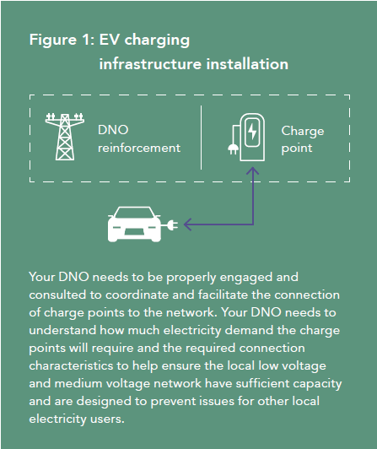
Figure 5: This image shows how the DNO works [11].

. Risk assessment
3.1 Groundwork installation
During the groundworks phase of this installation, it is important to carry out the tasks carefully as well as efficiently. To do this risk assessments must be carried out to ensure that the job is done safely and mitigate accidents. During the groundwork phase risks such as trenching, even though at a shallow depth, slips trips and falls, manual handling and exposure to hazardous substance may lead to injuries and illnesses.
Hiring an established and experienced company in this field means the person(s) will have an understanding of spotting the risks beforehand and how to avoid them. Additionally, sticking to the health and safety at work act 1974 with regards to wearing correct PPE will further minimize any potential hazards [12].
Risk | Severity | Likelihood
Trench collapsing | High | Low
Slips, trips and falls | Medium | Medium
Manual handling | Medium | Medium
Exposure to hazardous substances | High | Medium
Table 3: This table shows each risk associated with the groundwork installation, with the severity and likelihood.
3.2 Electrical installation
When working on the electrical phase, there are greater risks of serious injuries or death to the worker. Risk assessments must be carried out to spot and minimize potential hazards and to mitigate them. During this phase, risks such as electrical shock, arc flash due to incorrect installation and fire risks. Aswell as slips trips and falls and manual handling risks as stated previously.
To mitigate the risks of accidents an experienced electrician with the correct qualifications and knowledge shall be selected. The Workplace Charging Scheme provides a list of electricians to choose from to install these EV stations whilst complying with the grant's requirements.
Risk | Severity | Likelihood
Electric shock | High | Low
Arc Flash | High | Low
Fire risk | High | Medium
Manual handling | Medium | Medium
Slip, trips and falls | Medium | Medium
Table 3: This table shows each risk associated with the Electrical installation, with the severity and likelihood

4.Ethical and environmental impact
4.1 Ethics
During the installation of these EV charging stations, it is important to keep in mind accessibility and able use for everyone. Following the Equality Act 2010 legislation, sufficient adjustments must be made so they are accessible for disabled people [13]. Adhering to this, it has been decided to install signage, railings and widen the bays, so that it can accommodate for anyone who wishes to use the stations.
4.2 Environment
Whilst carrying out this project, it is important to consider the potential impact on the environment and biodiversity, so the project will adhere to the environment act 2021[14]. A survey will be carried out to see if they will be any disturbance to local inhabitants. Once the survey is complete the project will commence, all turf and soil will be re-instated as per pre installation to allow a natural regrowth of the turf and local biodiversity.
Also, whilst the installation is underway, there will be use of harmful substances, which raises risks due to accidental spillages and so forth. To manage risks and possible pollution to the environment, all substances and left over material should be used correctly then disposed and recycled in the right manner adhering to the COSHH legislation 2002 [15].

5.Conclusion
In conclusion, the installation of Rolec Basic Charge Smart EV Charging stations demonstrates the importance of aligning sustainability. Through careful planning and adherence to UK regulatory and environmental standards, the installation has been planned to deliver both functionality and environmental benefits. Also, not only considering technical requirements and user accessibility but also the impact on the environment, such as minimising disruption to local insect habitats. The project supports broader commitments to green infrastructure. This assignment shows how a well managed EV infrastructure project can contribute to a more sustainable, accessible and future ready environment.

6. References
[1] V. Tiwari, P. Aditjandra, and D. Dissanayake, “Public attitudes towards electric vehicle adoption using structural equation modelling,” Transportation Research Procedia, vol. Volume 48, pp. 1615–1634, 2020, [Online]. Available: https://www.sciencedirect.com/science/article/pii/S2352146520306207

[2] “UK Electric Car sales Statistics | Top EV brands 2023,” Road Genius. https://roadgenius.com/cars/ev/statistics/uk/

[3] Department for Transport, “Pathway for zero emission vehicle transition by 2035 becomes law,” GOV.UK, Jan. 03, 2024. [Online]. Available: https://www.gov.uk/government/news/pathway-for-zero-emission-vehicle-transition-by-2035-becomes-law

[4] “Google Maps,” Google Maps. https://www.google.com/maps/@51.7194337,-3.3493718,34m/data=!3m1!1e3?entry=ttu&g_ep=EgoyMDI1MDYwMi4wIKXMDSoASAFQAw%3D%3D

[5] “Workplace Charging Scheme - GOV-UK Find a grant.” https://www.find-government-grants.service.gov.uk/grants/workplace-charging-scheme-2

[6] “Electric vehicle infrastructure grant for staff and fleets - GOV-UK Find a grant.” https://www.find-government-grants.service.gov.uk/grants/electric-vehicle-infrastructure-grant-for-staff-and-fleets-1

[7] “AC vs DC Charging: 7 Fundamental Differences,” go-e, Jan. 15, 2025. https://go-e.com/en/magazine/ac-dc-charging#:~:text=Which%20charger%20is%20best%20for,Charger%20are%20the%20optimal%20choice.

[8] National Grid, “A guide on electric vehicle charging and DNO engagement for local authorities.”

[9] “AC vs DC Charging: 7 Fundamental Differences,” go-e, Jan. 15, 2025. https://go-e.com/en/magazine/ac-dc-charging#:~:text=Which%20charger%20is%20best%20for,Charger%20are%20the%20optimal%20choice.

[10] “CEF,” CEF. https://www.cef.co.uk/catalogue/products/5110072-basiccharge-smart-ev-charging-pedestal-2-x-7-4kw-type-2-sockets-black?gad_source=1&gad_campaignid=8243746995&gclid=EAIaIQobChMIzcWhmrv4jQMVx5xQBh1z-QmBEAAYASAAEgLEF_D_BwE&gclsrc=aw.ds (accessed Jun. 23, 2025).
[11] National Grid, “A guide on electric vehicle charging and DNO engagement for local authorities.”

[12] Bytes, “Keeping Quality-focus consistent, through periods of change.,” BBA, Mar. 25, 2021. [Online]. Available: https://www.bbacerts.co.uk/news-and-media/news/7-ways-to-mitigate-risk-in-construction/

[13] D. Riggott, “The rules on disabled car parking bays,” Clean & Retrieve, Jul. 13, 2023. https://c-r.co.uk/the-rules-on-disabled-car-parking-bays/#:~:text=The%20Equality%20Act%202010%20is,be%20given%20to%20accessible%20bays. (accessed Jun. 24, 2025).

[14] King’s Printer of Acts of Parliament, “Environment Act 2021.” https://www.legislation.gov.uk/ukpga/2021/30/contents/enacted (accessed Jul. 09, 2025).

[15] “Control of substances hazardous to health (COSHH) - HSE.” https://www.hse.gov.uk/cleaning/topics/coshh.htm (accessed Jul. 10, 2025).


Appendix A.



