

BA (Hons) Business Management

Research Proposal

“Evaluation of the role of competitive intelligence in feature development decisions in the UK: A case study of Apple’s wearable devices”

Word count - 2000 words

Student name: Lachezar Nikolov

Student ID: 1916906
Abstract
This research has been done to evaluate the effects of competitive intelligence on the Apple Inc. wearable devices feature development decision-making in the UK. The literature review part incorporates with role, challenges and opportunities of competitive intelligence. To simplify the understanding of the theoretical framework of this study, the Resource-Based View (RBV) and Dynamic Capabilities Theory have been employed with the discussion of the literature gap to set out the loopholes of this segment. The research methodology chapter has explained which research methods and methodical instruments are used in the course of the research supported by the relevant data, facts and evidence.

Table of Contents
Chapter 1: Introduction 4
1.1 Background and Context 4
1.2 Significance of the Topic 4
1.4 Research Aim and Objectives 4
1.5 Research Questions 5
Chapter 2: Literature Review 6
2.1 Role of competitive intelligence in the feature development decision-making process 6
2.2 Challenges and Opportunities in Leveraging Competitive Intelligence 6
2.3 Theoretical Framework 7
2.3.1 Resource-Based View 7
2.3.2 Dynamic Capabilities Theory 7
2.5 Literature Gap 8
Chapter 3: Research Methodology 9
3.1 Research Philosophy 9
3.2 Research Approach - Explanatory research design 9
3.3 Research Design 10
3.4 Data collection method 10
3.5 Data collection source 10
3.6 Data analysis 11
3.7 Sampling Method 11
3.8 Ethical Consideration 11
Research Timeline 12
Reference List 13

List of Figures
Figure 1: Resource Based View 8
Figure 2: Research Onion 10
Figure 3: Gantt chart of Research Timeline 13

Chapter 1: Introduction

1.1 Background and Context
This generation is more into a wearable technology so commonly people are using Smart Watches, Fitness Trackers and Health Trackers. Apple is a giant firm in this sector and the United Kingdom is struggling to stand on top by offering new excellent features. CI is a concept in which a firm examines the market trends and requisites post which precedes the competitors’ business moves for decision making. The wearable technology market is very popular in the current generation; people are eager to use smart watches, fitness trackers, health trackers and many more. Following this trend, Apple is also in the leading edge in the market for wearable technologies in the UK. Apple’s approach is, when one firm decomposes market trends and needs followed by the competitor business actions for the development of business strategies are taken more efficiently (Cavallo et al., 2021, pp. 260). In the United Kingdom, a huge number of consumers are there who are tech-savvy and prefer wearable technology with updated features.

1.2 Significance of the Topic
This topic is relevant and significant because it provides information on Apple's implementation of competitive intelligence for production and that will help other companies to establish strategies accordingly. This research helps to focus on innovation, adaptation and continuous upgradation for service provision to satisfy targeted customers. To meet the market demands, companies like Apple reformed their business strategies by modifying competitive intelligence measures. These factors are also helpful for further academic knowledge on competitive intelligence and its incorporation of feature development on technology.

1.4 Research Aim and Objectives
Aim
The primary aim of the research is to evaluate the effects of competitive intelligence on the Apple Inc. wearable devices feature development decision-making in the UK and determine the key impacts on market positioning, innovation, and competitive advantage.
Research Objectives
- To analyse the role of competitive intelligence in the feature development decision-making process of Apple’s wearable devices in the UK.
- To identify the sources Apple uses to gather competitive intelligence in the UK market.
- To assess the influence of competitive intelligence on Apple's innovation strategies and product development in the UK.

1.5 Research Questions
- What is the role of competitive intelligence in the feature development decision-making process of Apple’s wearable devices in the UK?
- What sources does Apple use to gather competitive intelligence in the UK market?
- How much does competitive intelligence influence the innovation strategies and product development of Apple in the UK?

Chapter 2: Literature Review

2.1 Role of competitive intelligence in the feature development decision-making process
Competitive intelligence (CI) plays a significant role in the feature development decision-making process, mainly in those sectors where market conditions, technology consumer preferences are rapidly evolving. According to Calof et al., (2020), competitive intelligence help aids organisations to understand the latest trends in their industry, including changing consumer behaviour, regulatory landscapes and technological advancement. By understanding the market trends and competitive landscape companies can assess their strength and weaknesses, and redesign their feature to meet customer demand more effectively. Competitive intelligence helps companies to identify their potential threats from disruptive technologies, competitors or new entrants. This information is very crucial for every company to maintain and increase a competitive edge along with to make informed decisions on which features will develop in future. After knowing what features competitors are working on, companies can keep away from unnecessary developments and concentrate on value-adding and unique features.

2.2 Challenges and Opportunities in Leveraging Competitive Intelligence
As per Bharadiya, (2023), leveraging Competitive Intelligence (CI) for business purposes has lots of benefits but often professionals face challenges that effectively hamper the collection and utilisation of important market data. Competitive Intelligence provides detailed information about customer preferences, market trends and competitor strategies that allow for more effective and informed strategic planning. This information helps companies to anticipate their position and market shift and helps to get an extra competitive advantage against competitors. Competitive Intelligence informs companies about competitor’s product offerings and customer feedback, by acknowledging these companies can draw their new feature more uniquely to meet optimum consumer preference. On the other hand, Boronat-Navarro et al., (2024), argued that there are huge amounts of data available in the market about any company it is very difficult to find irrelevant data and concentrate on actionable information. Analysing vast amounts of data can slow down or obstruct the feature development decision-making process. It is very difficult for Competitive Intelligence, to ensure that all collected data are accurate and reliable, outdated or inaccurate information can suggest poor strategic decisions.

2.3 Theoretical Framework

2.3.1 Resource-Based View
The Resource-Based View (RBV) is widely regarded as one of the most contentious approaches to understanding the origin of relative competitive advantage in a firm. RBV holds the view that only those resources that are valuable, rare, inimitable and non-substitutable can be a source of competitive advantage to organisations. Hence, organisations would be able to identify their competitive place and devise strategies that build on internal resources (Arranz et al., 2020, pp. 05). In competitive intelligence, this approach assists firms in identifying the resource-based ‘vulnerabilities’ of their rivals with a view of forestalling their action or checking on them in the right manner.
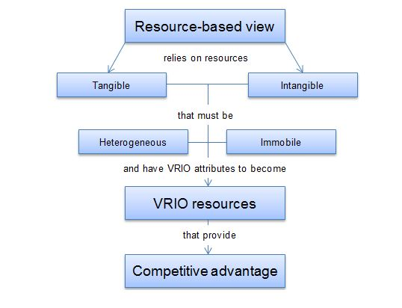
Figure 1: Resource Based View
(Source: strategicmanagementinsight, 2024)

2.3.2 Dynamic Capabilities Theory
Dynamic capabilities are defined as processes through which organisations successfully sense, create, and exploit new opportunities and make changes to other organisational resources and competencies in response to the environment. It is particularly concerned with how the organisation can sense opportunities and threats, capture them, and then adapt to stay ahead of the competition (Gupta et al., 2020, pp. 06). This theory also assists organisations in the area of competitive intelligence as it can assist in the ongoing monitoring of the environment and the acquisition and evaluation of appropriate information to make modifications to operational models whenever necessary. With dynamic capabilities, an organisation can scale up its performance in a way that counters the moves of other organisations, adapt to new conditions in the market and, therefore, build lasting competitive advantage.

2.5 Literature Gap
The study has been extensively done on the purpose of competitive intelligence in the field of feature development decisions in multiple industries. It reflects the significance of competitive intelligence in innovation and efficient decision-making. However, applying in some technology sectors and renowned companies like Apple, some literature gaps are found. There is a lack of proper research on how competitive intelligence influences feature development in the rapidly growing industry of wearable technology. The competitive intelligence is particularly relevant in the case of reputed businesses like Apple, where they have to decide about featuring decisions. Apple's research and innovation strategies are widely analysed to understand any gap in the feature development process concerning its competitors.

Chapter 3: Research Methodology

3.1 Research Philosophy
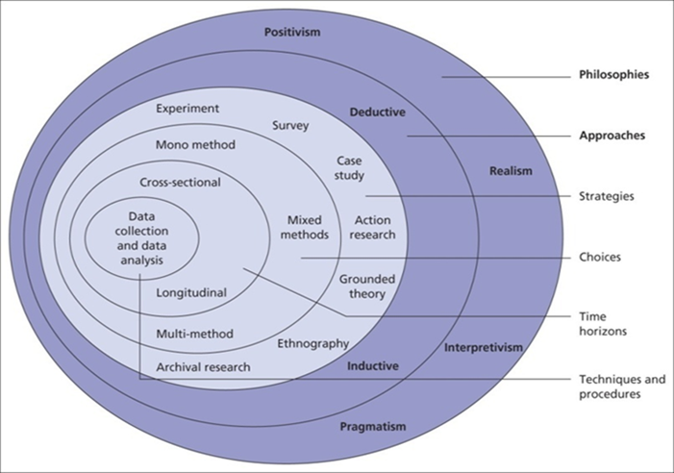
Figure 2: Research Onion
(Source: Saunders et al., 2015)
To conduct this research authentically “Interpretivism research philosophy” will be used thoroughly for better approachability. This research philosophy is based on a subjective matter of various sociocultural perspectives considering broad ranges of clauses and morals (Withanachchi, 2021, pp. 25). This research philosophy will help evaluate the role of competitive intelligence in feature development for Apple. Through interpretivism, collected data will be more subjective and beneficial to understanding the social aspects of the research topic in terms of flexibility. On the other hand, it is important to mention that, interpretivism is more likely to be generalised and time-consuming, to sum up, own thoughts in the research analysis. From different websites, research papers, books etc, relevant data will be collected to execute the research successfully.

3.2 Research Approach - Explanatory research design
For proper approachability and execution of the research on the chosen topic, an “Explanatory research approach” will be used. This type of research approach is used when a topic has limited resources to gather data and analyse the topic in an explanatory manner (Taherdoost, 2022, pp. 57). Currently, very little information is available on the internet regarding competitive intelligence and its impact on Apple's feature development. That is why an explanatory research approach will be implemented to identify potential difficulties in the competitive intelligence of Apple and describe the various factors in this matter. The pros of this approach are to highlight every minute detail of the topic whereas this approach cannot find out conclusions but rather only discuss the topic. Identifying the key variables and establishing hypotheses for qualitative data analysis will be incorporated in this research to conclude this topic.

3.3 Research Design
“Explanatory research design” will be used for this research project, since there is no strong evidential information on this topic. This topic is quite new and contemporary, by channelising general intelligence on this topic this research will be conducted for further qualitative explanation (Ansari et al., 2022, pp. 1133). It helps in improving deeper and broader knowledge on a particular topic whereas limited qualitative data leads to biased and one-way thinking on a specific research topic. With the help of multiple books, research papers and website information, data will be collected for this research progress.

3.4 Data collection method
In this research, a “Qualitative data collection method” will be used to gather data and information regarding the topic. This method is particularly useful in gaining richer insight into participants’ views and concerns as well as their reasons for participation which is one of the prerequisites for studying multidimensional phenomena (Humbe and Mozelius, 2022, pp. 06). The qualitative data collection method offers freedom to choose subjects and the depth of information that can be gathered. Through this method, the researcher will be able to interview some of the stakeholders to get adequate information and to give a comprehensive discussion of the research topic.

3.5 Data collection source
The research will employ secondary data collection techniques that will include; a literature review, reports and databases. This method helps to gather information that is already in the public domain in the form of journals, industry reports and government publications. This paper is inclined to use secondary data of its effectiveness and the opportunity to obtain a large amount of data from online research papers, articles, Ebooks, blogs and journals (Lobe et al. 2020, pp. 04). The advantages of this method are the relatively low cost of the surveys and the availability of a large volume of data. However, it has its drawbacks – the possibility of receiving outdated or not very relevant information. Secondary data collection source helps to acquire adequate data for the paper to provide adequate discussion and analysis based on the research topic.

3.6 Data analysis
“Thematic data analysis method” will be used to gather data and analyse. This is especially useful in studying compound and subtle data, as the analyser can discern patterns by looking at recurring themes, issues or categories pertinent to the area of study. The rationale for adopting thematic analysis is to do with the versatility of the method, and primarily, its capacity to provide depth, description and meaning (Khan and MacEachen, 2022, pp. 05). The strength of this method is the ability of the researcher to be flexible in answering different research questions, and the richness of the data collected using this method. It can be used by the researcher to facilitate the organization and the interpretation of the data, promoting the topic’s analysis.

3.7 Sampling Method
“Convenience Sampling Method” will be used to gather information for this research paper. It is a non-probability and qualitative sampling strategy that chooses participants depending on their availability and accessibility to the author (Mweshi and Sakyi, 2020, pp. 190). The convenience sampling method is very inexpensive, efficient, easy to implement and quick which will help the author to gather information with minimal resources and in a short period. The major drawback of the convenience sampling method is that often the outcomes are not generalisable for the broader community, due to its non-random sampling nature.

3.8 Ethical Consideration
Ethical considerations are one of the vital aspects of every research to ensure the credibility and integrity of the scientific process. All secondary data collecting processes will be carried out via the Internet as this will be the most appropriate way of getting authentic data and from there, arriving at more authentic results. The research discussion will also use ‘Harvard’s citation and reference style, to acknowledge the sources from which secondary information and data will be obtained (Suri, 2020, pp. 50). The writer of this research will observe and adhere to the “Data Protection Act 2018” when handling any of the research participants’ data as these data is covered under this act.

Research Timeline
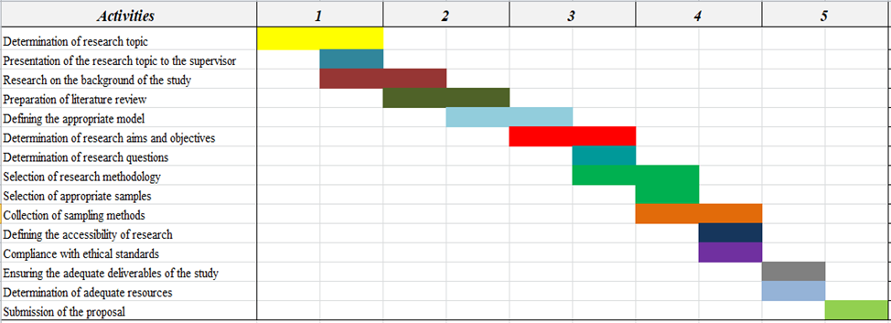
Figure 3: Gantt chart of Research Timeline
(Source: Self-made)

Reference List
Ansari, M.R., Rahim, K., Bhoje, R. and Bhosale, S., (2022). A study on research design and its types. International Research Journal of Engineering and Technology (IRJET), 9(7), pp.1132-1135. Available at: https://d1wqtxts1xzle7.cloudfront.net/92557672/IRJET_V9I7216-libre.pdf?1665985227=&response-content-disposition=inline%3B+filename%3DA_STUDY_ON_RESEARCH_DESIGN_AND_ITS_TYPES.pdf&Expires=1723637496&Signature=GaKi7Je2lnJsOEc
Arranz, N., Arroyabe, M., Li, J. and Fernandez de Arroyabe, J.C., (2020). Innovation as a driver of eco‐innovation in the firm: An approach from the dynamic capabilities theory. Business strategy and the environment, 29(3), pp.1494-1503. Available at: https://repository.essex.ac.uk/26160/3/BSE%20R1%20DEF%20%2820-11-19%29%28I%29.pdf
Bharadiya, J.P., (2023). Machine learning and AI in business intelligence: Trends and opportunities. International Journal of Computer (IJC), 48(1), pp.123-134. Available at: https://www.researchgate.net/profile/Jasmin-Bharadiya-4/publication/371902170_Machine_Learning_and_AI_in_Business_Intelligence_Trends_and_Opportunities/links/649afb478de7ed28ba5c99bb/Machine-Learning-and-AI-in-Business-Intelligence-Trends-and-Opportunities.pdf?origin=journalDetail&_tp=eyJwYWdlIjoiam91cm5hbERldGFpbCJ9
Boronat-Navarro, M., Escribá-Esteve, A. and Navarro-Campos, J., (2024). Ambidexterity in micro and small firms: Can competitive intelligence compensate for size constraints?. BRQ Business Research Quarterly, 27(3), pp.210-226. Available at: https://journals.sagepub.com/doi/pdf/10.1177/23409444211054861
Calof, J., Arcos, R. and Sewdass, N., (2020). Competitive intelligence practices of European firms. In Corporate Foresight and Innovation Management (pp. 34-47). Routledge. Available at: https://d1wqtxts1xzle7.cloudfront.net/114292139/European_20competitive_20intelligence_20practices_20submitted_20version-libre.pdf?1715151043=&response-content-disposition=inline%3B+filename%3DCompetitive_intelligence_practices_of_Eu.pdf&Expires=1723639695&Signature=gk~EaGLaujj26aDipW6M9-L
Cavallo, A., Sanasi, S., Ghezzi, A. and Rangone, A., (2021). Competitive intelligence and strategy formulation: connecting the dots. Competitiveness Review: An International Business Journal, 31(2), pp.250-275. Available at: https://www.emerald.com/insight/content/doi/10.1108/CR-01-2020-0009/full/pdf
Gupta, S., Modgil, S., Gunasekaran, A. and Bag, S., (2020), July. Dynamic capabilities and institutional theories for Industry 4.0 and digital supply chain. In Supply Chain Forum: An International Journal (Vol. 21, No. 3, pp. 139-157). Taylor & Francis. Availabl at: https://www.researchgate.net/profile/Shivam_Gupta30/publication/341071702_Dynamic_capabilities_and_institutional_theories_for_Industry_40_and_digital_supply_chain/links/5ec3ec40299bf1c09aca2e5f/Dynamic-capabilities-and-institutional-theories-for-Industry-40-and-digital-supply-chain.pdf
Humble, N. and Mozelius, P., (2022), May. Content analysis or thematic analysis: Similarities, differences and applications in qualitative research. In European conference on research methodology for business and management studies (Vol. 21, No. 1, pp. 76-81). Available at: https://papers.academic-conferences.org/index.php/ecrm/article/download/316/320
Khan, T.H. and MacEachen, E., (2022). An alternative method of interviewing: Critical reflections on videoconference interviews for qualitative data collection. International Journal of Qualitative Methods, 21, p.16094069221090063. Available at: https://journals.sagepub.com/doi/pdf/10.1177/16094069221090063
Lobe, B., Morgan, D. and Hoffman, K.A., (2020). Qualitative data collection in an era of social distancing. International journal of qualitative methods, 19, p.1609406920937875. Available at: https://journals.sagepub.com/doi/pdf/10.1177/1609406920937875?%5D
Mweshi, G.K. and Sakyi, K., (2020). Application of sampling methods for the research design. Archives of Business Review–Vol, 8(11), pp.180-193. Available at: https://d1wqtxts1xzle7.cloudfront.net/65093418/ABR_9042-libre.pdf?1606982124=&response-content-disposition=inline%3B+filename%3DApplication_Of_Sampling_Methods_For_The.pdf&Expires=1723640034&Signature=ezg6Tvc5mCtvru0~QsQRgHHv1NzkXtj9xRqUW3hmMUB-3ZCcJd6dZ-kMTmdOu3etS2HWzmAqDQ4t~QbjhTSKEXsi7DqFyfm~to-HR.
Strategicmanagementinsight.com, (2024). What is a resource-based view? [Available at: https://strategicmanagementinsight.com/tools/resource-based-view/], [Accessed on: 14-08-2024]
Suri, H., (2020). Ethical considerations of conducting systematic reviews in educational research. Systematic reviews in educational research: Methodology, perspectives and application, pp.41-54. Available at: https://library.oapen.org/bitstream/handle/20.500.12657/23142/1007012.pdf?s#page=59
Taherdoost, H., (2022). What are different research approaches? Comprehensive Review of Qualitative, quantitative, and mixed method research, their applications, types, and limitations. Journal of Management Science & Engineering Research, 5(1), pp.53-63. Available at: https://hal.science/hal-03741840/file/What%20Are%20Different%20Research%20Approaches%20Comprehensive%20Review%20of%20Qualitative%2C%20Quantitative%2C%20and%20Mixed%20Method%20Research%2C%20Their%20Applications%2C%20Types%2C%20and%20Limitations.pdf
Withanachchi, C., (2021). Effective Dealing with Insider Threats a Comparison of Qualitative and Quantitative Research. Asian Journal of Research in Computer Science, 7(2), pp.22-28. Available at: http://info.euro-archives.com/id/eprint/133/1/129-Article%20Text-237-1-10-20220914.pdf

