Zartasha Zahied
student number - 2015319
Professional and career development – reflective portfolio
Module code – BMSW 4005
Lecturer – Yohan Mendis

Table of Contents
Introduction 3
1. Evaluation of my skills 3
1.1. Swot analysis 3
1.2. Personal development plan 3
2. Skills to be an effective social worker manager 4
2.1. Be fair and ethical 4
2.2. Listening and empathizing when supervising and during meetings. 4
2.3. Insight into understanding human behavior 5
2.4. Respect for diversity 5
2.5. Communication and decision making. 5
3. My reflection on what I have learned from this module. 5
3.1. How to become more employable. 5
3.2. Self-awareness. 7
Bibliography 11

Introduction
Throughout this assignment I will be talking about my personal skills and competencies. I will be discussing the skills I have and the skills I have learned to help me with my career as a social worker in the future. To display this analysis these are the two analysis techniques I will be using.
- SWOT analysis
- PDP analysis
I will also be discussing the skills required to be an effective manager within the workplace. Lastly, I will be reflecting on concepts I have learned from this module using Driscoll's reflective model.

Evaluation of my skills

Swot analysis
A SWOT analysis evaluates the "strengths", "weaknesses", "opportunities", and "threats" of an organization, it determines what you are doing well currently and highlights things that need improvement. (SWOT Analysis: Strengths, Weaknesses, Opportunities, Threats, 2021)
Strengths  - Communication  - Communication/teamwork is a strength because in my previous job I was able to speak to colleagues and deal with some inconvenient situations.  - I can think critically when in challenging decisions. | Weaknesses  Lack of emotional stability and control.  This can at times obstruct me from achieving my goals.  I can be overfriendly, which can be positive and negative.
Opportunities  I am constantly in search of any opportunities that will help increase my knowledge and provide me with some extra knowledge.  An example of this would be in my previous job as a sales assistant I would do any extra training available, I would reach out for all opportunities to grow in the business. | Threats  People that surround me whose approach is negative can discourage me which will negatively impact my personal growth.  My weakness of lack of emotional stability and control could be seen as a threat in my line of work.  To overcome this believe I would need some therapy.

Personal development plan

What are your long-term goals? | What are your specific career goals? | What are the key skills needed for each one of your goals? | What skills do you need to work on? | What actions are you going to take? | Date of completion.
To become a social worker, working with young children and adults. | Become a registered social worker. | Communication  Leadership skills  determination | Determination | Keep my expectations high.  Work hard, be flexible. | 01/2024
 | Graduated from UNI with my health and social care degree. | Commitment  Motivation  Eager to learn | Motivation | I am making a commitment to myself.  View my goals regularly. | 01/2023
 | Become a professional within the industry. | Gain experience.  Management skills  Decision making skills.  Self-management. | Self-management skills | Focus on what I can control.  Who myself so I know who I am. | 01/2025

Skills to be an effective social worker manager

Be fair and ethical
Managers make decisions daily that can affect their entire organization's social workers treat each person with dignity and in a caring, respectful manner. Ethics in business relates to how a corporation handles situations that require moral decisions. (“SE Oklahoma's MBA Programs Teaches Ethics”) Engage in ethical reasoning using legal and human rights concepts to analyze professional practice, rights and entitlements, and question and challenge others Utilize supervision, team discussion, and other professional justifiable means of support to recognize and handle conflicts of values and ethical issues, challenging others and asking questions as necessary -- including those from other professions. Keeping personal information private while promoting trust and justifying, explaining, and taking appropriate action when the right to privacy is overridden.

Listening and empathizing when supervising and during meetings.
Active listening validates a person's need to vent, their need to be understood, and their need to be heard. This also helps with empathy as it allows the social worker to put themselves in the position of another to try and gain an understanding of what life for the client is like. The bonding formed through these two key skills makes the social worker a reliable and approachable person for not only clients but colleagues too.

Insight into understanding human behavior
The knowledge of human behavior contributes to professionals understanding oof their clients and in turn, allows them to make a better assessment of their client's needs. However, this also allows social workers to understand themselves better too as they need to understand their own motives, emotions, and reactions to situations. “Understanding human behavior is necessary if you are to provide appropriate social services to diverse populations without bias, particularly when working with people that do not share your own cultural beliefs.” (“Understanding Behavior in the Context of Time Theory ...”)

Respect for diversity
Diversity is multi-dimensional and includes race, disability, class, sex, age, and many more. It is important as a social worker to be able to promote diversity. Creating and embedding it within the organization. To be able to sustain an environment where people/clients feel supported.

Communication and decision making.
Social workers reflect critically on their practice, use analysis Make a reasoned determination based on professional judgement. Social workers apply professional judgment, reflection, analysis, and rational discernment to their practice. Knowledge and evidence from multiple sources are identified, evaluated, and integrated. The impact and benefit of our services are continually evaluated. As part of our practice and wellbeing, we utilize supervision and other support mechanisms.

My reflection on what I have learned from this module.

How to become more employable.
Throughout this module, I have learned about interviews, what makes a good and bad interview.
Bad interview
- A bad first impression.
- Being nervous.
- Being unfocused.
- Unprepared.
Good interview
- Self-awareness
- Engaging
- Excellent communication skills
- Prepared.
We also learned about CVs and cover letters. We started off by looking at CVs, learning how to produce a professional and formal CV as this is the first step to becoming employable, this means being able to identify your personal skills and the skills required by the job you are applying for. During this module I also took part in a mock interview where I picked the job role I would ideally want to apply for and then was interviewed according to that job role, this was to give us an insight into what a real-life interview would be like preparing us for employability. When I completed my interview, I felt as though I did well, but I was incredibly nervous and sometimes intimidated by the questions being asked. However, I realized that I did not go into the interview prepared and I failed to do the correct research which was highlighted during my interview, and it was evident that I was underqualified for the job role I chose, I was given feedback from the interviewer which also stated the following
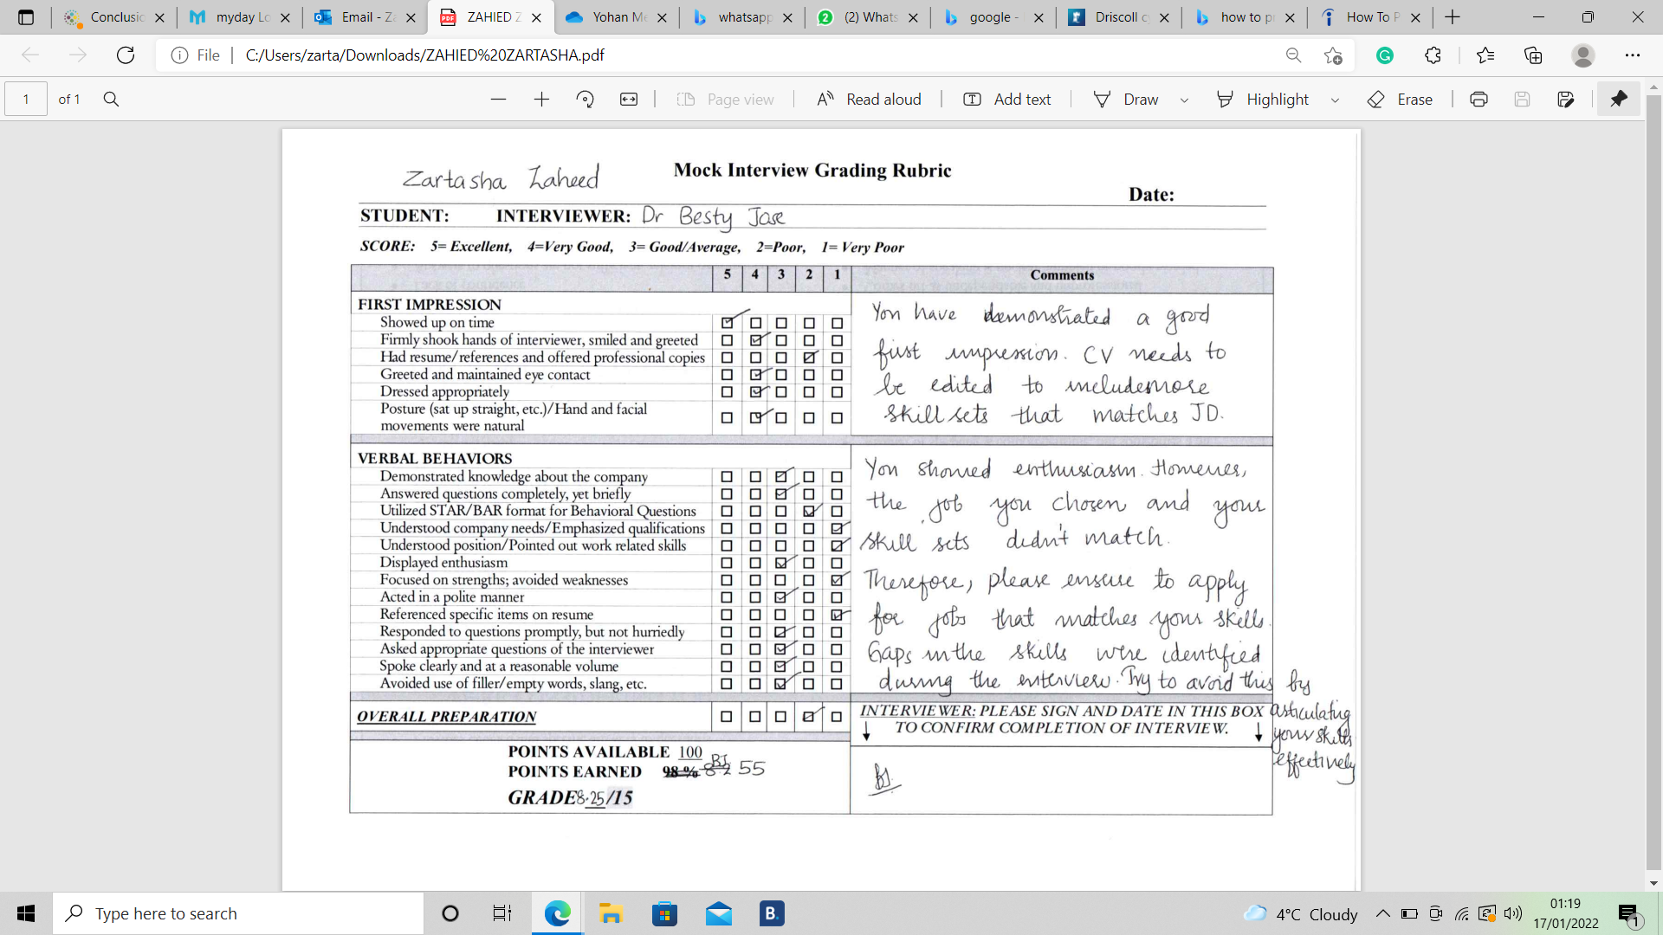
The interviewer mentioned that my CV did not match the job description, they also stated that the gaps in my skills were identified during the interview too. The interviewer suggested that I apply for a job that matches my skills set and adjust my CV so that the skills and job description match. From this, I have learned that in A good interview it is crucial to do your research, firstly on the company and secondly on the job role you are applying for. I did not take the time to understand that I cannot just jump to a job that requires so much skill and experience. This was ignorant of me, and I did not analyze my personal skills prior to job searching. This was one of the main things I learned throughout this module, and it has made me more aware of what it is exactly that I need to do and what steps I need to take to be successful in future interviews, some of the steps to a successful interview include:
  - Examine the job description, this is usually posted alongside the job role.
  - Know why I am doing the interview and consider my qualifications.
  - Research the company, this will provide me with context as well as questions for the interviewer.

Self-awareness.
Another key skill I have learnt within this module is self-awareness. Self-awareness is knowing your own personality, your strengths, and weaknesses. When we can see ourselves clearly, we are more confident we are able to engage with others better. Within this module we discussed the four levels of self-awareness consciousness.
- Unconsciousness
Being non-responsiveness to self and environment
- Consciousness
Focusing attention on the environment; processing incoming external stimuli.
- Self-awareness
Focusing attention on the self; processing private and public self-information. (“Self-Awareness Part 1: Deﬁnition, Measures, Effects ...”)
- Meta-self-awareness
Being aware that one is self-aware
We also learnt about the Johari window; this is one of my favorite concepts when it comes to self-awareness as it implements growth, by showing you the 4 elements to oneself and what they know about themselves and what others know. the objective of this concept it to enlarge the ‘open self’ and reduce ‘unknown self.’
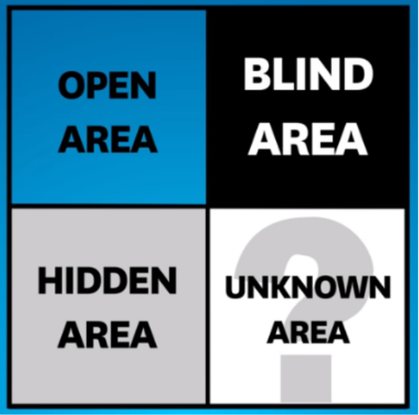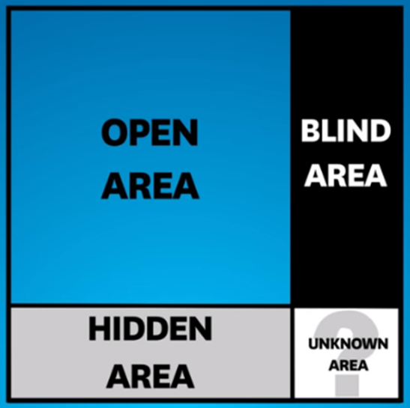
This simply suggest allowing yourself to learn about your own self and allow others to know this information too. This will stem your personal growth and permit you to learn about who you are.
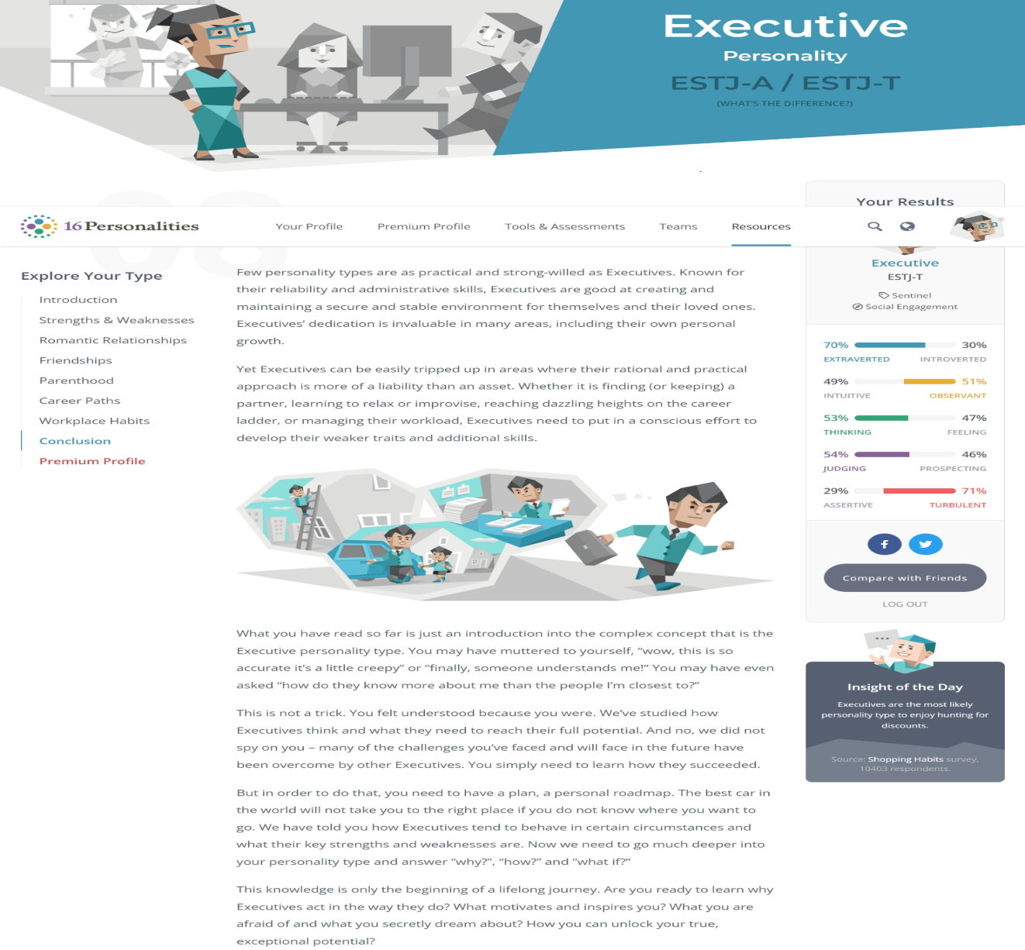
During this module we did a personality test and here are my results.
My personality test results allowed me to understand some of my weaknesses that I was unaware of, here are some of the weaknesses-
- Difficult to relax
- Too focused on social status
- Uncomfortable with unconventional situation
These results have allowed me to understand my self-better and most importantly to understand what my weaknesses are, this will allow me to develop myself and make others aware of myself which will in turn better my employability chances and allow me to find a suitable job according to me and my personality traits.
To conclude I believe that this module has made me realize what needs to be done to get on to the employability ladder and what steps need to be taken. I have learned many things throughout this module but have only been able to show you a glimpse. This module has allowed me to realistically think about my future job choices and which sector I want to go in to, ideally, I would like to become a social worker one day and thanks to this module I have learnt about what I need to do before I get there and how to set my aims and goals to achieve this. My steps to accomplishing my goal will be to:
- Complete my course in health and social care.
- Gain some work experience in the role I would want to be in or something in the same sector.
- Enhance my knowledge on the subject.
- Start off somewhere small and work my way up.
I have realized that I will not just be able to jump to my dream job and in fact it will take time and hard work to get there so I will need to start of somewhere small and work my way up. By doing this I will also gain more experience and knowledge of the field which will help me in the long run.

Bibliography

- Gurl, E (2017) SWOT analysis: A theoretical view. AURA: Alfred University Research & Archives. (online) https://demo.dspacedirect.org/bitstream/handle/10673/792/swot%20pdf.pdf?sequence=1&isAllowed=y (Accessed 05/12/2021)
- Mindtools.com. 2021. SWOT Analysis: Strengths, Weaknesses, Opportunities, Threats. [online] Available at: <https://www.mindtools.com/pages/article/newTMC_05.htm> (Accessed 04/12/2021)
- G. Houben, K. Lenie, K. Vanhoof, A knowledge-based SWOT-analysis system as an instrument for strategic planning in small and medium sized enterprises, Decision Support Systems, Volume 26, Issue 2, 1999, Pages 125-135,
- Figure 1: Fox, G., 2021. SWOT Analysis – A How To – Plus 4 Free Templates. [online] GARY FOX. Available at: <https://www.garyfox.co/swot-analysis-free-templates/> [Accessed 7 December 2021].
- Beausaert, S., Segers, M., Fouarge, D. and Gijselaers, W. (2013), "Effect of using a personal development plan on learning and development", Journal of Workplace Learning, Vol. 25 No. 3, pp. 145-158. https://doi.org/10.1108/13665621311306538
- Putter, M., 2021. What is a personal development plan? [online] CPD Online College. Available at: <https://cpdonline.co.uk/knowledge-base/business/what-are-personal-development-plans/> [Accessed 7 December 2021].
- Heatley, s., 2018. The ultimate personal development plan guide + free templates. [Blog] perkbox, Available at: <https://www.perkbox.com/uk/resources/blog/the-ultimate-personal-development-plan-guide-free-templates> [Accessed 7 December 2021].
- UK GOV: National careers. social services manager, available at https://nationalcareers.service.gov.uk/job-profiles/social-services-manager (Accessed 05/12/2021)

