Introduction to Portfolio
This portfolio reports the student youth worker's transformative journey through their Level 6 placement with the Boys' and Girls' Clubs of Wales (BGC Wales) and their partnership with the South Wales Police (SWP) Police Youth Volunteer (PYV) scheme. Through a collection of documents, this portfolio provides an in-depth examination of the student's roles and responsibilities, as well as a SWOT analysis. The portfolio also highlights their personal development and learning, aligned to their Personal Development Plan (PDP), which reflects their goals and accomplishments throughout their placement.
The portfolio is informed by key guiding policies and frameworks, including the National Occupational Standards for Youth Work (NOS) (Community Learning and Development, Standards Council Scotland (CLD SCC), 2019), the Principles and Purposes of Youth Work in Wales (Youth Work in Wales Review Group, (YWIWRG), 2022), the Youth Work Strategy for Wales (Welsh Government, 2019), and the United Nations Convention on the Rights of the Child (UNCRC), UNICEF, 1989). This framework ensures that the student's practice is grounded in best practices and principles that promotes young people’s personal, social and educational development.

Roles and Responsibilies of the Student Youth Worker
For placement the student youth worker was employed at the BGC Wales in a role that involved the co-design, development and delivery of the whole youth work programme for the SWP PYV scheme. The student then delivered this programme weekly in 3 of the 10 hubs across South Wales. The student identifies the key activities and initiatives that they have led and managed across the hubs. However, it is worth noting that the student actually carried out well in excess of 40 activities and events across the term. Moreover, their delivery encompassed the Values, Principles and Purpose of Youth Work (CLD SCS, 2019; YWIWRG, 2022), the Youth Work Strategy for Wales (Welsh Government, 2019), the Wellbeing of Future Generations (Wales) Act 2015 (Welsh Government, 2015), and the UNCRC (UNICEF, 1989). By showcasing some of these activities, the student aims to highlight the meaningful impact the PYV scheme has had on the lives of young people.
The Peace Mala Programme
Peace Mala is a distinguished, multi-award-winning educational initiative that offers a comprehensive, effective, and innovative response to the Government's ESDGC directive (Education for Sustainable Development and Global Citizenship) (Peace Mala, no date). The student led the development and implementation of this project, ensuring that its core values and concepts were seamlessly integrated into the PYV Curriculum. This initiative also provided opportunities for the young people to achieve accreditation, further enhancing its impact and credibility.
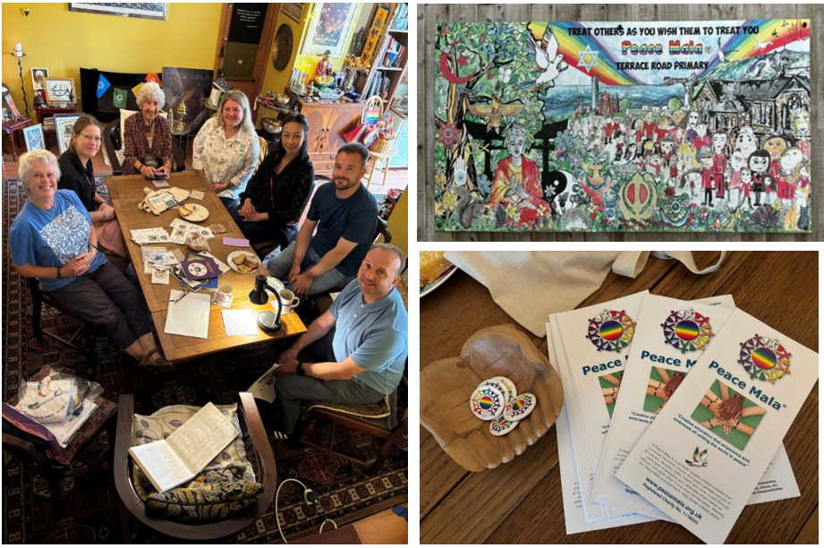
To enhance the understanding of the Peace Mala programme among PYV leaders, the student proactively cultivated positive relationships with the Peace Mala team. To facilitate this, the student organised for key personnel, including BGC CEO and manager, PYV youth workers, and a SWP PYV leader to visit the Peace Mala HQ to meet with its founder and directors. This visit served as an invaluable opportunity for collaboration and insight, strengthening the connections among the three organisations. Additionally, the student attended the Seeds of Hope Exhibition (This is Our Age, 2025) alongside Peace Mala’s founder Pam Evans MBE, further fostering relationships and networking with other organisations dedicated to advancing the United Nations (no date), Sustainable Development Goals (STGs). In alignment with the performance criteria set out in the CLD SCS (2019), these experiences underscore the student's ability to develop and maintain productive working relationships with colleagues, agencies, and stakeholders, effectively aligning shared goals to benefit young people and enhance their opportunities.

Icebreakers
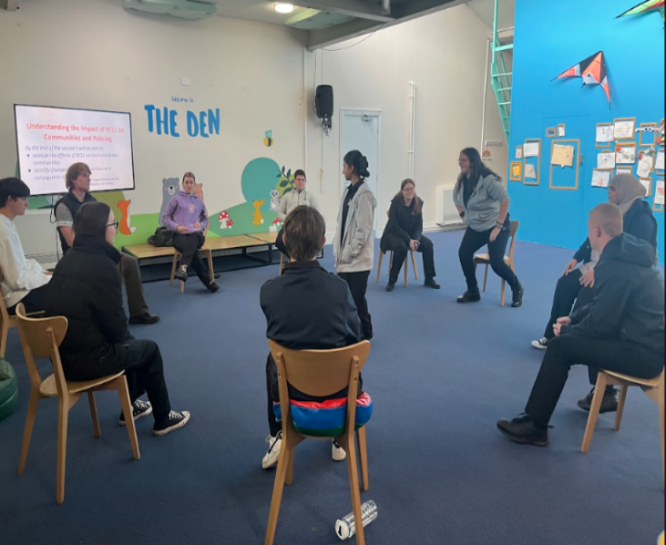
The student youth worker’s role involved fostering comfortable and supportive environments where the young people felt welcome, and could have fun (Welsh Government, 2019). To achieve this, they facilitated icebreakers at the beginning of each hub session. According to Mepieza (2023), icebreakers foster positive learning atmospheres by enhancing speaking and listening skills, boosting mood, and stimulating brain activity. This ‘Circle of Truth’ (Priestley, 2014) icebreaker for example, was purposely chosen to promote the ‘Five Ways to Well-being’ (NHS, 2022) and uphold youth work principles of inclusion, active participation, and empowerment (CLD SCS, 2019).
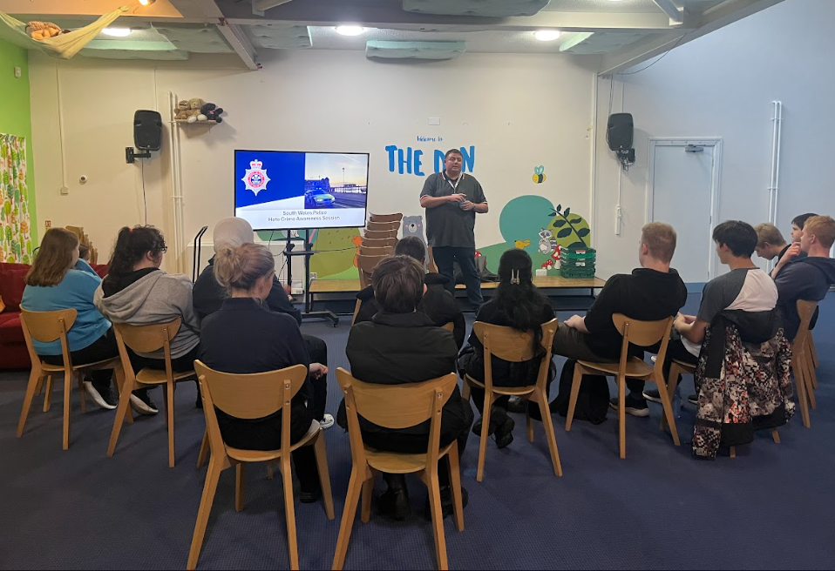
Introducing Peace Mala
The responsibility of the student involved fostering environments of equality, diversity, and inclusion (CLD SCS 2019). Therefore, at one of their hub sessions, they invited a hate crime officer to attend and educate the young people about the realities of hate and discrimination to raise awareness and encourage critical thinking about these issues.
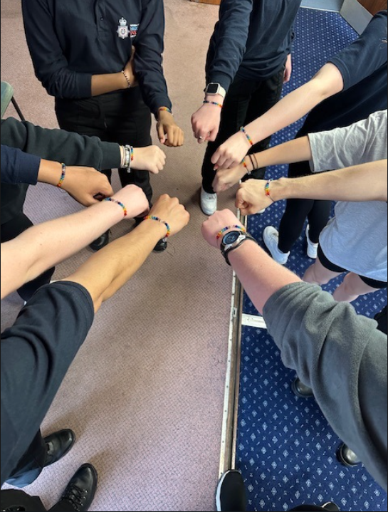
Additionally, the introduction of the Peace Mala initiative was a significant step in promoting the Golden Rule of treating others with respect and understanding (Peace Mala, no date). By facilitating the creation of Peace Mala bracelets and encouraging discussions about various spiritual paths and cultures, the youth worker sought to build empathy and strengthen community bonds among the young participants. These actions align with youth work policies that emphasise the importance of tackling discrimination and promoting inclusivity, such as the UNCRC (UNICEF, 1989) and the Wellbeing of Future Generations (Wales) Act (2015) (Welsh Government, 2015).
Youth Work’s principles of empowerment was a central theme in the student’s approach (CLD SCS, 2019). For instance, the youth worker facilitated an artistic activity where participants could express their personal beliefs, spiritualities, cultures, traditions, or hobbies. This not only allowed the young people to open up and share their perspectives but also encouraged meaningful conversations and self-reflection.
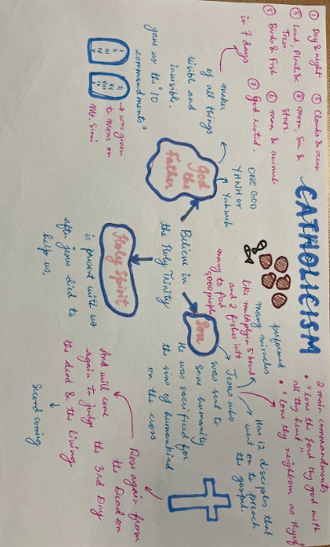
By doing so, the youth worker aimed to build their confidence and a sense of agency. This approach aligns with the standards established by the CLD SCS (2019), which emphasise the role of youth workers in supporting young people’s personal, social, spiritual, and educational growth, as well as enhancing their self-awareness, confidence, and active participation. Moreover, the student encouraged young people to critically reflect on their values and beliefs while actively contributing to a society characterised by diversity and different perspectives (CLD SCS, 2019). This exploration happened within the context of fostering good relations and ensuring equality of opportunity for all (CLD SCS, 2019). These actions reflect the core values and purposes of youth work (CLD SCS, 2019), the Youth Work Strategy for Wales (Welsh Government, 2019), the Well-being of Future Generations (Wales) Act (Welsh Government, 2015), and the UNCRC (UNICEF, 1989).
To conclude, the student has embraced a diverse range of roles and responsibilities within the organisation. Their leadership and management of initiatives such as the Peace Mala programme embodies their commitment to the principles of active participation, inclusion, and empowerment (CLD SCS, 2019). Through various activities and collaborative efforts, the PYV scheme has significantly benefited the lives of young people, bringing them together for meaningful shared experiences.

References
CLD Standards Council Scotland (2019) Youth Work National Occupational Standards. Glasgow: CLD Standards Council Scotland.
Mepieza, R.Y. (2024) ‘The Power of Ice Breaker Activity: Examining the Impact of Icebreakers on Student Participation and Engagement in the Classroom’, European Journal of Learning on History and Social Sciences, 1(1), pp.22–36.
National Health Service (2022) 5 steps to mental wellbeing. Available at: https://www.nhs.uk/mental-health/self-help/guides-tools-and-activities/five-steps-to-mental-wellbeing/ (Accessed: 22 January 2025).
National Youth Agency (no date) What is youth work? Available at: https://nya.org.uk/what-is-youth-work/#:~:text=Youth%20workers%20play%20a%20crucial%20role%20in%20the,giving%20them%20a%20place%20to%20simply%20be%20themselves (Accessed: 22 January 2025).
Peace Mala (no date) Benefits of Peace Mala Accreditation for schools, youth and community groups. Available at: https://www.peacemala.org.uk/accreditation-benefits.php (Accessed: 22 January 2025).
Priestley, D. (2014) Circle of Truth. Available at: https://ventureteambuilding.co.uk/circle-truth/ (Accessed: 22 January 2025).
This is Our Age (2025) MAKING THE SDGs A REALITY: Seeds of Hope and Action Exhibition. Available at: https://thisisourage.co.uk/seeds-of-hope-and-action-exhibition/ (Accessed: 22 January 2025).
United Nations (no date) The 17 Goals. Available at: https://sdgs.un.org/goals (Accessed: 22 January 2025).
Welsh Government (2015) Well-being of Future Generations (Wales) Act 2015: the essentials. Available at: https://www.gov.wales/well-being-future-generations-act-essentials-html (Accessed: 15 December 2024).
Welsh Government (2024) Youth Work Strategy for Wales. Available at: https://www.gov.wales/sites/default/files/publications/2024-10/youth-work-strategy-for-wales.pdf (Accessed: 15 December 2024).
UNICEF (no date) A Summary of the UN Convention on the Rights of the Child. Available at: https://www.unicef.org.uk/wp-content/uploads/2019/10/UNCRC_summary-1_1.pdf (Accessed: 14 December 2024).

Community Profile of Port Talbot
According to Hawtin and Murray (2007), a community profile provides a thorough overview of a population's needs and resources, incorporating active participation from community members to develop an action plan that enhances quality of life. This community profile for Port Talbot, informs youth work praxis by integrating statistical data, youth work theories, and the perspectives of local young people. It embodies the principles of active participation, inclusion, and empowerment (CLD SCS, 2019) and aligns with Article 12 of the UNCRC (UNICEF, 1989). Additionally, its recommendations support the Extending Entitlement (WAG, 2002), the Youth Work Strategy for Wales (Welsh Government, 2019) and the Well-being of Future Generations (Wales) Act (Welsh Government, 2015).
Population
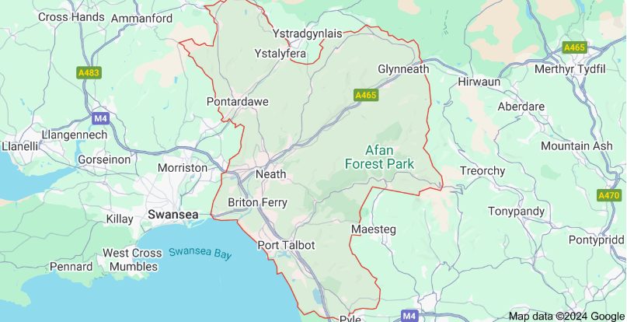
The ONS (2022) 2021 census shows that Neath Port Talbot has a population of 142,300, a 1.8% increase since 2011. Notably, 29% of this population are under the age of 25, indicating a significant need for targeted youth services in the area (ONS, 2022).
Transport Links
Promoting young people’s rights (UNICEF, 1989), transport links in Port Talbot serve as valuable assets for young people, facilitating their access to education, employment, and social activities (International Transport Forum, 2024). The M4 runs directly through Port Talbot, providing ease of connectivity to London and the Southeast via junctions 40 and 41 (NPTC, no date). Local public transport, including regular bus and train services further supports this mobility (NPTC, no date). Such access reflects youth work’s principles of participation and inclusion (CLD SCS, 2019) and supports the vision of the Well-being of Future Generations (Wales) Act (Welsh Government, 2015).
Economic Transition
Port Talbot's rich industrial heritage, particularly in coal and steel, is also a notable asset. At its peak in the 1970s, the steelworks employed over 30,000 people (Dramatic Heart, 2023). However, employment numbers dropped significantly by 2014 to 34,500, and recent closures have resulted in approximately 75% of the workforce losing their jobs, creating uncertainty for local young people (BBC Newsround, 2024).
In response to these challenges, the NPT Well-being Plan 2023-2028 aims for economic decarbonisation and the creation of new job opportunities (NPT Public Services Board, 2023). Notably, plans by Associated British Ports to develop Port Talbot Docks into an offshore wind turbine production hub, have the potential to generate sustainable employment, thus addressing concerns about the shifting job market (NPT Public Services Board, 2023). Such plans align with the Well-being of Future Generations (Wales) Act (2015) and reflect a proactive approach to economic challenges.

Mainstream Education
Disengagement from mainstream education has become a pressing issue for young people in Port Talbot. Statistics reveal that many students leave school with qualifications below the Welsh average, accompanied by higher rates of unauthorised absences than the national average (NPT Public Services Board, 2024). In July 2023, approximately 2.2% of Year 11 leavers in Port Talbot were classified as NEET (Not in Education, Employment, or Training), further underscoring the need for interventions that uphold young people’s right to education (UNICEF, 1989). Local young people express a desire for diverse educational pathways, particularly vocational learning opportunities that cater to their individual interests and skills (NPT Public Services Board, 2024).
Mental Health and Well-being
The COVID-19 pandemic has significantly impacted the mental health of young people in Port Talbot, with approximately 1 in 6 individuals aged 7 to 16 reported having a probable mental health disorder (NHS Digital, 2022, cited in NYA, 2024). Long waiting lists for Child and Adolescent Mental Health Services exacerbate these challenges, highlighting an urgent need for accessible mental health resources and proactive support systems that effectively address young people’s evolving needs (NPT Public Services Board, 2024).
Importance of Leisure
According to the House of Commons Education Committee (2011), young people spend an estimated 85% of their waking hours outside formal education. Engaging in positive leisure activities is linked to better educational outcomes, enhanced employment skills, and improved mental health and well-being (Atkinson et al., 2014; Driver, 1992; Dworkin et al., 2003). This reflects the outcomes outlined in the National Youth Service Strategy for Wales (WAG, 2007; Welsh Government, 2019).
Leisure Facilities in Schools
While many leisure facilities exist in Port Talbot, a significant number are located within school premises. Article 12 of the UNCRC states that young people have a right to access safe places for play (UNICEF, 1989). However, a local young person states, ‘there is nowhere around to play football in the evenings. There are lots of fields, but they are all located on school premises. You either have to pay to use them or they are locked up’ (Young Person 1, 2024).
For instance, Ysgol Bae Baglan has excellent facilities, including sports halls and pitches (Ysgol Bae Baglan, no date), yet these remain inaccessible at night and cost £20 per hour to hire, making them unaffordable for many young people.
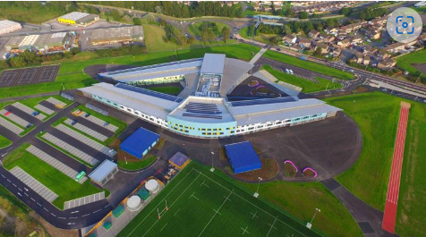
Youth and Community Clubs
Youth and community clubs in Port Talbot serve essential functions by providing safe spaces for young people to gather, receive guidance, and engage in meaningful activities. According to Williamson (1995), young people have four key needs: a gathering place, engaging activities, personal space, and guidance. Local youth clubs satisfy these needs, as evidenced by testimonials from attendees who appreciate the supportive environment and opportunities for learning new skills, such as sewing and cooking (Young Persons 2 and 3, 2024).
The clubs also act as a safety net for vulnerable young people living in poverty. Key worker 1 (2024) describes the youth club as a ‘safe haven’, providing warmth, meals, and an escape from challenging home environments. Despite their significance, many clubs are volunteer-run and only operational one or two evenings a week, limiting their potential. Increased funding would enable the opening of more regular sessions, hire qualified staff, and enhance service quality (Key Worker 2, 2024).
Organisations like BGC Wales (no date), with about 20 affiliated clubs, augment these efforts by offering diverse opportunities ranging from sports to international exchanges. However, recent funding cuts have threatened vital programmes like the Port Talbot's SWP PYV scheme, which focused on providing vocational experiences. The scrapping of such initiatives highlights the challenges youth services face in securing sustainable funding.
Conclusion and Recommendations
Youth work plays an invaluable role in the development and well-being of young people in the NPT area, which is crucial in the context its Children's and Young People's Plan (NPT Public Services Board, 2024). While the plan highlights educational attainment and addresses mental health, bullying, and disengagement from school, it overlooks the significant impact that youth work can have in meeting these objectives.
One key advantage of youth work is its accessibility and flexibility. By utilising school facilities outside of regular hours, youth workers can create programmes that not only complement formal education but also cater to the diverse needs of young people. This reflects youth work’s principles of active participation, inclusion, and empowerment (CLD SCS, 2019), as well as Article 12 of the UNCRC (UNICEF, 1989).
Additionally, while the plan emphasises staff training for teachers, it is equally important to invest in the professional development of youth workers. Many local youth clubs are volunteer run, which can hinder consistent and high-quality programming. Increased funding for training would enable youth workers to better address the evolving needs of young people. These recommendations align with the Youth Work Strategy for Wales (Welsh Government, 2019) and the Well-being of Future Generations (Wales) Act (Welsh Government, 2015).
Youth work is also vital in fostering resilience and life skills, providing young individuals with mentorship and safe spaces to express themselves (NYA, 2024). This is particularly important in a community where many feel marginalised, empowering them to make informed choices about their futures and pathways to education or employment. This reflects the Extending Entitlement (WAG, 2002).
In conclusion, to fulfil the goals of the Children’s and Young People's Plan, NPT must explicitly recognise the value of youth work in supporting young people’s development. Policymakers should prioritise equitable funding, ensure extended access to school facilities, and invest in the training of youth workers. By doing so, NPT can create a comprehensive support system that enriches the lives of young people and fosters a more inclusive community.

References
Atkinson, R. et al. (2014) ‘The impact of positive leisure activities on educational outcomes in youth’, Journal of Youth Studies, 17(3), pp. 220-235.
BBC Newsround (2024) Port Talbot: Town says goodbye to traditional steelworks. Available at: https://www.bbc.co.uk/newsround/articles/czxgy5yw8z7o (Accessed: 15 December 2024).
Boys’ and Girls’ Clubs of Wales (no date) Member Clubs. Available at: https://www.bgc.wales/member-clubs (Accessed: 17 December 2024).
CLD Standards Council Scotland (2019) Youth Work National Occupational Standards. Glasgow: CLD Standards Council Scotland.
Dramatic Heart (2023) Pride in our world-renowned industrial past. Available at: https://dramaticheart.wales/blog/pride-in-our-world-renowned-industrial-past/ (Accessed: 14 December 2024).
Driver, B. (1992) ‘Leisure and mental health: A review of the literature’, Journal of Leisure Research, 24(1), pp. 57-69.
Dworkin, J.B., Larson, R. and Hansen, D. (2003) ‘Adolescents’ Accounts of Growth Experiences in Youth Activities’, Journal of Youth and Adolescence, 32(1), pp.17–26.
Hawtin, M. and Percy-Smith, J. (2007). Community profiling: a practical guide. Maidenhead: Open University Press.
House of Commons Education Committee (2011) Services for Young People. Available at: https://publications.parliament.uk/pa/cm201012/cmselect/cmeduc/744/744i.pdf (Accessed: 20 December 2024).
(International Transport Forum, 2024) Youth on the Move: Young People and Transport in the 21st Century. Available at: https://itf-oecd.org/youth-move-transport#:~:text=How%20young%20people%20use%20transport%20matters%20for%20society.,for%20sustainability%2C%20economic%20development%2C%20liveability%2C%20health%20and%20well-being. (Accessed: 16 December 2024).
Key Worker 1 (2024) Conversation, 10 December.
Key Worker 2 (2024) Conversation, 10 December.
National Youth Agency (2024) National Youth Work Curriculum. Available at: https://nya.org.uk/wp-content/uploads/2024/04/5.3.1-0923-NYA-Youth-Work-Curriculum-DIGITAL1-03.24-1.pdf (Accessed: 29 December 2024).
Neath Port Talbot Council (no date) Transport Links. Available at: https://www.wgsb.wales/1945#:~:text=Excellent%20location%20on%20the%20M4,By%20Sea (Accessed: 14 December 2024).
Neath Port Talbot Public Services Board (2024) Neath Port Talbot Early Years, Children & Young People’s Plan. Available at: https://democracy.npt.gov.uk/documents/s98900/Appendix%201%20-%20Children%20and%20Young%20Peoples%20Plan.pdf (Accessed: 14 December 2024).
Neath Port Talbot Public Services Board (2023) Well-being Plan. Available at: https://democracy.npt.gov.uk/documents/s87178/Appendix%202%20Draft%20Wellbeing%20Plan%2020232028.pdf (Accessed: 14 December 2024).
Office of National Statistics (2022) How the population changed in Neath Port Talbot: Census 2021. Available at: https://www.ons.gov.uk/visualisations/censuspopulationchange/W06000012/ (Accessed: 14 December 2024).
UNICEF (no date) A Summary of the UN Convention on the Rights of the Child. Available at: https://www.unicef.org.uk/wp-content/uploads/2019/10/UNCRC_summary-1_1.pdf (Accessed: 14 December 2024).
Welsh Assembly Government (2002) EXTENDING ENTITLEMENT: support for 11- to 25-year-olds in Wales. Available at: https://www.gov.wales/sites/default/files/publications/2018-02/direction-and-guidance-extending-entitlement-support-for-11-to-25-year-olds-in-wales.pdf (Accessed: 16 December 2024).
Welsh Assembly Government (2007) Young People, Youth Work, Youth Service: National Youth Service Strategy for Wales. Cardiff: Welsh Assembly Government.

Welsh Government (2015) Well-being of Future Generations (Wales) Act 2015: the essentials. Available at: https://www.gov.wales/well-being-future-generations-act-essentials-html (Accessed: 15 December 2024).
Welsh Government (2024) Youth Work Strategy for Wales. Available at: https://www.gov.wales/sites/default/files/publications/2024-10/youth-work-strategy-for-wales.pdf (Accessed: 15 December 2024).
Williamson, H. (1997) ‘So what for young people’ in Ledgerwood, I. and Kendra, N. (eds.) The Challenge of the Future. Lyme Regis: Russell House.
Young Person 1 (2024) Conversation, 10 December.
Young person 2 (2024) Conversation, 10 December.
Young Person (2024) Conversation, 10 December.
Ysgol Bae Baglan (no date) Community Facilities. Available at: https://ysgolbaebaglan.j2bloggy.com/facilities/#:~:text=There's%20also%20a%20wide%20range,a%20multi%2Duse%20games%20area (Accessed: 14 December 2024).

A SWOT Analysis
A SWOT (Strengths, Weaknesses, Opportunities, and Threats) analysis, as defined by Sapin (2013), serves as an effective framework for youth workers aiming to gain a nuanced understanding of the organisational contexts within which they operate. By engaging in this analytical process, youth workers can critically reflect on both the internal dynamics of their organisations and the external environments that influence their service delivery.
The youth work landscape is notably dynamic, with organisational structures constantly evolving, yielding both positive and negative impacts on the young people served (Tyler et al., 2009). The holistic contribution of youth work to meeting the interests and needs of young individuals is paramount; however, such contributions can be compromised without careful consideration of the contextual factors influencing practice (Davies and Merton, 2009, cited in Tyler et al., 2009).
This SWOT analysis of the BGC Wales partnership with the SWP PYV scheme offers a matrix of key findings and an examination of critical areas affecting the programme. By doing so, this analysis aims to enhance the effectiveness of the PYV scheme, providing tangible roadmaps and timelines for potential solutions. Ultimately, the goal is to ensure that youth work remains understood, valued, and effectively delivered for the benefit of young people (Welsh Government (2019).
SWOT Analysis Matrix
SWOT Analysis | Strengths | Weaknesses
Internal Factors | - Programme designed and delivered by qualified youth workers. | - New project teething problems such as adjusting to new management.
 | - Partnership with South Wales Police. | - SWP’s focus on compliance.
 | - Emphasis on continuous learning through supervision and team meetings. | - Rigid adherence to the SWP safeguarding protocols.
 | - Positive relationships with other organisations. | - Transport and venue issues impacting logistics and accessibility.
 | - Regular feedback mechanisms from young people. | - Job security concerns for staff due to short term contracts.
External Factors | Opportunities | Threats
 | - Improve collaboration and communication with SWP. | - Cost of living increases, impacting participation and funding.
 | - Maintain an ongoing feedback loop to adapt to young people's needs. | - Potential erosion of community trust impacting programme engagement.
 | - Explore additional funding for improved transportation options. | - Risks from natural disasters, or pandemics, disrupting programme.
 | - Establish arrangements for suitable venues to prevent logistical issues. | - Competition for resources and funding among other organisations and charities.
 | - Increase attendance from lower-socioeconomic groups of young people. | - Programme being cancelled due to funding cuts within SWP.

Strengths: Youth Work Approach
The primary strength of the scheme lies in its youth work approach, which emphasises relational learning over traditional transmissive methods (Batsleer and Davies, 2010). Previously managed by PCSOs and SWP personnel, the programme's engagement with young people was limited. Under BGC Wales, it now fosters environments where young people feel valued and understood (YWIWRG, 2022). Sessions prioritise positive relationships through informal education and dialogue, encouraging active engagement and reflection via collaborative learning (Batsleer and Davies, 2010; Jeffs and Smith, 2010).
This young person-led approach, along with regular feedback loops, ensures that young people feel seen and heard. This reflects youth work’s principles of inclusion, participation and empowerment (CLD SCS, 2019), and Article 12 of the UNCRC (UNICEF, 1989). Additionally, BGC Wales’s emphasis on continuous learning through supervision and team meetings enhances the effectiveness of critically reflective youth work practitioners (CLD SCS, 2019)
Weaknesses: Meeting Targets
A weakness identified in the SWOT analysis is the challenge of meeting targets and outcomes set by SWP. For instance, the rapid design and development of the PYV curriculum, driven by SWP requirements, limited opportunities for youth workers to understand young people's needs and interests, factors essential for effective youth work (CLD SCS, 2019). Rose notes that there is often a conflict between professional codes that prioritise attention to expressed needs and bureaucratic pressures for efficiency and predetermined outcomes (Jeffs and Smith, 2010).
Another identified weakness is the rigid adherence to SWP safeguarding protocols, which can inhibit young people's autonomy and limit opportunities for meaningful engagement. Despite thorough planning, preparation, and risk assessments, opportunities for young people’s development are often curtailed due to these strict guidelines. The cancellation of the reward trip to Heatherton serves as a prime example of how these protocols can lead to disappointment among young people and frustration among youth workers.
This disconnect undermines the core objective of empowering young individuals through experiential learning (Kolb, 2015) and creates disenchantment, as young people may perceive that their voices and interests are not adequately considered. The cancellation of this activity highlights a policy implementation issue where safeguarding takes precedence to the detriment of young people’s participation. Ultimately, this undermines the programme’s objectives to foster transformative learning experiences for young people's personal, social, and spiritual development (Jeffs and Smith, 2010).
Threats: Funding Instability
A letter has arrived at BGC Wales, announcing that the new Police and Crime Commissioner has terminated their partnership with SWP. This decision brings to an abrupt end all the hard work, relationships built, and commitments made to young people, their families, and communities, all expected to unravel within the next two months.
The termination of the BGC Wales partnership poses a significant risk to the continuity of youth services provided through the PYV scheme. Funding is vital for youth work, and when political priorities shift, essential programmes often become vulnerable to cuts (NYA, 2024). The NYA, (2024) emphasises the critical role of youth work in supporting young people's development and well-being. Their manifesto highlights that cuts to statutory youth services over the last decade have resulted in inconsistent access to vital support, leaving many young people without a trusted adult.
The NYA (2024) calls for a National Youth Strategy, a dedicated Youth Minister, and a new Statutory Youth Services Act to ensure sustainable funding and equitable access to youth services. They stress the need for long-term funding solutions, the rebuilding of the youth workforce, and improved data collection to showcase the impact of youth work. Overall, sustained investment is essential to prevent the erosion of vital youth services amid shifting political priorities. The situation underscores the critical need for advocacy and strategic planning by youth workers to secure ongoing governmental support aligned with youth development goals. McCulloch (2016) emphasises that social pedagogy requires youth workers to collaborate strategically, ensuring holistic support for young people through effective advocacy.
Conclusion
The termination of the BGC Wales partnership with the SWP PYV scheme has significant implications for young people, staff, and the broader youth work sector. For young people, the loss of this programme means reduced access to relational learning opportunities and a supportive environment that prioritises their voices and needs. Staff members face uncertainty and the challenge of transitioning their expertise and efforts to other initiatives, potentially disrupting the continuity of youth services. BGC Wales must now focus on collaboration and advocacy to secure alternative funding and partnerships. This effort is essential to mitigate the negative impact of the programme's closure and to ensure that the principles of youth work continue to guide future initiatives.
References
CLD Standards Council Scotland (2019) Youth Work National Occupational Standards. Glasgow: CLD Standards Council Scotland.
Jeffs, T. and Smith, M. (2010) Youth Work Practice. Basingstoke: Palgrave Macmillan.
McCulloch, H. (2016). Social Pedagogy and Working with Children and Young People: A UK Perspective. London: Jessica Kingsley Publishers.
Kolb, D.A. (2015) Experiential Learning: Experience As the Source of Learning and Development. 2nd edn. New Jersey: Pearson Education.
National Youth Agency (2024) NYA Manifesto 2024- Youth Work for all Young People. Available at: https://nya.org.uk/wp-content/uploads/2024/04/NYA-Manifesto-2024-%E2%80%93-Youth-work-for-all-young-people-1.pdf (Accessed: 10 December 2024).
Tyler, M., Hoggarth, L. and Merton, B. (2009) Managing modern youth work. Exeter: Learning Matters.
UNICEF (no date) A Summary of the UN Convention on the Rights of the Child. Available at: https://www.unicef.org.uk/wp-content/uploads/2019/10/UNCRC_summary-1_1.pdf (Accessed: 20 October 2024).
Welsh Government (2024) Youth Work Strategy for Wales. Available at: https://www.gov.wales/sites/default/files/publications/2024-10/youth-work-strategy-for-wales.pdf (Accessed: 19 November 2024).
Youth Work in Wales Review Group (2022) Youth Work in Wales: Principles and Purposes. Available at: https://www.cwvys.org.uk/youth-work-in-wales-principles-and-purposes-2/ (Accessed: 19 November 2024)

A Summary of Learning and Development
Before beginning the Level 6 placement, the student identified key areas for professional growth as a youth work practitioner within their PDP. Throughout the placement, the student actively pursued every opportunity that arose, leading to the successful achievement of all set goals and beyond. This summary encapsulates the student’s transformative journey, showcasing accomplishments and areas needing improvement. The student's experiences were informed by various guiding frameworks, including their PDP, the Principles and Purposes of Youth Work in Wales (CLD SCS, 2019; YWIWRG, 2022), the National Youth Strategy for Wales (Welsh Government, 2019), and the UNCRC (UNICEF, 1989).
In alignment with the Five Pillars of Youth Work in Wales (CLD SCS, 2019), the student prioritised creating opportunities for young people's active participation and empowerment. The youth worker successfully integrated the UNCRC into the PYV curriculum, designing session plans and activities that educated and engaged young people about their rights. This approach not only built resilience among participants but also empowered them to advocate for themselves and others (YWIWRG, 2022). The incorporation of the Peace Mala initiative introduced peaceful conflict resolution skills, fostering healthier interpersonal relationships within their social circles. This approach reflects the vision set forth by the Wellbeing of Future Generations (Wales) Act, (Welsh Government, 2015).
One notable achievement was the facilitation and management of a social action event that allowed young people to take the lead in organising a community gathering. The afternoon tea event with local elderly residents provided a platform for young people to learn crucial empathy skills, especially in interacting with individuals affected by dementia. Through this initiative, the youth worker aimed to deepen the young participants’ understanding of the challenges faced by the elderly in their community, such as scams and online fraud, thus fostering a sense of responsibility and active participation in addressing these issues (CLD SCS, 2019).
Additionally, the student organised experiential learning opportunities, such as a sailing trip, and collaborated on overnight residential events aimed at introducing young people to the Duke of Edinburgh Award programme. These initiatives provided valuable hands-on experiences, promoting young people’s personal and social development, resilience and wellbeing (CLD SCS, 2019).
Participation in a BGC Wales Hustings event, where over 100 young people engaged in a mock general election with Welsh Assembly members, highlighted the disconnect between politicians and the lived experiences of young people. Recognising this gap, the student is motivated to work towards helping local government understand and engage with young people more effectively.
To further promote inclusion and address the well-being of young people, the student developed strong relationships with each individual, ensuring that their diverse needs, interests, and goals were prioritised (CLD SCS, 2019). This commitment involved co-designing and delivering sessions that raised awareness on various topics, including mental health, suicide prevention, LGBTQ+ issues, and social justice themes such as Black History Month and the International Day for the Elimination of Violence Against Women. Activities were tailored to young people's interests, including fitness sessions and workshops on the Five Ways to Wellbeing.
Throughout the curriculum, the student facilitated career exploration activities, which aligned with the principles of Extending Entitlement (WAG, 2002). By connecting young people with opportunities in emergency services, the student empowered them to explore potential career paths and gain insights into the professional world. Incorporating guest speakers from various professions enhanced this experience, allowing young people to engage directly with role models and learn about the diverse career options available to them. Furthermore, visits to police headquarters, where participants interacted with police dogs and horses, enriched the students' experiences by providing hands-on learning opportunities. These activities not only inspired interest in public service careers but also fostered a deeper understanding of community roles and responsibilities, enhancing young people's sense of connection to their communities as outlined in the National Youth Work Strategy for Wales (Welsh Government, 2019).
After each session, the student documented reflections, identifying successes and areas for improvement to enhance their practice in areas such as active participation (CLD SCS, 2019). The student also engaged in various training opportunities, including First Aid, Outdoor First Aid, IOSH Training, and awareness sessions on autism and LGBTQ+ issues.
To foster and sustain productive working relationships with colleagues, agencies, and stakeholders in the field of youth work (CLD SCS, 2019), the student actively pursued various networking opportunities with a range of partnerships and organisations, including South Wales Police and Peace Mala. Additionally, the student seized the opportunity to visit Atlanta, Georgia, where they engaged with young people and youth workers from around the world. This international experience not only broadened the student’s perspective on youth work practices but also enhanced their ability to collaborate effectively across cultures. Through these engagements, the student strengthened their professional network, shared best practices, and brought back valuable insights to enrich their own work within the community.
The student's placement has not only provided a wealth of learning opportunities but also opened doors to new and exciting roles within the youth work sector. As a testament to their exceptional skills and commitment, the student has been offered a new role at BGC Wales as a Youth Participation Officer. In this role, the student will be working with young people to develop a toolkit for local government to be able to engage and understand the needs and interests of young people. Furthermore, the student has also been presented with the opportunity to work with BGC Wales Mexico to develop a programme that shapes young people's perceptions of masculinity to promote gender equality. This programme aligns with the student's passion for social justice and their commitment to promoting positive change in the lives of young people.
To conclude, the student's placement has been a resounding success, marked by significant growth, achievement, and new opportunities. Their commitment to youth work values, inclusivity, and diversity has made a tangible impact on the lives of young people.

References
CLD Standards Council Scotland (2019) Youth Work National Occupational Standards. Glasgow: CLD Standards Council Scotland.
Jeffs, T. and Smith, M. (2010) Youth Work Practice. Basingstoke: Palgrave Macmillan.
UNICEF (no date) A Summary of the UN Convention on the Rights of the Child. Available at: https://www.unicef.org.uk/wp-content/uploads/2019/10/UNCRC_summary-1_1.pdf (Accessed: 23 January 2025).
Welsh Assembly Government (2002) EXTENDING ENTITLEMENT: support for 11- to 25-year-olds in Wales. Available at: https://www.gov.wales/sites/default/files/publications/2018-02/direction-and-guidance-extending-entitlement-support-for-11-to-25-year-olds-in-wales.pdf (Accessed: 16 December 2024).
Welsh Government (2024) Youth Work Strategy for Wales. Available at: https://www.gov.wales/sites/default/files/publications/2024-10/youth-work-strategy-for-wales.pdf (Accessed: 23 January 2025).
Youth Work in Wales Review Group (2022) Youth Work in Wales: Principles and Purposes. Available at: https://www.cwvys.org.uk/youth-work-in-wales-principles-and-purposes-2/ (Accessed: 23 January 2025).

