Measuring Biodiversity: Dissection of Barn Owl Pellets

Introduction
Estimation of biodiversity through traps is difficult and the process used is somewhat controversial and flawed. This is where owl pellet dissection becomes a useful supplement or alternative; owls will usually hunt more species than normal trap lines catch and cover a larger area. (Andrade, Menezes, & Monjeau, 2016)
Dissecting barn owl (tyto alba) pellets will give a baseline of what organisms exist within the hunting range of Parc-le-Breos. This will also provide indicators as to whether that habitat has or is experiencing stress or if conservation work is required to increase the biodiversity in the area.

Methodology
Using owl pellets (see Figure 2) as a method to measure and manage biodiversity as opposed to trapping is cheaper, less time-consuming and labour-intensive, covers a larger survey area (particularly if multiple nest and perch sites are used), and the area is easy to calculate based on the hunting patterns owls have in foraging areas. (Heisler, Somers, & Poulin, 2016)
Pellets were collected by wardens from a perch at the Parc-le-Breos site in the Gower Peninsula between 2008-2011. These were stored without being dried for some years, upon which were then stored in the lab at UWTSD ready for analysis. Barn owl pellets are roughly 30-70mm in length and range between 4.5-6.5g in weight. (RSPB, nd) As the pellets had become loose over time it was decided that samples would be taken via weight within this range to maintain as much consistency as possible.
Using fine tweezers, microscopes and skull/jawbone ID charts, the pellet would then be dissected and bone fragments separated to be identified. Once identified, each individual fragment would be marked as an individual on a form. This form listed the most documented prey for the barn owl: field vole (microtus agrestis), bank vole (myodes glareolus), wood mouse (apodemus sylvaticus), harvest mouse (micromys minutus), house mouse (mus musculus), rat (rattus norvegicus), common shrew (sorex araneus), pygmy shrew (sorex minutus), water shrew (neomys fodiens), bird (no specific species as a rare occurrence but still documented), and other (such as reptiles/amphibians/etc). From this list, the only species that is on the UK BAP (JNCC, 2007) that applies to Wales is the harvest mouse (micromys minutus), so it was imperative to be as accurate as possible to determine whether any conservation action needed to be taken.
It was expected to see a high number of pellets with little prey variation; from weather reports across 2008-2011 the period was subject to three consecutive harsh winters, along with excessive rain and wind before becoming milder in 2011 (Met Office, nd). This weather would have had a direct impact on the owl’s hunting capabilities; as per Figure 1, they have light bodies that can’t hold much weight and use this with specially adapted feathers to fly and hunt silently. In exchange for this, they aren’t able to retain much warmth and the feathers aren’t waterproof, so are unable to hunt in poor weather. (The Barn Owl Trust, nd) This would limit their range for a significant amount of time and therefore the organisms predated on would be limited to what inhabits that area.

Figure 1: Basic Barn Owl Identifiers
Figure 2: Owl Pellet Degradation
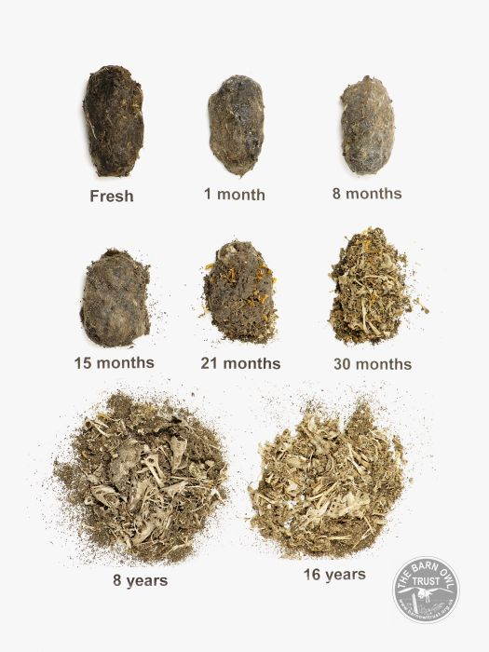
(The Barn Owl Trust, nd) (The Barn Owl Trust, nd)
Given the location the pellets were collected from and the estimated seasonal fluctuation in home range (approximately 1km radius in summer up to 4km in winter) (DEFRA, 2004), it would be expected to see a slightly higher number of unusual prey items compared to what would be found further inland. For instance, with the proximity to beach and coastal areas, which can be seen in Figures 3 and 4, and the typical dusk/dawn hunting pattern used by barn owls, reptile and amphibian remains should be present. Though it is understood that reptile remains are far more fragile than mammal and may be compressed beyond recognition, making this slightly more difficult to determine.
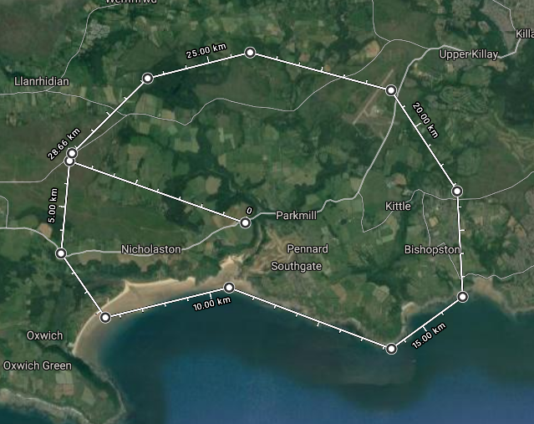
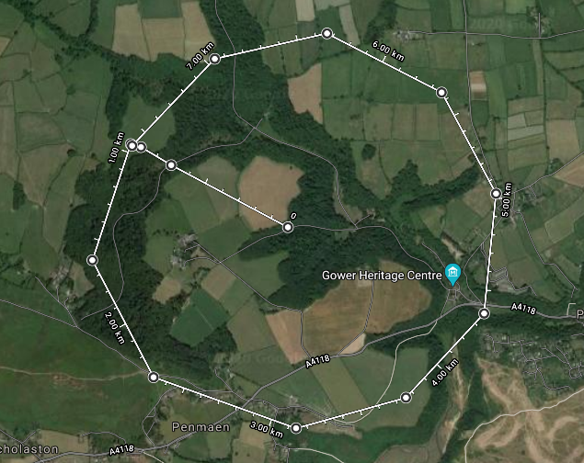
Figure 3: Estimated Summer Home Range Figure 4: Estimated Winter Home Range
(Author's Own, 2020) (Author's Own, 2020)
It was also expected that between 45-55% of the prey found would be field vole as this makes up most of the barn owl’s diet, followed by wood mice making up around 15-20% with the rest being more traditionally opportunistic prey. The study by Andrade et al (Andrade, Menezes, & Monjeau, 2016) found that barn owls in arid landscapes would hunt at random with no favoured areas within their home range, whereas work by Heisler et al (Heisler, Somers, & Poulin, 2016) found that owls in richer environments had favoured routes to aid flight paths through trees. From this it was expected to see pellets generally having a similar composition across the board given that the habitat is known to be rich in terms of plant biodiversity. (Swansea Council, 2017)

Results and Discussion
Table 1: Total Organisms Found in Dissected Samples

Table 2: List of Findings Per Pellet

A lot of owl pellets had been collected, though covering a perch/nest area for 3 years would naturally result in samples this size given that the average barn owl can produce 2-3 pellets every 24 hours. As the samples weren’t dried, they had started to disintegrate as per Figure 2 with few remaining intact pellets. The samples dissected totalled 123 pellets at approximately 5-5.5g each, or 615-676.5g (average of 645.75g). This was approximately one third of what had been provided, so the total weight would be approximately 1.94kg of pellets.
Table 3: Percentage Breakdown Per Species

Most of the prey was field vole, which is to be expected given the rough estimate on the fluctuating home range and that it is the primary prey for the barn owl. At 565 individuals across 123 pellets, this species far exceeds anything else found and averages 4-5 per pellet. Such a high number would suggest that food sources are not scarce in this home range; indeed, field vole is so readily available that it continually accounted for the expected percentage range, as can be seen from Tables 3 and 4.

Table 4: Percentage of pellets with species listed

The figure for pygmy shrews was much higher than expected; it may be possible that a number of these were incorrectly identified juvenile common shrews, though this is less likely given four students were dissecting individually and still finding the same results. This suggests that there is a large pygmy shrew population in the area and given the average pygmy shrew will eat approximately 125% of its body weight in 24 hours (The Wildlife Trust, nd), would also suggest a thriving insect and arthropod community to support this.
It was initially thought to be unusual to see so few water shrews found in the samples; given the proximity to the Ilston river, it would have been expected to see a slightly higher number. However, after further investigation into the distribution of the water shrew, it was found that they are not commonly found in the Gower Peninsular (The Mammal Society, 2018), and so this would account for the results.
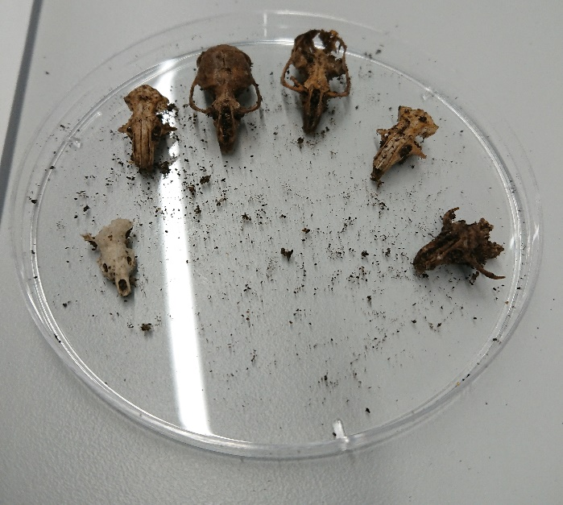
Figure 5: Prey Samples from One Pellet
Figure 6: Further Prey Samples from Dissected Pellet
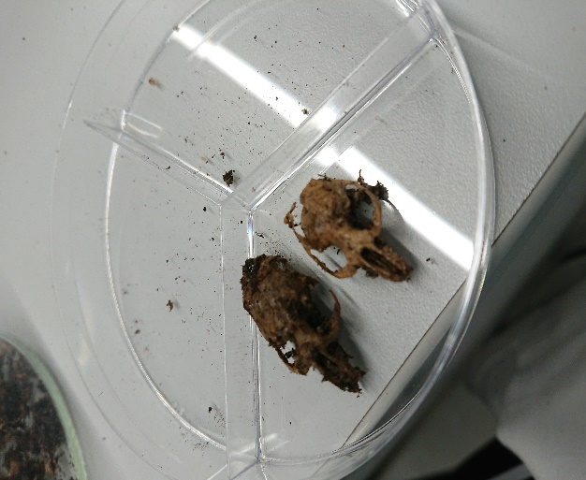
Figures 5 & 6: (Author's Own, 2020)
For small mammals in the area, the Simpson Index (Countryside Info, nd), which calculates biodiversity by taking into account the number species present as well as the abundance of each, scores the biodiversity quite low at 0.3257. However, applying the Simpson Index to barn owl pellet sampling would not provide an adequate measure of the biodiversity of an area as it only accounts for the prey of that species rather than all of the species present and sampled.
There were three several flaws in this study that became apparent quite early on; the samples had not been dried after collection and so the majority had disintegrated from pellet shape. This resulted in most samples being taken by weight of approximately 5g, which often came back with very different results compared to the intact pellets. The tendency to sift for samples that contained high levels of bone matter also can’t be disregarded, especially as only approximately a third of what was provided was analysed; further analysis of the remainder would likely contain lower levels. There is then some level of ambiguity over the accuracy over the figures logged and whether they are over-estimating the prey count. This could have been counteracted by using further methods to measure biodiversity, such as the study by Torre et al (Torre, Arrizabalaga, & Flaqer, 2004) which also utilised trap sampling and genet scats (though understandably an alternative native predator would need to be used for Parc-le-Breos).
The second issue was the nature of how prey was being logged. Individual skulls or jawbones would be marked as independent prey rather than piecing them together to make one full organism. This had a large effect on the figures; where the skull and jawbones fall roughly into three separate pieces, this should have been logged as one individual rather than three. Admittedly piecing samples together would be far more time-consuming than this study allowed, but for more accuracy this is a recommendation should the remainder of the samples be analysed further.
The third main issue was that the samples taken date back a considerable amount of time and aren’t a clear indicator of any current environmental changes that may have occurred. It would have been beneficial to analyse these along with more recent samples to determine whether there have been any fluctuations in population, or what other differences there may have been in the last ten years. It would have also been beneficial to narrow down the samples to times of year to account for seasonal variations. It also wasn’t specified if it was a nest or perch for a solitary owl, a breeding pair, or a site used by multiple owls with overlapping ranges.
There was also evidence of an abundance of moth larvae in the samples, though this wouldn’t have broken down any of the bone matter that was being analysed.
There are other smaller issues with exclusively using owl pellets as an estimate for biodiversity, particularly if you are only interested in a certain area; namely, as the home ranges fluctuate seasonally and naturally overlap with the ranges of other owls, it is difficult to attain an accurate reading of one area without possibly taking samples that cover further afield.

Conclusion
The findings from this study show that whilst owl pellets can be good indicators to the biodiversity of an area, it is not the sole measurement that should be taken as it only accounts for a small portion of the overall habitat and the methodology needs to be stricter for accurate numbers.
However, the data it does provide infers a significant amount towards the overall richness. The field vole, the primary food source of the barn owl, is clearly in abundance in the area. It also confirms that the 2018 study into the distribution of water shrews (The Mammal Society, 2018) is correct to list that they do not commonly inhabit the Gower Peninsula. The abundance of pygmy shrew in samples also provides a strong indicator into the abundance of insects and arthropods, in turn suggesting larger bird numbers in the area (further strengthened by the bird samples found, which whilst low are still uncommon). The harvest mouse numbers are also small enough that it doesn’t appear that any further conservation work to boost their numbers is necessary, and the predation by owls isn’t a strong threat.
Given the weather reports from that period and the increasingly colder winters that have been recorded since, it would be recommended to install further nest and perch spaces across the Parc-le-Breos site to encourage hunting in other areas, hopefully limiting over-hunting in one space and reducing food scarcity.
As areas of the home range are used for anthropogenic purposes, namely leisure activities and agriculture, it would also be recommended to limit the extent of these and promote further growth of rough grassland. Understandably agricultural areas are unlikely to change, though installing perches at the borders of these would encourage natural pest control. Continuing to follow the resource plans for part of the area set out by Natural Resources Wales would be a good start. (Natural Resources Wales, nd)
In conclusion, whilst this did provide a lot of indicators, to get a more accurate measure of the biodiversity in the area, it would be recommended to follow the 3 stage approach used in the study by Torre et al (Torre, Arrizabalaga, & Flaqer, 2004) as it would both minimise the margin for error and provide a wider scope of the species in the habitat.

References
Andrade, A., Menezes, J. F., & Monjeau, A. (2016). Are Owl Pellets Good Estimators of Prey Abundance? Journal of King Saud University - Science.
Author's Own. (2020). Maps: Estimated Home Ranges.
Author's Own. (2020). Photo of Prey Samples from One Pellet.
Countryside Info. (nd). Simpsons Index. Retrieved from Countryside Info: http://www.countrysideinfo.co.uk/simpsons.htm
DEFRA. (2004, 01). Barn Owls and Farms. Retrieved from Department for Environment, Food and Rural Affairs: http://adlib.everysite.co.uk/adlib/defra/content.aspx?id=000HK277ZW.09RB2N45RACV8V
Heisler, L. M., Somers, C. M., & Poulin, R. G. (2016). Owl Pellets: A More Effective Alternative To Conventional Trapping For Broad-Scale Studies Of Small Mammal Communities. British Ecological Society: Methods in Ecology and Evolution, 96-97. Retrieved from British Ecological Society.
JNCC. (2007). UK BAP - Priority Terrestrial Mammals. Retrieved from Joint Nature Conservation Committee: https://hub.jncc.gov.uk/assets/98fb6dab-13ae-470d-884b-7816afce42d4#UKBAP-priority-terrestrial-mammals.pdf
Met Office. (nd). Past UK Weather Events. Retrieved from Met Office: https://www.metoffice.gov.uk/weather/learn-about/past-uk-weather-events
Natural Resources Wales. (nd). Gower and Penllergaer Forest Resource Plans. Retrieved from Natural Resources Wales: https://naturalresourceswales.gov.uk/about-us/what-we-do/welsh-government-woodland-estate/gower-and-penllergaer-forest-resource-plans/?lang=en
RSPB. (nd). Owl Pellets. Retrieved from RSPB: http://ww2.rspb.org.uk/Images/Owlpellets_tcm9-133500.pdf
Swansea Council. (2017, 08 14). Swansea Local Biodiversity Action Plan. Retrieved from Swansea County Council: https://www.swansea.gov.uk/article/10113/Swansea-Local-Biodiversity-Action-Plan
The Barn Owl Trust. (nd). Barn Owl Facts. Retrieved from The Barn Owl Trust: https://www.barnowltrust.org.uk/barn-owl-facts/
The Barn Owl Trust. (nd). Barn Owl Pellet Analysis. Retrieved from The Barn Owl Trust: https://www.barnowltrust.org.uk/barn-owl-facts/barn-owl-pellet-analysis/
The Barn Owl Trust. (nd). Baron Owl Facts: Home Range. Retrieved from The Baron Owl Trust: https://www.barnowltrust.org.uk/barn-owl-facts/barn-owl-home-range/
The Mammal Society. (2018). The Water Shrew. Retrieved from Mammal: https://www.mammal.org.uk/species-hub/full-species-hub/discover-mammals/species-water-shrew/
The Wildlife Trust. (nd). Pygmy Shrew. Retrieved from The Wildlife Trust: https://www.wildlifetrusts.org/wildlife-explorer/mammals/pygmy-shrew
Torre, I., Arrizabalaga, A., & Flaqer, C. (2004). Three Methods for Assessing Richness and Composition of Small Mammal Communities. Oxford Journal of Mammology, 525-526.

