
The Global Business Environment

Assessment 1
Environmental Analysis of the Automobile Industry

Student Name: Nicolae-Alexandru Voinea
Student ID: 2119833
Lecturer: Alfred Mensah
Module code: LCBB4005
Deadline: 06/05/2022

Table of Contents

Introduction 3
The major forces shaping the global business environment 4
Internal environment analysis of Vauxhall Motors 5
The reasons why organisations engage in international trade 10
Assessment of the market for Vauxhall Motors 11
Conclusion 13
References 14

1.Introduction
Businesses are affected largely by its surroundings where it is located and operated business activities. These surrounding factors are considered as business environment. In global context, the culture, economy, language, behaviour, geography, demography, and lifestyle of people of different countries and regions are considered as business environment (Kasemsap, 2018). These environmental factors differ from one country to another and from one region to another. The automobile industry is one of the largest industries in the world economy and lots of multination brands have production facilities and distribution centres all over the world. It becomes very difficult for businesses in this industry to maintain their business activities in different global situations. Through this report, we are going to evaluate the international environment for an automobile manufacturer organization named Vauxhall Motors Limited.
Vauxhall is a British car manufacturer that operates within the UK and its headquarter is located in Chalton, Bedfordshire, England. The company was established in 1857 by Alexander Wilson. The company has two manufacturing facilities with 4029 workers in the UK and itstotal revenue was £3,162.8 million in 2019.

2.The major forces shaping the global business environment
Global business environment is largely affected by the external macro environmental factors within a country where the business operates. Global businesses face different political, social and economic system while beginning any kind of business activities in that country. Moreover, major changes in technology and economy in any country where the business is currently not operating also affect local businesses (Radović-Marković et al., 2019). So, it is very important for car manufacturing businesses like Vauxhall to evaluate the global business environment for making a futuristic business decision and corporate strategy. To evaluate the major forces that shape the global business environment can be identified through the PESTLE analysis of Vauxhall Motors.
2.1PESTLE analysis of Vauxhall
Political forces: Political factors include government policies, political conditions, and laws of a country. The automobile industry is also affected by the government’s decisions on production regulations, exporting and importing vehicles, and environmental and local safety regulations. Due to Brexit, the owner of the company has faced huge in the pound’s value crash. It has made the organization to cut production in European countries and a negative footprint in the organization’s revenue.
Economical forces: Economical factors include the level of disposable income of society, inflation, exchange rate, the tax rate on buying a vehicle, and the overall economic condition of a country (Marques and Diogo, 2021). Different automobile manufacturers have production facilities in different countries, but they sell the products in different countries where they have to assess the tax rate and foreign exchange rate while determining the price of their vehicle. For example, insufficient liquidity has become a major problem for Vauxhall in recent years because of high inflation and interest rate. If Vauxhall tries to establish a new production facility in other nations, it needs to evaluate the average salary, transpiration cost, and economic condition of that nation.
Social forces: The automobile industry must consider the taste, fashion, trends, and other cultural factors while operating globally. Social forces influence businesses to change the design, features, and name of a new car while launching in different nations. Vauxhall identifies the social taste and preferences for designing their car models and making good sales.
Technological forces: Technological factors are the main influencer in the automobile industry among the other environmental forces. Automobile industry implements and introduces new technologies in vehicles and their production facilities day by day. For example, the mass production of electronic vehicles is challenging the old combustion engine vehicles in the market. All the large and small automobile brands are participating in the race with Tesla to create more effective efficient production processes and vehicles to grab market share (Radović-Marković et al., 2019). Vauxhall introduces new technology in its new models and invests in innovation for its own EV model.
Legal forces: The laws and regulations of a country and the UN are the legal factors to consider in the automobile industry. The laws and regulations for automobile businesses in the UK are requires abiding by all automobile businesses including Vauxhall Motors. Vauxhall also needs to abide by the environmental laws, labour laws, and employment laws for avoiding any legal threat from the government. Moreover, it may face legal proceedings if they use any faulty parts in its vehicles.
Environmental forces: Vehicle causes greenhouse emissions by burning fissile fuels and affects the environment negatively throughout their lifecycle (Ha and Woo, 2022). Many countries in the world as well as the UK are concerned about the carbon footprint of the automobile industry. Countries and NGOs are also encouraging people to avoid buying personal vehicles and use public transportation. It may affect negatively the sale of vehicles throughout the world. However, businesses are also introducing new technology for developing fuel-efficient cars and electric vehicles. Businesses are also concerned about eliminating the carbon footprint throughout the life of a vehicle.

3.Internal environment analysis of Vauxhall Motors
Internal environment analysis of a business organization helps the business to understand its strengths and weaknesses and allocate resources effectively and efficiently. It helps businesses to establish a corporate and business strategy that is required for the expansion of the organization. Value network, Porter’s five forces, and porter’s diamond model is used for evaluating the internal environment of Vauxhall Motors.
SWOT Analysis of Vauxhall: The analysis will identify the strengths, weaknesses. Opportunities, and threat of the organization.
Strengths | Opportunities
- Strong branding.  - Available investment.  - Skill labour force. | - Opportunity in increasing market share in developing countries.  - Increasing demand for hybrid vehicle.
Weaknesses | Threats
- Decreased of liquidity.  - Decrease in net profit.  - Decrease in market share. | - Economic downturn due to the pandemic.  - Increased fuel price in Europe will increase product cost.  - Continuous innovation of new technologies.
Table 1 SWOT Analysis of Vauxhall Motors (Source; self-made)
Value chain analysis: the value network process of a business organization refers to the interaction between individuals and corporations for benefiting the whole organization (Ghauri et al., 2021). Vauxhall must maintain an integrated value network that includes values in every step from collecting the raw materials to the delivery of the product to the final users.
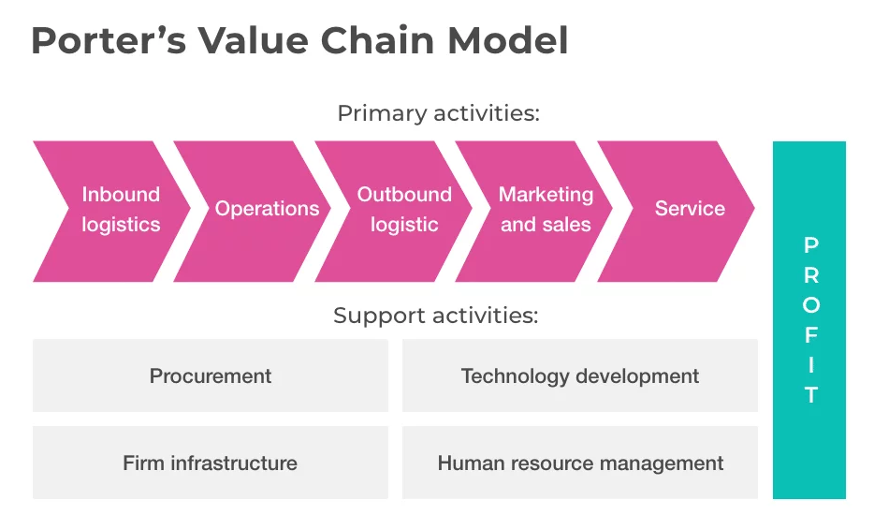
Figure 1 Porter’s Value Chain Model (Sathasivam et al., 2021)
3.1 Primary Activities
Inbound logistics: the management of raw materials and other resources from outside organization which will be used in production and operation activities are the inbound logistics. Vauxhall produces lots of vehicle parts in the UK to reduce transportation and inventory cost.
Operations: The process of transforming the raw materials and other resources into the final goods is called the operation of a business organization. Vauxhall collects different parts from different organizations all over the world and uses them in its manufacturing plants for producing final products.
Outbound logistics: The supply of goods and services to the final users is called outbound logistics (Dinçer and Yüksel, 2018). Vauxhall uses different transportation for delivering its final products in different showrooms throughout the country.
Marketing and sales: The promotional activities and making customers aware of the brand are the marketing activities of Vauxhall. It helps the organization to increase sales to earn revenue.
Service: Vauxhall provides spare parts and technical support to the operators of its vehicles. These are the after-sale services from Vauxhall.
3.2 Support Activities
Procurement: The activities to find suppliers for the business and manage the relationship with them for maintaining production are the procurement activities (Yang and Zentefis, 2022). Vauxhall has different suppliers from china to minimise its production cost.
Technology development: It involves the investments in research and development of new features, new business process and implementing IT and computer technology in the business process for reducing cost and increasing income.
Firm infrastructure: the management of different legal authorities, government agencies, investors, and organizational departments refer to the organizational infrastructure. The functional structure method is used in designing the organizational structure of Vauxhall.
Human resource management: The management of an organization’s most important human resources with proper remuneration and training is the human resource management of Vauxhall (Liang and Fu, 2021). Vauxhall has developed integrated training sessions to motivate and develop their 1944 employees.

Porter’s Diamond Model
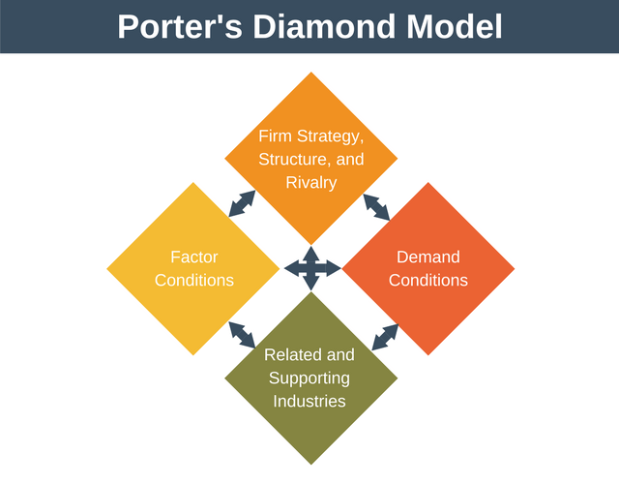
Figure 2 Porter's Diamond Model (Deng, 2021)
Factor conditions: The availability of different resources within a nation is considered as the factor condition of that nation. Advance factors like skilled workforce, available capital, specialist in automobile industry can bring competitive advantage for Vauxhall. But basic factors such as natural resources and unskilled labour cannot create any competitive advantage for the organization.
Demand conditions: It refers to the level of demand for the goods and services in a particular country or region. The demand for UK made vehicles has dropped in 2020 significantly over 30 percent from previous year. Total demand for cars in 2020 was 941,000 units.
Related and supporting industries: The well establishment of related and supporting industry could bring financial and marketing success to a business organization (Hacioglu, 2019). Vauxhall uses its supporting and related industry for cutting production costs and increasing revenue.
Firm strategy, structure, and rivalry: The organizational strategy and structure have a great impact on how an organization is going to operate and meet its goals and objectives. Moreover, high competition in the market drives organizations for innovation and research.

Porter’s five forces
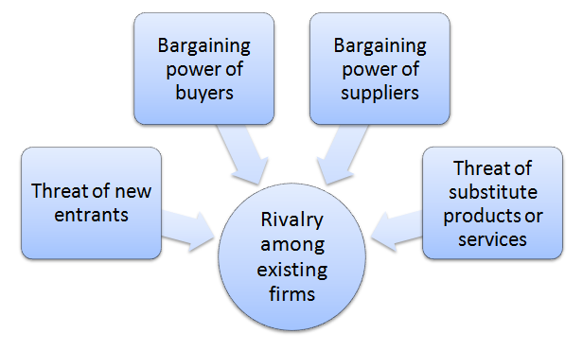
Figure 3 Porter's Five Forces (Tomori, 2021)
Threat of new entrants: Threat of new entrants is high for Vauxhall as there are lots of new brands are developing for manufacturing electronic vehicles (Kasemsap, 2018).
Bargaining power of buyers: The bargaining power of buyers is also high due to the existence of lots of brands in the market.
Bargaining power of suppliers: Bargaining power of suppliers is medium because there are some specific buyers for their products.
Threat of substitutes: Since there are lots of automobile brands existing in the country and increasing sales of EVs, the threat of substitutes is high for Vauxhall.
Rivalry among firms: Rivalry among automobile manufacturers has increased in recent decades. Vauxhall is introducing new features and marketing strategies to compete in the market.

4. The reasons why organisations engage in international trade
International market introduces new opportunities as well threats for business organizations (Radović-Marković et al., 2019). For the automobile industry, going international introduces a new market and access to local natural and human resources.
4.1 Reduce dependence on the local market: The international market is huge, and it reduces the dependence of a local business on its local market. Vauxhall could reduce its dependency on the UK market by selling its product abroad.
4.2 Increase productivity: The international market has a high demand for goods and services. So, organizations need to go mass production of goods and services and maximize their production level (Tomori, 2021). Vauxhall can efficiently use its production facilities and increase the profit margin.
4.3 Increase Efficiency: International environment helps businesses to acquire and retain global talents so that businesses can effectively and efficiently use their resources. A skilled workforce helps Vauxhall to reduce the wastage of resources and increase productivity.
4.4 Access to new talent: Organizations can hire the best talents from foreign countries and understand their capabilities and working styles. It helps the automobile industry to motivate innovation and gain a competitive advantage. New talents can reduce Vauxhall’s dependence on traditional vehicle manufacturing and introduce a new process for EVs.
4.5 Access to new technology: Technology is the main factor that brings a competitive advantage to automobile manufacturers. Through internationalization, organizations can identify new technology in different countries and implement those technologies for gaining a competitive advantage (Liang and Fu, 2021).
4.6 Growth: International trade opens a huge marketplace for organizations to compete. It increases the breadth of the organization’s target market and increases brand popularity. Huge marketplace results in increasing sales and continuous growth of the organization.
4.7 Increase chances of success: Internationalization increases the chances of the success of an organization through innovation, technology, market share, and increasing the experience of its employees. As international trade opens new opportunities, proper corporate and business strategies will make an organization sustainable.

5. Assessment of the market for Vauxhall Motors

5.1 Understanding their micro-economic and macroeconomic foundations
Microeconomic factors include customers, employees, competitors, media, shareholders, and suppliers and macroeconomic factors include economic growth rates, interest rates, unemployment, international trade, and inflation. These factors affect almost every business organization in the world.
The microeconomic foundation for Vauxhall is strong due to the availability of employees, organized distribution channels, permanent and temporary suppliers, huge investments, and a high level of competition (Ha and Woo, 2022). Macroeconomic foundation affects Vauxhall in international trade, interest rate, and inflation. The company was also affected by the slow economic growth rate in recent years due to the COVID-19 pandemic.
5.2 Market structures and their influence on firm strategy
Market structures are the differences between different industries according to their level of competition in the market. The competition in any market structure is determined by the availability of total buyers and sellers in that market (Ghauri et al., 2021). There are four types of marketsthat existed in today’s world. These are perfect competition, monopolistic competition, oligopoly, and monopoly.
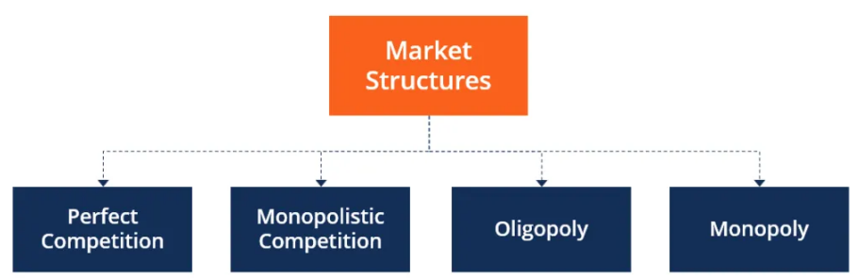
Figure 4 Different market structures (Radović-Marković et al., 2019).
Automobile industry is a perfect competition market where many buyers and sellers are concentrated on same product with different features and design (Yang and Zentefis, 2022). Vauxhall must invest in innovation and research project to gain competitive advantage in this market.

5.3 Major features of the current international economy
The international economy is full of threats and opportunities for business organizations around the world. The innovation of computers, globalization and internet technology has shaped the world economy with mass production and effective and efficient transportation (Deng, 2021). Here are some features of the current international market:
- Current international economy is providing numerous options to the organizations for production.
- It is providing information to the automobile industry to identify new markets.
- It is providing an efficient and effective communication system to the industry.
- It is eliminating the cultural barriers between the two countries.
- It is providing a level playing field to the organizations.

6. Conclusion
The complexity in global environment is a hard for organizations to understand and critical for organizational success. Worldwide innovation of new technology and processes is making the global environment much competitive than ever (Kasemsap, 2018). Organizations have to use effective tools and technologies for assessing the global environment. Proper understanding of different culture and the expectations of people from a particular society are essential for the sustainability of an organization. The report has focused on identifying the forces of global change, internal and external environmental analysis tools, reason behind international trade, and a framework for assessing international market.

References
Deng, Y., 2021. Agglomeration of technology innovation network of new energy automobile industry based on IoT and artificial intelligence. Journal of Ambient Intelligence and Humanized Computing, pp.1-17.
Dinçer, H. and Yüksel, S. eds., 2018. Handbook of research on managerial thinking in global business economics. IGI Global.
Ghauri, P., Strange, R. and Cooke, F.L., 2021. Research on international business: The new realities. International Business Review, 30(2), p.101794.
Ha, Y.K. and Woo, S.H., 2022. Transportation Infrastructure or Economic Power? Development of the Automobile Industry in the United States. Sustainability, 14(3), p.1649.
Hacioglu, U. ed., 2019. Digital Business Strategies in Blockchain Ecosystems: Transformational Design and Future of Global Business. Springer Nature.
Kasemsap, K., 2018. Mastering business process management and business intelligence in global business. In Global Business Expansion: Concepts, Methodologies, Tools, and Applications (pp. 76-96). IGI Global.
Liang, X. and Fu, J., 2021. Environmental improvement or industry enhancement? A case study on the impact of environmental regulations on Chinese automobile industry. Regional Sustainability, 2(3), pp.256-263.
Marques, J.P.C. and Diogo, S.V., 2021. Sources and Types of Innovation-A Case in the Automobile Industry. In ISPIM Conference Proceedings (pp. 1-16). The International Society for Professional Innovation Management (ISPIM).
Radović-Marković, M., Salamzadeh, A. and Vujičić, S., 2019. Selection of organization models and creation of competences of the employed people for the sake of competitiveness growth in global business environment. International Review, (1-2), pp.64-71.
Sathasivam, K., Hashim, R.C. and Bakar, R.A., 2021. Automobile industry managers' views on their roles in environmental sustainability: a qualitative study. Management of Environmental Quality: An International Journal.
Tomori, F., 2021. Environmental Policies in International Markets (Doctoral dissertation, UniversitatRoviraiVirgili).
Yang, K.H. and Zentefis, A.K., 2022. Efficient Market Structures Under Incomplete Information.

