
Investigation into Resonant Circuits
Electrical & Electronic Principles ACDA4006 ACDB4002

University of Wales Trinity St Davids
James Holliman 1901805

Abstract
This report describes an A.C. series and one A.C. parallel circuit design, which each contain a sine generator, a resistor, a capacitor, and an inductor. These circuits were created using the Proteus software. By inputting values of frequency between 100Hz and 20kHz, output was calculated and plotted for each circuit. The resulting current and frequency data were exported out of Proteus and imported into Excel software to generate several graphs to calculate the resonant frequency and Q factor. To ensure the data was unique, my student number was used to generate the values for the Resistor (19Ω), Capacitor (01µF), and Inductor (508mH). The resonant frequency was found to be 178Hz for both circuit, whilst the Q factor was found to be 1.78 for series and 1.49 for parallel. The resonant frequency value was compared with the theoretical value (177.39Hz) and found to be in good agreement. Using this data, the impedance was calculated for both the series and parallel circuits. The current and voltage magnitude and phase were calculated using these four bits of data against frequency to generate four graphs.
Introduction
Circuits are given this name because, according to Khan Academy (2021), the concept of the power source, signal sources, and real components all connecting, so the current flows in a circle.
Both circuits used in this experiment are open circuits meaning that they are not connected in a circle; one circuit is a series circuit, and the other a parallel circuit.
This experiment aims to prove the alternating Current (A.C.) theory for series and parallel circuits using a frequency graph, A.C. theory, and Q factor theory.
A.C. theory is different from D.C. theory because A.C. theory, according to OpenStax. (2020) uses inductive and capacitive reactance instead of inductive and capacitive resistance to calculate Current and frequency.
According to Hamidah et al. (2019), the Q factor or quality factor means that the higher the Q factor is, the lower the energy loss rate. Q factor is a dimensionless entity that relates to the efficiency of the circuit.
Simulation setups
The experiment was set up using the Proteus software for each circuit.
For both circuits, the units of measurement were 19Ω for the Resistor, 1µF for the capacitor and 508mH for the inductor.
To create the series circuit:
- A sine generator was placed on the grid in the Proteus software.
- A capacitor, inductor, and Resistor were placed on the grid and connected as shown in Figure 1.
- A current meter was placed on the net between the Resistor and inductor, as shown in Figure 2.
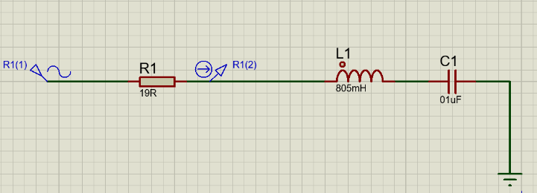
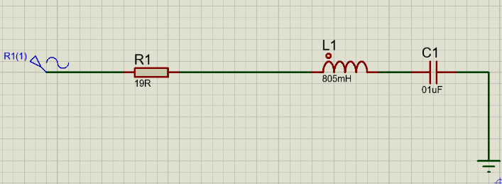
- A frequency graph was generated using the current meter.
Figure 2: Series circuit with current probe attached
Figure 1: Series circuit connected
To create a parallel circuit:
- A sine generator, Resistor, capacitor and inductor were placed on the Proteus grid, as shown in Figure 3.
- A current meter was placed on the net between the Resistor and the inductor/capacitor.
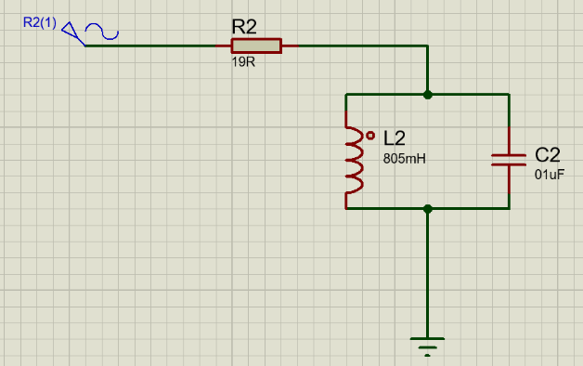
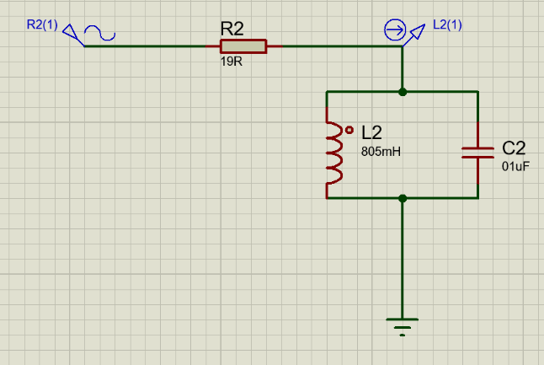
- A frequency graph was generated using the current meter.
Figure 4: Parallel circuit with Current probe attached
Figure 3: Parallel circuit connected
Results
Figure 5 shows the graph of V_{c}+V_{L} (V_{c} being the capacitor voltage and V_{L} being the inductor voltage) against frequency for the series circuit.
This graph is interesting as, looking from low to high frequency, it drops rapidly at low frequency before rising again and levelling off at a higher voltage than the start point.

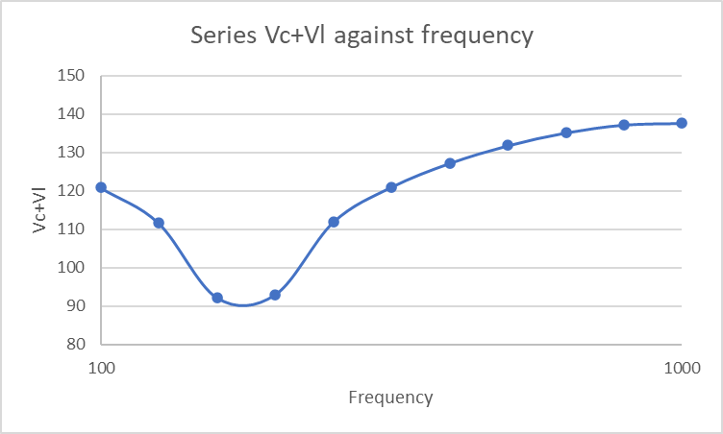
Figure 5: Graph of series Vc+Vl (volts) against frequency (Hz)

Figure 6 shows the graph of V_{c}+V_{L} against frequency for a parallel circuit. An interesting thing about this graph is that it shows an opposite pattern to the series circuit. So, looking from low to high frequency, the voltage immediately rises at low frequency and then drops to below the start voltage at higher frequency.

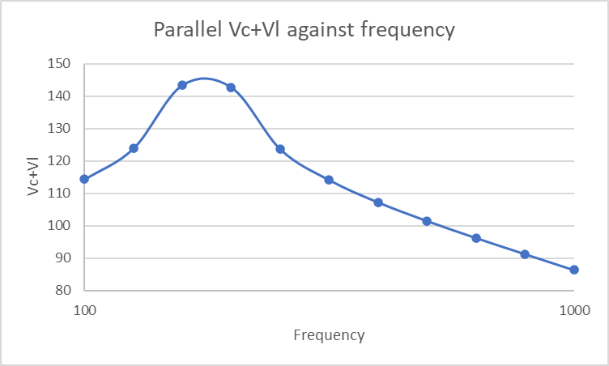
Figure 6: Parallel graph of Vc+Vl (volts) against frequency (Hz)

Figure 7 shows the graph of Current against frequency. The data in the graph shows both the current magnitude (I_{mag}) in blue and the current phase (I_{phase}) in orange for the series circuit. The Current is measured in amps (A)

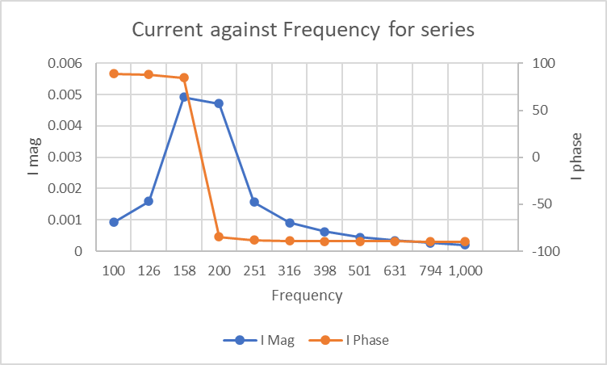
Figure 7: Series graph of Current (amps) against Frequency (Hz)

Figure 8 shows the graph of voltage output against frequency, showing both the voltage magnitude (V_{mag}) in blue and the voltage phase (V_{phase}) in orange for the series circuit. The V_{out} is measured in volts (V)
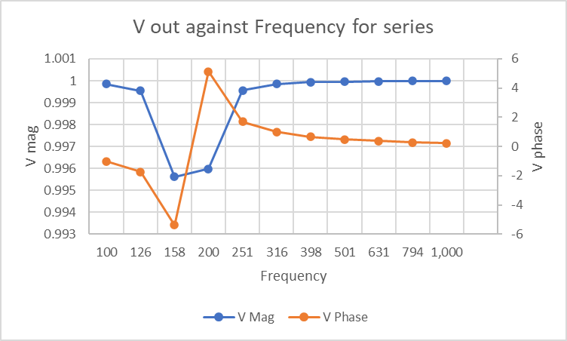
Figure 8: Series graph of voltage output (volts) against Frequency (Hz)

Figure 9 shows the graph of Current against frequency for the parallel circuit showing the current magnitude (I_{mag}) in blue and the current phase (I_{phase}) in orange. Both of these are measured in amps (A).
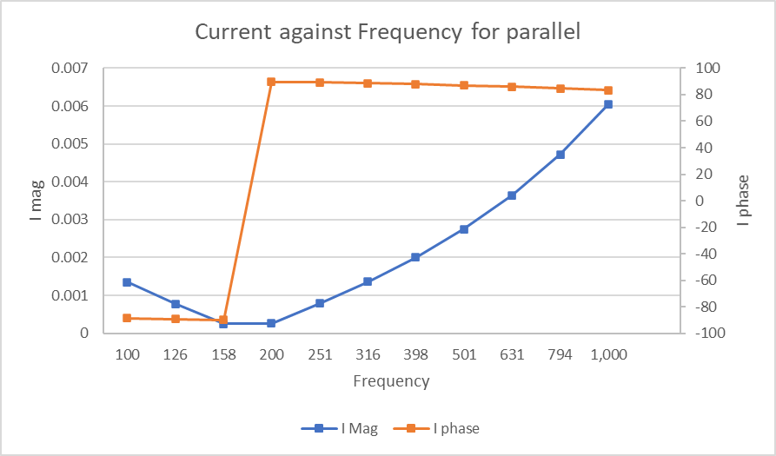
Figure 9: Parallel graph of Current (amps) against Frequency (Hz)

Figure 10 shows the graph of voltage output against frequency for the parallel circuit showing the voltage magnitude (V_{mag}) in blue and the voltage phase (V _{phase}) in orange. Both of these are measured in volts (V)
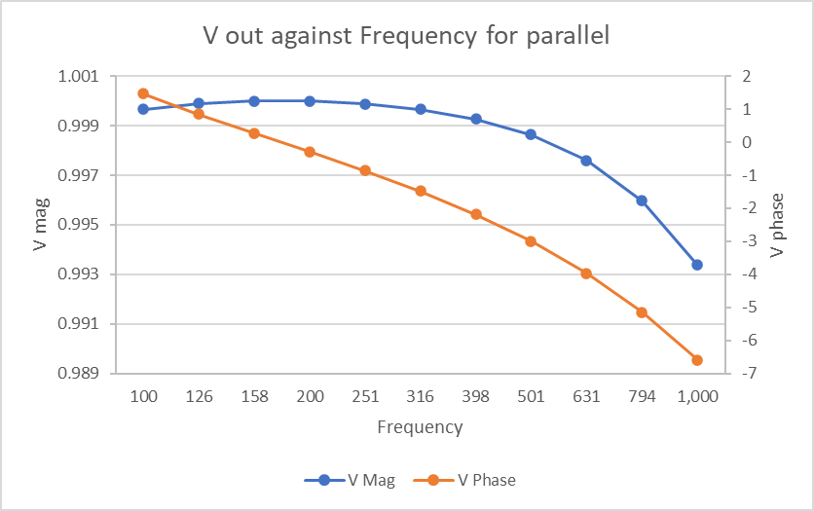
Figure 10: Parallel graph of Voltage output (volts) against Frequency (Hz)

Comparison of tables:
The data from the experiment shown in these two graphs show some similarities and differences between the series graph (Figure 5) and parallel graphs (Figure 6).
An interesting similarity and difference between these two graphs is that they mirror each other at 115Hz, so they have the same journey but the opposite way, so the series falls in voltage before rising in the same time, it takes the parallel rises in voltage before falling.

Figures 9 and 7 are similar in that the I_{phase} mirrors between the graphs but differs in values as Figure 9 starts at roughly 0.0005V and finishes at roughly 0.0065V, while Figure 7 does the opposite. Another difference in that the I_{mag} of both graphs are vastly different, with the series rising and falling and the parallel circuit showing an initial decrease and then a curved increase.
Figures 10 and 9 are similar in that the V_{mag} mirrors in shape as the two lines both Figure 9 dips before rising and Figure 10 rises before dropping but the values of the graphs. The graphs also differ in that the V_{phase} have very different paths
Figures 7 and 8 are similar in that the style is similar but the opposite way round but with very different values, with Figure 8 starting at 1 V and only dropping to just below 0.996 V while Figure 7 starts at 0.001V and ends at just below 0.005 V, showing that the two lines have similar distance between points.

Discussion
Figure 5 and 6 show the results from the experiment used to calculate the resonant frequency and the quality factor. Before generating the graph, the voltage had to be calculated for the inductor and capacitor from the current using the equations that Learn about Electronics (2021) states are based on Ohm’s law with $Vc=I*Xc$ for capacitor voltage with I being the current and Xc being the capacitor value and $Vl=I*Xl$ with Xl being the inductor value.
According to Bhatia (2012), in order to calculate V_{c} and V_{L}, the inductor and capacitor values have to be calculated using the formulas $Xl=2πfL$ with f being frequency measured in hertz (Hz) and L the inductance measured in miliHenrys (mH) and $Xc=\frac{1}{2πfC}$with C being the capacitance measured in microFarads (µF).
The resonant frequency (f_{r}), according to Kuphaldt (2020), is the tipping point of the curve. It can also be calculated from theory using the equation $f_{r}=\frac{1}{2π√LC}$ where L is the inductance and C is the capacitance. In this experiment, the value of L used was 805 milliHenrys (mH), and the value of the capacitance C was 1.0 microFarads (µF). From these values, the theoretical resonant frequency has been calculated as 177.39 hertz (Hz). This result can be compared with Figure 5 and 6, where the data show a value of 178 Hz. This means that the graph is accurate when compared with the theoretical value.
According to Kuphaldt (2021), the theoretical Q factor can be calculated using the bandwidth (B.W.), which is measured in hertz. The bandwidth is calculated using the formula $BW=Hf-Lf$, with L.F. being the lower frequency (Hz) and H.F. being the higher frequency (Hz), with these values measured at 70.7% of the peak height. From the data found in this experiment, the resonant frequency value can be calculated as 114 Hz for the series graph and 125 Hz for parallel, as shown in Figures 11 and 12. Using these values, the higher and lower frequencies can be found, with L.F. being 133 Hz and H.F. having a value of 236 Hz (shown in Figure 11) for the series graph and L.F.= 128 Hz and H.F.= 246Hz for the parallel graph (shown in Figure 12). These results enable the bandwidth to be calculated as 118 Hz for series and 103Hz for parallel.
Using the bandwidth and the resonant frequency, the Q factor can be calculated for both circuits. According to Kuphaldt (2021) and Electronicnotes (2021), by using the equation $Q=\frac{F_{r}}{B.W.}$ the Q factor can be calculated as Q = 1.78 for series and Q= 1.49 for parallel. An interesting fact about the Q factor is that the higher it is, the better the results, so for the results to be small suggests there is energy lost from these circuits during the experiment.
Using X_{c} and X_{L}, the impedance of the two circuits can be calculated, and this is done in different ways. The series circuit impedance is calculated using the formula $Z=R+j\left(X_{L}-X_{C}\right)$ where R is the resistor value (19 ohms), but the parallel requires an extra step before the total impedance can be calculated. For the parallel circuit, first, a value for ZLC is calculated using the equation $ZLC=\frac{jX_{L}×-jX_{C}}{jX_{L}-jX_{C}}$ and then with this, the total impedance can be found with the following formula $Z=R+ZCL$.
Using the impedance and the initial voltage, the Current can then be calculated for both circuits using the equation $I=\frac{V}{Z}$ . In this report, where Excel software has been used to calculate the results, then the IMABS function was used to find the absolute value of current magnitude (I_{mag}). Using the current (I) and the Excel function IMARGUMENT within a DEGREES function, it is possible to calculate the current phase (I_{phase}). Both the I_{phase} and I_{mag} are shown in Figures 7 and 9.
The voltage output was calculated next using the formula $V_{out}=V_{in}\frac{j\left(X_{L}-X_{C}\right)}{R+j\left(X_{L}-X_{C}\right)}$ for both circuits. Then the IMABS function was used to calculate the absolute value of voltage magnitude (V_{mag}). Using the voltage output (V_{out}) and the IMARGUMENT function, the radian of the voltage output then used the DEGREES function to get the voltage phase (V_{phase}). Both of these are shown in Figures 8 and 10.

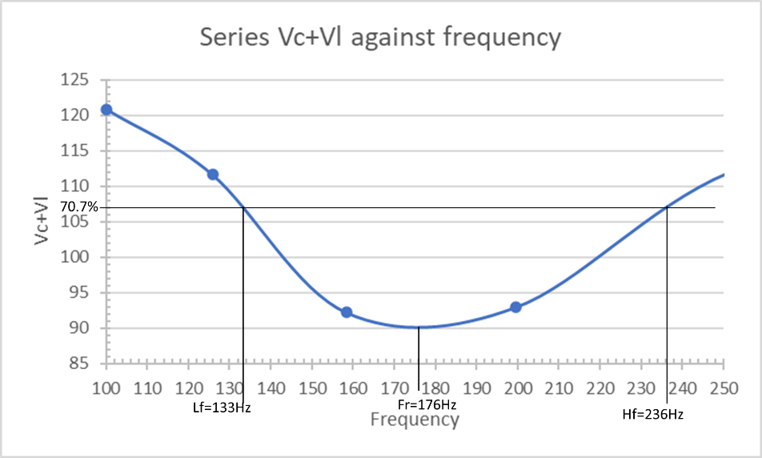
Figure 11: section of Figure 5 between 100 Hz and 250Hz
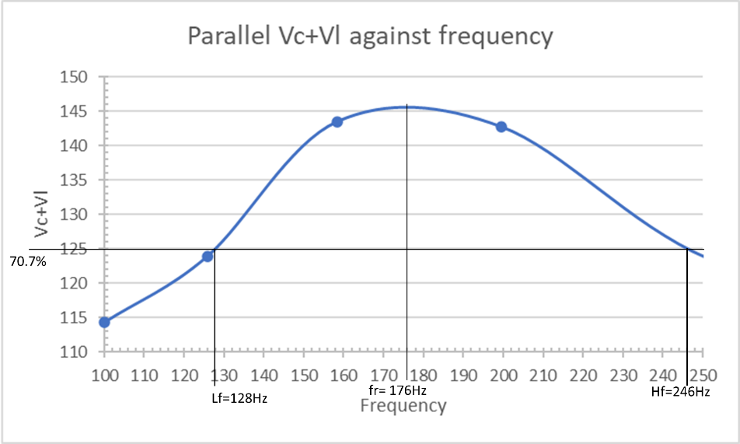
Figure 12: Section of Figure 6 between 100 Hz and 250Hz
Conclusions
In conclusion, the report aimed to prove A.C. theory using resonant frequency and Q factor. Using the data to generate a graph for series and one for parallel (Figure 5 and 6) and then comparing them with basic theory to see that there is minimal difference between them, the Q factor was low, so there was energy lost. However, despite this, the graph is proved to be accurate. The impedance was then calculated to find the magnitude and phase for both current and voltage output to show the effect of reactance.

References
Bhatia, A (2012) 'Reactance and Impedance', in Bhatia, A (ed.) Electrical Fundamentals. Fairfax: PDH Online, PDH Center, pp. 4:1-4:40.
Electronicnotes (2021) Quality Factor / Q Factor; formulas and equations, Available at: www.electronics-notes.com/articles/basic_concepts/q-quality-factor/basics-tutorial-formula.php (Accessed: 8th April 2021).
ElectronicsTutorials (2021) Parallel Resonance Circuit, Available at: www.electronics-tutorials.ws/accircuits/parallel-resonance.html (Accessed: 12th April 2021).
Hamidah, I et al. (2019) 'AC Circuits', Journal of Engineering Science and Technology, 14(1), pp. 489 - 497 [Online]. Available at: www.researchgate.net/profile/Ida-Hamidah/publication/331546233_Q_factor_simulation_on_voltage_stabilizer_with_rlc_circuits/links/5f079b9792851c52d62524a1/Q-factor-simulation-on-voltage-stabilizer-with-rlc-circuits.pdf (Accessed: 14th April 2021).
Learn about Electronics (2021) Learnabout Electronics - AC Theory, Available at: learnabout-electronics.org/Downloads/ac_formula_finder.pdf (Accessed: 15th April 2021).
Khan Academy (2021) Circuit terminology, Available at: www.khanacademy.org/science/electrical-engineering/ee-circuit-analysis-topic/circuit-elements/a/ee-circuit-terminology (Accessed: 10th April 2021).
Kuphaldt, T (2021) RESONANCE, Available at: www.ibiblio.org/kuphaldt/electricCircuits/AC/AC_6.html (Accessed: 13th April 2021).
Kuphaldt, T. and Crunkilton, D. (2011) Vol. II - Alternating Current (AC). [Online]. Available at: www.allaboutcircuits.com/textbook/alternating-current/chpt-15/vol-ii-credits/ (Accessed: 10th April 2021).
Openstax (2021) College Physics (OpenStax). [Online]. Available at: www.allaboutcircuits.com/textbook/alternating-current/chpt-15/vol-ii-credits/ (Accessed: 11th April 2021).

