SJIE5004
Celebrating Language and Culture – Belonging to Wales

The History of Castel Coch
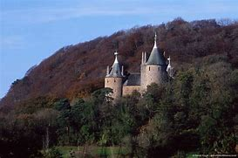
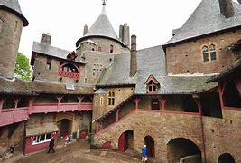
https://travelwithlittleone.com/wpcontent/uploads/2018/03/castell-coch.jpg

https://51h2lc4n573ga5bh382hhw1s-wpengine.netdna-ssl.com/wp-content/uploads/2014/08/Castell_Coch_4629.jpg
Contents Page
Page
Introduction 3
Literacy 4
Art 5
Information Technology 5
Educational Visit 6
Numeracy 6
Cookery 6 -7
Evaluation 7
Appendix 8 - 14
Reference List 15

Introduction
In this portfolio I will be talking about different lessons and activities that work alongside the welsh culture within my setting which I will refer to as setting A. The Main Objective is Castel Coch as there are many small activities that link into this activity. The Activities I will be focusing on are Literacy, Numeracy, Art, Information Technology, Cookery and an Educational Visit to the Castle. Each activity I will be splitting the pupils into groups to look at the smaller activities. Before we start the activities I will be showing the pupils as a whole group a PowerPoint about a castle (See Appendix 1). The School setting in which I work has its Adored Cymric Policy which states that “We believe that all pupils have a right to access the curriculum that is meaningful and appropriate to their individual needs whilst not compromising their entitlement, We also believe that lessons should motivate and engage our pupils”.(Setting A Adored Policy). The reason that one picked activities that were to do with a Welsh Castle was they are fun, meaningful and can be tailored to the needs and abilities of the pupils with in one’s class setting. Setting A’s welsh policy also states that “We believe that all children should be presented with the opportunity to learn and enjoy the language of welsh. This is achieved primarily through incidental approach and through welsh lesson content. (Setting a Welsh policy 2019)”. “A perspective of that kind and a social model of language development may have implications for how teachers think about their pupils’ abilities. (Bourne 2005) criticized school language policies in which: Speaking and listening are most often presented as individualised skills or competences”. (Bourne 2005:3) “At worst there is the risk that low expectations are set for some children who are learning EAL (Early Learning Goals) because their language needs are mistaken for learning difficulties in the sense in which that term has been used for SEN” ( Special Educational Needs) (Cline & Shamsi 2000). At the end of each session I will call the pupils back as a whole group to give verbal feedback from myself and also peer feedback which covers the assessment of learning. Dylan Wiliam suggests that “formative assessment is far more effective as a diagnostic tool, allowing for difficulties to be seen and addressed prior to summative assessments being carried out. The assessment reform group (ARG) (1999), of which Dylan Wiliam was a part, set out five (5) elements for assessment to improve learning in the follow – up publication assessment for learning: these being:
- The provision of effective feedback to students.
- The active involvement of students in their own learning.
- The adjustment of teaching to take into account the results of assessment
- The recognition of the profound influence assessment has on the motivation and self - esteem of students, both of which are critical influences on learning.
- The need for students to assess themselves and understand how to improve.
All the activities the pupils will be doing are all cross curricular.

During our literacy lesson we will be looking and talking about different areas of wales that you think will have a big impact on the welsh language and heritage.
Our focus will be looking at Castel Coch.
I will be talking to the pupils about the history about the castle and when it was built and who by and why it was given its name that it has.
“Castel Coch was built in the 13th Century by a welsh lord: It replaced a fort once occupied by welsh chieftan, Ifor Bach”. (Walesonline.co.uk)
“Castel Coch is the Castle’s welsh name which translates in English as red castle. The name came from the sandstone in which is located in the area and which is built. The castle is located near a village of Tongwynlais just outside Cardiff. The castle was built by John Crichton – Stuart and William Burgess in the 11th – 13th century and then rebuilt in 1875 – 1891”. (Walesonline.co.uk)
We will now look at the PowerPoint of a castle, once we have gone through the PowerPoint you will be put into four (4) groups of three (3).
Once in your groups you will firstly look at sequencing cards in order of when you think the castle was first built until the present day.
The first group will be working on an acrostic poem about the castle,
You will think of a word that starts with each letter of what you think best describes the castle. See appendix 2
group two (2) will be playing bingo about parts of a castle,
you will each have a bingo board with different words of parts of the castle, one of you will have the bingo caller and whoever completes their board first is the winner. See appendix 3
group three (3) will be labelling a castle worksheet
You will each have a worksheet and you fill in the gaps to label the parts of the castle. See appendix 4
group four (4) will be doing a wordsearch to do with castles.
You will each be given a word search and you will have to find the words in the grid from the list. See appendix 5
Once everyone has finished their activities we will come back together as a full group and tell everyone in turn what you have been doing in our groups and we will each in turn say what we thought of that persons work.

During our art session today, you will be split into four (4) groups of three (3) each group will be doing a different activity.
Group one (1) will be designing a castle on A3 paper and decorating it the way you think it would look and using what textures and colours you think that they are made of.
See appendix 6
You will need to go to the art cupboard and get the materials you think you will need for you activity and take them back to your table.
Group two (2) will be colouring in different styles of castles using chalk, crayons, felts or paint. See appendix 7
You will also need to go to the art cupboard and get what materials you need for your activity.
Group three (3) will be building a castle out of junk like Cardboard tubes, bits of cardboard, lollypop sticks, tissue paper etc See appendix 8
You will also need to go to the art cupboard and get what materials you need for your activity.
Group four (4) will be designing a castle out of clay using different cutters, stamps and shapes.
At the end of the session we will all come back together as a big group and show the group what we have been doing and talk through why you chose the design you did and what materials you used. There will also be peer feedback on how you think the design looks. Pupils will see if they can say the colours in welsh as well as English.

For our Information Technology (I.T) session you will work in pairs to look at different designs and the different sorts of castles. You will then compare the styles, designs and different types of castle to see if they do have any similarities. You will save some pictures to refer to and type a paragraph about what you found out about each castle and how the people might have lived and the type of food they might have eaten. As an extension activity you will look at a menu from a castle and then design your own menu and invitation to a castle party. See appendix 9
At the end of the session we will come back together as a whole group and tell each other what you found out about the castles and show you menu and invitation design we will then have a vote on which menu to use and which invitation to send out to the other classes and also to parents to come to our castle party.
This session also ties in with the art session of designing a menu and invitation.

During our visit to Castel Coch we will be looking at the style, design, age and colour of the castle. You will do brick rubbings of the outside walls.
When inside we will be looking at all the rooms and taking photos of the different décor in each room and seeing if any of the rooms have any similarities.
When looking at the kitchen we need to be looking at the style of kitchen that the people would be working in and compare it to our modern kitchens. We will look at a menu of what the food would be like daily and a party menu. When we get back to school, we will be designing our own castle party menu, invitations and decorations. We will look at what decorations they would have while we walk around as to what the family would have as decorations. Staff member: - A question would there be basic decorations or very glitzy very expensive decorations? Pupils: - Glitzy, expensive decorations. You will also need to take some photos of the decorations on your ipads to look at when we get back to school. This activity ties in with the IT session as pupils are taking pictures of the castle decorations.

Our Numeracy lesson today will be counting objects up to 20. We will go in to three (3) groups.
Group one (1) will be doing a worksheet counting castle objects up to the value of 5 see appendix 10
Pupils will be able to add the objects to the value of 5 independently and reliably
Group two (2) will be doing a worksheet adding castle objects up to the value of 10 See appendix 11
Pupils will be able to add the objects to the value of 10 independently and reliably
Group three (3) will be doing a worksheet adding and subtracting castle objects to the value of 20. See appendix 12
Pupils will be able to add and subtract the objects to the value of 20 independently and reliably. Pupils will also be counting in welsh as well as English

In our cookery session today, we will be looking at two (2) recipes they are welsh cakes and Bara Brith. We will firstly look at each recipe as a group and talk about the ingredients and what the pupils think makes them welsh.
I will now put you into two (2) groups of Six (6)
Group one will be making the welsh cakes, you will need to look at what ingredients and equipment you will need to make your welsh cake and collect them from the cupboard and take them back to your table.
You will then take it in turns to weigh out the ingredients and mix them together by following your recipe and the instructions. You will help each other to make sure you have the correct amounts so the mixture is not too runny or too thick. Staff will then help you to cook the welsh cakes as the cooker is very hot and dangerous for pupils to be near.
Group two (2) will be making the Bara brith, you will also need to look at what Ingredients and equipment you need and collect them from the cupboard and take them back to your table. You will take it in turns to weigh out the ingredients and mix them together, Talking and helping each other with the weighing of the ingredients to make sure that you have the correct amount and also talking about the consistency of the mixture for example is it too runny or too thick.
Staff will the put the mixture in the oven to cook as it is dangerous for pupils to do as the oven is very hot.
Once both the welsh cakes and Bara brith are cooked we will come back together as a whole group and taste them and say whether we like them or not.
The recipe also tie in with numeracy as it is following measurements and also literacy as it is the communication aspects of helping each other with the ingredients to make sure they put the correct ingredient in and the correct amount.

Evaluation
Looking back at the Activity again I would not do a Castle theme as after doing more research I have found both more and better activities to celebrate the welsh language and culture for example I could have done the activities on St Fagan’s as we could have looked into how people lived in the 1950s, what their school life was like and what it was like to have different currency and weights in the shop, also the types of clothes they wore, the way they travelled and how they got water to their houses. I also imagine that St Fagan’s would be more meaningful and interesting to the pupils as they would be able to see what it would be like to be in school and the style of clothes that were worn while on a visit to St Fagan’s. They would also be able to experience the welsh foods that were eaten and to make their own version of it when back in school. While looking at the shop they could take photos on their iPad to make a home corner in the classroom so they could pretend they are in the shop like in St Fagan’s. Whereas the castle theme was interesting there was a lot of things they could not see in the castle that they would have liked to seen, like the throne room and the Kitchen as they were blocked off to the public so they have to imagine what those rooms looked like. They also couldn’t make a home corner of the castle as there was no ideas that they could imagine to make one. The pupils enjoyed the art, cookery and Information Technology activities as they were fun and they could use their imagination for the art. They could use what cutters they wanted for the shape of the welsh cakes and experiment with different filling so instead of using raisins they suggested chocolate chips, Jam and also different types and tastes of chocolate to see which tastes the best.
Appendix

1.

2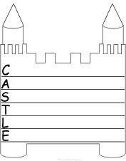

3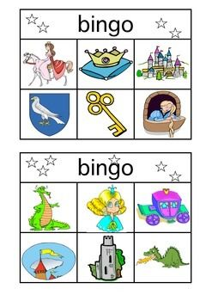

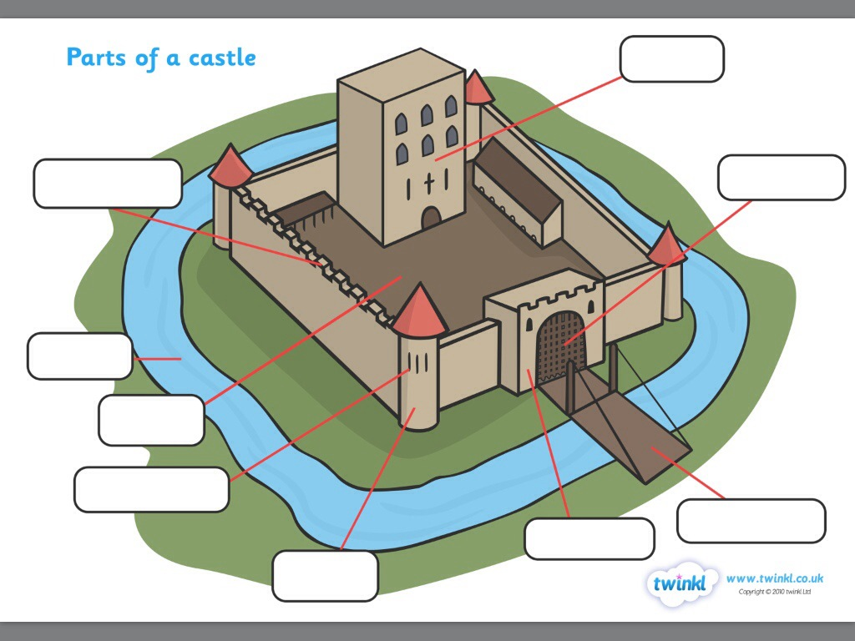
45
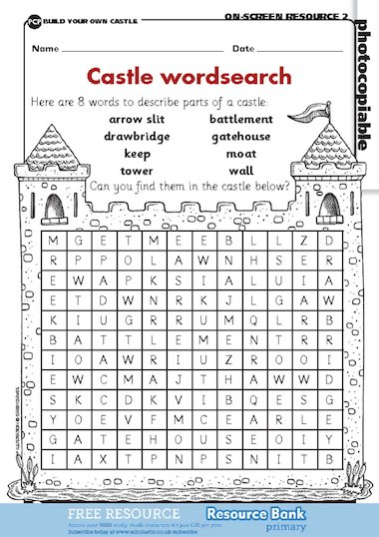
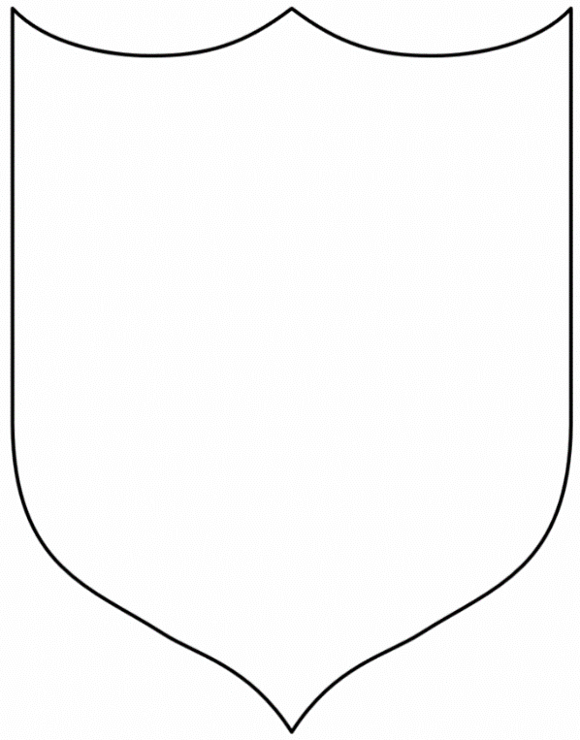
6

7

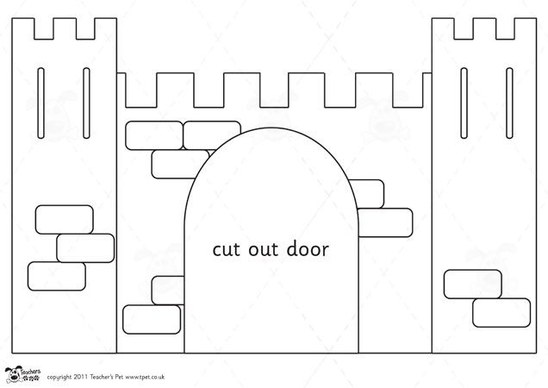
8

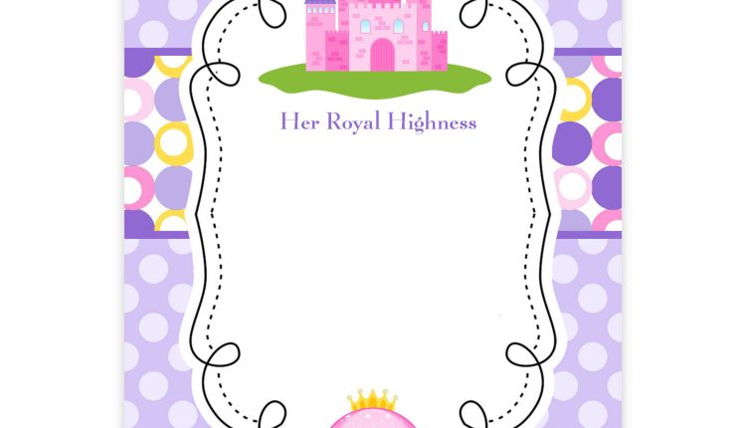
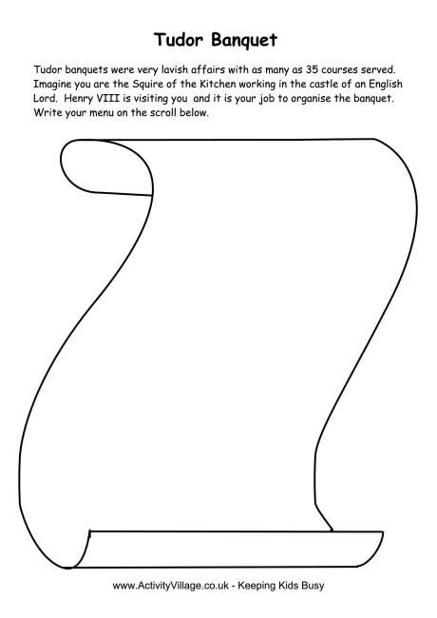
9

10
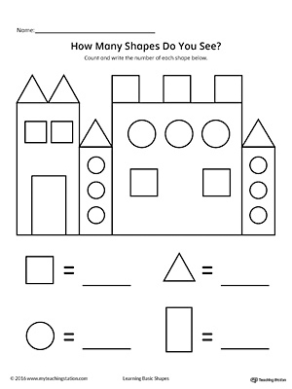
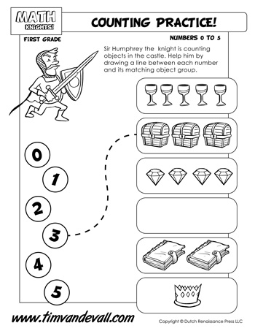

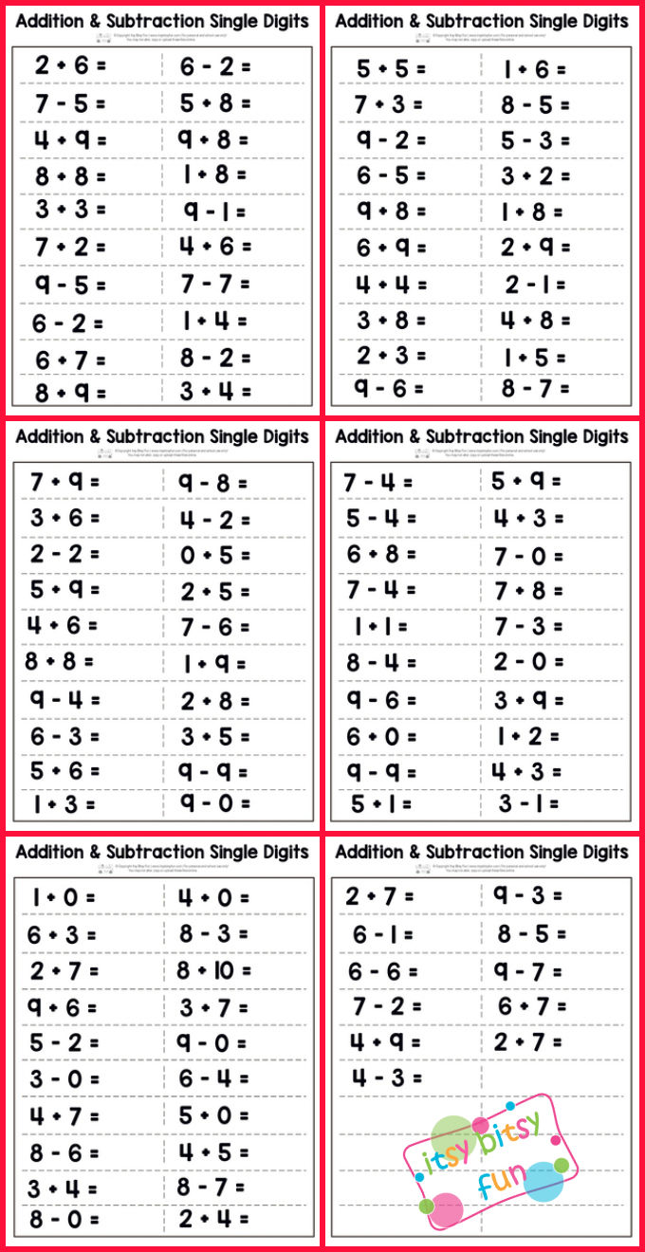
12

13 https://www.bbcgoodfood.com/recipes/welsh-cakes
14 https://www.bbc.co.uk/food/recipes/bara_brith_33441

Reference List
.https://travelwithlittleone.com/wpcontent/uploads/2018/03/castell-coch.jpg
.https://51h2lc4n573ga5bh382hhw1s-wpengine.netdna-ssl.com/wp-content/uploads/2014/08/Castell_Coch_4629.jpg
. Setting A Agored Policy
. Setting A Welsh Policy (2019)
.Wiliam D Understanding and using Educational theories chapter 16 Assessment for learning page 247 last paragraph
. Wiliam D Understanding and using Educational theories chapter 16 Assessment for learning page 248first paragraph
. https://www.twinkl.co.uk/
. https://www.pinterest.co.uk/pin/84653667981431167/
. https://www.pinterest.co.uk/pin/308918855671738072/
. https://www.pinterest.co.uk/pin/180636635030403473/?send=true
. https://www.bagvania.com/princess-birthday-invitations.html/free-printable-princess-invitation-template-castle-violet?bamp-skip-redirect=1
. https://www.timvandevall.com
. https://www.itsybitsyfun.com/blog/single-digit-addition-and-subtraction-worksheet/
. https://www.bbcgoodfood.com/recipes/welsh-cakes
. https://www.bbc.co.uk/food/recipes/bara_brith_33441

