


Network Security (NS)

Lab – System Enumeration

Faculty of Architecture, Computing & Engineering
School of Applied Computing
Mount Pleasant Campus
Swansea
SA1 6ED

- INTRODUCTION AND OBJECTIVES OF THE LAB
In the lectures, you learnt about network scanning tools. This laboratory exercise is a follow up of what you learnt in class. Enumeration is defined as the process of extracting usernames, passwords, machine names, user groups, domain names, networks resources, shares and services. Enumeration techniques are carried within the target network. It involves active and live connection to target hosts within the target network. Enumeration is the first stage of System Hacking Lifecycle as shown in Figure 1 below.

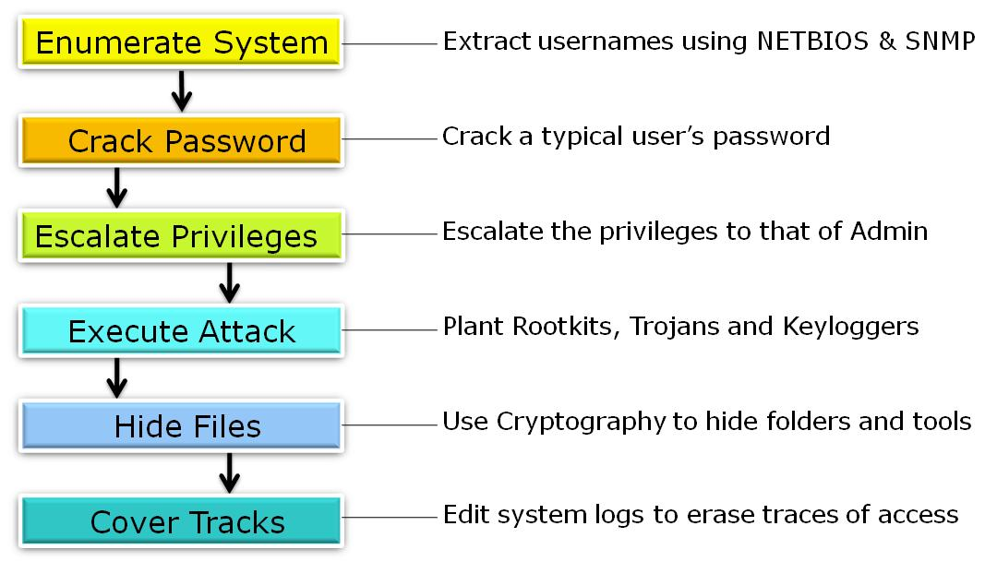
Figure 1: System Hacking Lifecycle.

There are several reasons why hackers and security experts are able to enumerate. These reasons are inherent design flaws (vulnerabilities) that exist in computer systems. Some of these major vulnerabilities are outlined below:
- Operating Systems have hidden IPC (Inter process communication) share (IPC$)
- Common Internet File System (CIFS) is a building block of Windows file sharing
- Server Message Block (SMB) is another basis for file and print sharing
- Network Basic Input Output System (NETBIOS) for inter computer communications
- SNMP (Simple network management protocol) used in network management system
- HTTP (Hyper Text Transport Protocol) Banner: Exploited to reveal more
In order to exploit the above vulnerabilities and others, there are several methods and techniques devised by hackers and security experts to conduct System Enumeration. Some of these methods are outlined below in Table 1.

Enumeration Method | Port used to enumerate
- NETBIOS Null Session | TCP 139/445
- NETBIOS Name Service | UDP 137
- SNMP Enumeration | UDP 161
- Win 2000 Active Directory using LDAP
- DNS Zone Transfer | TCP 53
- SMTP Enumeration | TCP 25
- HTTP Enumeration | TCP 80

Table 1: Enumeration Methods and ports used for enumeration.

The purpose of today’s laboratory exercise is to use one of two tools to conduct NETBIOS Null Session enumeration. The two tools are:
- Hyena.exe
- DumpSec.exe

The two above tools come together in single software called SystemTools.exe. This tool is added to your Moodle folder and can be downloaded when you login on Moodle.
Following today’s laboratory exercise you will be able to achieve the following:
- Enumerate local connections on a computer
- Enumerate local users on a target computer
- Enumerate local groups in a computer
- Enumerate local printers
- Enumerate local services
- Enumerate local shares
- Enumerate user rights and policies
- Enumerate local registry

  - INSTALLING THE ENUMERATION TOOLS
Download the SystemTools.exe software as provided by your Laboratory Tutor on Moodle and install it on your local machine in the lab. After double clicking the SystemTools.exe file and following few steps, the following window appears as shown in Figure 2

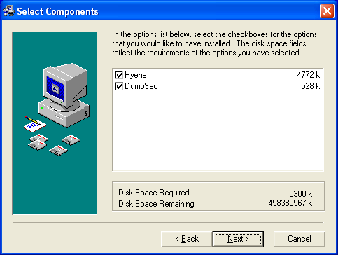
Figure 2: Selecting Components Window.

Click on the check buttons against “Hyena” and “Dumpsec” then followed by the “Next” button at the bottom of the window. Click the “next” button twice until you get to the “Finish” button. Once you click on the “Finish” button, the installation process ends and the installation window disappears.
On the bottom left hand corner of your computer, click on the “Start” button. Then select the “All Programs” and then browse through the list of applications installed on your computer. You will see a group called “System Tools”. This group contains the Hyena.exe and Dumpsec.exe applications.

- CONDUCTING ENUMERATION
You begin your enumeration by running the Hyena.exe application. Once the application starts, you will get the window shown below in Figure 3.
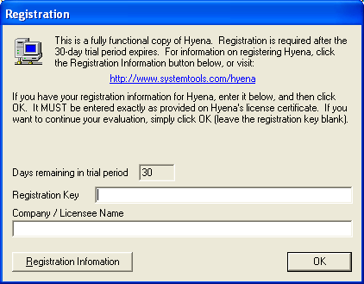
Figure 3: Hyena Registration Window.

Ignore the “Registration Key” window and the “Company Licence Name” window. Just click on the “OK” button. This distribution of Hyena allows you to use it for 30 days.
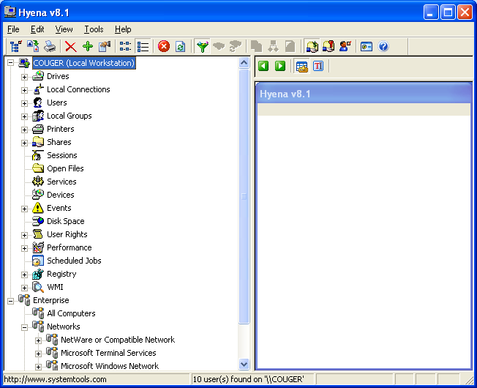
Figure 4: Hyena Enumeration Tool.
Task 1:
Click on “Local Connections” button.
How many local connections are there on this computer? ________________________
What is the significance of the IPC$ Connections? ________________________________
What happens if that connection is hijacked? Discuss with your colleagues. ______________

Task 2:
Click on “Users” button. How many users are you able to enumerate on your local computer? _____________________________________
What other information can you obtain about every one of the users? ________________

How is this information useful to a hacker? ___________________________________

_____________________________________________________________________
Discuss this with your colleagues. Do the same exercise for “Local Groups”.

Task 3:
Double click on “Scheduled Jobs”. Notice that the right hand pane of the window is populated by several jobs.
How many jobs are schedule to run on your computer. ____________________________
What types of jobs are scheduled to run on your computer? _______________________

Why do you think a hacker will be interested in knowing the types of jobs that are scheduled on a computer? _________________________________________________________

Discuss with your colleagues.

Task 4:
Click on the “Registry” button. Then double click on the “HKEY_LOCAL_MACHINE”. Notice that the right hand pane of the window will be populated as shown below in Figure 5. Warning! Do not mess with this file. You risk damaging your computer and it may have to be rebuild!
What is the Registry file? __________________________________________________

Why do you think a hacker will be interested in this file? __________________________

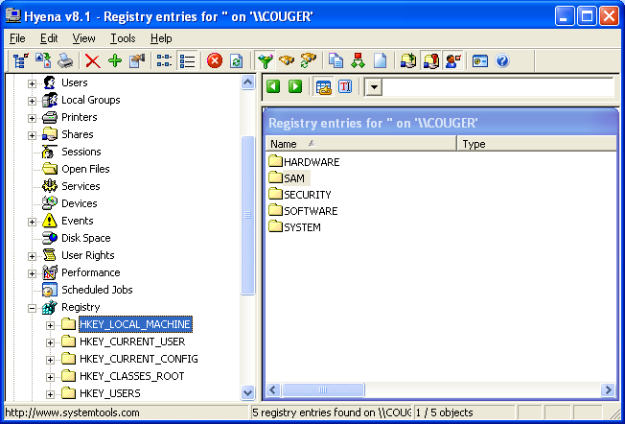
Figure 5: Enumerating the Registry.

On the right hand pane double click on the “SAM” The current pane will disappear and another one will appear with “SAM” again. Double click again on the new “SAM”.
What error message did you get? _____________________________________________
Why did you get this error message? _________________________________________
What type of file is SAM? _________________________________________________
What is its application to computer security? __________________________________
Discuss with your colleagues.

