Component 2: Written Assignment Report

Bsc Health and Social Care
Module: Creativity and Value Creation
Module code: BMHP5014

Component 2: Written Assignment Report
Lecturer Name: Tsiwani Khumalo
Student Name: Amie Banja
Student ID: 2309251

Contents
Task 1 Poster 3
Task 2 Pitch 4
Introduction 4
The Problem 5
The Innovative Solution 5
Target Audience and Expected Impact 5
Implementation Strategy 6
Regulatory and Ethical Considerations 7
Technology Integration 7
Dissemination and Promotion 8
Creativity, Value Creation, and Sustainability 8
Conclusion 10
References 11

Task 1 Poster
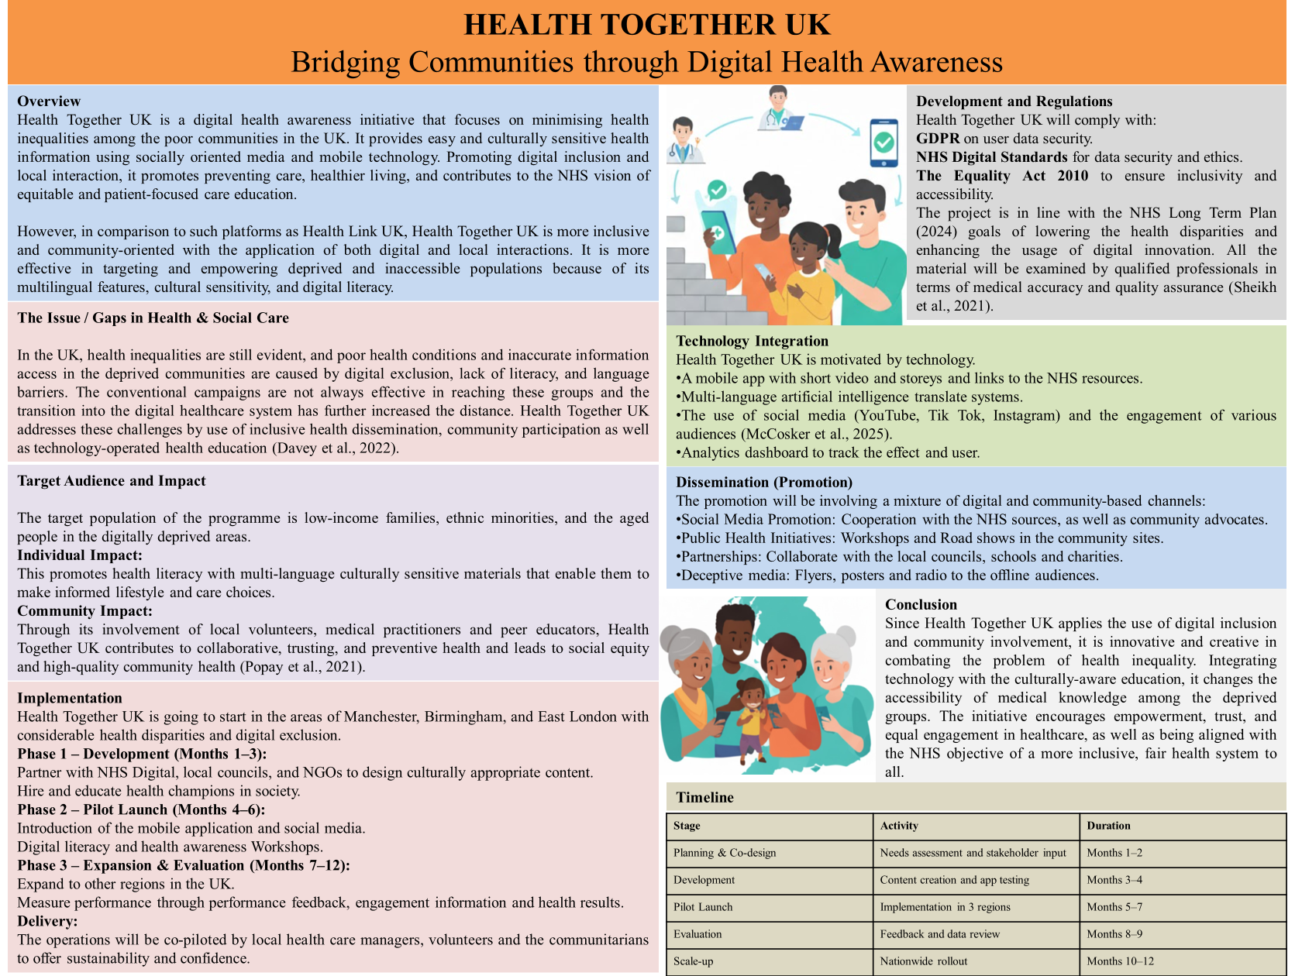

Task 2 Pitch

Introduction
Inequality of health also remains a significant issue in the health and social care environment in the United Kingdom. Nevertheless, although there is increased access to healthcare, the population in the poorest neighborhoods continues to die earlier, develop more chronic diseases, and have worse mental health than those in affluent communities. Caused by digital inequalities, low health literacy levels, and lack of cultural sensitivity, these disparities hinder vulnerable communities through mainstream health activities.
The solution to this challenge that Health Together UK provides is creative and practical. It is a community based digital health awareness initiative that aims at providing accessible, inclusive and culturally sensitive health education via mobile devices and social media channels. The project is in alignment with the mission of NHS to respond to the reduction of health inequalities and strengthen digital inclusion and empowerment of communities to assume charge of their own wellbeing.

The Problem
The COVID-19 crisis demonstrated the underlying disparity of digital access and general health knowledge. The number of digitally excluded adults in the UK have reached millions with most of the population residing in underprivileged neighbourhoods. Some of them do not have any digital literacy or are unable to access serious internet access which makes it hard to use NHS web-based services, book appointments, and access health education resources (Heaslip et al., 2022). Moreover, the language obstacles, cultural stigma, and the lack of trust in institutions are the obstacles to ethnic minorities and low-income families.
The old-fashioned public health campaigns cannot appeal to these audiences, because they are based on the use of formal language and a universal method. This is why it is necessary to develop the innovative, community-oriented, and technologically empowered solution that should address these groups directly in the relatable and engaging manner.

The Innovative Solution
Innovative and engaging health awareness platform Health Together UK suggests combining the use of technology, storey-telling, and involvement of communities. The programme will be based on the mobile app and combined social media opportunities, including YouTube, Instagram, and Tik Tok, which will be used to provide short educational video lessons in various languages. The videos will be aimed at major healthcare issues, including healthy eating on a low income, mental health, managing chronic health conditions, and local healthcare services and usage with the help of personal narratives and culturally associated images (Anderson et al., 2022).
One of the peculiarities of Health Together UK is its model of peer-to-peer. Local volunteers and trained healthcare workers will also work as community health champions and co-develop the content and interact with the residents using workshops and digital literacy training. This practise will bring about trust, inclusivity and retention among the efforts of co-production and community empowerment (Borg et al., 2019).
Compared with the years before the COVID-19 pandemic (2017 to 2019), life expectancy at birth in England declined in the most deprived areas between 2020 and 2022. For men, it fell by 1.4 years to 72.6 years, and for women, it decreased by 1.1 years to 77.7 years (ONS, 2023).
During 2020 to 2022, the gap in life expectancy between the most and least deprived areas reached 10.7 years for men and 8.5 years for women, based on the slope index of inequality. This continues a long-term pattern of rising inequality. For healthy life expectancy, the differences were even larger: 19.1 years for men and 20.2 years for women (ONS, 2023).
In the same period, men born in the most disadvantaged areas were expected to spend 70.4% of their lives in good health, compared with 84.5% in the least deprived areas. For women, the proportions were the lowest since the time series began in 2013–2015, at 65.1% in the most deprived areas and 81.5% in the least deprived (ONS, 2023).

Target Audience and Expected Impact
The initiative will initially target three high-need groups:
- Low-income families facing social and economic disadvantages.
- Ethnic minority groups with limited English proficiency.
- Elderly individuals struggling with digital exclusion and isolation.
The impact of Health Together UK will be both individual and collective.
- Individually, it will enhance health literacy, promote preventive behaviours and users to make informed decisions regarding their health.
- Collectively, it will contribute to community participation, minimise misinformation, and increase the level of trust in the healthcare system among people.
Health Together UK can play a role in creating social value by addressing both educational and digital distress including creating a fair and healthier society that provides everyone with decent health know-how irrespective background or income.

Implementation Strategy
The implementation of Health Together UK will occur in three carefully planned stages:
Development Phase (Months 1–3)
- Conduct needs assessments in partnership with local councils and NHS trusts in Manchester, Birmingham, and East London.
- Recruit and train community health champions.
- Develop multilingual educational content and ensure compliance with healthcare communication standards.
Pilot Launch (Months 4–6)
- Deploy the app and launch social media campaigns.
- Run digital literacy workshops in community centres and schools.
- Gather feedback from participants to refine content and usability.
Scale-Up and Evaluation (Months 7–12)
- Expand the programme to other deprived regions.
- Evaluate outcomes through surveys, engagement analytics, and health behaviour indicators.
- Publish a public impact report for stakeholders and funders.
It is possible as the sustainability and learning are supported with the staged rollout, so that the programme is relevant to the needs of communities and regional issues.

Regulatory and Ethical Considerations
Health Together UK will operate within the legal and ethical framework governing UK healthcare.
- GDPR will ensure all user data remains private and secure.
- The Equality Act guarantees inclusivity and accessibility.
- The NHS Long Term Plan supports the integration of digital innovation for better patient outcomes (Leach et al., 2022).
The initiative also takes into account the principles of ethical communication, i.e. it does not use medical jargon, should be culturally respectful, and rely on tested facts of NHS and Public Health England origin.

Technology Integration
Technology is the foundation of this innovation. The Health Together UK app will:
- Provide offline access to key videos and guides for those with limited internet connectivity.
- Use AI-powered translation and speech tools to personalise learning in different languages.
- Include a feedback feature where users can ask questions anonymously, fostering trust and engagement.
- Use analytics of data to gauge the engagement and see what should be approached further.
This is due to the interweaving of technology that facilitates the availability and effectiveness and real-time measurements, key component of digital value creation in the modern context of healthcare (Tan and Rajaratnam, 2025).

Dissemination and Promotion
Health Together UK will use multi-channel dissemination strategy in order to reach as many people as possible:
- Social Media Campaigns: Partnership with NHS pages, influencers and charities in the area.
- Community Partnerships: Liaising with local councils, GPs, and schools to present information.
- Traditional Media: Non-digital audiences, Leaflets, posters, and local radio.
- Public Events: Publicity “Health awareness fairs and open workshops to present success storeys and collect testimonials (Liu et al., 2023).
These will enhance exposure, mobilisation, and buy in amongst the stakeholders on behalf of the NHS England, the local authorities and the health NGOs.

Creativity, Value Creation, and Sustainability
Health Together UK is a problem solving technique, which is creative, whereby there is a narration and cooperation between technology and storytelling. Its power is in the reformulation of the procedure of health education, its interaction, personalisation, and inclusion (Al-Shorbaji, 2022). The project generates various layers of value:
- Personal value through empowerment and knowledge.
- Social value through reduced inequalities and improved community wellbeing.
- Economic value by reducing unnecessary healthcare costs through prevention and awareness.
Moreover, through training of local champions and incorporation of digital literacy, Health Together UK creates sustainability, meaning that once the funds are over, the communities still enjoy the community-led initiative.

Conclusion
Health Together UK is an innovative and ethical approach in UK health and social care. It fills the technology-community divide by empowering individuals who tend to be marginalised in the digital health reforms. It also aids the wish of the NHS to achieve health equity and the common good through the use of creativity, collaboration and inclusivity. Through investment in Health Together UK, policymakers and other stakeholders can contribute to a future in which all communities, regardless of income, backgrounds, and digital proficiencies, will have the same chance to have healthier and better informed lives.

References

Davey, F., McGowan, V., Birch, J., Kuhn, I., Lahiri, A., Gkiouleka, A., Arora, A., Sowden, S., Bambra, C. and Ford, J., 2022. Levelling up health: a practical, evidence-based framework for reducing health inequalities. Public health in practice, 4, p.100322.
McCosker, A., Tucker, J. and Kennedy, J., 2025. Digitally skilled but socially disadvantaged: Enabling digital capabilities in low-income families. Convergence, 31(2), pp.616-633.
Popay, J., Whitehead, M., Ponsford, R., Egan, M. and Mead, R., 2021. Power, control, communities and health inequalities I: theories, concepts and analytical frameworks. Health promotion international, 36(5), pp.1253-1263.
Sheikh, A., Anderson, M., Albala, S., Casadei, B., Franklin, B.D., Richards, M., Taylor, D., Tibble, H. and Mossialos, E., 2021. Health information technology and digital innovation for national learning health and care systems. The Lancet Digital Health, 3(6), pp.e383-e396.
Al-Shorbaji, N., 2022. Improving Healthcare Access through Digital Health: The Use of. Healthcare Access, p.315. Available at: https://www.google.co.in/books/edition/Healthcare_Access/VARgEAAAQBAJ?hl=en&gbpv=1&dq=Digital+health+care+aearness+with+online+medium+&pg=PA315&printsec=frontcover
Anderson, M., Pitchforth, E., Edwards, N., Alderwick, H., McGuire, A. and Mossialos, E., 2022. United Kingdom: Health System Review. Health systems in transition, 24(1), pp.1-194. Available at: https://europepmc.org/article/med/35579557
Borg, K., Boulet, M., Smith, L. and Bragge, P., 2019. Digital inclusion & health communication: a rapid review of literature. Health communication, 34(11), pp.1320-1328. Available at: https://doi.org/10.1080/10410236.2018.1485077
Office for National Statistics (ONS) 2023, Health state life expectancies by national deprivation deciles, England: 2020 to 2022, Office for National Statistics, viewed 15 Nov 2025, https://www.ons.gov.uk/peoplepopulationandcommunity/healthandsocialcare/healthinequalities/bulletins/healthstatelifeexpectanciesbynationalareadeprivationengland/2020to2022
.
Heaslip, V., Thompson, R., Tauringana, M., Holland, S. and Glendening, N., 2022. Health inequity in the UK: exploring health inequality and inequity. Practice Nursing, 33(2), pp.72-76. Available at: https://doi.org/10.12968/pnur.2022.33.2.72
Leach, B., Parkinson, S., Gkousis, E., Abel, G., Atherton, H., Campbell, J., Clark, C., Cockcroft, E., Marriott, C., Pitchforth, E. and Sussex, J., 2022. Digital facilitation to support patient access to web-based primary care services: scoping literature review. Journal of medical Internet research, 24(7), p.e33911. Available at: https://www.jmir.org/2022/7/e33911/
Liu, Y., Wang, X.J., Chen, Z.S., Zhang, Y., Zhao, S., Devici, M., Jin, L. and Skibniewski, M.J., 2023. Evaluating digital health services quality via social media. IEEE Transactions on Engineering Management, 71, pp.9981-9993. Available at: https://ieeexplore.ieee.org/abstract/document/10199134
Tan, E.X. and Rajaratnam, V., 2025. Transformative Digital Leadership: Integrating Digital Health and Credentialing Innovations. In Digital Leadership for Sustainable Higher Education (pp. 75-124). IGI Global Scientific Publishing.

