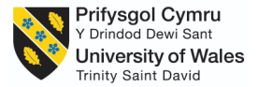

BMMB7026 Managing Marketing Change
Strategic Change Management and Marketing Transformation at British Airways: A Critical Evaluation of Organisational Change, Digitalisation and Customer-Centric Strategy

STUDENT NAME: MINHAJUR RAHMAN KHAN MISU

STUDENT ID: 2511789
WORD COUNT: 3800

Executive Summary
British Airways (BA) is a flag carrier of the United Kingdom that is among the most popular international airlines in the world and that belongs to the International Airlines Group (IAG). Its premium positioning, network through Heathrow and brand heritage have enabled the airline to build a strong global reputation. Nevertheless, BA is experiencing serious marketing issues such as growing competition, shifting customer demands, digital disruption, uneven customer experiences, and the rising demand for sustainable travel.
This report critically assesses the marketing activities of BA, its segmentation, targeting, positioning, marketing mix, communication channels and performance measurement strategies. The results suggest that BA enjoys the advantages of good brand equity and customer loyalty but needs more personalisation, enhanced digital activity and better sustainability communication.
The report suggests a future marketing approach with AI-based personalisation, omnichannel customer interaction, amplified social media marketing, open sustainability campaigns and better Executive Club loyalty service to enhance customer value and competitive advantage.

Table of Contents
Executive Summary 2
1.1 Background of British Airways 5
1.2 Purpose and Scope of Report 6
2. Critical Evaluation of Marketing Activities at British Airways 7
2.1 Concept and Strategic Importance of Marketing at British Airways 7
2.2 Marketing Environment Analysis: Macro and Micro Factors 8
2.3 Target Market, Segmentation, Targeting and Positioning (STP) 11
2.4 Marketing Mix Evaluation (4Ps/7Ps) of British Airways 12
2.5 Marketing Communication Channels and Effectiveness 15
3. Measuring Marketing Success at British Airways 16
4. Conclusion: Shortcomings of British Airways Marketing Strategy 18
5. Recommendations: Future Marketing Plan for British Airways 18
References 21

1. Introduction

1.1 Background of British Airways
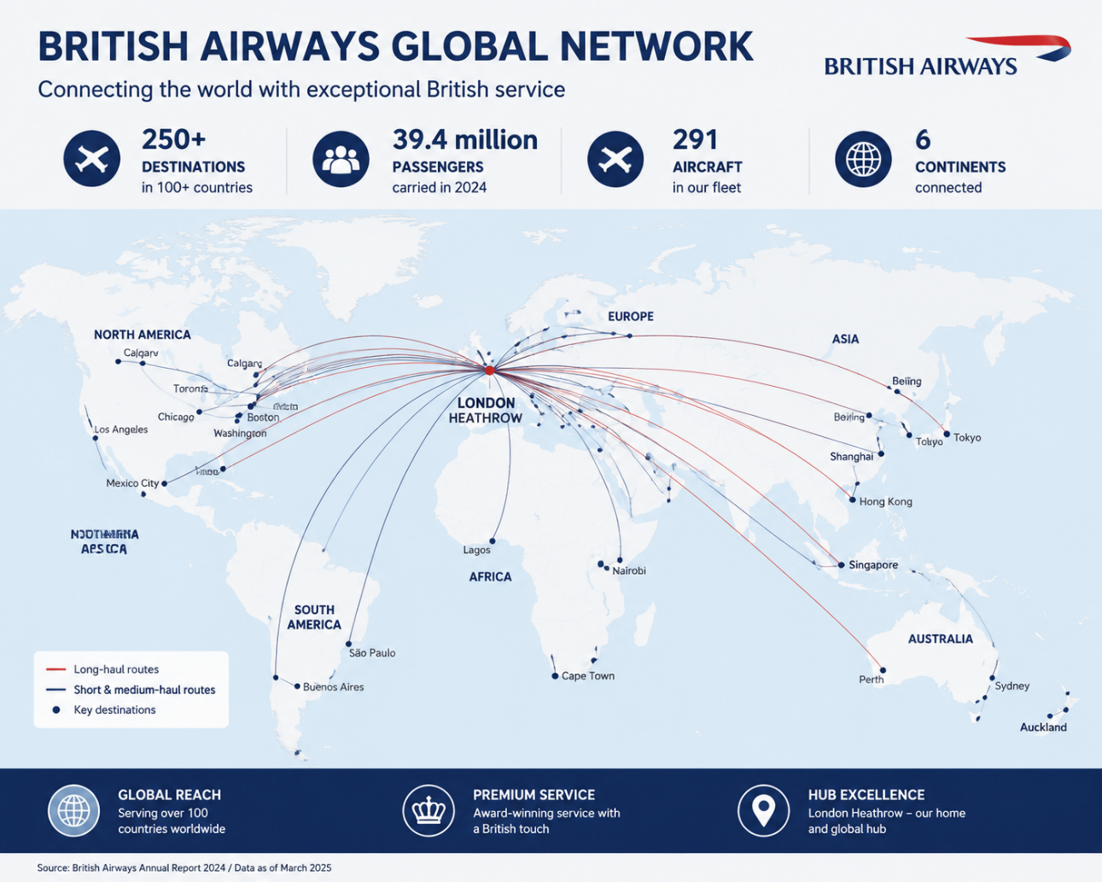
Figure 1 BA global network
Source: (IAG, 2025)
British Airways (BA) is one of the major international airlines in the world and the flag carrier of the United Kingdom. It is an International Airlines Group (IAG) subsidiary and serves over 200 destinations in Europe, North America, Asia, Africa and other parts of the world. BA enjoys an excellent reputation in the world market due to its high-quality service, vast network from Heathrow Airport and long history of the brand (IAG, 2025). But the airline business has become more competitive as the cost of operating has increased, customer demands have changed, there has been disruption from digitalisation and pressure from both premium and low-cost airlines.
Marketing in the aviation industry is a very important aspect in the aviation industry since an airline does not just offer transportation services but also sells customer experiences. Through proper marketing, airlines gain brand value, find target customers, create loyalty and have a competitive edge. In the case of BA, marketing is necessary in conveying its premium positioning, enhancing customer relations as well as reacting to evolving passenger demands. The adoption and development of digital technologies, artificial intelligence and personalisation in marketing have augmented the significance of information-driven marketing strategies within the aviation industry.

1.2 Purpose and Scope of Report
This report is a critical analysis of the marketing operations of British Airways and an assessment of their success in responding to the business issues of the day. The report will be based on the marketing environment, target markets, positioning, marketing mix, communication channels, and performance measurement techniques of BA (Cameron and Green, 2015). It also determines the major flaws in the current marketing strategy and suggests the future of marketing.
The report bridges the performance gap between marketing activities and overall organisational performance by showing the contribution of marketing towards customer satisfaction, brand competitiveness and long-term business success. The following contemporary challenges are considered in the analysis: digital transformation, growing competition, sustainability expectations and evolving customer behaviour.

2. Critical Evaluation of Marketing Activities at British Airways

2.1 Concept and Strategic Importance of Marketing at British Airways
Marketing in British Airways (BA) is not just about conventional announcements and advertisements. As a strategic process in the aviation industry, marketing is a process that builds customer value through the knowledge of passenger requirements, creation of meaningful experiences and the establishment of long-term relationships. The services of an airline are intangible, unlike other products; thus, marketing assists the customers in assessing the service quality, reliability and brand trust level prior to making a purchase (Buchanan and Badham, 2008). In the case of BA, marketing directly contributes to competitive advantage as it helps the airline maintain its premium status and distinguishes it against its competitors.
BA uses various marketing strategies to sustain its international brand name. Brand campaigns convey British heritage, quality service and overseas connectivity of the airline. As an example, BA's series of campaigns (A British Original) revolved around celebrating personal stories of people travelling instead of just selling flights (Burnes, 2014). This was an effort to establish emotional appeal with the customers and enhance brand relevance following the shock instituted by the COVID-19 pandemic.
Digital marketing has found its way into the strategy of BA, too. The airline leverages its site, mobile app, email marketing and customer data platforms to enhance customer interaction during the travel experience. BA has opportunities to present offers individually, inform about updates in travel and boost repeat purchases via online channels (Aaker, 2015). Moreover, the British Airways Executive Club loyalty scheme aids customer retention in that frequent travellers are rewarded with Avios points, tier benefits and relationships with partners.
Nonetheless, despite BA marketing investment contributing to good brand recognition, it must be given a critical assessment. The benefits of premium positioning of BA include increased customer loyalty and brand value, especially among business travellers. Nonetheless, there are expectations of high service quality with premium pricing (Bieling, Stock and Dorozalla, 2015). New operational challenges, such as flight delays, baggage delays and customer experience complaints, have created misalignance between brand commitments and customer experiences.

2.2 Marketing Environment Analysis: Macro and Micro Factors
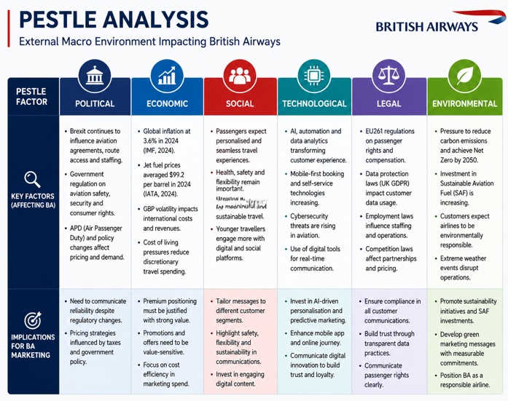
Figure 2 Pestle Analysis
Source: (Self-made)
A number of external and internal environmental factors affect the marketing strategy of BA. A PESTLE analysis shows the extent to which marketing choices are influenced by broader market factors.
Factor | Influence on BA Marketing Strategy
Political | Aviation regulations, Brexit impacts and government policies influence international operations and customer communication.
Economic | Inflation, fuel costs and reduced consumer purchasing power affect pricing and customer demand.
Social | Customers increasingly expect personalised, convenient and sustainable travel experiences.
Technological | AI, digital platforms and data analytics are transforming customer engagement.
Environmental | Climate concerns require stronger sustainability communication.
Political factor: Political factors have a lot of influence on the marketing of BA. Brexit added more complexity to UK airlines because of the alterations in the European aviation set-up, free movement of people and access to the global market (Danciu, 2013). BA has to convey reliability and connectivity across the world and deal with customer issues about restrictions to travel and changes in regulations. Moreover, aviation laws of passenger rights and compensation affect customer expectations and communication of services.
Economic factor: Economic pressures have had a major impact on airline marketing strategies. World inflation has added to the operating expenses, especially fuel and labour costs. The International Air Transport Association (IATA, 2025) reported that even now, one of the biggest airline operating costs is fuel; about a third of all industry costs. The increasing price puts pressure on BA to continue being premium and prove customer value. Moreover, the crisis in the UK cost-of-living has also affected consumer behaviour, with some leisure travellers becoming price-sensitive and evaluating BA against cheaper rivals like easyJet and Ryanair. This poses a problem to BA since its premium approach relies on customers accepting to pay a premium price in return for excellent service (Foreman et al., 2014).
Social factor: The social factors have also affected the marketing strategy in BA. Contemporary passengers are becoming more demanding in their demands in terms of having customised experiences, flexible booking and smooth online communication. Business travellers are efficient, and younger customers require airlines to communicate with them via social media and mobile (Kim and Mauborgne, 2004). BA has reacted to these changes by improving digital and personal communication, but with more digitally-first competitors threatening its ability to engage with its customers, the digital aspect of its operations remains a weakness.
Technological factor: Technological development has emerged as a significant marketing driver. Customer analytics and automation enable artificial intelligence (AI) to help airlines comprehend passenger behaviour and give offers in a targeted manner (Kim and Mauborgne, 2004). Personalisation can be enhanced by BA using customer information provided by interactions via Executive Clubs and online interactions. Nevertheless, the efficient utilisation of data about customers demands good privacy control and ethics in data management.
Environmental factor: The marketing of airlines is also being remodelled due to environmental pressures. The growing concern about climate change has led to the need to have eco-friendly travel options. Through the environmental strategy of IAG, BA has advanced sustainability activities, such as investing in sustainable aviation fuel (SAF) (Kim and Mauborgne, 2014). Nonetheless, customers are demanding clear evidence instead of just sustainability claims.
The marketing choices of BA are also affected by the micro environment. The central stakeholders are the customers since the expectations are directly linked to service design and communication strategies. BA primarily appeals to premium passengers, frequent fliers and international passengers; however, competition has been increasing. Virgin Atlantic competes in the direct markets of the premium long-haul by branding the customer experience, whereas Emirates and Qatar Airways compete with luxury positioning and worldwide connectivity. Low fares taken by low-cost airlines like Ryanair and easyJet threaten BA because they are drawing price-sensitive customers.
The marketing ability of BA is also determined by the suppliers, the airport partners and stakeholders. Heathrow Airport also gives BA a high strategic position because of its worldwide connectivity, yet reliance on airport capacity and operational partners has the potential to influence customer experience.

2.3 Target Market, Segmentation, Targeting and Positioning (STP)
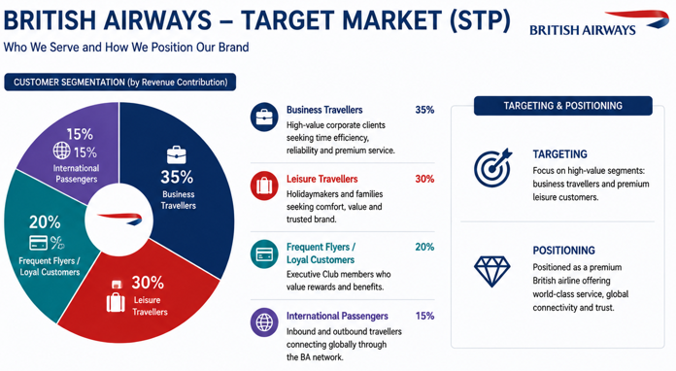
Figure 3 Target Market, Segmentation, Targeting and Positioning (STP)
Source: (Self-Made)
British Airways employs segmentation in the market, with the aim of discovering various types of customers and formulating appropriate marketing strategies. The primary segments of the airline are business travellers, premium leisure travellers, frequent flyers and international customers.
Customer Segment | Marketing Focus
Business travellers | Reliability, Heathrow connectivity, premium cabins and loyalty benefits
Premium leisure travellers | Comfort, quality service and unique travel experiences
Frequent flyers | Executive Club rewards and personalised offers
International customers | Global network and British brand reputation
Targeting present in BA is highly geared towards premium customers as its business model is not focused on price but on the quality of its services (ACI, 2025). Heathrow Airport also offers BA access to significant business destinations across the world and is therefore appealing to corporate travellers who embrace convenience, frequency and reliability. This premium orientation helps in generating more revenue via business-class and long-haul services.
The positioning of BA is based on the idea of a British premium airline with the main differentiators being its heritage, service reputation and its global network. The premium cabins that the airline offers, such as Club World and First Class, are promoted as comfortable, exclusive, and enriched customer experiences (British Airways, 2025). This positioning is enhanced by the Executive Club, which promotes loyalty among high-value customers.
Nonetheless, the premium positioning that BA possesses is challenged. Although heritage and reputation are still important assets, young digital customers are focusing more on technology, sustainability and personalised experience when judging airlines. Emirates competitors like luxury experiences, whereas low-cost airlines lure customers with affordability (McKinsey and Company, 2024). Hence, BA has to strike a balance between its legacy premium and digital demands.
The digital campaigns and loyalty activities of BA show the efforts to modernise their positioning. The personalisation of the Executive Club with Avios partners enables their customers to earn and redeem points over various services, which boosts engagement (Frow and Payne, 2009).

2.4 Marketing Mix Evaluation (4Ps/7Ps) of British Airways
The marketing mix is a valuable framework to assess how British Airways (BA) can generate customer value and sustain competitive advantage (Chylinski et al., 2020). Being an airline service provider, BA has not only to deal with the conventional marketing factors but also service marketing factors like people, processes and physical evidence.
Marketing Element | British Airways Activities | Critical Evaluation
Product | Premium cabins, international routes, Executive Club, customer service experience | Strong brand value, but service consistency remains a challenge.
Price | Premium pricing strategy based on quality and reputation | Effective for business customers but may reduce appeal among price-sensitive travellers
Place | Heathrow hub, online booking platforms, mobile application | Strong distribution advantage but digital experience requires improvement
Promotion | Advertising campaigns, social media, partnerships | Builds emotional connection but requires stronger personalisation
People | Cabin crew, customer service teams and employees | Employee experience directly affects customer satisfaction
Process | Digital check-in, online booking, automated services | Improves convenience but disruption management needs improvement
Physical Evidence | Aircraft interiors, lounges, airport experience | Supports premium image but must match customer expectations
Product: BA does not just provide the products of air transportation but the entire travel experience. The differentiation of the airline is based on the premium services, such as First Class, Club World business class, airport lounges and global connectivity via Heathrow (Chaffey and Ellis-Chadwick, 2022). The campaign A British Original reinforced this product identity by emphasising the personal experiences of travelling as opposed to just a functional advantage.
Nonetheless, the demands of customers towards high-profile airlines are very high. Delays, poor consistency in managing onboard services and disruption management can be issues that decrease perceived value (Lemon and Verhoef, 2016). Thus, although a premium product offered by BA is a sound competitive edge, service delivery must be able to sustain its marketing pledges.
Price: BA is a premium airline and sets fares at higher rates than its low-cost competitors like Ryanair and easyJet. Such a strategy is well-grounded in its brand name, Heathrow connections, high frequency and high quality services (Dwivedi et al., 2021). Convenience and reliability could be a value to the business traveller even in the face of increasing prices.
But quality pricing poses a problem at times of economic stress. Inflation and decline in consumer buying power have made customers more sensitive towards the price of tickets. BA should make sure that customers do feel that they are getting a distinct extra value as opposed to paying more money because of the brand name.
Place: The Heathrow hub, which is one of the busiest international airports in the world, is an advantage to BA. This opens up good business and international markets. Customers can also find, book and manage journeys through its digital distribution channels such as the BA website and mobile application (Huang and Rust, 2021).
However, online platforms should keep enhancing as current travellers demand uninterrupted online experiences like technology-oriented business enterprises.
Promotion: BA applies integrated marketing communications in the form of advertising, social media, partnership and loyalty marketing. Programs like “A British Original” were effective in strengthening emotional relationships with clients and emphasising the heritage of BA (Kotler and Keller, 2016).
Nevertheless, the promotion might be enhanced with greater data-based personalisation. The competition is turning to customer analytics to offer targeted deals, and BA will need to create even more personalised messages.
People, Process and Physical Evidence: The service marketing of BA is dominated by employees since the cabin crew and customer service groups have a direct impact on the experience of passengers (Payne et al., 2017). Employee education and involvement are thus significant towards sustaining high-quality standards.
Digital check-in, online booking and automated customer services have enhanced the processes in BA. Nonetheless, disruption management is also a field in need of enhancement, especially in operational issues.
Premium positioning is supported by physical evidence, such as the aircraft design, the airport lounges and the British Airways brand identity (IAG, 2024). Nonetheless, these aspects should constantly be upgraded to suit customer needs as far as comfort, technology and sustainability are concerned.

2.5 Marketing Communication Channels and Effectiveness
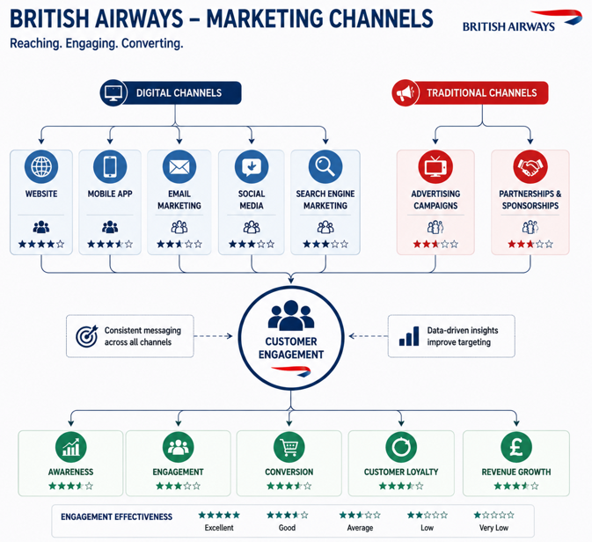
Figure 4 Marketing Communication Channels
Source: (Self-Made)
BA operates both online and offline communication systems to access varied groups of customers. Digital platforms have gained more significance due to the fact that consumers have become demanding in terms of instant and personalised communication.
Channel | Purpose | Effectiveness
Website and mobile app | Booking, travel management and customer service | Convenient but requires stronger personalisation
Social media | Brand engagement and customer communication | Effective for awareness but requires faster responses
Email marketing | Offers and loyalty communication | Useful for retention through targeted messages
Search engine marketing | Customer acquisition | Helps capture travel demand
Traditional advertising | Brand awareness | Supports premium identity
The mobile application and the web of BA assist with the contemporary customer experience, as passengers can book flights, handle their reservations and access travel information (Department for Transport, 2024). Executive Club members can also find email marketing especially useful as it allows communicating with the customers in a way that is narrow and specific to their customer behaviour.
Social media enables BA to be visible and have dialogue with clients. Nevertheless, customers of the airline are more and more engaging in social media to complain and receive immediate assistance, which means that any slowness in responding can hurt the brand image.
The role of traditional advertising for BA is still significant since emotional branding is a part of its premium positioning. Campaigns like British Originals are effective in conveying heritage and customer stories (CAA, 2025). Alliances and joint ventures also contribute to enhancing brand awareness among global markets.

3. Measuring Marketing Success at British Airways
Measuring marketing effectiveness is also critical to British Airways (BA) as airline marketing investments have to show how they contribute to customer satisfaction, loyalty and financial performance. BA uses a mixture of customer-based, digital and financial measures to assess its marketing performance (Ryan and Jones, 2012). The scores of customer satisfaction and Net Promoter Score (NPS) are significant metrics since they assess the attitude of passengers to the quality of the service and their readiness to recommend the carrier. The measures are especially applicable to BA since the company relies on the impact of customer experience to position its operations as premium.
The Executive Club membership growth and retention of customers are other pertinent measures of marketing success. With a robust loyalty base, BA has the ability to develop repeat business, especially with frequent business travellers and high-end customers (Deloitte, 2024). Moreover, online performance measures like traffic to the webpage, usage of the mobile application, online reservations and social media presence can be used to measure the success of digital marketing activities.
Another important measure is revenue contribution since commercial performance is supposed to be backed by effective marketing. Ticket sales, lifetime value and revenue from loyalty members are some metrics that can be used to reveal whether the marketing activities are paying off.
Nonetheless, despite the fact that BA employs a number of performance measures, existing measurement methods might be ineffective in the rapidly evolving digital world. Classical measures like customer satisfaction and revenue will have meaningful results but might not offer a comprehensive understanding of customer behaviour at the point in time (Weiss, 2025). Advanced analytics and artificial intelligence (AI) are today being employed by competitors to anticipate customer needs and personalise their interactions.

4. Conclusion: Shortcomings of British Airways Marketing Strategy
The analysis reveals that British Airways has a robust marketing base anchored on its premium brand name, worldwide network and customer loyalty programme. The marketing campaigns like the A British Original, the Executive Club and premium cabin have been able to solidify its brand as being an airline like a leading British airline. Nevertheless, its existing marketing strategy has a number of weaknesses.
To begin with, BA is significantly reliant on its traditional premium positioning that might not be able to satisfy younger digital customers that prioritize personalisation, sustainability and technology-driven experiences. Secondly, BA has invested in digital platforms, but its utilisation of customer data and AI is not as developed as in the case of digital-first competitors. This restricts the ability to do personalised marketing and customer engagement.
Moreover, a lack of consistency in the customer experience when there is disruption in operations brings about a disparity between marketing claims and actual provision of services. The involvement of social media and immediate communication with customers also needs to be enhanced. Lastly, and most importantly, BA must convey their sustainability initiatives even more clearly and transparently to establish trust with environmentally conscious travellers through sustainability marketing practices.
On the whole, the marketing strategy of BA is efficient in keeping the brand power but needs more digital innovation, individualisation and communication with customers in order to stay competitive.

5. Recommendations: Future Marketing Plan for British Airways
Recommendation 1: Implement an AI-Based Personalised Marketing Strategy
BA ought to create an enhanced AI-driven marketing strategy, relying on customer data of Executive Club memberships, booking history and digital interactions. AI is able to study the likes and preferences of passengers and offer personalised flight suggestions, special deals and customised travel.
As an illustration, business travellers would get offers as far as flexibility in travel is concerned, whereas leisure customers would get recommendations on destinations depending on their past behaviour. This would enhance the relevance of the customers, boost loyalty and enhance customer lifetime value. Nevertheless, BA has to take care of ethical handling of data and transparency in order to ensure customer trust.
Recommendation 2: Develop Omnichannel Customer Engagement
BA ought to establish an integrated communication system within its mobile application, its website, emails and social media platforms. Customers are becoming a lot more demanding of uniformity of information in all channels, especially during disruption.
A better omnichannel strategy would enable flight updates in real time, personalised messages and in-time customer service using digital platforms. This would alleviate congestion in times of disruption and enhance customer satisfaction. Channel integration of customer service data would also enable BA to have better insight into customer needs.
Recommendation 3: Strengthen Digital and Social Media Marketing
BA needs to interact more with younger travellers by creating more interactive digital campaigns. Despite the presence of the current campaigns, which are effective in conveying brand heritage, marketing in the future needs to be more digital, with more emphasis on influencer collaboration and user-generated content.
The use of social media campaigns related to the experiences of customers, destinations and sustainability efforts might enhance brand relevance among younger people. Enhanced reaction on social platforms to customer queries would reinforce trust and interaction as well.
Recommendation 4: Develop Sustainability-Focused Marketing
To achieve better communication on sustainability, BA should clarify its environmental efforts focused on the investment in sustainable aviation fuel (SAF) as well as its initiatives related to carbon reduction. Environmental responsibility is becoming a significant concern for customers when it comes to brand selection.
Clear sustainability marketing backed by quantifiable improvements would enhance the reputation of BA and set the company apart in the market. Nevertheless, to prevent the appearance of greenwashing, the sustainability claims should be backed by evidence.
Recommendation 5: Enhance Loyalty Marketing Through Executive Club Development
BA needs to evolve the Executive Club further by providing rewards that are more individual and increasing partnerships with hotels, retailers and travel services. The programme ought to develop intimate experiences of various groups of customers, as opposed to the narrow scope of accumulating points.
Increased loyalty marketing would raise repeat purchases, enhance customer retention and enhance the relationship with high-value travellers of BA. Using loyalty data and AI-generated insights, BA will be able to develop a more customer-oriented marketing ecosystem.

References
Aaker, D. (2015) ‘Brand personalities are like snowflakes’, Marketing News, 49(7), pp. 20–21.
ACI (2025). The trusted authority on air travel demand insights | ACI World. [online] ACI World. Available at: https://aci.aero/2025/02/26/the-trusted-authority-on-air-travel-demand-insights/ [Accessed 8 July 2026].
Bieling, G., Stock, R.M. and Dorozalla, F. (2015) ‘Coping with demographic change in job markets: how age diversity management contributes to organisational performance’, Zeitschrift für Personalforschung, 29(1), pp. 5–30.
British Airways (2025). Join the British Airways Club | British Airways. [online] Britishairways.com. Available at: https://www.britishairways.com/content/the-british-airways-club [Accessed 8 July 2026].
Buchanan, D.A. and Badham, R.J. (2008) Power, Politics and Organisational Change. 2nd edn. London: Sage Publications.
Burnes, B. (2014) Managing Change. 6th edn. Harlow: Pearson.
CAA (2025). UK Aviation Consumer Survey | UK Civil Aviation Authority. [online] Caa.co.uk. Available at: https://www.caa.co.uk/data-and-analysis/data-for-passengers/uk-aviation-consumer-survey/ [Accessed 8 July 2026].
Cameron, E. and Green, M. (2015) Making Sense of Change Management: A Complete Guide to the Models, Tools and Techniques of Organisational Change. 4th edn. London: Kogan Page.
Chaffey, D. and Ellis-Chadwick, F. (2022). Digital Marketing: Strategy, Implementation and Practice. 7th ed. Harlow, England: Pearson.
Chylinski, M., Heller, J., Hilken, T., Keeling, D.I., Mahr, D. and de Ruyter, K. (2020). Augmented reality marketing: A technology-enabled approach to situated customer experience. Australasian Marketing Journal (AMJ), 28(4).
Danciu, V. (2013) ‘The future of marketing: an appropriate response to the environment changes’, Theoretical and Applied Economics, 20(5), pp. 33–52.
Deloitte (2024). Upward climb with uphill struggles: 2024 Deloitte corporate travel study. [online] Deloitte Insights. Available at: https://www.deloitte.com/us/en/insights/industry/transportation/corporate-business-travel-survey/2024.html [Accessed 8 July 2026].
Department for Transport (2024). Sustainable Aviation Fuel (SAF) Mandate. [online] GOV.UK. Available at: https://www.gov.uk/government/collections/sustainable-aviation-fuel-saf-mandate [Accessed 8 July 2026].
Dwivedi, Y.K., Hughes, L., Ismagilova, E., Aarts, G., Coombs, C., Crick, T., Duan, Y., Dwivedi, R., Edwards, J., Eirug, A., Galanos, V., Ilavarasan, P.V., Janssen, M., Jones, P., Kar, A.K., Kizgin, H., Kronemann, B., Lal, B., Lucini, B., Medaglia, R., Le Meunier-FitzHugh, K., Le Meunier-FitzHugh, L.C., Misra, S., Mogaji, E., Sharma, S.K., Singh, J.B., Raghavan, V., Raman, R., Rana, N.P., Samothrakis, S., Spencer, J., Tamilmani, K., Tubadji, A., Walton, P. and Williams, M.D. (2021). Artificial Intelligence (AI): Multidisciplinary Perspectives on Emerging challenges, opportunities, and Agenda for research, Practice and Policy. International Journal of Information Management, 57(101994), p.101994. doi:https://doi.org/10.1016/j.ijinfomgt.2019.08.002.
Foreman, J. et al. (2014) ‘The performance implications of planning, implementation, and evolution of firms’ customer and competitor orientations’, Journal of Marketing Theory and Practice, 22(4), pp. 349–366.
Frow, P.E. and Payne, A.F. (2009). Customer Relationship Management: A Strategic Perspective. Journal of business market management, [online] 3(1), pp.7–27. doi:10.1007/s12087-008-0035-8.
Huang, M.-H. and Rust, R.T. (2021). A Strategic Framework for Artificial Intelligence in Marketing. Journal of the Academy of Marketing Science, 49(1), pp.30–50.
IAG (2024). BRITISH AIRWAYS SIX MONTH RESULTS. [online] Available at: https://www.iairgroup.com/media/gssms4s5/2024-q2-imr-final.pdf [Accessed 8 July 2026].
IAG (2025). We connect what matters Annual Report and Accounts 2025. [online] Available at: https://www.iairgroup.com/media/ktnlp1jx/iag-annual-report-and-accounts-2025.pdf [Accessed 8 July 2026].
IATA (2025). Global Outlook for Air Transport June 2025. [online] Iata.org. Available at: https://www.iata.org/en/publications/economics/reports/global-outlook-for-air-transport-june-2025/ [Accessed 8 July 2026].
Kim, W.C. and Mauborgne, R. (2004) ‘Blue ocean strategy’, Harvard Business Review, 82(10), pp. 76–84.
Kim, W.C. and Mauborgne, R. (2014) ‘Blue ocean leadership’, Harvard Business Review, 92(5), pp. 60–72.
Kotler, P. and Keller, K.L. (2016). Marketing Management. 15th ed. Harlow: Pearson Education.
Lemon, K.N. and Verhoef, P.C. (2016). Understanding Customer Experience Throughout the Customer Journey. Journal of Marketing, [online] 80(6), pp.69–96. doi:https://doi.org/10.1509/jm.15.0420.
McKinsey & Company (2024). What are the latest travel trends? | McKinsey. [online] Www.mckinsey.com. Available at: https://www.mckinsey.com/featured-insights/mckinsey-explainers/what-is-the-future-of-travel [Accessed 8 July 2026].
Payne, A., Frow, P. and Eggert, A. (2017). The Customer Value proposition: Evolution, development, and Application in Marketing. Journal of the Academy of Marketing Science, [online] 45(4), pp.467–489. doi:10.1007/s11747-017-0523-z.
Reinartz, W. and Kumar, V. (2012). Customer Relationship Management: Concept, Strategy, and Tools | Request PDF. [online] ResearchGate. Available at: https://www.researchgate.net/publication/237100536_Customer_Relationship_Management_Concept_Strategy_and_Tools [Accessed 8 July 2026].
Ryan, D. and Jones, C. (2012). Understanding Digital Marketing: Marketing Strategies for Engaging the Digital Generation. [online] Google Books. Kogan Page Publishers. Available at: https://books.google.com/books/about/Understanding_Digital_Marketing.html?id=vcU3AAAAQBAJ [Accessed 8 July 2026].
Weiss, E. (2025). Generative AI in Travel. [online] Accenture.com. Available at: https://www.accenture.com/us-en/blogs/travel/empowered-traveler [Accessed 8 July 2026].
World Economic Forum (2026). Travel and Tourism. [online] World Economic Forum. Available at: https://www.weforum.org/communities/travel-and-tourism/ [Accessed 8 July 2026].

