Sarah Marsh 28002939 ECAY 5001 - Resubmission
The writer has chosen to comment on the increasing emphasis on well-being and resultant implications for the community that resides in the small semi-rural coastal town of Burry Port in Carmarthenshire, demonstrating the variable well-being needs of the transient population that includes tourists, older residents, younger residents and a trend leaning towards an influx of holiday home buyers. This work will consider the planned development of the town which seeks to address the town’s perceived lack of housing and closures of local businesses, one of only two General Practice surgeries and the town’s attempts to reverse the effects of this using the Wellbeing of future Generations (Wales) Act 2015. In order for this to happen multi-disciplinary agencies are beginning to come together with the realisation that to be able to give the residents of community what they need and wish to see in the town those people need to be included in the future plans, their opinions canvassed and invite citizen advocacy, the way this is being done will be illustrated within this work.
The Well-being of Future Generations (Wales) Act 2015 is essentially a piece of legislation placing duties on public bodies in wales that will carry out work, projects and establish services that will help Wales to Address issues such as climate change, poverty, health inequality, jobs and growth. It is believed that by addressing these issue the people of Wales and in this instance Burry Port will be able to enjoy a good quality of life now and in the future. Welsh Government (2019) . In order to collate information specific to Burry Port the write has utilised lived and experience and knowledge gained through currently being employed as a Co-op Member Pioneer with a role specification that includes the following skills as stated by Rebecca Birbeck, Director of Community Engagement for the Co-operative Society.
“We have over 200 Member Pioneers - special people who share our passion to make great things happen - bringing our colleagues, members and local causes together to find new ways to co-operate and get things done in our communities.” Birbeck, R (undated)
Before attempting to precisely answer this brief it is important to attempt to define exactly what is meant by the term ‘wellbeing’. In their 1978 work Shin and Johnson reported that wellbeing is ‘a global assessment of a person’s quality of life according to his own chosen criteria‛ (p. 478). This further leads to a question as to what exactly is understood by the term ‘quality of life’ ? This is defined by the World health organisation as
‘an individual’s perception of their position in life in the context of the culture and value systems in which they live and in relation to their goals, expectations, standards and concerns. It is a broad ranging concept affected in a complex way by the person’s physical health, psychological state, personal beliefs, social relationships and their relationship to salient features of their environment’ (World Health Organization, 1997)
These two descriptions each describe an individual’s perception of their own wellbeing and comprises their own choices and lifestyles is therefore not a constant state which the writer argues is as things should be as there are very few people who have 100% opinions and needs as that of others. Maslow’s Hierarchy of Needs illustrates elements of basic needs that in theory a person needs to achieve self-fulfilment (happiness). The writer would argue that the theory applies to a community striving for success and growth as described by the World Health Organisation.

Sarah Marsh 28002939 ECAY 5001 – Resubmission
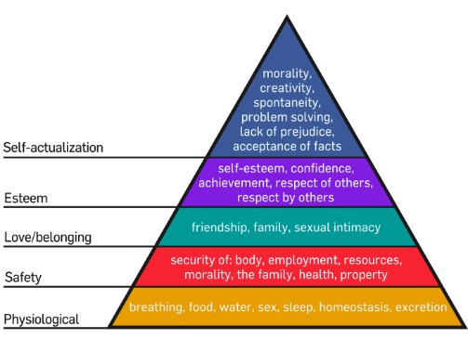
Each of these needs can be equally applied to a community or a community group. If the reader substitutes human needs with community needs, and self-actualisation as the success of the community as an entirety or a group that exists within that community. In this case the town of Burry Port.

@ Marsha Chan(2016)

Wales is in the unique position of being the only country/Principality in the world to make legislation that applies Well-being for future generations to its population. In her press release Sophie Howe, Future Generations Commissioner for Wales stated -
“ in 2015 Wales became the first and only country to legislate for future generations When the National Assembly of Wales passed the ground-breaking Well-being of future generations Act Wales.2 Howe, S. (2019).
She further reported the necessity for “organisational change” and “ a cross sector movement, where public, third and private sector organisations, strive towards a shared vision which is long term, responsible and collaborative”. (sic).
The Well- being of future Generations (Wales) Act 2015 imposes duties on local authorities and health boards to set up what termed Public bodies as detailed below
Public Bodies
Welsh Ministers | Local Authorities | Local Health Boards
Public Health Wales  NHS Trust | Velindre NHS Trust | National Park  Authorities
Fire and Rescue  Authorities | Natural Resources  Wales | The Arts Council  of Wales
Sports Council of  Wales | The National Library  of Wales | The National Museum of Wales
WCVA (2019)
The public bodies will, in conjunction with Public Service Boards within local authorities deliver local well-being plans, the public service boards include that of Carmarthenshire, Bridgend, Swansea Monmouthshire, Blaenau Gwent, Caerphilly, Merthyr and RCT-Cwm Taf, Pembrokeshire, to name a few. The local well being plans will detail how the boards will improve the local, social, environmental, economic and cultural well being of the community they serve. WCVA (2019)

The ACT has put in place seven well-being goals which must be addressed by the public Bodies and Service Boards. These being
- A globally Responsible Wales
- A Prosperous Wales
- A resilient Wales
- A healthier Wales
- A more equal Wales
- A Wales of cohesive communities
- IA Wales of Vibrant culture and thriving Welsh language
Welsh Government
The reader will now begin to visualise the complexity of addressing community well-being and achieving the wellbeing goals by looking at the numbers of agencies and variety of disciplines involved in the processes. Furthermore, the Act lays down a sustainable development principle that informs the bodies how they should go about achieving their goals.
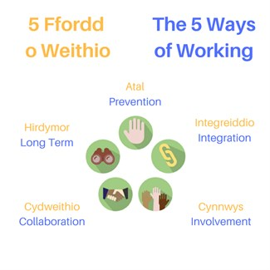
WCVA (2019)

It can be seen from the above image that there is an expectation of joint working , multi-disciplinary teams i.e. integration, collaboration, involvement. The community of Burry Port is currently experiencing a period of change, partially brought on by public discontent and hard feelings due to the local development plan now going ahead with large housing developments in the town. The feelings have been commented on for several months in local press. On 2nd June, 2019, a lead headline on Wales Online stated ‘ The town at war over a development which will change the face of it’ ‘ The future of Burry Port has divided residents and many are nervous about what’s to come’ Bannon, C. (2019) The news item details and illustrates the proposed developments of over 400 residential homes, a hotel, public house, café, supermarket, enterprise zone and leisure outlets are planned. The article puts forward several opinions both for and against the development and appears to have chosen a variety of people of differing ages. However, looking at the goals of the Act in detail one of which is a healthier Wales the residents of Burry Port agree that any future development in the town will affect the infrastructure including schools and health facilities. Until two years ago there were two doctor’s surgeries in the town one of which closed, leaving an already overstretched health centre which has also seen two doctors leave. The online newspaper reports
“At the time it was believed that Harbour View Surgery had around 1,400 patients, many of whom later tried to transfer to the nearby Meddygfa Tywyn Bach as a result of its closure.
Hywel Dda University Health Board confirmed that as of April 1 this year, Meddygfa Tywyn Bach had 7,215 patients - a significantly higher number than the amount previously registered with Harbour View. Bannon, C. (2019).
It is reported by Carmarthenshire County Council that Burry Port has the highest proportion of people aged over 45, proportion aged over 65-74 and 75+ higher than the Carmarthenshire average. Higher proportion than the Carmarthenshire average of people with limiting long term illness. It would be a safe assumption that the needs and wishes of those residents will differ from those of younger people who may want to see facilities more suited to them such as restaurants, cafes, perhaps a leisure centre. A proposed new eco-friendly housing development with accommodation that is suitable for adaptation in future for older persons with access to a care centre next door has been met with opposition due to the fact that it will take away informal parking from the houses opposite and create more traffic in the town. Councillor Amanda Fox stated in an interview “ the new housing does come at a cost of losing an area of green space but the benefits of new affordable housing outweighs the cost of losing the land, some local residents are concerned about parking, When asked about the lack of health facilities to accommodate incomers she said The more people who come in to Burry Port the more ammunition we have for doctors and services. The writer argues that this is an unsafe outlook for the health and well being of the local residents, due to insufficient GP services.
There are several independent businesses in the town that include one remaining butcher shops, a gift shop, several barbers and hairdressers two opticians and Co-operative store, gif t shop and cafes. The flagship redevelopment has been that of the Royal National Lifeboat Institution new Lifeboat Centre, the lifeboat and its’ crewmembers form the hub of the community with the majority of the crewmembers either younger and have been to school locally or older and are local businesspeople. Not one person in the town spoke out against the development and welcomed the new landmark which provides training facilities and a shop fully accessible to all with a viewing platform for both boats and is seen as a tourist attraction.
The Pembrey and Burry Port Town Council recently held public meetings to which all residents were invited in order to access community forums that fell into the seven well-being goals -after which the council published a further online invitation for the community - http://pembreyburryport-tc.gov.uk/latest-news-for-pembrey-and-burry-port/ that asks for further input
When describing the aims and objectives of the public meetings Councillor Mike Theodulou stated
‘ The move is driven by the Wellbeing and Future Generations Act and the Town Council is taking this opportunity to change how it works by handing over more decisions to the people it serves. This is a new way of working, a way that makes us the Peoples Council. In challenging times with cutbacks to funding and increased demands on public services we have to change the way we do things. Different parts of the system should no longer work in isolation to each other and Town Councils should not work in isolation to the people they serve. Working with the community makes us more powerful and abler to get things done.”
These words accurately sum up the aims of the public bodies, the writer would argue that if one examines the members of the forums and public service bodies natural opposition could be described as an expectation, if one returns to the Wales online news item one resident is quoted as Pressure needs to be put on the owners of the empty shops on Station Road to bring them back to life," he said. “do these before building more houses and an enterprise site. Let's get what we've already got right first." Sic
The own council has arranged a public ‘well-being’ event to be held at the end of the month. Which could suggest there is a move to council run events taking place as a result of the recent meeting due to the fact The writer is responsible for the attendance of the RNLI to give sea safety training due to a well- received suggestion from the writer at that time. – ( Appendix A). It should be noted that the poster is bi-lingual and the majority of the activity providers are local if not to the town to the county, it remains to be seen if the event is inclusive of all abilities. The writer argues that events of this kind would serve the community and its transient tourist community well if it became a monthly event.
In another attempt to address Well-being The Co-operative Group commissioned a piece of research work in 2018’ to be able to understand and establish what matters to the residents in the communities it serves’ the research informed a report published by the Co-op The Community Well-being Index: people place and relationships. The Co-op partnered with Geolytics which provides data and mapping tools via Google and The Young Foundation – an independent think tank which specialises in social innovation to be able to provide a picture of how the Co-op community foundation can measure and assist to improve Community Well-being. Views were sought from experts in academia, local government and third sector organisations. Four hundred people were asked about what matters to them in their communities. It has to be acknowledged that this is a very small sample and there is no mention of any disparity of age or ethnicity.
The research identified what matters most by hosting community workshops over UK and invited participants to comment on what matters most the them. This fell into three main categories with three sub-categories People – health, education and learning, economy, work and employment, Relationships – relationships and trust, equality, voice and participation, Place – culture heritage and leisure, housing , space and environment, transport, mobility and connectivity. It can be seen that the well-being commented on by the Co-op is not entirely dissimilar from the Well-being of Future Generations (Wales) Act 2015 and neither of those are too far removed from Maslow Hierarchy of Need. The Act focuses on national well-being to be in accord with legislation, whereas the writer is well aware that the Co-op Community Wellbeing Index is biased towards where the stores are, this is out of necessity because the results of that research will inform how the stores can best collaborate with it’s customers and provide what is needed locally. The report itself is detailed and gives the reader an in depth knowledge of what indicators have been used to calculate results some of which involve the proximity of shops and co-op member engagement – an obvious bias however it could be argued that this type of index gives a far more reliable view of local wishes than a council facilitated public event that aligns itself to government policies which could be biased purely because of the political views of the participants as opposed to the local politician delivering the event.
The writer has accessed the well-being index produced for Burry Port Town (Appendix B) and using local knowledge would comment that these represent an accurate picture of the town reflecting the limited availability of G.P, the struggling local economy, the recent building of a new Welsh language medium school, a large comprehensive school and two nurseries. There is a culture of mistrust in the local town council which is again reflected in the score in the Co-operative Community Well-being Score. This index appears to be at a grass roots level reflecting what is happening locally.
Burry Port is currently a town in dispute with itself there is a huge divide over what the town needs to prosper and become resilient, the old industries such as Carmarthen Bay Power station have disappeared. The local cockle beds are now managed by Natural Resources Wales. Natural Resources Wales (2019) one of the designated public bodies under the Act, there are several local men ‘one the cockles’ as it is known colloquially, this rarely provides a sustainable income and is to certain extent weather permitting and certainly well licensed and seasonal. The town is well served by rail and bus networks but the times are not conducive to shift work patterns for industries such as TATA steel in nearby Llanelli.
Whilst the town and county councils are pressing for more housing and large developments in the town of Burry Port which is stated will improve the economy it has been reported in Issues – World Health by UNICEF that children in UK are being denied their basic human right to clean air and face a long term health crisis because of fumes they breath in on their way to and from school. Issues Vol 348 pg 10.
In May 2018 the Welsh Audit Office published a report entitled Reflecting on Year One: How have Public Bodies Responded to the Well-being of Future Generations (Wales) Act 2015.? The report contains overarching statements such as ‘No other nation is taking these bold steps to legislate for the long-term well-being goals …… it will serve as the central theme of all our policies and legislation.’ Cuthbert J, Minister for Communities and Tackling Poverty, 2014. Another ‘ The Bill is perhaps the most ambitious piece of legislation that the Welsh Government has ever attempted. It will require a fundamental shift in how we seek to tackle or biggest challenges as a nation.’ Carl Sargeant Natural Resources Minister, 2014. In conclusion to this report the Auditor General Concluded that: Public bodies support the principles of the Well-being of Future Generations (Wales) Act 2015 and are taking steps to change how they work. Huw Vaughan Thomas Auditor General for Wales (2018).
In comparison, during the year October 2017 to October 2018 the Co-operative stores in UK raised £19m from carrier bag levies, co-op brand points earned and selling re-usable carrier bags. From now until 2020 the Co-operative Group is working with Locality – an organisation that is aiming to save endangered space in local areas to prevent them being sold off for building etc. The Co-op and Locality have this year committed to work in partnership to save 2000 of such spaces by 2022. Asking people to nominate local endangered spaces in their communities to save them. Co-op Group (2019).
The writer asks are these not a more tangible and acceptable demonstrations of community engagement delivered by community organisations in the locale, rather than albeit well-meant public meetings facilitated by politicians with sometimes opposing views and no budget to carry out the wishes of the community without the need to apply to committees and sub committees? There are no easy solutions to managing community well-being, particularly when there are political influences that rely on multi-disciplinary teams/agencies with differing needs and the public at large with different wishes.

APPENDIX A 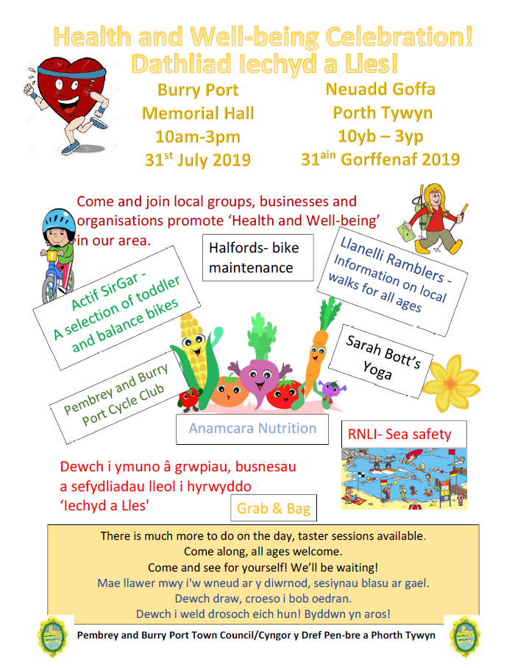

Appendix B

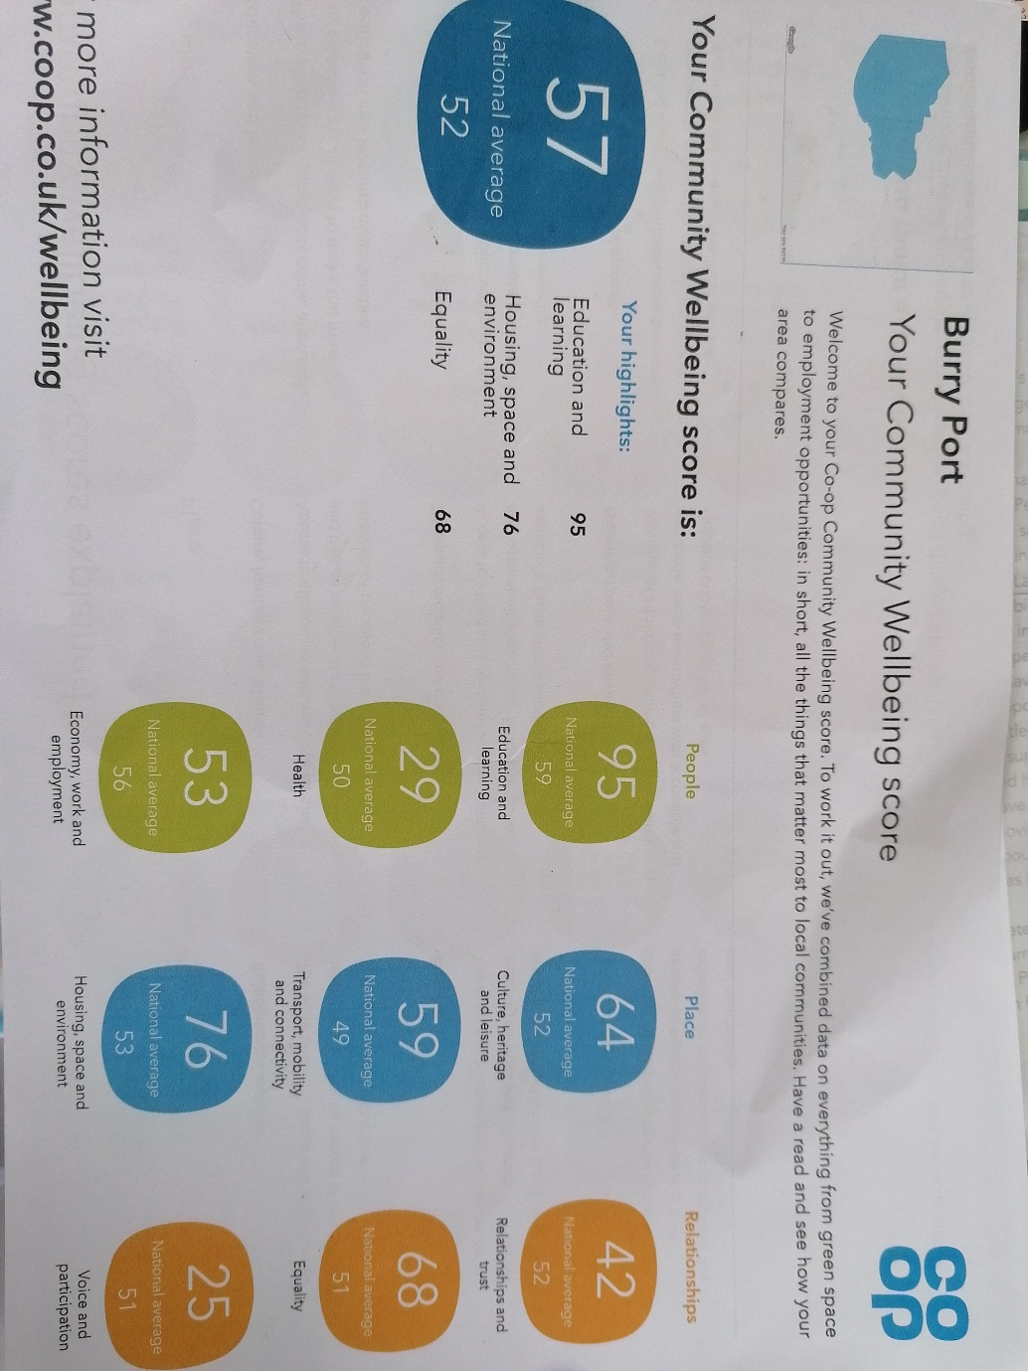

Sarah Marsh 28002939 ECAY 5001 - Resubmission

References
Bannon, C.
Birkbeck, R. (undated), The Co-operative Group Limited, The Community Wellbeing Index, people, place and relationship. (2018).
Available at: Co-op.co.uk/wellbeing
Downloaded 2018

Burry Inlet cockle fishery order 1965, Management Plan.

Department for Natural Resources of the Welsh Government. Well-being of Future Generations Act Wales (2015), The Essentials, May 2015.
Marsha, C Maslow’s hierarchy of needs.
Available at:. https://medium.com/@MarshaChan/applying-some-psychology-to-social-media-9deb505f678
Accessed 13th July 2019

Taylor, M (2019) UK Children denied basic human right to clean air , says UNICEF.
Cited in Biram, T(2019) World Health Cambridge: Independence Educational Publishers

Shin, D., & Johnson, D. (1978). Avowed happiness as an overall assessment of the quality of life. Social Indicators Research, 5(1), 475–492. http://dx.doi.org/10.1007/BF00352944Cited in Dodge, R., Daly, A., Huyton, J., & Sanders, L. (2012). The challenge of defining wellbeing. International Journal of Wellbeing, 2(3), 222-235. doi:10.5502/ijw.v2i3.4
Welsh Audit Office Reflecting on Year One : How Have Public Bodies Responded to the Well-being of Future Generations Wales (Act) 2015. Welsh Udit Office, 24 Cathedral Road, Cardiff 2018.

WCVA What we do, The future Generations Act Wales, What you need to know
Wales Council for Volunteering 2019

World Health Organization. (1997). WHOQOL Measuring Quality of Life. Geneva: World Health Organisation.

