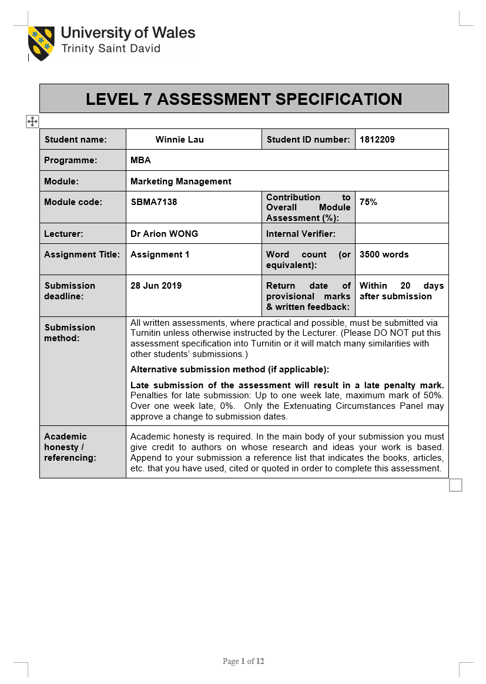

Title: A marketing report of Giordano Ladies

Executive summary
This report was to appraise the key marketing activities of Giordano Ladies by Giordano International Limited. This report evaluated the future developments in marketing through technology to recommend ways of improving its marketing strategies. The research draws attention to the situation analysis of Giordano Ladies and its marketing mix. It is recommended that take immediate measures to launch the online shopping store.
Table of contents | Page
1. Introduction | 3
2. Situation Analysis | 5
2.1 Macro environment | 5
2.2 Micro-environment | 6
2.3 Political | 7
2.4 Economical | 7
2.5 Social | 8
2.6 Technological | 8
2.7 Impacts in the coming three years | 8
3. Market Strategy | 9
3.1 Segmentation | 9
3.2 Targeting | 10
3.3 Positioning | 10
4. Marketing Mix | 11
4.1 Product Offering | 11
4.2 Price | 12
4.3 Promotion | 12
4.4 Place | 13
5. Promotional Mix | 13
6. Recommendations and Conclusion | 14
7. References | 16

- Introduction
This paper appraised the key marketing activities of an apparel retailer in the business sector of fashion apparel and accessories in Hong Kong. According to Chan (2019), Chan mentioned that the apparel industry is a major manufacturing sector of Hong Kong with the largest manufacturing forces in Hong Kong. There were 603 established companies and employed 4,027 workers as of March 2018. Hong Kong is considered as a clothing industry sourcing hub and also a distribution and promotion center in Asia-Pacific. There are many large international apparel retailers operated in Hong Kong such as Gap, Zara, H&M, Marks & Spencer and various premium clothing brands such as Club Monaco, Calvin Klein, Ralph Lauren and etc. Other than the international ones, there are a few well-established local appeal retailers have entered into the appeal retailing market in Hong Kong very long time, such as Crocodile, Giordano, Baleno, G-2000, Bossini, Episode, Esprit, Moiselle and I.T. This paper selected the label of Giordano Ladies by Giordano International Limited to appraise its key marketing activities and the contribution of its marketing department for Giordano Ladies. This paper analysed the data of its products, markets, competitors and customer to evaluate a marketing plan of future developments for three years in the field of marketing through technology.
Giordano International Limited was founded in 1981. It is a Hong Kong fashion brand and clothing retailer of men’s, women’s and children’s apparel. It is traded at Hong Kong Stock Exchange with code 709. The financial report stated that it has more than 2,400 retail stores operating in more than 30 countries across Asia, Australasia and the Middle East. It is one of the major fashion retailers in the Asia Pacific market. The annual report mentioned that the company and its subsidiaries distribute and sell fashion apparel under the brand names of Giordano, Giordano Ladies, Giordano Junior, BSX and Beau Monde. (Giordano, 2018)
Giordano Ladies was launched in 1997. It is considered as a high end and premium women appeal brand among the Giordano Group. It presents a culture of simple but stylish, classic and timeless clothes to expresses a woman's special character and brings out her inner beauty in every angle. The clothes are tops, t-shirts, skirts, wide leg trousers and dresses in a simple and timeless design and classic colors such as while, light pink and beige. The brand provides comfortable shopping space and warm customer service to every visitor. The annual report of 2018 stated that the sales of Giordano Ladies was continued to grow. (Giordano, 2018) There were 84 Giordano Ladies stores in 2018 which recorded total sales of 452 million, compared with total sales of 423 million in 2017, representing an increase of 6.9%. For operating profit, it recorded 72million in 2018, compared with operating profit of 67 million in 2017, representing an increase of 7.5%. (Giordano, 2017)
- Situation Analysis
This chapter analysed the current industrial environment of Giordano Ladies in various aspects including Macro-environment, Micro-environment, political, economical and social. This chapter then forecasted the impacts of the company in the coming three years.
  - Macro-environment
The health of the overall economy influences the company’s performance as well as the business in whole clothing industry. The business was affected by the Sino-US trade dispute and volatility in the stock market, which increased uncertainties on Hong Kong and China’s economic growth and negatively impacted the domestic retail performance. According to Census and Statistics Department (2019), the Gross Domestic Product (GDP) increased by 0.6% in real terms year on year in the first quarter of 2019, compared with the increase of 1.2% in the fourth quarter of 2018. Due to the slowdown in global economic expansion and the increasing uncertainties from the external environment, the Government's forecast of Hong Kong’s GDP for 2019 is to increase by 2% to 3% in real terms. The Hong Kong Trade & Development Council (2019) published the latest retail sales figures, it decreased by 4.5% in nominal terms year on year in April 2019 over the same month a year earlier, compared with a year on year decrease of 0.2% in March 2019. The uncertainty seems continue to prevail and the retail sector will face ongoing challenges from the slowdown of macroeconomic conditions.
  - Micro-environment
The microenvironment has been defined as a company’s external business environment. The suppliers, customers and competitors are the external environments’ factors beyond the control of marketers but influence the marketing strategy made by management. According to the annual report, Giordano (2018) stated that there was an increased in cost by the Renminbi exchange rate appreciation as the raw material suppliers are mostly from Mainland China. However, the impact began to diminish with the help from the suppliers in Vietnam and Bangladesh and Renminbi began to depreciate in 2019. From the business challenges mentioned above, the consumer sentiment is expected to be cautious and constantly evolving consumer behavior will all pose challenges to the business in the longer term. The major competitors are Club Monaco, Massimo Dutti from the Inditex group which is the same group with Zara and Esprit. They are offering high-quality clothing with classic design. The products are similar with Giordano Ladies. However, Massimo Dutti and Esprit offer 30 days return with full refund if customers change their mind. This can be an advantage for them to draw customers to revisit their stores frequently. Esprit also has online store with free shipping.
  - Political
According to the Hong Kong Trade & Development Council (2019), it mentioned that most of the Hong Kong clothing retailers have been switching the production line from mainland China to Southeast Asian countries like Indonesia, Vietnam, Bangladesh and Cambodia due to the stricter environmental regulations on the Chinese mainland. When the nationwide environmental stress is high, and the production cost is higher follow by the high regulation cost. Strengthening environmental regulation would have some negative influences on the manufacturing factories in China. (Wang and Feng, 2014) However, those Southeast Asian countries are not matured enough to handle high quality clothing. Hence, the company remains the high-end clothing production part in China and leaves the non-sophisticated part for Southeast Asian countries.
  - Economical
According to the annual report of Giordano (2018), mentioned that there was an increased in cost of raw materials due to the Renminbi exchange rate appreciated in 2018. Also, it was an increase in labor cost in China. (Trading Economics, 2019). Even though the company started to source and to produce the products in Southeast Asian countries but there will be foreign currency risk. The impact of currency fluctuation will affect the profit of the company.
  - Social
Social medias have heavy cultural influence on the fashion market and on the consumers nowadays. Consumers are easily influenced by the Key Opinion Leaders (KOLs) from social media such as Facebook, Instagram and YouTube. The KOLs from internet are different pertaining to different geographies. Since the clothing from Giordano Ladies are quite simple and classic but standardized. It should consider different cultures of different geographies. Moreover, Giordano (2018) claimed that the two strategic channels of e-business and franchising will continue to be our key drivers in the medium term. The Giordano brand offers online shopping but not in the case of Giordano Ladies. Zhang et al (2017) argued that the greater usage of
social medias have positive relationship with consumers’ online shopping activity. The article mentioned the retailers expose new shopping-related information to their potential customers to achieve greater marginal revenue. The group should consider developing the online shopping platform for it. E-business plays a big role to capture the customers who do not have time to shop but have time to surf the internet.
  - Technological
Development of online and mobile app shopping platform leads to increase in sales and cost savings from operating costs in long run. Chan(2019)reported that there were 533 million online shoppers in 2017 and appeal and accessories were among the most purchased items online in the Chinese mainland. The online shopping website will eventually evolve from a tool to a lifestyle.
  - Impacts in the coming three years
Giordano Ladies is offering high-end clothing and it will face ongoing challenges from the slowdown of macroeconomic conditions in the coming three years. The major competitors like Massimo Dutti and Esprit have full refund policy to draw their regular customers to visit more often. Giordano Ladies would lose market share to them if remain the same return policy. For the factories in the Southeast Asian countries, the group could consider to provide more skill training to them so they could handle sophisticated clothing production in the near future to avoid the higher production cost and currency fluctuation from China. E-business will continue to play a big role in coming three years. Hence, develop a comprehensive online and mobile app shopping platform is necessary.

- Market Strategy
This chapter analysed the segmentation, targeting and positioning strategies of Giordano Ladies and examined the existing marketing mix. Efanny, et al (2018) stated that a marketing program is made by the company to build brand image with its existing customers and potential customers. A good marketing plan is a critical driver for the business.
  - Segmentation
Based on FORD (2019), segmentation strategies are to differentiate between one group of customers and another. The segmentation of Giordano Ladies is simple, and it can tell by the brand name which is for woman. Segmentation is the gender female and the brand only offer clothing to female. Statista(2019), disclosed a statistic report about popular online shopping categories in the United States in 2017. It was found that a more female shoppers then male shoppers had purchased clothing online in the past 3 months in 2017 via internet for apparel and accessories. According to Cho and Workman (2014), they mentioned that women had greater desire in shopping for fashion than men. Women had a greater tendency to enjoy processing feelings during apparel shopping.

Hence, the female customer segment is continuing to lead in consumption as they not only shop for what they need also what they desire.
  - Targeting
For the segmentation of Giordano Ladies is the gender female , it defines ladies as its target customers. The company is targeting the clothes for female aged between 25 to 50 which are the middle-aged women in Hong Kong as they may have more financial assets then the younger aged group. Occupations of target market for this target are office ladies, businesswoman and female entrepreneurs as can afford higher price. Giordano Ladies presents the concept of looking smart and classic for work. For the ladies who like classic clothes and the best quality of products to wear it to work.
  - Positioning
Positioning of Giordano Ladies is high value for high priced. With positioning high value for money, the company give the best quality of products and a comfortable shopping area for the customers. When the middle aged women come to shopping, they prefer to spend on items that offer comfort, not radical and value-for-money besides the designs. Giordano Ladies provides fashionable clothes with decent quality at a higher price. With positioning high-priced clothing ,Giordano Ladies also provides warm customer services with the well-experienced sales assistants.

- Marketing Mix
Managers should utilize the marketing mix when employing a marketing strategy to to influence consumers to purchase its products. ( Sinapuelas, et al, 2015). In order to formulate strategic marketing program, marketing objectives and strategies are specified. Follow with identified four program components, namely as Product offering, Price, Promotion and Place. The manager of a company uses the marketing mix of controllable variables to carry out a marketing strategy. From the company website, it stated the corporate mission is to provide the simple, modern and classic clothes to bring out the inner beauty in every woman.
  - Product Offering
In order to stay competitive in the market, the company should make strategies to introduce products which are high in demand, then remove the ones which cause loss to the company. Strategic decisions regarding the clothing quality, fabric, design, product variety, features and packaging are to be made by managers. The unique features of the Giordano Ladies’s clothes is timeless. The clothes will not go out of style anytime soon. The design is trendy but simple and has a good quality for the material. The product collections are basic and practical women’s tops, t-shirts, skirts, wide leg trousers and dresses. Giordano Ladies often uses cashmere and silk as the fabric to make the clothes look finer and feel softer on skin. For services , the stores has the alternation services for clothes with extra charges. Customers can alternate the trousers and customized the clothes to the best fit for body. The value-added services give to the customer for their satisfaction.
  - Price
The price of Giordano Ladies is considered as high-priced. The price for the middle-aged businesswomen is affordable for them. However, in order to remain popular in the market, the company should consider using the going-rate pricing approach that maintains product price equal to its major competitors. For example, to estimate customer value by assessing value in use is the way that by selecting a reference product such as a hot-selling item to compare the price to a major competitor’s product. Moreover, Giordano Ladies could offer trade-in allowances as a form of incentive for customers who bring their unwanted clothes to recycle and buy new ones with discount. It could deliver higher satisfaction for customers as it is an environmentally friendly activity.

  - Promotion
For the advertising, Giordano Ladies does not have much advertisement. It has internet appearance on Facebook and Instagram. However, there is no online coupon or subscription discount or it. The company accounts on Facebook and Instagram are relatively simple compare to its competitors like Massimo Dutti and Club Monaco. For the sales promotion, it has two times per year and it happens usually in June and December which is around the same time with the major competitors. Giordano Ladies uses personal selling assistants to handle the customer’s enquiry, deliver the fashion trend information and explain about the clothes whereas Massimo Dutti leaves the customer free to shop. There is a advantage for Giordano Ladies as sales assistants could help the company to sell more.
  - Place
Giordano Ladies now to reach its customer is through its stores. It has account on internet but there is no shopping website and mobile app. It has 13 stores among Hong Kong island, Kowloon and New Territories They are either located in prime areas or in a shopping mall. It provides relaxing and comfortable shopping space to its customers. Dennis et al (2018) stated that women shoppers tend to browse and enjoy shopping more then men. They are the emotional shoppers. Thus, women will purchase more when they are in a comfortable and relaxing environment. From the above evaluation, Giordano Ladies provided premium clothing for middle-aged women with a high-priced and fine shopping experience. It reaches its customers in the physical store. However, it can not capture the people who like to shop online. It will lose market share to its competitors that have online shopping platform.

- Promotion Mix
In order to increase market share and increase the demand for goods. The company can use a promotional mix to achieve the objective. Firstly, to define the audiences, set promotional objective, define the promotion budget, design the promotion mix and evaluate the result. Based on the analysis from the previous chapters, Giordano Ladies should adopt market penetration strategy. To increase the market share by increasing the penetration of current with current products, increasing the frequency of customer visitation and increasing the quantity per sales purchase. The promotion mix should take place on online store. To gain the competitive strength by enlarging market share, enhancing brand awareness and brand preference on internet. According to WRIGHT, B. et al. (2017), the marketing study stated that there is a positive relationship between marketing mix-related social media communications and brand equity and purchase intention from customers. The audiences are the busy female individuals who aged between 25 to 50 and do not have time to go to the store. Hence, they can shop whenever they have the free time. The promotional objective boosts the growth of sales by increasing total sales in 10% per year in the coming three years. The promotion budget can be high at the beginning even though the company already has a website. The company need to develop a payment platform, enhance the product pages and develop of some online shopping assistants such as virtual fitting, video shopping and mobile snapshot for clothing.

When it has the shopping platform, marketing department should aggressively mail out fashion trend information, product max and match information to the ones who subscribed the newsletters. When customer purchase one thing, the company could send out a mail for recommendation for customer to increase the add-on sales. After the program is launched, managers can evaluate the result of campaign and monitor customer’s activities by subscription record and purchasing record.

- Recommendations and Conclusion
The growing variety of online shopping sites such as ASOS Marketplace in the UK and Taobao in China, plus the group shopping like G-market in Korea and mobile retailing, is expected to boost online shopping and sales further. According to Chan (2019), the report estimated that global retail online shopping sales will growth to US$4.5 trillion by 2021, up from the 2017 level of US$2.3 trillion globally. Thus, to develop online shopping platform is a must. Also, customers nowadays are becoming more thoughtful and socially conscious. The drive to embed sustainability within the clothing industry will likely bring forth new materials and innovative ways of production and product promotion such as enable the reuse and recycling of textile fibers and fabrics. Fast fashion brand H&M also has responded by expanding their assortment of sustainable clothing. The company may consider to use stain-resistant and wrinkle-free fabrics as an innovative design. Promotion for recycle unwanted clothes a new method to draw customer’s attention.

- References

Census and Statistics Department. (2019) Census and Statistics Department. [online] Available at:
https://www.censtatd.gov.hk/press_release/press_releases_on_statistics/gdp/gdp_1q2019/index.jsp

Chan, L. (2019). Clothing Industry in Hong Kong | HKTDC. [online] M.hktdc.com. Available at: pagehttp://m.hktdc.com/business-news/article/Hong-Kong-Industry-Profiles/Clothing-Industry-In-Hong-Kong/hkip/en/1/1X000000/1X003DCL.htm [Accessed 2 Jun. 2019].

Cho, S. and Workman, J. E. (2014) ‘Relationships among Gender, Fashion Leadership, Need for Affect, and Consumers’ Apparel Shopping Preference’, Family & Consumer Sciences Research Journal, 42(4), pp. 369–385. doi: 10.1111/fcsr.12070.

Dennis, C. et al. (2018) ‘A Cross-National Study of Evolutionary Origins of Gender Shopping Styles: She Gatherer, He Hunter?’, Journal of International Marketing, 26(4), pp. 38–53. doi: 10.1177/1069031X18805505.

Efanny, W. et al. (2018) ‘The relationship between marketing mix and retailer-perceived brand equity’, IMP Journal, 12(1), pp. 192–208. doi: 10.1108/IMP-12-2016-0019.

FORD, J. B. (2019) ‘What Do We Know About Segmentation and Targeting?’, Journal of Advertising Research, 59(2), pp. 131–132. doi: 10.2501/JAR-2019-018.

Giordano. (2017).Giordano. [online] Available at: http://corp.giordano.com.hk/en/financial_reports.aspx [Accessed 2 Jun. 2019].

Giordano. (2018).Giordano. [online] Available at: http://corp.giordano.com.hk/en/financial_reports.aspx [Accessed 2 Jun. 2019].
Sinapuelas, I. et al. (2015) ‘The interplay of innovation, brand, and marketing mix variables in line extensions’, Journal of the Academy of Marketing Science, 43(5), pp. 558–573. doi: 10.1007/s11747-015-0437-6.

Trading Economics. (2019). Trading Economics. [online] Available at:
https://tradingeconomics.com/china/labour-costs [Accessed 6 Jun. 2019].

Wang, Z. and Feng, C. (2014) ‘The impact and economic cost of environmental regulation on energy utilization in China’, Applied Economics, 46(27), pp. 3362–3376. doi: 10.1080/00036846.2014.929629.

WRIGHT, B. et al. (2017) ‘Brand Marketing via Facebook: An Investigation of the Marketing Mix, Consumer-Based Brand Equity, and Purchase Intention in the Fitness Industry’, Marketing Management Journal, 27(2), pp. 131–142. Available at: http://search.ebscohost.com/login.aspx?direct=true&db=bth&AN=128190013&site=ehost-live (Accessed: 7 June 2019).

Zhang, Y. et al. (2017) ‘Online Shopping and Social Media: Friends or Foes?’, Journal of Marketing, 81(6), pp. 24–41. doi: 10.1509/jm.14.0344.

Statista. (2019) Statista. [online] Available at:
https://www.statista.com/statistics/311406/us-online-shopping-categories-gender/ [Accessed 2 Jun. 2019].

