PROGRAMME: MASTER OF BUSINESS ADMINISTRATION
MODULE: MARKETING MANAGEMENT
MODULE CODE: LCMB7024
ASSIGNMENT TITLE: ASSESSMENT COMPONENT 2: MARKETING STRATEGIES PORTFOLIO
STUDENT NAME: Nicolae Mihai
Teacher: TaongaKaonga Sobere-Sinthers

STUDENT ID: 2124103@student.uwtsd.ac.uk

Table of Contents
1. Introduction 2
Element 1: Brand Extension Overview 3
Poster 3
2.1 Description of the Brand Extension 4
2.2 Market Appeal and Emerging Trends 4
2.3 Sustainability Alignment 4
Element 2: Segmentation, Targeting, Differentiation and Positioning (STDP) 4
3.1 Market Segmentation Analysis 4
3.2 Target Market Selection 5
3.3 Differentiation Strategy 6
3.4 Brand Positioning 6
Element 3: Marketing Mix Strategy (7Ps) 7
4.1 Product 7
4.2 Price 7
4.3 Place 7
4.4 Promotion 8
4.5 People 8
4.6 Process 8
4.7 Physical Evidence 8
Element 4: Reflection 9
5.1 Reflection on Brand Extension Development 9
5.2 Reflection on Poster Design and Presentation 9
5.3 Personal and Professional Development 9
5.4 Areas for Future Improvement 10
6. Conclusion 10
7. References 11

1. Introduction
Amazon is a technology-focused, global brand that has grown to be an e-commerce enterprise, with significant competence in areas of cloud computing, artificial intelligence, digital media, and smart technologies. Its focus on sophisticated data analytics, personalisation through artificial intelligence, extremely efficient global logistics networks, and the cloud infrastructure, is offered by Amazon Web Services. These strengths lead to a customer-obsession, innovation, operational excellence, and long-term value-creation-focused brand identity. Amazon has a strong brand equity as evidenced by customers who are trusting it, loyal, convenient, fast, and technologically mature. The highly competitive and dynamic technology markets require continuous brand building to maintain the growth, competition leadership and relevance to the evolving consumer demands. The customer-centricity and focus on innovation enables Amazon to consider brand extension as one of the strategic options, where the company can utilise the existing brand equity when expanding into new value-generating areas. The new brand extension proposed by Amazon, “Amazon EcoSmart Living”, is presented as a technology-powered sustainable living platform that combines innovation with sustainability.

Element 1: Brand Extension Overview

Poster
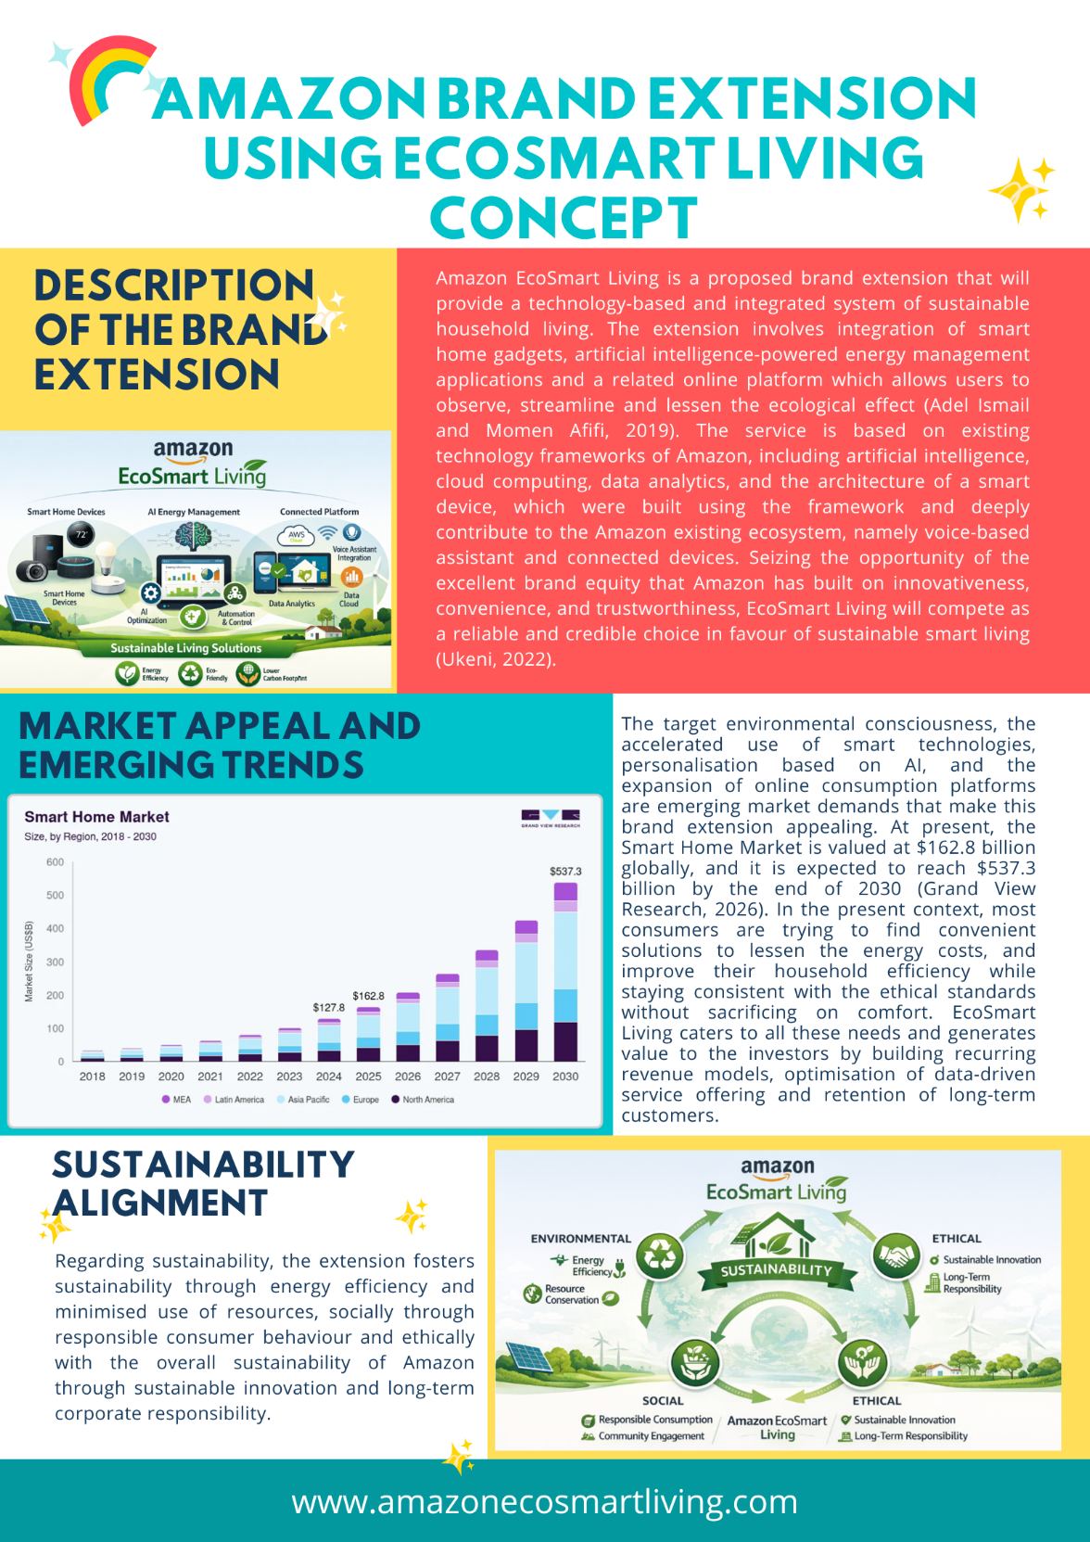
Figure 1: Amazon EcoSmart Living Brand Extension Concept Poster
(Source: Learner)

2.1 Description of the Brand Extension
Amazon EcoSmart Living is a proposed brand extension that will provide a technology-based and integrated system of sustainable household living. The extension involves integration of smart home gadgets, artificial intelligence-powered energy management applications and a related online platform which allows users to observe, streamline and lessen the ecological effect (Adel Ismail and Momen Afifi, 2019). The service is based on existing technology frameworks of Amazon, including artificial intelligence, cloud computing, data analytics, and the architecture of a smart device, which were built using the framework and deeply contribute to the Amazon existing ecosystem, namely voice-based assistant and connected devices. Seizing the opportunity of the excellent brand equity that Amazon has built on innovativeness, convenience, and trustworthiness, EcoSmart Living will compete as a reliable and credible choice in favour of sustainable smart living (Ukeni, 2022).

2.2 Market Appeal and Emerging Trends
The target environmental consciousness, the accelerated use of smart technologies, personalisation based on AI, and the expansion of online consumption platforms are emerging market demands that make this brand extension appealing. At present, the Smart Home Market is valued at $162.8 billion globally, and it is expected to reach $537.3 billion by the end of 2030 (Grand View Research, 2026). In the present context, most consumers are trying to find convenient solutions to lessen the energy costs, and improve their household efficiency while staying consistent with the ethical standards without sacrificing on comfort. EcoSmart Living caters to all these needs and generates value to the investors by building recurring revenue models, optimisation of data-driven service offering and retention of long-term customers.

2.3 Sustainability Alignment
Regarding sustainability, the extension fosters sustainability through energy efficiency and minimised use of resources, socially through responsible consumer behaviour and ethically with the overall sustainability of Amazon through sustainable innovation and long-term corporate responsibility.

Element 2: Segmentation, Targeting, Differentiation and Positioning (STDP)

3.1 Market Segmentation Analysis
Amazon EcoSmart Living focuses on a well-defined and appealing market with the help of a multi-dimensional segmentation strategy. Geographically, the brand extension will pursue the global approach but will have an initial preference to regions that are both developed and fast growing and urbanising including the regions of North America, Europe, and parts of the Asia Pacific (Hugo, 2019). These markets are characterised by rising adoption levels of the smart-home, high-tech digital infrastructure, and favourable regulation and consumer engagement relating to sustainability. The solution can also be developed over the years to suit the emerging markets as more people become digital connected and conscious of the environment.
When it comes to demographic segmentation, the main target group is the young adult segments (25-55 years), which would contain young professionals, dual-income families, and families (Kolny, 2022). The medium-high disposable income, stable employment, and financial ability to spend on smart technologies to bring long-term cost-saving are typical in this group. The jobs mostly involve white-collar positions and knowledge intensive jobs as well as a high degree of digital literacy and regular contact with the global web and related devices.
Psychographic segmentation addresses consumers who embrace convenience, efficiency, and sensible consumption. These people have busy, urban lives and are driven by creativity, technological advances and aspects of energy conservation. They are the first or early majority consumers that can incorporate smart technologies in their daily lives in order to add comfort and control (Lin and Chen, 2025).
Behaviourally, the target group is very active in terms of consumption of digital services, subscription-based sites and smart devices (Sanguinetti, Karlin and Ford, 2018). Loyalty levels associated with brand are rather high as a result of having good experience within the Amazon ecosystem, speedy service delivery, and customised solutions. The major advantages to be considered are lower energy price, intuitive automation, convenience, information-based insights, and the value of feeling that we are making our lives more presentable.

3.2 Target Market Selection
Amazon EcoSmart Living provides its services to very attractive segments of the market that have been defined by high potential to grow, rising popularity of smart home solutions, and the growing levels of sustainability consciousness. The core target market is urban, digitally ready, middle- to high-income families that are proactive in their desire to use technology-based solutions to become more efficient in energy consumption and less harmful to the environment. This is a desirable market segment because of its purchasing power, eagerness to embrace new products and long-term value of subscription-based services. The secondary target group comprises the small companies that are environmentally focused and remote workers who need effective and smart energy management systems in their hybrid living and working stations (Chakraborty et al., 2023). These segments are closely correlated with the strategic potential of Amazon, such as the level of data analytics, personalisation with the help of AI, and scalable cloud infrastructure. Besides, an excellent brand reputation of reliability, convenience, and technological advantage makes Amazon more reliable, convenient and, consequently, improves consumer trust. Customers and cross-selling possibilities, as well as long-term competitive edge, are further increased by the fact that the introduction of EcoSmart Living into the existing digital ecosystem of Amazon can enhance customer loyalty to Amazon.

3.3 Differentiation Strategy
Amazon EcoSmart Living is distinguished by the product among competitors in terms of strong integration with the eco-system, the presence of artificial intelligence with personalisation, and a smooth customer experience. In contrast to individual smart home/energy management suppliers, the extension makes use of the end-to-end digital platform of Amazon, connecting smart devices, cloud-based analytics, and voice interactions to one intuitive platform. Artificial intelligence allows optimising energy in real-time, making predictions, and individual recommendations depending on the household behaviour (Guo et al., 2019). The solution will focus on the ease of adoption, centralised control, and frictionless service delivery, with a well-developed infrastructure in logistics and customer support systems. This combined strategy yields a lasting competitive edge by raising switching costs, and raising user dependency on the ecosystem, and empowering the constant improvement of the services provided through learning based on information. Individual features can be imitated by competitors, and the ability to match the scale, data processing, brand recognition, and cross-platform integration that Amazon offers, in order to reduce any potential challenges and strengthen long-term performance of the brand.

3.4 Brand Positioning
Amazon EcoSmart Living will be billed as a convenient, and eco-friendly smart living solution capable of allowing the households to save on their energy use without compromising on comfort and control. The positioning statement will emphasise on positioning the company as “a technology-powered ecosystem that integrates intelligent automation, artificial intelligence-driven insights, and trustworthiness to simplify and make the process of living sustainably easy and appealing.” EcoSmart Living is in a differentiated position between high cost smart home service providers and low-cost less functional service providers. The brand is viewed as a valued and reliable company, which provides advanced functionality, and affordable prices, all supported by Amazon. The expansion is very significant to the overall brand architecture of Amazon as it supports the brand as innovative, customer obsessed, convenient and scalable company (Cruz Lopez, 2023). Being a sub-brand of the Amazon ecosystem, EcoSmart Living has the benefit of supporting the master brand and shares the credibility, technological development, and wide range of customers.

Element 3: Marketing Mix Strategy (7Ps)

4.1 Product
EcoSmart Living, on the most basic level, will offer the key advantage of allowing households to be more efficient and sustainable in their energy consumption. The physical product will consist of smart home, AI-powered energy management software, and a cloud-centred dashboard to provide real-time insights and personal advice. The augmented product adds value with a form of uninterrupted integration with existing smart ecosystems, software upkeep, customer care, and insights that is based on data, which enhances performance over time. It has innovation integrated in its approach (AI, machine learning, and connectivity through AI) (Herrero, Nicholls and Strengers, 2018). High design quality and reliability guarantee usage and simplicity, ensuring compatibility across different devices.

4.2 Price
EcoSmart Living has a hybrid value-based and subscription business model (Schneider and Imai, 2020). With an entry-level freemium, customers can use the most basic monitoring features, reduce adoption barriers and encourage trial. Advanced analytics, automation, and optimisation tools are unlocked to create recurring revenue streams by using premium subscription levels (Bankole and Tewogbade, 2024). Pricing is perceived value based on trade-offs of cost against sophisticated capabilities is that the service can be affordable but technologically developed. The use of competitive pricing can be explained by the economies of scale, cloud efficiencies, cross-subsidisation in the broader ecosystem of Amazon, which is undoubtedly able to deliver strong value, when compared to standalone smart energy solutions.

4.3 Place
The distribution strategy is primarily online, using the services of Amazon platforms, applications, and smart device marketplaces (Hahn, Kim and Youn, 2018). Platform delivery guarantees smooth onboarding, remote access and regular updates without any physical limitation. The distribution of compatible hardware devices is supported across the world with the Amazon global logistics networks whereas cloud-based services are used to provide instant scalability across regions. This mix offers coverage of all places around the globe, quick market penetration and the ability to localise services to regional regulatory and energy infrastructure needs.

4.4 Promotion
EcoSmart Living is adopting the use of integrated marketing communications strategy, that focuses on education, engagement and trust development. Digital advertising emphasises the benefits of cost savings, sustainability and usability and content marketing describes complex energy processes using easily available storytelling (Kexel, Osterloh and Hanel, 2020). The access to social proof and credibility is improved through influencer collaborations with sustainability activists and reviewers of technologies. The brand storytelling focuses on the importance of empowerment, responsible consumption and innovation, promoting credibility and rooting on the customer-based reputation of Amazon.

4.5 People
Human employees as well as interfaces powered by AI represent the people aspect of the business. Technical teams carry out reliability of the system, innovation and constant improvement and customer service teams carry out onboarding and problem solving. AI-powered customer experience, like smart assistants, is unique and personalised. Collectively, these aspects will guarantee high customer satisfaction and common service across touchpoints.

4.6 Process
Service delivery operations are automated, based on data and ease of use. The manual aspect of the processes, are reduced to digital sign-up, device integration, real-time optimisation, and reporting. Automation and AI have the benefit of improving efficiency on prediction of the trend in energy consumption, finding opportunities to optimise, and learning constantly through the behaviour of users (Zaidan and Zaidan, 2020). This guarantees stability in performance as well as minimizes operational expenses.

4.7 Physical Evidence
Physical evidence is mostly digital and consists of an intuitive user interface, application design, dashboards, and the regular use of a consistent branding indicator that makes the quality and trust. Visual representation of energy saving and sustainability implication would be beneficial to perceived value and credibility, as it would ensure that the customers can physically feel the difference that EcoSmart Living would provide.

Element 4: Reflection

5.1 Reflection on Brand Extension Development
Planning of the brand extension for Amazon, EcoSmart Living was a good experience on how the theory of past marketing can effectively be utilised as a strategic plan to a practical technology brand. Such notions as brand equity, the brand extension strategy, STDP, marketing mix, etc. got their actual sense when they were discussed in the context of active and multifaceted Amazon ecosystem. Among the main lessons was the concept of the power of a brand that not only minimises the risk of penetrating the market, but also creates limitations since any extension made should be strictly consistent with brand values and customer anticipations. One of the major issues to withstand strategic decision making process was the balance between innovation and feasibility, especially arrangements of the proposed extension being ambitious but realistic considering competitive pressures, sustainability need and the problem in customer adoption (Uchechukwu, 2024).

5.2 Reflection on Poster Design and Presentation
The elements of poster designing and presentation helped in developing practical communication skills in visual communication and convincing storytelling. To execute a detailed plan into a succinct, Canva Poster, it needed to be clear-thinking and focus on important messages and understand the audience. This exercise enhanced the skill of conveying complicated concepts in a concise manner whilst being strategically coherent (Wisanti, Indah and Putri, 2024). Presentation of the poster was aimed at gaining more confidence in the area of professional communication, especially in explaining strategic reasoning, answering question, and defending decisions in a structured and logical way.

5.3 Personal and Professional Development
Personally and professionally, the project greatly improved strategic thinking, analytical ability and creativity. The review of the market segments, positioning, and competitive differentiation increased the capacity to critically evaluate business issues as a unified whole and adopt evidence-based judgement. One area where creativity was exercised was in designing a new brand extension that inclined sustainability, technology as well as customer-oriented value addition. All these can be directly applied to marketing and management in the future where thinking strategically, being innovative and communicating with stakeholders is essential.

5.4 Areas for Future Improvement
Personal analysis reveals what needs to be enhanced in future, especially the ability to further develop the quantitative analysis and include more specific financial projection to build up the strategic rationale. The increased application of scenario planning and competitor benchmarking would also promote strength in the like projects. There can be better performance in future assignment through increasing time on development of visual material by iterating repeated development, and incorporation more inter-functional viewpoints, operations and finance, to justify more holistic strategic delivery (Wilson, Joiner and Abbasi, 2021).

6. Conclusion
Amazon EcoSmart Living would be an extension of the Amazon brand that is strategically coherent given the existing technological capabilities of Amazon, customer-centric culture, and high brand equity to generate significant value in a fast-growing market. The extension will improve the differentiation as well as respond to the changing consumer demands of convenience and responsible consumption by resolving the needs of the changing consumer expectations by integrating smart technology, AI-driven insights, and sustainability-oriented solutions. With the long-term strategy, EcoSmart Living can enhance long-term brand expansion, through customer retention, recurring revenues, and solidifying the issue of Amazon as a forward-thinking and reliable technology leader. Additionally, the extension will help to deliver to the sustainability goals as it will promote energy efficiency and ethical consumption to guarantee the closeness between commercial success and long-term environmental and social responsibility.

7. References
Adel Ismail, A. and Momen Afifi, M., (2019). Smart Eco Home: Towards Sustainable Community Within Relevant Strategic Integrated Intelligence of Architecture. Engineering Research Journal, 163, pp.80-105.
Bankole, F.A. and Tewogbade, L., (2024). Optimizing subscription cost structures in technology enterprises using scalable, data-informed forecasting techniques. International Journal of Scientific Engineering Research and Science Education and Technology, 11(6), pp.359-392.
Chakraborty, A., Islam, M., Shahriyar, F., Islam, S., Zaman, H.U. and Hasan, M., (2023). Smart home system: a comprehensive review. Journal of Electrical and Computer Engineering, 2023(1), p.7616683.
Cruz Lopez, D.E., (2023). Amazon Corporate Analysis. Available at SSRN 4656587.
Grand View Research. (2026). Smart Home Market (2025 - 2030). Grandviewresearch. Available at: https://www.grandviewresearch.com/industry-analysis/smart-homes-industry (Accessed on: 02/02/2026).
Guo, X., Shen, Z., Zhang, Y. and Wu, T., (2019). Review on the application of artificial intelligence in smart homes. Smart Cities, 2(3), pp.402-420.
Hahn, Y., Kim, D. and Youn, M.K., (2018). A brief analysis of Amazon and distribution strategy. Journal of Distribution Science, 16(4), pp.17-20.
Herrero, S.T., Nicholls, L. and Strengers, Y., (2018). Smart home technologies in everyday life: do they address key energy challenges in households?. Current Opinion in Environmental Sustainability, 31, pp.65-70.
Hugo, G., (2019). Patterns and trends of urbanization and urban growth in Asia. In Internal migration, urbanization and poverty in Asia: Dynamics and interrelationships (pp. 13-45). Singapore: Springer Singapore.
Kexel, C.A., Osterloh, J. and Hanel, C., (2020). Smart home–A new marketing era. In Facetten der Digitalisierung: Chancen und Herausforderungen für Mensch und Management (pp. 31-53). Wiesbaden: Springer Fachmedien Wiesbaden.
Kolny, B., (2022). Young consumers towards smart homes. Marketing Instytucji Naukowych i Badawczych, 44(2), pp.105-125.
Lin, J.Y. and Chen, C.C., (2025). Factors Influencing Consumer Buying Behavior for Smart Home Technologies. Sustainability, 17(7), p.2992.
Sanguinetti, A., Karlin, B. and Ford, R., (2018). Understanding the path to smart home adoption: Segmenting and describing consumers across the innovation-decision process. Energy research & social science, 46, pp.274-283.
Schneider, R. and Imai, J., (2020). User-based valuation of digital subscription business models. International journal of real options and strategy, 8, pp.1-26.
Uchechukwu, A.J., (2024). Crafting Profitable Business Ideas: A Comprehensive Guide to Market Demand, Feasibility, and Innovation. RESEARCH INVENTION JOURNAL OF RESEARCH IN EDUCATION Учредители: International Digital Organization for Scientific Research, 4(3), pp.24-28.
Ukeni, C.S., (2022). Strategy Behind the Business Success of Amazon: A Case Study. Texila International Journal of Management, 8(1), pp.116-131.
Wilson, R., Joiner, K. and Abbasi, A., (2021). Improving Students' Performance with Time Management Skills. Journal of university teaching and learning practice, 18(4), p.16.
Wisanti, W., Indah, N.K. and Putri, E.K., (2024). Scientific digital poster assignments: strengthen concepts, train creativity, and communication skills. International Journal of Evaluation and Research in Education (IJERE), 13, pp.1035-44.
Zaidan, A.A. and Zaidan, B.B., (2020). A review on intelligent process for smart home applications based on IoT: coherent taxonomy, motivation, open challenges, and recommendations. Artificial Intelligence Review, 53(1), pp.141-165.

