Structural Design: Seismic Design of Buildings
ACBA6007
Seismic Design Essay
By: Joshua Albrighton

Contents
- Introduction- Page 3
1.1- Earthquakes- Page 3
2.0- Structural Considerations- Page 4
2.1- Dynamic Analysis- Page 4
2.2- Material Properties Effective Against Earthquakes- Page 6
2.3- Base Isolation & Damping Devices- Page 6
3.0- Architectural Considerations- Page 8
4.0- Design Codes and Methods- Page 10
5.0- Case Studies- Page 11
6.0- Conclusions- Page 13
7.0- References- Page 14

1.0 Introduction
Seismic design is a specific area in architecture that focuses on reducing the devastation on buildings caused by earthquakes. This is done through structural analysis of buildings as well as the investigation and recording of seismic activity in surrounding areas to design the building in such a way that the devastation caused is reduced by using structurally sound methods and materials to prevent the complete structural failure of a building. While it is understood that damage caused by seismic activity is unfortunately inevitable in some situations, seismic design can save many of the residents in areas prone to earthquakes by preventing buildings from collapsing completely (All the Science, n.d.).
This essay aims to investigate seismic design of buildings and their impact on architecture in terms of analysis, selection of materials, design codes that can impact the selection of materials, and structural systems that can assist in preventing damage using case studies to demonstrate research in seismic design.

1.1 Earthquakes
When investigating seismic design, research must be conducted first into earthquakes and their effects on buildings. The average amount of earthquakes that reach between 5.0-5.9 magnitude on the Richter scale is around 800 globally. This is considered moderate shaking. When looking at earthquakes that cause strong shaking between magnitudes of 7.0-7.9 the amount that occur globally is down to 18 per year globally. This is an important figure when considering seismic design as it brings to light the considerations that must be taken into account when considering cost verse safety factor of the building. Should the buildings be designed to withstand the strongest earthquakes possible at any given time even if they are rare or should they be designed to withstand the likely seismic activity in the area? This is why research int the area being considered is very important in the design of the building as different areas that are on different fault lines on the worlds crust are under different dangers in terms of the strength of the seismic waves (The Constructor, 2010).

2.0 Structural Considerations
2.1 Dynamic Analysis
One way that can ensure that buildings are able to withstand forces acting upon them without complete structural failure is through dynamic structural analysis. Dynamic analysis aims to discover a buildings response to different forces being applied to it such as seismic activity, ground acceleration, wind load, and possible ground displacement. It is achieved through accurate 3D modelling of the structure being designed and focuses on the dynamic characteristics of a building such as its dampening qualities, natural frequencies, mode shapes, and responses to different dynamic loads (Prasad, 2023).
As previously mentioned, 3D modelling is the first step in dynamic analysis and it is important to create an accurate model of the building in question, factoring in the materials being used, dampening methods, boundary conditions, and buildings dimensions (Carvajal, 2023).
The next step involved in dynamic analysis is to define the loads that will be applied to the building. In seismic design, the main load investigated will be the ground motion. This will be defined by looking at records of the ground movement for the area historically as well as investigating the response spectra (Carvajal, 2023).
The next step in dynamic analysis is method selection. It is important to select the correct method of dynamic analysis to gain accurate and insightful data (Carvajal, 2023).
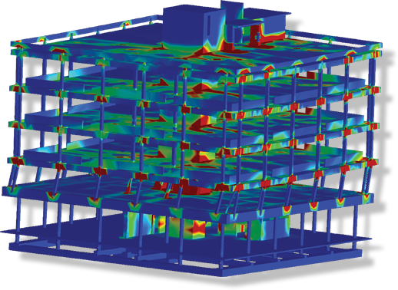
(Figure 1- 3D model used for dynamic analysis. (Applied Science International, LLC, n.d.))
There are a few different methods of dynamic analysis, one of the popular methods is modal analysis. To identify the dynamic properties of a structural system, it is necessary to solve its eigenvalue problem. Modal analysis offers critical information on the prevalent modes of vibration and their related frequencies, which aids in the next phases of analysis. Once the eigenvalue values are found, the natural frequencies and mode shapes of the building can be found indicating how the structure will tend to vibrate and how the frequency of the vibrations will impact the deformation of the building (Prasad, 2023).
Another widely used method of dynamic analysis is response spectrum analysis. This method is used to investigate how structures respond to seismic loads. The method uses a response spectrum to demonstrate how the structure responds at different frequencies. This method is extremely useful for assessing a building’s performance under seismic induced movements and ground movements that can be expected to occur in the area (Prasad, 2023).
One other method of dynamic analysis is time history analysis. This method involves simulating the ground movements that the building can be expected to experience. This method is useful for obtaining information on the buildings dynamic response and is effective when dealing with complex loads or non-linear loads (Prasad, 2023).
Once the natural frequencies and mode shapes of the structure are found and the dynamic analysis has been undertaken it is then possible to evaluate how the structure will respond to the loads accurately and internal forces, acceleration, and displacements can be calculated determining the critical points in the building and how the building will respond to the forces before construction begins.

2.2 Material Properties Effective Against Earthquakes
When designing a building in an area with expected seismic activity it is important that the correct materials are selected as some materials characteristics are better than others in resisting the high frequency vibrations and ground movement.
One property that has shown effective against seismic activity is ductility as a material having a high elasticity will allow the forces acting upon it to pass through somewhat without failing as a brittle material with low ductility would. Structural steel is an effective material as it is able to undergo large deformations and tensions without snapping and this will prevent a building from complete structural failure.
Materials used also need to be lightweight with a high strength to weight ratio so as not to add extra tension in the structure where it is not needed. This is why steel, and timber are preferred to concrete as concrete is very heavy and brittle which will cause failure when experiencing seismic activity (cedengineering, n.d.).

2.3 Base Isolation & Damping Devices
As well as material selection being important there are also different methods that can be adopted to lessen the effects of an earthquake. One method of earthquake proofing a building is through base isolation. This involves lifting the building onto isolated foundations above the earth on flexible steel, lead pads, and rubber so that when the ground is shaken by seismic activity it is the isolated foundations that shake and not the building on top cedengineering, n.d.)
Damping is another effective method of absorbing some of the seismic activity through counter forces. There are two primary methods of damping. These are vibrational control devices and pendulum power (Papagiannopoulos, 2012).
Pendulum power is used often in skyscrapers and involves suspending a large ball from steel cables connected to a hydraulic system at the top of the building so when the building begins to swing from ground movement the ball will move in the opposite direction, essentially stabilizing the building (Papagiannopoulos, 2012).
The other method is vibrational control devices. This involves placing dampers made from piston heads and silicon oil filled cylinders at every level in between the columns and the beams so when the building begins to vibrate under seismic forces, the dampers at every level dampen the vibrational forces by dissipating it into heat energy (Papagiannopoulos, 2012).
Another method of damping used to shield buildings from vibration is called the “seismic invisibility cloak” and uses systems similar to the vibrational control devices under the building to turn the vibrational energy into heat energy and dissipate it into the ground rather than the building, effectively dampening the vibrational forces (BigRentz, 2023).
As well as using systems to reinforce the building it is also important to reinforce the structure to ensure that is as strong as possible to resist seismic activity (BigRentz, 2023).
One way this can be achieved is through cross bracing the buildings frame. This is done by creating X-shaped beams throughout the building’s frame to add shear strength to the building as well as resistance to compression and tension (origindesign.com, n.d.).
Another way that is similar to this is shear walls. These are cross braced frames that are constructed in panels designed to improve compressive and tensile strength of a building and can aid in decreasing damage caused by seismic activity (origindesign.com, n.d.).
Diaphragms are also extremely important in decreasing tension in a building, therefore increasing its strength. This is achieved through horizontal frames that the building’s floor is laid over, pushing the forces into the building’s vertical structure (BigRentz, 2023).
Moment resisting frames are also useful in decreasing devastation caused by earthquakes as they allow a building’s columns and beams to flex while remaining rigid as they are placed in the frame’s joints, increasing the ability to resist wind loads and earthquake loads (BigRentz, 2023).

3.0 Architectural Considerations
Architects must use specific design elements that improve an earthquake-resistant structure. Architectural decisions have a significant influence on a structure's overall performance and safety during an earthquake, even if structural systems are the primary way of resisting seismic forces. The key architectural criteria for earthquake resistance include the following:
Utilizing more regular shapes in the buildings design can create a stronger building as forces can be distributed evenly. Shapes such as squares or rectangles have proven to resist seismic activity more efficiently than irregular or complicated shapes as the symmetry in the shapes allow for the loads to be spread evenly throughout the structure (Shareef, 2023).
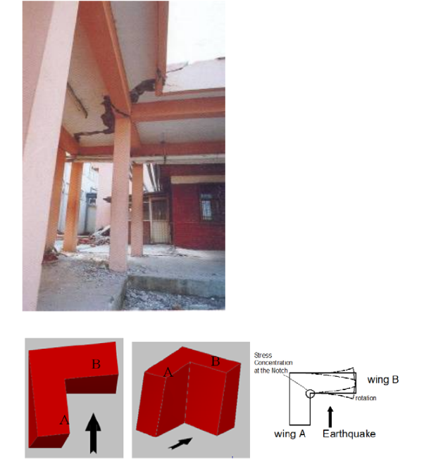
(Figure 2- L-Shaped building reaction to earthquake (Korkmaz, 2019))
Avoiding designing large open spaces in a building’s architecture can also prove effective in resisting earthquakes as open spaces such as atriums as they often allow for higher frequencies of vibrations throughout with less structural components running through them to add strength. Avoiding creating open spaces can decrease the risk of structural failure in many cases (Shareef, 2023).
Using lightweight cladding on buildings and buildings roofs can also reduce the risk of structural failure as less stress on the building is important. Lightweight cladding on roofs allows for the mass of the building to remain lower down in the building, avoiding extra compressive stresses so in the event of an earthquake the structure remains sound (Shareef, 2023).
Rooftop fittings must also be fastened correctly as any fittings that become dislodged during an earthquake can become lethal to any pedestrians below. The use of dampeners on rooftop fittings and isolators is also encouraged as it prevents the fittings providing more top-heavy sway to the building in the event of an earthquake (Shareef, 2023).
It is also important for architects to design safe and accessible safety routes that can be accessed in the event of an earthquake that people can use without the danger of debris or collapse endangering them (Shareef, 2023).

4.0 Design Codes and Methods
As well as structural considerations such as analysis and architectural considerations such as symmetry and safety routes it is important to adhere to international design codes when designing a building that is earthquake resistant as these design codes are founded from in depth research and analysis using data from previous seismic activities as well as cutting edge technology to ensure that the most lives are saved in the event of an earthquake as possible.
In the Unites States, most states adhere to codes created and maintained by the International Code Council such as the International Building Code used for new buildings, the International Residents Code that applies to 1 and 2 story family dwellings and townhouses, and the International Existing Buildings Code that applies to any buildings that are being repaired/retrofitted (FEMA, 2023).
The design codes describe how foundations, frames, beams, attachments, and other structural components should be attached and give guidance on what techniques should be used depending on soil conditions, location, historical activity, stiffness of elements in the structure and many more variables (NEHRP, 2020)
The codes are enforced by the local authorities in the area through planning permission and inspections and they can influence the way buildings are constructed as they stop contractors and architects cutting costs on materials and seismic design methods (FEMA, 2023).
In Europe, Eurocode 8 covers seismic design codes that cover provisions for assessing seismic hazards, retrofitting, and designing structures. This is widely followed in European countries that incorporate seismic design.

5.0 Case Studies
Case study 1: Sabancı Towers, Istanbul
These towers in Istanbul, Turkey were constructed in 1997 in an area that is seismically active and demonstrate many design and analysis features that are used to effectively seismic design a structure (Gunal and Jamo, 2023).

(Figure 3- Sabancı Towers (koray, n.d.))
The towers are constructed with a reinforced concrete structure that are constructed with ductility and strength in mind to withstand seismic forces. The towers also incorporate viscoelastic dampers to dissipate the forces, enhancing the towers further to reduce risk caused by seismic activity (Gunal and Jamo, 2023).
The towers adhere to Turkish Earthquake design codes assessing seismic activity previously in the area and incorporating much of the guidance set by the codes such as the soil-structure interaction as the site is on a geologically complex area with soft soils and layers of fill materials. However, by following the guidelines set by the Turkish earthquake design codes the risk of soil liquification and ground movement is mitigated (Gunal and Jamo, 2023)
In 1999, the area was hit with the İzmit earthquake, and the towers showed resilience and remained standing, demonstrating the need for sound seismic design showing only minor damage to the structure and saving many lives. The earthquake that struck the area had a 7.6 magnitude and the towers withstanding the seismic activity goes to prove the effectiveness of seismic design and its importance (Gunal and Jamo, 2023).
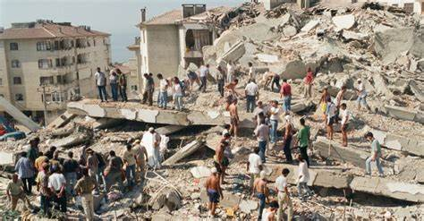
(Figure 4- Building in Istanbul not seismically sound resulting in structural failure (sabah, 2019))

6.0 Conclusion
In conclusion, seismic design is crucial in combatting earthquakes in seismically active areas as correct analysis using dynamic analysis to assess the dangers, selecting the correct materials to reduce the stresses on the building caused by seismic activity, correctly implementing structural systems that can dampen the impacts of seismic forces, and following seismic design codes can be detrimental in saving lives in the event of an earthquake. Correctly implementing seismic design principles can reduce the damage caused by seismic activity tenfold, not only saving many lives by reducing the risk of complete structural failure but also by reducing damage caused to the building making it a more cost-effective method in the long run as the damages caused are reduced making the repair costs lower after a disaster.

7.0 References
All the Science. (n.d.). What is Seismic Design? (with pictures). [online] Available at: https://www.allthescience.org/what-is-seismic-design.htm. [Accessed 4 May 2024]
BigRentz (2023). How Earthquake-Proof Buildings Are Designed in 2024. [online] Bigrentz.com. Available at: https://www.bigrentz.com/blog/earthquake-proof-buildings#:~:text=Timber%2C%20steel%20and%20reinforced%20concrete%20are%20the,most%20popular%20materials%20used%20in%20earthquake-proof%20buildings. [Accessed 6 May 2024].
Cedengineering. (n.d.). CED Engineering. [online] Available at: https://www.cedengineering.com/userfiles/S03-028%20-%20Seismic%20Design%20of%20Structures%20According%20to%20ASCE%20SEI%207-22.pdf. [Accessed 5 May 2024]
Carvajal, F. (2023). Mapping faults in 3D seismic data – why the method matters. [online] ScienceDirect. Available at: https://www.sciencedirect.com/science/article/pii/S0191814123001931 [Accessed 6 May 2024].
FEMA (2023). Seismic Building Codes | FEMA.gov. [online] www.fema.gov. Available at: https://www.fema.gov/emergency-managers/risk-management/earthquake/seismic-building-codes. [Accessed 5 May 2024]
Gunal, A.Y. and Jamo, M. (2023). Review of Earthquake-resistant Design Strategies for Tall Structures: Lessons from Global Case Studies. [online] Research Gate. Available at: https://www.researchgate.net/publication/371807331_Review_of_Earthquake-resistant_Design_Strategies_for_Tall_Structures_Lessons_from_Global_Case_Studies [Accessed 6 May 2024].
NEHRP (2020). Recommended Seismic Provisions for New Buildings and Other Structures Volume I: Part 1 Provisions, Part 2 Commentary. Available at: https://www.fema.gov/sites/default/files/2020-10/fema_2020-nehrp-provisions_part-1-and-part-2.pdf. [Accessed 4 May 2024].
origindesign.com. (n.d.). Cross Bracing: Why It’s Important | Projects Origin Design. [online] Available at: https://origindesign.com/articles/cross-bracing-why-its-important#:~:text=Cross%20bracing%20is%20used%20to%20keep%20buildings%20stable. [Accessed 5 May 2024]
Papagiannopoulos, G.A. (2012). Damping identification for building structures subjected to earthquakes: A review. [online] ResearchGate. Available at: https://www.researchgate.net/publication/259486396_Damping_identification_for_building_structures_subjected_to_earthquakes_A_review [Accessed 7 May 2024].
Prasad (2023). Dynamic Analysis of Structures: Basics and Applications. [online] Structural Guide. Available at: https://www.structuralguide.com/dynamic-analysis/. [Accessed 5 May 2024]
Shareef, S.S. (2023). Earthquake Consideration in Architectural Design: Guidelines for Architects. [online] ResearchGate. Available at: https://www.researchgate.net/publication/373956203_Earthquake_Consideration_in_Architectural_Design_Guidelines_for_Architects [Accessed 6 May 2024].
The Constructor. (2010). SEISMIC DESIGN PHILOSOPHY FOR BUILDINGS. [online] Available at: https://theconstructor.org/structural-engg/seismic-design-philosophy-for-buildings/2781/ [Accessed 5 May 2024].
‌Figure Reference List
Figure 1- Applied Science International, LLC. (n.d.). Seismic Analysis. [online] Available at: https://www.appliedscienceint.com/seismic-retrofit-analysis-engineering/ [Accessed 7 May 2024].
Figure 2- Korkmaz, S. (2019). Seismic Design Considerations for Architectural Design Aspects. [online] ResearchGate. Available at: https://www.researchgate.net/publication/338251309_Seismic_Design_Considerations_for_Architectural_Design_Aspects [Accessed 7 May 2024].
Figure 3- Koray. (n.d.). Tüm Projeler - Koray Group - Sabancı Center. [online] Available at: https://koray.com/sabanci-center [Accessed 7 May 2024].
Figure 4- sabah, daily (2019). 1999 earthquake remains a grim reminder for Turkey. [online] Daily Sabah. Available at: https://www.dailysabah.com/turkey/2019/08/16/1999-earthquake-remains-a-grim-reminder-for-turkey. [Accessed 7 May 2024]

‌
‌
‌
‌

