
Academic and Employability Skills
Module code: BMSW4001
Term 2 (June 2020)
Arteom Poleacov (1917562)
Lecturer name: Sylvia Hoffmann

Abstract:
This report was written to express the knowledge and reflections I learned during term one and two. During the lectures, we had dealt with various topics, which I would like to talk about some of them that affected me and made me develop and grow my skills. I will also explain how do these topics impact in my workplace and my life.

Table of Contents:
- Time Management

- Research Skills

- Employability Skills

- Public speaking

- Reflective writing

Introduction:
Nowadays It is essential to have an excellent organisation to carry out different activities, which can be: work, school, conferences, family etc. For this, it is essential to have a good education and organisational technique, so that in the immense world of work, we can be accepted and make the difference.

Time Management:
Excellent time management permit you to achieve more in a shorter timeframe, which prompts all the more available time, which lets you make the most of learning openings, brings down your pressure and causes you centre, which inspires more profession achievement. Each advantage of the time the board improves another part of your life. During the class, I understood how important it is to manage your time correctly to avoid being at the last moment to do things. One rule I have learned personally is to get things done as soon as possible.
For me, the most time-consuming activities are:
- Work
- Lectures and classes
- Sport
Based on the daily activities I have to do, I create my program to keep in mind or write it in the memo if there are many things to do. I try to organise myself by prioritising the most important things first and the rest on the second stage. When I'm on the busiest days, I try to minimise wasted time to make it as efficient as possible for doing my activities and avoiding everything that can be a distraction for me during this time. Sometimes I have to plan my programme for a week, but most of the time I try to improvise every day. In conclusion, when I started university, that helps me a lot to understand, I improved a lot organising myself and schedule my daily plan.

Research Skills:
Research skills are our capacity to discover a response to an inquiry or an answer for an issue. Exploration aptitudes incorporate the ability to accumulate data about the point, a survey that data and examine and decipher the data in a way that carries us to an answer. From my point of view, researching is one of the essential things that can help you to learn, discover and make sure about a topic. I remember that from when I was young, at school, researching helped me a lot for my homework, improving a lot my skills and knowledge. Also can save a lot of time, meaning that you can do your search from home without going to the library for example.
What research can offer you is new information, views and arguments substance. Also may provide essential information that will enable you to develop clear strategies.
We have a different type of research:
- Desktop examination alludes to looking for realities, general data on a subject, verifiable foundation, study results, and so on.

- Interviews and discussions are utilised when you need to discover the network's involvement in an issue.

- Surveys are utilised if you need to realise what the vast majority in the network think or feel about an issue.

- Community examination includes setting off to a territory to build up realities about a particular issue or situation.

- Case examinations that depict the experience of people or gatherings influenced by an issue can be advantageous for research that plans to change a circumstance or impact leaders.

Following the scheme, my best type of research is from the internet because I get used to doing it, and it's a more comfortable and faster way for me.

Employability Skills:
Employability skills are a set of achievements and understandings and individual properties that make people bound to pick up business and to be effective in their picked occupations. Are essential because the labour market is intensely competitive, and employers are looking for flexible people, take the initiative and have the ability to undertake a variety of tasks in different environments.
During class sessions at university, we talked about some topics that interested me a lot; one of these is body language, something fundamental nowadays if we want to be different from other people.
Talking about me, I firmly believe that our life since birth is based on the relationship that accompanies us to communication, an indispensable element in our existence initially with our family, then kindergarten, school, after school activities, and then the world of work.
Although I am only 26 years old, my curiosity about life and experiences led me to enter the world of work soon after I graduated, leading me to have various teamwork experiences in a couple of companies in Italy. However, at the same time, since when I was a child, I always had a passion for Latin American dancing.
Years and years of study, training, groups, dance partners, and competitions until one can then become a teacher. All this happens only by communicating with those around you in that context, using time together, compromising, sometimes accepting other points of view, other forms of beauty and language.

Public Speaking:
Speaking in front of many people is not something easy, require experience and knowledge. To be more specific, open talking is a procedure of addressing a gathering of individuals in an organised, intentional way expected to illuminate, impact, or engage the audience members. It is firmly united to "introducing", even though the last has, to a greater extent a business notice implication. Public speaking is usually comprehended as an up-close and personal talking among people and the crowd for correspondence.
During our class session at university, we had an opportunity to exercise talking about yourself and three essential achievements that we obtained lately in front of a video call. We discussed Pre-talking preparation, where you should prepare yourself before going to talk, relaxing mentally and maintaining the focus on the topic that we want to talk. When starting a conversation, also it's crucial to know how to open the arguments and catch the people attention on it. How to speak is something essential to know precisely how to set up our presentation, we need to talk clearly and repeat critical information giving to the listeners time to digest the information provided. Maintaining eyes on the audience, it's also vital to have the right body language using natural gesture, meaning that you are communicating to the public.
Talking about my experience in the past, I had been working for a private travel club called Worl Ventures two years ago, where I experience so many new things and improved my communication skills with the people. The company usually organised event's where it was some famous motivational people speaking in front of more than five thousand people.
I had the honour to speak face to face with some of them, and I cached crucial points of public speaking, for example how to prepare yourself before the presentation, doing some focused thinking in mind. I also improved a lot how to deal with the people to be able to engage more people in our travel company.
This Experience in the Worl Ventures was one of my best that I had, and I'm continually carrying with me because from what I've seen, it's helpful.

Reflective writing:
Reflective writing is a training wherein the author portrays a whole or nonexistent scene, occasion, association, passing idea, memory, structure, including an individual reflection the significance of the thing or occurrence, thought, feeling, or circumstance in their life. You are examining the occasion or thought (thinking top to bottom and from other points of view and attempting to clarify, regularly concerning a model or hypothesis from your subject). You are contemplating what the occasion or thought implies for you and your continuous advancement as a student or potentially rehearsing proficient.
During the classes, we have seen what a reflective report is, a bit of composing that sums up an understudy's critical reflection on a subject. Gives a chance to you to increase further bits of knowledge from your work through more profound reflection on your encounters and new thought of different points of view from individuals and hypothesis.
While customary scholastic composing demoralises first-individual accounts, reflective reports rely on them.
Personally I have never had excellent skills in written reflections, but thanks to this course that I took at the university, I got a solid idea, and consequently I improved.
"It is not sufficient to have the experience to learn. Without reflecting upon this experience, it may quickly be forgotten, or its learning potential lost. It is from the feelings and thoughts emerging from this reflection that generalisations or concepts can be generated."
(Gibbs, 1988)

Common frameworks of reflection:
- Gibb's 'Reflective Cycle' (1988):
Urges individuals to think efficiently the encounters they had during a particular circumstance, occasion or action. Utilising a hover, reflection on those encounters can be organised in stages.
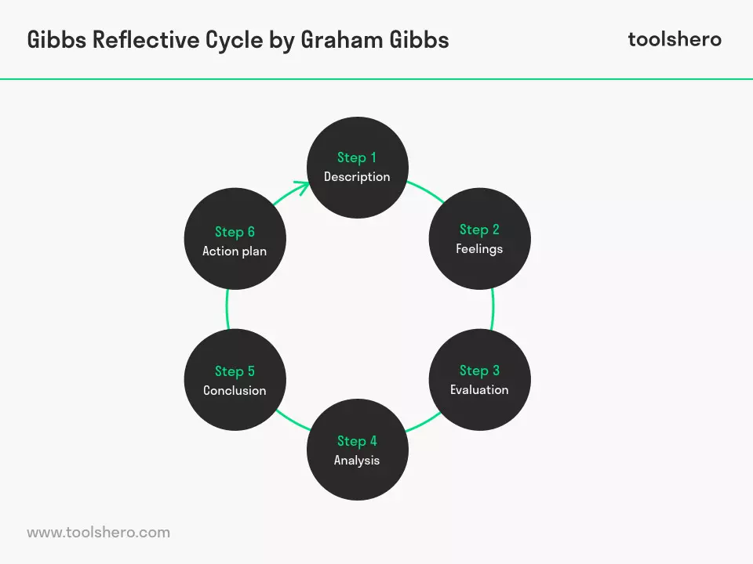

- Kolb's 'Experiential Learning Cycle' (1984):
1. Substantial experience - another experience or circumstance is experienced, or a reevaluation of existing expertise.
2. Intelligent Observation of the New Experience - of specific significance are any irregularities among knowledge and comprehension.
3. Theoretical Conceptualisation reflection offers to ascend to another thought or a change of a current dynamic idea (the individual has gained from their experience).
4. Active Experimentation - the student applies their concept (s) to their general surroundings to perceive what occurs.

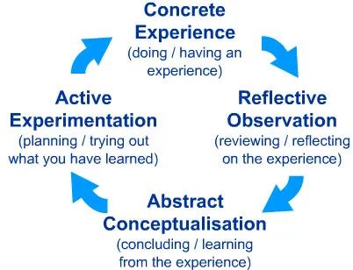
- Driscoll's Model (1994, 2000):
Driscoll model of reflection is perhaps the least complex model you will at any point go over. Driscoll created it in 1994, 2004 and 2007. Primarily, Driscoll examined the three stem addresses which were at first asked by Terry Boston in 1970, they were:
What?'
What of it?'
Presently What?'
He coordinated them to the phases of an experiential learning cycle. Additionally, he included trigger inquiries which are commonly used to finish the period.

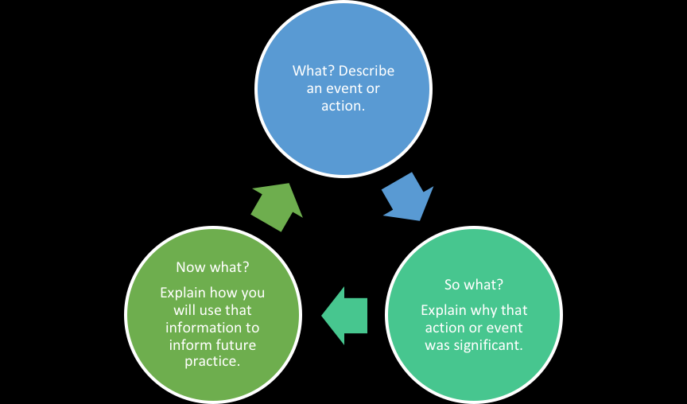
Conclusion:
In conclusion, these were the four points that struck me and were generally useful to me during term one and two. I had the chance to learn and advance my insight, also the fact to have the opportunity to contrast myself and my friends during the exercises. I plan to improve considerably more since I'm sure there is still a long way to go.
Finally, without being denied by facts or by anyone, the future of work in every field of the globalised world is projected into working situations to group working methods made up of individuals with individual skills that are brought to be capitalised in the team's work.
Still, we are amid consumerism of things and spiritual needs that change at the speed of light and that only the corporate worlds capable of responding with a work team made up of individuals from different disciplines can keep up.

References:
- Moodle – Employability Skills - Week 1b - Time Management (Accessed 20.08.2020)
- Time management Definition, https://www.mindtools.com/pages/article/newhte_00.htm#:~:text=%E2%80%9CTime%20management%E2%80%9D%20is%20the%20process,tight%20and%20pressures%20are%20high. (Accessed 19.08.2020)
- Moodle – Employability Skills - Week 1 - Introduction to research skills (Accessed 20.08.2020)
- Research Skills definition and Examples: https://www.indeed.com/career-advice/career-development/research-skills (Accessed 19.08.2020)
- Moodle - Week 2b - Introduction to Employability (Accessed 20.08.2020)
- What are employability skills? https://www.jobjumpstart.gov.au/article/what-are-employability-skills (Accessed 21.08.2020)
- Moodle - Giving PowerPoint Presentations (updated March 2020) – (Accessed 21.08.2020)
- What is public speaking? https://business.tutsplus.com/tutorials/what-is-public-speaking--cms-31255 (Accessed 21.08.2020)
- Moodle - Reflective Writing (Feb 2020) (Accessed 22.08.2020)
- What is reflective writing? https://grammar.yourdictionary.com/for-students-and-parents/what-is-reflective-writing.html (Accessed 22.08.2020)

