A Thematic Analysis of Factors Affecting Motivation in Students

Abstract
As more and more people from a variety of backgrounds and ages choose to attend countless different university courses, the pool of reasons they do so also expands. Continual motivation is an absolute necessity for students in higher education and this motivation can come from almost anywhere (Allahqoli et al., 2019) from internal self-validation and aspirations to external family influences, the pursuit of a better career, money and prestige or anything in-between. Bringing together four participants, this study will investigate what intrinsic and extrinsic motivators are common among university students while interpreting the types of goals, drives and factors that allow for persistence in higher education utilising a thematic analysis of a focus group, the results of which are discussed in relation to the motivation of Mastery goals or ego involvement (Stirling, 2013) as well as Clark Hull’s Drive Reduction Theory (Leeper & Hull, 1954).
Introduction
Motivation derives from the Latin word ‘movere’ meaning “to move”, this term can widely be defined as internal or external forces leading to the arousal of behaviours that direct actions and persistence for achieving a goal (Helms, 2009). Motivation can be split into two categories: Intrinsic motivation comes from within, created by an instinctual human need to feel competent and self-determining (Vernon, 1969). Intrinsically motivated behaviours can also come from the want to conquer challenges that are encountered or created, such as reducing uncertainty or for personal satisfaction (Deci, 1976). Extrinsic motivation is influenced by external factors, most commonly external regulation in which an individual engages in activities and behaviours to attain rewards/avoid punishment (Mitchell et al., 2020). Students, for example, may partake in extrinsic actions with resentment while also acknowledging the value of the task concerning their long-term academic goals, leaving extrinsic motivation almost a spectrum from purely external regulation to a somewhat internal valuing of a task, this autonomy and competence is known as Self-Determination (Ryan & Deci, 2000).
A learner's ultimate goal or drive will likely differ widely between different types of students, as will their reasons to persist with the challenges of learning. Some students may persist in seeing their self-worth as they may view their self-definition as their ability to achieve competitively (Pintrich et al., 2009). Students could also be driven to persist thanks to the positive influences of both peers and lecturers, the latter of which are instrumental in fostering the attainment of objectives and improving the competencies of students, supported by the findings of Green & Kelso (Green & Kelso, 2006; Schunk & Pintrich, 2014).
Motivation remains a key requirement for success and continuity throughout the academic process (Allahqoli et al., 2019). Motivators will look very different between a student of 18 years old and one of 40+. As the average age of a university student creeps upward, so changes the values and factors motivating said students. Students often have a desired end goal, such as the attainment of money, power, self-actualisation or social relations, achieving this will require deliberation and forcefully directed actions to succeed (Ball & Vidler, 1977). Higher education is a prime example of Hull’s Drive Concept, the instinctual psychological desire to avoid or resolve a negative state of tension when a need is unmet or unsatisfied (Bolles, 1975; Leeper & Hull, 1954). Students may long for extrinsic factors such as the prestige that comes with achievement or more material benefits such as money or better career options than peers (Jung, 1978). This report aims to interpret and analyse common motivators and drives that university students experience, with references to previous studies and theories of motivation.

Method
Participants
Volunteer participants came from a range of courses within UWTSD to take part in a focus group. They were selected based on availability for the date/time of the interview and interest based on email communication stating the basic purpose of the study. Volunteers were at different stages of their respective degrees and were of a variety of ages. The pseudonyms (names changed for anonymity) of the four participants who took part in this focus group were as follows;
- Sarah, 32 BSc Psychology
- Alex, 20, BA Applied computing
- Mark, 45, BA Construction and the Built Environment
- Emily, 22, BSc Psychology
Data Collection
Participants took part in a 60-minute focus group in the form of a semi-structured interview involving 10 open-ended questions led by the researcher. Participants were informed that the nature of the interview was to explore their motivations as undergraduate students. A recording device was used to capture the interview to be later transcribed verbatim. The researcher used materials, such as the transcription (Appendix A) and a list of 10 open-ended questions (Appendix B). Each participant would have been issued a consent form (Appendix C) and debrief form (Appendix D), outlining the participant's rights within the study by the BPS Code of Human Research Ethics (BPS, 2016).
Data Analysis
The focus group transcription underwent a thematic analysis to first code and then interpret potential motivational themes within the interview and between participants. Stages of thematic analysis include.
- Familiarisation – Includes the initial transcription and read-through while taking initial notes.
- Coding – Involves beginning to highlight anything deemed relevant or noteworthy within the transcript and assigning them labels or ‘codes’ depending on what is generally being expressed.
- Generating themes – Coding would have identified thoughts, patterns, ideas, taking points, etc. within the transcript. These codes can then be generalised into more broad, overarching interview themes.
- Reviewing Themes - Themes are reviewed to ensure that they are both relevant to the research question and accurate representations of the data transcript, identifying if themes are common or rare as well as identifying sub-themes.
- Defining/Naming themes – Final themes are given names using psychological terminology and are defined to understand exactly what is being referred to for each theme as well as gathering supporting quotations from the transcript to be displayed within a table. (Braun & Clarke, 2006).
Results
Theme | Sub-Themes | Supporting Quotes
Future Developments | Be the “boss” | “I’d love to get back on the building sites, but the other side of it you know. Be the boss, be the one who knows the shit and tells people what to do” (Mark, line 116).
Future Developments | New learning experiences | “Understanding and making peace with the fact that I didn’ know it all at that point. That was a big thing and I was learning and, actually, the learning was the enjoyment from that point on.” (Mark, line 325).  “Just thinking about what I want to do as I get older. Thinking about what I really want, what types of people I want to work with and what I want to gain from this course as well” (Emily, line 769).
Environmental influence | Interactions with peers | “They had an impact – a negative impact on my motivation to be there” (Sarah, line 629).  “If they are there, I will go because I know that I can get through even things I don’t particularly enjoy when they’re there because it makes it a bit more fun” (Alex, line 664).
Environmental influence | Relationships with Lecturers | “I think we all get on with different lecturers, but they're all great at what they do and they really do help in that motivation for me to turn up as well” (Sarah, line 646).
Family Influence | Influence from parents | “I really want for my dad to be proud of me. I really want to prove to him that you know, this course wasn't just for nothing and doing well will hopefully get me to a place that I want to be and that I will get some enjoyment from. And yeah, I really want to show him that. He can be proud of me for doing what I chose to do” (Alex, line 780).  I had my mum just on my case, ‘why are you always moaning? Why don't you go and do something else then’ and eventually I kind of just did. (Emily, line 555).
Family Influence | Providing for/setting examples for children. | “It's all to try and give them a better life and to show them (daughters) that they can do whatever it is they want” (Sarah, line 475).

As seen in the above table (Appendix E), a total of three prominent themes were interpreted from the transcript, however, only two of these will be discussed in detail as the themes of Future Developments and Environmental Influence best reflect the focus group as a whole as each participant evidently has their own experiences with these motivators. Overall, the results show that the four participants are widely different individuals, some come from a place of intrinsic motivation and others from extrinsic ones. The two most prominent themes interpreted were those that clearly influenced each member of the group.
Theme 1: Future Developments
The foremost theme that can be interpreted from this transcript is that of each participant's hopes and aspirations for the future that they hope to achieve through their university course. Naturally, most university students are motivated by their career aspirations.
Sub-theme 1.1: Be the “Boss”
Mark makes frequent references to the fact that his main motivation is to return to the construction industry in a leadership position. Despite his new disability, Mark consistently displays great motivation to return to work as a more knowledgeable veteran of his field. “I’d love to get back on the building sites, but the other side of it you know. Be the boss, be the one who knows the shit and tells people what to do” (Mark, line 116).
Likewise, Alex states that he has no intention of working for someone else and indicates that one of his primary motivations is to “aim high” and use his degree to own his own company. “My literal dream would be to have my own game development studio or company or something. I don’t really want to work for someone else” (Alex, line 179).
Sub-theme 1.2: New learning experiences
Throughout the transcript, it is alluded to in many instances that a key motivator is the new learning opportunities that university provides, whether this be learning more about one’s self or learning more transferable skills that would fortify a future career;
The motivation to carry on came from understanding and making peace with the fact that I didn’ know it all at that point. That was a big thing and I was learning and, actually, the learning was the enjoyment from that point on (Mark, line 324).
Emily interestingly states that one of her motivators is her own self-discovery; “I thought pursuing a psychology degree would allow me to understand what I’m ‘like’ maybe?” (Emily, line 133).
In Summary, it may seem obvious that university students value their future development, however, it is each unique drive on display, paired with a few participants sharing values that led to the identification of this theme.
Theme 2: Environmental Influence
Another relevant theme is that of the learning environment the students experience. There are sparse mentions of how the campus's physical environment plays a part in motivation, but this line of questioning quickly transitions into sub-themes of motivational influences of interactions with both peers and lecturers, whether these be for better or for worse.
Sub-theme 2.1: Interactions with peers
Each member of this focus group has their own unique opinions and experiences with their peers. On one side is Emily, the self-proclaimed introvert, who affirms that she is content to be self-motivated and does not require motivation from peers.
There have been a couple of things that we’ve had to do in groups this year and I’m not really the person that is into that at all. I just kind of like to do my own thing. Not sure how I feel about there being more interaction in the second year (Emily, Line 242).
The other extreme example is Sarah, who chose Psychology as she states “I really enjoy interacting with people” (Sarah, line 224) indicating that she finds interactions with her peers as a positive motivator. Sarah also gives an example of how interactions with her peers became a negative motivator, yet also acknowledges the positive benefits of good interactions. “My interactions didn't - they had an impact - a negative impact on my motivation to be there” (Sarah, line 629).
Most interestingly however is Alex, who initially claims that he too is an introvert, even claiming that his main motivation is the isolation and focus he gets from being alone.
The parts of my studies I enjoy the most are when I get to sit in a room for hours on end just me and my computer and I get to sit there and just be my own and not have to answer to anybody or have to deal with anybody (Alex, line 236).
Alex later contradicts this, stating that another main motivator is attending classes with his friends, claiming that there is a direct correlation between his friend's attendance and his own. This leaves it confusing as to whether peer interactions are a positive or negative motivator for Alex. “If they are there, I will go because I know what that I can get through even things I don't particularly enjoy when they're there because it just makes it a bit more fun” (Alex, line 664).
Sub-theme 2.2: Interactions with Lecturers
The group unanimously agreed that there is a positive correlation between having a competent/enthusiastic lecturer and their motivation to attend, the transcript is littered with various examples and anecdotes of such lecturers; Sarah expresses that “they're all great at what they do and they really do help in that motivation for me to turn up as well” (Sarah, line 647), Emily supports this and states that “It's easy to be interested in something when the person teaching you is interesting as well” (Emily, line 680).
It is agreed as a group that positive interactions with lectures provide key motivations to persist through difficult times in their studies, likewise, it seems the general consensus is that positive interactions with peers are also highly valued by the majority and negative ones should be avoided.
Discussion
It is important to state that the above results and this discussion are the researcher’s own interpretation of the transcript, others (particularly the participants) may interpret the qualitative data differently and thus draw different conclusions. This analysis was conducted with an heir of reflexivity and drew conclusions and interpretations impartially whilst also acknowledging that these findings may remain slightly subjective (Finlay, 1998). This being said, the two key themes being analysed are strongly associated with the theories found in the literature covered in the introduction.
The first theme of Future Developments shows that most participants integrate both intrinsic and extrinsic factors into their motivation, leaning further into Self-Determination theory (Deci & Ryan, 1985). Most participants persist through Mastery Goals as many goal-oriented approaches to motivation state that Mastery Goals emphasise the intrinsic value of university and greater effort is related to greater competency and thus reward (Stirling, 2013).
The final question of the interview asks the participants their main influence in being motivated. Regardless if these influences were intrinsic or extrinsic, each participant's answer relates back to their ideas and goals for the future, this is their Drive. More specifically, only Mark has a realised end goal. Sarah, Emily and Alex all state that university is a necessary ‘stepping stone’ to greater futures. As these futures remain vague, the participants also value the sub-theme of new learning experiences that provide context and outcome expectations for the goals (Schunk et al., 2014).
The idea that motivation can be derived from positive interactions with lecturers in sub-theme 2.2 supports the study by Green & Kelso who found that particularly adult learners, find the dynamic between students and competent lecturers stimulate their desire to succeed (Green & Kelso, 2006). This is reflected by the various statements made by the participants of all ages, who support that peer interactions help motivate persistence, whether they realise it or not.
Future studies of this nature could benefit from a wider range of participants to improve ecological validity and get a wider sense of universal themes, in addition, another study could benefit from having more than one researcher to reduce subjectivity.

References
- Allahqoli, L., Nithyanantham, V., Rahmani, A., Allahveisi, A., Gheshlagh, R., Fallahi, A., & Nemat-Shahrbabaki, B. (2019a). Exploring the factors affecting the motivation for learning
- Bolles, R. C. (1975). 5. THE DRIVE CONCEPT. In Theory of motivation (pp. 107–127). essay, Harper & Row.
- Braun, V., & Clarke, V. (2006). Using thematic analysis in psychology. Qualitative Research in Psychology, 3(2), 77–101. https://doi.org/10.1191/1478088706qp063oa
- British Psychological Society (BPS). (2016). Code of Human Research Ethics. British Psychological Society.
- Deci, E. L. (1976). Chapter 2: Conceptualizations of intrinsic motivation. In Intrinsic motivation (pp. 23–63). essay, Plenum Press.
- Deci, E. L., & Ryan, R. M. (1985). Conceptualizations of intrinsic motivation and self-determination. Intrinsic Motivation and Self-Determination in Human Behavior, 11–40. https://doi.org/10.1007/978-1-4899-2271-7_2
- Finlay, L. (1998). Reflexivity: An essential component for all research? British Journal of Occupational Therapy, 61(10), 453–456. https://doi.org/10.1177/030802269806101005
- from the perspective of public health students: A qualitative study. Journal of Mind and Medical Sciences, 6(2), 319–326. https://doi.org/10.22543/7674.62.p319326
- Green, T. M., & Kelso, C. M. (2006). Factors that affect motivation among adult learners. Journal of College Teaching &amp; Learning (TLC), 3(4). https://doi.org/10.19030/tlc.v3i4.1729
- Helms, M. M. (Ed.). (2009). Motivation and Motivation Theory. In Encyclopedia of Management (5th ed., pp. 563–565). essay, Gale Cengage.
- Jung, J. (1978). Chapter 6. Individual Motivation: Achievement. In Understanding human motivation: A cognitive approach (pp. 135–166). essay, Macmillan Publishing.
- Leeper, R., & Hull, C. L. (1954). A behaviour system: An introduction to behaviour theory concerning the individual organism. The American Journal of Psychology, 67(2), 375. https://doi.org/10.2307/1418653
- Mitchell, R., Schuster, L., & Jin, H. S. (2020). Gamification and the impact of extrinsic motivation on needs satisfaction: Making work fun? Journal of Business Research, 106, 323–330. https://doi.org/10.1016/j.jbusres.2018.11.022
- Pintrich, P. R., McKeachie, W. J., Covington, M. V., & Roberts, B. W. (2009). 7. Self-worth and college achievement: Motivational and Personality Correlates. In Student, motivation, cognition and learning: Essays in honour of Wilbert J. McKeachie (pp. 157–188). essay, Routledge.
- Ryan, R. M., & Deci, E. L. (2000). Intrinsic and extrinsic motivations: Classic definitions and New Directions. Contemporary Educational Psychology, 25(1), 54–67. https://doi.org/10.1006/ceps.1999.1020
- Schunk, D. H., & Pintrich, P. R. (2014). 9. Teacher and classroom influences. In Motivation in education: Theory, research and applications (pp. 325–366). essay, Pearson.
- Schunk, D. H., Meece, J. L., & Pintrich, P. R. (2014). 5. The Role of Expectancy and Self-Efficacy Beliefs. In Motivation in education: Theory, research and applications (pp. 67–103). essay, Pearson.
- Stipek, D. (1998). Chapter 2: Defining Achievement Motivation. In Motivation to learn: From theory to practice (pp. 9–24). essay, Allyn and Bacon.
- Stirling, D. (2013). MOTIVATION IN EDUCATION. Aichi Universities English Education Research Journal, 51–72.
- Vernon, M. D. (1969). The nature of motivation. In Human motivation (pp. 1–8). essay, CUP.
- Vidler, D. C. (1977). 4. Achievement Motivation. In S. Ball (Ed.), Motivation in education (pp. 67–89). essay, Academic Press.

Appendices
Appendix A: Thematic analysis of Focus Group transcript
SEE PHYSICAL COPY
Appendix B: Question list
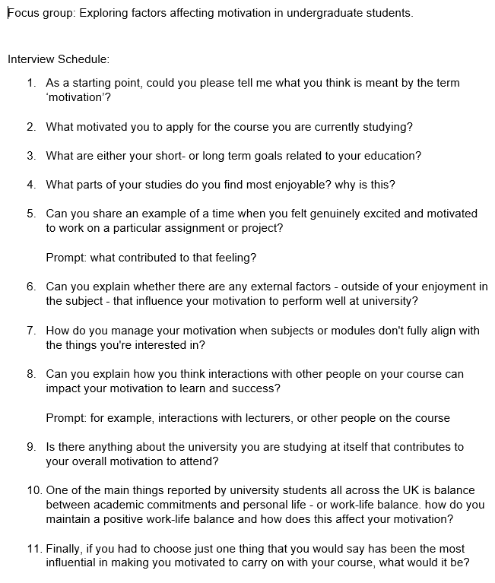

Appendix C: Consent Form


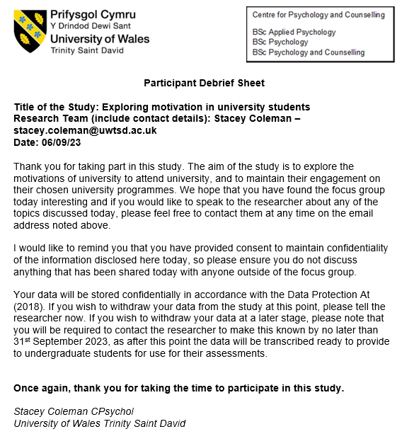
Appendix D: Debrief Form

Appendix E: Table of interpreted themes
Theme | Sub-Themes | Supporting Quotes
Future Developments | Be the “boss” | “I’d love to get back on the building sites, but the other side of it you know. Be the boss, be the one who knows the shit and tells people what to do” (Mark, line 116).
Future Developments | New learning experiences | “Understanding and making peace with the fact that I didn’ know it all at that point. That was a big thing and I was learning and, actually, the learning was the enjoyment from that point on.” (Mark, line 325).  “Just thinking about what I want to do as I get older. Thinking about what I really want, what types of people I want to work with and what I want to gain from this course as well” (Emily, line 769).
Environmental influence | Interactions with peers | “They had an impact – a negative impact on my motivation to be there” (Sarah, line 629).  “If they are there, I will go because I know that I can get through even things I don’t particularly enjoy when they’re there because it makes it a bit more fun” (Alex, line 664).
Environmental influence | Relationships with Lecturers | “I think we all get on with different lecturers, but they're all great at what they do and they really do help in that motivation for me to turn up as well” (Sarah, line 646).
Family Influence | Influence from parents | “I really want for my dad to be proud of me. I really want to prove to him that you know, this course wasn't just for nothing and doing well will hopefully get me to a place that I want to be and that I will get some enjoyment from. And yeah, I really want to show him that. He can be proud of me for doing what I chose to do” (Alex, line 780).  I had my mum just on my case, ‘why are you always moaning? Why don't you go and do something else then’ and eventually I kind of just did. (Emily, line 555).
Family Influence | Providing for/setting examples for children. | “It's all to try and give them a better life and to show them (daughters) that they can do whatever it is they want” (Sarah, line 475).

