

EXAMINATION PAPER
MARKS AND COMMENTS SHEET

PROGRAMME | OME Degree Apprenticeship
LEVEL | 4
MODULE | ACDB4011 Chemistry
STUDENT I.D. | 2426152
EXAMINER | Ewa Kazimierska | INTERNAL VERIFIER
Once completed marks only should be transferred onto the front of the examination paper (no comments other than ticks or crosses on the examination paper)

Question  Number | Comments | Marks available | Marks awarded | 2nd marker (sample) | 3rd marker (where necessary)
1 | Excellent performance — all True/False items correct. Strong grasp of key chemical principles. | 15 | 15
2 | All parts correct and clearly explained. Well-constructed Bohr model, charges, and bonding. | 11 | 11
3 | Good understanding of photon energy and emission. Unpaired electrons not stated in part b, but other sections were strong. | 10 | 9
4 | Strong start with correct equation and mass calculations. Errors in part c with STP conditions and no alternative method; mistakes in conversions in d. | 15 | 11.5
5 | Oxygen balance concept well understood in part a. No attempt on remaining parts (b–e), resulting in lost marks. | 16 | 3
6 | Energy profile lacked correct enthalpy and activation energy assessment. | 7 | 5
7 | Excellent interpretation of phase diagrams and transitions. | 11 | 11
8 | Correct approach in part a but with sig fig error. Net ionic equation was missing in part b. | 5 | 2.5
9 | Fully correct response. Calorimetry concept, equation, and calculation well applied. | 5 | 5
10 | Redox process partially understood. Only Al correctly identified as reducing agent; redox pairs not recognised. | 5 | 1.5
 |  |  | 74.5

1st Marker Name | Ewa Kazimierska | 1st Marker Signature | 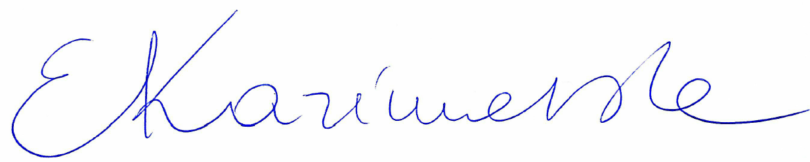
2nd Marker Name |  | 2nd Marker Signature
3rd Marker Name |  | 3rd Marker Signature
Reasons for awarding the final mark where there is more than one marker
Notes:
- The 3rd marker may be used where there is more than a 10 percentage point difference (in the TOTAL mark) between markers 1 and 2 OR when it is not possible to get agreement between markers 1 and 2. Reasons must be given where an agreed mark is given.
- This form is for internal use only and is NOT to be returned to the student. The final agreed marks must be transferred to the student feedback sheet in the assignment specification.
- The external examiner MUST be shown this form.

