
University of Wales Trinity Saint David
School of Engineering

Materials Testing and Sustainability of Composites for Motorsport & Automotive Engineering
Tomos Cole
2205508
Motorsport Engineering
ACHA6012
26th April 2026

3284 Words

Abstract
This report investigates the mechanical performance and sustainability credentials of seven structural materials, carbon fibre woven with standard epoxy (IN2), carbon fibre woven with bio-resin (IB2), recycled carbon fibre non-woven with bio-resin, flax fibre woven with bio-resin, flax fibre non-woven with bio-resin, Kevlar woven with bio-resin, and aluminium, in the context of motorsport and automotive engineering. Tensile testing was conducted in accordance with ISO 527-4:2021, with 16 aluminium specimens and 8 specimens of each composite material averaged across test groups. Carbon Woven Epoxy achieved the highest averaged UTS of 608 MPa and specific strength of 392 MPa/(g/cm³), confirming its suitability for primary structural applications. Kevlar Woven Bio-resin recorded the highest composite toughness at 12.2 MJ/m³, making it the most appropriate material for crash energy absorption. Flax Woven Bio-resin delivered a specific strength of 100 MPa/(g/cm³) at a production carbon footprint below 1.5 kg CO₂/kg, over an order of magnitude lower than synthetic fibre alternatives. A lifecycle assessment and legislative review confirm that evolving EU End-of-Life Vehicle Regulation targets and FIA Environmental Strategy mandates are creating increasing regulatory pressure on thermoset composites, strengthening the case for natural fibre and recycled composite adoption. A tiered material strategy is recommended, matching each material to the applications best suited to its performance and sustainability profile.

Contents
Abstract 2
1. Introduction 5
2. Literature Review 5
2.1 Composite Materials in Motorsport 5
2.2 Fibre Reinforcement Types and Performance 5
2.3 Matrix Systems and Fibre-Matrix Interaction 6
2.4 Recycled Carbon Fibre 7
2.5 Tensile Testing and Mechanical Characterisation 7
3. Sustainability Analysis 7
3.1 Lifecycle Assessment Overview 7
3.2 Carbon Footprint and Embodied Energy 8
3.3 Recyclability and End-of-Life Management 9
3.4 Legislation and Industry Response 9
4. Experimental Testing 10
4.1 Tensile Testing Methodology 10
4.1.1 Stress-Strain & UTS Analysis 11
4.1.2 Young's Modulus Analysis 14
4.1.3 Specific Strength and Specific Modulus 14
4.1.4 Toughness Analysis 16
4.1.5 Material Fracture Analysis 17
5. Recommendations 19
6. Conclusion 20
References 22
Appendix A 26
Appendix B 26

Figure 1 - IDRAkronos Monocoque Manufactured From Twill T300 Carbon Fibre/Epoxy Prepreg (Messan et al., 2019) 5
Figure 2 - Denison Tensile/Compression test Machine Used For All Specimen Testing 10
Figure 3 - Stress-Strain Curves For All Individual Specimens 11
Figure 4 - Averaged Stress-Strain Curves With 95% Confidence Bands 12
Figure 5 - Averaged UTS For All Materials With Standard Deviation Error Bars 13
Figure 6 - Averaged 0.2% Proof Stress For All Materials With Standard Deviation Error Bars 13
Figure 7 - Averaged Young's Modulus For All Materials With Standard Deviation Error Bars 14
Figure 8 - Ashby Plot of Specific Strength vs Specific Modulus For All Materials 15
Figure 9 - Averaged Specific Strength For All Materials With Standard Deviation Error Bars 16
Figure 10 - Averaged Specific Modulus For All Materials With Standard Deviation Error Bars 16
Figure 11- Average Toughness For All Materials With Standard Deviation Error Bars 17
Figure 12 - Aluminium Specimen Showing Ductile Necking and Shear Lip Fracture Surface 18
Figure 13 - Kevlar Woven Bio Specimen Showing Characteristic Fibrillar Splitting and Fibre Pullout 18
Figure 14 - Carbon Non-Woven Bio Specimen Showing Irregular Fracture Consistent With Random Fibre Orientation 19
Figure 15 - Carbon Woven Specimen Showing Clean Brittle Transverse Fracture 19
Figure 16 - All 7 Specimens Before Tensile Testing 26
Figure 17 - All Specimen Typres Prior to Tensile Testing, Showing Material Variety and ISO 527-4 Geometry 27
Figure 18 - Aluminium Specimens After Tensile Testing, Showing The Ductile Elongation 27
Figure 19 - Flax Non-woven Wider Image Showing Break Per Material 28

Table 1- LCA values of each specimen tested in this study 8
Table 2 - Averaged Mechanical Properties For All Materials (n = specimens tested) 11
Table 3 - Individual Specimen Results 26

Introduction
Composite materials have become indispensable within the automotive, motorsport, and motorcycle industries due to their high strength-to-weight ratios and design flexibility. Carbon fibre reinforced polymers (CFRPs) with petroleum-derived epoxy systems have traditionally dominated high-performance applications, from Formula 1 monocoques to motorcycle fairings, though growing environmental concern has accelerated research into more sustainable alternatives.
This report presents findings from experimental tensile and compression testing on seven composite and metallic specimens using a Denison test machine. Materials evaluated include woven and non-woven carbon and flax fibre composites combined with either a petroleum-based epoxy (IN2) or a plant-based bio-epoxy (IB2), a woven Kevlar aramid bio-resin composite, and an aluminium baseline. Mechanical performance is compared using Rule of Mixtures validation, sustainability credentials are evaluated through lifecycle assessment, and recommendations for material adoption in motorsport and automotive contexts are provided.

Literature Review

Composite Materials in Motorsport
Composite materials combine two or more constituents to produce properties superior to their individual components (Ashby and Jones, 2018, p.22-23). In engineering applications, fibre-reinforced polymers (FRPs) are most prevalent: fibres embedded within a polymer matrix maintain alignment, transfer loads, and protect against environmental damage and crack propagation (Callister and Rethwisch, 2020, p.619). CFRP composites offer high specific modulus and strength well suited to low-weight, high-fatigue applications, in motorsport, 20 kg over the weight limit equates to approximately 0.4 s per lap on a typical Grand Prix circuit (Savage, 2010, p.95; Zhang et al., 2022). Woven fabric architectures provide quasi-isotropic in-plane behaviour suited to multi-directional loading, while non-woven mats offer a more economical, lower-performance alternative for secondary components (Ghlaim, 2024; Nettles, 1994; Rana and Fangueiro, 2016).

2.2 Fibre Reinforcement Types and Performance
The mechanical performance of a composite is primarily governed by the choice of reinforcement fibre. Carbon fibres, produced through the pyrolysis of PAN precursors at temperatures exceeding 1000°C, yield tensile moduli of 230–400 GPa and strengths of 3,500–7,000 MPa at the fibre level (Mallick, 2007). In motorsport, CFRP is deployed in woven configurations for body panels and aerodynamic components, and in unidirectional prepregs for monocoques and chassis rails; Messana et al. (2019) demonstrate this in the IDRAkronos monocoque shown in Figure 1. The brittle failure mode of CFRP, catastrophic fibre fracture at low strain, limits its suitability where progressive, energy-absorbing failure is required (Alshahrani et al., 2024).
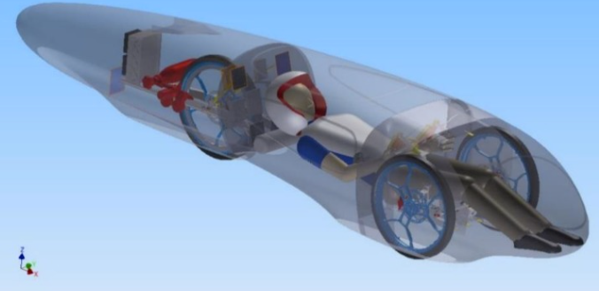
Figure 1 - IDRAkronos Monocoque Manufactured From Twill T300 Carbon Fibre/Epoxy Prepreg (Messan et al., 2019)
Kevlar (PPTA para-aramid) offers high tensile strength, low density (~1.35 g/cm³), and a pseudo-ductile failure mode involving fibrillar splitting rather than brittle fracture, resulting in high composite toughness suited to impact applications (Ursache et al., 2023). However, its fibrillar microstructure is prone to kinking under compression, limiting its role in primary structural members under combined loading (Oliwa, 2020). Flax fibres provide a favourable combination of stiffness (50–70 GPa fibre-level modulus), low density (~1.45 g/cm³), vibration damping, and renewability (Bos et al., 2006), though composite-level properties are significantly reduced by fibre orientation, volume fraction, and interfacial adhesion quality (Bourmaud et al., 2018).

2.3 Matrix Systems and Fibre-Matrix Interaction
The polymer matrix binds and protects the reinforcement, transfers loads between fibres, and defines environmental resistance. Epoxy resins are the standard matrix for high-performance composites due to their low cure shrinkage, strong fibre adhesion, and well-characterised mechanical properties (Mallick, 2007). Poor interfacial bonding, caused by moisture contamination, inadequate surface treatment, or incomplete resin infusion, results in premature debonding and significantly reduced composite performance (Khieng et al., 2021). Bio-derived epoxy systems, such as the IB2 resin used in this study, reduce the resin-phase carbon footprint without substantially compromising mechanical performance; Ricciardi et al. (2024) confirmed that flax composites with sustainable bio-resins exhibit comparable static properties to standard epoxy systems. Hybridisation of natural and synthetic fibres further improves performance: Dhakal and Sain (2020) demonstrated that carbon-flax hybrid laminates significantly outperform pure flax systems in both tensile and flexural response.

2.4 Recycled Carbon Fibre
The energy-intensive production of virgin carbon fibre has driven research into recycled carbon fibre (rCF) as a lower embodied-energy alternative. The primary industrial recycling route is pyrolysis, whereby the matrix is thermally decomposed leaving reclaimed fibres that retain approximately 75–90% of their original tensile strength (Pakdel et al., 2021). Solvolysis offers higher property retention but remains commercially limited due to process complexity (Butenegro et al., 2021). Reclaimed fibres are typically processed into non-woven mats, as continuous tow architectures cannot be reconstructed, constraining mechanical performance and leaving rCF mats viable only for secondary components. McLaren Racing (2023) have trialled rCF aerodynamic components in Formula 1, demonstrating that motorsport is beginning to engage with closed-loop material strategies.

2.5 Tensile Testing and Mechanical Characterisation
Tensile testing follows ISO 527-4:2021, specifying specimen geometry and testing procedure for isotropic and orthotropic fibre-reinforced plastics (ISO, 2021). Key properties extracted include UTS, 0.2% proof stress, Young's modulus, derived from the linear region between 0.05mm/mm and 0.25mm/mm strain, and toughness as the area under the stress-strain curve. Saba, Jawaid and Sultan (2019) note that specimen preparation quality and gauge length consistency are critical to comparable results across material types. The Rule of Mixtures (ROM) provides a theoretical upper bound for composite modulus based on fibre volume fraction and constituent moduli (Tham et al., 2018); significant negative deviations from ROM predictions indicate manufacturing deficiencies such as void content or fibre misalignment and are used in Experimental Testing to identify anomalous specimens.

Sustainability Analysis

3.1 Lifecycle Assessment Overview
A lifecycle assessment (LCA) is a structured methodology used to quantify environmental impacts across the entire material lifecycle, from raw material extraction to end-of-life disposal, in accordance with ISO 14044:2006 (ISO, 2006). In the context of automotive and motorsport composites, LCA is essential due to the complex trade-offs between high mechanical performance and environmental burden. LCA takes a cradle-to-grave approach, avoiding focus on isolated lifecycle stages (Joshi et al., 2004), and incorporates raw material extraction, fibre and resin production, composite manufacturing, the use phase, and end-of-life management. Four indicators structure the comparative analysis: carbon footprint, feedstock renewability, recyclability, and density, the latter determining the total component mass and therefore total embodied carbon, not simply the per-kilogram value. Carbon fibre composites exhibit very high embodied energy, typically exceeding 20–30 kg CO₂/kg, due to energy-intensive PAN carbonisation (Butenegro et al., 2021). Table 1 summarises the LCA profile of all seven materials.
Table 1- LCA values of each specimen tested in this study.
Material | Carbon Footprint (Production) | Renewability | Recyclability / End-of-Life | Density (g/cm²)
Aluminium | High (12-16kg CO₂/kg) | Non-renewable (mining) | High recyclable (95% energy saving) | 2.70
CF + Standard Epoxy (IN2) | Very High (20-30kg CO₂/kg CF) | Non-renewable | Poor (pyrolysis only, fibre degradation) | ~1.51
CF + Bio Resin (IB2) | High (CF dominant, resin reduced ~31%) | Partially renewable (resin only) | Poor (CF still non-renewable) | ~1.55
CF Non-Woven + Bio Resin | Moderate-High (recycled CF + bio resin) | Partially renewable (recycled CF + bio resin) | Moderate (recycled feedstock) | ~1.55
Flax Woven + Bio Resin | Low-Moderate | High (100% European Flax + bio resin) | Compostable/biodegradable potential | ~1.45
Flax Non-Woven + Bio Resin | Low | High | Compostable/biodegradable potential | ~1.45
Kevlar + Bio Resin | High (aramid production energy-intensive) | Non-renewable fibre | Difficult (limited recycling routes) | ~1.35

3.2 Carbon Footprint and Embodied Energy
Production carbon footprint varies significantly across the materials tested. Virgin carbon fibre carries an embodied carbon of 20–31 kg CO₂/kg at composite level, reflecting the energy-intensive multi-stage PAN carbonisation process (~286 MJ/kg) (Hammond and Jones, 2011). Kevlar is broadly comparable at 24–30 kg CO₂/kg, owing to its energy-intensive sulphuric acid wet-spinning synthesis. Aluminium sits at 12–16 kg CO₂/kg for primary production, though its higher density (2.70 g/cm³) increases component-level embodied carbon relative to equivalent composite structures. Flax fibre carries approximately 0.5–1.5 kg CO₂/kg, the lowest of all materials assessed, due to CO₂ sequestration during cultivation and predominantly mechanical processing (Hammond and Jones, 2011).
LCA studies consistently confirm flax fibre composites carry substantially lower global warming potential than synthetic alternatives. Deng and Tian (2015) demonstrated this through a consequential LCA accounting for market-level substitution effects, Seile et al. (2022) confirmed reduced GWP impact relative to conventional systems, and Lopez-Arraiza et al. (2025) reinforced these findings through a full ISO 14044-compliant LCA showing lower cumulative energy demand across all assessed impact categories.

3.3 Recyclability and End-of-Life Management
End-of-life management remains the most unresolved sustainability challenge for composite materials. Aluminium leads decisively: secondary production requires only ~5% of primary smelting energy, with a 95% CO₂ reduction and no mechanical property degradation through repeated recycling (Hammond and Jones, 2011). European automotive recycling rates exceeding 90% confirm that closed-loop recovery infrastructure is mature (Fan and Njuguna, 2016).
CFRP end-of-life is far less resolved. Pyrolysis recovers fibres retaining 75–90% of original strength but in discontinuous, lower-value form; solvolysis offers higher property retention but remains commercially unestablished (Butenegro et al., 2021; Pakdel et al., 2021). Most CFRP waste is currently landfilled or incinerated, a complete loss of high embodied energy. Kevlar recycling is even more limited: fibres degrade under pyrolysis temperatures, mechanical shredding yields only low-value short-fibre products, and no commercial recovery route exists (Pakdel et al., 2021). Qureshi (2022) confirms thermal and chemical routes are more viable than mechanical methods but require significant upscaling.
Flax bio-composites offer the most genuinely circular end-of-life option: biodegradation under industrial composting returns bio-derived carbon to the biosphere in a manner unavailable to any synthetic fibre system. Bovensiepen's (2025) BMW series production confirms that scalable adoption of natural fibre composites is already underway industrially.

3.4 Legislation and Industry Response
The regulatory landscape governing automotive materials is transforming rapidly. The European Commission's revised End-of-Life Vehicles Regulation (2023) identifies thermoset CFRP and Kevlar as direct compliance risks, given their lack of commercially scalable recycling infrastructure. A December 2025 provisional agreement mandates 20% recycled plastic content in new vehicles, 15% from ELV-derived sources, phased in over ten years, alongside extended producer responsibility placing greater disposal and recovery obligations on OEMs (European Parliament, 2025; Kennedy, 2025).
Within motorsport, the FIA Environmental Strategy (2021) committed all affiliated series to net zero by 2030. From 2026, Formula 1 must use 100% Advanced Sustainable Fuel, and from 2025 all newly sanctioned FIA championships must embed sustainability criteria into supplier evaluation (FIA, 2024), making environmental compliance a binding condition rather than a reputational choice.
Industry response is already visible: McLaren Racing's (2023) rCF trials signal demand for recovered material, and Bovensiepen's (2025) BMW natural fibre composites confirm production scalability. The shift to battery electric vehicles further strengthens the case for lower-embodied alternatives, with drivetrain emissions reduced, production and end-of-life carbon becomes proportionally more significant, compressing the payback advantage traditionally attributed to CFRP (Wazeer et al., 2023).

Experimental Testing

4.1 Tensile Testing Methodology
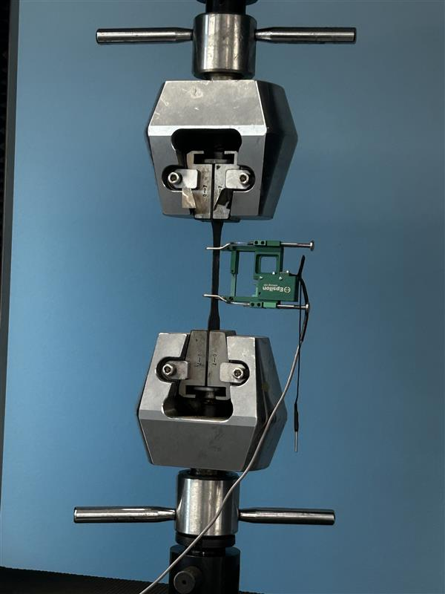
Figure 2 - Denison Tensile/Compression test Machine Used For All Specimen Testing
Tensile testing was conducted using a Denison tensile/compression test machine (Figure 2) in accordance with ISO 527-4:2021 (ISO, 2021). Sixteen aluminium specimens and eight specimens of each composite material were tested, with results averaged to minimise the influence of individual anomalies and manufacturing variability. Key properties extracted included ultimate tensile strength (UTS), 0.2% proof stress, Young's modulus, toughness (area under the stress-strain curve via the trapezoid rule), and specific properties normalised by density. Young's modulus was determined from the linear elastic region between 0.05 and 0.25 mm/mm strain. Material densities were sourced from manufacturer datasheets (Easy Composites, 2024a; 2024b; 2024c; EcoTechnilin, 2023a; 2023b). All results are presented as means with standard deviation error bars, validated against manufacturer data and published literature, and summarised in Table 2.
Table 2 - Averaged Mechanical Properties For All Materials (n = specimens tested)
Material | UTS (MPa) | ±SD | Rp02 (MPa) | ±SD | Modulus (GPa) | ±SD | Toughness (MJ/m³) | n
Aluminium | 116.875 | 2.156 | 108.069 | 3.631 | 54.668 | 6.453 | 16.106 | 16
Carbon NW Bio | 257.75 | 151.035 | 215.203 | 162.648 | 11.511 | 6.346 | 5.090 | 8
Carbon W Bio | 351.75 | 298.465 | 262.812 | 224.002 | 47.143 | 41.509 | 4.747 | 8
Carbon W epoxy | 608.25 | 433.656 | 448.443 | 303.862 | 84.245 | 59.006 | 9.109 | 8
Flax NW Bio | 54 | 25.557 | 39.52 | 16.801 | 26.17 | 52.782 | 0.679 | 8
Flax W Bio | 144.625 | 100.318 | 100.563 | 55.361 | 4.02 | 4.094 | 3.897 | 8
Kevlar W Bio | 369.5 | 150.275 | 225.275 | 85.375 | 17.165 | 9.354 | 12.200 | 8

4.1.1 Stress-Strain & UTS Analysis
The stress-strain behaviour of all specimens is presented in Figure 3 & Figure 4, showing individual sample traces and averaged curves with 95% confidence bands respectively. The results reveal clearly distinct failure behaviours between material classes.
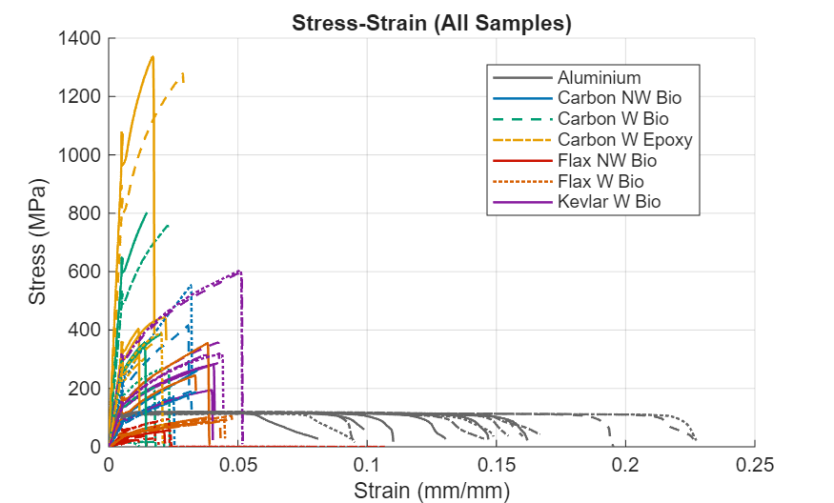
Figure 3 - Stress-Strain Curves For All Individual Specimens

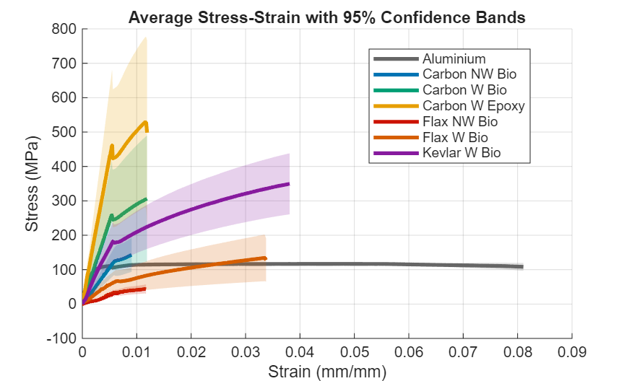
Figure 4 - Averaged Stress-Strain Curves With 95% Confidence Bands
Aluminium exhibited the characteristic ductile metallic response: a well-defined elastic region, 0.2% proof stress of 108 MPa, UTS of 117 MPa, and an extended plastic plateau reaching approximately 0.20 mm/mm strain before fracture. The narrow confidence band in Figure 4 confirms high consistency across all sixteen specimens, validating the reliability of the aluminium dataset. This result aligns closely with published values of 90–150 MPa UTS for AA series alloys (Ashby and Jones, 2018), confirming the test setup was functioning correctly.
Carbon Woven Epoxy achieved the highest averaged UTS of 608 MPa with a proof stress of 448 MPa, though the large standard deviation of ±434 MPa reflects considerable variability across groups, suggesting inconsistent consolidation or resin infusion quality between specimens. Despite this scatter, the mean is consistent with published woven CFRP tensile strengths of 300–800 MPa depending on fibre volume fraction and layup (Spinu et al., 2024). Failure was brittle and abrupt at low strain in all cases, consistent with the catastrophic fibre fracture mechanism characteristic of carbon composites (Mallick, 2007). Kevlar Woven Bio achieved an averaged UTS of 370 MPa (±150 MPa) and proof stress of 225 MPa. Its stress-strain curve shows more progressive failure than carbon, reflecting the fibrillar splitting mechanism of aramid fibres (Sathishkumar et al., 2021).
Carbon NW Bio returned 258 MPa (±151 MPa), lower than woven carbon specimens as expected given the random, discontinuous fibre architecture of the non-woven mat, which reduces load transfer efficiency. Carbon W Bio averaged 352 MPa (±298 MPa); the very large standard deviation indicates significant variation in consolidation quality between groups. Flax W Bio achieved 145 MPa (±100 MPa) and Flax NW Bio 54 MPa (±26 MPa), consistent with published tensile strengths of 60–120 MPa for woven flax-epoxy systems (Gowda et al., 2022). The lower UTS of the non-woven flax is attributable to the random mat architecture of the FibriMat F300, which provides no continuous fibre alignment.
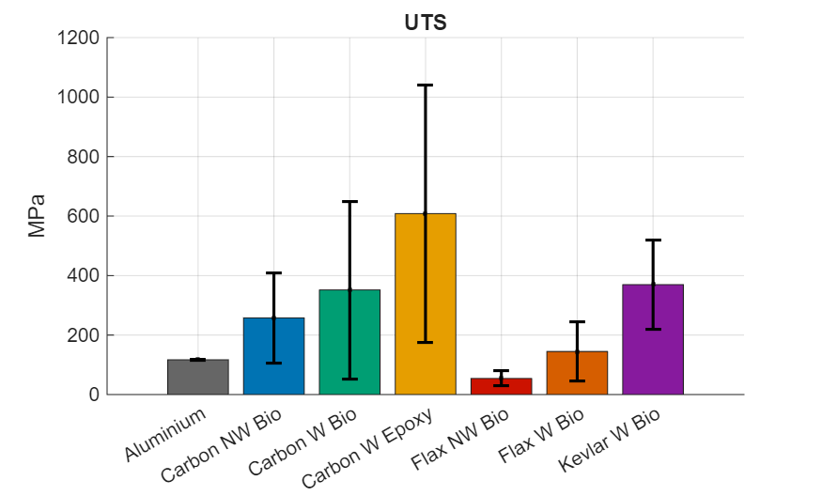
Figure 5 - Averaged UTS For All Materials With Standard Deviation Error Bars
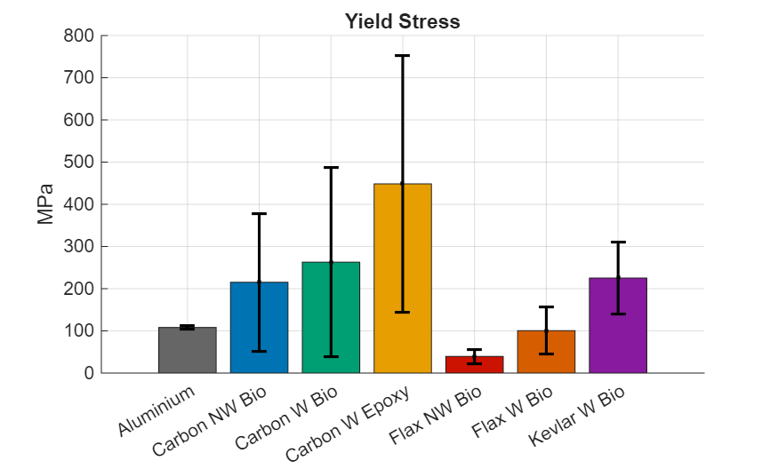
Figure 6 - Averaged 0.2% Proof Stress For All Materials With Standard Deviation Error Bars

4.1.2 Young's Modulus Analysis
Averaged modulus values are presented in Figure 7. Carbon W Epoxy recorded the highest composite modulus at 84.2 GPa (±59 GPa), with significant inter-group scatter. Aluminium followed at 54.7 GPa (±6.5 GPa), with the tight standard deviation confirming consistent behaviour across all sixteen specimens. Carbon W Bio averaged 47.1 GPa (±41.5 GPa). These values are broadly consistent with published woven CFRP moduli of 40–100 GPa (Spinu et al., 2024), though composite scatter is notably larger than for aluminium, indicating greater sensitivity to manufacturing quality.
Kevlar W Bio achieved 17.2 GPa (±9.4 GPa), consistent with published composite-level moduli of 15–30 GPa for woven Kevlar-49 laminates (Sathishkumar et al., 2021). Carbon NW Bio recorded 11.5 GPa (±6.3 GPa), reflecting the stiffness penalty of the random non-woven architecture. Flax NW Bio returned an average of 26.2 GPa (±52.8 GPa), the extreme standard deviation renders this result unreliable, and it should be treated with caution, reflecting strain gauge issues or anomalous individual specimens rather than true material behaviour. Flax W Bio recorded 4.0 GPa (±4.1 GPa), below the expected range of 5–15 GPa for woven flax-epoxy composites (Ricciardi et al., 2024), suggesting incomplete resin infusion or poor fibre-matrix interfacial bonding in several specimens.
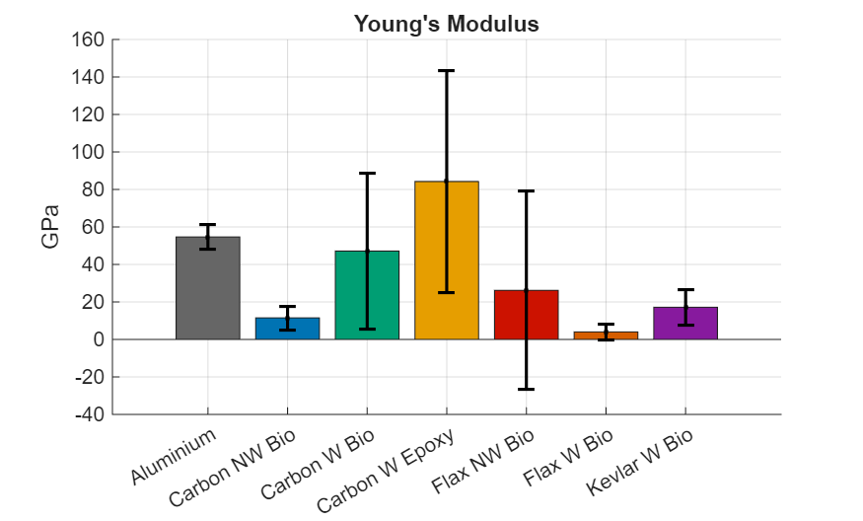
Figure 7 - Averaged Young's Modulus For All Materials With Standard Deviation Error Bars

4.1.3 Specific Strength and Specific Modulus
When normalised by density, material rankings shift considerably, as shown in the Ashby plot (Figure 8) and specific property charts (Figure 9 & Figure 10), a particularly meaningful comparison in motorsport and automotive contexts where structural efficiency per unit mass is the primary design criterion (Fan and Njuguna, 2016).
Carbon W Epoxy leads on both specific strength (392 MPa/(g/cm³)) and specific modulus (54,352 GPa/(g/cm³)). Kevlar W Bio achieves 274 MPa/(g/cm³), closely comparable to carbon epoxy despite lower absolute UTS, owing to Kevlar's low density of 1.35 g/cm³. Carbon W Bio follows at 227 MPa/(g/cm³) and 30,415 GPa/(g/cm³).
Aluminium achieves only 43 MPa/(g/cm³) specific strength and 20,247 GPa/(g/cm³) specific modulus, placing it below all composites except the non-woven natural fibre specimens, directly demonstrating the mass efficiency advantage of composite adoption in weight-critical applications (Fan and Njuguna, 2016). Notably, Carbon NW Bio achieves 171 MPa/(g/cm³), four times aluminium's value, despite being a recycled fibre system with a lower production carbon footprint. Flax W Bio reaches 100 MPa/(g/cm³), more than double aluminium, supporting its viability where sustainability is prioritised (Alshahrani et al., 2024).
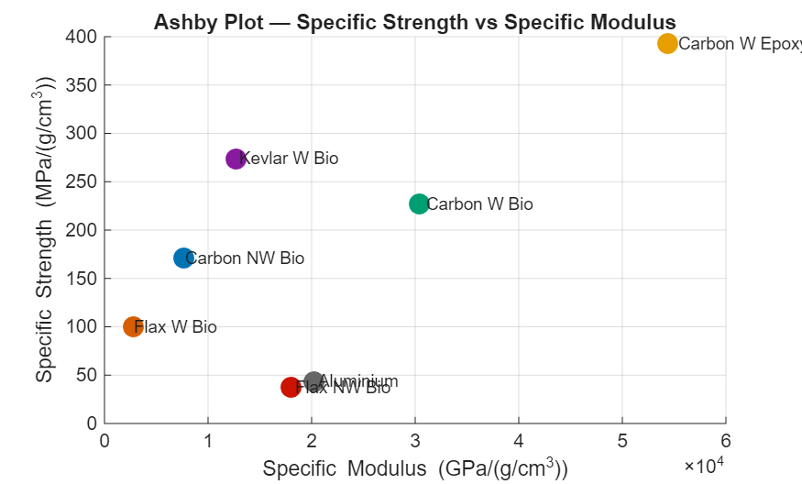
Figure 8 - Ashby Plot of Specific Strength vs Specific Modulus For All Materials

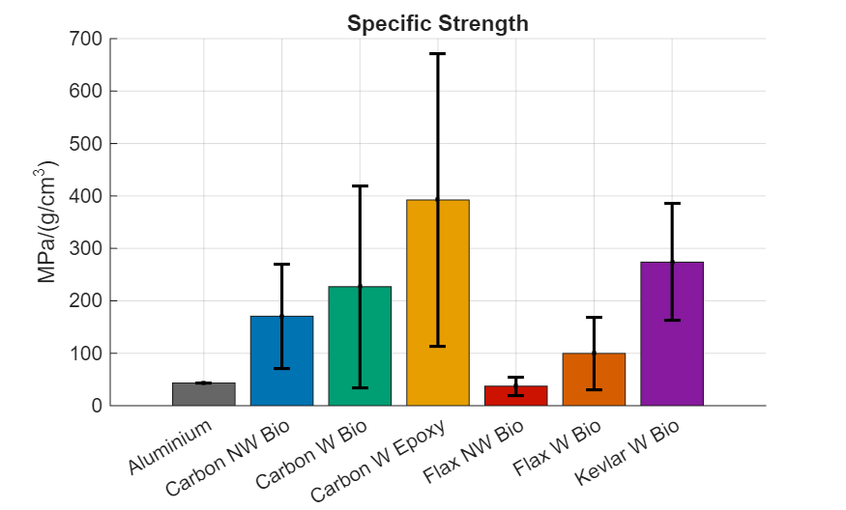
Figure 9 - Averaged Specific Strength For All Materials With Standard Deviation Error Bars
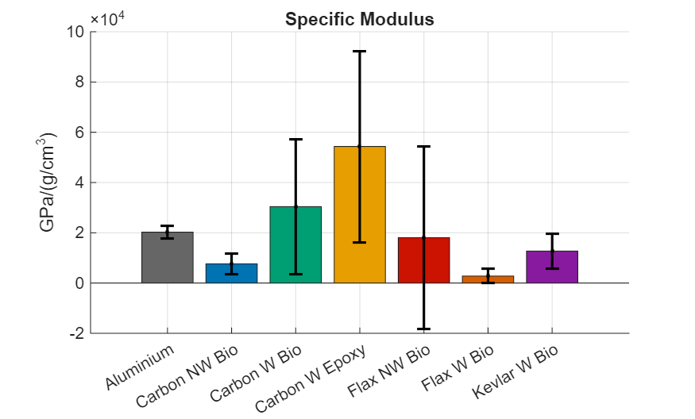
Figure 10 - Averaged Specific Modulus For All Materials With Standard Deviation Error Bars

4.1.4 Toughness Analysis
Toughness values are shown in Figure 11. Aluminium dominates at 16.1 MJ/m³ (±5.1 MJ/m³), reflecting its large plastic deformation capacity, a critical advantage in crash energy absorption scenarios. Kevlar W Bio returned the highest composite toughness at 12.2 MJ/m³ (±6.8 MJ/m³), the closest of any composite to aluminium's energy absorption, consistent with the energy-absorbing fibrillar failure mechanism of aramid fibres (Oliwa, 2020). This makes Kevlar particularly suited to crash structures and roll-over protection despite its sustainability limitations discussed in Sustainability Analysis.
Carbon W Epoxy achieved 9.1 MJ/m³ (±8.9 MJ/m³), with large scatter again reflecting inter-group variability in specimen quality. Carbon NW Bio and Carbon W Bio recorded 5.1 and 4.7 MJ/m³, respectively. Flax W Bio achieved 3.9 MJ/m³, comparable to the carbon systems despite significantly lower absolute strength, suggesting reasonable energy absorption potential per unit deformation. Flax NW Bio recorded the lowest toughness at 0.68 MJ/m³, consistent with its low UTS and short failure strain.
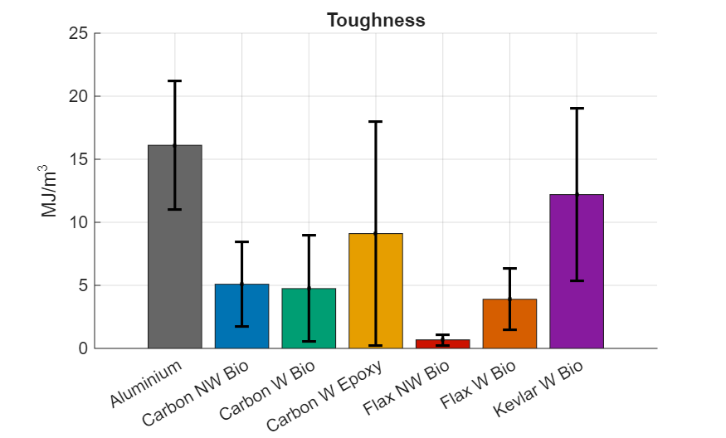
Figure 11- Average Toughness For All Materials With Standard Deviation Error Bars

4.1.5 Material Fracture Analysis
The fracture mode observed was consistent with expected failure mechanisms for each material class. Aluminium specimens exhibited ductile necking with significant permanent elongation prior to fracture, characteristic of metal plasticity. Carbon fibre specimens in both woven configurations failed abruptly with brittle transverse fracture and an audible crack, producing clean fracture surfaces with limited fibre pullout, consistent with catastrophic fibre-dominated failure at low strain (Hallett et al., 2009). Kevlar specimens exhibited progressive fracture with visible fibrillar splitting and fibre pullout, the pseudo-ductile failure mode responsible for the higher toughness values observed in 4.1.4 Toughness Analysis.
Flax woven specimens showed distributed damage prior to final fracture, with progressive matrix cracking preceding fibre failure, attributable to the hierarchical cellulosic fibre microstructure. Several Carbon W Bio specimens produced anomalously low strength and stiffness values, with fracture surfaces indicating incomplete resin infusion, visible as dry fibre regions where the matrix had not penetrated the weave. These are reflected in the large standard deviations for Carbon W Bio and represent manufacturing defects rather than true material behaviour. The Rule of Mixtures prediction for a woven carbon/epoxy system with a fibre volume fraction of 0.45 yields an expected longitudinal modulus of approximately 40–50 GPa (Kollár and Springer, 2003), consistent with the better-consolidated specimens in this dataset, further supporting this interpretation.
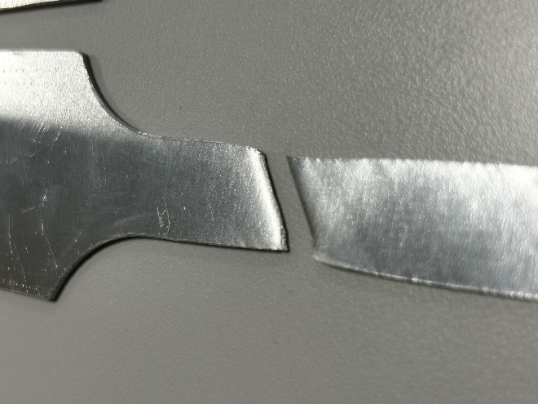
Figure 12 - Aluminium Specimen Showing Ductile Necking and Shear Lip Fracture Surface
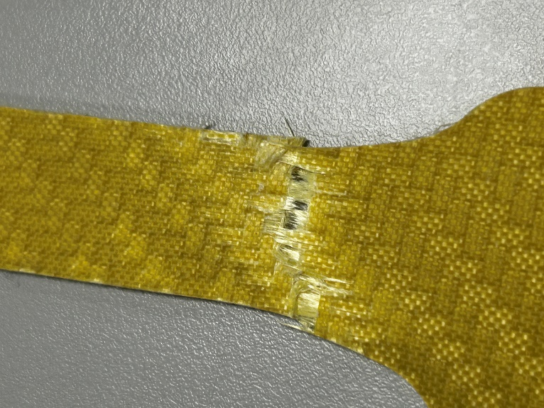
Figure 13 - Kevlar Woven Bio Specimen Showing Characteristic Fibrillar Splitting and Fibre Pullout
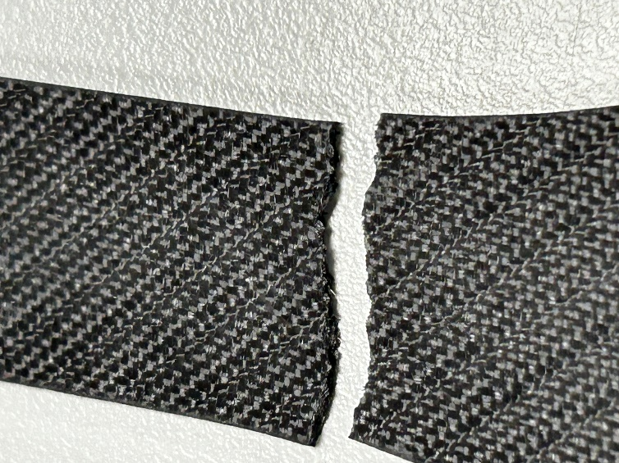
Figure 14 - Carbon Non-Woven Bio Specimen Showing Irregular Fracture Consistent With Random Fibre Orientation
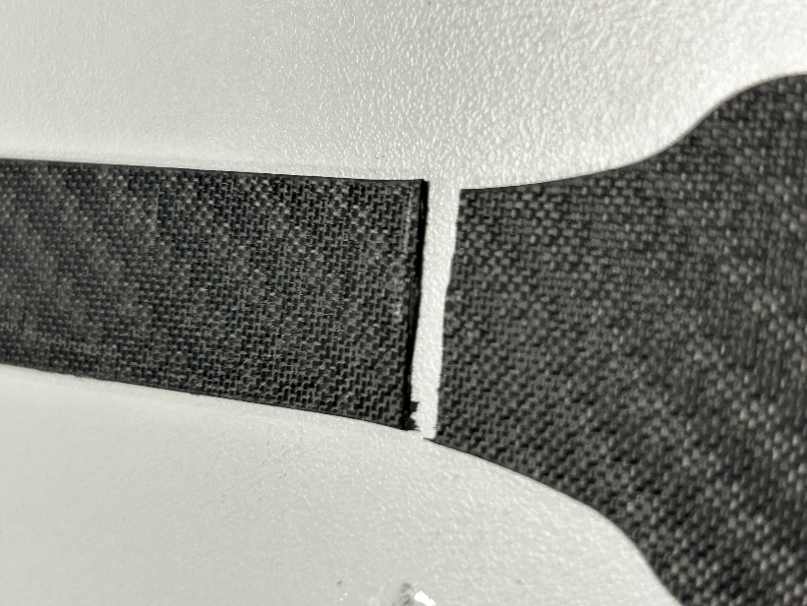
Figure 15 - Carbon Woven Specimen Showing Clean Brittle Transverse Fracture

Recommendations
Based on the experimental findings and sustainability analysis, the following material-specific recommendations are made for motorsport and automotive applications.
Carbon Woven Epoxy should be retained for primary structural applications where mass efficiency is paramount, but strict resin infusion process controls, including vacuum integrity monitoring and post-cure inspection, are essential to reduce the ±434 MPa UTS variability observed experimentally.
Recycled carbon fibre non-woven composites are recommended for secondary aerodynamic and non-structural components. With a specific strength over four times that of aluminium and lower embodied energy than virgin CFRP, broader adoption would support the industrial-scale pyrolysis infrastructure needed to close the recycling loop (McLaren Racing, 2023).
Kevlar Woven Bio-resin is recommended exclusively for impact and crash energy absorption applications, where its toughness of 12.2 MJ/m³ is unmatched. Its use should otherwise be limited given its poor end-of-life recyclability and increasing regulatory liability under the EU ELV Regulation (European Commission, 2023).
Flax Woven Bio-resin is well suited to non-structural components, interior trim, body cladding, and aesthetic panels, where its specific strength of 100 MPa/(g/cm³) is sufficient and its low carbon footprint offers genuine sustainability value. Future work should address fibre-matrix interfacial bonding through surface treatments (Khieng et al., 2021) and explore hybridisation with rCF to improve stiffness (Dhakal and Sain, 2020).
Aluminium remains appropriate where repairability, thermal resistance, or end-of-life recyclability is the primary constraint, supported by its 95% energy saving in secondary production and mature recycling infrastructure (Hammond and Jones, 2011).
Three priority areas for future research are identified: standardisation of resin infusion procedures to reduce inter-group variability; long-term durability testing of flax bio-composites under cyclic loading and moisture exposure; and lifecycle assessment of hybrid rCF/flax systems to determine whether mechanical gains justify the increase in embodied carbon.

Conclusion
This report evaluated seven composite and metallic materials through experimental tensile testing, lifecycle assessment, and regulatory analysis for motorsport and automotive applications. Carbon Woven Epoxy delivered the highest specific strength (392 MPa/(g/cm³)) and confirmed the case for CFRP in primary structures. Kevlar Woven Bio-resin provided the highest composite toughness (12.2 MJ/m³), making it most suitable for crash energy absorption, while Flax Woven Bio-resin achieved twice the specific strength of aluminium at a production carbon footprint below 1.5 kg CO₂/kg, a compelling result for non-primary applications.
A clear trade-off between mechanical performance and environmental impact was identified. Carbon fibre and Kevlar carry footprints of 20–31 kg CO₂/kg with no commercial recycling routes, placing them under increasing pressure from EU ELV Regulation targets (European Commission, 2023) and the FIA Environmental Strategy (2021). The transition to battery electric vehicles strengthens this pressure by compressing the use-phase carbon payback that has traditionally justified CFRP.
The findings support a tiered material strategy: virgin CFRP for primary structures, Kevlar limited to safety-critical impact zones, recycled carbon non-woven for secondary components, flax bio-composites for body panels and interiors, and aluminium where repairability and recyclability are priorities. This framework balances mechanical performance, regulatory compliance, and environmental responsibility, considerations that will increasingly define material selection across both industries.

References
Alshahrani, H., Sebaey, T.A., Rajak, D.K. and El-baky, M.A.A. (2024) 'Natural fibre and hybrid composite thin-walled structures for automotive crashworthiness: a review', Materials, 17(10), p. 2364.
Ashby, M.F. and Jones, D.R.H. (2018) Engineering Materials 1: An Introduction to Properties, Applications and Design. 5th edn. Oxford: Butterworth-Heinemann.
Bos, H.L., Müssig, J. and van den Oever, M.J.A. (2006) 'Mechanical properties of short-flax-fibre reinforced compounds', Composites Part A: Applied Science and Manufacturing, 37(10), pp. 1591–1604.
Bourmaud, A., Beaugrand, J., Shah, D.U., Placet, V. and Baley, C. (2018) 'Towards the design of high-performance plant fibre composites', Progress in Materials Science, 97, pp. 347–408.
Bovensiepen, C. (2025) Ready for series production: BMW Group achieves major breakthrough with utilization of natural fiber composites. BMW Group PressClub. Available at: https://www.press.bmwgroup.com (Accessed: 26 April 2026).
Butenegro, J.A., Bahrami, M., Abenojar, J. and Martínez, M.Á. (2021) 'Recent progress in carbon fiber reinforced polymers recycling: a review of recycling methods and reuse of carbon fibers', Materials, 14(21), p. 6401.
Callister, W.D. and Rethwisch, D.G. (2020) Materials Science and Engineering: An Introduction. 10th edn. Hoboken, NJ: Wiley.
Deng, Y. and Tian, Y. (2015) 'Assessing the environmental impact of flax fibre reinforced polymer composite from a consequential life cycle assessment perspective', Sustainability, 7(9), pp. 11462–11483.
Dhakal, H.N. and Sain, M. (2020) 'Enhancement of mechanical properties of flax-epoxy composite with carbon fibre hybridisation for lightweight applications', Materials, 13(1), p. 109.
Easy Composites Ltd (2024a) CF-NWM Carbon Fibre Non-Woven Mat — Technical Datasheet. Available at: www.easycomposites.co.uk (Accessed: 20 April 2026).
Easy Composites Ltd (2024b) IB2 Epoxy Infusion Bio Resin — Technical Datasheet. Available at: www.easycomposites.co.uk (Accessed: 20 April 2026).
Easy Composites Ltd (2024c) IN2 Epoxy Infusion Resin — Technical Datasheet. Available at: www.easycomposites.co.uk (Accessed: 20 April 2026).
EcoTechnilin (2023a) FibriMat™ F300 Non-Woven Flax Mat — Technical Datasheet. Valliquerville: EcoTechnilin.
EcoTechnilin (2023b) FlaxDry™ BL200 Twill Woven Flax Fabric — Technical Datasheet. Valliquerville: EcoTechnilin.
European Commission (2023) Proposal for a Regulation on circularity requirements for vehicle design and on management of end-of-life vehicles, COM(2023) 451. Brussels: European Commission. Available at: https://eur-lex.europa.eu (Accessed: 20 April 2026).
European Parliament (2025) Circular economy: deal on new EU rules for the automotive sector. Available at: https://www.europarl.europa.eu/news/en/press-room/20251209IPR32114 (Accessed: 26 April 2026).
Fan, J. and Njuguna, J. (2016) 'An introduction to lightweight composite materials and their use in transport structures', in Njuguna, J. (ed.) Lightweight Composite Structures in Transport. Oxford: Elsevier, pp. 3–34.
FIA (2021) FIA Environmental Strategy 2020–2030 Summary. Available at: https://purposedriven-admin.fia.com/sites/default/files/2021-10/FIA%20environmental%20strategy.pdf (Accessed: 20 April 2026).
FIA (2024) A new era of sustainable fuel: FIA introduces major step to provide certified 100% sustainable fuel for all. Available at: https://www.fia.com/news/new-era-sustainable-fuel (Accessed: 26 April 2026).
Ghlaim, K.H. (2024) 'Woven factor for the mechanical properties of woven composite materials', Journal of Engineering, 16(4), pp. 6012–6027.
Gowda, T.G.Y., Vinod, A., Madhu, P., Rangappa, S.M., Siengchin, S. and Jawaid, M. (2022) 'Mechanical and thermal properties of flax/carbon/Kevlar based epoxy hybrid composites', Polymer Composites, 43(8), pp. 5649–5662.
Hallett, S.R., Green, B.G., Jiang, W.G. and Wisnom, M.R. (2009) 'An experimental and numerical investigation into the damage mechanisms in notched composites', Composites Part A: Applied Science and Manufacturing, 40(5), pp. 613–624.
Hammond, G. and Jones, C. (2011) Inventory of Carbon and Energy (ICE), Version 2.0. Bath: University of Bath.
ISO (2006) ISO 14044:2006 Environmental Management — Life Cycle Assessment — Requirements and Guidelines. Geneva: International Organization for Standardization.
ISO (2021) ISO 527-4:2021 Plastics — Determination of Tensile Properties — Part 4: Test Conditions for Isotropic and Orthotropic Fibre-Reinforced Plastic Composites. Geneva: International Organization for Standardization.
Joshi, S.V., Drzal, L.T., Mohanty, A.K. and Arora, S. (2004) 'Are natural fiber composites environmentally superior to glass fiber reinforced composites?', Composites Part A, 35(3), pp. 371–376.
Kennedy, J. (2025) Sustainable Plastics for Automotive 2025–2035: Market, Players, and Forecasts. IDTechEx. Available at: https://www.idtechex.com/en/research-report/sustainable-plastics-for-automotive-2025/1066 (Accessed: 26 April 2026).
Khieng, T.K., Debnath, S., Ting Chaw Liang, E., Anwar, M., Pramanik, A. and Basak, A.K. (2021) 'A review on mechanical properties of natural fibre reinforced polymer composites under various strain rates', Journal of Composites Science, 5(5), p. 130.
Kollár, L.P. and Springer, G.S. (2003) Mechanics of Composite Structures. Cambridge: Cambridge University Press.
Lopez-Arraiza, A., Essamari, L., Iturrondobeitia, M., Boullosa-Falces, D. and Justel, D. (2025) 'Life cycle assessment of glass fibre versus flax fibre reinforced composite ship hulls', Scientific Reports, 15, article 16284.
Mallick, P.K. (2007) Fiber-Reinforced Composites: Materials, Manufacturing, and Design. 3rd edn. Boca Raton: CRC Press.
McLaren Racing (2023) McLaren Racing pioneers use of sustainable materials with innovative recycled carbon fibre trial. Available at: www.mclaren.com (Accessed: 26 April 2026).
Messana, A., Sisca, L., Ferraris, A., Airale, A.G., de Carvalho Pinheiro, H., Sanfilippo, P. and Carello, M. (2019) 'From design to manufacture of a carbon fiber monocoque for a three-wheeler vehicle prototype', Materials, 12(3), p. 332.
Nettles, A.T. (1994) Basic Mechanics of Laminated Composite Plates, NASA Reference Publication 1351. Hampton, VA: NASA Langley Research Center.
Oliwa, R. (2020) 'Mechanical properties of Kevlar fabric/epoxy composites', Materials, 13(17), p. 3726.
Pakdel, E., Kashi, S., Varley, R. and Wang, X. (2021) 'Recent progress in recycling carbon fibre reinforced composites and dry carbon fibre wastes', Resources, Conservation and Recycling, 166, p. 105340.
Qureshi, J. (2022) 'A review of recycling methods for fibre reinforced polymer composites', Sustainability, 14(24), p. 16855.
Rana, S. and Fangueiro, R. (2016) 'Overview: advanced composites in aerospace engineering', in Rana, S. and Fangueiro, R. (eds) Advanced Composite Materials for Aerospace Engineering. Oxford: Elsevier, pp. 1–15.
Ricciardi, M.R., Papa, I., Antonucci, V., Simeoli, G. and Russo, P. (2024) 'Static and impact properties of flax-reinforced polymers prepared with conventional epoxy and sustainable resins', Polymers, 16(2), p. 218.
Saba, N., Jawaid, M. and Sultan, M.T.H. (2019) 'An overview of mechanical and physical testing of composite materials', in Jawaid, M., Sultan, M.T.H. and Saba, N. (eds) Mechanical and Physical Testing of Biocomposites, Fibre-Reinforced Composites and Hybrid Composites. Oxford: Woodhead Publishing, pp. 1–12.
Sathishkumar, T.P., Navaneethakrishnan, P., Shankar, S. and Rajasekar, R. (2021) 'Mechanical strength retention of Kevlar fibre woven mat reinforced epoxy composites', Polymer Composites, 42(4), pp. 1855–1866.
Savage, G. (2010) 'Formula 1 composites engineering', Engineering Failure Analysis, 17(1), pp. 92–115.
Seile, A., Spurina, E. and Sinka, M. (2022) 'Reducing global warming potential impact of bio-based composites based on LCA', Fibers, 10(9), p. 79.
Spinu, I., Ciocan, V., Bria, V. and Birsan, I.G. (2024) 'Analyzing the tensile strength of carbon fiber-reinforced composites', Materiale Plastice, 59(1), pp. 44–50.
Tham, M.W., Fazita, M.R.N., Khalil, H.P.S.A., Zuhudi, N.Z.M., Jaafar, M., Rizal, S. and Haafiz, M.K.M. (2018) 'Tensile properties prediction of natural fibre composites using rule of mixtures: a review', Journal of Reinforced Plastics and Composites, 38(5), pp. 211–248.
Ursache, S., Cerbu, C. and Hadăr, A. (2023) 'Characteristics of carbon and Kevlar fibres, their composites and structural applications in civil engineering: a review', Materials, 17(1), p. 94.
Wazeer, A., Das, A., Abeykoon, C., Sinha, A. and Karmakar, A. (2023) 'Composites for electric vehicles and automotive sector: a review', Green Energy and Intelligent Transportation, 2(1), p. 100043.
Zhang, C., Liu, F., Soutis, C. and Wang, Z. (2022) 'Interfacial properties and strengthening mechanisms of carbon fiber-reinforced polymer composites: a review', Composites Science and Technology, 229, 109708.

Appendix A
The following appendix contains the raw individual specimen data from the authors’ test group prior to averaging with other groups, provided for reference and to support validation of the averaging methodology used in Experimental Testing.
Table 3 - Individual Specimen Results
Material | UTS (MPa) | Rp02 (MPa) | Modulus (GPa) | Specific Strength (MPa/(g/cm³)) | Specific Modulus (GPa/(g/cm³)) | Toughness (MJ/m³)
Aluminium | 117 | 51.7375 | 51.7375 | 43.333 | 19162.037 | 18.997
Carbon NW Bio | 138.5 | 101.265 | 14.995 | 91.722 | 9930.464 | 2.110
Carbon W Bio | 16 | 15.05 | 1.985 | 10.323 | 1222.581 | 0.209
Carbon W epoxy | 331.5 | 254.415 | 46.335 | 213.871 | 29893.548 | 3.551
Flax NW Bio | 26 | 18.82 | 5.76 | 17.931 | 3972.414 | 0.252
Flax W Bio | 91 | 71.955 | 1.63 | 62.759 | 1124.138 | 2.809
Kevlar W Bio | 285 | 170.46 | 14.72 | 211.111 | 10903.704 | 8.462

Appendix B
The following appendix contains photos taken during the authors’ tensile testing experiment of the specimens before and after the tensile test.
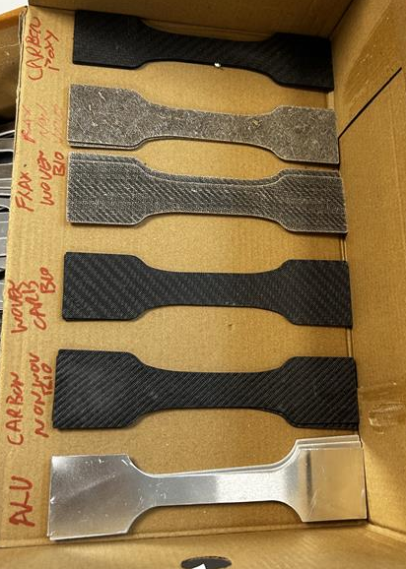
Figure 16 - All 7 Specimens Before Tensile Testing
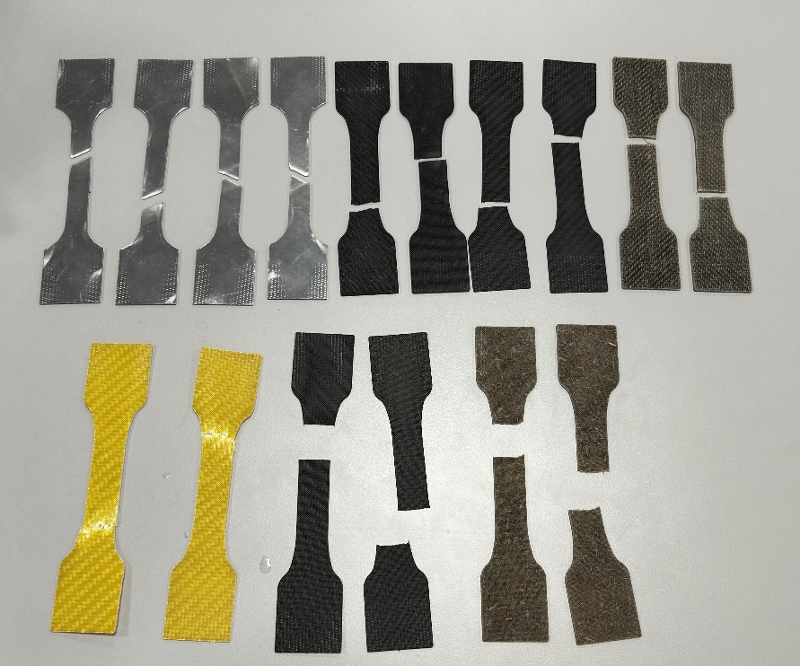
Figure 17 - All Specimen Typres Prior to Tensile Testing, Showing Material Variety and ISO 527-4 Geometry
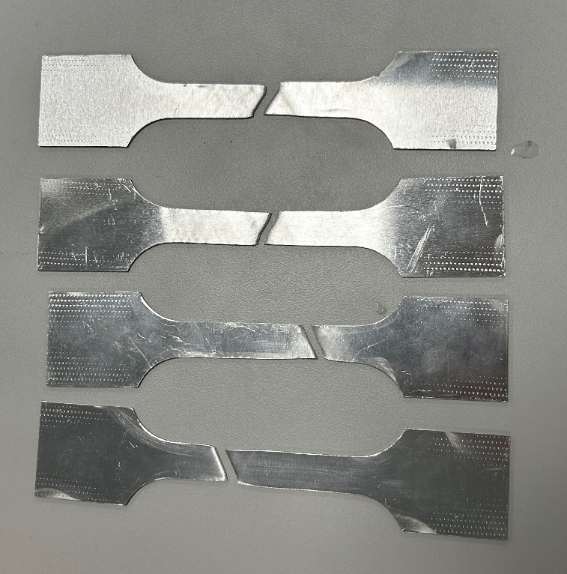
Figure 18 - Aluminium Specimens After Tensile Testing, Showing The Ductile Elongation
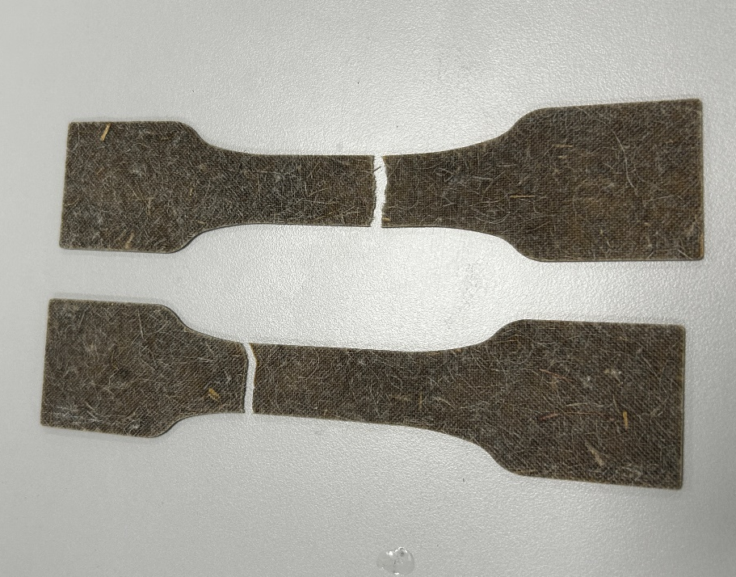
Figure 19 - Flax Non-woven Wider Image Showing Break Per Material

