Santino Luzzi (2320579)
2320579@student.uwtsd.ac.uk

Environment Design
BA Computer games design (ACCA4032)

Contents
Youtube Video Link 1
Screenshots of Finished Diorama 2
Bibliography 4

Youtube Video Link
Link : https://youtu.be/s0d698jPM4g

Screenshots of Finished Diorama
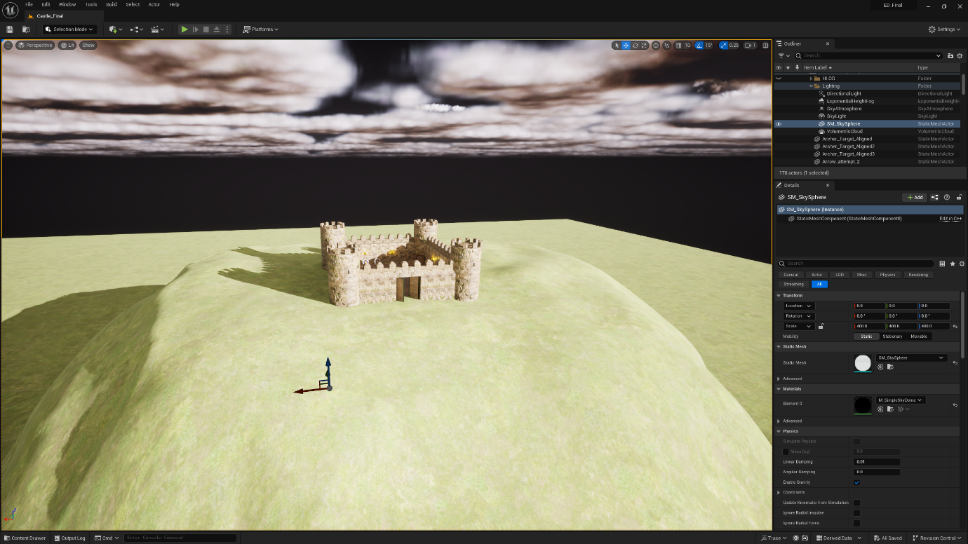

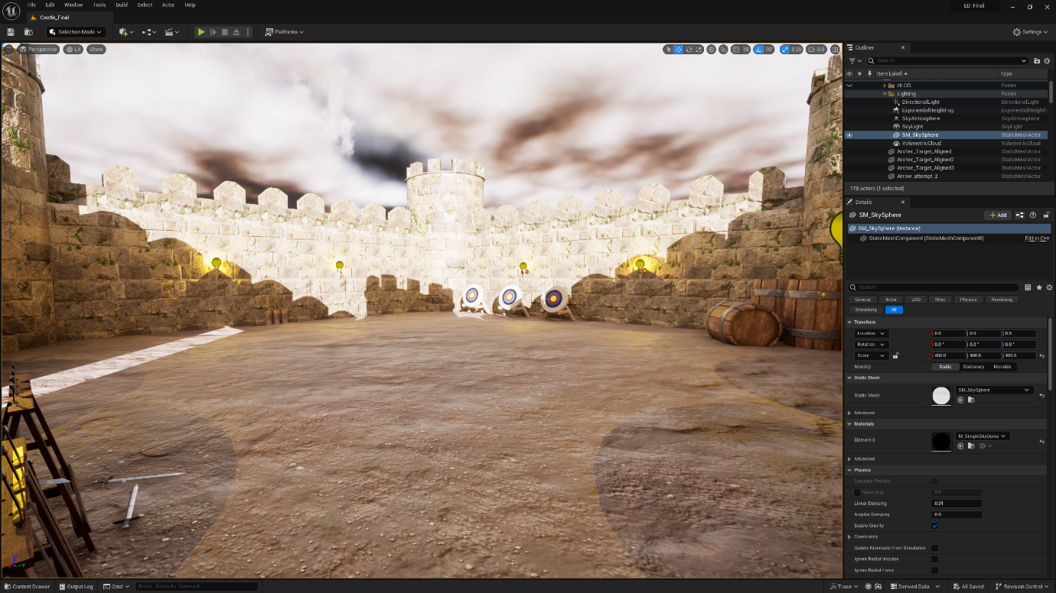

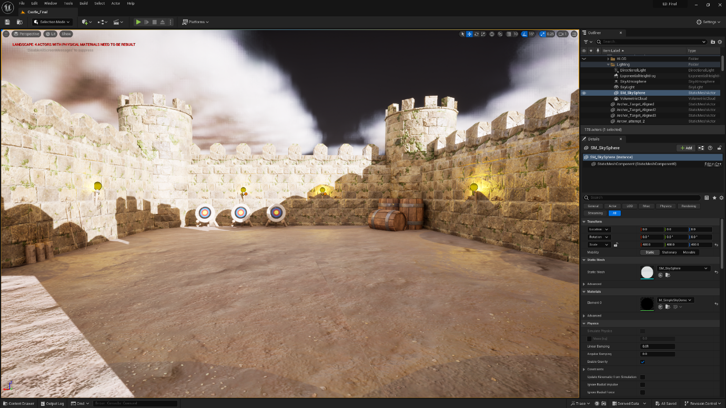

Bibliography
- [1] “How to fix seams in substance painter,” YouTube, https://www.youtube.com/watch?v=ckKJxVXoMH8 (accessed May 3, 2024).
- [2] “Substance 3D painter textures into Unreal engine 5 including emission,” YouTube, https://www.youtube.com/watch?v=wcpz9_stKgs (accessed May 3, 2024).
- [3] Substance 3D assets homepage, https://substance3d.adobe.com/assets (accessed May 2, 2024).
- [4] R. Romeu, Artstation - explore, https://www.artstation.com/ (accessed Apr. 25, 2024).
- [5] The simple medieval castle - make CNC, https://www.makecnc.com/the-simple-medieval-castle.php (accessed Apr. 22, 2024).

