5OS01

Learner Assessment Brief
Assessment ID / CIPD_5OS01_23_01

- Evaluate the aims and objectives of employment regulation. (AC 1.1)

Employment law has evolved rapidly over the last 50 years to address emerging workplace trends, conflict, technology advancements and external influencers (Daniels, 2022, p. 2). As described by CIPD (no date), “employment law regulates the relationships between employers and employee” and therefore, failure to comply and act in accordance with legislation increases the risk of legal action, financial penalties, damaged reputation, and the loss of trust between employee and employer (Taylor and Woodham, 2022, p. 90).

Debates surrounding employment law continue with those in favour and those against query the effectiveness and the implications it can cause for both workers and employees. Taylor and Woodhams (2022, p. 90) state employment law stems from “the desire to enhance social justice” by enforcing the Working Time Regulations Act (1998) where employees’ health and safety is protected by limiting maximum working hours, ensuring rest periods, and guaranteeing paid annual leave. In addition to this, employment law also aims to protect people against discrimination or unfair treatment, through the establishment of the Equality Act (2010), where someone may be subject to being treated less favourably due their age, gender, race, sexual orientation, or other protected characteristic (ACAS, 2023a). In accordance with this law, employers must take actions to prevent discrimination in the workplace, otherwise face costly legal fines, reputational damage and could risk affecting the morale on the rest of its workforce.

Although employment law cannot guarantee all employees and workers will be treated well, it does impose consequences on those who violate regulations and act unlawfully. In a world where employment law would cease to exist, employees would be more vulnerable to exploitation, unsafe working conditions and prevalent discrimination, creating an unhealthy work environment and society (Daniels, 2022, p. 3). Thus, it prevents employers from exploiting their power by empowering employees of their rights.

- Examine the role played by the tribunal and courts system in enforcing employment law. (AC 1.2)

The UK employment law system is made up of specific courts that deal with different cases, as highlighted in image A (Judiciary, no date a):
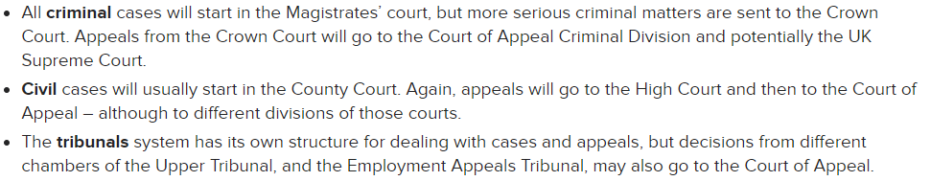
Image A

Employment tribunals are the “judicial body with responsibility for workplace justice” which act as the primary forum for initial disputes relating to employment law (Judiciary, no date b), with avenues for appeal to courts such as the Employment Appeal Tribunal (EAT) and higher civil courts (Judiciary, no date a). Cases may progress up the hierarchy if one of the parties involved is unhappy with the outcome of the ET. It is also possible to review the judgement (known as reconsideration) or escalate an appeal to the EAT (Daniels, 2022, p. 30).

If the dispute does not reach a settlement outside of the tribunal, it will progress to County Court, or further to the High Court if it is more complex and of higher monetary value; according to Taylor (2023), the High Court deals with claims excessive of £15,000. Appeals from either of these may then be taken to the Court of Appeal where cases are reviewed – this occasionally results in overturning a decision of an EAT or reinstating the initial ET conclusion. (Taylor, 2023). After this, appeals to the Supreme Court would only include matters of public interest, whereby employers and employees across the UK may be impacted (Taylor, 2023). This serves as the final court of appeal within the system for both criminal and civil cases. Successful appeals to higher courts can lead to the creation of new law or clarifications in existing legislation (Taylor and Woodhams, 2022, p. 92). A visual diagram of the UK court system is provided below (image B), (Judiciary, 2021):
Image B
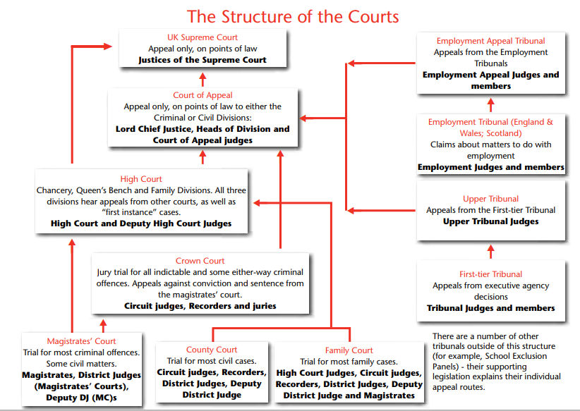

In summary, the UK’s legal system is an intricate hierarchy of courts and tribunals which serves numerous purposes that support the system’s needs. The aim of the tribunal and courts system is to provide justice to people and businesses, uphold the rule of law and resolve disputes effectively and fairly.
- Explain how cases are settled before and during legal procedures. (AC 1.3)

Settlement of claims can be resolved without needing to go through a formal hearing procedure. Claimant and respondent may choose to engage with each other directly to resolve their differences, use the conciliation services provided by ACAS, or through an internal or external mediator (Ayling and Suff, 2023).

ACAS works with both parties involved in a dispute to help reach an agreement without proceeding further to an employment tribunal (ET) (ACAS, 2022). Contacting ACAS must be done within the specific timescale: 3 months minus 1 day from the time the incident occurred but in certain circumstances, such as equal pay claims can be made within 6 months minus 1 day (ACAS, 2023b). If the claimant wants to continue, a Conciliation Officer will be assigned to the case and will be responsible for facilitating a settlement between the claimant and the employer; the Officer will have 6 weeks to achieve this (Daniels, 2022, p. 21).

Alternatively, if the claimant does not want to continue with early conciliation, ACAS will issue a certificate with an early conciliation number (ACAS, 2023b). If the respondent of the claim declines early conciliation, ACAS will provide the claimant with a certificate and early conciliation number. This certificate and number enables the claimant to complete an ET1 form if they wish to proceed to a tribunal (ACAS, 2023b).

If a settlement is achieved, ACAS provides a legally binding COT3 form highlighting what has been agreed (ACAS, 2023b). This is a settlement agreement (Ayling and Suff, 2023). It is a legally binding document that contains the terms and conditions agreed during conciliation. The key features of settlement agreements are outlined by Ayling and Suff (2023) in image C below:
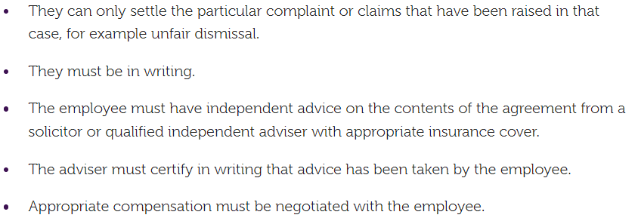
Image C

If the case cannot reach agreement and proceeds to an ET, the communications and offers made during the settlement negotiations cannot be used as evidence in tribunal proceedings – this is also known as ‘without prejudice’, which supports both parties involved to explore solutions openly and reach a settlement, without the risk of negotiations being used “in any subsequent unfair dismissal claim” (ACAS, 2013).

Seeking independent legal advice before signing a settlement agreement is critical to ensure individuals fully understand the terms and conditions and any possible implications that may result in unforeseen consequences (Barbeary and Rafaeli, 2021). Employments Right Act (1996), section 203, states “an employee or worker must have received legal advice as to the terms and effect of the proposed agreement and, in particular, its effect on his ability to pursue his rights before an employment tribunal” for the settlement to be legally effective.

And provide tailored advice for each of the following scenarios:

- Charlotte and Madeleine are aware discrimination legislation exists. They are unsure how this might affect their approach to recruitment and selection of employees for their two new branch openings. They want to avoid dealing with retirement and do not want their business disrupted by employees taking maternity leave. To overcome this, they decide to appoint young men. Advise them on the decision of appointing young men only. (AC 2.1)

Warranting impartial and non-discriminatory practices in recruitment and selection processes is not only ethical, but a legal obligation under the Equality Act (2010) which prohibits all forms of discrimination based on the protected characteristics set out in section 4 of the Act:
- Age
- Disability
- Gender reassignment
- Marriage and civil partnership
- Race
- Religion or belief
- Sex
- Sexual orientation

As highlighted, sex and age discrimination are forbidden in all forms of employment. It is important to note that discrimination can be presented in several different ways, so being educated on these is vital to avoiding unintentional biases. Miller (2023) highlights the different forms that sit within the Act:
- Direct
- Indirect discrimination
- Associative discrimination
- Perceptive
- Victimisation
- Harassment
- Occupational requirement
- Positive action

According to Daniels (2022, p. 94), direct discrimination happens at recruitment or promotion where an employer “fails to shortlist, appoint or promote a well-qualified” individual based on a protected characteristic. As Charlotte and Madeleine have decided to only hire young men to ‘avoid dealing with retirement’ and not be ‘disrupted by maternity leave’, this constitutes direct discrimination as it involves treating individuals less favourably based on their characteristics (ACAS, 2023c). This could have a significant legal and ethical ramification on the recruitment and selection process; individuals seeking employment who encounter discriminatory practices due to their gender or age would be entitled to file a claim for discrimination (Morris, 2022), not only would this impact the organisation financially, but it could also damage their reputation too. There are exceptions where an employer must hire a particular group of people for a particular type of work, such as a job that requires providing intimate care that would be inappropriate for the opposite sex to do, otherwise known as ‘occupational requirements’ (Daniels, 2022, p. 120). Due to the reasons Charlotte and Madeleine have given, this does not apply.
Employers can provide targeted support, known as positive action, where they imbed lawful initiatives to identify underrepresented groups at work and take actions to rectify (Taylor and Woodhams, 2022, p. 204). During recruitment and selection, organisations can take positive action by encouraging individuals of a particular characteristic to apply for a role in their organisation, if they are underrepresented (Daniels, 2022, p. 131). This is different to positive discrimination, where an individual is treated more favourably based on their characteristics and employers must be able to justify using positive action (Taylor and Woodhams, 2022, p. 205).

- Cat, a restaurant manager, has recently become aware that she is paid less than Kit, another manager who is male. Her salary is £28,000 a year, whereas Kit earns £30,000 a year. She asked Charlotte to increase her salary to match Kit’s, but she refused saying Kit deserved the extra money. (AC 2.2)

The Equal Pay Act 1970 was the first Act (UK) to introduce equal pay for equal work principles between men and women, which is now a part of the Equality Act 2010 (Daniels, 2022, p. 131). The legislation aims to prevent discrimination in pay against employees who perform the following (Image B), and employees are entitled to make a claim against these (Cotton, 2023):
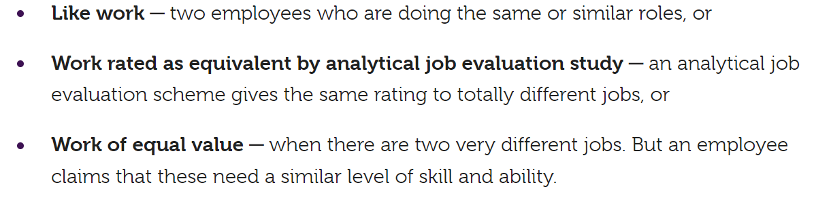
Image B

As Cat and Kit work for the same employer, Kit has been identified as a comparator against Cat’s salary, and they do like work, then Cat would have the right to raise an equal pay claim (Daniels, 2022, p. 131). The reason Charlotte has given for the discrepancy in pay will not be sufficient should Cat proceed with a claim; as Daniels (2022, p. 134) outlines, “the tribunal must be convinced that the reason given is genuine and not an excuse.” Additionally, if an employer is found guilty because of such claim, they are then required to carry out a pay audit which will need to be published online for three years; financial penalties can be imposed if an employer fails to do this (Cotton, 2023).

Employers with more than 250 employees are now required to produce a gender pay gap report as part of section 78 of the Equality Act 2010, however this is optional for private and voluntary sector organisation (Cotton, 2023). It is recommended that Catherine carries out an equal pay review to identify if there are employees carrying out ‘equal work’ and form an action plan to rectify discrepancies at the earliest convenience to avoid a possible ET (ACAS, 2024a).

- The lease on an existing site is due to expire in four months’ time and the new terms are prohibitively expensive. Charlotte and Madeleine decide to close the restaurant when the lease expires, rather than renew the lease. When the restaurant closes, they intend to dismiss all six employees, paying each person two weeks’ notice as stated in their contracts of employment:
  - Angelica, the manager (eight years’ service, 53 years old, salary £700 per week)
  - Saffron, the supervisor (five years’ service, 30 years old, salary £350 per week)
  - Chip and Cherry, full-time sales assistants, who are 18 years old, and Reese and Carmel, full-time sales assistants who are 19 years old. All four employees have one year’s service, are paid £9.00 per hour and work 25 hours a week)

Advise why their approach is risky and what they should do instead. (AC 3.1)

As the decision to close the business due to expensive lease terms leads to terminating all staff, this scenario applies to redundancy as all roles are due to be ceased, therefore it is vital to ensure Charlotte and Madeleine are aware of the legal and ethical implications surrounding this concern (Ayling and Suff, 2024a).

As redundancy is considered a dismissal, it is important to ensure it follows a fair practice. ACAS (2024b) advise looking at alternative options before starting the process to mitigate potential risks and reduce the negative impact (image C):
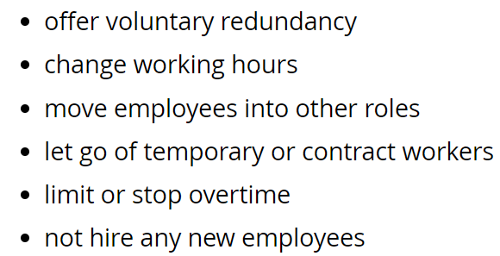
Image C

According to ACAS (2024b), a ‘fair’ process should involve consulting staff to ensure transparency, they are aware of their rights and prioritise their wellbeing in the course. As the redundancy in this scenario is imminent, the managers should follow this procedure. If Charlotte and Madeline do not consult with their staff prior to carrying out the redundancies, they risk potential ET claims for unfair dismissal (ACAS, 2024c). Furthermore, a written redundancy notice should be provided following consultation which provides either statutory or contractual notice depending on which is greater (Ayling and Suff, 2024a). The statutory redundancy notice period is highlighted in image D below (ACAS, 2024d);

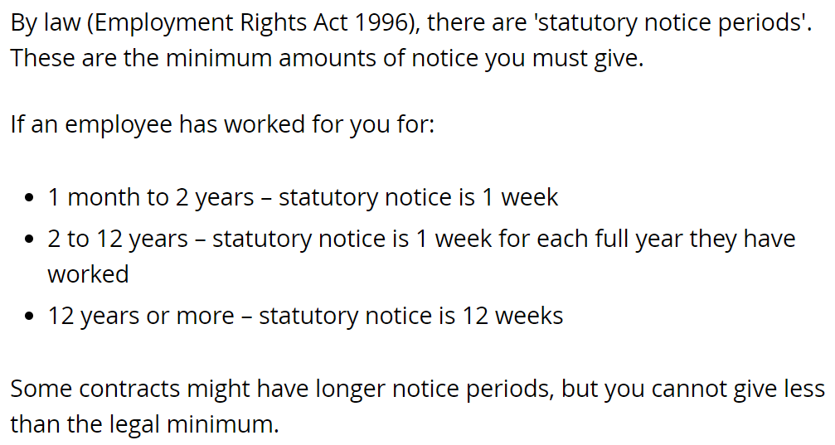
Image D

Also, the legal statutory redundancy pay will be paid to employees with two years or more service. The information in image E applies (GOV.UK, no date a):
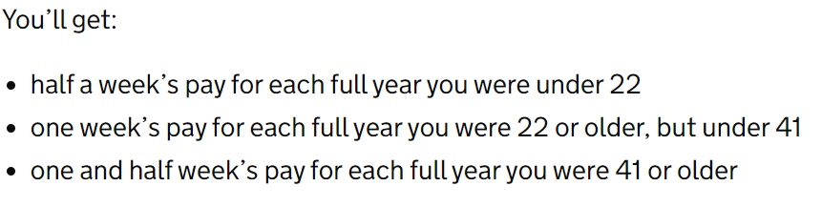

Payments should be made to the staff no later than the final pay day – any later than this should be agreed in writing; if Charlotte and Madeleine do not pay expenses on time, they may be subject to an ET claim (ACAS, 2024e). Based on the information provided, Charlotte and Madeleine should therefore proceed with the following:

Angelica
1.5 weeks x £700 = £1,050
£1,050 x 8 years = £8,400 total
8 weeks’ notice

Saffron
1 week x £350 = £350
£350 x 5 years = £1,750 total
5 weeks’ notice

Chip, Cherry, Reese and Carmel
These members of staff are not entitled to statutory redundancy pay as they have less than two years’ service, therefore should be paid:
£9.00 x 25 hours = £225
£225 x 2 weeks = £450pp total
1 weeks’ notice

- The takeover of Crumbly Cakes is due to be complete in four months. Ownership will transfer to Peachy Desserts Ltd, and the identity of the owner will change. Charlotte and Madeleine consider the takeover a ‘good fit’ with their business, as the nature of the business is the same and they will take over all tangible assets. Charlotte and Madeleine do not dispute that Peachy Desserts Ltd will become the employer of the 12 employees of Crumbly Cakes but plan to give the employees of Crumbly Cakes new contracts on the same terms and conditions as their existing employees. Advise on the legal risk of this approach and what should be done instead. (AC 3.2)

In this upcoming business transfer where Peachy Desserts Ltd is set to take ownership of Crumbly Cakes, including the identity and all tangible assets, the Transfer of Undertakings (Protection of Employment) Regulations 2006 (TUPE) applies (Suff, 2023).

Employees’ contractual rights are protected under TUPE; all contractual rights from Crumbly Cakes will automatically transfer to Peachy Desserts Ltd which ensures the continuation of their terms and conditions of employment including length of service, contract of employment, trade union recognition, and other contractual benefits (Daniels, 2022, p. 207). TUPE legislation restricts a new employer from altering terms and conditions if the reason is based on the transfer; as outlined by ACAS (2021), the only reasons Peachy Desserts Ltd may be able to makes these changes if:
- They improve the terms and conditions, such as increased holiday entitlement.
- There are ‘economic, technical or organisational’ (ETO) reasons for the change, such as a restructure.

If the change is unrelated to the transfer, then modifications to terms and conditions for new employees may be justified (ACAS, 2021). It is worth mentioning employees may not want to transfer; in this case they would usually have no right to claim unfair dismissal or redundancy but should seek legal advice prior to informing an employer (ACAS, 2021). It will be treated as a resignation if an employee does not want to transfer. if an employee is dismissed due to the transfer, this will automatically be considered as unfair dismissal unless related to genuine ETO reasons that follow appropriate procedure and consultations (Suff, 2023).

It is recommended Charlotte and Madeleine prioritise consulting with either the trade union, employee representatives or directly with the 12 employees to ensure they understand their rights within TUPE processes, how it may affect them and any implications they should be aware of (ACAS, 2023d). It is a legal obligation to inform and consult employees and if an organisation does not abide, those affected would be entitled to pursue a claim at an ET – the penalty for this is up to 13 weeks’ uncapped pay for each affected individual (ACAS, 2023d).

- Charlotte and Madeleine are aware there are changes to the National Minimum Wage each year. They firmly believe that all sales assistants work hard regardless of age and as such should be paid the same. All sales assistants are currently paid £9.00 per hour. They want to check their approach is lawful and wonder whether there are any rights related to pay statements they need to comply with. (AC 4.1)

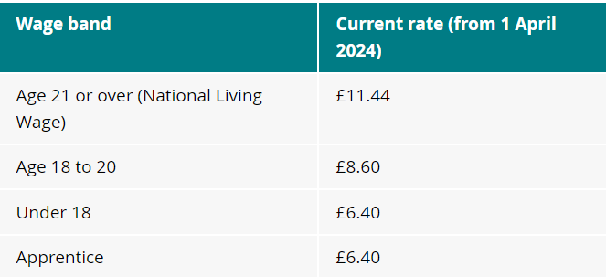
As per the National Minimum Wage (NMW) Act 1998, an employer must pay a minimum hourly wage which is subject to age and whether a worker is an apprentice – the minimum wage applies to those aged 20 and under (Daniels, 2022, p. 97). The National Living Wage (NLW) was also introduced in 2021, which applies to those aged 21 and over. The current rates are provided in image F below (ACAS, 2024f). The wages are reviewed yearly with increases to NMW every April(ACAS, 2024g).
Image F

It is mandatory for Charlotte and Madeleine to pay the NMW and to ensure accurate,up-to-date payment records are available upon request (ACAS, 2024h). It is also a requirement for employers to provide an itemised pay statement, or a payslip, which includes how much they are paid and any deductions like pensions, NI and tax (ACAS, 2024i). ACAS (2024i) advise providing payslips prior to payday to ensure issues can be resolved by time of payment - there are times where payslips are not correct which can be resolved informally, but an employee or worker is able to raise a grievance if it is not resolved. If a payslip is not provided and this has been raised informally, the employee or worker can raise a grievance, and then escalate to an ET claim if they still do not receive one (ACAS, 2024i)
While paying everyone the same seems fair, doing so could cause backdating expenses and legal repercussions (ACAS, 2024d). Employers must pay employees or workers the NMW or above, no less. If it is not being paid, an employer or worker could raise a formal grievance with Charlotte and Madeleine, they would be entitled to contact HMRC or make an ET claim for non-payment of NMW dating back 2 years (ACAS, 2024g).

Not only will this impact the business financially, but reputational damage may also be detrimental – if this escalates, employers are ‘named and shamed’ by the government following a breach of the law (GOV.UK, 2023).
Charlotte and Madeleine must have an understanding of legislation and complications that may arise to prevent facing legal claims. , It is recommended toconduct a pay audit to review current rates and ensure compliance by utilising the NMW calculator (GOV.UK, 2021).
- Charlotte has received a complaint from Kit, manager of a restaurant that trades seven days a week. Kit states his working hours are too long, and that he does not have adequate breaks or sufficient days off. He normally works five days a week from 9.30am to 9.30pm but when his supervisor is on holiday, he must cover their days off. Advise on whether Kit has a legal cause for complaint, with reference to employment law. (AC 4.2)

Through Working Time Regulations 1998, employers have a legal responsibility to prioritise the health and safety of their employees and workers by establishing rest breaks, annual leave entitlement, and adequate working hours to safeguard their wellbeing (Daniels, 2022, p. 85). Image G highlights employees’ and workers’ rights in line with the legislation (Ayling and Suff, 2024b):
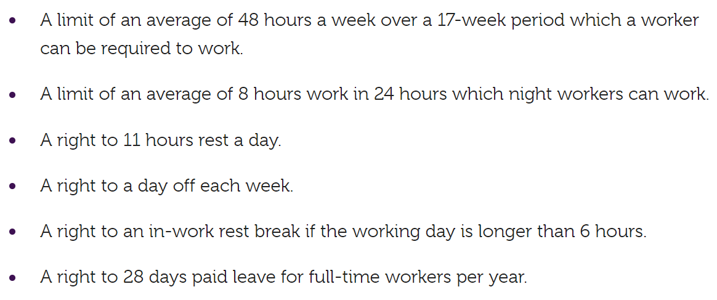
Image G

As mentioned in image G, the 48-hour maximum working week serves to protect employees and workers from working excessive hours health, safety, and wellbeing (ACAS, 2024j), however it is important to note that they can voluntarily opt out from this limit – this cannot be forced upon employees or workers. This decision is ultimately a choice of the employee or worker, and they are also able to cancel this agreement at any time, providing their employer with sufficient notice; this agreement is separate from a contract of employment, should be in writing and signed by the employee - this is known as an ‘opt-out agreement’ (ACAS, 2024h). An employer does not have to offer more pay because of this; however, they may decide to offer overtime pay (ACAS, 2024h). If an employee or worker exceeds this and has not opted out, they should work less the following week to even the average over the 17-week period (Daniels, 2022, p. 89), this is also known as time off in lieu (TOIL). Additionally, employees and workers are entitled the following rest breaks (Daniels, 2022, p. 91):
- 11 hours every 24-hour period
- 24 hours every 7 working days
- Minimum 20-minute break for over a 6-hours’ work
And 5.6 weeks’ (28 days) paid annual leave, which is broken into 20 days statutory paid leave and an additional 8 days’ bank holiday (Daniels, 2022, p 88). Entitlement can be calculated by multiplying the number of working days by 5.6 (ACAS, 2024k).
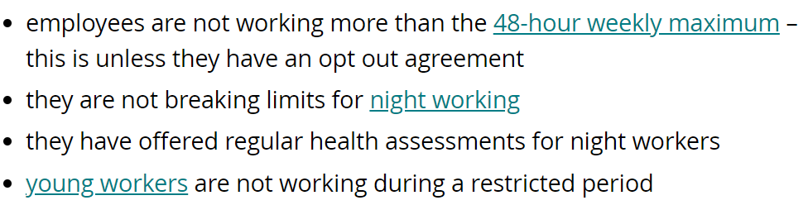
Image H

Therefore, Kit is entitled to 28 days annual leave with a minimum 20-minute break a day. Employers also have a responsibility to keep records for 2 years that prove the following (image H), (ACAS, 2024k):

Kit is also working a 60-hour week on average and has not opted out of the 48-hour maximum working week without making up for missed rest, therefore has a legal cause for complaint. This may either be resolved informally between Kit and Charlotte, or Kit would be entitled to raise a grievance (ACAS, 2024l). If this is not resolved, then Kit would be able make an ET claim or report this to the Health & Safety Executive (HSE) as it is a breach of the WTR 199 (ACAS, 2024k). Kit has a legal cause as his employer has not followed the following laws (ACAS 2024k), and if he feels that his employer has caused detriment for raising this concern (image I):
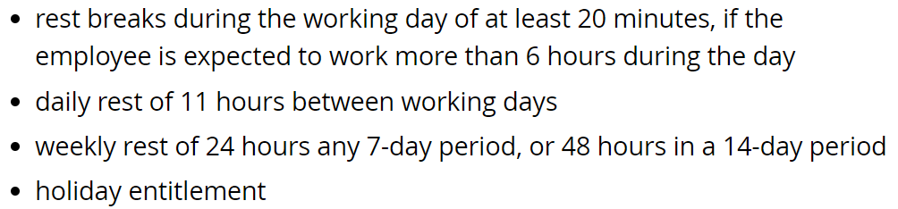
Image I

And (image J):
Image J
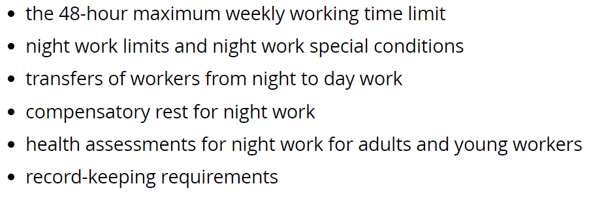

It is recommended that Charlotte speaks to Kit in private to discuss his working hours, breaks and rest days, as well as his annual leave entitlement to ensure transparency as well as in line with the law as an employer. In addition to this, Charlotte should listen to Kit’s concerns and how they compare with company policies and the WTR 1998, so that appropriate adjustments can be made against the relevant legislation. If Kit agrees to sign the out opt agreement going forward, Charlotte has been advised to ensure these records are kept for 2 years in line with legal requirements.

- Coco, a restaurant manager with eight years’ service, was delighted to inform Charlotte and Madeleine that she is pregnant and that her baby is due in six months’ time. Charlotte, who took two weeks off after the birth of her baby, is unhappy at the disruption this will cause but is happy to let Coco book two weeks’ annual leave to coincide with the birth of her baby. Charlotte feels a small business cannot afford the maternity leave and maternity pay that a larger organisation could offer, and she knows from experience that two weeks off is sufficient. Advise Charlotte and Madeleine on Coco’s maternity rights. You are concerned about Charlotte and Madeleine’s lack of knowledge in this area and decide to add a brief overview of paternity and adoption rights in case they make mistakes in this area too. (AC 4.3)

The main principles of maternity, paternity, and adoption rights guarantee employees to have access to necessary statutory leave, payment and support before, during and after childbirth or adoption which are governed by the Acts highlighted in image K (Ayling and Suff, 2024c):
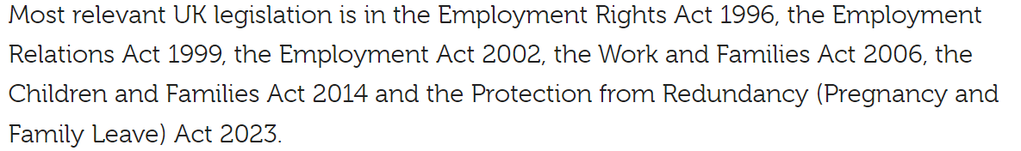
Image K

Legally, employees are entitled to take up to 52 weeks’ maternity leave, providing they give the correct notice of no longer than 15 weeks before the due date, also known as the ‘qualifying week’ (GOV.UK, no date b). Although it is a personal decision whether an employee takes the full duration, however, it is mandatory Coco takes minimum 2 weeks’ due to health and safety reasons, this would typically be 4 weeks in a factory (ACAS, 2024m). The statutory maternity leave is broken down as follows (GOV.UK, no date c):
- Ordinary maternity leave (OML) – 26 weeks
- Additional maternity leave (AML) – 26 weeks

All employees are also entitled to reasonable time off for any antenatal care appointments with full pay. Additionally, statutory maternity pay (SMP) is entitled to employees who meet the following and the payments are illustrated in image L (ACAS, 2024n):
- Worked for an organisation for 26 continuous weeks before the qualifying week.
- Earn at least £123 per week (on average) for 8 weeks prior to the qualifying week.

Image L
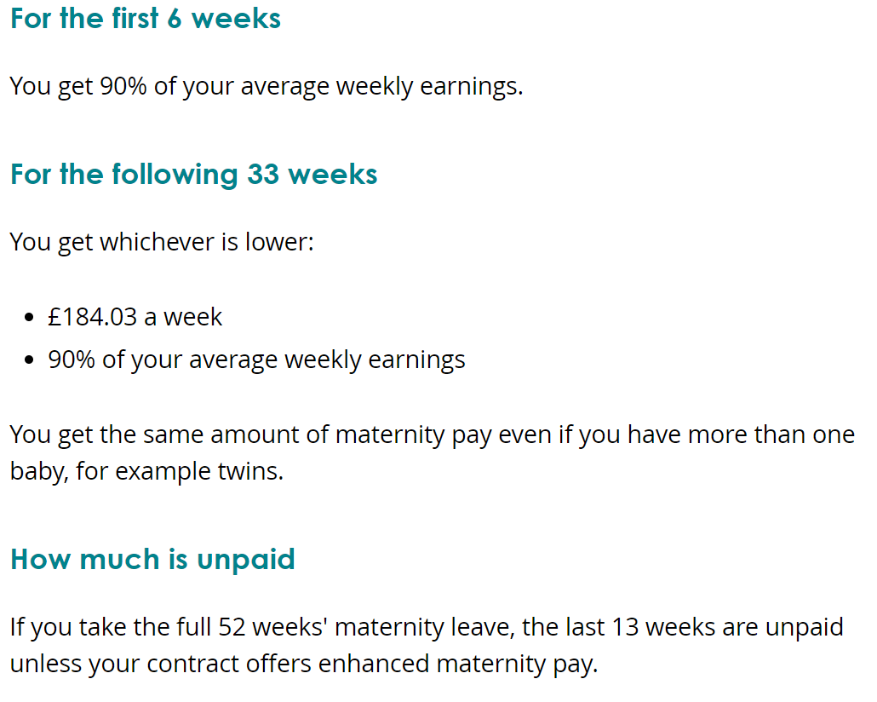

Therefore, Coco is entitled to 52 weeks’ statutory maternity leave with SMP.

Charlotte and Madeleine have a duty as the employer to ensure the health and safety of Coco and a risk assessment should be undertaken to make sure that she is able to perform work duties without jeopardy (ACAS, 2024o). The lack of understanding surrounding these rights, coupled with opinion of Coco’s health and wellbeing, raises concerns. Unfavourable treatment of a pregnant employee would be considered as discrimination and therefore may result in an ET claim (Ayling and Suff, 2024b):
- Mrs M Dobson v Michael Cook Law Firm and Mr M D Cook: 2500923/2023
Total compensation for Mrs M Dobson was £26,474.91 due to unfavourable treatment due to a protected characteristic (pregnancy) as well as failing to comply with ACAS Code of Practices.

To qualify for statutory paternity leave, an employee must (Ayling and Suff, 2024b):
- Be employed for 26 continuous weeks prior to the qualifying week.
- Be the biological father or partner of the mother with expectation of raising the baby.

As of 7th April 2024, employees entitled to SPL can take 2 weeks consecutively or separately but cannot be taken prior to the birth (ACAS, 2024p). Statutory paternity pay (SSP) also works out at either 90% of weekly average earnings or £184.03 per week, whichever is lowest and must qualify the criteria in image M (ACAS, 2024q):
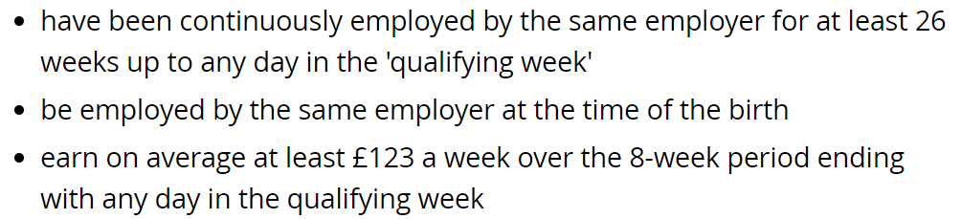
Image M

Adoption rights protect those who adopt or are fostering to adopt and apply to parents having a child through surrogacy (GOV.UK, no date d). Statutory adoption leave (SAL) is:
- 26 weeks ordinary adoption leave
- 26 weeks additional adoption leave
Only one person can take this and the other may apply for SPL (GOV.UK, no date e). SAL must be taken within the following (GOV.UK, no date e), (image N):
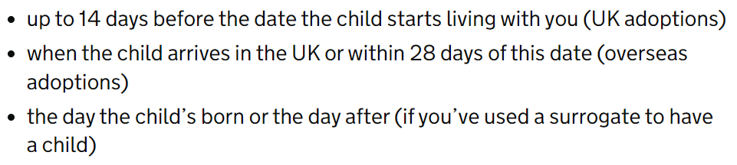
Image N

Statutory pay (SAP) is applied in the same way as SMP. Some companies offer adoption pay schemes which may enhance income, but the above figures are the minimum to be provided by an employer (GOV.UK, no date f).

- Chelsea, a restaurant manager, has made a flexible working request and wants to change from working full-time to working three days a week. Charlotte informs you she will let Chelsea know that Peachy Desserts Ltd ‘don’t do’ flexible working and if she does not like it, she should leave and find a part-time job somewhere else. Advise Charlotte and Madeleine of the risks of their approach and what they should do instead. (AC 4.4)

As of 6th April 2024, flexible working requests are applicable to all employees from the first day of employment and requests can be made twice within a 12-month period (McCartney, 2024). Charlotte and Madeleine, as the employers, have a duty to consider Chelsea’s request in a reasonable manner (within 2 months) and can only reject if there is a genuine reason that contrasts with the business needs (McCartney, 2024). Charlotte and Madeleine, by law, must consult with Chelsea first before deciding to refuse – as the employee, Chelsea is protected by the new legislation and is not required to give an explanation what impact this request has on the business (McCartney, 2024). Charlotte and Madeleine could be subject to an ET claim if they do not follow the correct procedure.

If there is a genuine business reason to refuse the full request, then Charlotte and Madeleine must arrange a meeting to discuss alternative options, such as (ACAS, 2024r), image O:

Image O

The statement ‘Peachy Desserts Ltd don’t do flexible working’ is not a valid or justifiable reason to deny Chelsea’s request. GOV.UK (no date g) highlights genuine business reasons (image P):
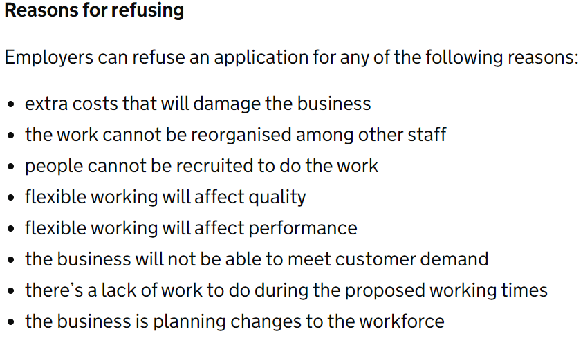
Image P

Chelsea and Madeleine must be aware that Chelsea would be entitled to raise a grievance or complain to an ET if they do not follow legislation, dismiss, or treat Chelsea unfairly due to the request, or reject the application based on untrue information (GOV.UK, no date h). Charlotte and Madeleine would be expected to compensate if the claim is deemed successful, as demonstrated in case Mr D Grosvenor v J Huggins & Son Ltd: 3304988/2022 where the respondent was required to pay the claimant £3,111.94 for breaching duties to consider a flexile working request.

Additionally, refusing a flexible working request without justification could be considered as either direct or indirect discrimination if it does not follow protocol and troubles someone due their protected characteristic (CIPD, 2024). In the case Webster v Princes Soft Drinks: ET/1803942/2004 (CIPD, 2024), the claimant was successful in an indirect sex discrimination claim, where a rejected flexible working request was wrongfully refused.

Reference List
- ‘Mr D Grosvenor v J Huggins & Sons Ltd (2022) Employment Tribunal, case: 3304988/2022. Available at: https://assets.publishing.service.gov.uk/media/65a7e59594c9970013aeb908/Mr_D_Grosvenor_-_v_-__J_Huggins___Son_Limited_-_3304988-2022_-_Judgment.pdf (Accessed: 3rdMay 2024)
- ‘Mrs M Dobson v Michael Cook Law Firm and Mr Michael D Cook’ (2023) Employment Tribunal, case: 2500923/2023. Available at: https://assets.publishing.service.gov.uk/media/663242d802f02aa4f31e4129/Mrs_M_Dobson_v_Michael_Cook_Law_Firm_and_Mr_Michael_D_Cook_-_2500923-2023_-_Judgment.pdf (Accessed: 2nd May 2024)
- Abbas, T (2023) 05 Steps of Communicating Payroll Changes to Employees. Available at: https://changemanagementinsight.com/05-steps-of-communicating-payroll-changes-to-employees/ (Accessed: 29th April 2024)
- ACAS (2013) Settlement Agreements (under section 111A of the Employment Rights Act 1996). Available at: https://www.acas.org.uk/acas-code-of-practice-settlement-agreements/html#settlement-agreement-cannot-be-agreed (Accessed: 12th April 2024)
- ACAS (2021) Changing an employment contract after a TUPE transfer: employer responsibilities. Available at: https://www.acas.org.uk/changing-an-employment-contract-after-a-tupe-transfer-employer-responsibilities (Accessed: 15th April 2024)
- ACAS (2022) Early conciliation: how the process works. Available at: https://www.acas.org.uk/early-conciliation/how-early-conciliation-works (Accessed: 11th April 2024)
- ACAS (2023a) Discrimination at work. Available at: https://www.acas.org.uk/discrimination-and-the-law (Accessed: 2nd April 2024)
- ACAS (2023a) Discrimination at work: Discrimination and the Equality Act 2010. Available at: https://www.acas.org.uk/discrimination-and-the-law (Accessed: 11th April 2024)
- ACAS (2023b) Employment tribunal time limits. Available at: https://www.acas.org.uk/employment-tribunal-time-limits (Accessed: 11th April 2024)
- ACAS (2023c) Discrimination at work: Direct discrimination. Available at: https://www.acas.org.uk/discrimination-and-the-law/direct-discrimination (Accessed: 15th April 2024)
- ACAS (2023d) TUPE: informing and consulting. Why you must consult. Available at: https://www.acas.org.uk/inform-and-consult-staff-in-a-tupe-transfer (Accessed: 15th April 2024)
- ACAS (2024a) Equal pay: employer responsibilities. Preventing issues. Available at: https://www.acas.org.uk/equal-pay/employer-responsibilities (Accessed: 15th April 2024)
- ACAS (2024b) Step 1: Check redundancy is needed. Available at: https://www.acas.org.uk/manage-staff-redundancies (Accessed: 30th April 2024)
- ACAS (2024c) Step 4: Hold consultations. Available at: https://www.acas.org.uk/manage-staff-redundancies/redundancy-consultations (Accessed: 30th April 2024)
- ACAS (2024d) Step 7: Give notice. Available at: https://www.acas.org.uk/manage-staff-redundancies/give-employees-notice-of-redundancy (Accessed: 30th April 2024)
- ACAS (2024e) Step 6: Work out redundancy pay. Available at: https://www.acas.org.uk/manage-staff-redundancies/work-out-redundancy-pay (Accessed: 30th April 2024)
- ACAS (2024f) What is the minimum wage. Available at: https://www.acas.org.uk/national-minimum-wage-entitlement#:~:text=Current%20rate%20%28from%201%20April%202024%29%20Age%2021,Age%2018%20to%2020%20%C2%A38.60%20Under%2018%20%C2%A36.40 (Accessed: 29th April 2024)
- ACAS (2024g) When increases are paid. Available at: https://www.acas.org.uk/national-minimum-wage-entitlement/when-your-rate-increases (Accessed: 29th April 2024)
- ACAS (2024h) If an employer pays less. Available at: https://www.acas.org.uk/national-minimum-wage-entitlement/if-an-employer-does-not-pay-minimum-wage (Accessed: 29th April 2024)
- ACAS (2024i) Payslips. Available at: https://www.acas.org.uk/payslips. (Accessed: 6th June 2024)

- ACAS (2024j) The 48-hour weekly maximum. Available at: https://www.acas.org.uk/working-time-rules/the-48-hour-weekly-maximum (Accessed: 6th May 2024)
- ACAS (2024k) How much holiday someone gets. Available at: https://www.acas.org.uk/checking-holiday-entitlement (Accessed: 6th May 2024)
- ACAS (2024l) Understanding the Working Time Regulations. Available at: https://www.acas.org.uk/working-time-rules (Accessed: 6th May 2024)
- ACAS (2024m) Checking your rights. Available at: https://www.acas.org.uk/your-maternity-leave-pay-and-other-rights (Accessed: 2nd May 2024)
- ACAS (2024n) Pay – Maternity leave and pay. Available at: https://www.acas.org.uk/your-maternity-leave-pay-and-other-rights/working-out-maternity-pay (Accessed: 2nd May 2024)
- ACAS (2024o) Health at work during pregnancy. Available at: https://www.acas.org.uk/your-maternity-leave-pay-and-other-rights/health-at-work-during-pregnancy (Accessed: 2nd May 2024)
- ACAS (2024p) Taking paternity leave. Available at: https://www.acas.org.uk/paternity-rights-leave-and-pay/taking-paternity-leave (Accessed: 2nd May 2024)
- ACAS (2024q) Statutory paternity pay. Available at: https://www.acas.org.uk/paternity-rights-leave-and-pay/paternity-pay (Accessed: 3rd May 2024)
- ACAS (2024r) Making a decision. Available at: https://www.acas.org.uk/statutory-flexible-working-requests/making-a-decision#:~:text=As%20an%20employer%2C%20you%20must%20agree%20to%20an,to%20consult%20the%20employee%20before%20making%20a%20decision. (Accessed: 3rd May 2024)
- Ayling, L. and Suff, R. (2023) The role of employment tribunals. Available at: https://www.cipd.org/uk/knowledge/factsheets/tribunals-factsheet/ (Accessed: 12th April 2024)
- Ayling, L. and Suff, R. (2023b) Working Hours & Time Off Work. Available at: https://www.cipd.org/uk/knowledge/factsheets/working-time-factsheet/ (Accessed: 6th May 2024)
- Ayling, L. and Suff, R. (2024a) Redundancy. Available at: https://www.cipd.org/uk/knowledge/factsheets/redundancy-factsheet/ (Accessed: 30th April 2024)
- Barbeary, T. and Rafaeli, S. (2021) Settlement Agreements: Your FAQ’s Answered. Available at: https://lennonssolicitors.co.uk/article/settlement-agreements-faqs/#:~:text=The%20legal%20adviser%20will%20act%20as%20a%20relevant,any%20of%20the%20terms%20in%20the%20Settlement%20Agreement. (Accessed: 12th April 2024)
- CIPD (2024) Flexible and hybrid working: UK employment law. Available at: https://www.cipd.org/uk/knowledge/employment-law/flexible-working/ (Accessed: 3rd May 2024)
- CIPD (no date) Employment law. Available at: https://www.cipd.org/uk/knowledge/employment-law/#:~:text=Employment%20law%20regulates%20the%20relationship,and%20employees%27%20rights%20at%20work. (Accessed: 25th March 2024)
- Cotton, C. (2023) Pay Fairness & Reporting. Available at: https://www.cipd.org/uk/knowledge/factsheets/pay-fairness-reporting-factsheet/ (Accessed: 15th April 2024)
- Daniels, K. (2022) Introduction to Employment Law. 6th edn. London: Kogan Page.
- Employment Rights Act 1998. Available at: https://www.legislation.gov.uk/ukpga/1996/18/section/203 (Accessed: 12th April 2024)
- Equal Pay Act 1970. Available at: https://www.legislation.gov.uk/ukpga/1970/41/enacted (Accessed: 6th May 2024)
- Equality Act 2010, c. 2. Available at: https://www.legislation.gov.uk/ukpga/2010/15/part/2/chapter/2 (Accessed: 25th March 2024)
- GOV.UK (2021) Calculating the minimum wage. Available at: https://www.gov.uk/guidance/calculating-the-minimum-wage (Accessed: 29th April 2024)
- GOV.UK (2023) ‘More than 200 companies named for not paying staff minimum wage.’ 21 June. [Press release] Available at: https://www.gov.uk/government/news/more-than-200-companies-named-for-not-paying-staff-minimum-wage (Accessed: 29th April 2024)
- GOV.UK (no date a) Redundancy: your rights. Available at: https://www.gov.uk/redundancy-your-rights/redundancy-pay (Accesed: 30th April 2024)
- GOV.UK (no date b) Maternity pay and leave: Eligibility. Available at: https://www.gov.uk/maternity-pay-leave/eligibility (Accessed: 2nd May 2024)
- GOV.UK (no date c) Maternity pay and leave: Leave. Available at: https://www.gov.uk/maternity-pay-leave/leave (Accessed: 2nd May 2024)
- GOV.UK (no date d) Adoption pay and leave. Available at: https://www.gov.uk/adoption-pay-leave (Accessed: 3rd May 2024)
- GOV.UK (no date e) Adoption pay and leave. Available at: https://www.gov.uk/adoption-pay-leave/leave (Accessed: 3rd May 2024)
- GOV.UK (no date f) Adoption pay and leave. Available at: https://www.gov.uk/adoption-pay-leave/pay (Accessed: 3rd May 2024)
- GOV.UK (no date g) Flexible working. Available at: https://www.gov.uk/flexible-working/after-the-application (Accessed: 3rd May 2024)
- GOV.UK (no date h) Flexible working: appeals. Available at: https://www.gov.uk/flexible-working/appeals (Accessed: 6th May 2024)
- Judiciary (2021) Courts Structure. Available at: https://www.judiciary.uk/wp-content/uploads/2021/07/courts-structure-0715.pdf (Accessed: 25th April 2021)
- Judiciary (no date a) What are the Employment Tribunals? Available at: https://www.judiciary.uk/courts-and-tribunals/tribunals/employment-tribunal/employment-tribunal-england-wales/work-of-the-employment-tribunal/what-is-the-employment-tribunal/ (Accessed: 25th April 2024)
- Judiciary (no date b) Structure of the Courts & Tribunals system. Available at: https://www.judiciary.uk/about-the-judiciary/our-justice-system/court-structure/ (Accessed: 25th April 2024)
- McCartney, C. (2024) Flexible working practices. Available at: https://www.cipd.org/uk/knowledge/factsheets/flexible-working-factsheet/ (Accessed: 3rd May 2024)
- Miller, J. (2023) Sex discrimination and employment. Available at: https://www.cipd.org/uk/knowledge/factsheets/sex-discrimination-factsheet/ Accessed: 15th April 2024)
- Morris, A. (2022) Avoiding Discrimination in Recruitment. Available at: https://www.davidsonmorris.com/recruitment-discrimination/ (Accessed: 15th April 2024)
- National Minimum Wage Act 1998. Available at: https://www.legislation.gov.uk/ukpga/1998/39/contents (Accessed: 29th April 2024)
- Suff, R. (2023) TUPE (Transfer of undertakings): An introduction. Available at: https://www.cipd.org/uk/knowledge/factsheets/tupe-factsheet/ (Accessed: 15th April 2024)
- Suff, R. (2023b) Maternity, paternity and adoption rights. Available at: https://www.cipd.org/uk/knowledge/factsheets/maternity-paternity-rights-factsheet/#maternitypaternityadoption (Accessed: 1st May 2024)
- Taylor, S. (2023) Employment law in the UK: the court system. Available at: https://www.cipd.org/uk/knowledge/factsheets/uk-court-system-factsheet/#criminal-and-civil-courts (Accessed: 25th April 2024)
- Taylor, S. and Woodhams, C. (2022) Human Resource Management. 5th edn. London: Kogan Page.
- The Transfer of Undertakings (Protection of Employment) Regulations 2006. Available at: https://www.legislation.gov.uk/uksi/2006/246/contents/made (Accessed: 15th April 2024)
- The Working Time Regulations 1998, c. 3. Available at: https://www.legislation.gov.uk/uksi/1998/1833/regulation/3 (Accessed: 25th March 2024)

