MANAGING PEOPLE
LCBB 5004

ASSESSMENT 2

Core behaviours, extend the Profession Map applies to HR professionals, current skill shortages causes and long-term solutions

Nishi Rumsurrun

Lilija Tconeva
2029799

Word Count: 2078

August 2022
TABLE OF CONTENTS

1. Introduction 4

Part 1

1.1 Core behaviours 4

1.2 The Profession Map and HR professionals 7

Part 2

2.1 Skills shortage causes despite unemployment rate in UK 9

2.2 Long term solutions to skills shortages 10

3. Conclusion 11

References 13

List of Figures 14

List of Figures

Figure No | Description | Page No
1 | Core behaviours | 4
2 | Profession Map | 7

1. Introduction

HRM has a direct impact on employee motivation, skill, engagement and commitment, improving organisational performance in terms of quality, productivity and customer service which ultimately results in employee satisfaction and organisational achievements. HR professionals provide insight on the performance issues that affect organisations, draw well-reasoned conclusions and solutions based on HR strategies and test them against relevant standards and criteria. One such guidance on what is required of HR professionals to become experts in the field is presented by the Profession Map.
This report consists of two parts. The first part discusses the properties of core behaviours and the importance of the Profession Map as a manual to HR professionals. Part two of the report emphasises on the causes for skill shortages despite the high unemployment rate in the UK as well as the long- term solutions.

Part 1

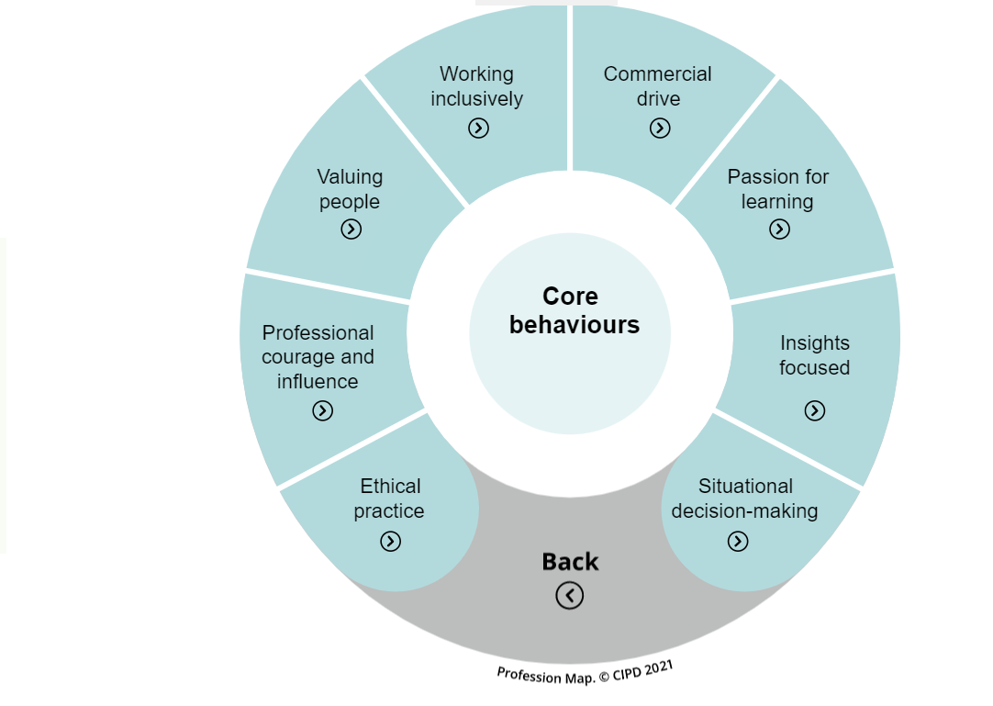
Figure 1: Core behaviours (CIPD, 2021)

1.1 Core Behaviours

The profession Map consists of Core Behaviours which are ways of thinking and acting, required of effective people professionals. Core Behaviours (CIPD, 2022)

- Ethical practice

Ethics refer to a framework of approaches that guide ethical behaviour such as fair treatment, justice and equity. Therefore, HR professionals have the responsibility to raise awareness for ethical issues, to promote ethical behaviour, leading by example, manage compliance and monitor arrangements, communicate codes of ethical conduct on how people should be treated so they become values in use rather than professed values in a code of practice. (Armstrong and Taylor, 2020, p. 189- 292)

- Professional courage and influence

This core behaviour is concerned with building trust and credibility by showing courage to challenge accepted practice and offer a range of perspectives on how to create organisational value through people and influence others to obtain support. While challenging unethical behaviour could be sometimes hard, it is important to challenge.
By showing courage to speak up, HR professionals act as role models that have the capability to build trust, change or improve practices. (Armstrong and Taylor, 2020, p. 196, 200)

- Valuing people

It is concerned with creating a common purpose and diversity, allows development, voice and wellbeing. Ensuring everyone is valued and given equal opportunities to develop and make maximum contributions brings benefits to the employer that can be summed up in three broad statements: improves workforce quality, enhances employees’ relations, reduces labour turnover. (Torrington et al. 2017, p.474)

- Working inclusively

Working inclusively and effectively leads to achieving organisational goals. It has effect on the organisational culture and behaviour because groups or teams develop an ideology which affects their satisfaction, attitudes and actions. Social processes such as communicating, interaction and networking, leadership and conflict also affect the way they function. Therefore, HR professionals who exercise leadership have the important role to get their teams into action and deliver the results expected from them. (Armstrong and Taylor, 2020, p. 318- 320)

- Commercial drive

Value can be measured in terms of employee contribution to the profitability of a company. In non- financial terms, it refers to the skill base and capabilities. According to the human capital theory, people are assets and investment in them generates worthwhile returns. It’s critical for HR professional to attract high quality people and enhance their commitment to a company by applying retention policies in order to prevent the human capital investment to other companies. (Armstrong and Taylor, 2020, p.102-103)

- Passion for learning

It concerns curiosity to learn, improve and innovate. HR professionals have the important role to ensure that they have the knowledgeable and skilled people they need and that the organisational goals are achieved through integrated L&D strategies, practices and policies. Strategic L&D focuses on creating a learning culture with organisational and individual learning strategies such as coaching, mentoring and guidance, self-managed learning and programs. (Armstrong and Taylor, 2020, p. 606)

- Insights focused

Evaluating ideas and evidence in order to gain a better insight and understanding. For instance, HR professionals are to critically analyse any evidence before addressing issues so that an informed judgement could be made about the relevance, validity and usefulness of ideas or arguments. For and against arguments are weighed against evidence and bias critically assessed. Conclusion is reached on the base of research methodology and data collecting techniques. (Armstrong and Taylor, 2020, p. 1108- 1109)

- Situational decision making

Effective decision making based on a certain situation or context. Important part of the HR professional’s responsibilities is deciding or making a choice based on a situation and often in conditions of uncertainty. The process involves analysing the situation and courses of actions, weighing them up, implement the preferred one and evaluating its effectiveness. (Armstrong and Taylor, 2020, p. 954- 955)

1. 2 The Profession Map and HR professionals.

The Profession Map provides the foundation to the people profession by setting up the knowledge and behaviour required to make greatest impact in the changing world of work. It is relevant to everyone regardless of position in the profession. Profession Map is applied to guide better decisions and outcomes, to act confidently, perform effectively, drive change and for career progression. Moreover, articulating the knowledge and the behaviour help professionals to become experts in people, work and change. (CIPD, 2022)

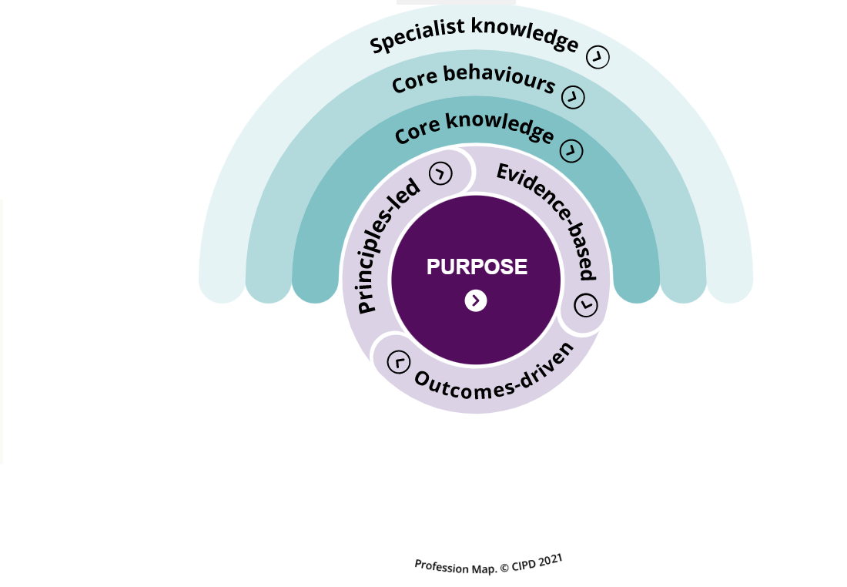
Figure 2: Profession Map (CIPD, 2021)
The Professional Map starts with purpose to champion better work and working lives, and everyone has a role in understanding what is important. Then, the core knowledge, which is relevant to all regardless of role, sector, specialism. There are six core areas of knowledge needed for a positive impact:

- People practice
- Culture and behaviour
- Business acumen
- Evidence based practice
- Technology and people
- Change
Core knowledge (CIPD, 2022)

The Profession Map includes Core behaviours, discussed previously and nine Specialist Knowledge disciplines which could lead to career path or progress if chosen to develop:

- Employee experience
- Employee relations
- Inclusion and diversity
- L&D
- OD&D
- People analytics
- Resourcing
- Reward
- Talent management
Specialist knowledge (CIPD, 2022)

The Profession Map guides HR professionals into understanding range of people practices, how they impact each other and how they could be integrated. These practices which have 4 levels of impact, are fundamental for all practitioners as they are used across the employee lifecycle. Some of them include flexible working, training and development, achieving organisational objectives and creating talent pools, all needed by people professionals to become experts in the knowledge of people, work and change.
For instance, The Profession Map outlines the necessity to integrate flexible working by balancing the needs of all employees and adapt peoples’ strategies to hybrid and remote working in order to enhance performance.
The Profession Map also guides HR professionals on performance management in terms of individual performance related pay. It prepares professionals how to conduct gap analyses and explore talent ultimately shaping organisational strategy. People practise (CIPD, 2022)

Part 2

2. 1. Skills shortages causes despite unemployment rate in UK

A range of issues can explain the dissatisfaction with work or organisations leading to unwanted turnover. Although organisations can address these issues, many of them fail because of lack of mechanisms to identify the signs of dissatisfaction. If opportunities to voice concerns don’t exist, employees inevitably look elsewhere. (Torrington et al. 2017, p. 275)

- Poor handling of new recruits
Staffing is important HRM function that covers processes necessary for management of all employees, including steps making new recruits feel welcome and supported. With new employees on board, a retention plan would outline the opportunities for career advancement within an organisation, avoiding disappointments and act as a guide to HR practitioners in ensuring that employees have the qualifications and skills to carry out their work. (Bogardus, 2006, p. 51)

- Unfavourable terms and conditions of employment
A badly paying employer or one that pays people inequitably usually do not benefit from highly engaged workforce or retention. Evidence suggests that companies which offer attractive pay have lower attrition rates however, as good deal as higher pay is, there are other more important factors pushing an employee towards quitting. (Torrington et al. 2017, p. 277- 278)

- Low morale
It is another reason for skills shortages in the public sector. An efficient way to increase morale and retention is to follow a performance management plan, which also describes the performance appraisal process in a company. (Bogardus, 2006, p. 229)
- High hygiene factors
Herzberg’s hygiene factors are extrinsic factors such as company’s policies and procedures, employment relationships and working environment can be very demotivating if managed poorly.

- Lack of equipment to work
At minimum, a place of work needs to be arranged including all equipment required to do the job. (Bogardus, 2006, p. 137)

- Poor working conditions
These include the physical environment such as health risks, long hours of work, lack of flexible working opportunities, unsuitable place of work or no holidays that lead to job dissatisfaction. (Torrington et al. 2017, p. 206)

- No job security
High unemployment rate impacts labour mobility. It makes individuals more concerned about job security and fearful of the reduction in statutory employment protection when starting a job and influences job changing decisions. (Pilbeam and Corbridge, 2010, p. 96)

2.2 Long- term solutions to skill shortages

Motivation strategies aim to create working environment and develop policies that provide for higher level of performance from employees. Motivation theories such as equity, expectancy, goal setting and cognitive evaluation discover that people are motivated when they expect a course of action to follow an attainment of a goal in the form of a reward that satisfy their wants and needs.
An efficient way to address skills shortages issues is development of a reward system, which provides opportunities for financial and non-financial rewards, keeping in mind that incentive pay have a short-term effect while recognition of individual accomplishments where people feel valued, is likely to have deeper, long-term effect. Skill shortages could be addressed by creating opportunities to grow by training and development. HR contribution should be focused on career planning processes as well as more formal training. (Armstrong and Taylor, 2020, p. 416)
High involvement management which empowers people, proves that employees increase their work engagement when given the chance to manage and understand their work. It means treating employees as partners and respecting their interests. It also means providing employees with voice.
Concrete communication enables employees to communicate concerns, ideas and opinions with management. Moreover, it enhances employees’ positive attitudes and behaviours when they feel valued by the employer. (Armstrong and Taylor, 2020, p. 445)
In addressing skills shortages, HRM should focus on retention planning and morale increase. Retention strategies should be based on understanding those factors that affect employees whether they stay or leave such as effectiveness of recruitment, selection and deployment and workforce planning within an enterprise. (Armstrong and Taylor, 2020, p. 567)
Improved recruitment processes and workforce planning could contribute to making an organisation “an employer of choice”. Formal workforce plans set out the number and categories of people required e.g., graduates as well as requirements defined in the form of role profile, job descriptions and person specifications. Vacancies are to be posted on company’s website, social network sites and the internet and then candidates are assessed by interview and selection tests. (Armstrong and Taylor, 2020, p. 474)
Companies should encourage apprenticeships and allow employees gain the knowledge and skills they need for their immediate job and future career. (Armstrong and Taylor, 2020, p. 649)

3. Conclusion

HR practitioners have the responsibility to manage the most valuable resource of businesses- the employees. As a result, they gain insights on the workforce, review and improve HR practices and processes, ensure employees are satisfied, supported and have the resources they need to perform as expected. With the help of the Profession Map as an interactive tool, people professionals can reflect on the knowledge, behaviours and values needed for a positive impact. It is equally effective for goals setting, role design, workforce planning and even interview questions.
In addressing the talent shortages in the UK, the role of diversity should be considered while providing effective diversity programs to allow more robust talent pool for businesses. Organisational structure needs to change in order to accommodate more flexible work opportunities. HR needs to look for skills solutions outside companies- those can be in partnering with agencies, consultants, government or educational institutions. In summary, HR professionals face difficulties with the current employment market issues but have the means to take on the skills challenges and build resilience in the workforce.

REFERENCES

Armstrong, M. and Taylor, S. (2020) Armstrong’s handbook of human resource management practice. 15th Ed. London, England: Kogan Page

Bogardus, Anne M. (2006) Human resources jumpstart. Alameda, CA: SYBEX

CIPD (2021) Profession Map: an introduction [video]. Available at: https://peopleprofession.cipd.org/profession-map (Accessed: 10th August 2022)

CIPD (2022) Core behaviours. Available at: https://peopleprofession.cipd.org/profession-map (Accessed: 11th August 2022)

CIPD (2022) Core knowledge. Available at: https://peopleprofession.cipd.org/profession-map/core-knowledge (Accessed: 11th August 2022)

CIPD (2022) People practice. Available at: https://peopleprofession.cipd.org/profession-map/core-knowledge/people-practice (Accessed: 11th August 2022)

CIPD (2022) Specialist knowledge. Available at: https://peopleprofession.cipd.org/profession-map/specialist-knowledge (Accessed: 11th August 2022)

Pilbeam, S. and Corbridge, M. (2010) People resourcing and talent planning: HRM in practice. 4th Ed. Harlow: Pearson

Torrington, D. et al. (2017) Human resource management. 10th Ed. Harlow, England: Pearson

References (Figures)

CIPD (2021) Core behaviours [Figure]. Available at: https://peopleprofession.cipd.org/profession-map (Accessed: 14th August 2022)

CIPD (2021) Profession Map [Figure]. Available at: https://peopleprofession.cipd.org/profession-map (Accessed: 14th August 2022)

