Computer Architecture and Operating Systems

(ACCA4022)

Operating Systems

Stephen Protheroe-Hewitt – 2112883

Data and Information Systems

Contents

List of Figures/Tables 4
Abstract 7
Introduction 8
Operating Systems and Key Functions 9
Memory and Process Management 10
File Systems and Directory Management 11
System Security Management 12
Device Management 13
Use of Windows OS CLI Commands 14
All IP Configurations Command 14
Ping Command 15
Tracert Command 16
Tasklist Command 17
Netstat Command 18
System Information Command 19
Check Disk Command 20
Power Configuration Energy Command 21
System File Checker (Verify Only) Command 21
Start Command 22
Use of Linux OS CLI Commands 23
Change Directory / Command 23
LS Command 23
Tree Command 24
Make Directory Command 24
Remove Directory Command 25
History Command 25
Touch Command 26
Echo Command 26
Cat Command 27
Date Command 27
Use of Windows OS Scripts 28
Variables Script 28
Go to Command Script 29
If Statement Script 31
For Loop Script 32
Array Script 33
Function Script 34
User Input Script 35
Use of Linux OS Scripts 36
Variables Script 36
If Statement Script 38
Case Statement Script 39
While Loop Script 42
Array Script 43
Function Script 44
User Input Script 45
Conclusion 46
References 47
Appendix A 55
Memory and Process Management – Virtual Memory 55
File System and Directory Management – Server OS 55
Appendix B 56
General-Purpose Operating Systems 56
Mobile Operating Systems 56
Network Operating Systems 56
Embedded Operating Systems 57
Real-Time Operating Systems 57
Appendix C 58
Online Certified Course 58

List of Figures/Tables

Fig. 1 User Interaction with an Operating System 9
Fig. 2 How Deadlocks Occurs 10
Fig. 3 The Five-State Process Lifecycle Model 10
Fig. 4 Single Thread and Multi thread Process 11
Fig. 5 Operating System Protection Rings 12
Fig. 6 Device Management on Windows Operating System 13
Fig. 7 First Part of ‘Ipconfig /all’ Command 14
Fig. 8 Second Part of ‘ipconfig /all’ Command 15
Fig. 9 ‘Ping’ Command 15
Fig. 10 ‘Tracert’ Command 16
Fig. 11 ‘Tasklist’ Command 17
Fig. 12 ‘Netstat’ Command 18
Fig. 13 First Part of ‘Systeminfo’ Command 19
Fig. 14 Second Part of ‘Systeminfo’ Command 19
Fig. 15 First Part of ‘Chkdsk’ Command 20
Fig. 16 Second Part of ‘Chkdsk’ Command 20
Fig. 17 ‘Powercfg -energy’ Command 21
Fig. 18 ‘Powercfg -energy’ Command 21
Fig. 19 ‘Start’ Command 22
Fig. 20 ‘CD /’ Command 23
Fig. 21 ‘LS’ Command 23
Fig. 22 ‘Tree’ Command 24
Fig. 23 ‘Mkdir’ Command 24
Fig. 24 ‘Rmdir’ Command 25
Fig. 25 ‘History’ Command 25
Fig. 26 ‘Touch’ Command 26
Fig. 27 ‘Echo’ Command 26
Fig. 28 ‘Cat’ Command 27
Fig. 29 ‘Date’ Command 27
Fig. 30 Variable Script from Notepad++ 28
Fig. 31 Variable Script Executed in Command Prompt 28
Fig. 32 Go to Command Script from Notepad++ 29
Fig. 33 First Part of Go to Command Script Executed in Command Prompt 29
Fig. 34 Second Part of Go to Command Script Executed in Command Prompt 30
Fig. 35 Third Part of Go to Command Script Executed in Command Prompt 30
Fig. 36 If Statement Script from Notepad++ 31
Fig. 37 If Statement Script Executed in Command Prompt 31
Fig. 38 For Loop Script from Notepad++ 31
Fig. 39 For Loop Script Executed in Command Prompt 32
Fig. 40 Array Script from Notepad++ 33
Fig. 41 Array Script Executed in Command Prompt 33
Fig. 42 Function Script from Notepad++ 34
Fig. 43 Function Script Executed in Command Prompt 34
Fig. 44 User Input Script from Notepad++ 35
Fig. 45 User Input Script Executed in Command Prompt 35
Fig. 46 Variable Script for Bash from Notepad++ 36
Fig. 47 Variable Script Executed via Bash 37
Fig. 48 If Statement Script for Bash from Notepad++ 38
Fig. 49 First Part of If Statement Script Executed via Bash 38
Fig. 50 Second Part of If Statement Script Executed via Bash 38
Fig. 51 Third Part of If Statement Script Executed via Bash 38
Fig. 52 Case Statement Script for Bash from Notepad++ 39
Fig. 53 First Part of Case Statement Script Executed via Bash 39
Fig. 54 Second Part of Case Statement Script Executed via Bash 39
Fig. 55 Third Part of Case Statement Script Executed via Bash 39
Fig. 56 Fourth Part of Case Statement Script Executed via Bash 40
Fig. 57 Fifth Part of Case Statement Script Executed via Bash 40
Fig. 58 Sixth Part of Case Statement Script Executed via Bash 40
Fig. 59 Seventh Part of Case Statement Script Executed via Bash 40
Fig. 60 Eighth Part of Case Statement Script Executed via Bash 40
Fig. 61 Ninth Part of Case Statement Script Executed via Bash 40
Fig. 62 Tenth Part of Case Statement Script Executed via Bash 40
Fig. 63 Eleventh Part of Case Statement Script Executed via Bash 41
Fig. 64 Twelfth Part of Case Statement Script Executed via Bash 41
Fig. 65 Thirteenth Part of Case Statement Script Executed via Bash 41
Fig. 66 Fourteenth Part of Case Statement Script Executed via Bash 41
Fig. 67 Fifteenth Part of Case Statement Script Executed via Bash 41
Fig. 68 Sixteenth Part of Case Statement Script Executed via Bash 41
Fig. 69 Seventeenth Part of Case Statement Script Executed via Bash 41
Fig. 70 While Loop Script for Bash from Notepad++ 42
Fig. 71 While Loop Script Executed via Bash 42
Fig. 72 Array Script for Bash from Notepad++ 43
Fig. 73 Array Script Executed via Bash 43
Fig. 74 Function Script for Bash from Notepad++ 44
Fig. 75 Function Script Executed via Bash 44
Fig. 76 User Input Script for Bash from Notepad++ 45
Fig. 77 User Input Script Executed via Bash 45
Fig. 78 Learning PowerShell Welcome Screen 56
Fig. 79 What Learners Should Know for PowerShell 57
Fig. 80 What is PowerShell? 57
Fig. 81 Reading PowerShell 57
Fig. 82 Getting Help on PowerShell 58
Fig. 83 Discovering Cmdlets and Aliases 58
Fig. 84 ‘Get-Service’ and ‘Get-Member’ Commands 58
Fig. 85 First Part of Chapter One Quiz 59
Fig. 86 Second Part of Chapter One Quiz 59
Fig. 87 Final Part of Chapter One Quiz 60
Fig. 88 Learning Functions in PowerShell 60
Fig. 89 ‘Whatif’ and ‘Confirm’ Commands 60
Fig. 90 Integrated Scripting Environment (ISE) 61
Fig. 91 Working with Outputs 61
Fig. 92 PowerShell Grid View 61
Fig. 93 Running PowerShell Remotely 62
Fig. 94 First Part of Chapter Two Quiz 62
Fig. 95 Second Part of Chapter Two Quiz 62
Fig. 96 Final Part of Chapter Two Quiz 63
Fig. 97 Finding and Installing Modules 63
Fig. 98 Server Cmdlets 63
Fig. 99 Connecting to Office 365 with PowerShell 64
Fig. 100 Managing Azure with PowerShell 64
Fig. 101 Chapter Three Quiz 64
Fig. 102 Learning PowerShell Conclusion 65
Fig. 103 Learning PowerShell Course Completion 65
Fig. 104 Exam Answer One 66
Fig. 105 Exam Answer Two 66
Fig. 106 Exam Answer Three 66
Fig. 107 Exam Answer Four 67
Fig. 108 Exam Answer Five 67
Fig. 109 Exam Answer Six 67
Fig. 110 Exam Answer Seven 68
Fig. 111 Exam Answer Eight 68
Fig. 112 Exam Answer Nine 68
Fig. 113 Exam Answer Ten 69
Fig. 114 Exam Answer Eleven 69
Fig. 115 Exam Answer Eleven 69
Fig. 116 Learning PowerShell Course Completion with Exam Credits 70

Abstract

With the ever-increasing need for modern computers to perform increasingly complex processes regularly, operating systems must continuously evolve to ensure that computers can perform processes efficiently and be able to communicate with the computer hardware to function correctly. If the operating system cannot communicate with the hardware, the computer cannot function.

This report provides an overview and analysis of operating systems and their key functions, and an overview and demonstration of Windows and Linux operating system command line interfaces and scripts. The report ends with a conclusion indicating the dangers of command line interfaces by attackers and an example of what can happen following an attack.

Introduction

With the ever-increasing need for modern computers to perform increasingly complex processes regularly, operating systems must continuously evolve to ensure that computers can perform processes efficiently. All operating systems must have intuitive user interfaces for users to navigate and complete actions effectively, communicate with computer hardware to coordinate and function correctly, monitor the computer’s health so there are no unexpected performance issues and be able to store and retrieve data on a computer’s hard drive [1]. If any of these areas do not function correctly, the operating system and computer will fail.

This report provides an overview and analysis of operating systems and their key functions, and an overview and demonstration of Windows and Linux operating system command line interfaces and scripts. The report ends with a conclusion indicating the dangers of command line interfaces by attackers and an example of what can happen following an attack. While many operating systems process and communicate differently, they must all function similarly for desired outputs to be achieved.

Operating Systems and Key Functions

Operating systems (OS) are the master software performing all software and hardware functions on computers [2], [3]. Figure 1 shows how OS’s functions.

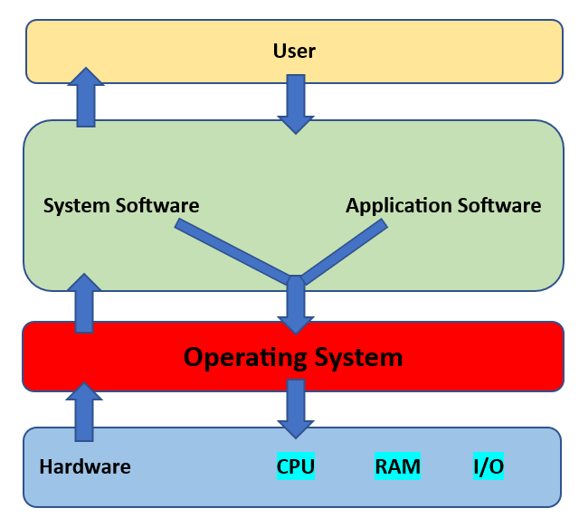
Fig. 1 User Interaction with an Operating System [3]

The kernel is the central component of OS’s managing central processing unit (CPU) and memory operations between applications and data processing, being the first program loaded into the memory when OS’s start up and remain until computers shut down [4].

Memory and Process Management

Memory management is the management of Random Access Memory (RAM), controlling usage for different applications and devices running coherently, utilising the CPU, memory, and storage efficiently [5]. Process management manages system processes like ensuring resources and memory usage are allocated for computers to function efficiently [6], [7], including deadlock management like in Figure 2, where a process requiring a function never happens because one process using resources and requesting further resources are held by another process [8].

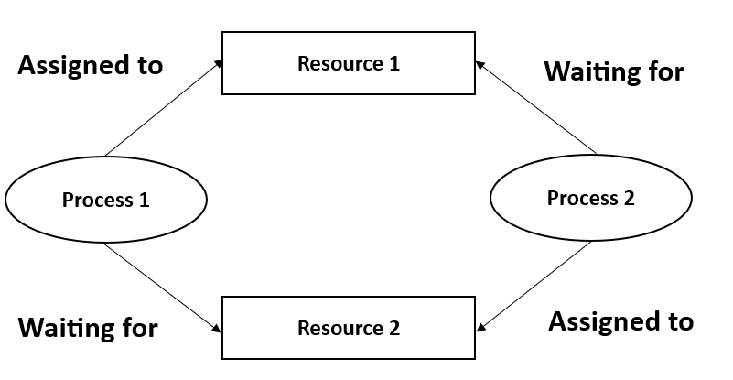
Fig. 2 How Deadlocks Occurs [9]

An aspect is process (or job) scheduling, providing CPU execution time limits for processes and allowing quick response times for software [10]. When processes start, the process lifecycle begins, going through stages to start and finish processes [11], [12], with the five-state model the most common like in figure 3.

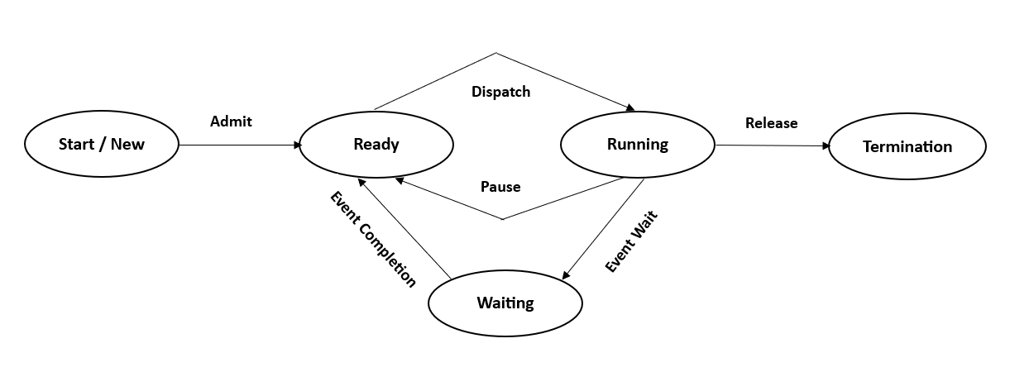
Fig. 3 The Five-State Process Lifecycle Model [12]
Information for virtual memory is available in Appendix A.

Executed processes create a thread, providing singular sequences of tasks executed within a process to share resources, improving efficiency [13], [14], [15]. OS’s are capable of multitasking for processes and programs simultaneously, utilising context switching to perform multiple processes via one CPU, storing statuses of ongoing processes to resume execution from that point when required [16]. This creates multithreading in processes, allowing OSs to perform multiple threads in a process simultaneously, like multiple actions performed by users [17], like in Figure 4.

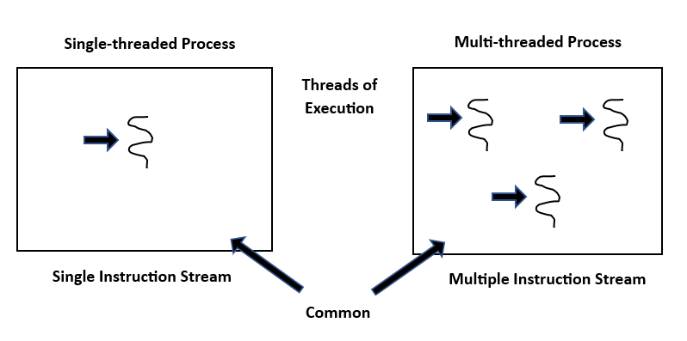
Fig. 4 Single Thread and Multi thread Process [18]

File Systems and Directory Management

File systems and directory management are file structures and directories by OS’s for storage and retrieval of files [19], [20], [21]. There are different types of file systems on OS’s, like New Technology File Systems (NTFS) in Windows, used in electronic devices for its simplicity [22], the Extensible File System (Ext) in Linux, building on Unix file systems using blocks and block groups to improve file systems, keeping parts of the same file closer [23] and the Apple File System (APFS) in Macs, improving efficiency to data backups and improving speed [24].

Information for file system and directory management in server OS’s is available in Appendix A.

System Security Management

System security management is how OS’s protect computers and anything stored from system start up to shut down [25]. There are measures that OS’s use, including:

- Authentication – Authorised users access computers via username and password or smartcards [26].
- Network Security – Like installing anti-virus software, reducing access permissions, and installing patches and updates for OS’s [27].
- Protection Rings – Processes are executed in different ‘rings’, allowing different access permissions for system resources [28].

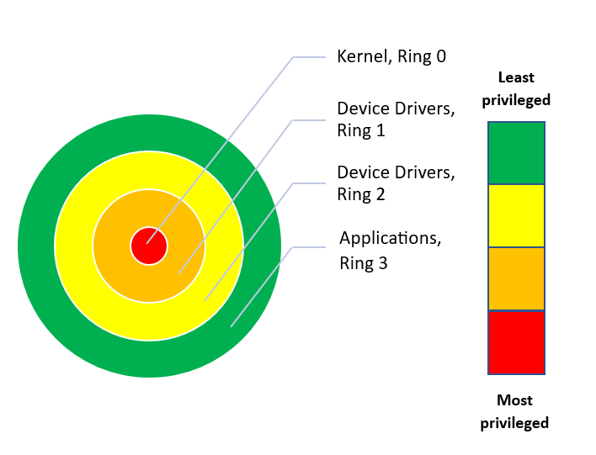
Fig. 5 Operating System Protection Rings [28]

Device Management

Device management manages hardware and devices on computers, to which input (like keyboards) and output (like speakers) devices are allocated by OS’s to the CPU when required via programs and processes [29], [30]. These devices use software programs called drivers, allowing hardware devices to communicate with OS’s to perform the required functions of that device, as the hardware will fail to operate and function as intended without the driver [31], [32].

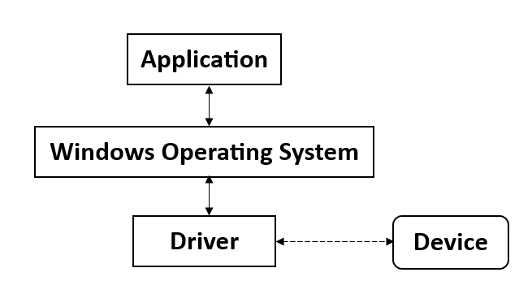
Fig. 6 Device Management on Windows Operating System [32]

Use of Windows OS CLI Commands

A Command Line Interface (CLI) is a program used to input text and perform OS functions like computer configurations [33].

Windows OS uses two CLIs.

- Command Prompt – Executes commands using a text-based interface via ‘cmd.exe’ files for troubleshooting Windows issues [34].
- PowerShell – Allows more advanced executions, controlling and automating processes and applications using ‘PowerShell.exe’ [35].

Ten commands performed within Windows are as follows.

All IP Configurations Command

The ‘ipconfig /all’ command displays all Transmission Control Protocol and Internet Protocol (TCP/IP) information of computers [36]. Figures 7 and 8 show my laptop’s TCP/IP details like the IP configuration and physical/MAC address.

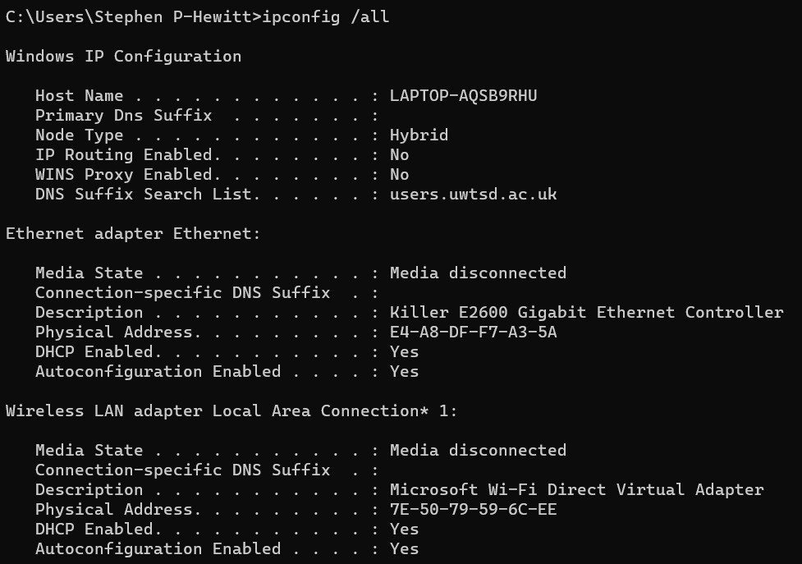
Fig. 7 First Part of ‘Ipconfig /all’ Command

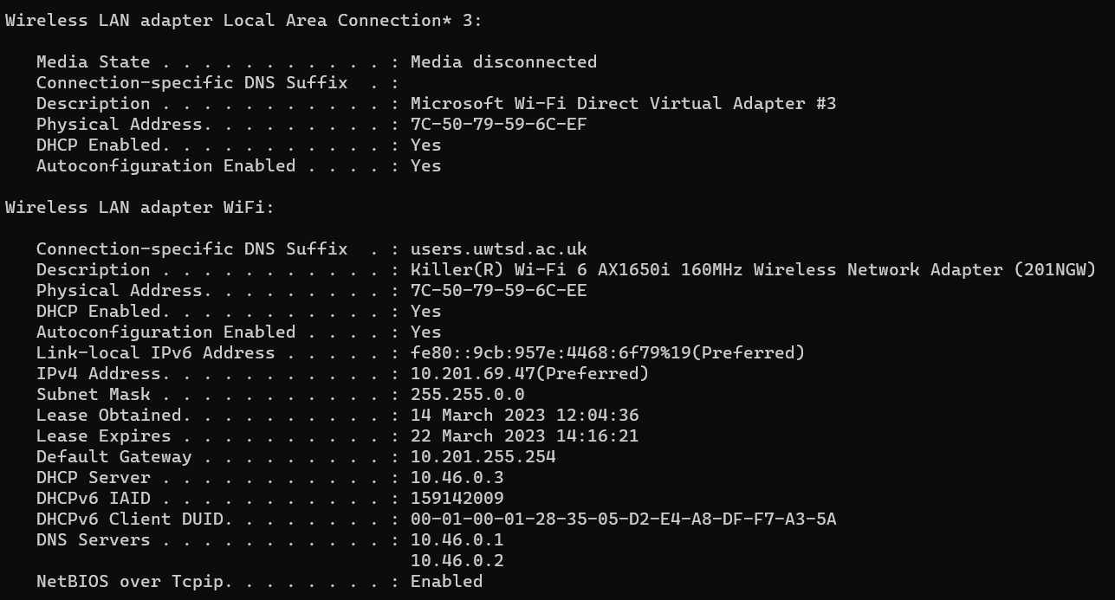
Fig. 8 Second Part of ‘ipconfig /all’ Command

Ping Command

The ‘ping’ command tests connections via packets between computers and specified destinations, checking active connections [37]. Figure 9 shows my laptop attempting connections to www.amazon.co.uk and responses received.

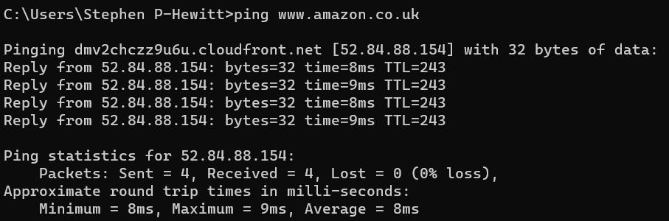
Fig. 9 ‘Ping’ Command

The 0% loss means each packet sent was returned, meaning my laptop can communicate successfully with Amazon.

Tracert Command

The ‘tracert’ command tests connections via packets between computers and specified destinations, allowing for troubleshooting if connections cannot be made [38]. Figure 10 shows my laptop attempting connections to www.google.com, showing the routes and time taken.

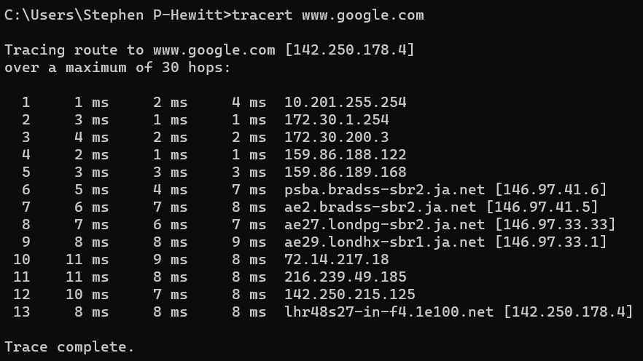
Fig. 10 ‘Tracert’ Command

In each instance, a successful trace was completed against Google, with no issues identified.

Tasklist Command

The ‘tasklist’ command shows all current processes running on a computer [39]. Figure 11 shows processes running on my laptop and the memory being used.

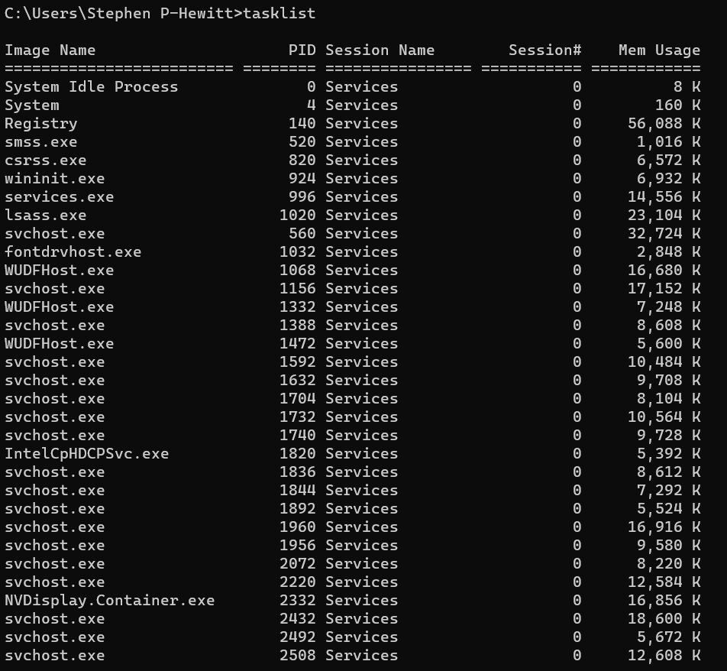
Fig. 11 ‘Tasklist’ Command

Netstat Command

The ‘netstat’ command displays network statistics like active connections and traffic breakdown for network diagnostics [40], [41]. Figure 12 shows the TCP protocols like connections in use on my laptop.

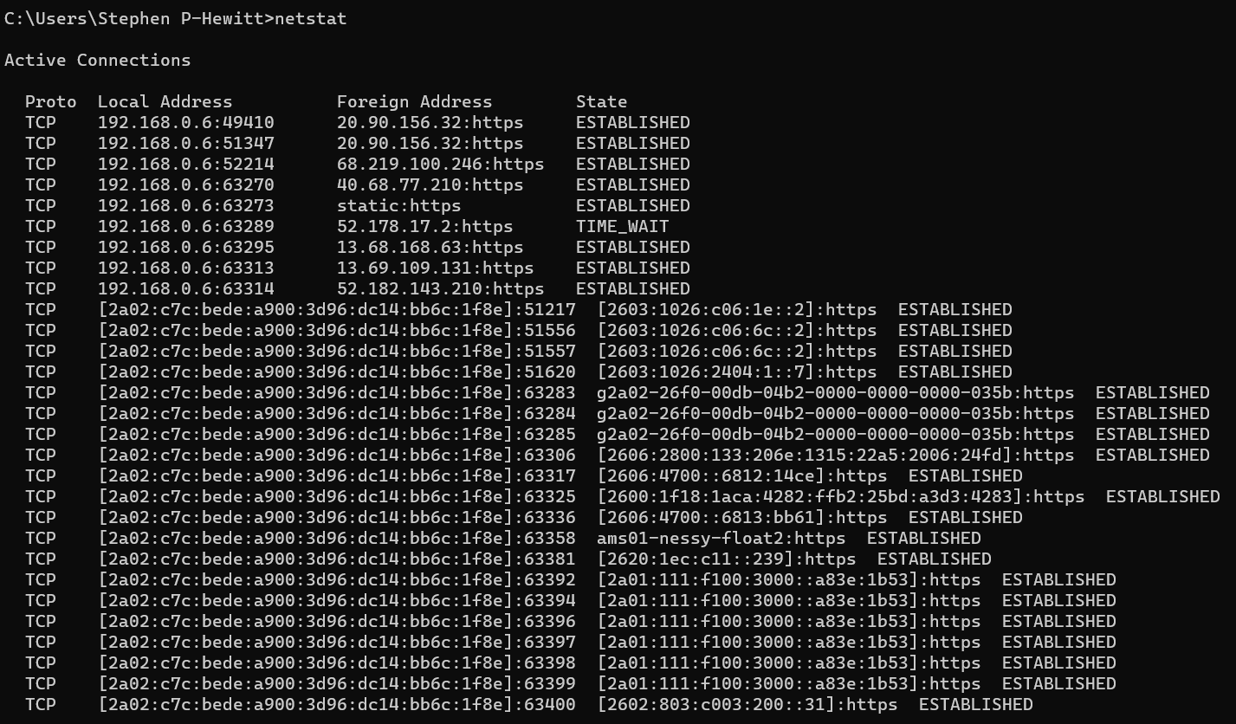
Fig. 12 ‘Netstat’ Command

System Information Command

The ‘systeminfo’ command displays the drivers installed on a computer [42], [43]. Figures 13 and 14 show my laptop's OS details, memory and drivers.

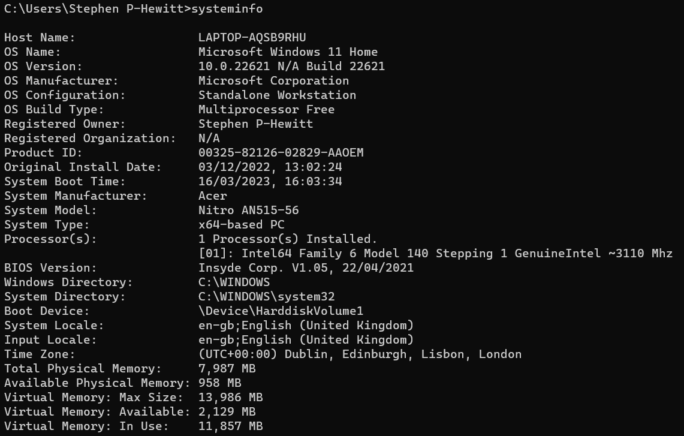
Fig. 13 First Part of ‘Systeminfo’ Command

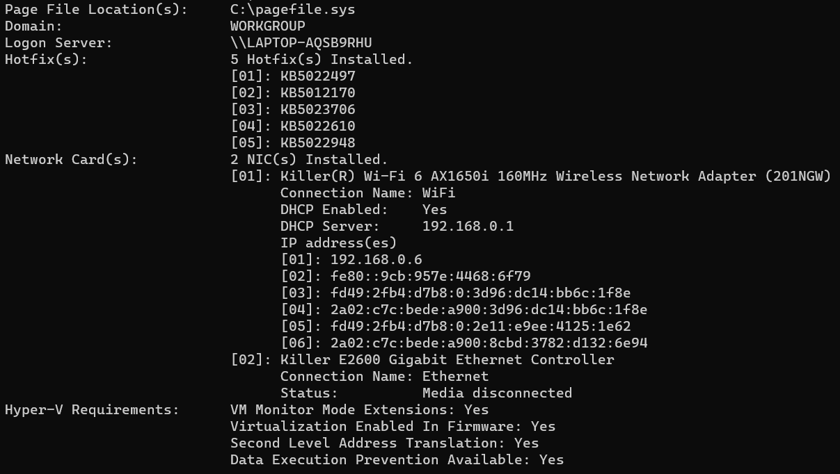
Fig. 14 Second Part of ‘Systeminfo’ Command

Check Disk Command

The ‘chkdsk’ command checks the hard disk for errors and corrects them if possible [44], [45]. Figures 15 and 16 provide a report into my laptop’s file system, showing errors and any actions required.

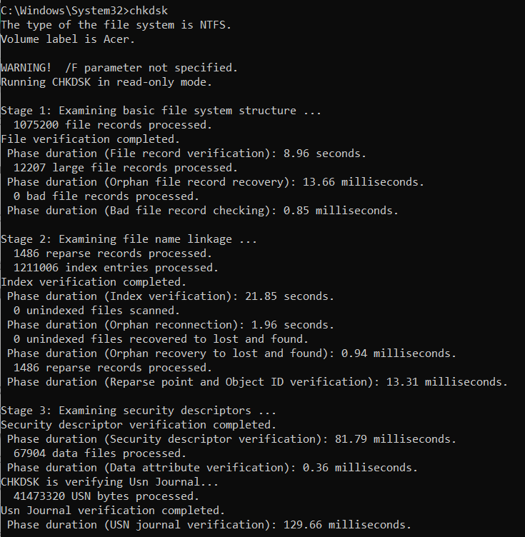
Fig. 15 First Part of ‘Chkdsk’ Command

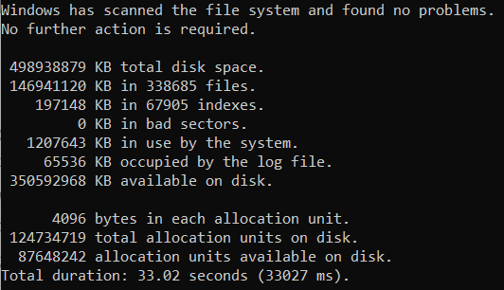
Fig. 16 Second Part of ‘Chkdsk’ Command

Power Configuration Energy Command

The ‘powercfg -energy’ command allows administrators to check computers for energy efficiency and battery life issues [46]. Figure 17 shows my laptop analysed for energy efficiency issues and any problems identified.

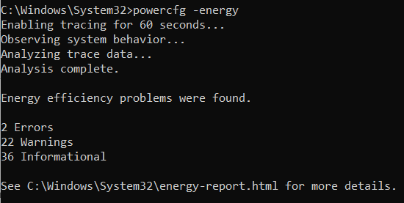
Fig. 17 ‘Powercfg -energy’ Command

System File Checker (Verify Only) Command

The ‘sfc /verifyonly’ command allows administrators to scan and verify system files without fixing them [47]. Figure 18 shows my laptop being scanned and verified, identifying issues and repair options.

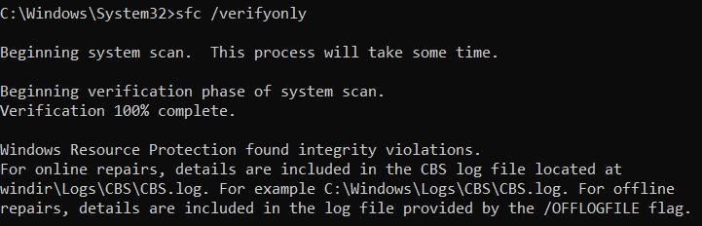
Fig. 18 ‘Powercfg -energy’ Command

Start Command

The ‘start’ command runs specified applications or webpages [48]. Figure 19 shows the command to open applications like Notepad++ and webpages like www.bbc.com/news.

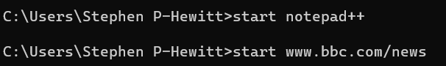
Fig. 19 ‘Start’ Command

Use of Linux OS CLI Commands

Linux OS use shell CLIs, communicating with the kernel to perform actions and responding with data back to the CLI, converting into understandable text [49], with Bash as a commonly used shell.

Ten commands that can be performed within Linux are as follows via the Alpine Linux CLI [50].

Change Directory / Command

The ‘cd /’ command changes the directory to the main root directory [51]. Figure 20 takes us and shows the command and root directory once executed.

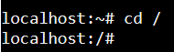
Fig. 20 ‘CD /’ Command

LS Command

The ‘ls’ command lists all subdirectories of a directory [52]. Figure 21 shows users the subdirectories of the root directory after the ‘cd /’ command was used.

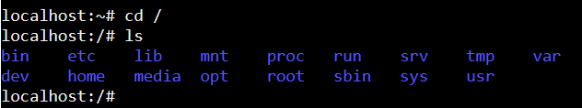
Fig. 21 ‘LS’ Command

Tree Command

The ‘tree’ command lists the file within specific directories [53]. Figure 22 shows users the files within the ‘opt’ directory after going to the root directory and accessing the subdirectories from the root directory.

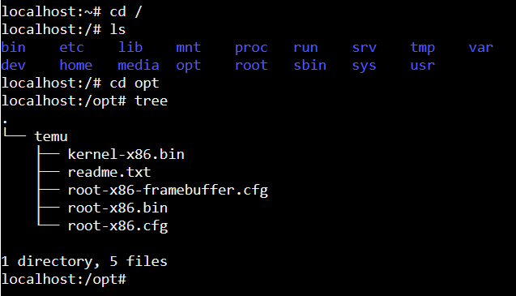
Fig. 22 ‘Tree’ Command

Make Directory Command

The ‘mkdir’ command allows users to create new directories [54]. Figure 23 shows the directory ‘SPH_Test’ created after accessing the root directory and accessing the subdirectories.

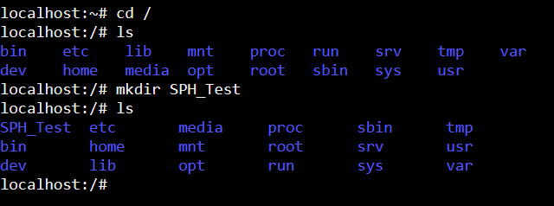
Fig. 23 ‘Mkdir’ Command

Remove Directory Command

The ‘rmdir’ command allows users to remove empty directories [55]. Figure 24 shows the ‘SPH_Test’ directory being deleted after initially being created within the root directory.

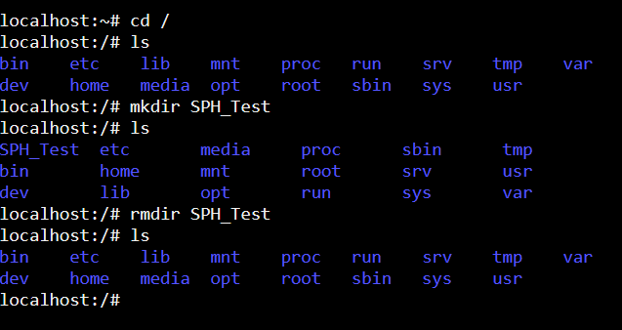
Fig. 24 ‘Rmdir’ Command

History Command

The ‘history’ command allows users to see previous commands they have entered [55]. Figure 25 shows previous commands used, including the ‘mkdir SPH_Test’ and ‘rmdir SPH_Test’ commands.

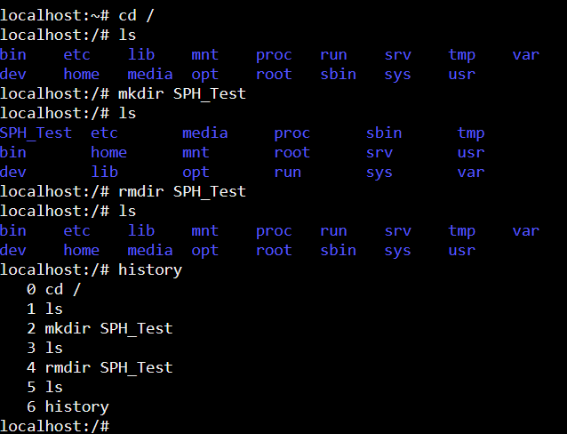
Fig. 25 ‘History’ Command

Touch Command

The ‘touch’ command allows users to create empty files [56]. Figure 26 shows the file ‘SPH_Test.txt’ being created in the ‘SPH_Test’ directory, showing the empty file in the ‘SPH_Test’ directory.

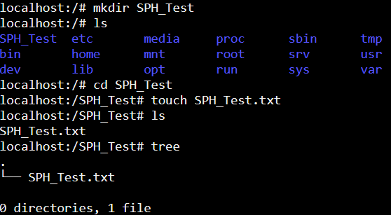
Fig. 26 ‘Touch’ Command

Echo Command

The ‘echo’ command allows users to enter text into specific areas or files [57], [58]. Figure 27 shows text being inputted into the file ‘SPH_Test.txt’.

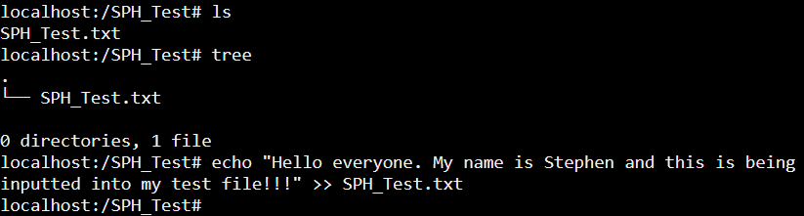
Fig. 27 ‘Echo’ Command

Cat Command

The ‘cat’ command allows users to output what is in a specific file [57]. Figure 28 shows the text being outputted from the file ‘SPH_Test.txt’.

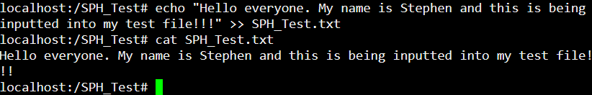
Fig. 28 ‘Cat’ Command

Date Command

The ‘date’ command displays information like the date and time [57], [59]. Figure 29 displays the date, time, and user’s time zone.

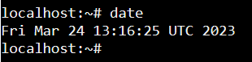
Fig. 29 ‘Date’ Command

Use of Windows OS Scripts

Scripts are used to automate tasks like scheduling and streamlining processes to minimise errors and save time, improving efficiency [60]. Windows Batch scripts are created within text editor files like Notepad++ and executed via CLI programs [61].

Seven scripts that can be performed within Windows are as follows, with @echo used to stop all commands being shown on screen [62].

Variables Script

Variables allow users to create and set specific variables to store within scripts to use, either as static (strings or integers) or dynamic (like functions) variables [63]. Figures 30 and 31 set the age, message and three numbers as variables, the numeric operators and command showing the result.

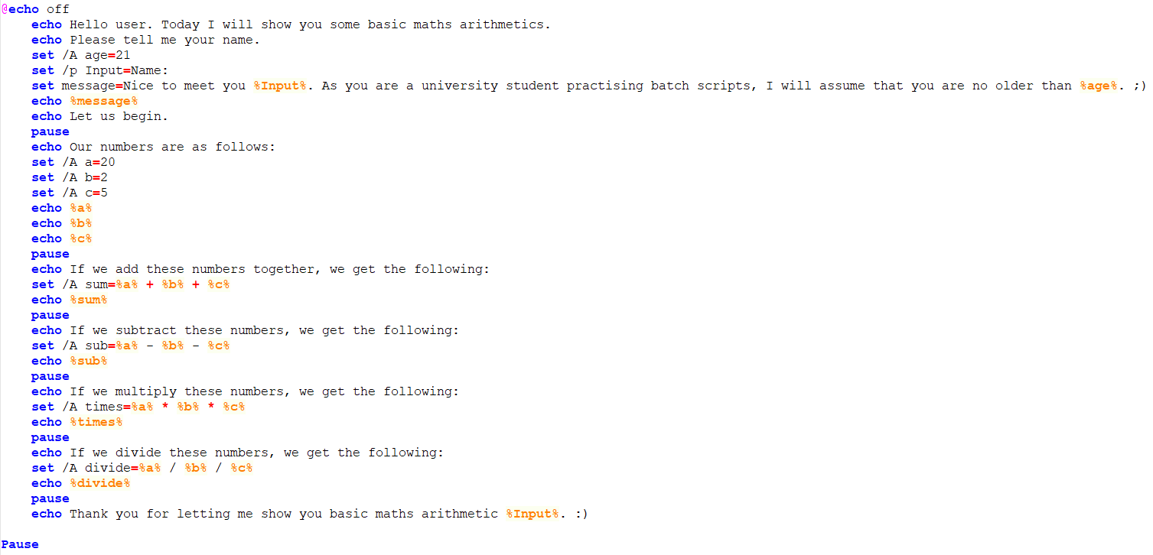
Fig. 30 Variable Script from Notepad++

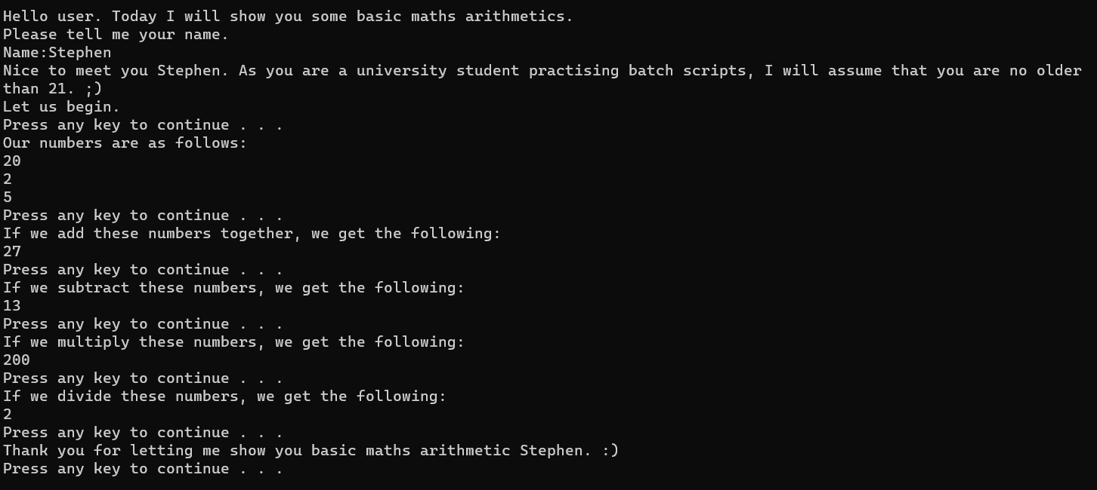
Fig. 31 Variable Script Executed in Command Prompt

Go to Command Script

The ‘Go to’ command directs commands to specific areas in scripts that, when labels match, the script continues from there [64]. Figures 32 to 35 direct users to a specific area of the script, depending on the choice made.

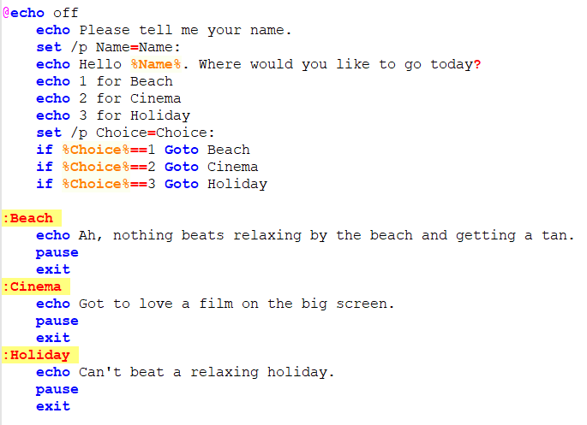
Fig. 32 Go to Command Script from Notepad++

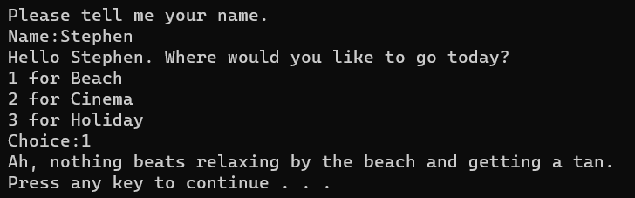
Fig. 33 First Part of Go to Command Script Executed in Command Prompt

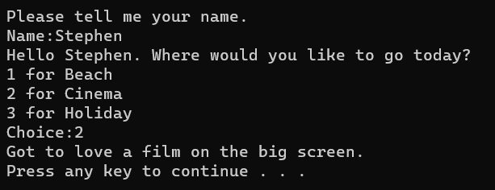
Fig. 34 Second Part of Go to Command Script Executed in Command Prompt

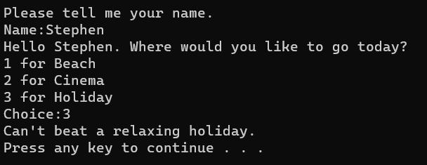
Fig. 35 Third Part of Go to Command Script Executed in Command Prompt

If Statement Script

If statements allow users to program decisions via ‘True’ or ‘False’ logic to meet certain conditions [65]. Figures 36 and 37 ask users to guess the correct number between 1 and 10, with incorrect guesses prompting users to guess again until the answer is correct.

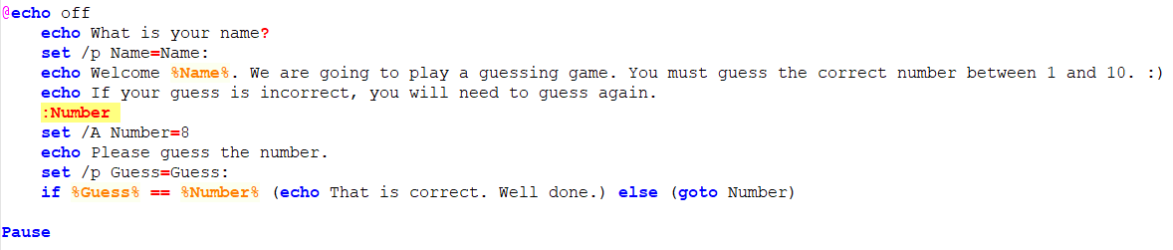
Fig. 36 If Statement Script from Notepad++

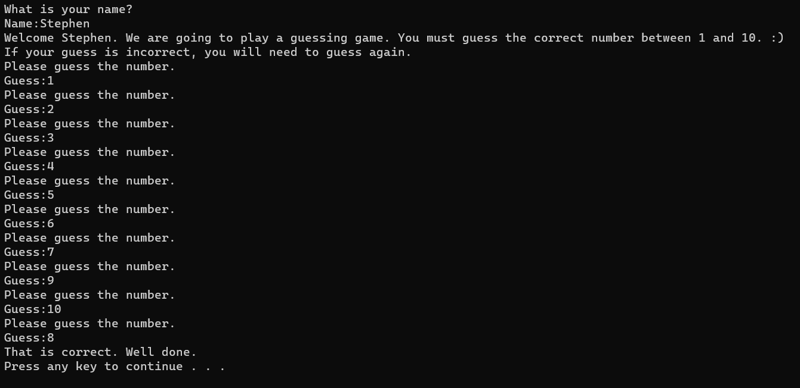
Fig. 37 If Statement Script Executed in Command Prompt

For Loop Script

For loops are created for statements to continuously process until specified conditions are met [66]. Figures 38 and 39 show the ‘for loop’ command and values from 0 to 1,000 via increments of 50.

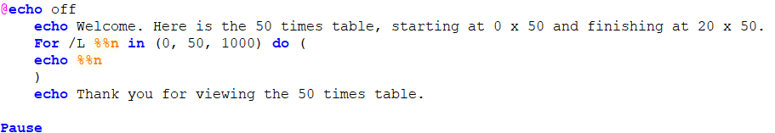
Fig. 38 For Loop Script from Notepad++

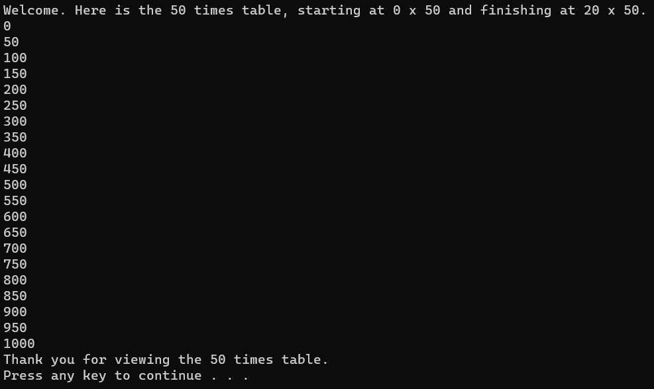
Fig. 39 For Loop Script Executed in Command Prompt

Array Script

Arrays allow users to store set values of any data type and volume [66]. Figures 40 and 41 show favourite TV characters when set as an array and a ‘for loop’ displaying each character via the array number.

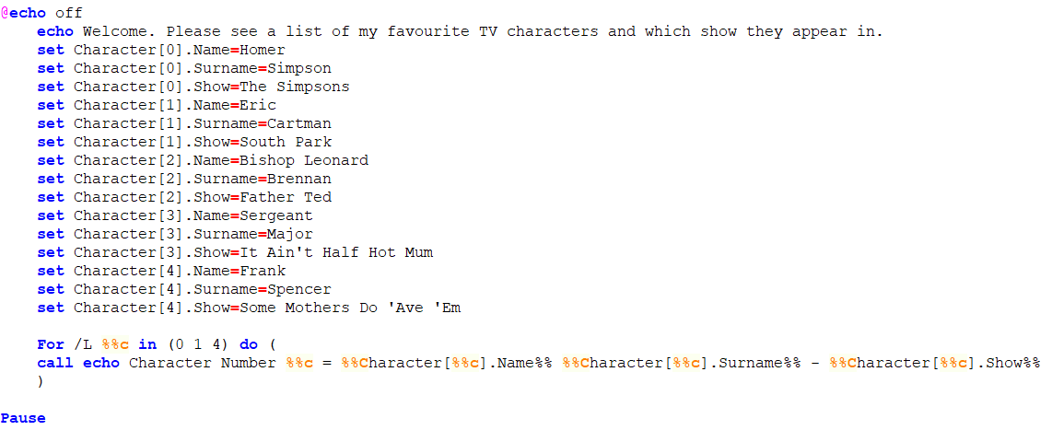
Fig. 40 Array Script from Notepad++

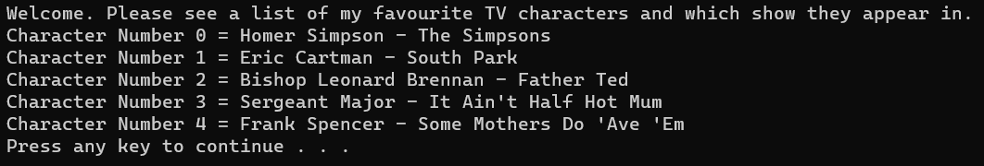
Fig. 41 Array Script Executed in Command Prompt

Function Script

Functions allow users to create groups of statements to perform a specific task and use them within scripts [67]. Figures 42 and 43 show the function used for the song ‘Twelve Days of Christmas’, the function used and the retrieved values.

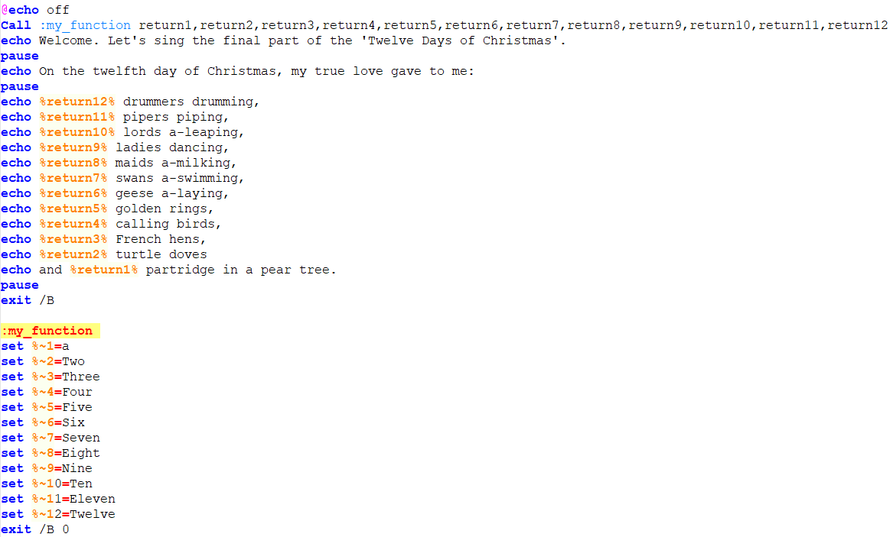
Fig. 42 Function Script from Notepad++

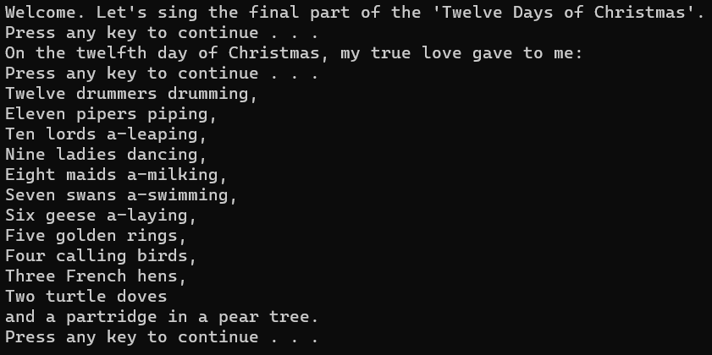
Fig. 43 Function Script Executed in Command Prompt

User Input Script

User input scripts can be created for users to input variables via the ‘set /p’ command [68], [69]. Figures 44 and 45 ask the user five questions, to which they input an answer before continuing.

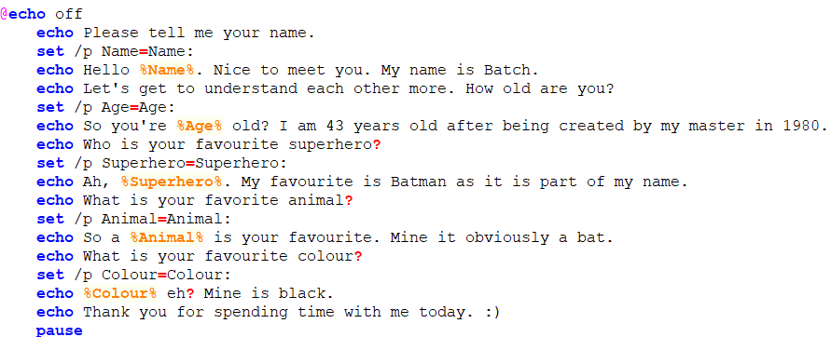
Fig. 44 User Input Script from Notepad++

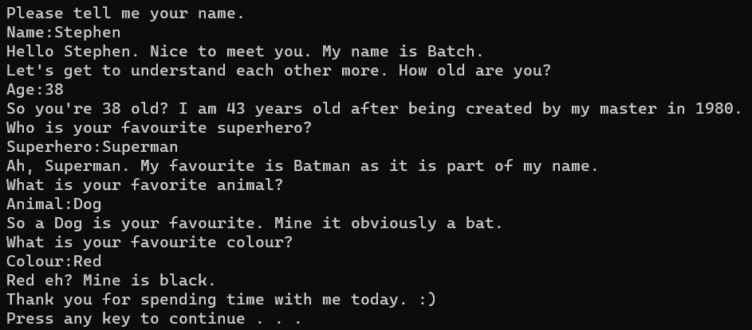
Fig. 45 User Input Script Executed in Command Prompt

Use of Linux OS Scripts

Like with Windows, Linux Bash scripts are created via a text editor like Notepad++ and executed via Linux CLI shell programs [70].

Seven scripts that can be performed within Linux are as follows via Replit.com [71].

Variables Script

Variables are created via the equal symbol, with no spaces before or after the equal symbol and requiring the ‘$’ symbol before variable names [72]. Figures 46 and 47 show the variables set for the name, age and three numbers, as well as the numeric operators and resulting equations.

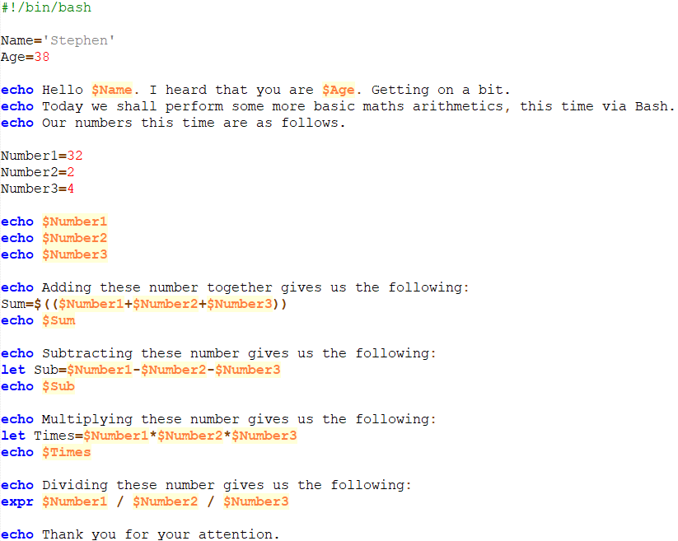
Fig. 46 Variable Script for Bash from Notepad++

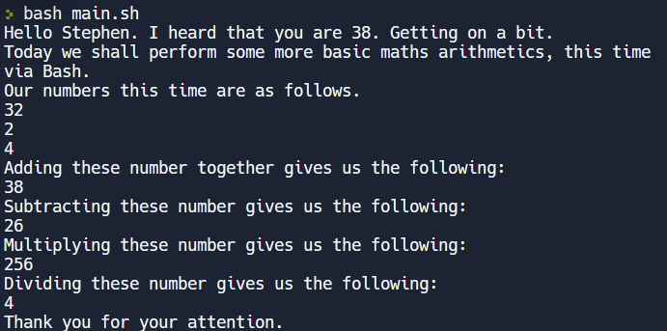
Fig. 47 Variable Script Executed via Bash

If Statement Script

Like in Windows, if statements in Linux allow decisions to be made to run specific code based on set conditions [73]. Figures 48 to 51 allow users to choose a breakfast order and receive the appropriate response.

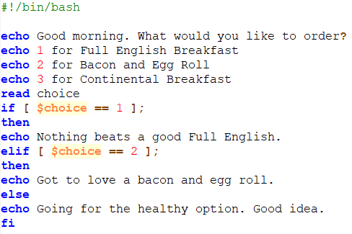
Fig. 48 If Statement Script for Bash from Notepad++

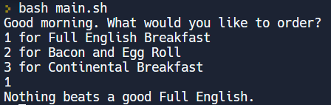
Fig. 49 First Part of If Statement Script Executed via Bash

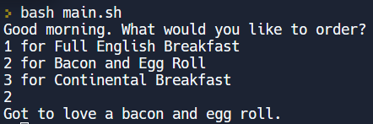
Fig. 50 Second Part of If Statement Script Executed via Bash

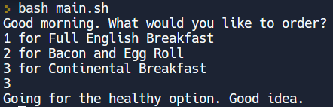
Fig. 51 Third Part of If Statement Script Executed via Bash

Case Statement Script

Case statements use a value against numerous conditions until that value is found, where the specific code is executed, and the case statement terminated [74]. Figures 52 to 69 provide users with a choice of four animals and the message provided based on the user’s choice.

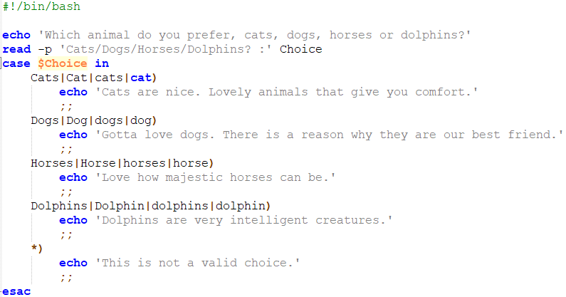
Fig. 52 Case Statement Script for Bash from Notepad++

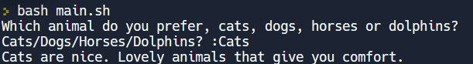
Fig. 53 First Part of Case Statement Script Executed via Bash

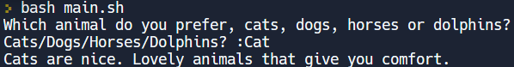
Fig. 54 Second Part of Case Statement Script Executed via Bash

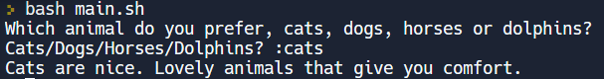
Fig. 55 Third Part of Case Statement Script Executed via Bash

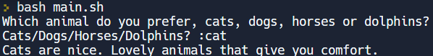
Fig. 56 Fourth Part of Case Statement Script Executed via Bash

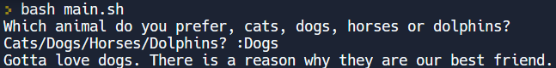
Fig. 57 Fifth Part of Case Statement Script Executed via Bash

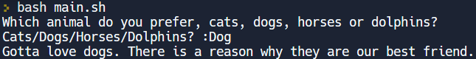
Fig. 58 Sixth Part of Case Statement Script Executed via Bash

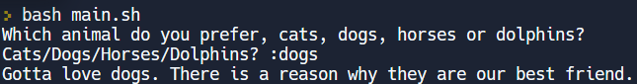
Fig. 59 Seventh Part of Case Statement Script Executed via Bash

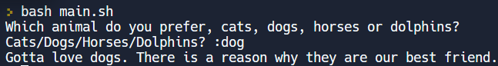
Fig. 60 Eighth Part of Case Statement Script Executed via Bash

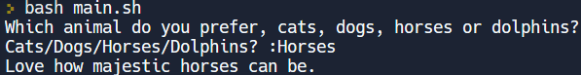
Fig. 61 Ninth Part of Case Statement Script Executed via Bash

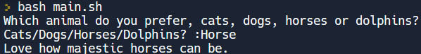
Fig. 62 Tenth Part of Case Statement Script Executed via Bash

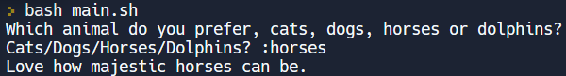
Fig. 63 Eleventh Part of Case Statement Script Executed via Bash

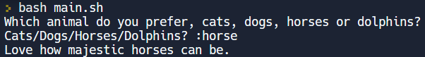
Fig. 64 Twelfth Part of Case Statement Script Executed via Bash

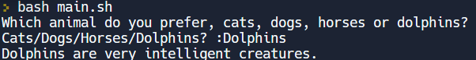
Fig. 65 Thirteenth Part of Case Statement Script Executed via Bash

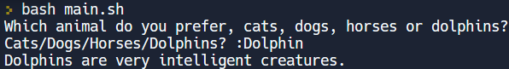
Fig. 66 Fourteenth Part of Case Statement Script Executed via Bash

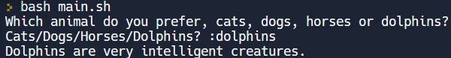
Fig. 67 Fifteenth Part of Case Statement Script Executed via Bash

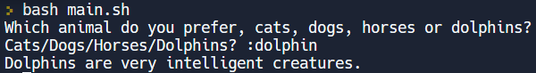
Fig. 68 Sixteenth Part of Case Statement Script Executed via Bash

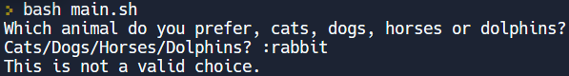
Fig. 69 Seventeenth Part of Case Statement Script Executed via Bash

While Loop Script

While loop commands continuously execute if a condition has no known limit, and the condition is true [75]. Figures 70 and 71 show the script beginning at 20 and reducing by 1, with the loop continuing until it satisfies the condition that 0 is not greater than 0.

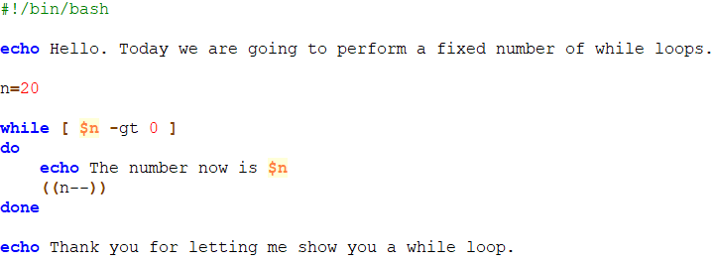
Fig. 70 While Loop Script for Bash from Notepad++

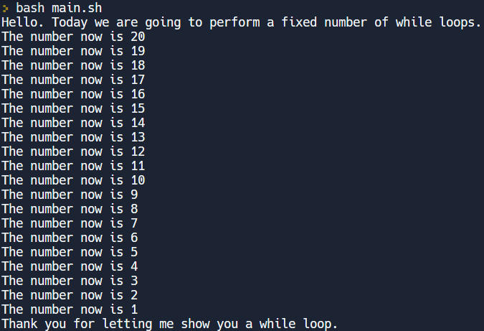
Fig. 71 While Loop Script Executed via Bash

Array Script

Bash allows two types of arrays: indexed (storing numeric values as a lowercase ‘a’) and associative (storing strings as an uppercase ‘A’) [76]. Figures 72 and 73 show a sports list in an array set and the favourites displayed in the executed command.

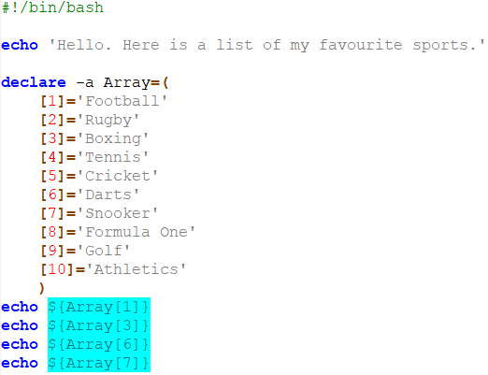
Fig. 72 Array Script for Bash from Notepad++

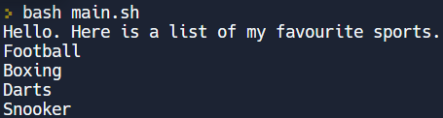
Fig. 73 Array Script Executed via Bash

Function Script

Like in Windows, functions in Linux allow users to create commands within a single function to reuse when required [77]. Figures 74 and 75 show a passing argument being set as part of a function at the beginning of the script to show each colour.

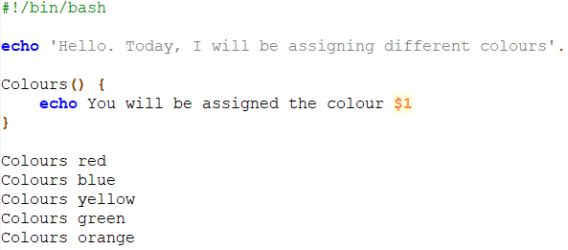
Fig. 74 Function Script for Bash from Notepad++

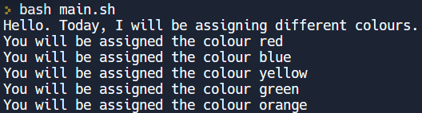
Fig. 75 Function Script Executed via Bash

User Input Script

Within Linux, scripts can allow user inputs via the ‘read’ command to enter a variable of their choosing [78]. Figures 76 and 77 ask five different questions for users to answer before continuing.

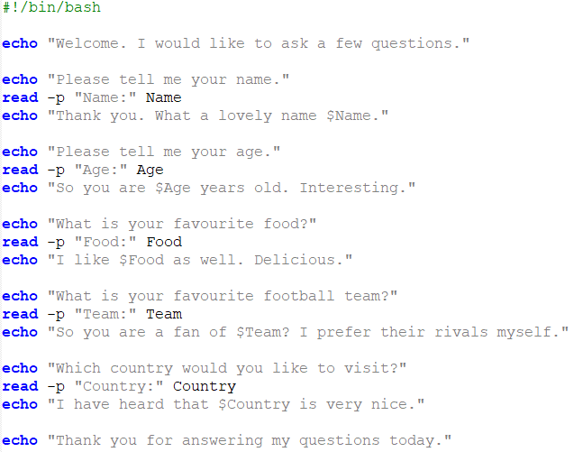
Fig. 76 User Input Script for Bash from Notepad++

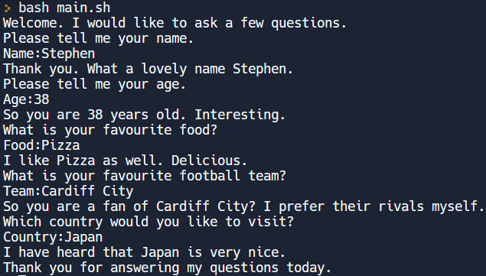
Fig. 77 User Input Script Executed via Bash

Conclusion

The OS is the most important part of a computer, allowing the CPU to perform different management aspects and processes as part of daily operations, while CLI programs like PowerShell and Linux shells are powerful tools used by software developers and system administrators to create automated programs for improved efficiency and timeliness of processes.

However, with the ever-increasing reliance on digital technology worldwide, it is increasingly important that OS’s and CLI’s are protected as much as possible from attackers. Belding [79] mentions of real-world attacks using the CLI, such as ‘PoisonIvy’ to allow remote access for attackers to access the computer’s CLI and the trojan ‘Kazaur’ that affects Windows and Mac OS’s and perform remote commands on compromised computers.

A high-profile example of an attack via the CLI was when Capital One was hacked in March 2019, where the attacker created a script with three commands to gain unauthorised access to Amazon Web Service (AWS) hosted server, with Capital One confirming that the commands were executed [80]. The attacker was able to access the personal information of 106 million customers, with 140,000 Social Security numbers and 80,000 bank accounts being exposed, resulting in Capital One being fined $80m and agreeing on a settlement of $190m as part of a class-action lawsuit [81], [82].

References

[1] | S. Jernigan, “CompTIA IT Fundamentals (FC0-U61) Cert Prep 1: Computer Basics, Hardware, and Operating Systems,” Linkedin.com, Carpenteria, Jan. 16, 2020. [Online] Available: https://www.linkedin.com/learning/comptia-it-fundamentals-fc0-u61-cert-prep-1-computer-basics-hardware-and-operating-systems/operating-system-functions?autoplay=true&resume=false&u=77966930 [Accessed Feb. 7, 2023].
[2] | G. Chow, “Working with Computers and Devices,” Linkedin.com, Carpenteria, Aug. 12, 2020. [Online] Available: https://www.linkedin.com/learning/working-with-computers-and-devices/understand-the-role-of-an-operating-system?autoplay=true&resume=false&u=77966930 [Accessed Feb. 12, 2023].
[3] | University of Wollongong Australia, “Understanding operating systems,” University of Wollongong Australia [Online] Available: https://www.uow.edu.au/student/learning-co-op/technology-and-software/operating-systems/ [Accessed Feb. 12, 2023].
[4] | Geeks for Geeks, “Kernel in Operating System,” Geeks for Geeks, Dec. 22, 2022. [Online] Available: https://www.geeksforgeeks.org/kernel-in-operating-system/ [Accessed Feb. 12, 2023].
[5] | Apple, “Introduction to Memory Management,” Apple [Online] Available: https://developer.apple.com/library/archive/documentation/mac/pdf/Memory/Intro_to_Mem_Mgmt.pdf. [Accessed Feb. 21, 2023].
[6] | IBM, “Process management,” IBM, Jan. 20, 2023. [Online] Available: https://www.ibm.com/docs/en/aix/7.2?topic=administration-process-management [Accessed Feb. 21, 2023].
[7] | M. Narang, “Functions of Operating System,” Naukri Learning, Feb. 17, 2023. [Online] Available: https://www.naukri.com/learning/articles/functions-of-operating-system/#Process-management [Accessed Feb. 21, 2023].
[8] | A. W. Salim et al, “Implementation Resource Request Alghoritm In Simulation of Deadlock Avoidance,” Journal of physics: Conference series, vol. 1230, no. 1, p. 12096, July 2019. [Online] Available: 10.1088/1742-6596/1230/1/012096 [Accessed Mar. 9, 2023].
[9] | A. Sugandhi, “What is Deadlock in Operating System (OS)?,” Knowledge Hut, Jan. 23, 2023. [Online] Available: https://www.knowledgehut.com/blog/web-development/deadlock-in-os [Accessed Feb. 7, 2023].
[10] | L. Williams, “Process Scheduling in OS: Long, Medium, Short Term Scheduler,” Guru99, Jan. 31, 2023. [Online] Available: https://www.guru99.com/process-scheduling.html#what-is-process-scheduling [Accessed Mar. 9, 2023].
[11] | Tutorialspoint, “Operating System - Processes,” Tutorialspoint [Online] Available: https://www.tutorialspoint.com/operating_system/os_processes.htm [Accessed Mar. 9, 2023].
[12] | S. Datta, “Process Lifecycle,” Baeldung, Nov. 11, 2022. [Online] Available: https://www.baeldung.com/cs/process-lifecycle [Accessed Mar. 9, 2023].
[13] | Codecademy, “Processes and Threads,” Codecademy [Online] Available: https://www.codecademy.com/learn/operating-systems-processes/modules/os-processes-and-threads/cheatsheet [Accessed Mar. 9, 2023].
[14] | A. Fatima, “What are threads in operating systems?,” Educative [Online] Available: https://www.educative.io/answers/what-are-threads-in-operating-systems [Accessed Mar. 9, 2023].
[15] | JavaTpoint, “Threads in Operating System (OS),” JavaTpoint [Online] Available: https://www.javatpoint.com/threads-in-operating-system [Accessed Mar. 9, 2023].
[16] | P. Shah, “CPU Context Switching in OS,” Scaler, Apr. 29, 2022 [Online] Available: https://www.scaler.com/topics/operating-system/context-switching-in-os/ [Accessed Mar. 9, 2023].
[17] | P. Kirvan, “multithreading,” TechTarget, May 2022. [Online] Available: https://www.techtarget.com/whatis/definition/multithreading [Accessed Mar. 9, 2023].
[18] | Geeks for Geeks, “Multithreading in Operating System,” Geeks for Geeks, Jan. 13, 2023. [Online] Available: https://www.geeksforgeeks.org/multithreading-in-operating-system/ [Accessed Feb. 7, 2023].
[19] | IBM, “File systems,” IBM, Feb. 22, 2023. [Online] Available: https://www.ibm.com/docs/en/aix/7.2?topic=management-file-systems [Accessed Mar. 10, 2023].
[20] | IBM, “Directories,” IBM, Feb. 22, 2023. [Online] Available: https://www.ibm.com/docs/en/aix/7.2?topic=systems-directories [Accessed Mar. 10, 2023].
[21] | Codecademy, “File Systems,” Codecademy [Online] Available: https://www.codecademy.com/learn/becp-22-fundamentals-of-operating-systems/modules/wdcp-22-file-systems/cheatsheet [Accessed Mar. 10, 2023].
[22] | J. Ryoo, “Operating System Forensics,” Linkedin.com, Carpenteria, 2019. [Online] Available: https://www.linkedin.com/learning/operating-system-forensics/windows-file-systems?autoplay=true&resume=false&u=77966930 [Accessed Mar. 10, 2023].
[23] | J. Ryoo, “Operating System Forensics,” Linkedin.com, Carpenteria, 2019. [Online] Available: https://www.linkedin.com/learning/operating-system-forensics/linux-file-systems?autoplay=true&resume=false&u=77966930 [Accessed Mar. 10, 2023].
[24] | J. Ryoo, “Operating System Forensics,” Linkedin.com, Carpenteria, 2019. [Online] Available: https://www.linkedin.com/learning/operating-system-forensics/apple-file-systems?autoplay=true&resume=false&u=77966930 [Accessed Mar. 10, 2023].
[25] | Microsoft, “Windows operating system security,” Microsoft, Dec. 9 2022 [Online]. Available: https://learn.microsoft.com/en-us/windows/security/operating-system [Accessed Feb. 28, 2023].
[26] | L. Bock, “IT Security Foundations: Operating System Security,” Linkedin.com, Carpenteria, Apr. 29, 2022 [Online] Available: https://www.linkedin.com/learning/it-security-foundations-operating-system-security-14816522/ensuring-system-security?autoplay=true&resume=false&u=77966930 [Accessed Feb. 28, 2023].
[27] | IBM, “Techniques for Securing the Operating System,” IBM, Mar. 3, 2021 [Online] Available: https://www.ibm.com/docs/en/cognos-analytics/10.2.2?topic=SSEP7J_10.2.2/com.ibm.swg.ba.cognos.crn_arch.10.2.2.doc/c_securing_the_operating_system.htm [Accessed Feb. 28, 2023].
[28] | FutureLearn, “Layers of an Operating System,” FutureLearn [Online] Available: https://www.futurelearn.com/info/courses/computer-systems/0/steps/53514 [Accessed Mar. 9, 2023].
[29] | JavaTpoint, “Device Management in Operating System,” JavaTpoint [Online] Available: https://www.javatpoint.com/device-management-in-operating-system [Accessed Mar. 10, 2023].
[30] | P. Singh, “Device Management in Operating System,” Scaler, Oct. 13, 2022 [Online] Available: https://www.scaler.com/topics/device-management-in-operating-system/ [Accessed Mar. 10, 2023].
[31] | S. Jena, “Device Driver and It’s Purpose,” GeeksforGeeks, Sept. 28, 2022 [Online] Available: https://www.geeksforgeeks.org/device-driver-and-its-purpose/ [Accessed Mar. 10, 2023].
[32] | Microsoft, “What is a driver?,” Microsoft, Nov. 4, 2022 [Online] Available: https://learn.microsoft.com/en-us/windows-hardware/drivers/gettingstarted/what-is-a-driver- [Accessed Mar. 10, 2023].
[33] | W3Schools, “What is Command Line Interface (CLI)?,” W3Schools [Online] Available: https://www.w3schools.com/whatis/whatis_cli.asp [Accessed Mar. 13, 2023].
[34] | Dell, “The Command Prompt: What It Is and How to Use It on a Dell System,” Dell, Aug. 17, 2021 [Online] Available: https://www.dell.com/support/kbdoc/en-uk/000130703/the-command-prompt-what-it-is-and-how-to-use-it-on-a-dell-system [Accessed Mar. 13, 2023].
[35] | Microsoft, “PowerShell,” Microsoft, Feb. 3, 2023 [Online] Available: https://learn.microsoft.com/en-us/windows-server/administration/windows-commands/powershell [Accessed Mar. 13, 2023].
[36] | Microsoft, “ipconfig,” Microsoft, Feb. 3, 2023 [Online] Available: https://learn.microsoft.com/en-us/windows-server/administration/windows-commands/ipconfig [Accessed Mar. 14, 2023].
[37] | M. R. Mayfeld, “How to Verify an IP Address,” A V Technology, vol. 6, no. 5, pp. 36, 38, June 2013.
[38] | A. Yee, “6 COMMAND-ROMPT COMMANDS YOU SHOULD STILL BE USING,” PC World, pp. 103-106, Jul. 2021 [Online] Available: https://www.proquest.com/trade-journals/how-verify-ip-address/docview/1636559115/se-2 [Accessed Mar. 25, 2023].
[39] | Microsoft, “tasklist,” Microsoft, Feb. 3, 2023 [Online] Available: https://learn.microsoft.com/en-us/windows-server/administration/windows-commands/tasklist [Accessed Mar. 18, 2023].
[40] | N. Gaur, “Use the power of ifconfig and netstat,” Inside Solaris, vol. 8, no. 5, pp. 3-6, May 2002 [Online] Available: https://www.proquest.com/magazines/use-power-ifconfig-netstat/docview/191117658/se-2 [Accessed Mar. 18, 2023].
[41] | IBM, “Using the netstat command,” IBM, Jan. 20, 2023 [Online] Available: https://www.ibm.com/docs/hr/aix/7.2?topic=command-using-netstat [Accessed Mar. 18, 2023].
[42] | Microsoft, “driverquery,” Microsoft, Feb. 3, 2023 [Online] Available: https://learn.microsoft.com/en-us/windows-server/administration/windows-commands/driverquery [Accessed Mar. 18, 2023].
[43] | A. Gangwar, “20 Command Prompt Tricks that You Should Know,” Beebom, Dec. 20, 2021 [Online] Available: https://beebom.com/command-prompt-tricks-to-know/#5 [Accessed Mar. 18, 2023].
[44] | Dell, “Using the Chkdsk Utility,” Dell, Mar. 28, 2021 [Online] Available: https://www.dell.com/support/kbdoc/en-uk/000148643/using-the-chkdsk-utility [Accessed Mar. 18, 2023].
[45] | R. Dube, “21 CMD Commands All Windows Users Should Know,” Help Desk Geek, Feb. 21, 2019 [Online] Available: https://helpdeskgeek.com/help-desk/21-cmd-commands-all-windows-users-should-know/ [Accessed Mar. 18, 2023].
[46] | Computer Hope, "Windows command line powercfg command," Computer Hope, Dec. 30, 2021 [Online] Available: https://www.computerhope.com/powercfg.htm [Accessed Mar. 18, 2023].
[47] | Computer Hope, “MS-DOS and Windows command line sfc command,” Computer Hope, Jan. 31, 2023 [Online] Available: https://www.computerhope.com/sfc.htm [Accessed Mar. 18, 2023].
[48] | Microsoft, “start,” Microsoft, Feb. 3, 2023 [Online] Available: https://learn.microsoft.com/en-us/windows-server/administration/windows-commands/start [Accessed Mar. 18, 2023].
[49] | G. McWilliams, “Linux: Desktops and Remote Access,” Linkedin.com, Carpenteria, Dec. 15, 2016 [Online] Available: https://www.linkedin.com/learning/linux-desktops-and-remote-access/choosing-a-shell?autoplay=true&resume=false&u=77966930 [Accessed Mar. 21, 2023].
[50] | F. Bellard, “Alpine Linux CLI,” Fabrice Bellard, Mar. 16, 2023 [Online] Available: https://bellard.org/jslinux/ [Accessed Mar. 24, 2023].
[51] | A. Prakash, “7 Practical Examples of cd Command in Linux,” Linux Handbook, Jan.25, 2023 [Online] Available: https://linuxhandbook.com/cd-command-examples/ [Accessed Mar. 24, 2023].
[52] | S. Simpson, “Learning Linux Command Line,” Linkedin.com, Carpenteria, 2021 [Online] Available: https://www.linkedin.com/learning/learning-linux-command-line-14447912/write-commands-in-a-shell-at-the-prompt?autoplay=true&resume=false&u=77966930 [Accessed Mar. 24, 2023].
[53] | S. Henry-Stocker, “Viewing files and processes as trees on Linux: A look at three Linux commands - ps, pstree and tree - for viewing files and processes in a tree-like format,” Network World (Online), Oct. 9, 2019 [Online] Available: https://www.proquest.com/trade-journals/viewing-files-processes-as-trees-on-linux/docview/2303326712/se-2 [Accessed Mar. 24, 2023].
[54] | IBM, “Creating directories (mkdir command),” IBM, Mar. 24, 2023 [Online] Available: https://www.ibm.com/docs/en/aix/7.1?topic=directories-creating-mkdir-command [Accessed Mar. 24, 2023].
[55] | C. Negus, Linux Bible, 9 ed., Indianapolis, Indiana: John Wiley & Sons, Incorporated, 2015. [E-book]
[56] | A. Oliveira, “Linux essentials: How to create and delete files and directories,” Red Hat, Jul. 19, 2022 [Online] Available: https://www.redhat.com/sysadmin/create-delete-files-directories-linux [Accessed Mar. 24, 2023].
[57] | E. Siever, Linux in a nutshell, 6th ed., Sebastopol: O'Reilly, 2009 [E-book].
[58] | J. LaCroix, “The Echo Command,” Linux Journal, Jul. 13, 2022 [Online] Available: https://www.linuxjournal.com/content/echo-command [Accessed Mar. 24, 2023].
[59] | O. Farooq, “Linux Date Command,” Linux Hint, Jan. 24, 2023 [Online] Available: https://linuxhint.com/linux_date_command/ [Accessed Mar. 24, 2023].
[60] | S. Tentarelli, R. Romero and M. L. Lamb, “Script-based automation of analytical instrument software tasks,” vol. 27, no. 3, pp. 209-213, Jun. 2022 [Online] Available: https://doi.org/10.1016/j.slast.2021.10.019 [Accessed Mar. 24, 2023].
[61] | J. Williams, Windows OS Batch/Bat Scripts, Swansea: University of Wales, Trinity St. Davids, 2023.
[62] | Microsoft, “Echo,” Microsoft, Feb. 3, 2023 [Online] Available: https://learn.microsoft.com/en-us/windows-server/administration/windows-commands/echo [Accessed Mar. 26, 2023].
[63] | L. Cleary, “PowerShell 7 Essential Training,” Linkedin.com, Carpenteria, Dec. 17, 2020 [Online] Available: https://www.linkedin.com/learning/powershell-7-essential-training/utilize-variables?autoplay=true&resume=false&u=77966930 [Accessed Mar. 25, 2023].
[64] | Microsoft, “Goto,” Microsoft, Feb. 3, 2023 [Online] Available: https://learn.microsoft.com/en-us/windows-server/administration/windows-commands/goto [Accessed Mar. 26, 2023].
[65] | Try to Program, “Batch file if else,” Try to Program [Online] Available: http://www.trytoprogram.com/batch-file-if-else/#introduction [Accessed Mar. 26, 2023].
[66] | Microsoft Web Builder, Microsoft Web Builder, vol. 4, no. 1, pp. 11-13, 1999 [Online] Available: https://www.proquest.com/trade-journals/scripting-with-arrays-loops/docview/223424989/se-2 [Accessed Mar. 26, 2023].
[67] | Tutorials Point, “Batch Script - Functions,” Tutorials Point [Online] Available: https://www.tutorialspoint.com/batch_script/batch_script_functions.htm [Accessed Mar. 26, 2023].
[68] | Geeks for Geeks, “Batch Script – Input / Output,” Geeks for Geeks, Nov. 28, 2021 [Online] Available: https://www.geeksforgeeks.org/batch-script-input-output/ [Accessed Mar. 26, 2023].
[69] | Bardimin, “Creating Batch Script with User Input,” Bardimin, May 29, 2022 [Online] Available: https://bardimin.com/en/windows-en/creating-batch-script-with-user-input/ [Accessed Mar. 26, 2023].
[70] | S. Henry-Stocker, “Learning to script on Linux using bash: Here are some basic skills to get started with bash, one of the best shells for preparing and using scripts on Linux,” Network World (Online), Mar. 16, 2022 [Online] Available: https://www.proquest.com/trade-journals/learning-script-on-linux-using-bash/docview/2640111558/se-2 [Accessed Mar. 26, 2023].
[71] | Replit, “Bash online editor, IDE, compiler,” Replit [Online] Available: https://replit.com/languages/bash [Accessed Mar. 14, 2023].
[72] | K. Dankwardt, “Linux: Bash Shell and Scripts,” Linkedin.com, Carpenteria, Sept. 16, 2016 [Online] Available: https://www.linkedin.com/learning/linux-bash-shell-and-scripts/time-commands-and-set-variables?autoplay=true&resume=false&u=77966930 [Accessed Mar. 26, 2023].
[73] | Ryans Tutorials, “Bash Scripting Tutorial - 5. If Statements,” Ryans Tutorials [Online] Available: https://ryanstutorials.net/bash-scripting-tutorial/bash-if-statements.php. [Accessed Mar. 28, 2023].
[74] | K. Buzdar, “How to Use the Bash Case Statement,” Linux Hint, Dec. 1, 2022 [Online] Available: https://linuxhint.com/bash_case_statement/ [Accessed Mar. 28, 2023].
[75] | R. Nozaki, “Linux scripting: 3 how-tos for while loops in Bash,” Red Hat, Mar. 11, 2021 [Online] Available: https://www.redhat.com/sysadmin/bash-scripting-while-loops [Accessed Mar. 28, 2023].
[76] | Digital Ocean, “Arrays in Shell Scripts,” Digital Ocean, Aug. 3, 2022 [Online] Available: https://www.digitalocean.com/community/tutorials/arrays-in-shell-scripts [Accessed Mar. 28, 2023].
[77] | Gnu, “3.3 Shell Functions,” Gnu [Online] Available: https://www.gnu.org/software/bash/manual/html_node/Shell-Functions.html [Accessed Mar. 28, 2023].
[78] | T. Miles, “Learning Linux Shell Scripting,” Linkedin.com, Carpenteria, 2018 [Online] Available: https://www.linkedin.com/learning/learning-linux-shell-scripting-2018/getting-input-from-users?autoplay=true&resume=false&u=77966930 [Accessed Mar. 28, 2023].
[79] | G. Belding, “MITRE ATT&CK: Command-line interface,” Infosec Institute, Nov. 11, 2019 [Online] Available: https://resources.infosecinstitute.com/topic/mitre-attck-command-line-interface/ [Accessed Mar. 30, 2023].
[80] | N. N. Neto, S. Madnick, A. M. G. de Paula and N. M. Borges, “A Case Study of the Capital One Data Breach,” Jan. 2020 [Online] Available: https://web.mit.edu/smadnick/www/wp/2020-07.pdf [Accessed Mar. 29, 2023].
[81] | Seattle Times, “Capital One fined $80 million in data breach,” Seattle Times, Aug. 6, 2020 [Online] Available: https://www.seattletimes.com/business/capital-one-fined-80-million-in-data-breach/ [Accessed Mar. 29, 2023].
[82] | D. Avery, “Capital One $190 Million Data Breach Settlement: Today Is the Last Day to Claim Money,” CNET, Sept. 30, 2022 [Online] Available: https://www.cnet.com/personal-finance/capital-one-190-million-data-breach-settlement-today-is-deadline-to-file-claim/ [Accessed Mar. 29, 2023].
[83] | B. Rand, “What Is Virtual Memory and How Does It Work? (With Example),” Indeed, Dec. 13, 2022 [Online] Available: https://www.indeed.com/career-advice/career-development/virtual-memory [Accessed Mar. 9, 2023].
[84] | Solarwinds, “What are Computer and Server Operating Systems?,” Solarwinds [Online] Available: https://www.solarwinds.com/resources/it-glossary/operating-system [Accessed Mar. 10, 2023].
[85] | H. Fang, J. Jiang, F. Lin and W. Zhang, “Optimized Design of Multilines Center of Subway AFC System via Distributed File System and Bayesian Network Model,” vol. 2021, pp. 1-16, 2021 [Online] Available: 10.1155/2021/1500829 [Accessed Mar. 10, 2023].
[86] | H. Consulting and A. Shaikh, “Tech Recruiting Foundations: 2 Understanding Hardware and Operating Systems,” Linkedin, Carpenteria, 2021 [Online] Available: https://www.linkedin.com/learning/tech-recruiting-foundations-2-understanding-hardware-and-operating-systems/importance-of-operating-systems?autoplay=true&resume=false&u=77966930 [Accessed Feb. 5, 2023].
[87] | H. H. Mulalić, N. Mučibabić, R. Numanović and A. A. Almisreb, “A review on mobile operating systems and application development,” Sustainable Engineering and Innovation, vol. 1, no. 1, pp. 49-56, Jun. 2019 [Online] Available: 10.37868/sei.v1i1.94 [Accessed Feb. 5, 2023].
[88] | Geeks for Geeks, “What is a Network Operating System?,” Geeks for Geeks, Jan. 24, 2022 [Online] Available: https://www.geeksforgeeks.org/what-is-a-network-operating-system/ [Accessed Feb. 5, 2023].
[89] | H. Sun, H. Lei, M. Elhoseny and X. Yuan, “Formal verification of a task scheduler for embedded operating systems,” Journal of intelligent & fuzzy systems, vol. 38, no. 2, pp. 1391-1399, 2020 [Online] Available: 10.3233/JIFS-179502 [Accessed Feb. 5, 2023].
[90] | P. Singh, “Embedded Operating System,” Scaler, Oct. 15, 2022 [Online] Available: https://www.scaler.com/topics/embedded-operating-system/ [Accessed Feb. 5, 2023].
[91] | L. Williams, “Real-time operating system (RTOS): Components, Types, Examples,” Guru99, Jan. 31, 2023 [Online] Available: https://www.guru99.com/real-time-operating-system.html#3 [Accessed Feb. 7, 2023].
[92] | FreeRTOS, “What is An RTOS?,” FreeRTOS [Online] Available: https://www.freertos.org/about-RTOS.html [Accessed Feb. 7, 2023].
[93] | Z. Ma, L. Qiao, M.-F. Yang, S.-F. Li and J.-K. Zhang, “Verification of Real Time Operating System Exception Management Based on SPARCv8,” Journal of computer science and technology, vol. 36, no. 6, pp. 1367-1387, Nov. 2021 [Online] Available: 10.1007/s11390-021-1644-x [Accessed Feb. 7, 2023].
[94] | A. A. Y. Adegbenjo and Y. A. Adekunle, “PERFORMANCE ANALYSIS OF REAL-TIME OPERATING SYSTEM (RTOS) ON INFORMATION MODELS,” i-Manager’s Journal on Computer Science, vol. 8, no. 2, pp. 24-31, 2020 [Online] Available: 10.26634/jcom.8.2.17792 [Accessed Feb. 7, 2023].
[95] | M. Hester, “Learning PowerShell,” Linkedin.com, Carpenteria, Feb. 14, 2020 [Online] Available: https://www.linkedin.com/learning/learning-powershell/welcome-2?autoplay=true&u=77966930 [Accessed Apr. 4, 2023].

Appendix A

Memory and Process Management – Virtual Memory

One aspect is virtual memory, which manages the storage of an OS for transferring data between storage types, moving dormant processes to virtual memory to ensure efficient system processes, performed via paging (memory separation to different file sections) to not deplete the main memory, and segmentation (division of virtual memory into segments) to move unused segments to the hard drive [83].

File System and Directory Management – Server OS

This extends to server OS, which runs on client-server architectures to run various software types and capabilities to manage different applications and processes across servers [84]. There are several types of server OS’s, including Windows Server, Red Hat Enterprise Linux Server, and Oracle Solaris Server. These server OSs allow for distributed file systems (DFS), providing large, unified storage systems to store and read data across computer networks and local system files to share between users [85]. The DFS writes files to remote areas, which are read by other servers to allow storage and sharing of files, reducing redundancy as DFS servers communicate, synchronise and backup data between each other to maintain security and availability [85].

Appendix B

General-Purpose Operating Systems

General operating systems (OS, also known as system software) are vital software that works with the hardware to allow computers and IT systems to function properly, especially as application software cannot be installed onto hardware without the OS [86]. These are typically desktop OS’s such as Windows, Linux, and Mac. Some of the key functions of OS’s include ensuring the ‘BIOS’ (basic input output system) is working when starting a PC so that the different software and devices can communicate with each other, the correct device drivers for devices like keyboards and monitors are readily available to be used by users, and controlling the processor and monitoring it so that it is not overloaded [86].

Mobile Operating Systems

Mobile OS’s are the software that allows users to start up and run different applications, usually on mobile devices such as smartphones, with technology advancements resulting in mobile OS’s being more user friendly and providing further options and applications, such as internet browsers, messaging apps and games [87]. Mobile OS’s are used in smartphones such as Apple iOS and Google Android. Since mobile phones have evolved, mobile OS’s have also had to evolve to support the smartphone functions, to which some of the key functions of mobile OS’s include running most or all software applications, with each OS providing various differences such as user interfaces (how the OS and applications work with one another), how the processors work with the mobile OS and how the software and hardware components interact (for example, how they interact on iOS will be different to the interaction on Google Android) [87].

Network Operating Systems

Network operating systems (NOS) are software that allows computers and devices to connect to a network and allows users to share things such as files and documents over a network [88]. Network OS’s are typically used by Windows Server (such as Windows NT) and Linux. Some of the key functions of a NOS include the monitoring, management, configuration and access controls on networks, as well as allowing for communication between devices on a network [88].

Embedded Operating Systems

Embedded operating systems (EOS) control all software and hardware resources, control and organisation of many activities within the system [89] and are considered highly specialised OS’s used in things such as traffic lights, microwaves, ATM’s and washing machines [90]. Some of an embedded OS’s functionality include the usage of interrupts (which pauses certain processes to divert CPU resources to events and processes requiring immediate attention), input and output device flexibility that performs processes on a priority basis (for example, a user inputs their pin and selects what they want on an ATM and the ATM provides that output, such as viewing a balance or providing money) and provides a reactive operation that users input to receive an output (for example, requesting an alarm to ring at 8am) [90].

Real-Time Operating Systems

Real-time operating systems (RTOS) are part of embedded applications used to perform multitasking and data processing to ensure that RTOS’s work to predict events within strict time-bound constraints for the RTOS to work [91], [92], [93] and are used in areas such as air traffic control systems (to direct aircraft flow into airports), mechanical and industrial control systems to operate machinery [91], [94]. Some of an RTOS’s functionality include nested exceptions (whereby any high-priority Exception Service Routines (ESR) are prioritised and allocated the required CPU resources before executing anything else) and task switching (whereby any programs creating or deleting tasks result in task switching after they are completed, usually resulting in new tasks rather than the previous task) [93].

Appendix C

Online Certified Course

The online certified course being engaged with is Learning PowerShell, provided by LinkedIn Learning [95].

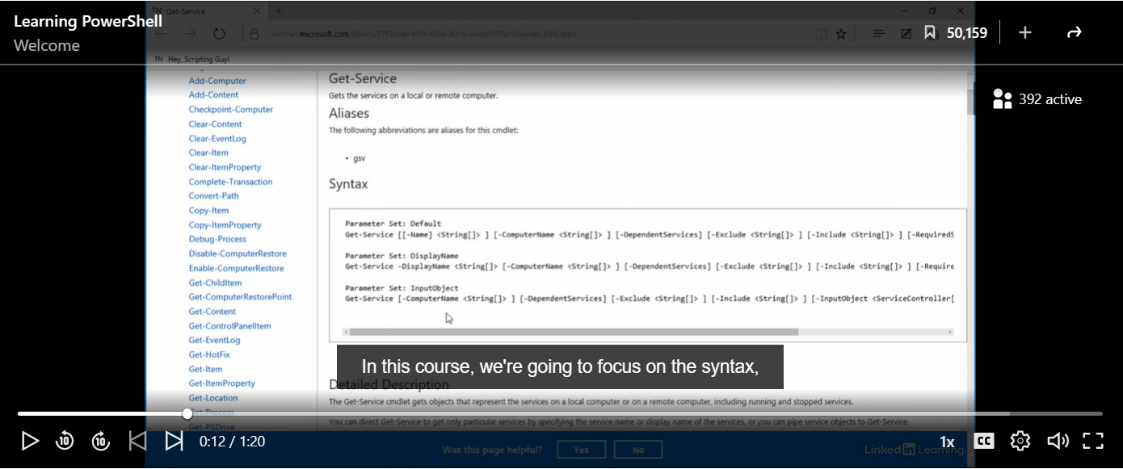
Fig. 78 Learning PowerShell Welcome Screen
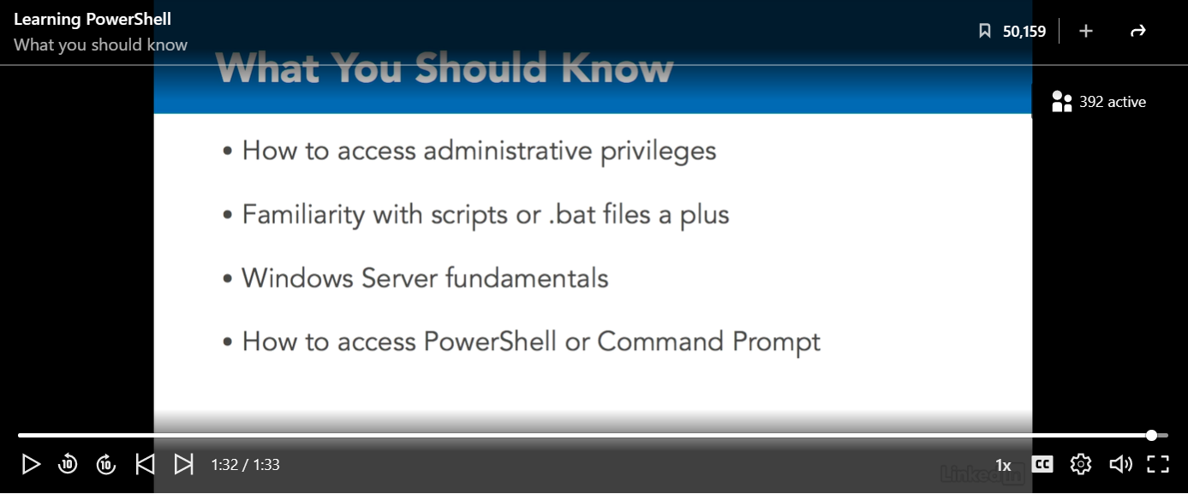
Fig. 79 What Learners Should Know for PowerShell

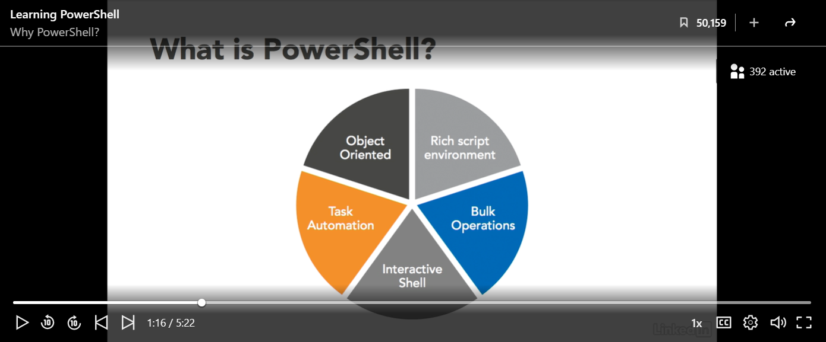
Fig. 80 What is PowerShell?

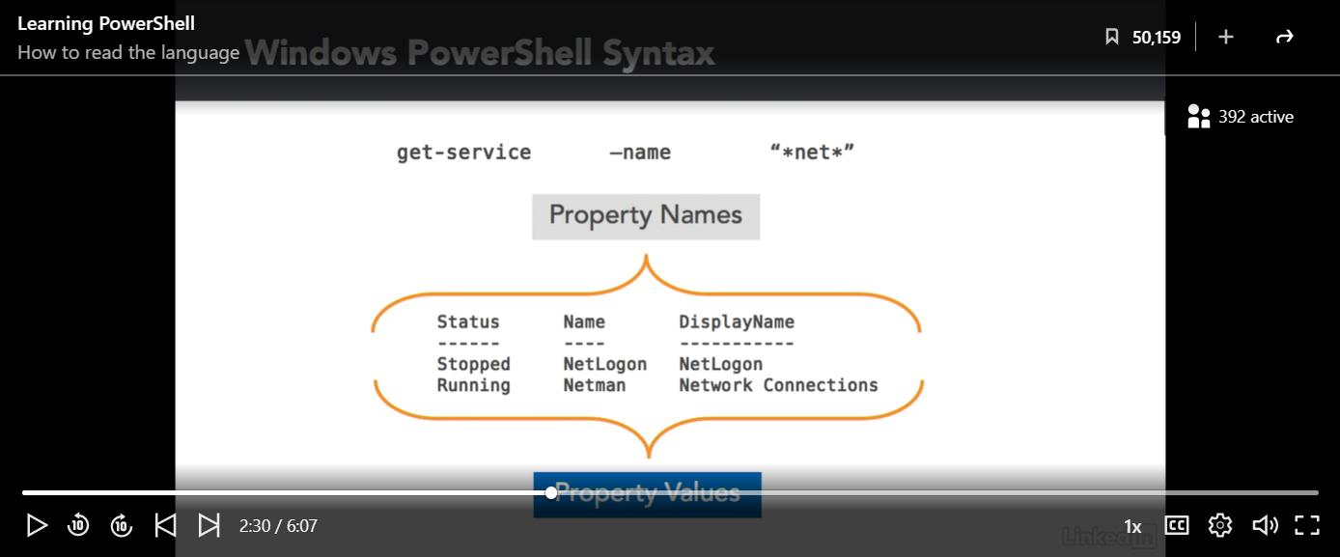
Fig. 81 Reading PowerShell
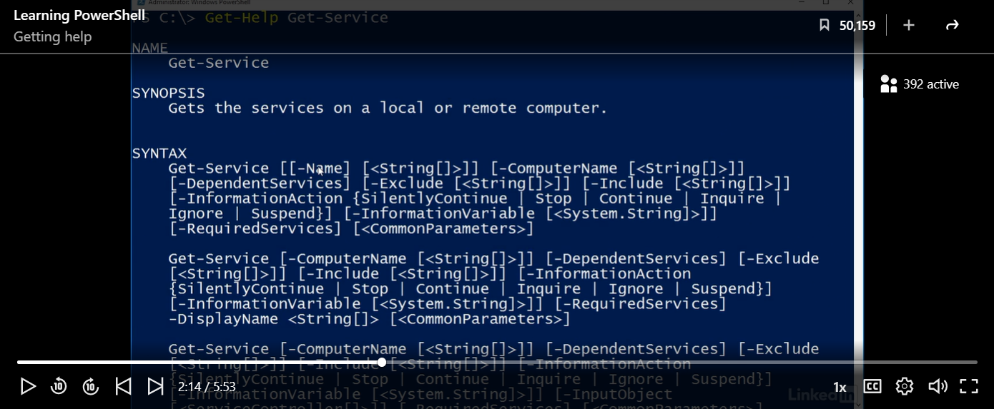
Fig. 82 Getting Help on PowerShell

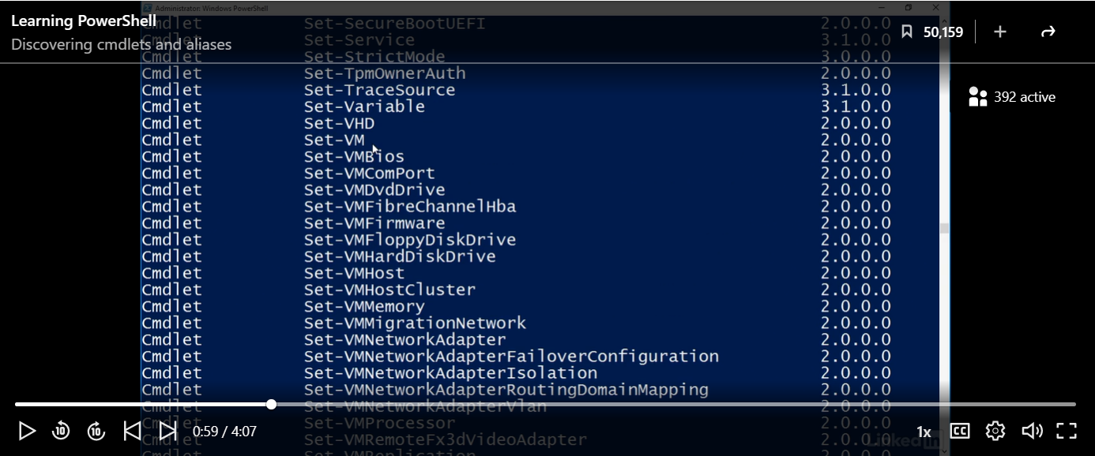
Fig. 83 Discovering Cmdlets and Aliases

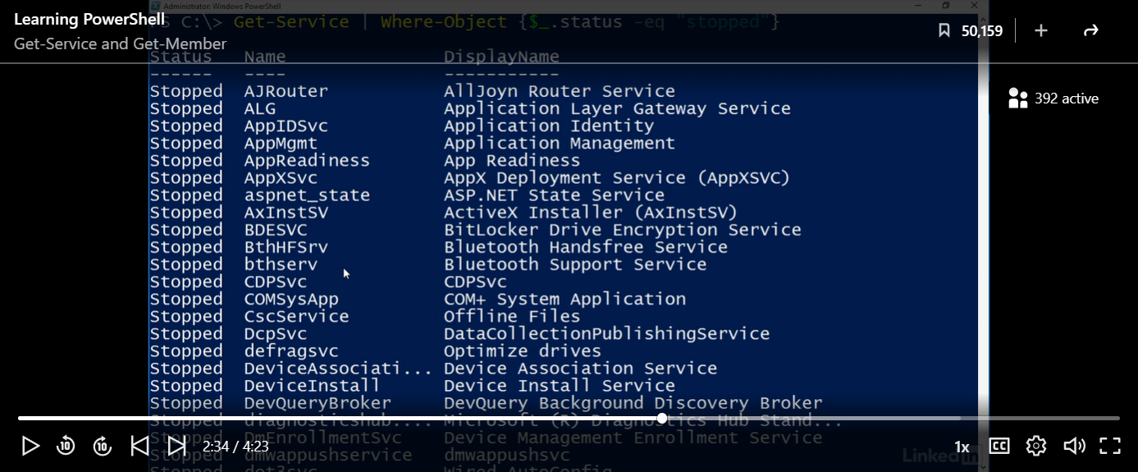
Fig. 84 ‘Get-Service’ and ‘Get-Member’ Commands
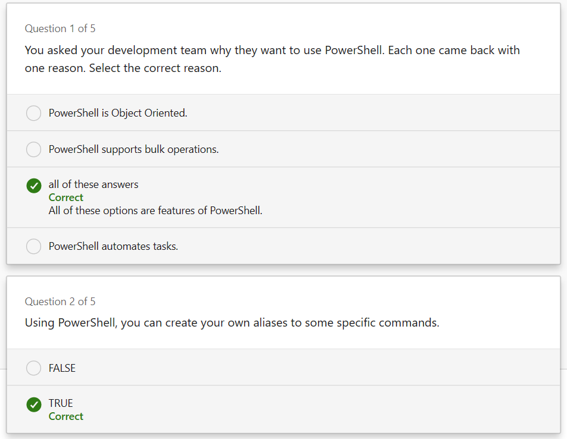
Fig. 85 First Part of Chapter One Quiz

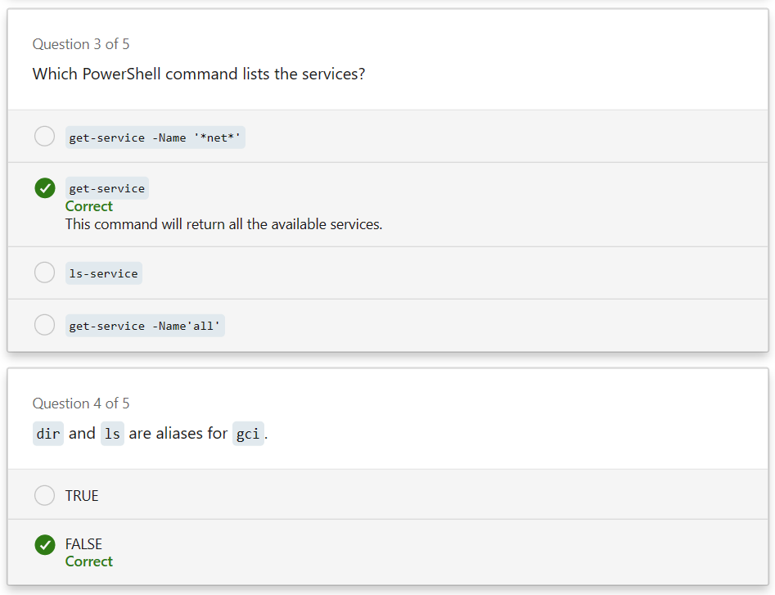
Fig. 86 Second Part of Chapter One Quiz
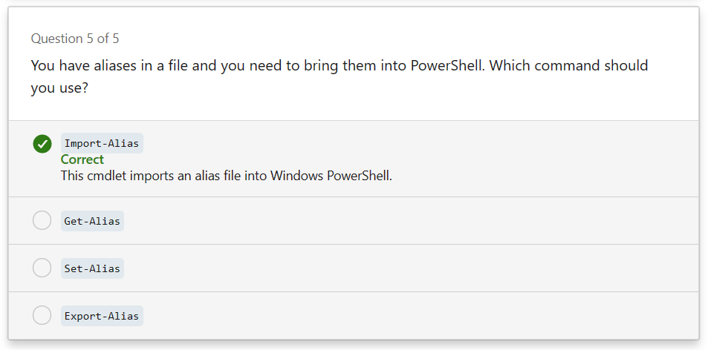
Fig. 87 Final Part of Chapter One Quiz

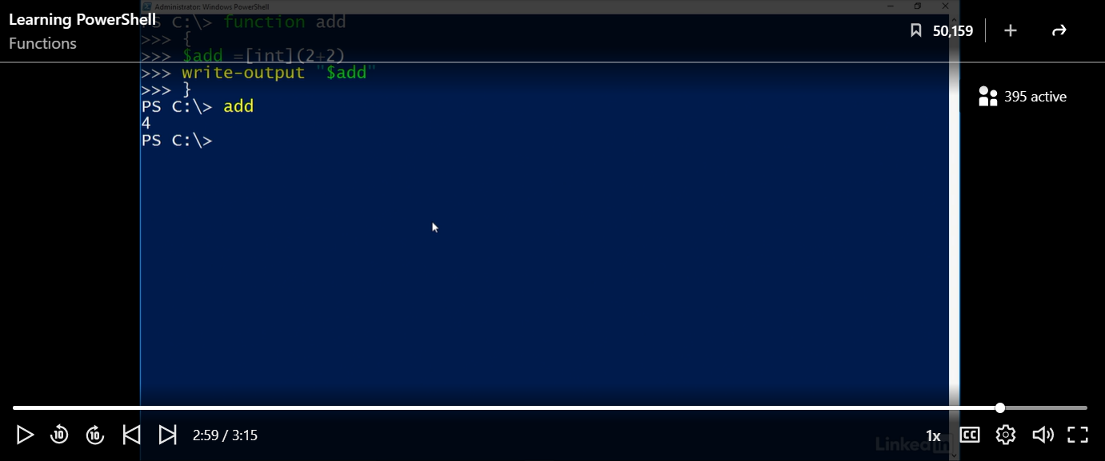
Fig. 88 Learning Functions in PowerShell

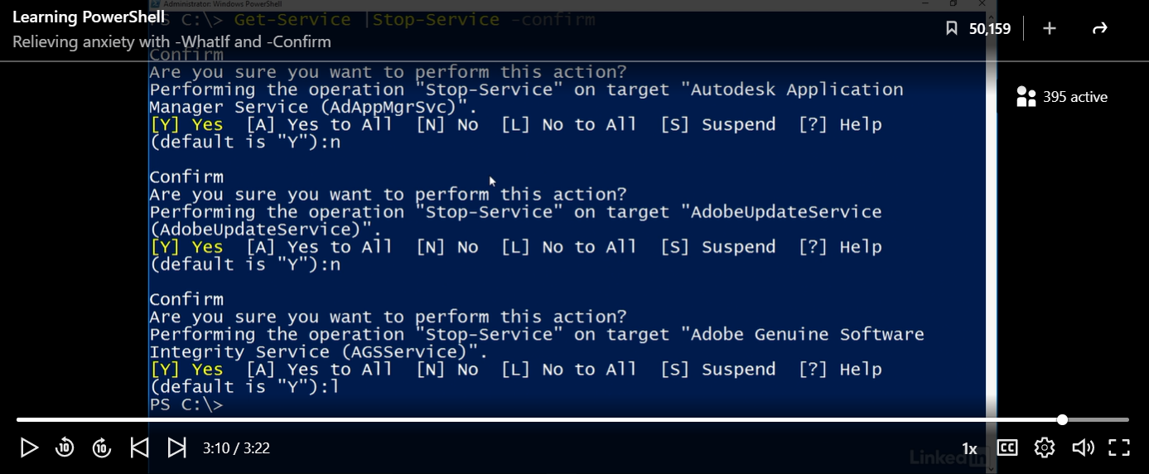
Fig. 89 ‘Whatif’ and ‘Confirm’ Commands
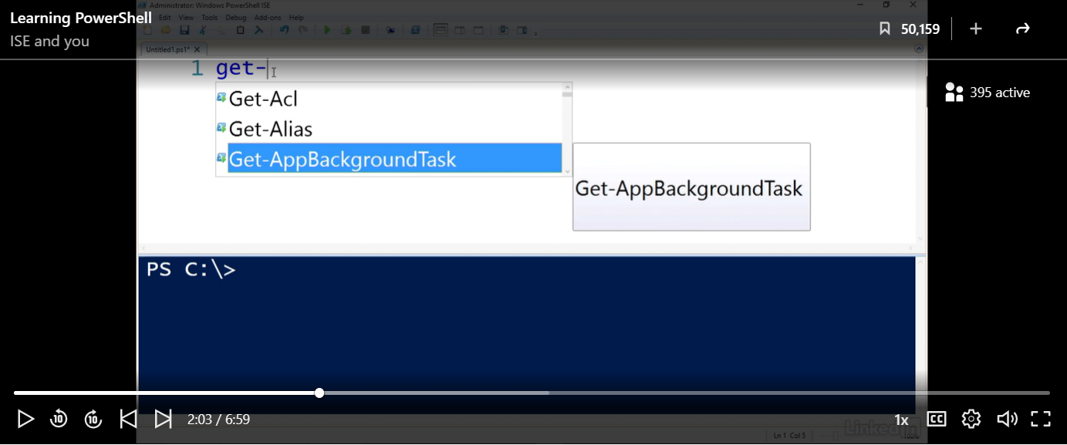
Fig. 90 Integrated Scripting Environment (ISE)

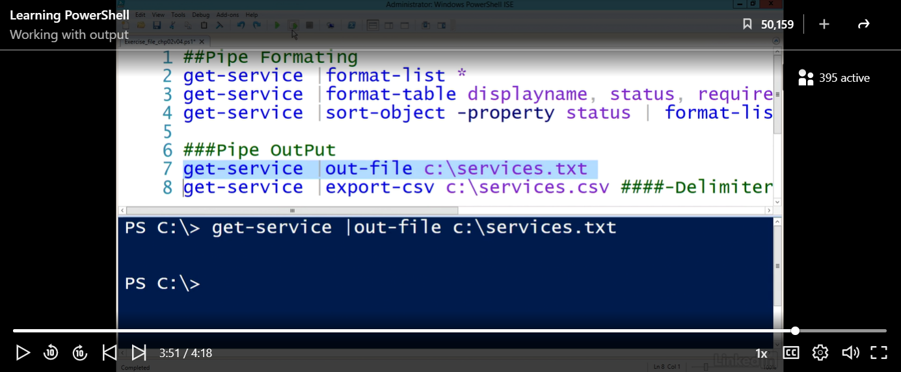
Fig. 91 Working with Outputs

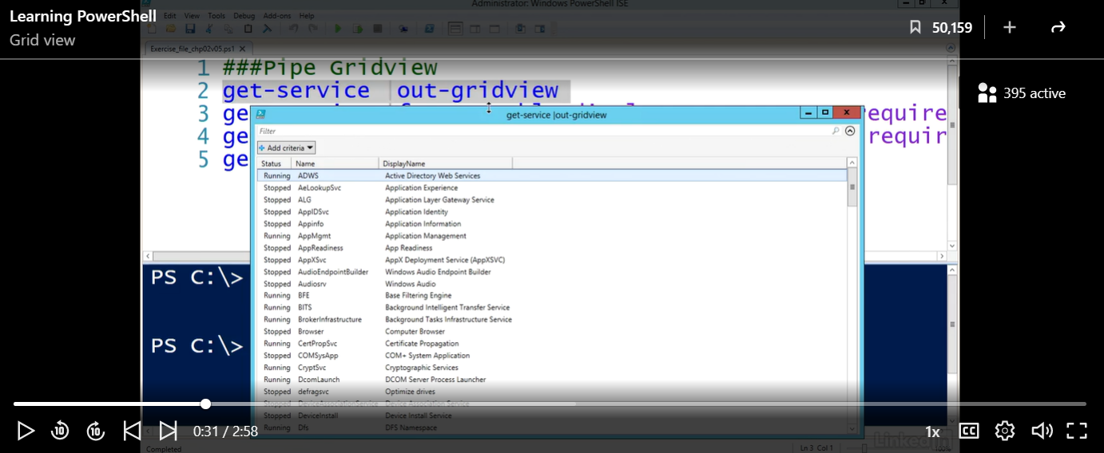
Fig. 92 PowerShell Grid View
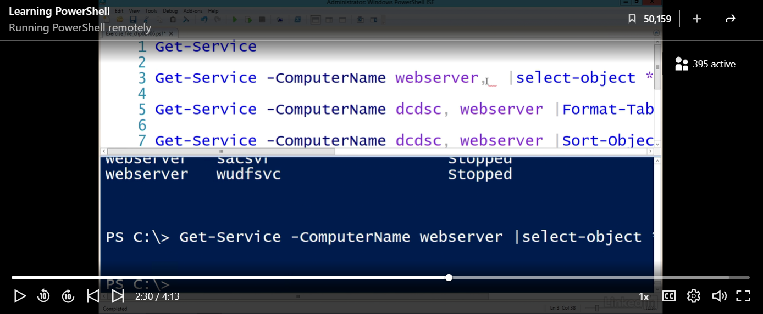
Fig. 93 Running PowerShell Remotely

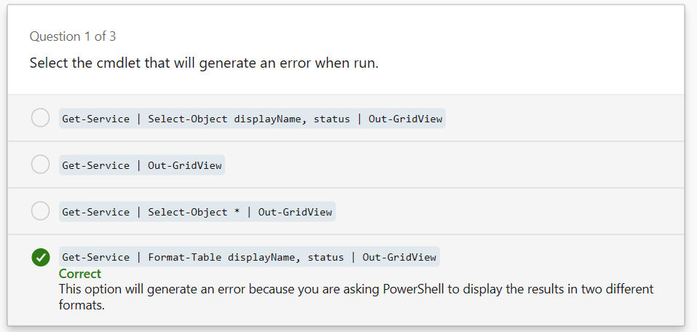
Fig. 94 First Part of Chapter Two Quiz

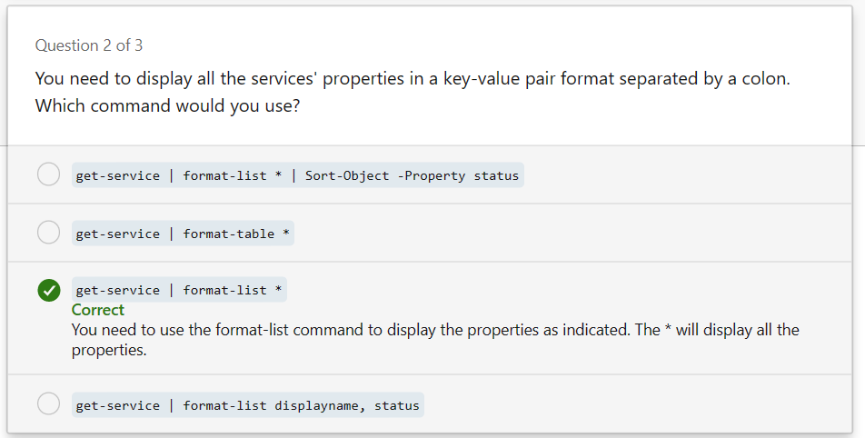
Fig. 95 Second Part of Chapter Two Quiz
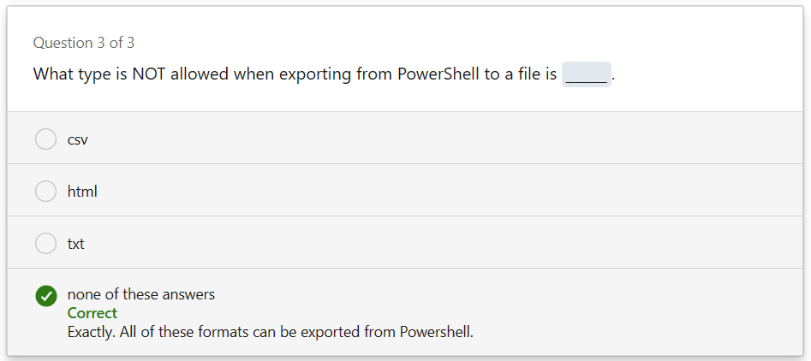
Fig. 96 Final Part of Chapter Two Quiz

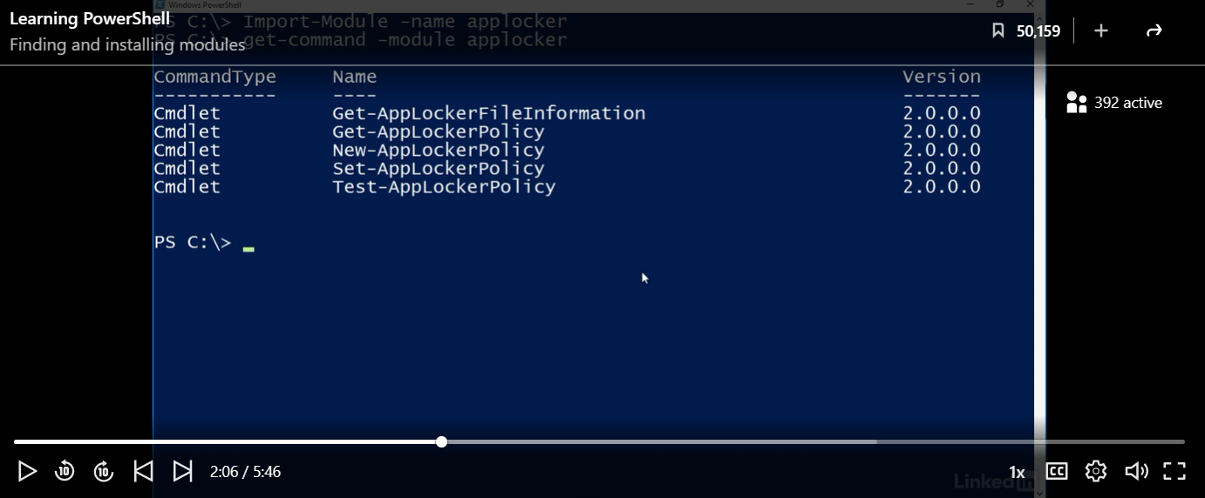
Fig. 97 Finding and Installing Modules

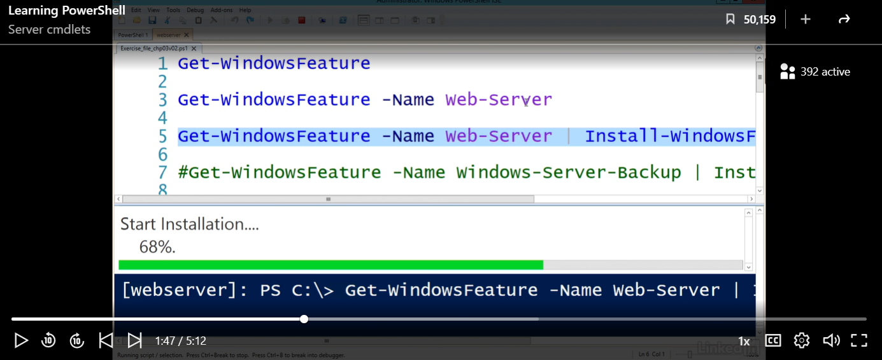
Fig. 98 Server Cmdlets
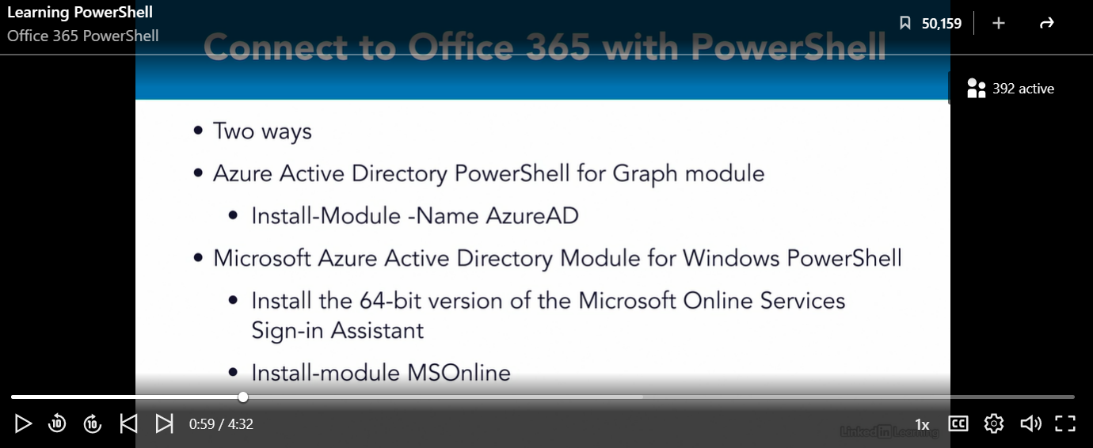
Fig. 99 Connecting to Office 365 with PowerShell

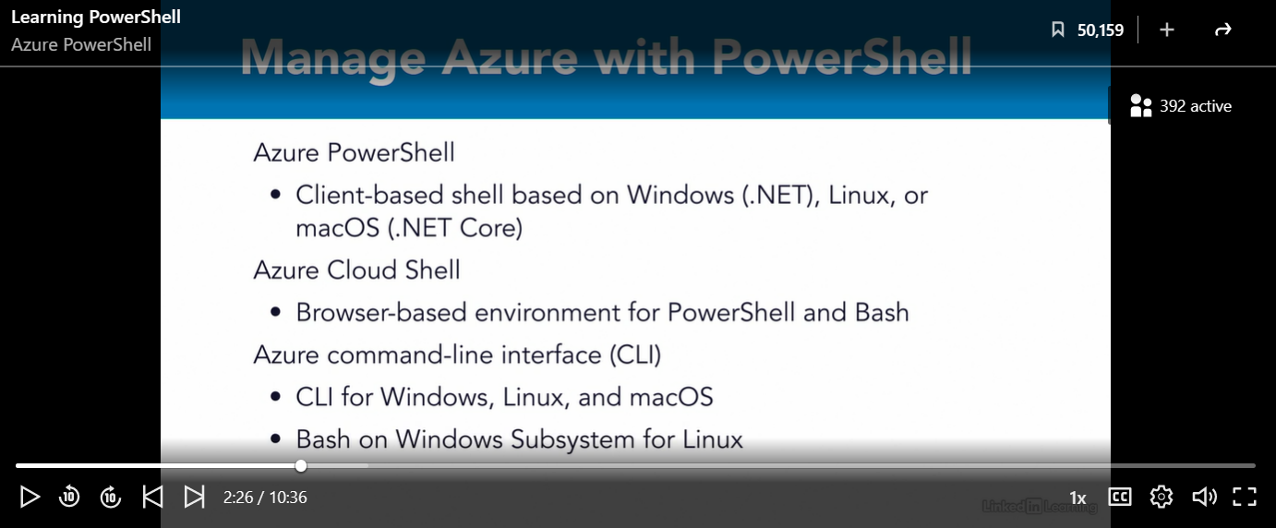
Fig. 100 Managing Azure with PowerShell

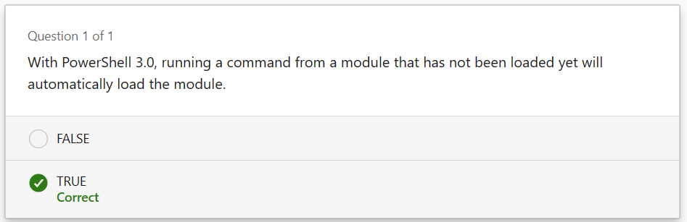
Fig. 101 Chapter Three Quiz

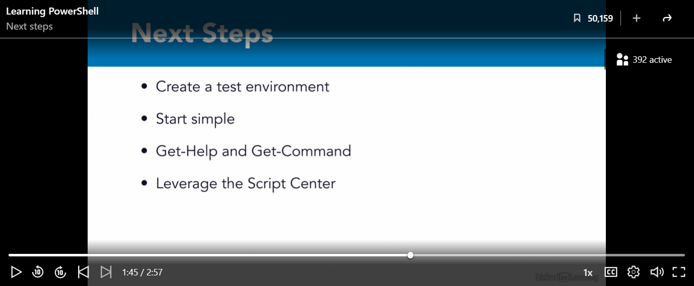
Fig. 102 Learning PowerShell Conclusion

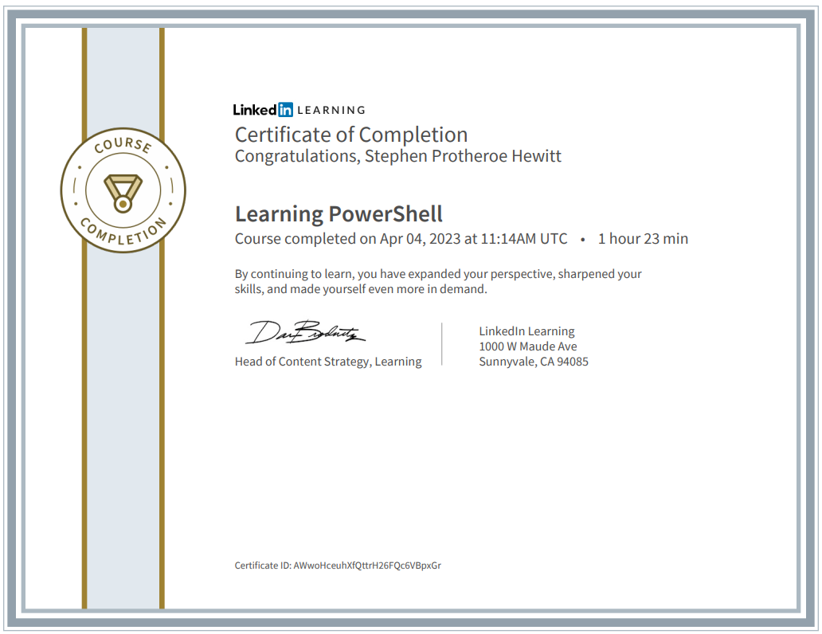
Fig. 103 Learning PowerShell Course Completion

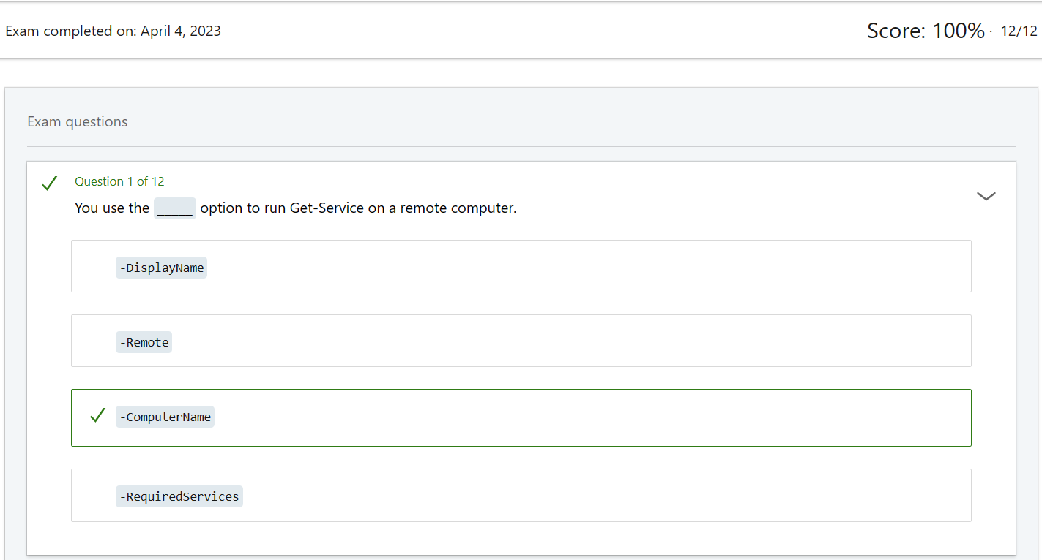
Fig. 104 Exam Answer One

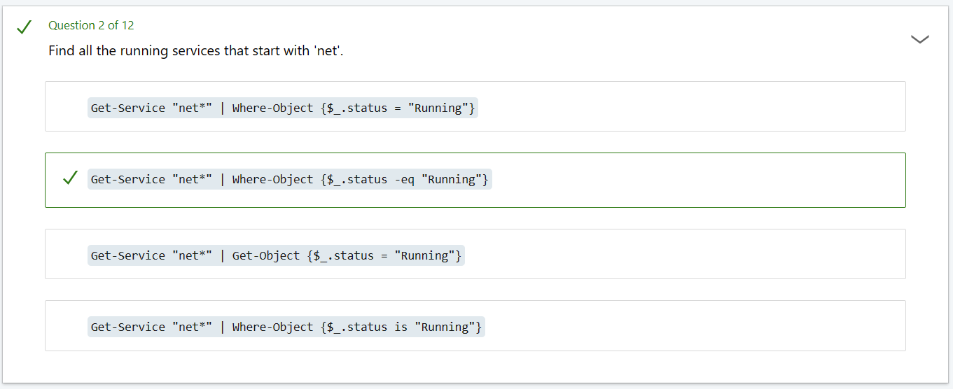
Fig. 105 Exam Answer Two

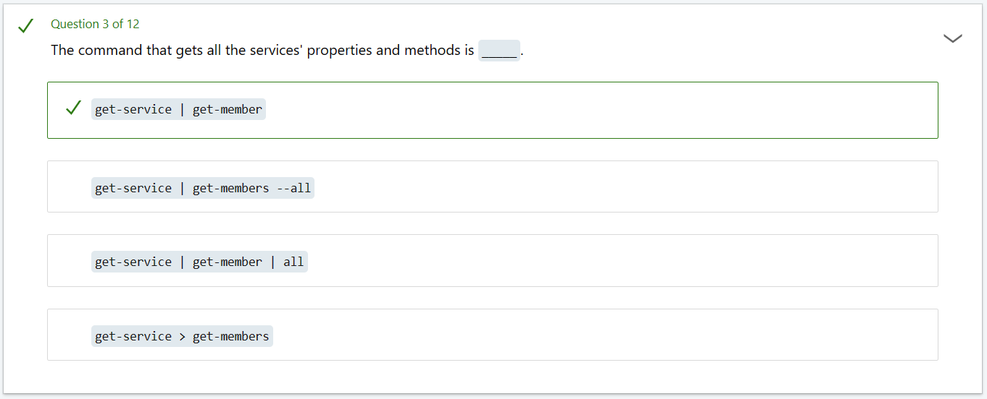
Fig. 106 Exam Answer Three
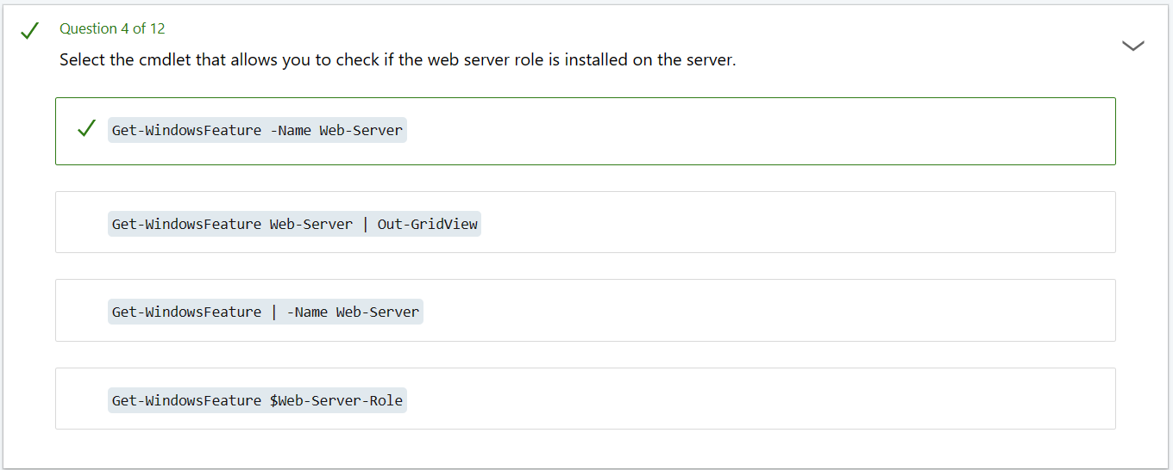
Fig. 107 Exam Answer Four

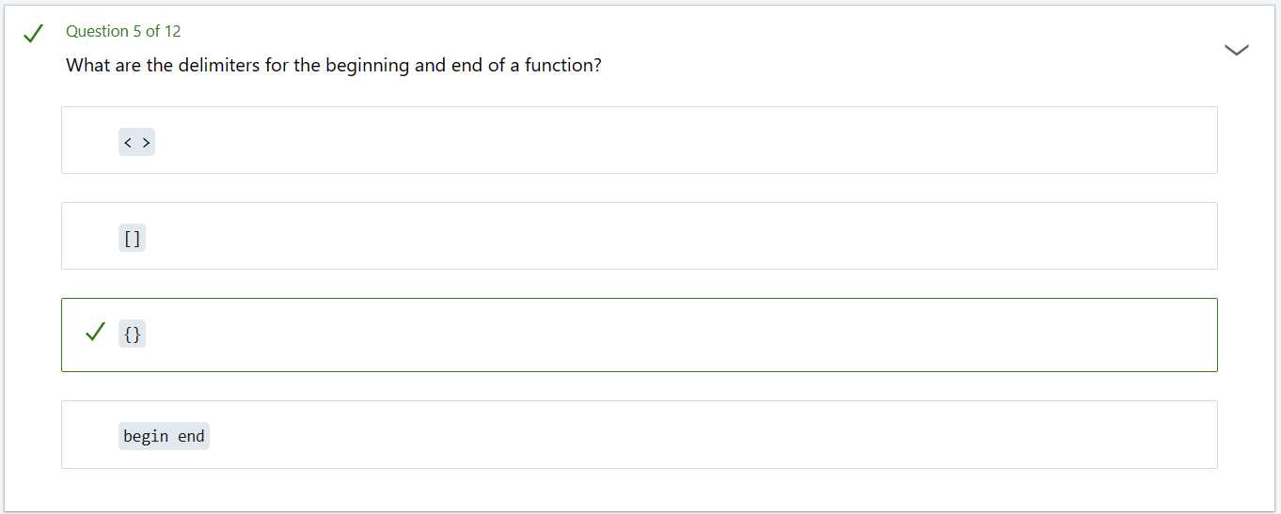
Fig. 108 Exam Answer Five

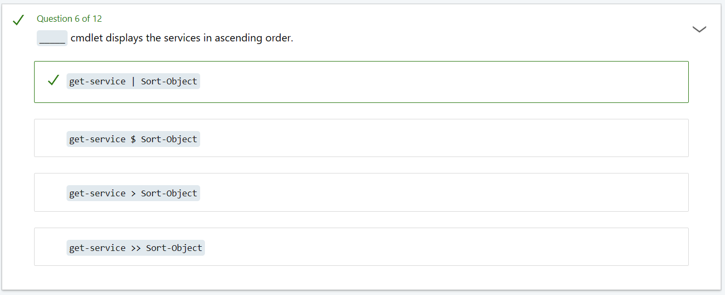
Fig. 109 Exam Answer Six
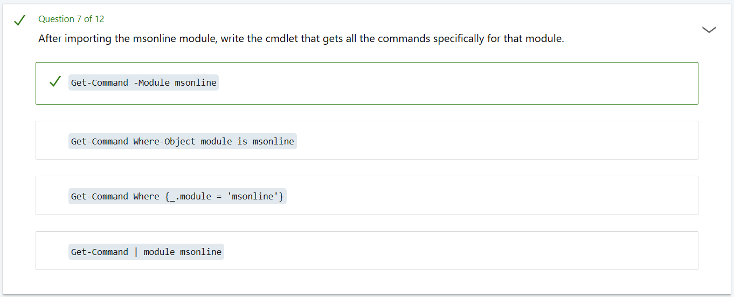
Fig. 110 Exam Answer Seven

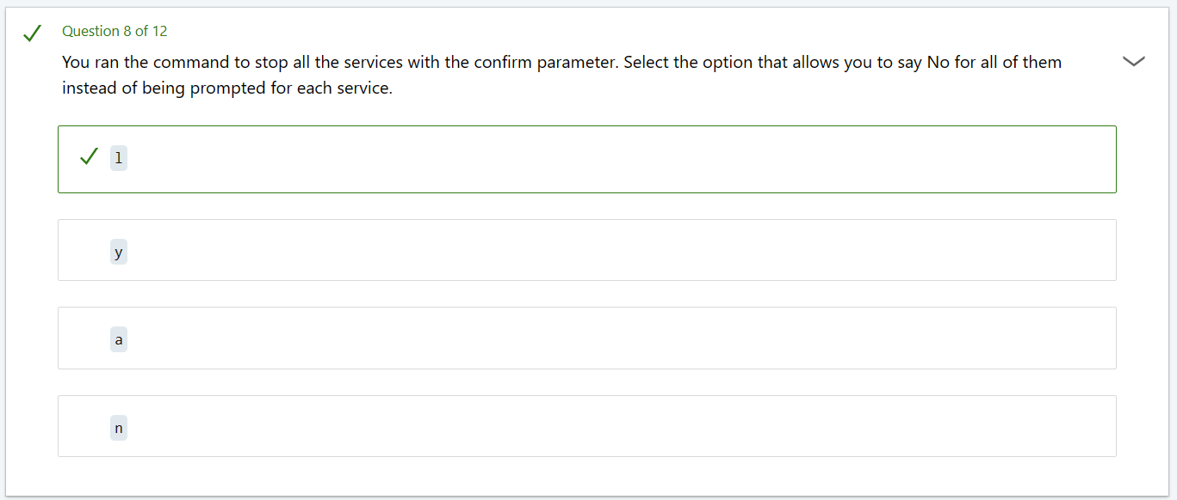
Fig. 111 Exam Answer Eight

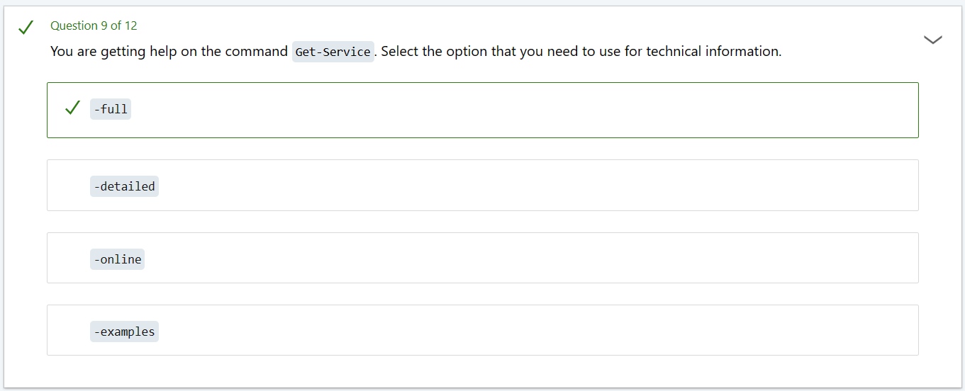
Fig. 112 Exam Answer Nine
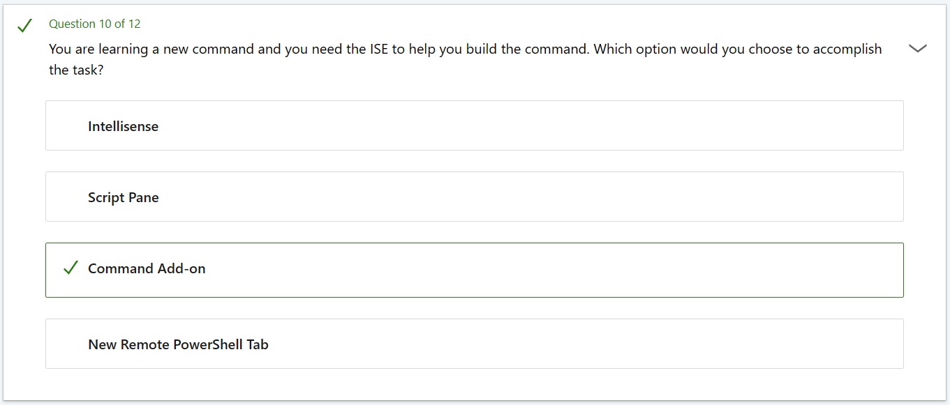
Fig. 113 Exam Answer Ten

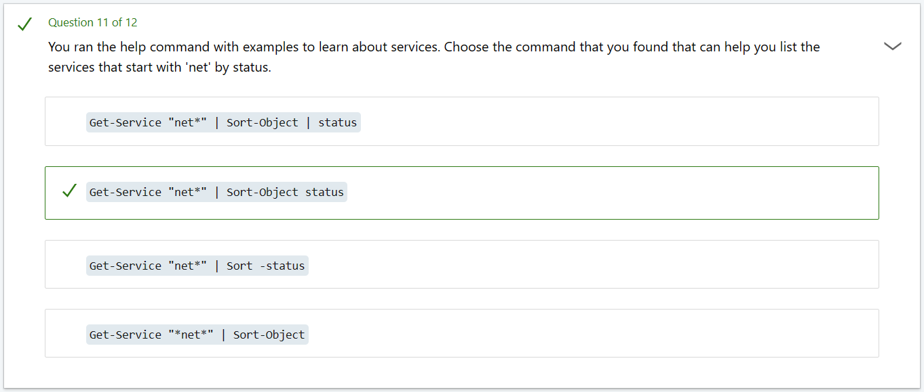
Fig. 114 Exam Answer Eleven

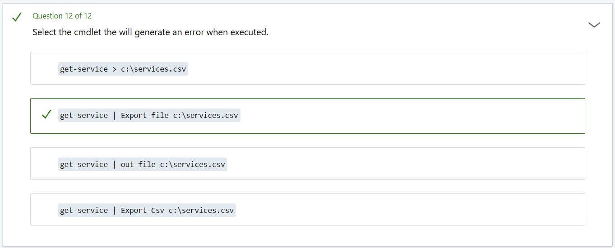
Fig. 115 Exam Answer Eleven
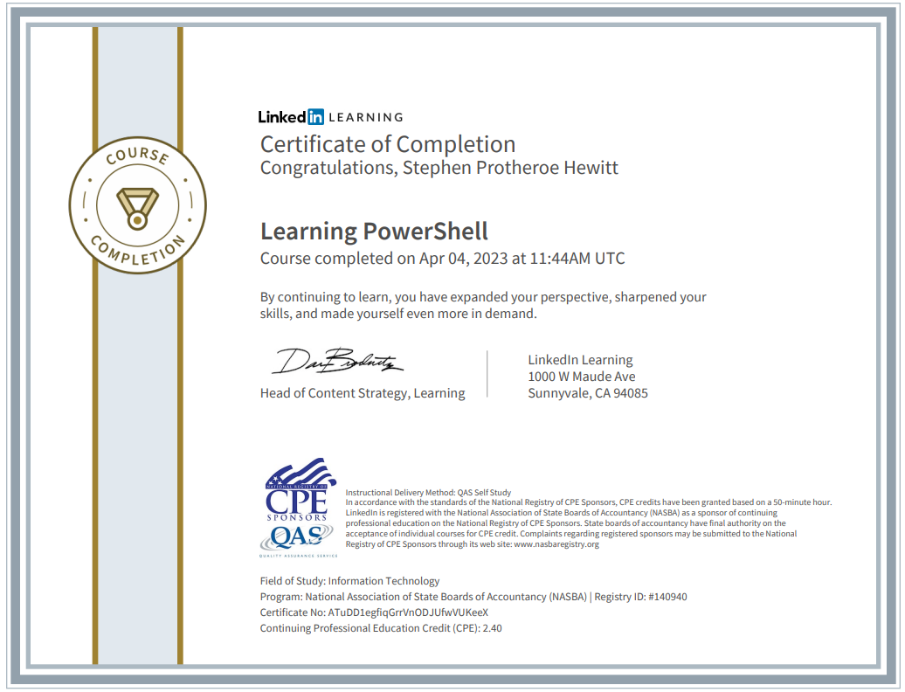
Fig. 116 Learning PowerShell Course Completion with Exam Credits

