UNIVERSITY OF WALES TRINITY SAINT DAVID
LONDON CAMPUS
Assignment 2
Learning in the Digital Era
Module Name: Learning in the Digital Era
Module Code: ACCA 4025

Student Name: Mohamed Fahith Mohamed Najath
Student ID: 2533542
Group: 2

Lecturer’s Name: Mr Koushik Modak
Video Link: https://youtu.be/22rdudIabYs

Table of Contents
Introduction 2
Main Body 2
Conclusion 11
References 12

Introduction
This word report is about a presentation on myself evaluation, my professional development plan and a summary of a topic from unit 4. In this report, all the mentioned above would be discussed further. Also, the word report consists of my further explanation of my strengths and weakness from my self-evaluation.

Main Body
This is going to be about my presentation I have completed for my assignment 2 for my module learning in the digital era.
Video Link: https://youtu.be/22rdudIabYs
Slide 1 COVER PAGE
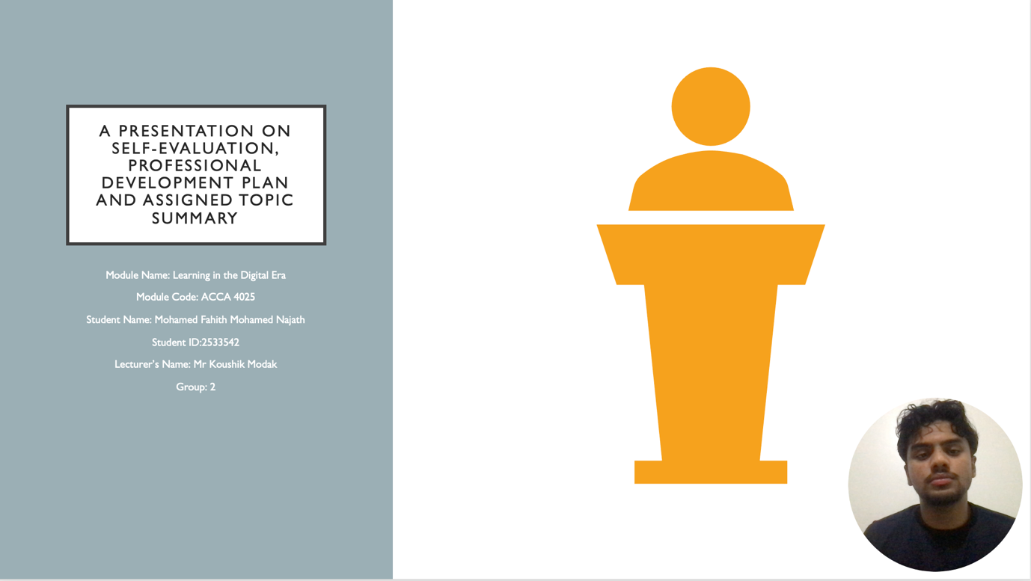

Slide 2 CONTENTS

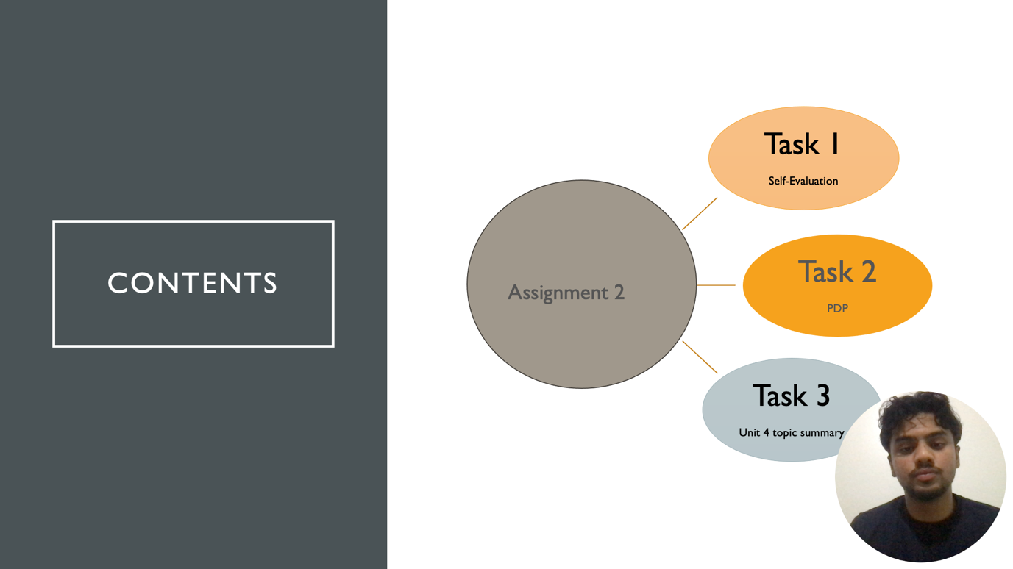
Slide 3 INTRODUCTION
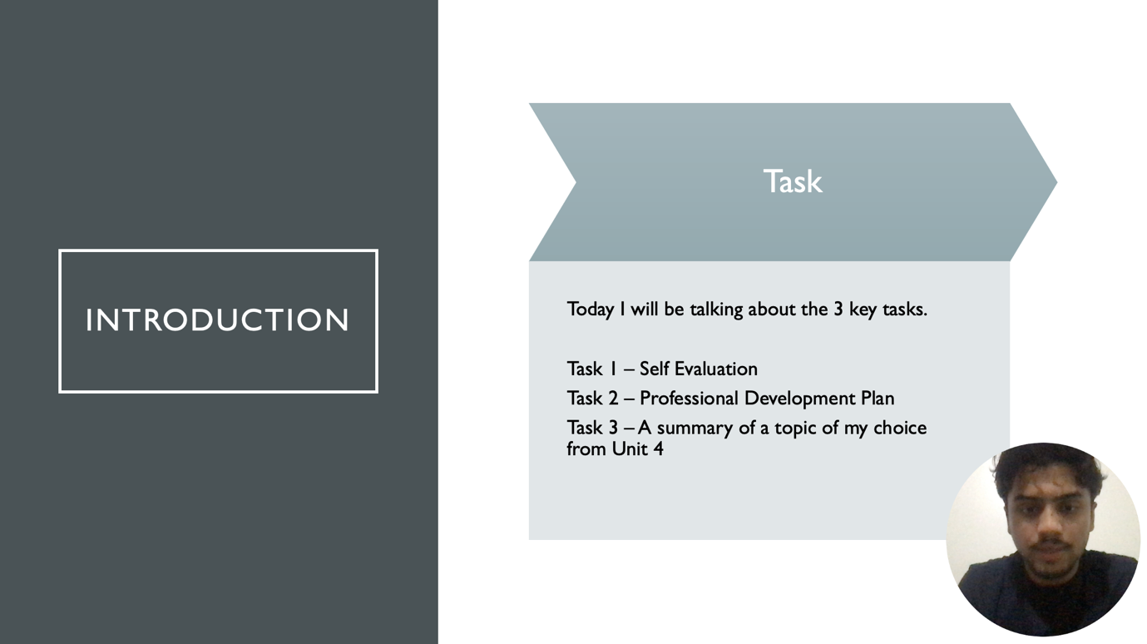

Slide 4 MAIN BODY
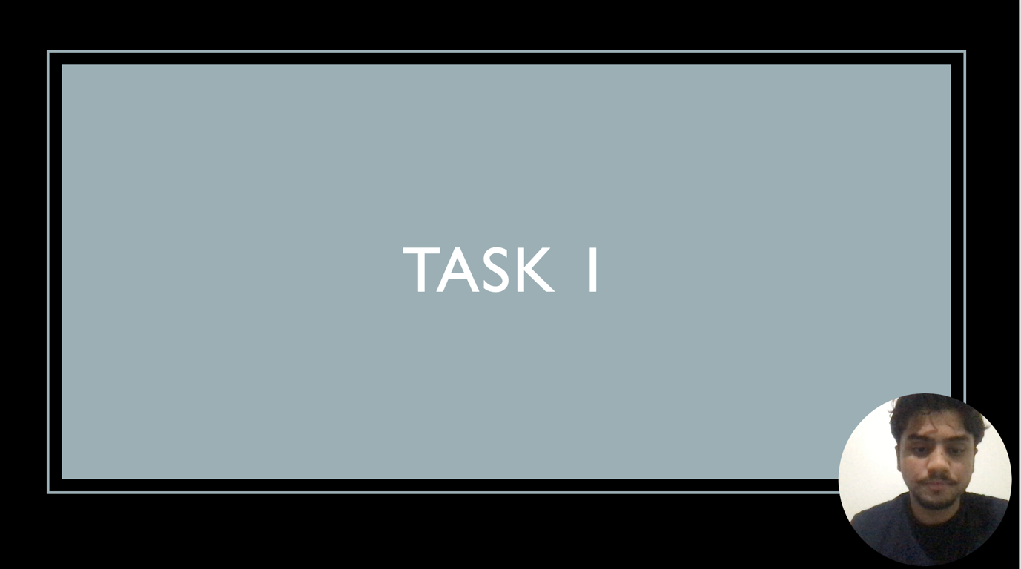

Slide 5 GIBB’s REFLECTIVE MODEL
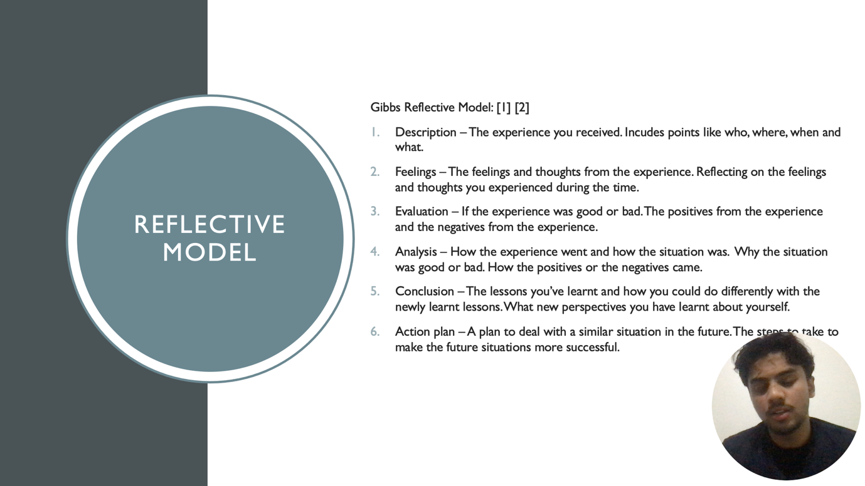
Gibbs reflective model consists of 6 make points. These points help with the how a person can develop and learn from a situation they may have gone through to self-reflect.
First is the description - the experience you received. Incudes points like who, where, when and what.
Second is the feelings – The feelings and thoughts from the experience. Reflecting on the feelings and thoughts you experienced during the time.
Third is evaluation – If the experience was good or bad. The positives from the experience and the negatives from the experience.
Fourth is analysis – How the experience went and how the situation was. Why the situation was good or bad. How the positives or the negatives came.
Fifth is conclusion – The lessons you’ve learnt and how you could do differently with the newly learnt lessons. What new perspectives you have learnt about yourself.
Finally, it is action plan – A plan to deal with a similar situation in the future. The steps to take to make the future situations more successful. [1] [2]
The way I will implement this into my assignment is that I have used this to do my self-evaluation in which I have found my strengths and weakness from pass experiences.

Slide 6 TASK 1: SELF EVALUATION
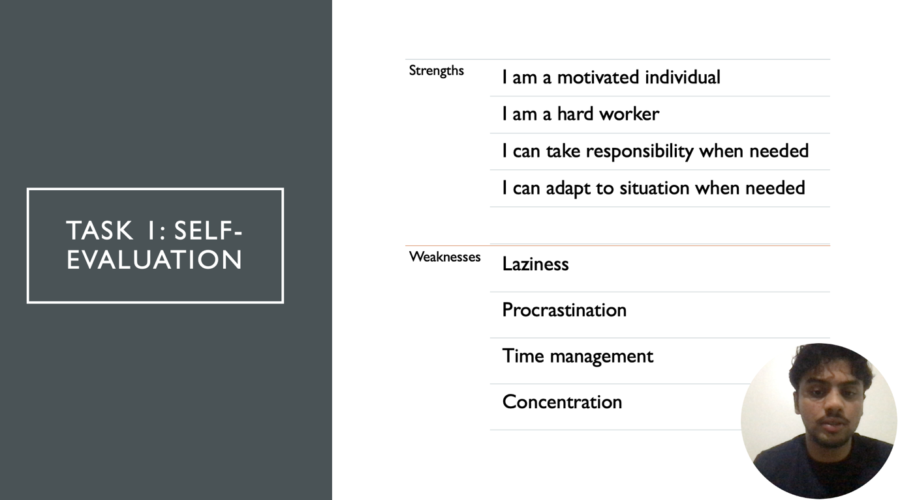
Strength – responsibility: I really believe this is one of my biggest strengths. I believe this because I tend to take responsibility when needed in situation when others would not. I take the responsibility so that if there are any mistakes, I will improve from it and improve my leadership skills with it.
Weakness – Procrastination: This is one of my weakness’ that is struggle with. When I need to get work done, I always tend to procrastinate and get it done in the last minute. This sometimes have affected me and sometimes I have not. For example, when I do work in the last minute, it tends to get rushed and the work is not up to the standard.

Slide 7 TRAITS GAINED FROM THE SELF EVALUATION
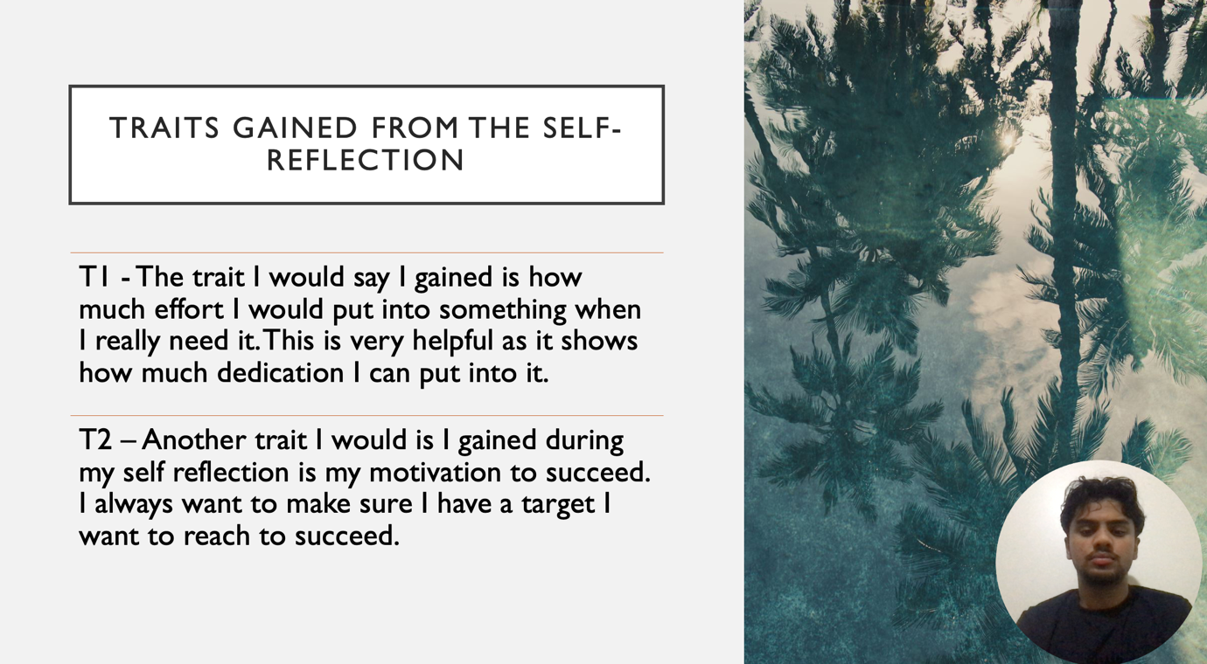
I believe I have some traits. But I believe these 2 traits are very big for me. One of my traits is the amount of effort I put into something when I want to succeed. The dedication I put shows me how much I effort I can put into something when I really need it. Another one is motivation to succeed. Similar to effort, I always want to make sure I put the correct effort to make sure I hit the target I have set.

Slide 8 PROFESSIONAL DEVELOPMENT PLAN
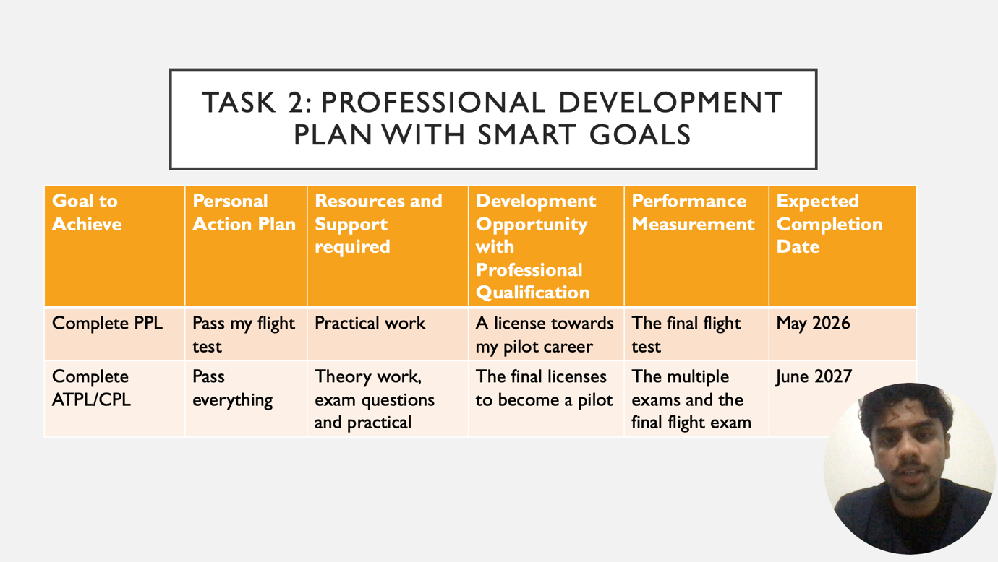
This is my professional development plan for a set target I have made. This table shows what I need, when I need to get it done by, the resources I should be using and measurements I have implemented to see my performance.

Slide 9 UNIT 4 TOPIC SUMMARY
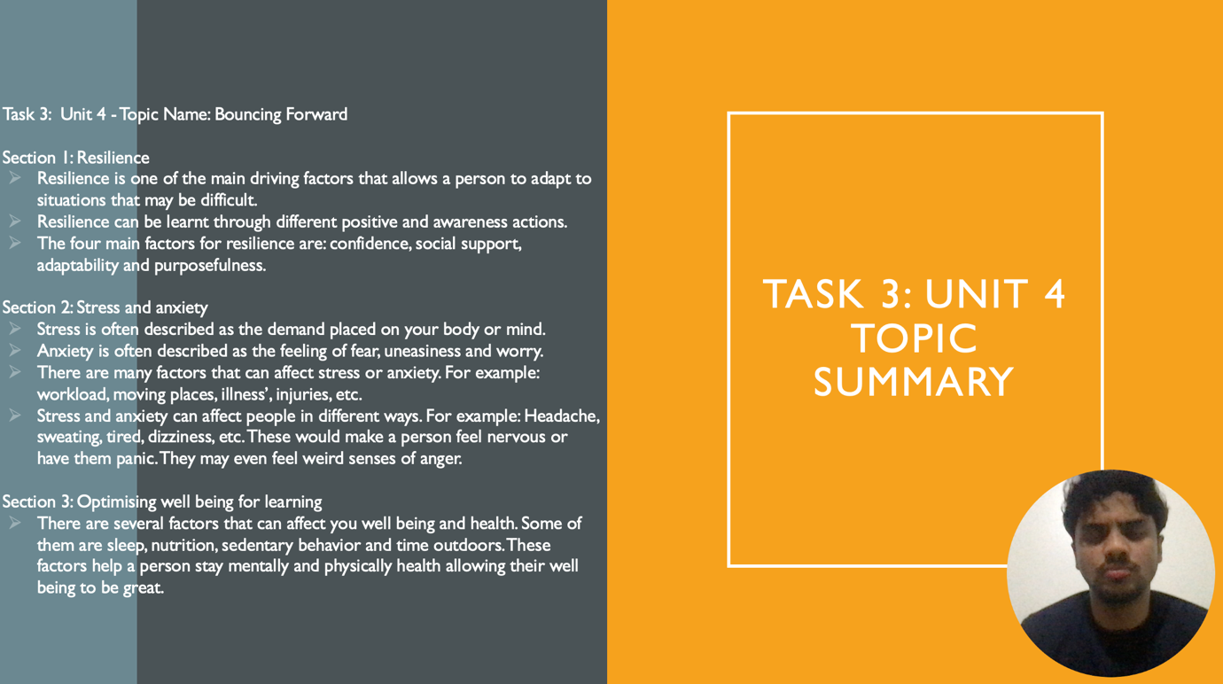
Unit 4 topic - Bouncing forward
From the topic bouncing forward, there are 3 main topics that can be discussed about.
Section 1: Resilience
Resilience is one of the main driving factors that allows a person to adapt to situations that may be difficult. This means that the determination that you put into those difficult situations would allow you to improve you as person and what you are doing. Resilience can be learnt through different positive and awareness actions. The four main factors for resilience are: confidence, social support, adaptability and purposefulness. These factors help you stay resilient and also improve your resilience. [3]
Section 2: Stress and anxiety
Stress is often described as the demand placed on your body or mind. Anxiety is often described as the feeling of fear, uneasiness and worry. There are many factors that can affect stress or anxiety. For example: workload, moving places, illness’, injuries, etc. Stress and anxiety can affect people in different ways. For example: Headache, sweating, tired, dizziness, etc. These would make a person feel nervous or have them panic. They may even feel weird senses of anger. [4]
Section 3: Optimising well-being for learning
There are several factors that can affect your well-being and health. Some of them are sleep, nutrition, sedentary behavior and time outdoors. These factors help a person stay mentally and physically health allowing their well-being to be great.

Slide 10 CONCLUSION

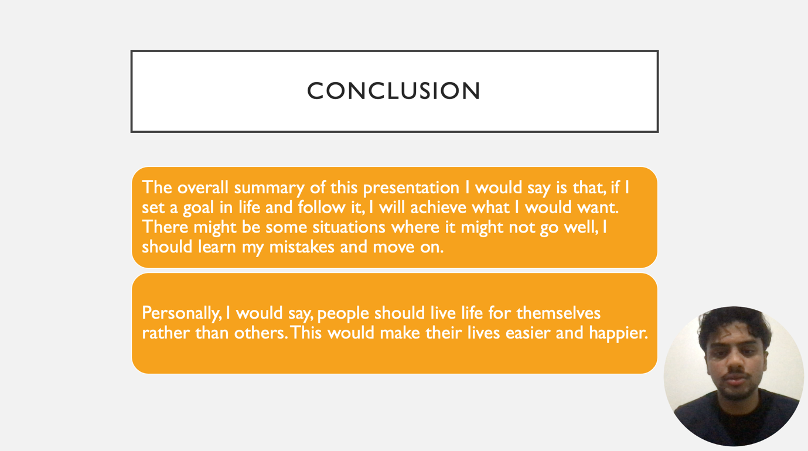

From my presentation, I can say that is a goal in life is something very important. By setting a goal, it allows a person to be motivated and determined to follow the path they have chosen to achieve the target they have picked. From the unit 4 topic, I have learnt that stress and anxiety is something that can play with someone’s life. This is something that made me think and come to a conclusion that people should live their lives for themselves rather than others as it would reduce the anxiety and stress that they receive. It would make them live easier and happier.

Slide 11
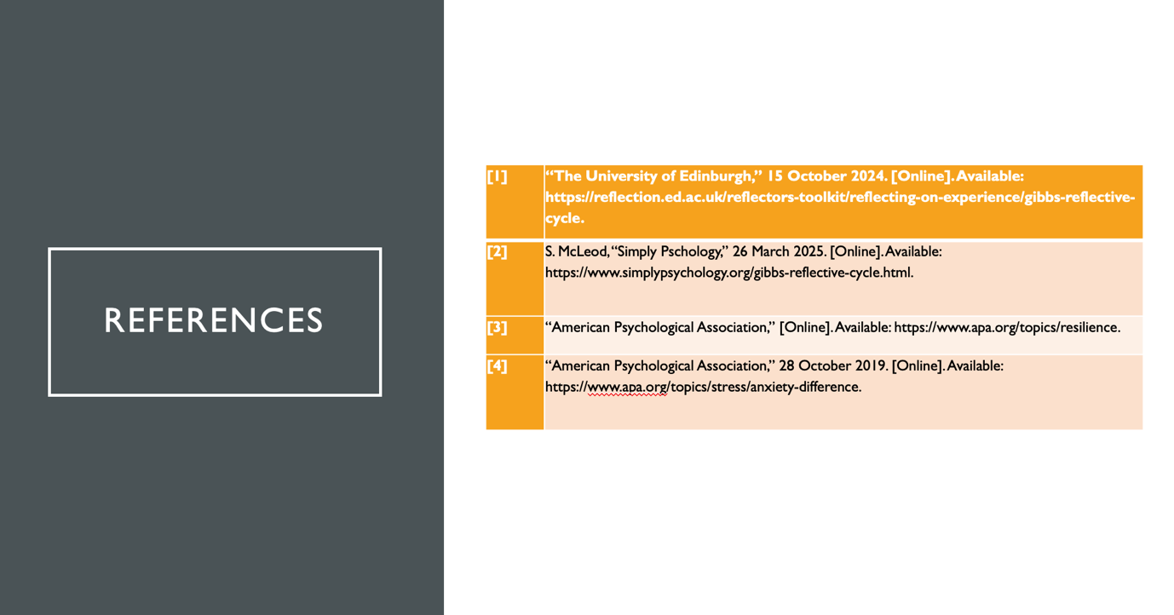

Conclusion
From this report, I have talked about the different factors that are within the self-evaluation process. The presentation I have made talks about all the key information about self-evaluation, the professional development plan and the topic of my choice from unit 4. These together help shape the view I have on myself regarding my own evaluation and the targets and goals I have set for myself to achieve.

References

[1] | “The University of Edinburgh,” 15 October 2024. [Online]. Available: https://reflection.ed.ac.uk/reflectors-toolkit/reflecting-on-experience/gibbs-reflective-cycle.
[2] | S. McLeod, “Simply Pschology,” 26 March 2025. [Online]. Available: https://www.simplypsychology.org/gibbs-reflective-cycle.html.
[3] | “American Psychological Association,” [Online]. Available: https://www.apa.org/topics/resilience.
[4] | “American Psychological Association,” 28 October 2019. [Online]. Available: https://www.apa.org/topics/stress/anxiety-difference.

