Isaac Francisco Feliz Vargas (2438248)
2438248@student.uwtsd.ac.uk
Abstract
MODULE CODE: ACCA4023
aSSESSMENT 1
Introduction to Web and Database Concepts

Table of Contents
Task 1: Scenario Analysis 3
Task 2: Entity-Relationship Diagram (ERD) 4
Task 3: Data Structure Development 6
Task 4: Normalisation Compliance 7
1NF: All attributes must be atomic (no repeated values) 7
2NF: To be in 1NF and have all attributes fully dependent on the primary key 7
3NF: To be in 2NF and to have no transitive dependencies 7
Task 5: Sample Data Population 8
Riders table 8
Station Table 9
Rental Table 9
Staff table 10
Maintenance table 10
TASK 6: Query Development 10
“Rider rent history” query 10
“Under maintenance query” 11
“Cost per hour” query 12

Introduction
The core objective of this undertaking revolves around crafting, deploying, and assessing a relational database geared towards the administration of a bicycle rental setup, with Microsoft Access at the helm as the developmental stage. This project sets out to showcase Access's flair at modelling tricky data structures, it links different components, imposes data reliability rules, plus runs query's getting insightful info to help people make the right call.
The database design itself follows normalisation guidelines up to the third normal form (3NF), which prevents repetition and guarantees data's match. The model's main players consist of important entities, namely "Riders" (customers), "Bikes," "Rentals," "Stations," "Maintenance," along with "Staff. " Every entity gets attributes and connections; all of this is carefully explained in an entity-relationship diagram (ERD).
Besides the logic, a bunch of practical questions have also been built to demonstrate how everything works when you put it into real life. It can pinpoint the bikes needing care, add the amount of time that bikes were rented, and even the amount it will cost the person who rode it. Questions have been built using graphic tools, plus SQL, all displayed together, along with the answers that came from them, and some pictures too.
This project shows two key things: Firstly, it proves a solid handle on Access as a data manager, secondly, using theoretical database ideas in a real-world, working and growable situation. Eco-Ride, this example, exhibits how a well-built database can boost how things work, make users happier and let administrators handle a green travel service better.

Task 1: Scenario Analysis
Eco-Ride is an electric bicycle rental system geared towards sustainable urban mobility. The system must allow for user registration, bicycle management (including type, condition, location, and maintenance), recording of rental transactions (dates, duration, cost), and tracking of staff participation in inspections and maintenance. The goal is to create a robust relational database in Microsoft Access that supports daily operations, facilitates querying and reporting of key information, and ensures data integrity.
Entities | Attributes
Riders | Rider name  Rider contact information  Rider id
Bikes | Type  Condition  Location  Maintenance History
Rider Station | Location
Maintenance | (no attributes)
Rental transactions | Rental Date  Return Date  Duration  Cost
Staff | Name  Roll

Riders: It represents customers who rent bicycles. Personal and contact information is stored, as well as a unique identifier.
Bike: Each bicycle has a unique identifier, type (urban, mountain, folding, etc.), status (available, in use, under maintenance), current location, and observations.
Rent: It records each rental transaction, associating the user and bicycle, start and end dates, duration and cost.
Staff: Include the employees responsible for inspections and maintenance, with their contact details and position.
Maintenance: It allows you to record each maintenance or inspection intervention, associating the bicycle, the responsible personnel, the date and the type of service performed.
Rider Station: It represents the physical points where the bicycles are located, with location and capacity information.

Task 2: Entity-Relationship Diagram (ERD)
The Entity-Relationship Diagram (ERD) is fundamental for visualising the logical structure of the database and the relationships between entities.
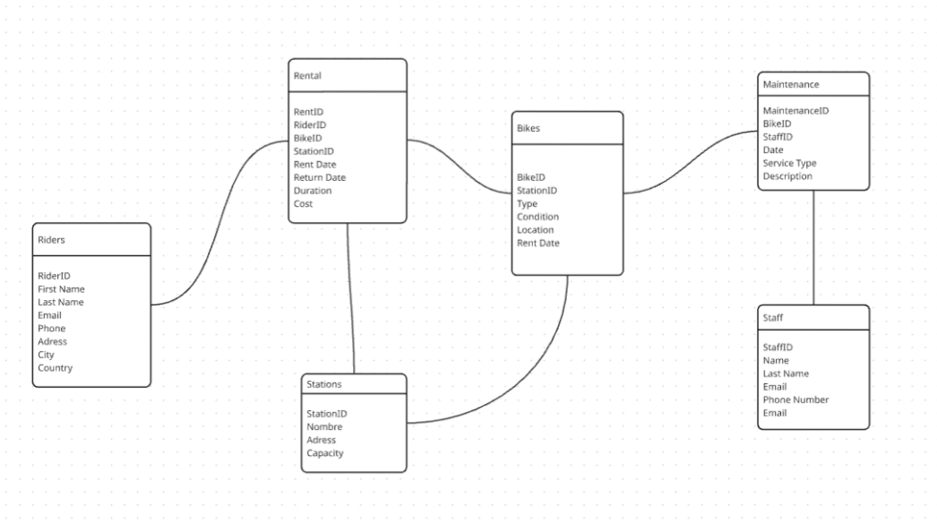

Here are the relationships of each table without their cardinality for the purpose of having an initial and simplified view of the system. This serves as a starting point to evaluate whether the proposed tables accurately reflect the requirements of the case.
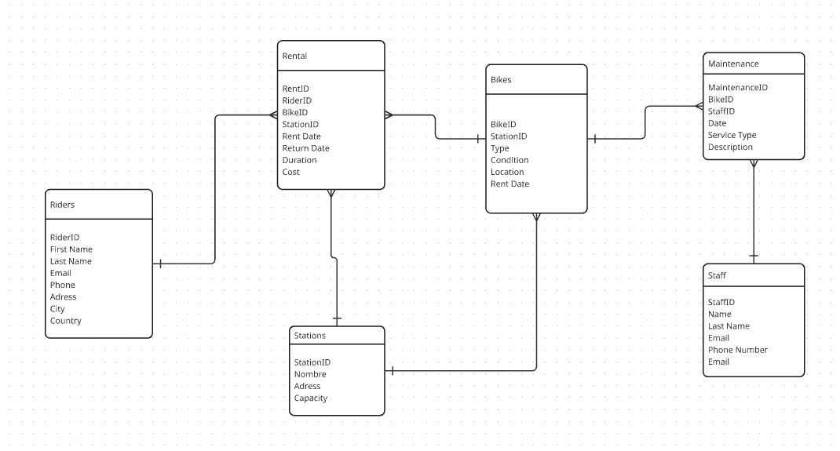

In this second representation, we have the relationships between tables with their cardinality specified. The objective with this is to show how the entities interact between themselves and ensure logical consistency of the model.

Task 3: Data Structure Development
Entity Definitions:
ENTITY | PRIMARY KEY | FOREIGN KEYS | ATRIBUTES
Riders | RiderID | NONE | FirstName LastName  Email  Phone  Address  City  Country
Bikes | BikeID | StationID | Type,  Condition, Location, RentDate
Station | StationID | NONE | Name  Address  Capacity
Rental | RentalID | RiderID  BikeID  StationID | RentDate  ReturnDate Duration  Cost
Maintenance | MaintenanceID | BikeID  StaffID | Date  ServiceType Description
Staff | StaffID | NONE | Name  LastName  Email PhoneNumber

Relationships:
RELATIONSHIP | TYPE
Riders-Rental | 1 to Many
Bikes-Rental | 1 to Many
Stations-Bikes | 1 to Many
Stations-Rental | 1 to Many
Bikes-Maintenance | 1 to Many

Task 4: Normalisation Compliance

1NF: All attributes must be atomic (no repeated values)
Riders: each field is indivisible (FirstName, LastName, Email, etc.).
Bikes: characteristics like Type, Condition, and Location are crucial.
Rentals: Dates and Costs are determined by registration.
The Staff and Maintenance are complete.

2NF: To be in 1NF and have all attributes fully dependent on the primary key
Riders: RiderID is the basis for all attributes.
Bikes are dependent on their BikeID.
Rentals: all depend on RentID (primary key).
Maintenance: all rely on MaintenanceID.
Employees: all rely on the StaffID.

3NF: To be in 2NF and to have no transitive dependencies
Riders: RiderID determines City and Country; no other attribute is accurate.
Bicycles: Location, Type, and Condition depend on the right BikeID.
Rentals: RentID determines the duration and cost.
Stations: Capacity depends on StationID
Maintenance: ServiceType and Description depend on MaintenanceID
Staff: All depend on StaffID

Task 5: Sample Data Population

Riders table
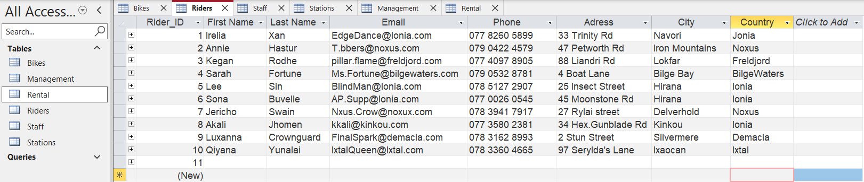
This is the table of the consumers who register for our service, referred to as riders. When registering to use our service, they are required to enter some of their information, such as name, surname, email, phone number, etc., in case of any unknown circumstances. The primary key of this table is the RiderID, which is auto-numbered and stored in our database once customers register for our service.
Bikes Table
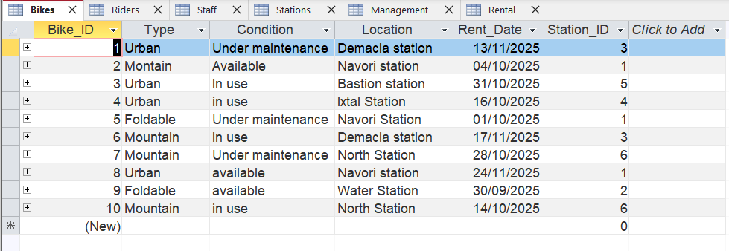
This is the table where our bicycles are registered. We have three types of bicycles:
- Urban: perfect for roads in large cities where you need to cover a long distance in a short time
- Mountain: for those who live in rugged and steep terrain
- Foldable: ideal if you want to use it for short trips.
As with the previous table, the primary key is its registration number, BikeID. They are associated with all the stations we have around the country, which are identified in the table as LOCATION, so we can see which station it was last used at.
Finally, we also have a record of when it was rented and the StationID of the station it is associated with.

Station Table
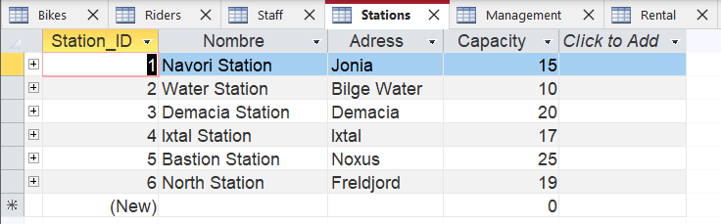
As I mentioned earlier, here you can see the stations to which the bicycles are associated, whose primary key is also their registration number, StationID. Their address is a name associated with the city, and next to it is the bicycle's capacity.

Rental Table
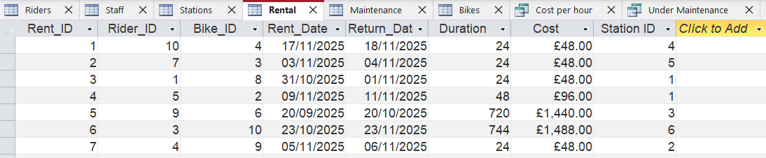
This table stores all bicycle rentals, with the primary key being RentalID. It associates riders, bicycles, and their stations, recording the rental and return dates, as well as the usage hours, ultimately calculating the total price the rider should pay.

Staff table
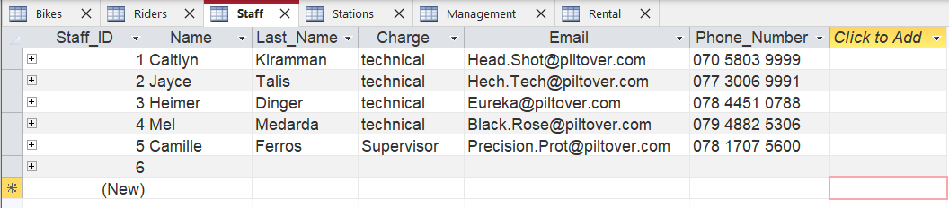
In this table, we would have registered our maintenance staff with their first and last names, along with their position, phone number and email address that we would use to contact them to find out how the maintenance of our bicycles is going.

Maintenance table
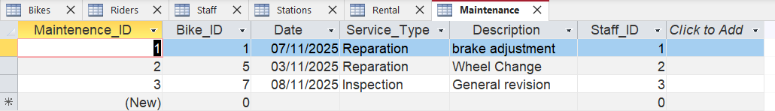
Finally, we have our maintenance table, where we would list the bicycles that have experienced a problem and require repair or routine maintenance. The primary key for this table will be the bicycle's automatically registered number, which is associated with the staff member responsible for repairing the bicycle.

TASK 6: Query Development

“Rider rent history” query
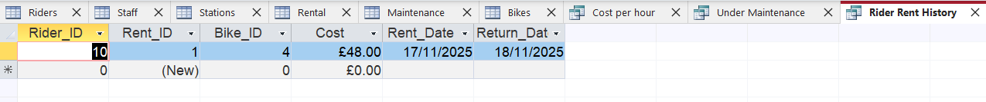
The purpose of this query is to view the history of any of our riders. An example where this could be useful is if we want to apply a discount to new users who don't have any rented bikes in their history, or if we want to apply a discount to regular customers.
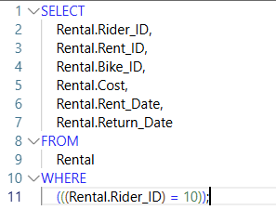
In this case, we wanted to check the rental history of our 10th customer, who has only rented one bike.

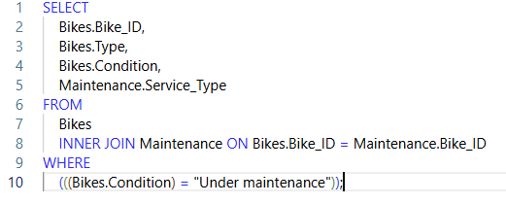
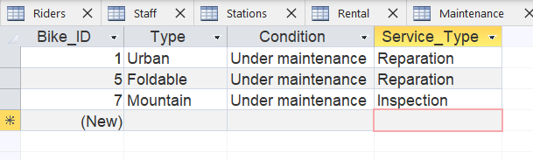
“Under maintenance query”
This query was created to manage which bicycles are or need maintenance. It's much simpler to have it this way: we can search one by one among our bicycles to see which one needs repair or routine maintenance and then communicate it to our staff as soon as possible, specifying the type of service required so they are prepared.

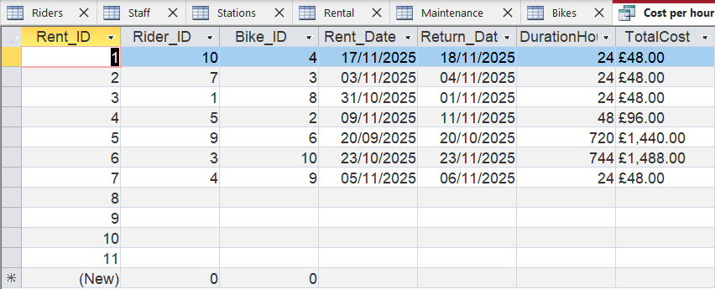
“Cost per hour” query

In this last one, we optimise two jobs at the same time by calculating the time in hours that one of our riders has used one of our bikes, so that it is then automatically added up, giving the total that said user would have to pay


