

Mechanical & Manufacturing Engineering

Tom Pettifer

11/12/18

Assignment 1 – Brushes & Sleeves.

Materials and introduction to manufacturing technology

Table of Contents
Mechanical & Manufacturing Engineering 1
Tom Pettifer 1
11/12/18 1
Assignment 1 – Brushes & Sleeves. 1
Materials and introduction to manufacturing technology 1
Introduction 3
Research 3
Gravity Die casting 4
4
Polymer injection moulding 4
Process, results, analysis. 5
Conclusion 6
Bibliography 6

Introduction

In this assessment I have been tasked with improving the manufacturing process of bushes and sleeves manufactured by a company. At the moment the company uses Sand-Casting and a secondary machining process. My task is to find a different manufacturing process which will improve surface finish and reduce waste and cost.

Research

Sand casting
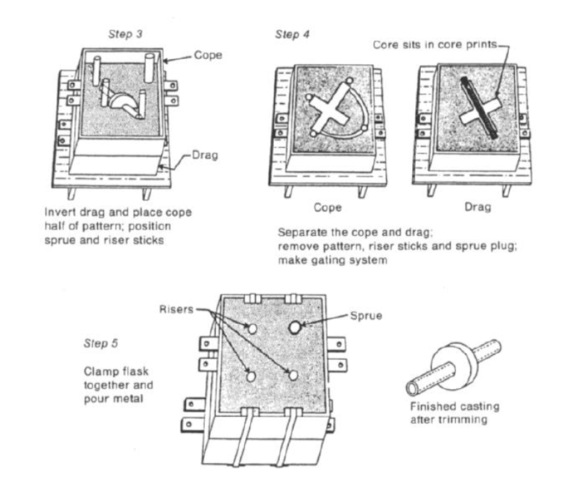
The current process the company are using is known as Sand casting. Sand casting is when a pattern (template for a mould) is placed in a flask filled with sand and is used to indent the sand to leave a cavity which can be casted. The pattern is removed from the sand which gets dusted in parting compound and the Drag (bottom of flask) and cope (top of flask) are clamped together. Runners and sprues are drilled out to allow the metal to be poured in before cooling and hardening in shape. The final piece is then machined to finish. Sand casting uses relatively low cost equipment compared to other metal casting processes, making it great for low output products. It can also be used to cast a variety of complex shapes with a short lead time, making it a cheap and efficient manufacturing process. Yet sand casting does have a lot of disadvantages in comparison to other casting processes. For instance, the surface finish in sand casting is usually poor and the part usually requires secondary machining to get the desired tolerances due to a lower dimensional accuracy. The finished part will also have a lower strength in comparison to a machined part due to high porosity. (Prakash, 2017)
Figure 1- Sand casting process (Alexander, 2018)
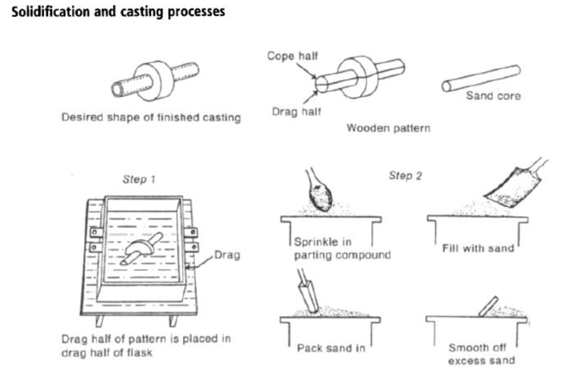
Figure 1 - Sand casting process (Alexander, 2018)

Gravity Die casting
One of the processes which I am going to be considering in this assignment is Gravity Die casting. Gravity Die casting is a casting process which uses gravity to fill a mould with molten metal. Gravity Die casting is similar to sand casting except the mould is not broken after when the part is released. The process has many advantages over sand casting. For example, Gravity die casting produces much stronger tensile strengths meaning the part, in this case the bush/sleeve, will have more uses in industry than one that has been sand cast. Thinner walls with higher dimensional accuracy are also achievable which means more complex shapes can be made and thinner bushes/sleeves are achievable. Another benefit of gravity die casting is a higher quality surface finish and a quicker production rate. The drawback of Gravity die casting would be the high initial cost but this can be nullified if the parts are being mass produced. (Investacast, 2018)
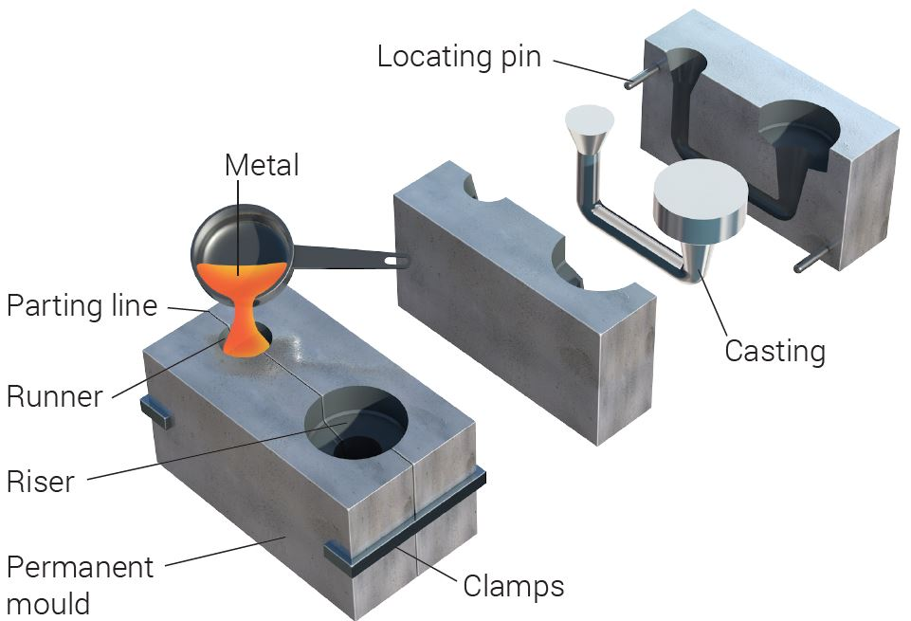

Figure 3 Gravity Die casting (EngineeringClicks, 2018)

Polymer injection moulding
Another process I am going to be exploring is Polymer injection moulding. Polymer injection moulding is a process where raw plastic materials are driven through a tube via a screw. The screw blends together the materials and gets rid of any air. The circumference of the tube starts to reduce, causing friction between the material, which leads to it heating up and plasticising. The melted material is then injected into a mould, and then left to cool and harden.
The benefits of this process are that it is a quick process and can allow lots of bushes/sleeves to be made in a short period of time. In addition to this the process can be run through programmed equipment, which means very little effort is needed to run it, making it cost effective. Also there is a high level of flexibility in regards to colour and materials used (limited to polymers) which could be desirable to certain customers.
The draw backs of this method are that metal components would not be able to be manufactured in this way. Furthermore, the moulds used in polymer injection moulding also take time make so it wouldn’t be as cost effective if new moulds had to be made for each customers.
(National moulding, 2018)
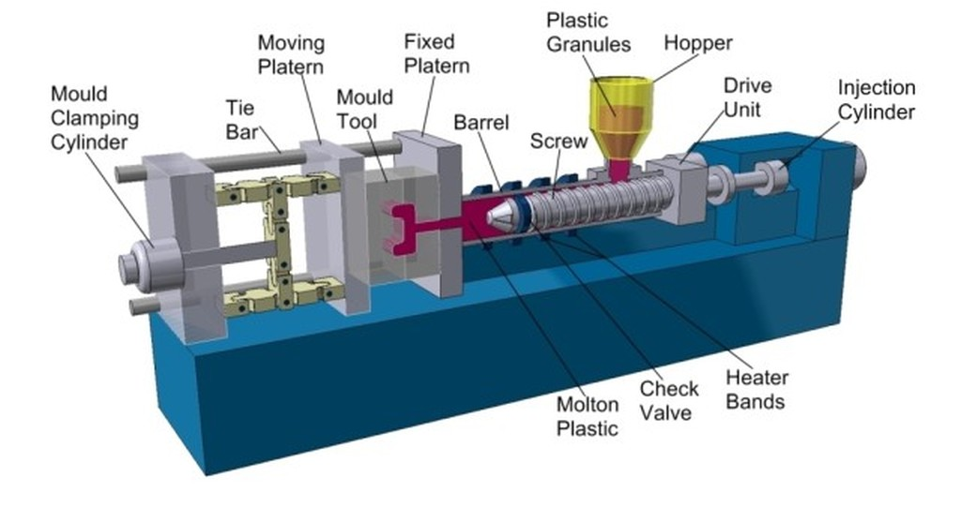
Figure 4 Polymer injection moulding (Teel, 2018)

Process, results, analysis.

The brief says that the company are looking for an improvement on their current manufacturing process of sand casting and secondary machining in order to improve surface finish as well as minimising waste and cost. The processes I have put forward in order to try and achieve this are Gravity Die casting and Polymer Injection moulding.
Polymer injection moulding would allow for quick effortless production, which would increase production and profits if the part was being mass-produced. It also allows for a range of colours and materials which could be desirable to certain customers depending on the function of the part. The negative side to polymer injection moulding is the limitations to polymers as polymers have less application in some markets due to their lower tensile strengths. Also the moulds take a long time to make so it would not be ideal if new shapes and sizes needed creating frequently.
One of the fundamental benefits of using gravity die casting would be an improved surface finish. This is a key factor that the company specifically stated they wished to improve and will be improved by using this casting process. Moreover, the tensile strengths of the parts will be increased giving the parts more versatility and durability to be used in more straining environments such as heavy machinery. In addition to all this gravity die casting allows for thinner walls with higher dimensional accuracy which will lessen the need for machining creating less waste, another key point in the brief, as well as increasing versatility. The high initial cost of Gravity die casting would be the only negative for the company if they were to change to this process, but this could soon be nullified over time, especially if the parts are being mass produced and less wastage is being created.

Conclusion

Overall I would strongly recommend transitioning to Gravity Die casting. This is due to the fact a higher quality part with more versatility could be manufactured. Even though initial costs are high this will be balanced out over time with the savings made on creating less waste. Also a more versatile product has more uses in industries so more markets could be reached by improving the casting process. In conjunction with this the surface finish of the parts will be improved and this is one of the key points mentioned in the brief.

Bibliography
Alexander, R., 2018. Casting , Swansea: Racheal Alexander UWTSD.
EngineeringClicks, 2018. EngineeringClicks. [Online]
Available at: https://www.engineeringclicks.com/die-casting/
[Accessed 11 12 2018].
Investacast, 2018. Gravity Die casting. [Online]
Available at: https://www.investacast.com/outsourcing/gravity-die-casting
[Accessed 12 December 2018].
National moulding, 2018. National moulding. [Online]
Available at: https://nationalmolding.com/blog/6-pros-and-cons-of-plastic-injection-molding/
[Accessed 11 12 2018].
Prakash, S. J., 2017. Pro's and con's of Sand casting. [Online]
Available at: https://engineeringproductdesign.com/advantages-disadvantages-sand-casting/
[Accessed 12 December 2018].
Teel, J., 2018. Predictable desings. [Online]
Available at: https://www.google.com/url?sa=i&rct=j&q=&esrc=s&source=images&cd=&ved=2ahUKEwjb9fm__ojgAhVU5uAKHUxFCBMQjRx6BAgBEAU&url=https%3A%2F%2Fpredictabledesigns.com%2Fintroduction-to-injection-molding%2F&psig=AOvVaw3hMG2XIKmBkRHGjB1WNAFj&ust=1548507580412939
[Accessed 11 12 2018].

