

University of South Wales Trinity Saint David

HNC in Electrical/Electronic Engineering

Dynamics Control and Instrumentation Assignment 1

By

Jonathan Spratt

Lecturer – L. Cook
Contents

- Task 1 – Strain Gauge

- Task 2 – CNC Control

- Task 3 – Open and Closed Loop

- References

Assignment
Task 1
“Explain the key principles governing the measurement of stress in a load bearing structure.”
Hooke’s Law states “that the stress imposed on a solid is directly proportional to the strain produced, within the elastic limit.” (William Collins Sons & Co. Ltd., 2012)
The measurement of stress in a load bearing structure can be found by measuring the strain in the structure. Strain is defined as “Strain is the amount of deformation of a body due to an applied force.” (National Instruments - Application Note 078.)
There are a few different ways of measuring stress, but the most common method is via strain gauges. Strain gauges have an electrical resistance that varies in proportion to the amount of strain in the device.
The most commonly used strain gauge is a bonded metallic strain gauge. The makeup of the strain gauges can consist of a very fine wire or more widely used, a metallic foil in a grid pattern. By using a grid pattern this maximizes the amount of metallic foil subject strain in the parallel direction. A metallic foil grid, which is bonded to a thin backing, is fixed directly to the component you wish to measure strain in. As the component experience strain it is transferred directly to the strain gauge, the resistance of the gauge then responds in a linear change.
Below is an example of a bonded metallic strain gauge.
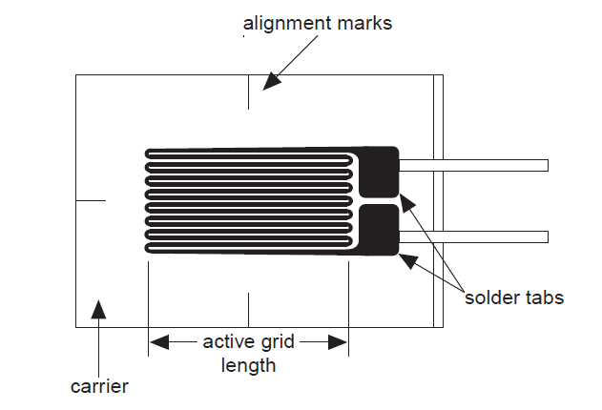

To measure the small changes in resistance in strain gauges a Wheatstone bridge is used. A Wheatstone bridge is a set of 4 resistors, with an excitation voltage applied across the two parallel voltage divider circuits, as seen in diagram below. If all the resistors are balanced then Vo is measured at 0v, any changes to these resistors creates a voltage which can be measured in relation to strain.
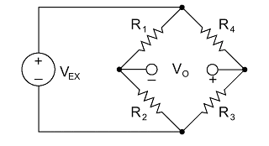

By replacing the resistor R4 with a strain gauge of the same resistance, any slight changes in resistance of the strain gauge will produce a voltage, which can be evaluated as a function of strain. In order to achieve a more accurate reading of strain, a second strain gauge can be added in place of R2. This second strain gauge, usually referred to as a “dummy” gauge, is placed in the opposite direction to the main strain. The dummy gauge helps to counter any external effects that could be applied to the strain gauge by reacting in an identical manner, thus ensure the measured voltage isn’t affected by external influences.

Below are examples of a Wheatstone bridge with R4 and R2 replaced with strain gauge. Also there is an example of how strain gauges are physically applied to a test specimen.
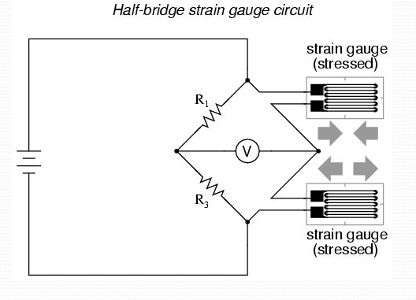
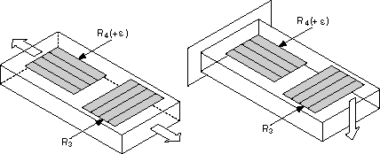

With R1 + R3 having a value of 120Ω and R2 + R4 replaced with 120Ω strain gauges we can calculate a value in Volts which can be measured proportionally to the amount of strain in the test specimen.
Using Young’s Modulus:
$$\frac{σ}{ϵ}=ε$$
Given the values:
$$σ=250{x10}^{3}$$
$$ϵ=200x{10}^{9}$$
We can calculate the value of strain$"ε"$:
$$ε=\frac{250{x10}^{3}}{200x{10}^{9}}$$
$$ε=1.25x{10}^{-6}$$

We then can calculate the resistance change in R2 and R4 using the typical Gauge Factor of 2. As the strain gauges are mounted in opposite directions, we use R4 as positive Gauge Factor and R2 as negative Gauge Factor.
$$GF= \frac{δR/R}{ε}$$
$$\frac{δR/120}{ε}=2$$
$$\frac{δR}{120}=2*1.25x{10}^{-6}$$
$$δR=120*2*1.25x{10}^{-6}$$
$$δR=0.0003Ω$$
$$δR4=120Ω+0.0003Ω$$
$$δR4=120.0003Ω$$
$$GF= \frac{δR/R}{ε}$$
$$\frac{δR/120}{ε}=-2$$
$$\frac{δR}{120}=(-2)*1.25x{10}^{-6}$$
$$δR=120*\left(-2\right)*1.25x{10}^{-6}$$
$$δR=-0.0003Ω$$
$$δR2=120Ω-0.0003Ω$$
$$δR2=119.9997 Ω$$
Given an excitation voltage of 10V, knowing that if $\frac{R1}{R2}=\frac{R3}{R4}$ then $V=0$ we can substitute R4 for δR4 and R2 for δR2.
$$Vo=Vex\left(\frac{R1}{R1+R2}\right)-Vex\left(\frac{R3}{R3+R4}\right)$$
$$Vo=10v\left(\frac{R1}{R1+δR2}\right)-10v\left(\frac{R3}{R3+δR4}\right)$$
$$Vo=10v\left(\frac{120Ω}{120Ω+119.9995Ω}-\frac{120Ω}{120+120.0003Ω}\right)$$
$Vo=1.67x{10}^{-5}$

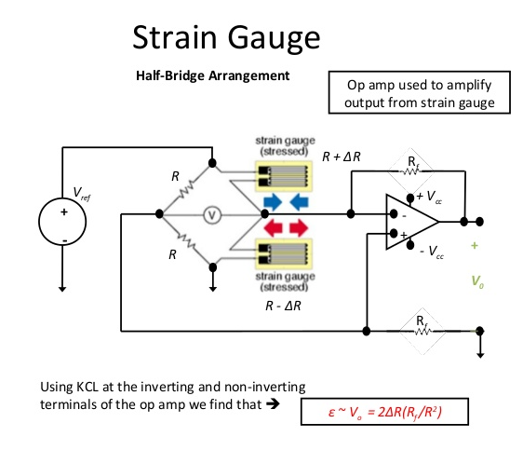
With the voltages being so small an Op amp can then be used to amplify the voltages to a more easily readable figure.

Several factors can affect the measuring performance of a strain gauge. When selecting you must use consider the bridge, signal conditioning, wiring. To ensure accurate strain measurements, consider the following:
- Bridge completion to complete the required circuitry for quarter- and half-bridge strain gages
- Excitation to power the Wheatstone bridge circuitry
- Remote sensing to compensate for errors in excitation voltage from long lead wires
- Amplification to increase measurement resolution and improve signal-to-noise ratio
- Filtering to remove external, high-frequency noise
- Offset nulling to balance the bridge to output 0 V when no strain is applied

Task 2

  - Consider that you are a design engineer tasked with designing part of a CNC drilling machine. The machine will drill holes in PCB boards to accommodate the pins on electrical components.

The key aspect to the design of the CNC drill is to be able to program the machine to deliver accurate and precise drilling, time after time without the risk of human error becoming an issue.
In order to deliver movement of the “X”, “Y” and “Z” axis linear motion is required. This is achieved by using rotation of different servo motors to drive each axis, which are to be controlled by servo drives and a CNC controller.
X Axis – The X axis will be driven via a servo motor driving a gear in mesh with a gear rack. This is commonly known as a rack and pinion. The motor will drive the X axis on the right hand side from the rack and pinion and due to the structure of the X axis, the left hand side will move along the slide way on roller bearings following the motors control.
To control the X axis motor a servo drive will be used, the servo drive is given the required motor speeds via the CNC controller. To ensure the motor is going at the speed the drive is telling it to, a transducer is attached to back end of the motor shaft, this is known as a resolver. The resolver measures the speed and feedback to the drive. The CNC controller also uses a linear encoder to calculate the required distance the machine needs to travel. The CNC control monitors the position of the encoder and it tells the drive whether to start or stop and go faster or slow down.
The linear encoder will be bolted to the rail of the X axis and a sensor will attached to the X axis body. The encoder needs a reference mark from the machine which can be used as the machine zero, in order to calculate the position.

Y Axis and Z Axis – Both the Y axis and Z axis will be driven via a servo motor driving a leadscrew, with the axis saddle sitting on top this. The motor will drive the Y and Z axis by sitting on the end of the leadscrew, as the motor turns the screw rotates inside the nut, moving the saddle in the direction required.
To control the Y and Z axis motors servo drives will be used, the servo drive is given the required motor speeds via the CNC controller. To ensure the motors are going at the speed the drive is telling it to, a transducer is attached to back end of the motor shaft, this is known as a resolver. The resolver measures the speed and feedback to the drive. The CNC controller also uses a rotary encoder to calculate the required distance the machine needs to travel. The CNC control monitors the position of the encoder and it tells the drive whether to start or stop and go faster or slow down.
The rotary encoder is coupled to the shaft of the leadscrew. The encoder needs a reference mark from the machine which can be used as the machine zero, in order to calculate the position.
The drill head will be driven by a 3 phase squirrel cage motor. Which is driven directly off the main supply via contactors. There is no feedback on this drive and will be controlled from the main CNC controller via a n/o push button for start and a n/c push button for stop.
Although the movement of the control will be done automatically by the CNC controller, the machine will have final limits on each axis, to stop the axis form over running and protect the hardware from being damaged if position or control is lost.

Examples of Drives and Encoders
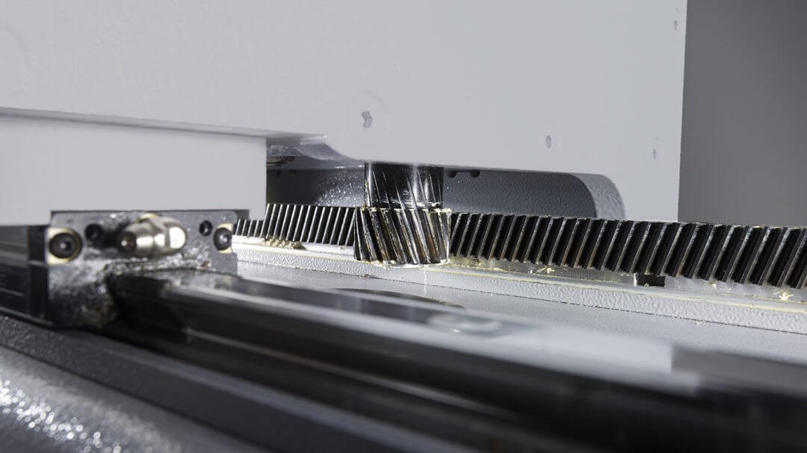

Rack and Pinion
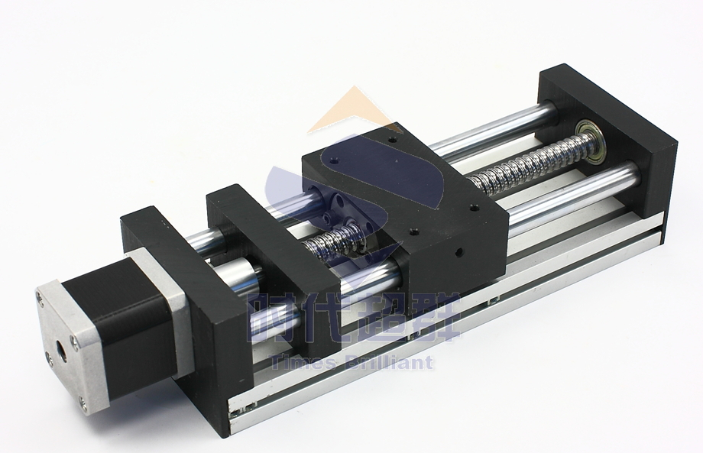

Leadscrew

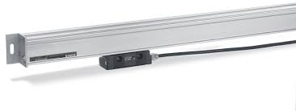

Linear Encoder
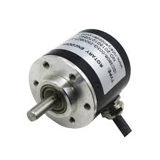

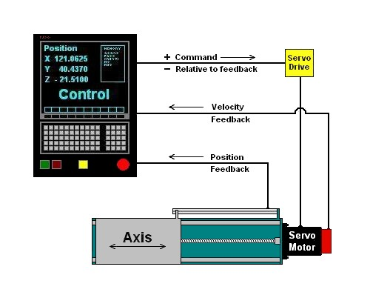
Rotary Encoder

Basic Layout of CNC Control System

Some issues that could cause problems with the design of the CNC drill are:
- Backlash in the rack and pinion. This is where the teeth of the rack and pinion produce play between them. The servo drive can be programmed to counter act the amount of play produced.

- Noise in the control cable. This is where the control cables can be effected by the magnetic fields of other cables in the cable looms, causing the signal it is delivery to be compromised. This can be counter by ensuring that the cable screening is sound through the cable and is grounded at one end, this grounding will take away any unwanted noise.

- The CNC machine will also need regular maintenance and cleaning. This will stop any components from being dirty or damaged and ensure the continued running of the machine.

  - Compare three methods of position measurement used in industrial control systems.

- Potentiometer – A potentiometer is used as a position transducer. As the knob is turned, the resistance is altered, which in turn can be used to calculate a voltage and be evaluated into a position depending on the size.
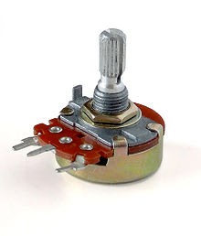

- Proximity Sensor – Proximity sensors are used to detect nearby objects without actual physical contact. They detect changes in the electromagnetic fields they emit, this is usually caused by metal parts of a machine they are attached to. Once activated the machine can calculate is position given the know location of the sensor.
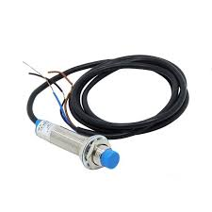

- Linear Encoder - A linear encoder uses a sensor and a scale that produces a positional output when the sensor is moved along the scale. It can provide a analogue or digital signal, which is then decoded into a readable value.

Task 3
- Compare and contrast Open and Closed loop control systems.

A control system is, “a mechanical, optical, or electronic system that is used to maintain a desired output.” (Farlex Inc, 2019 ).
There are two main types of control systems, Open loop and Closed loop. They are used in many different applications throughout industry and both have various advantages and disadvantages. The key difference between the two control systems is that Open loop does not have any feedback and Closed loop has feedback.
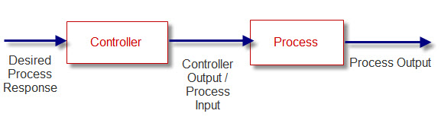
An Open loop control system works on fixed outcome and will continue to attempt to achieve the outcome regardless of external effects and any change in conditions. The controller does not have any feedback to monitor whether the output of the process has been achieved or not, it will continue to aim to produce the process output until it is shut off, even if the desired output is not achieved.
Basic Open Loop Control System

A Closed loop control system works by monitoring the actual process output and controlling it to ensure the desired process output is achieved. This is done by a feedback signal which measures the output and enables the controller to modify the input to ensure the correct desired output is maintained regardless of external effects and any change in conditions.
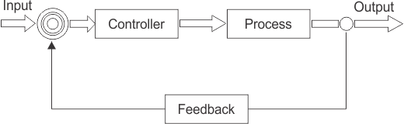

Basic Closed Loop Control System
An example of a basic Open loop control system is an electric fire. When switched on the fire will produce heat regardless of the required room temperature or room conditions. It will continue to produce the heat until the fire is manually switched off.
An example of a basic Closed loop system is an electric fire with a room thermostat connected in series with the control switch. With the control switch on the fire will heat up the room to the temperature set on the thermostat. Once the temperature is reached the thermostat will open circuit, causing the fire to be switched off. If there is then a dip in temperature the thermostat will the close back up and in turn switch the fire back on.

Open Loop Control System
Advantages:
- Economical and are more stable, due to having less components and less variables that could cause problems in the system
- Easier to construct, due to having a simple layout without and need for feedback.

Disadvantages:
- Are less accurate, no guarantee of system delivering the required output due to the lack of a feedback measurement.
- Less reliable, as they do not take in to account external disturbances or change in conditions.

Closed Loop Control Systems

Advantages:
- Can be highly accurate due to their feedback measurements, which can take into account changes in conditions and environment.
- Systems are easily automated due to the ability to remotely monitor conditions and control via the feedback loop.
Disadvantages:
- More complex to construct, have more components in the circuit.
- Cost, control loop systems are more expensive due to the need for feedback devices and a more complex controller.

- Provide an explanation for the following terms:

Set point – A set point is the desired outcome for the closed loop control system. A set point value is set into a control system and the output is measured. Depending on whether the measured value is higher or lower than the set point, the controller will increase or decrease the input to achieve the set point.
Process Variable – The process variable the actual measured value in the control system whilst the process is running. This is used to monitor the system and keep it within the correct parameters.
Plant - Plant is the place where a process of manufacturing or servicing takes place. Sometimes described as Plant and Equipment, this can also mean the machinery and tools used to supply a factory or production line.
Settling Time – Settling time is the time taken for the process variable value to settle at the required value of the output of the system.
Steady State Error – The steady state error is the final difference between the set point and the process variable. Steady state error is needed to drive the PID and is proportional to the process gain.
PID – A PID controller or proportional–integral–derivative controller is a device that controls a process by measuring the process variable against a given set point and then calculates the steady state error. Once it has calculated the SSE, the PID gives the required input into the system.

A large industrial compressor could be considered a piece of plant. This piece of plant is required to give a continuous supply of compressed air into an industrial workshop. The workshop needs a supply of around 7.0 bar in order to run efficiently. Before starting up the compressor a high set point of 7.5 bar is programmed into the controller and a low set point of 6.8 bar is programmed into the compressor. On starting up the compressor the pressure ramps up swiftly to the 7.5 bar upper set point with a very brief settling time once it is reached this. The process variable in this case is the measured pressure in the system. When the pressure reaches the upper set point the PID controller ramps down the pressure by calculating the steady state error between the measured pressure and the new target of the lower set point. The PID controller continues to constantly measure the pressure bouncing from the upper and lower pressure set points, maintaining the required pressure in the plant.

References

- Farlex Inc. (2019 , March 6). control system. (n.d.). Retrieved from American Heritage® Dictionary of the English Language, Fifth Edition. (2011).: https://www.thefreedictionary.com/control+system
- National Instruments - Application Note 078. (n.d.). Strain Gauge Measurement – A Tutorial.
- William Collins Sons & Co. Ltd. (2012). Collins English Dictionary. HarperCollins.

