

ANALYSIS OF THE ISSUE OF BALANCE BETWEEN
HUMAN TOUCH AND TECHNOLOGY IN TERMS OF CUSTOMER EXPECTATIONS IN THE GLOBAL HOSPITALITY INDUSTRY

Student name: Lavinia Curtean
Student ID number: 2232073
Lecturer’s name: Chris Wilkin
Submission date: 30/10/2025
Module name: Contemporary Themes in the Hotel and Hospitality Sector
Module code: BMIH6001

Abstract
The report has demonstrated the challenge of loss of human-level interaction in service delivery within the hospitality sector due to the incorporation of digital tools. For this purpose, the report has explored the rapid adoption of digital tools in the hospitality sector and the manner in which it threatens human interaction.
Study scope
The report has analysed the challenges associated with artificial intelligence incorporation in human touch loss within the hospitality sector. Based on these identified challenges, effective interventions have been evaluated for efficient service delivery.
Key Findings
- Artificial intelligence incorporation is predicted to rise in a robust manner in the future within the global hospitality industry.
- In order to address the issue of human touch loss, a technology-centric workforce has to be trained in the hospitality industry.
Recommendations
- Organisations need to implement balanced scorecard metrics
- Businesses can incorporate data privacy regulations for integrating technology without risking jobs.
Challenges
- Funding is required to skill staff
- Adaptability among customers for integrated service delivery
Conclusion
The integration of human interaction with technology enhances performance optimisation and service delivery within the hospitality sector.
Table of Contents
1. Introduction 5
1.1 Overview of the chosen contemporary issue 5
1.2 Relevance of the chosen issue in the hotel and hospitality sector 5
2. Literature Review 5
2.1 Analysis of artificial intelligence adoption in the hospitality industry 5
2.2 Positive and negative implications of artificial intelligence adoption in the hospitality industry 7
2.3 Evaluation of the issue of loss in 'human touch' in the hospitality industry 7
2.4 Strategic interventions to maintain balance between technology incorporation and 'human touch' in the hospitality industry 8
3. Method 9
3.1 Data Collection Procedures 9
3.2 Analytical techniques 9
3.3 Relevant frameworks 10
4. Analysis of the identified theme 10
4.1 Theme impact analysis with PESTLE framework 10
4.2 Impact of the contemporary theme on the hospitality and hotel industry 12
4.3 Reflection on the level of impact 12
4.3.1 Strengths 12
4.3.2 Limitations 13
5. Conclusion 13
6. Recommendations 13
6.1 Investment in staff training 13
6.2 Strengthening technology-enhanced human-centric workflows 13
6.3 Implementation of balance metrics 14
6.4 Leveraging the emotional intelligence element in the hospitality sector staff 14
7. Reference List 15

1. Introduction

1.1 Overview of the chosen contemporary issue
The global hospitality industry operates with the key focus of creating exceptional customer experience through sustainability initiatives and ethical leadership (Ford and Sturman, 2020). For incorporating sustainable management of the hospitality sector, especially after the post-pandemic period, concepts of 'digital hospitality' have gained prominence (Costa and Costa, 2022). However, the rise in 'digital hospitality' has often led to the issue of decreased human touch. In this regard, the report will underscore the challenge in balancing 'human touch' and advanced technology in addressing customer satisfaction in the global hospitality industry.

1.2 Relevance of the chosen issue in the hotel and hospitality sector
The contemporary hospitality industry is characterised by advanced innovation and regenerative trends (Sharma, Singh and Tyagi, 2024). However, there are concerns regarding a decrease in human touch from the hospitality sector due to the adoption of technological solutions. Studies highlight that customers prefer human interactions despite concerns about the pandemic. Although 'tech touch' tourism has become relevant, there are issues regarding the absence of 'human warmth' and 'interactive relationships' in technology-driven hospitality operations (Lei et al., 2025). Therefore, the issue of loss of balance between human touch and technological information is relevant for evaluating the future scope of global hospitality management.

2. Literature Review

2.1 Analysis of artificial intelligence adoption in the hospitality industry
Artificial intelligence has witnessed an increased adoption in the global hospitality industry to enhance service delivery and customer satisfaction. The artificial intelligence-based global tourism market has reached 2526.31million GBP in 2024 and is predicted to reach 10,387.45 million GBP by 2030. It accounts for a rise in CAGR by 26.7% between 2025 and 2030 (Grandviewresearch.com, 2025). For instance, in 2024, the Ministry of Transport collaborated with Huawei for optimising infrastructure and improving real-time operational visibility in the hospitality sector. In terms of technology-related solutions, the hospitality sector gained 64.1% revenue share in 2024.
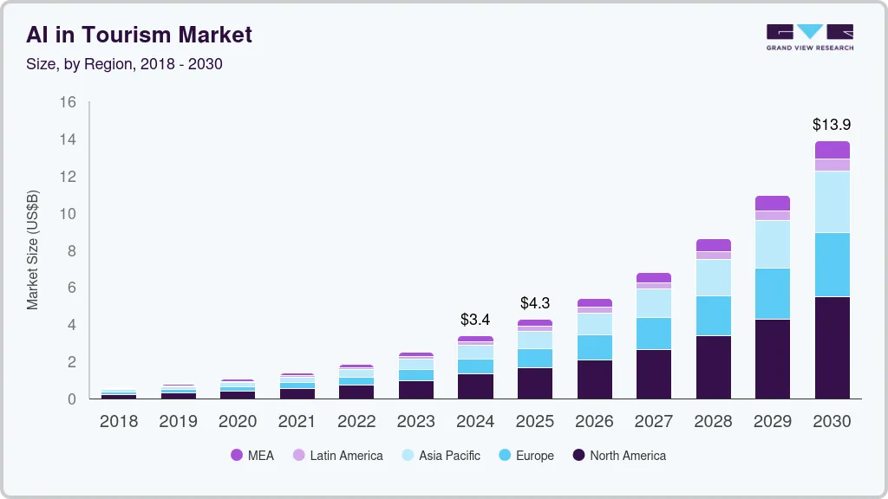
Figure 1: Graph depicting the adoption of 'artificial intelligence' in the global tourism market
(Source: Grandviewresearch.com, 2025).
On the other hand, in the context of the UK, the rate of artificial intelligence adoption is highest in the legal sector, followed by hospitality and health, which has a lower adoption rate of 11.5%. In this sector, artificial intelligence adoption is focused on 'machine learning' and advanced data management. Health care service delivery within the hospitality sector is estimated to witness the highest job gains in the next 20 years due to the incorporation of artificial intelligence and advanced digital tools.
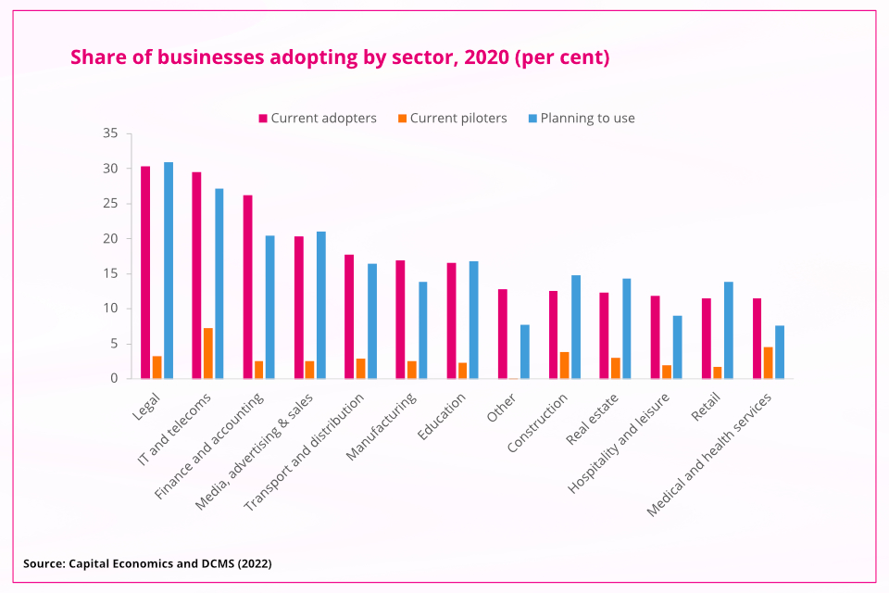
Figure 2: Rate of artificial intelligence adoption in the UK hospitality sector relative to other businesses
(Source: Forbes.com, 2025)

2.2 Positive and negative implications of artificial intelligence adoption in the hospitality industry
Adoption of artificial intelligence in the global hospitality sector is predicted to boost efficient management, organisation and facilitation of operational reform. In this regard, Ruel and Njoku (2021) state that technology-induced hotel and tourism operations strengthen customer satisfaction and reliance regarding request customisation, making reservations and purchasing hospitality-based products. In contrast, Zvaigzne et al. (2025) argue that artificial intelligence adoption has certain negative consequences on the global hospitality industry. The prominent consequence is loss of human-centric interactions between the customer and the service that often degrades customer trust and liability on the specific service.
Prominent hospitality sector businesses have benefited from rapid AI adoption. For instance, Hilton in the UK incorporates artificial intelligence applications for providing 'hyper-personalised' guest experiences to improve operational efficiencies (Klover.ai, 2025). It is predicted that through such intervention, Hilton will witness a 5%-8% revenue increase in future (Klover.ai, 2025). On the other hand, prominent hotels in the UK are exposed to the risk of data breaches due to artificial intelligence adoption. For instance, Marriott Hotels were fined 18.4 million Euros for a major data breach in 2020 that affected 7 million guests (BBC, 2025). Thus, in spite of the scope, there are certain negative implications of technology adoption in the hospitality sector.

2.3 Evaluation of the issue of loss in 'human touch' in the hospitality industry
Despite the profound influence of artificial intelligence adoption on the hospitality sector, it results in certain negative consequences. The first issue is ‘technological stress’ that often disrupts the efficient operation of the hospitality business. Moreover, Yasin et al. (2021) opine that increased adoption of artificial intelligence in the hospitality industry leads to 'overdependencies' in technology, leading to uncertainty of the 'human role' in service delivery. Therefore, in contrast to the common belief of job implication, loss of human touch often results in increased job complexity and overload. The risk of job uncertainty and overload hampers the quality and speed of service delivery in the hospitality sector in the long run.
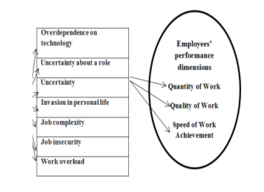
Figure 3: Negative impacts of artificial intelligence on hospital sector operations
(Source: Yasin et al., 2021)
Contrary to the above understanding, according to Parkash, Ngoruh and Chhabra (2022), technological intervention in the hotel industry impacts 'real-time' communication and coordination between customers and service delivery authorities. Although technological tools such as cloud-based 'PMS' allow better communication among hotel chains, they often restrict the role of 'word-of-mouth' service to enhance customer satisfaction in the hospitality sector. Therefore, loss of human touch often limits the scope of enhanced customer satisfaction within the hospitality industry.

2.4 Strategic interventions to maintain balance between technology incorporation and 'human touch' in the hospitality industry
With respect to the above-identified challenge of loss of 'human touch' in the hospitality sector, certain strategic interventions may be adopted. For this purpose, an integration is needed between technology, human capability and ethical consideration for responsible incorporation of artificial intelligence in service delivery (Martini, Bellisario and Coletti, 2024). The hospitality sector may consider the incorporation of artificial intelligence as an internal tool to strengthen the operational capability of staff instead of replacing them with digital tools.
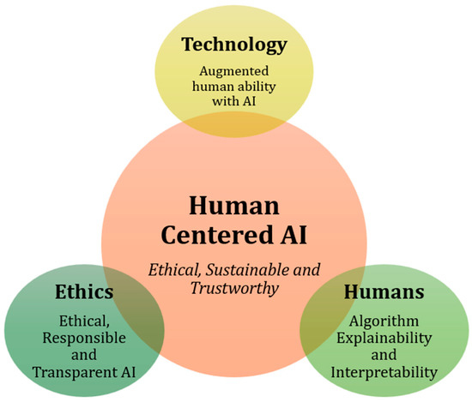
Figure 4: Integration between technology adoption and leveraging human capabilities
(Source: Martini, Bellisario and Coletti, 2024)
For this purpose, businesses in the hospitality sector may adopt an integrated technology suite for centralising customer data. This will enable better anticipation capability of the hospitality teams (Clegg, Skyttermoen and Vaagaasar, 2021). For instance, HTL Hotel chains focus on a transversal approach for integrating technology and staff capability (Hospitalitynet.org, 2025). The 'HTL Experience Centre' addresses the issue of human staff replacement by adopting artificial intelligence in delivering personalised service and facilitating the organisation in the work performed by the hotel staff.

3. Method

3.1 Data Collection Procedures
Data collection from secondary sources has been considered appropriate for conducting the study on the hospitality sector. The rationale behind considering secondary sources lies in their advantage of time and cost optimisation in integrating information related to the study area. Moreover, secondary sources enhance the scope of subjective interpretation of a specific issue (Mazhar et al., 2021). In regard to the study of the hospitality sector, consideration of secondary sources will enable a broader evaluation of the manner of integrating human-centric labour and technology for efficient service delivery.

3.2 Analytical techniques
Qualitative analysis will be considered suitable for this study for the purpose of collecting and disseminating data into relevant themes to accomplish the study objectives. In this regard, qualitative analysis involves the collection and interpretation of information collected from relevant sources and categorising the data into significant themes for alignment with the study objectives.

3.3 Relevant frameworks
Use of relevant frameworks provides a suitable roadmap for conducting a study in a simplified manner. In this respect, the frameworks of the technological acceptance model and behavioural reasoning have been applied for understanding the scope of the balance between artificial intelligence and the maintenance of human touch in service delivery within the hospitality sector.

4. Analysis of the identified theme

4.1 Theme impact analysis with PESTLE framework
PESTLE factors | In relation to the UK | Impact on the hospitality sector
Political | - Political stability score of 0.51 (Theglobaleconomy.com, 2025).  - Indicating a stable political structure.  - Likelihood of lower political violence and terrorism, Theglobaleconomy.com, (2025).  - 90% confidence rate among UK-based people regarding the political environment under the current Government (Tradingeconomics.com, 2025a). | Medium
Economic | - Current GDP of the United Kingdom is 2.78 trillion pounds GBP as of 2024 (Statista.com, 2025).  - The average per capita income of the UK is 23,927.54 GBP between 1960 and 2024 (Tradingeconomics.com, 2025b).  - Cost of living in the UK ranges between 651.75 GBP and 772.96 GBP in 2025 (Foyerglobalhealth.com, 2025). | High
Social | - The gender pay gap among UK-based employees is 7.0% in April 2024 (Ons.gov.uk, 2025).  - The UK ranks 22nd out of 153 nations in the gender justice index (Amnesty.org.uk, 2025).  - High income inequality.  - Prominent fall in income for the bottom 10% of the UK population (Commonslibrary.parliament.uk, 2025). | Medium
Technology | - Technology-related businesses contribute to 124 billion GBP in Gross Value Added (GVA) of the UK in 2023 (Assets.publishing.service.gov.uk, 2025).  - Specifically, London has 67% of artificial intelligence adoption rate (Productivity.ac.uk, 2025).  - Most preferred nation for technology-oriented business. | High
Legal | - Requirement of business compliance with the Companies Act, 2006 (Legislation.gov.uk, 2025a).  - Requirement of adhering to the regulation of corporate tax, capital gains related regulations.  - Adherence of UK-based businesses to contract regulation and consumer rights laws. | Medium
Environmental | - Compliance with the regulations under the Environment Act of 2021 (Legislation.gov.uk, 2025b).  - Compliance with Environmental regulations of 2004.  - Abiding by the Net Zero target and reduction in carbon emissions. | High
Table 1: Impact analysis through the PESTLE framework
Analysis
Based on the above table, it has been understood that the macro environmental conditions in the UK are favourable for balancing artificial intelligence and 'human touch' for leveraging better service delivery in the hospitality sector. In this regard, the favourable political and technological factors have the potential to integrate technology-induced human workforce in the UK hospitality sector. Moreover, integration of artificial intelligence in the service delivery of the hospitality sector is favourable in respect of the favourable economic environment in the UK.

4.2 Impact of the contemporary theme on the hospitality and hotel industry
The travel sector within the hospitality industry has been prominently impacted by the loss of human touch due to the incorporation of artificial intelligence. Based on a survey of 1000 travellers and 86 travel executives, it has been found that the travel industry will develop in future due to the transformative capabilities of artificial intelligence. The positive impacts of artificial intelligence will be on cost optimisation, as reported by 26% respondents, and 36% feel the hospitality sector will benefit from enhanced customer personalisation and quality outcome in service delivery (McKinsey.com, 2025). On the other hand, based on a study by Xu et al. (2025), it has been understood that integration of artificial intelligence within the hospitality industry increases the risk of high employee turnover. It reduces the scope of employment, especially for frontline workers. Therefore, the missed impacts of artificial intelligence adoption in the hospitality industry make it significant to establish a balance between human work and technology-driven outputs.

4.3 Reflection on the level of impact

4.3.1 Strengths
Based on the analysis of technology adoption's impact on the loss of human touch in the hospitality industry, it has been understood that there are certain positive aspects. For instance, I have understood that an increase in artificial intelligence applications may reduce the workload on employees, which can significantly address work-related health issues in the long run. Moreover, integrating technological incorporation in the hospitality sector may positively impact the optimisation of service delivery by staff for catering to the needs of customers. In addition, technological incorporation may create new job opportunities, for instance, in technical domains within the hospitality sector.

4.3.2 Limitations
However, I have evaluated that there is a scope of prominent risks in the absence of appropriate linkage between technological tools and 'human touch' in service delivery. I have understood that customers often feel dissatisfied in the absence of warmth and human interaction and cooperation for catering to their demands. Moreover, from the organisational perspective, staff may be exposed to increased risk of job loss due to work done by artificial intelligence and its associated tools. Additionally, overreliance on artificial intelligence has the risk of increasing data breach risks for the customers.

5. Conclusion
In retrospect to the above discussion, it has been concluded that the hospitality sector can leverage its operational outcome by integrating advanced technology and enhancing 'human touch' in service delivery. It has been inferred that the incorporation of artificial intelligence has certain merits and demerits in the operation of the hospitality sector. The advantages involve streamlining of complex tasks and cost optimisation. On the other hand, risks involve the threat of job loss and data breach issues. However, integration of artificial intelligence and a human-centric workforce can address the risks and optimise service delivery in the hospitality sector.

6. Recommendations

6.1 Investment in staff training
Providing appropriate training to staff for adopting advanced technology optimises organisational performance and service delivery by staff (Jackson and Allen, 2024). In this regard, the hospitality sector may optimise funds, time and resources for providing advanced training to staff in incorporating artificial intelligence in the service delivery. The staff may be trained to use artificial intelligence tools such as ‘Integrate.io' or 'Talend' to customise rooms based on client preferences. Moreover, the utilisation of artificial intelligence tools can be focused on collecting and integrating data from customers for improving hotel and tourism services (Cooper and Hall, 2019). It will result in a reduction of time and costs, along with maximisation of customer satisfaction.

6.2 Strengthening technology-enhanced human-centric workflows
A human-centric workforce trained in advanced technology enables seamless work with enhanced efficiency and optimisation of business operations (Bondy, 2021). Similarly, in respect of artificial intelligence adoption in the hospitality sector, a technologically inducted human-centric workforce may simplify complex and time-consuming tasks with better coordination and performance improvement. Software platforms such as 'X publisher' may be used by the hospitality industry to focus on task optimisation for people through user-friendly and intuitive technology collaboration.

6.3 Implementation of balance metrics
The contemporary tourism industry is characterised by trends and practices for promoting business dynamics (Batabyal and Das, 2019). In this context, for utilising the advantages of artificial intelligence in operational efficiency, the global hospitality industry may establish balanced scorecard metrics for integrating human-centric and technological service delivery. The use of balanced scorecard metrics will enable better monitoring of the performance of employees and the ethical use of digital tools. Moreover, the incorporation of balanced scorecard metrics positively benefits communication between the staff and customers for strengthening 'human touch' with advanced digital tools. Therefore, it enables the maintenance of consistency between organisational departments and allocated tasks.

6.4 Leveraging the emotional intelligence element in the hospitality sector staff
The functioning of the tourism sector is often inclined to interpret philosophical aspects of staff and customers (Tribe, 2009). In this regard, emotional intelligence plays a crucial role in the optimisation of service delivery. Emotional intelligence skills among staff of the hospitality sector facilitate leadership effectiveness and strengthen business dynamics by integrating technology adoption, such as artificial intelligence, and strengthening 'human touch' in developing service delivery within the hospitality sector. Leveraging emotional skills in service delivery develops trustworthiness among organisational staff and adaptability to the incorporation of artificial intelligence in service delivery in the hospitality sector.

7. Reference List
Amnesty.org.uk, (2025). We need Gender Justice to close the inequality gap here in the UK. Available at: https://www.amnesty.org.uk/blogs/amnesty-feminist-network-blog/we-need-gender-justice-close-inequality-gap-here-uk [Accessed 5 October 2025].
Assets.publishing.service.gov.uk, (2025). Technology Adoption Review. Available at: https://assets.publishing.service.gov.uk/media/6857e0995225e4ed0bf3ceb5/dsit_technology_adoption_review_web.pdf [Accessed 3 October 2025].
Batabyal, D. and Das, D.K. eds., (2019). Global trends, practices, and challenges in contemporary tourism and hospitality management. IGI Global.
BBC, (2025). Marriott Hotels fined £18.4m for data breach that hit millions. Available at: https://www.bbc.com/news/technology-54748843 [Accessed 12 October 2025].
Bondy, C., (2021). A framework for evaluating technology-mediated collaborative workflow. Rochester Institute of Technology.
Clegg, S.R. Skyttermoen, T. and Vaagaasar, A.L. (2021). Project Management: A Value Creation Approach. Sage, London.
Commonslibrary.parliament.uk, (2025). Income inequality in the UK. Available at: https://commonslibrary.parliament.uk/research-briefings/cbp-7484/ [Accessed 4 October 2025].
Cooper, C. and Hall, M. (2019). Contemporary Tourism: International Approach. 4th Edn. Goodfellows, Oxford.
Costa, V. and Costa, C. (2022). Challenges in Times of Crisis and Pandemics in the Hospitality Industry: A Systematic Literature Review. Sustainability and Competitiveness in the Hospitality Industry, pp.1-22.
Forbes.com, (2025). UK Artificial Intelligence (AI) Statistics And Trends In 2025. Available at: https://www.forbes.com/uk/advisor/business/software/uk-artificial-intelligence-ai-statistics/ [Accessed 14 October 2025].
Ford, R.C. and Sturman, M.C. (2020). Managing hospitality organisations: Achieving excellence in the guest experience. SAGE Publications.
Foyerglobalhealth.com, (2025). The cost of living in the UK. Available at: https://www.foyerglobalhealth.com/destination/the-cost-of-living-in-the-uk/ [Accessed 7 October 2025].
Grandviewresearch.com, (2025). AI in Tourism Market (2025 - 2030). Available at: https://www.grandviewresearch.com/industry-analysis/artificial-intelligence-ai-tourism-market-report [Accessed 15 October 2025].
Hospitalitynet.org, (2025). HTL Hoteles Is Balancing Technology and Human Touch. Available at: https://www.hospitalitynet.org/news/4128351.html [Accessed 11 October 2025]
Jackson, D. and Allen, C., (2024). Technology adoption in accounting: the role of staff perceptions and organisational context. Journal of Accounting & Organizational Change, 20(2), pp.205-227. DOI: http://dx.doi.org/10.1108/JAOC-01-2023-0007
Klover.ai, (2025). Hilton’s AI Strategy: Analysis of Dominance in Hospitality, Hotel AI. Available at: https://www.klover.ai/hilton-ai-strategy-analysis-of-dominance-in-hospitality-hotel-ai/ [Accessed 13 October 2025].
Legislation.gov.uk, (2025a). Companies Act 2006. Available at: https://www.legislation.gov.uk/ukpga/2006/46/contents [Accessed 1 October 2025].
Legislation.gov.uk, (2025b). Environment Act 2021. Available at: https://www.legislation.gov.uk/ukpga/2021/30 [Accessed 30 September 2025].
Lei, S.S.I., Wu, D., Liu, G.G. and Law, R., (2025). Customizing customer journey in hotels: A focus on human touch. International Journal of Hospitality Management, 124, p.103956. DOI: https://doi.org/10.1016/j.ijhm.2024.103956
Martini, B., Bellisario, D. and Coletti, P., (2024). Human-centered and sustainable artificial intelligence in industry 5.0: Challenges and perspectives. Sustainability, 16(13), p.5448. DOI: https://doi.org/10.3390/su16135448
Mazhar, S.A., Anjum, R., Anwar, A.I. and Khan, A.A., (2021). Methods of data collection: A fundamental tool of research. Journal of Integrated Community Health, 10(1), pp.6-10. DOI: https://doi.org/10.24321/2319.9113.202101
Mckinsey.com, (2025). Remapping travel with agentic AI. Available at: https://www.mckinsey.com/industries/travel/our-insights/remapping-travel-with-agentic-ai [Accessed 10 October 2025].
Ons.gov.uk, (2025). Gender pay gap in the UK: 2024. Available at: https://www.ons.gov.uk/employmentandlabourmarket/peopleinwork/earningsandworkinghours/bulletins/genderpaygapintheuk/2024 [Accessed 6 October 2025].
Parkash, G., Ngoruh, M.E. and Chhabra, S., (2022). Technological Advancement and Adaptation-Revitalisation of Hotel Industry or Loosing of the Human Touch??. New Challenges, Emerging Practices and Global Outlook in Service Management, p.41.
Productivity.ac.uk, (2025). Still a long way to improve digital technology adoption in the UK. Available at: https://www.productivity.ac.uk/news/still-a-long-way-to-improve-digital-technology-adoption-in-the-uk/ [Accessed 2 October 2025].
Ruel, H. and Njoku, E., (2021). AI redefining the hospitality industry. Journal of Tourism Futures, 7(1), pp.53-66. DOI: http://dx.doi.org/10.1108/JTF-03-2020-0032
Sharma, M., Singh, A.K. and Tyagi, P. (2024). Proceedings of the International Conference on Innovation and Regenerative Trends in Tourism and Hospitality Industry (IRTTHI 2024). 1st ed. Dordrecht: Atlantis Press Zeger Karssen.
Statista.com, (2025). Gross domestic product of the United Kingdom from 1948 to 2024. Available at: https://www.statista.com/statistics/ [Accessed 8 October 2025].
Theglobaleconomy.com, (2025). United Kingdom: Political stability. Available at: https://www.theglobaleconomy.com/United-Kingdom/wb_political_stability/ [Accessed 10 October 2025].
Tradingeconomics.com, (2025a). United Kingdom - Political Stability And Absence Of Violence/Terrorism: Percentile Rank, Upper Bound Of 90% Confidence Interval. Available at: https://tradingeconomics.com/united-kingdom/political-stability-and-absence-of-violence-terrorism-percentile-rank-upper-bound-of-90percent-confidence-interval-wb-data.html [Accessed 9 October 2025].
Tradingeconomics.com, (2025b). United Kingdom GDP per capita. Available at: https://tradingeconomics.com/united-kingdom/gdp-per-capita [Accessed 9 October 2025].
Tribe, J. ed., (2009). Philosophical issues in tourism (Vol. 37). Channel view publications.
Xu, T., Zheng, Y.H., Zhang, J. and Wang, Z., (2025). “They” threaten my work: How AI service robots negatively impact frontline hotel employees through organizational dehumanization. International Journal of Hospitality Management, 128, p.104162. DOI: https://doi.org/10.1016/j.ijhm.2025.104162
Yasin, E.S., Abdelmaboud, A.E., Saad, H.E. and Qoura, O.E., (2021). Side and the Light Side of technostress Related to hotel Innovations: Transforming the hospitality industry or threat to human touch. International Journal of Tourism, Archaeology and Hospitality, 1(1), pp.44-59. https://ijtah.journals.ekb.eg/article_243721_9e6f02c7326d2bafbdcaf6634cda78b1.pdf
Zvaigzne, A., Litavniece, L., Kodors, S. and Jurkane, K., (2025). Negative impacts of artificial intelligence technologies on the tourism industry. Worldwide Hospitality and Tourism Themes, 17(1), pp.22-34. DOI: https://doi.org/10.1108/WHATT-12-2024-0299

