3/24/2025
University of Wales Trinity Saint David
London campus
E-Portfolio Link:
Module Name: Learning In the Digital Era
Module Code: ACCA 4025

Student Name: Mohamed Ibrahim Mohamed Abdul Karem
Student ID: 2510896
Group: 2
Lecturer’s Name: Koushik Modak

LDE Assignment 1
E-Portfolio
Table of Contents
Introduction 2
Main Body 2
Task 1: Essential Academic and Employment Skills for the future career Path 2
Task 1 (a): Report on Essential Academic and Employment Skills 2
Task 1 (b): Evaluation of Task 1 (a) based on Similarity report 2
Task 2: Collaborative Mind Map and Individual Poster 2
Mind Map (Collaborative) 2
Poster (Individual) 2
Task 3: Virtual Collaboration and RefWorks 2
Report on Virtual Collaboration 2
Step-by-step process of using RefWorks with visuals 2
Task 4: E-Portfolio Creation and Evaluation 2
Task 4 (a): E-Portfolio Creation 2
Task 4 (b): Illustrative Review of E-Portfolio tool Selection 2
Conclusion 2
References 2
Task 1 References: 2
Task 3 References: 2

Introduction

Main Body

Task 1: Essential Academic and Employment Skills for the future career Path
Academic skills and employment are very important in this field, especially in the fields of Information Technology and all specialties, all dogs must develop their skills in basic academic employment skills in the field of self-employment and hard work so that the employee can develop the same in communicating with colleagues at work, study or anywhere and allows him to understand all work problems .[1]
Success in education or employment depends on the basic skills of the employee or student that facilitate his career, and he can face difficult challenges in the field of work, and the employee must be good manners, behaviours and tact and support teamwork and these skills allow in completing work tasks very positively and finding solutions to difficult issues.[2]
It allows the transfer of ideas and useful positive information through teamwork experiences, including the digital age, employees or students must deal with the useful development in working life, the most important of which are arithmetic skills and dealing with statistics in various skills that help in managing work, organizing workloads and adhering to work schedules.[3]
These skills help young new employees in working life, education or higher training, and these skills can be developed through university study and the most important skills that support teamwork and individualization in the work environment and interaction with employees, customers and other individuals in working life, digital dealing has become very necessary in the basics of employment, as it depends on how to deal with technology, software tools.[4]
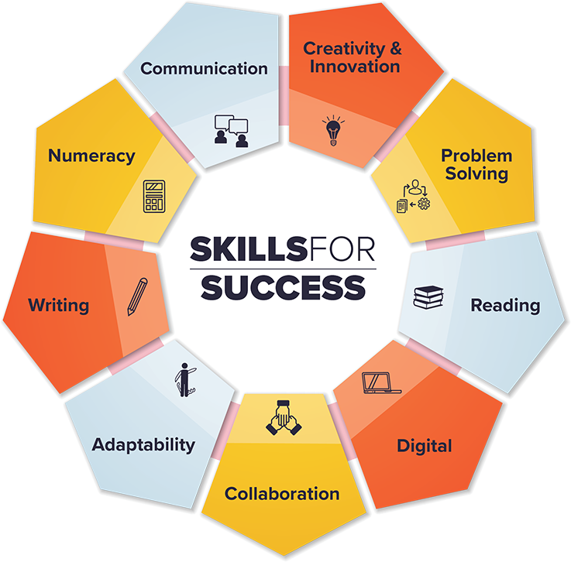Professionalism and a strong work ethic—characterised by reliability, punctuality, and responsible behaviour—are critical qualities that employers seek. Adaptability and flexibility are also important, as workplaces continue to evolve with new technologies and organisational changes. Finally, leadership skills, including the ability to motivate others and manage tasks, contribute to career growth and organisational success. In conclusion, essential academic and employment skills provide individuals with the tools needed to achieve success in both learning and professional environments. Developing these skills helps individuals become more capable, confident, and prepared for future opportunities[5].

Task 1 (a): Report on Essential Academic and Employment Skills

Task 1 (b): Evaluation of Task 1 (a) based on Similarity report

Task 2: Collaborative Mind Map and Individual Poster

Mind Map (Collaborative)

Poster (Individual)

Task 3: Virtual Collaboration and RefWorks

Report on Virtual Collaboration
Put your Chosen topic here

Step-by-step process of using RefWorks with visuals

Task 4: E-Portfolio Creation and Evaluation

Task 4 (a): E-Portfolio Creation

Task 4 (b): Illustrative Review of E-Portfolio tool Selection

Conclusion

References

Task 1 References:
References
[1] C. D. P. Mobley, North Carolina employers' perceptions of essential skills for entry-level employment of high school graduates: Implications for educational leadership, East Carolina University, 1998.
[2] A. Taylor, et al., The Skills Imperative 2035: What Does the Literature Tell Us about Essential Skills Most Needed for Work? Working Paper 1. ERIC, 2022.
[3] E. Dunne, N. Bennett and C. Carré, "Skill development in higher education and employment," in Differing visions of a learning society, Policy Press, 2000, pp. 105–138.
[4] J. F. Coates, "Skills required for twenty‐first century employment," Employ.Relat.Today, vol. 22, no. 3, pp.17–24, 1995.
[5] K. Gallagher, Essential study and employment skills for business and management students, Oxford University Press, 2022.

Task 3 References:

