Marcelus Pusey
2026791
Problem Solving and
Decision Making
Module BMSW4004
Tutor
Reducing absenteeism at Mid Cheshire NHS Foundation Trust (MCHT)

Reducing absenteeism at Mid Cheshire NHS Foundation Trust (MCHT)
Introduction
This paper seeks to identify the most effective method of reducing absenteeism at Mid Cheshire NHS Foundation Trust (MCHT). The Hospital has had issues with worker absenteeism, which has cost the Trust millions of pounds. Without absence tracking and reporting, the organisation will be unable to detect absenteeism before it becomes an issue.
The Trust recently dispatched a professional to determine the best way to retain employees. Using the Pestle model to identify the external factors affecting Mid Cheshire NHS Foundation Trust.
The issue at Mid Cheshire NHS Foundation Trust is that personnel are absent. There could be a variety of reasons for this, including low wages, feeling overworked, and not feeling valued. High rates of RN absenteeism could be the result of job unhappiness compounded by burnout, stress, lack of autonomy, or poor team cohesion, among other.
Controlling absenteeism at work is a major issue for UK firms. According to some studies, the sum might be as high as £29 million per year lost owing to employee sickness, with the average number of days missed per year per employee standing at 6.3.
Aside from the numbers, there is another cost of absence that is sometimes underestimated. The consequences of sick leave are not restricted to the person who is absent. It also has an influence on your entire team and has the potential to destabilise the overall working environment.
Businesses stand to lose significantly if the problem is not addressed, from the expense of replacement workers to lower productivity.

Top Causes of Absenteeism
Stress has been identified as a key cause of sick absence from work across all industries and organisation sizes. According to the Chartered Institute of Personnel and Development (CIPD), it is the second leading cause of short-term employee absenteeism (48%) after mild diseases such as colds and flu (95 percent).
• Minor illness is one of the top five short-term issues.
• Stress
• Musculoskeletal problems
• Mental illness
• Responsibilities for family/caregiver’s stress, coupled with acute medical illnesses such as stroke, heart attack, or cancer, is a primary cause of long- term absences.
• Severe medical conditions
Occupational health has an important role to play (Tamela et al., 2008) and a structured early intervention with an occupational physician can reduce sickness absence rates

What’s Contributing to Workplace Absenteeism?
Working conditions may have a significant influence on employees' physical and psychological well-being, resulting in high levels of absenteeism – which means there are methods to actively manage and control the problem.
1. Incompatible demands – increased absence (Eriksson et al., 2011)
2. Lack of trust – increased absence (Eriksson et al., 2011)
3. Presenteeism – increased absence (Janssens 2013)

Bernstrom, Vilde H., Kjekshus, Lars Erik (2015). Effect of organisational change type and frequency on long-term sickness absence in hospital. Journal of Nursing Management 23(6), 813

Inadequate infrastructure
Working conditions may have a significant influence on employees' physical and psychological well-being, resulting in high levels of absenteeism – which means there are methods to actively manage and control the problem.
Inadequate infrastructure
It is vital that employees have the tools they need to accomplish their jobs correctly. A lack of infrastructure and equipment reduces production and has a psychological impact
on workers as they grow irritated and disappointed. If the problems persist, your employees may be absent for an extended period of time.
While companies expect their employees to fulfil their commitments, it is also critical that organisations fulfil their own and equip workers with the necessary tools to help them do their jobs.

This Fishbone diagram below shows some of the external factor contributing to the problem at Mid Cheshire Trust.
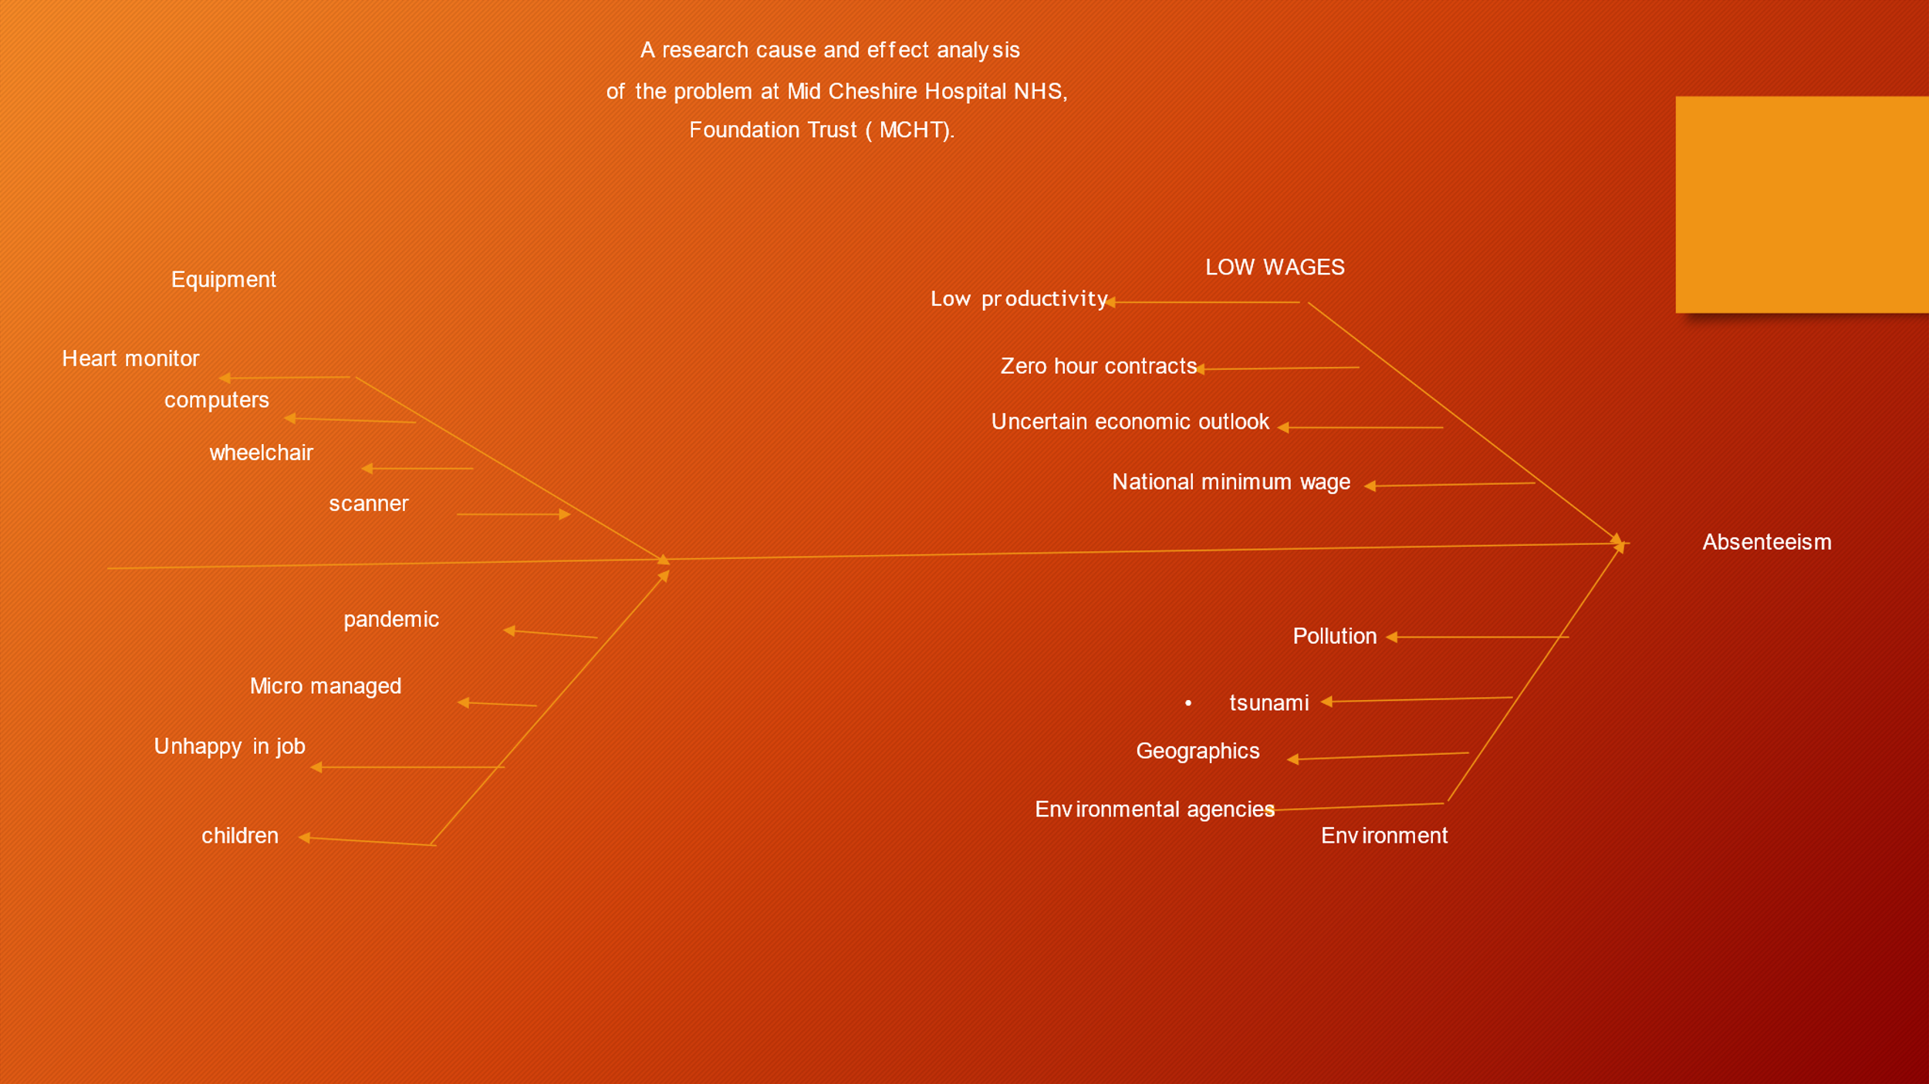

Ineffective leadership
The leadership style of a corporation influences how its employees behave.
When leaders lose their employees' respect, for example, through the stick vs carrot method, it might result in staff absenteeism, with people using sick leave to avoid the work environment.
The key to effective leadership is striking a balance between authoritarianism and helpful counsel.
NHS workers preferred in their leaders identified a number of leadership qualities, including a concern for others, empowering others to lead, being team-orientated, and supporting a development culture, qualities
https://www.england.nhs.uk/wp-content/uploads/2018/03/leadership-development.pdf

Demotivation
It's no surprise that employee engagement is becoming a higher concern for firms. According to one research, the cost of disengaged employees in the UK alone might be as high as £15 billion.
When employees are dissatisfied with their jobs, it can lead to poor performance and jeopardise their safety. Disengaged employees have an impact on the performance of people around them, influencing the entire work environment.
Whether there is an underlying issue with workplace culture or employees are demotivated owing to unrealistic goals, keeping employees satisfied with their jobs will provide significant advantages. You're also more likely to retain your employees.

Measuring Absenteeism
It is critical to be able to calculate absence in order to successfully control it. This begins with putting in place a strict system for tracking absences and recording employee entry and exit timings. This not only allows you to keep an eye on what's going on, but it also allows you to organise cover or the transfer of jobs in the event of long-term sickness, relieving strain on other staff.
To get your company's absenteeism rate, multiply the number of days each employee works each month by the number of employees. Make changes for part-time employees. You'll be left with the number of net hours your team is expected to work.
The absenteeism rate is computed by subtracting the net hours from It is critical to be able to calculate absence in order to successfully control it. This begins with putting in place a strict system for tracking absences and recording employee entry and exit timings. This not only allows you to keep an eye on what's going on, but it also allows you to organise cover or the transfer of jobs in the event of long-term sickness, relieving strain on other staff.
To get your company's absenteeism rate, multiply the number of days each employee works each month by the number of employees. Make changes for part-time employees. You'll be left with the number of net hours your team is expected to work.

(Lu et al. 2005, Davey et al. 2009 (2014 John Wiley & Sons Ltd838 Journal of Nursing Management, 2015, 23, 833–84) ( Davey M.M., Cummings G., Newburn-Cook C.V. & Lo E.A. (2009) Predictors of nurse absenteeism in hospitals: a systematic review. Journal of Nursing Management 17 (3), 312– 330)

A PESTEL analysis of the macro-environment factor contributing to the problem affecting Mid Cheshire NHS foundation trust.
A Pestel analysis will enable us to find the external macro-environment factor contributing to the problem affecting the foundation for example the Weather, Government legistration, natural disaster.

P - Political -
Changes in government, tax policies, and health and safety regulations all have an impact. Mid Cheshire NHS Foundation modifies their business Mid Cheshire NHS foundation tweaks their business Certain laws, such as tax policies, VAT policies, and so on, are accompanied by policies.
Trade policy, health and safety regulations, and the Civil Rights Act These.

E - Environmental
Recession, Inflation, and Easy Loan Access Changes in the environment cause political, economic, social, cultural, and technical changes in organisations such as hospitals.
Population ageing, health technological innovations, information technology advancements, and remote medical systems are some of the major changes.
To ensure the viability of their services, healthcare institutions must adapt to these fast environmental changes.

(Shadpour K. 2006);9(3):1–18.
Shadpour K. Health sector reform in Islamic Republic of Iran. Hakim Res J. 2006;9(3):1–18.
Davis MA, Miles G, McDowell WC. Environmental scanning as a moderator of strategy–performance relationships: an empirical analysis of physical therapy facilities. Health SERV Manage Res. 2008;21(2):81–92.

S - Social
Population, and so on medical care and ageing population is a widespread phenomenon all across the world. As healthcare improves, the average age of the population rises. Although this is a positive trend, an older population has greater health issues. Diabetes and different malignancies tend to emerge later in life and can be highly expensive to treat or control. As a result, the UK's ageing population is putting additional burden on the system.

T - Technology - Needs more investment, Lack of interest in investing in TECH
Healthcare is gradually improving as new technology are produced left, right, and centre. Scanning instruments are now more inexpensive than ever, making them a common sight in hospitals and clinics. Morbidity is being reduced with the development of various pumps and instruments for treating or managing conditions. Overall, these technology advancements in healthcare are beneficial to all parties involved. Not only do patients receive better treatment, but government agencies such as the NHS can speed up and automate more clinical procedures.

E - Environmental - Increase pollution, Global warming,
With Brexit concerns, financial challenges, an ageing population, and an increasing number of legal claims, it may appear that nothing is going right for the United Kingdom's National Health Service. Fortunately, technological advancements may make it easier for the body to give effective healthcare. However, it appears that the NHS will require far more funding if it is to satisfy rising expectations.

L - Legal Visa issue, weak regulatory bodies, Constant change of laws
Litigation is an increasing trend across the world, and it may occur in a variety of situations. Patients (or family members) who are dissatisfied with the quality of their care are turning to the courts for revenge now more than ever. This is not a new situation for the NHS: the UK has experienced an increase in the number of healthcare-related litigation, and the trend shows no signs of slowing. Unfortunately, this adds a new, significant cost to the healthcare system, as it is compelled to invest in costly legal defences and pay out countless settlements.

Discussion
A mixed method research with in-depth interviews and a survey was used to find influential environmental variables based on PESTLE (political, economic, social, technical, legal, and environmental) and the Douglas West framework to establish the efficiency and viability of factors. Over working, inequitable distribution of healthcare services, and high demand for expensive health services were recognised as microenvironmental issues Changes in illness patterns, incorrect hospital budgets, economic sanctions, government corruption, and healthcare centralization were among the macroenvironmental issues noted. To address the problem at Mid Cheshire Trust, it is critical to improve the staff situation. management, improve strategic policies for a more equal payment system, and increase the efficiency and value of services by implementing strategic inventory control. Furthermore, implementing a health transformation plan is another effective technique for reducing absenteeism cost.

Furthermore, outsourcing some expensive hospital aspects to private partners through "public–private-partnership models" might be a good technique for enhancing the compatibility between health policy and altering the paradigm from volume to value nominal penalty.
Downsizing was identified as a significant factor in the political dimension. This intervention has the potential to improve the performance of public hospitals by lowering administrative costs, increasing efficiency, and enhancing skills. Furthermore, as demonstrated by this study, healthcare technological advancements may be investigated and efficiently used to lessen the load on the healthcare staff and increase service efficiency. GYM membership, Counselling, Training, and smart hospitals are some applications of contemporary technology.

Overall, technology must be localised, and health technology assessments must be used to improve the correct utilisation of health technologies based on staff and public needs. Because of the growing economic costs of miscommunication and newly-emerging diseases caused by environmental changes, the major aspects in the legal dimension were highlighted as selecting the appropriate budgeting mechanism for hospitals (contraction–expansion). The findings demonstrated that microenvironmental factors impacted both the quality and the cost of services. Long wait times are one of the most important micro factors influencing efficiency, effectiveness, and customer satisfaction.

Conclusion

Three critical suggestions were made to enhance the quality and efficiency of services at Mid Cheshire hospitals as well as the entire healthcare system.
To begin, it is critical to transform the current referral system into a more sustainable system.
First (e.g., lowering the number of unnecessary referrals to specialists) in order to increase treatment cost-efficiency and fairness, particularly in remote and rural areas.
Second, in order to provide more comprehensive service, small public hospitals must be supported by strategic plans such as mergers with other hospitals and/or the development of hospital chains/networks.
Third, Better wages more recognition for job done well.

Pour Mohammadi, K., Bastani, P., Shojaei, P., Hatam, N. and Salehi, A., 2020. A comprehensive environmental scanning and strategic analysis of Iranian Public Hospitals: a prospective approach. BMC Research Notes, 13(1), pp.1-7.

