

LCLM6003 Leading and Implementing Change (LIC)
Assignment Title: A Strategic Change Plan

AI-Driven Electric Vehicle Transformation Across Jaguar Land Rover Under the Reimagine Strategy
Student Name: Alina-Nicoleta Radu
Student ID: 2312044
Lecture Name: Taonga Kaonga Sobere-Snithers

Executive Summary
The result of this report is reviewing a Jaguar Land Rover’s strategic reaction to the fast-changing automotive industry. The analysis spans the past few businesses history, internal pressures, external market forces, disruption due to digital, AI, and automation and the development of electric vehicles. Change-management models are assessed for their strengths and weaknesses to explain this within the Reimagine strategy. Leadership and organisational culture evaluated based on the support of employees, innovation, communication and implementation. A recommended change plan establishes clear goals, the sequence of actions, financial management, training of the workforce, communication and evaluation tools. Delivering effectively has the potential to enhance the quality of products, the efficiencies of operations, sustainability, competitiveness and long-term performance throughout Jaguar Land Rover across global markets.

Table of Contents
1. Introduction 4
2. Organisational Background and Recent History 4
2.1 Company Background 4
2.2 Reimagine Strategy and Recent Developments 5
3. Impact of the Changing Internal and External Environment 7
3.1 Internal Environmental Changes 7
3.2 External Environmental Changes 8
3.3 Impact of Digitalisation, Automation and Artificial Intelligence 9
4. Evaluation of Change-Management Models and JLR’s Change Process 10
4.1 Relevant Change-Management Models 10
4.2 Application of the Models to the JLR Problem 11
4.3 Evaluation of JLR’s Change Process 12
5. Leadership and Organisational Culture 13
5.1 Leadership Approach 13
5.2 Organisational Culture 14
6. Proposed Strategic Change-Management Plan 15
6.1 Set aim and objectives 15
6.2 Implementation, Finance and Communication 16
6.3 Evaluation and Control 17
7. Conclusion 18
8. References 19

1. Introduction
The automotive industry is undergoing a transformation at a very fast pace, all over the world. Business operations are transforming with the electric vehicles, digital technology, artificial intelligence, automation and environmental rules. Jaguar Land Rover (JLR) is a prominent car maker in Britain. The Range Rover, Defender, Discovery and Jaguar are all brands of luxury vehicle that JLR produces. Lack of competition, high production cost and fluctuating demand of customers have put pressure on the company performance.
The AI and digital systems to assist in the production of electric vehicles is the strategic change chosen for the Reimagine strategy. The change is to enhance the quality of a product in manufacturing, its efficiency of operation, its sustainability and its position in the market. For strategic change to occur, there must be a close connection between the environmental pressures, the company’s resources and future goals (Lynch, 2021). Digital transformation goes beyond technology systems (Verhoef et al., 2021) to impact on products, processes, skills and business models. The leadership of the corporate digital transformation, the acceptance by employees, financial resources, and effective decision-making systems are important factors to consider (Ngapey and Zhu, 2026).

2. Organisational Background and Recent History

2.1 Company Background
One of the recognised car manufacturers in the U.K. is JLR. It is engaged in the business of high end and luxury cars. Traditionally JLR has been built on the back of luxury sport utility vehicles and big internal combustion engines. Range Rover and Defender models have been giving popularity to the brand and commanding high prices. But there is a dependency on petrol and diesel cars that has led to environmental and regulation hazards. Consequently, electrification has become a key requirement to the business.
It is important to keep business goals, risks, processes and decision making close together when going through digital transformation (Coster et al., 2023). JLR requires fresh digital skills, in design, production, sales and customer service. Organisational knowledge, data resources and management (Mikalef and Parmiggiani, 2022) are other important factors for successful digital transformation.

2.2 Reimagine Strategy and Recent Developments
The Reimagine strategy was announced by JLR in 2021. The strategy focused on the future development of business with the centre pivoted on modern luxury, electrification, sustainability and digital services. Other plans under the strategy were to make Jaguar an electric luxury brand and for an electric offering to be available in other ranges.
Early change was a key aspect of orgasnisational restructuring. JLR confirmed that it would eliminate some 2000 jobs from its worldwide operations, of which 1000 would be "salaried". The reduction was supposed to reduce the cost, structure and make management easier, and to enable long-term transformation (Francis and Nandakumar, 2021). Cuts in staff also led to uncertainty for all concerned and the need for effective communication.
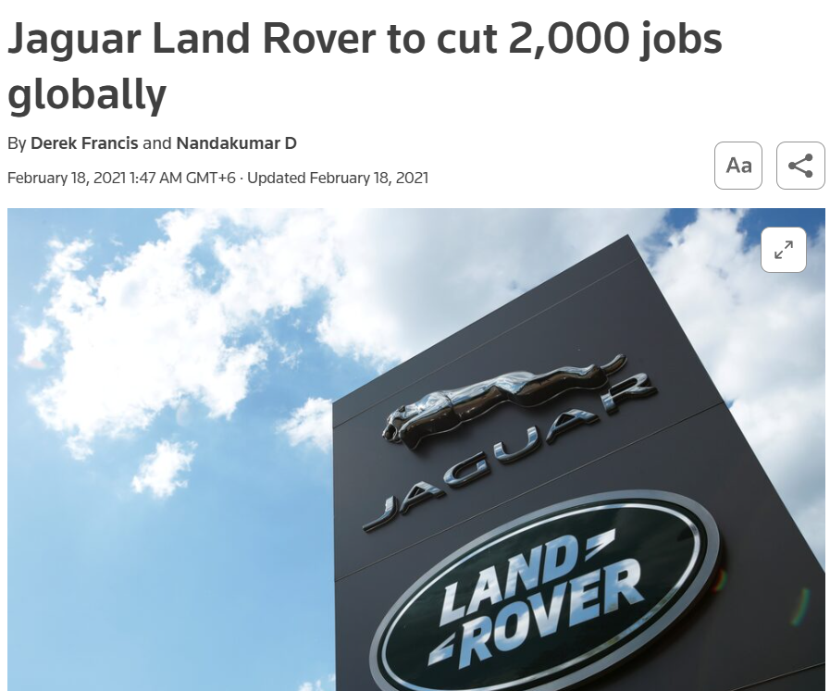
Figure 1: JLR’s 2,000 Global Job Cuts (Francis and Nandakumar, 2021)
The strategic announcement was followed by big investments. JLR has invested £500 million in upgrading its plant at Halewood. The investment helped to launch new production lines, electric and hybrid vehicle machinery and technology. The investment also helped enhance the flexibility of the factory and gets it ready for future EV production (Jolly, 2024).
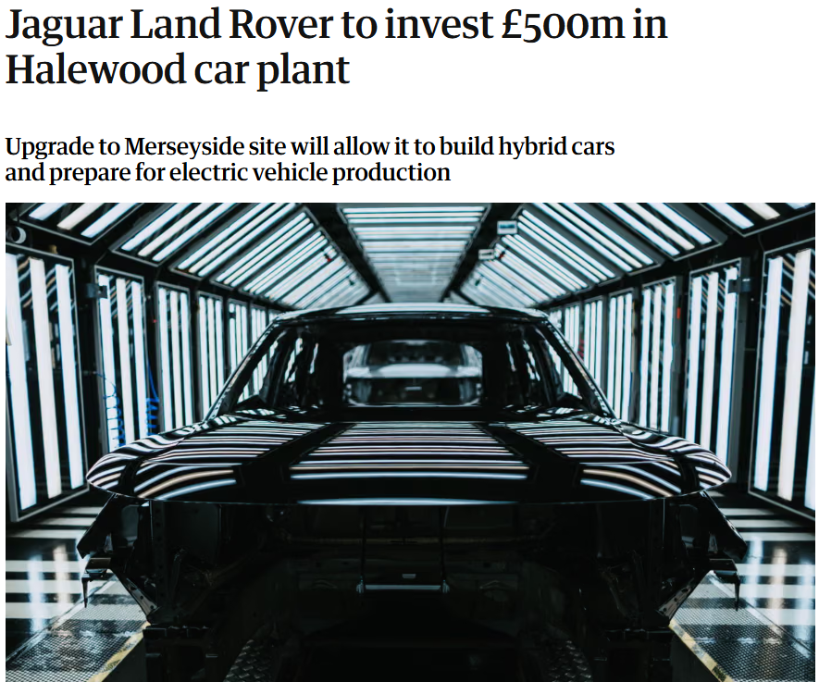
Figure 2: JLR’s £500 Million Halewood EV Investment (Jolly, 2024)
Business performance has been improving and has remained under pressure in recent times. Earlier, JLR has enjoyed excellent sales of some of its luxury products. But the sluggishness in China’s markets, higher operating expenses and tariff issues, as well as the slow pace of EV development have been impacting financial trust. A new profit recovery strategy involved in the company’s recent plan involved reducing costs, while also upping growth in the United States and operating margins. The investors’ response was guarded as the recovery targets seemed to be too high (Shah, 2026).
History over the last few years, therefore, contains a definite ruling trend and lack of execution. Reimagine has been able to provide significant investment and brand development. However, there is a need to accelerate the use of technology more, establish operational control and increase involvement of employees.

3. Impact of the Changing Internal and External Environment

3.1 Internal Environmental Changes
As a result of the internal environmental changes, JLR’s structure, human resources, technology, culture and production systems are impacted. The mechanical engineering, combustion engines and traditional production methods for cars and trucks played a crucial role in the traditional car industry. Battery systems, software engineering, digital testing and new safety procedures are needed for the production of EVs.
The flexibility, quality and productivity can be enhanced with Automation and Industry 4.0 systems. Investment is also needed and technical skills, good implementation plans are required for such systems (Matt et al., 2020). Automation in the manufacturing process, digital monitoring systems and flexible manufacturing lines have been introduced by JLR.
Another significant internal problem is the ability of employees. Knowledge of the batteries, the software, data analysis and electronic systems is needed for electric vehicle production. There may be a need to provide training and professional development for existing staff. There may also be a need for software programmers and data experts to be recruited. Management theories demonstrate that the knowledge of the employees and their motivation and organisational structure will have an impact on the performance of the company during change (Bright et al., 2019).
Organisational culture has an impact on change. JLR’s engineering prowess, luxury design and brand tradition have a long history. Traditions can be a powerful aid to quality and creativity. Whereas strong traditions can also establish resistance when new digital working methods come and challenge traditional ways of working. To foster creativity, freedom is required, as is a supportive environment for sharing knowledge and assistance from management (Zhou and Shalley, 2024).
There is another internal pressure as well, due to financial capability. Large investment of factories, batteries, research, software, and employee training for the development of EVs. JLR needs to manage costs in the here and now as well as invest in the future in order to transform it. The lack of good financial stewardship may result in the postponement of key projects. Too many cuts might also have a negative impact on innovation and on the confidence of employees.

3.2 External Environmental Changes
One of the external factors is the government policy. The UK and other markets are introducing regulations that are even tougher than the current ones and are encouraging the switch to ZEVs. These changes push the pace on EV development. Failure to meet the environmental requirements can lead to penalties, to a reduction of market access and of reputation.
Another factor that affects JLR is the economy. The cost of energy, labour, transport and vehicle components have risen due to inflation. Increased interest rates can make people more inclined to save money on their high-purchase price cars. Exchange rates influence the revenues from exports and the prices of imported components. Luxury customers might have higher spending power, but when the economy is uncertain, it can still have an impact on demand.
Social trends have become the benchmark for 21st-century customers. The environmental performance, digital features, safety systems and vehicle connectivity are now on many of the customers’ wish lists. Top-level customers are also looking for ease of buying online, customisation and frequent software updates. JLR can only compete on quality of their cars and on digital customer experience.
The level of competition has increased. Tesla has managed to establish itself well in the electric vehicle market. German luxury brands have beefed up the range of their EV models. International markets have also been invaded by Chinese manufacturers, who bring advanced technology, and competitive prices. JLR is under pressure to launch electric cars soon, while maintaining luxury standards.
Risk in the supply chain is an issue. A variety of batteries, semiconductors and electronic parts are imported from abroad. Political ques and trade bans, disruption of transport and shortage of materials can hinder production. Digital supply chain systems can help to enhance visibility, planning and supplier coordination (Wang and Pettit, 2022). JLR requires correct data from suppliers to minimise delays and manage the stock.

3.3 Impact of Digitalisation, Automation and Artificial Intelligence
With digitalisation, the entire production process of an automobile is going through a change. By using digital design systems, product development time can be shortened. Virtual testing can discover engineering issues before entering into real manufacturing. Factory equipment that is connected can furnish real-time data on equipment performance, production levels and maintenance requirements.
AI can be used to aid in quality control. These computer vision systems can analyse the surface of a vehicle, parts, and assemblies. The AI can detect defects quick than some manual inspection processes. AI’s potential application in the automobile industry is evident in defect detection and quality enhancement (Morales Matamoros et al., 2025).
In addition to supporting JLR factories, predictive maintenance can help. AI can analyse the data from the machines and flag potential issues with the equipment. Prevention is the best remedy, and that can help to limit stoppages and repairs. Artificial Intelligence (AI) can assist in manufacturing processes to achieve flexible, intelligent and cost-effective production (Soldatos, 2024).
Software and data are also crucial to the performance of EVs. AI can optimise battery management, energy consumption, route management, and driver support. Personalised services and maintenance information can be given by digital customer systems. These can help build customer satisfaction and new revenue streams from digital services.
The digital transformation can lead to the performance improvement of electric vehicle companies when there is one-to-one match between technology and organisation (Zhao et al., 2025) and between technology and environment. However, lack of data quality and low skills among employees and lack of cyber security can diminish the benefits. The more connected systems are in use the more vulnerable to cyberattacks and operational disruption they are.

4. Evaluation of Change-Management Models and JLR’s Change Process

4.1 Relevant Change-Management Models
The three-stage model by Lewin, the Kotter’s eight-step model and the ADKAR model are suitable models for JLR. Lewin’s Model comprises of unfreeze, change, refreeze. The un-freezing process helps to raise awareness of the need to change how things are being done. Changing programmes adds new systems, structures and behaviour. Refreezing establishes new practices as a part of normal practice.
The unfreezing phase is about pressures for JLR due to electric mobility, environmental regulation, competition and performance issues. Reimagine is the stage of change in the investment, restructuring, developing electric vehicles and digital manufacturing. New skills, policies, performance measures and workplace behaviour are needed in the refreezing stage.
Lewin’s model gives the structure of a basic model. But the environment of the auto industry is constantly evolving. There is no certainty that digital technology, regulations and customer demand will stay the same. A permanent refreezing stage may thus not be readily achievable.
Kotter’s model includes 8 steps. Key actions are establishing a sense of urgency, establishing a steering team, forming a vision, communicating a vision, overcoming obstacles, achieving short term milestones, and sustaining progress and embedding change. To ensure that the changes are implemented effectively, the employees need to be involved, and the process of change needs to be clearly directed, with robust implementation processes (Errida and Lotfi, 2021).
The Reimagine strategy helped drive urgency, by elaborating on why electrification and sustainability was necessary. The vision of the senior leaders was a clear one for the future, with focus on modern luxury and electric mobility. Practical advances were made also on factory investment and new electric projects. Kotter’s model is appropriate as JLR’s change impacts many departments, factories, suppliers and international markets.
Kotter’s model also can pose challenges. Eighth stages may seem measured and quite controlled. Very fast technological change can necessitate the simultaneous occurrence of several activities. There may be a decreased flexibility for use if each stage is used strictly. JLR therefore must take a flexible approach to the model and not use it as a rigid process.
The ADKAR model is individual change centred. The elements of ADKAR are: awareness, desire, knowledge, ability and reinforcement. Employee awareness relates to the awareness of the need for electric and digital transformation. Desire is having a desire to support change. Knowledge includes training and technical knowledge. Ability is ability to do something. New behaviours are supported by reinforcement.
The ADKAR model is valuable because it is an approach to help with large scale changes in the skills of the employees and changes to the job, they do on a day-to-day basis at JLR. The model can assist managers to pinpoint employee needs in various phases. There is one main constraint, and that is the emphasis on individuals. Strategic issues like investment, market conditions, supply chains and organisation structure are not so much covered as in large ones.

4.2 Application of the Models to the JLR Problem
A hybrid solution is more beneficial to JLR. The broad stages of change can be provided by Lewin’s model. Kotter’s model can be used to lead and implement in organisations. ADKAR can help employees in the training and transition to the workplace.
The first one has to do with having a clear case for change. Leaders should show an understanding of the risks to the business arising from slow electrification, low digital skills, and the challenge from their competitors. When information is clear, it helps to eliminate confusion and can assist employees’ awareness. The emotional perspectives on potential gains, potential losses and equity of employees can influence their reactions to the intervention (Oreg et al., 2018).
The other requirement that I see is a robust change leadership team. All senior managers, factory managers, engineers, software specialists, employee representatives and supply chain managers should be involved. Increased diversity in participation can help to make decisions and ward off opposition. Leadership, communication, group dynamics and the culture in the workplace all influence the organisational behaviour (Wood et al., 2024).
Reimagine gives a wide strategic guidance with a broad vision. But there must be clear targets, for each factory and department. These can range from electric vehicles production dates, training numbers, quality targets, cost reduction, to level of adoption of Artificial Intelligence.
One of the other requirements is communication. Senior leaders to give frequent updates of business, Employee meetings, Digital information pages and Training. Communication needs to convey the benefits to be expected, potential risks and staff duties. Communication should also provide opportunity to ask questions and give feedback.
The fifth one relates to training and hands-on assistance. The need of the hour is to provide appropriate education to engineers and factory employees in the field of battery systems, artificial intelligence, software, digital security and data utilisation. There is a need for leadership development tool for managers. Leadership development is an effective way for managers to manage uncertainty and conflict and employee concerns when going through change (Thorpe, 2016).
Short term gains are to be kept in sight. Progress may be seen in the successful factory upgrades, reduction in defects, employee training and production time. Practicable successes can boost confidence and help keep people on board.

4.3 Evaluation of JLR’s Change Process
There are number of strengths that are observed in JLR’s change process. Reimagine developed a sound vision. There was a commitment shown with a large investment in factories. The House of Brands organisation also established consolidated market positions for Range Rover, Defender, Discovery and Jaguar. Long term environmental and competitive projects are supported by digital and electric vehicle projects.
Leadership has been significant in providing direction and in authorising investments. A transformational leadership would seem to be appropriate for JLR. Transformational Leadership offers a vision, foster innovation and inspires people to put in the effort for the long term. This kind of leadership can aid in the electric and digital transformation.
The power of transformational leadership isn’t enough. There is also a need for transactional leadership in the areas of budgets, deadlines, quality targets and operational control. It’s possible to blend inspiration and clear performance requirements, then, in a balanced approach. Organisational culture can influence successful change management through the leadership style (Abawari et al., 2024).
There are a number of defects still evident. The market for EVs has proved to be less than prolific. Trust in the company could have been compromised with job cuts. The uncertainty of employees, investors and customers can be caused when there is delay and uncertainty regarding targets.
An organisational culture that supports and/or resists JLR. Innovation is aided by engineering skill, luxury design and product quality. There can be resistance to change of the traditional engines and working systems, which can hinder the adoption of digital. Leaders must safeguard precious traditions and eliminate policies which hinder change.
To achieve a more effective change process, more employees need to participate. Preventing workplace changes will require consultation to start before they occur. Training should start prior to new systems going into production. The employers should assess their employees’ knowledge and competence. Increase the likelihood of improvement through regular feedback.

5. Leadership and Organisational Culture

5.1 Leadership Approach
The change that has been chosen is the AI powered EV Transformation with the Reimagine strategy. JLR requires leadership that can provide a clear direction, foster innovation and control delivery. The right type of leadership is transformational as the change holds the promise of a new vision for electric mobility, digital production, and new luxury. Commitment can be established through transformational leadership by articulating the need for change, fostering new ideas and connecting what people do with what they want to achieve in the future.
Senior leaders need to send a unified message to people about the need for EVs, AI and digital. Uncertainty is minimised and employee confidence is enhanced when there is clear leadership. Leadership development also assists managers to manage conflict, resist and deal with shifts in responsibilities in the context of significant programmes (Thorpe, 2016).
Also, a transformational approach needs to be complemented by transactional leadership. Transactional Leadership has clear goals, budgets, deadlines and quality standards. The reason for JLR to have that control is due to the high investment and technical risk of the programmes on electric vehicles. It’s possible, then, to take a balanced approach that is inspirational and has strong operational control.
Participative leadership should also take place. Involve Engineers, production personnel, software experts and employee representatives in decisions. Taking part can enhance the practical planning and minimise resistance. Increase the likelihood of change to be successful by communicating why change is necessary and ensuring employees see the management is fair (Oreg et al., 2018).
Most daily information to the line managers and supervisors, which in turn goes to the factory workers, is provided by middle managers, making a vital role for them. The actions of management need to be clear and consistent. Managers should be at training and be responsive to safety issues, as well as using new systems. The organisation behaviour research indicates that role relationship, communication and motivation impact staff performance when going through change (Wood et al., 2024). Leadership also has a responsibility to safeguard the ethics. The use of AI must be transparent, secure and subject to human review. Establishing clarity of responsibility can help avoid unsafe decisions, suboptimal use of data, and loss of trust among employees. Regular patterns of behaviour can help translate strategic promises into the work place.

5.2 Organisational Culture
JLR has a robust culture that’s rooted in engineering quality, British design, luxury, safety and brand heritage. A culture like this helps to ensure superior product quality and customer confidence. But powerful traditions can also be a hindrance to digital transformation. Old practices can make the way in which the software-based system is used or how decision-making and cooperation will occur resistant.
A learning, experimenting and knowledge-sharing culture should be encouraged in a supportive culture. Creativity is enhanced by managers paying attention to new ideas, tolerating the occasional failure and rewarding anything innovative that is not terrible (Zhou and Shalley, 2024). JLR should therefore be incentivised to encourage the use of digital problem solving, cross-function team working and continual improvement.
Trust also is influenced by culture. Rather, there might have been fears about automation and job security at earlier job cuts and restructurings. Artificial Intelligence will help in work, enhance quality and minimise repetition, explain Leaders. Job roles may change and training and redeployment should be provided.
The relationship between culture and change success could be affected by the leadership style (Abawari et al., 2024). With this comes the need for leaders at JLR who are able to value the brand legacy but also stimulate new behaviour. The best culture is that of traditional engineering skills and digital learning, open communication and shared responsibility. This type of culture can help accelerate the change without compromising on the quality of products or the brand.

6. Proposed Strategic Change-Management Plan

6.1 Set aim and objectives
The proposed change is the implementation of AI-based EV production system in specific JLR sites in the UK. The first phase should be to concentrate on Halewood - extensive investment has already been made into electric vehicles at that site. The programme should be linked to data from employees, suppliers, predictive maintenance and digital quality inspection, with a focus on AI.
The primary goal is to take the quality and speed of EV manufacturing to the next level in 24 months. Other goals are to decrease production defects by 20 per cent, decrease unplanned machine stoppages by 15 per cent, and to train at least 80 per cent of the affected employees and increase employees’ confidence in digital systems. The success of digital transformation is more robust if there is a synergy between technology, organisational ability and environmental needs (Zhao et al., 2025).

6.2 Implementation, Finance and Communication
Plan area | Main actions | Time | Proposed cost | Success measure
Preparation | Create a change team, map processes and assess digital readiness | Months 1-3 | £2 million | Approved plan and risk register
Technology pilot | Install AI quality cameras, sensors and predictive maintenance systems on one production line | Months 4-9 | £12 million | Pilot system operating safely
Workforce development | Provide training in AI use, battery safety, data handling and cyber security | Months 4-15 | £5 million | 80 per cent training completion
Wider rollout | Extend successful systems across selected production areas | Months 10-20 | £25 million | Lower defects and machine stoppages
Evaluation | Review costs, quality, employee feedback and supplier performance | Months 18-24 | £3 million | Final benefits report
Contingency | Cover system changes, delays and additional training | Whole programme | £5 million | Risks controlled within budget
Total | Full programme cost | 24 months | £52 million | Objectives achieved

Table 1: Proposed strategic change plan (Errida and Lotfi, 2021).
The overall budget proposed is £52m. The budget is an estimate and will be finalised on the basis of a technical evaluation. The funding should be provided from the overall Reimagine investment programme, savings from the running of the service and approved capital expenditure spending. It is necessary to review finances monthly and compare expenditures with approved budget. If the cost goes up more than 10 per cent, it will need to be approved by the board.
Information in a communication plan is to be regular and simple. Senior leaders should make a statement about the programme and discuss business objectives and impacts, as well as any employment implications. Monthly meetings between the factory manager and the factory should be held. Team leaders to report weekly during the installation of the system. The digital information page should contain information about training dates, progress indicators, common questions and feedback forms.
Those who work in a place of business should be told early on about changes to the workplace. Consistencies in the data standards and security needs and delivery requirements should be communicated to suppliers. The information should be provided to the customers when the quality, safety and production dates are reliable. When communicating clearly, trust and understanding are built in the face of digital change (Coster et al., 2023).

Figure 3: Proposed 24-month implementation roadmap (Self-made)

6.3 Evaluation and Control
There should be a change steering group meeting each month to review progress. Some of the main measures should be: defect rates, machine downtime, production time, training completion, employee confidence, budget performance and cyber incidents. While the use of AI can enhance defect detection, human inspections must supplement quality control (Morales Matamoros et al., 2025).
The steering group should consist of operations, finance, human resources, information technology, engineering and cyber security and include employee representation. Overall responsibility should be the responsibility of a named programme director. The risk register should include risks of data failure, resistance of employees, delayed suppliers, safety issues, or budget constraints. All significant risks need to have an individual named as the risk owner and a risk response plan drawn up.
The employee survey should be conducted prior to the pilot, post training and post full implementation. The supplier performance should be evaluated quarterly. Formal reviews should be conducted at 9 months, 15 months and 24 months. A slow rollout, or further training, should be considered if weak results are obtained.
Short-term successes should be acknowledged to keep support going in the programme. It is important that the early success achieved on one production line is shared throughout JLR. The final review should be against the costs of the programme and financial benefits. Digital supply chain information is also needed in the next step to enhance supply chain planning and minimise disruptions (Wang and Pettit, 2022).

7. Conclusion
Electric mobility, digital competition and environmental regulations and customer expectations are all putting pressure on JLR. The Reimagine strategy offers an appropriate direction, but a more effective delivery of the strategy will need improved coordination, support from employees and financial management. Commitment can be achieved with transformational leadership, budgets, quality and deadlines can be safeguarded with transactional leadership. A culture of learning, trust and engineering excellence is one factor that will help minimise resistance. Proposed plan is a realistic path towards EV production with the aid of AI. Better production quality and organisational capability can be achieved through clear objectives, investment in a staged way, training, communication, regular evaluation. If implemented effectively, it will help to reinforce JLR’s market position, enable long term sustainability and ensure the value of British luxury vehicle brands.

8. References
Abawari, A.M., Debela, K.L. and Abegaz, M.B., 2024. The effects of organizational culture on change management in Oromia public sectors: the mediating role of leadership styles. Cogent business & management, 11(1), p.2375623.
Bright, D.S., Cortes, A.H., Hartmann, E., Parboteeah, K.P., Pierce, J.L., Reece, M., Shah, A., Terjesen, S., Weiss, J., White, M.A. and Gardner, D.G., 2019. Principles of management. OpenStax.
Coster, M., Danielson, M., Ekenberg, L., Gullberg, C., Titlestad, G., Westelius, A. and Wettergren, G., 2023. Digital transformation: Understanding business goals, risks, processes, and decisions. Open Book Publishers.
Errida, A. and Lotfi, B., 2021. The determinants of organizational change management success: Literature review and case study. International Journal of Engineering Business Management, 13, p.18479790211016273.
Francis, D. and Nandakumar D (2021). Jaguar Land Rover to cut 2,000 jobs globally. [online] Reuters. Available at: https://www.reuters.com/article/business/jaguar-land-rover-to-cut-2000-jobs-globally-idUSKBN2AH2JG/#:~:text=(Reuters)%20%2D%20Jaguar%20Land%20Rover,will%20be%20launched%20by%202030. [Accessed 13 July 2026].
Jolly, J. (2024). Jaguar Land Rover to invest £500m in Halewood car plant. [online] the Guardian. Available at: https://www.theguardian.com/business/2024/sep/26/jaguar-land-rover-jlr-halewood-car-plant-hybrid-electric-vehicle [Accessed 13 July 2026].
Lynch, R., 2021. Strategic management. Sage.
Matt, D., Modrák, V. and Zsifkovits, H., 2020. Industry 4.0 for SMEs: Challenges, opportunities and requirements. Palgrave Macmillan.
Mikalef, P. and Parmiggiani, E., 2022. Digital transformation in Norwegian enterprises.
Morales Matamoros, O., Takeo Nava, J.G., Moreno Escobar, J.J. and Ceballos Chávez, B.A., 2025. Artificial intelligence for quality defects in the automotive industry: A systemic review. Sensors, 25(5), p.1288.
Ngapey, J.D.N. and Zhu, N., 2026. Corporate Digital Transformation: A Review of Literature. Journal of Financial Risk Management, 15(2), pp.144-169.
Oreg, S., Bartunek, J.M., Lee, G. and Do, B., 2018. An affect-based model of recipients’ responses to organizational change events. Academy of Management Review, 43(1), pp.65-86.
Shah, A. (2026). JLR’s profit recovery plan disappoints investors despite US growth push. [online] Reuters. Available at: https://www.reuters.com/business/autos-transportation/british-luxury-carmaker-jlr-targets-double-digit-revenue-growth-2026-06-17/ [Accessed 13 July 2026].
Soldatos, J., 2024. Artificial intelligence in manufacturing: Enabling intelligent, flexible and cost-effective production through AI (p. 505). Springer Nature.
Thorpe, R., 2016. Gower handbook of leadership and management development. CRC Press.
Verhoef, P.C., Broekhuizen, T., Bart, Y., Bhattacharya, A., Dong, J.Q., Fabian, N. and Haenlein, M., 2021. Digital transformation: A multidisciplinary reflection and research agenda. Journal of business research, 122, pp.889-901.
Wang, Y. and Pettit, S., 2022. A primer on supply chain digital transformation. Digital Supply Chain Transformation, 121, pp.121-139.
Wood, J.M., Wiesner, R., Morrison, R.R., Factor, A. and McKeown, T., 2024. Organisational behaviour: Core concepts and applications. John Wiley & Sons.
Zhao, Y., Meng, Q. and Li, Z., 2025. Performance Enhancement Pathways for Electric Vehicle Manufacturing Companies Driven by Digital Transformation—A Configuration Analysis Based on the TOE Framework. Systems, 13(8), p.680.
Zhou, J. and Shalley, C.E. eds., 2024. Handbook of organizational creativity. Psychology Press.
‌

