Mark Vaughan (1909160)
190916@student.uwtsd.ac.uk
Computational Thinking – Design and implementation of a Lego Mindstorms Solution to a series of problems

Abstract
A Diagram Document to illustrate the UML Use Case and BPMN diagrams of the Lego robot system devised for the class test of semester one of 2020.
Contents
Use Case Diagrams 1
Use Case Documents 4
BPMN Diagrams 7
Robot Coding 0
Robot Design Photo’s 0
Bibliography 9

Authors Note: Due to zero experience with this programming system and coupled with a lack of access to the Lego system, the description shown in this document are based on research and observations during testing. As a result of this, the author based the initial design on a non – concurrent OS and only found out that there is a concurrency feature built into the system Therefor as a rewrite was not feasible, the document has been presented using the original model and may not represent a totally accurate picture of the finished design. The Project was broken up and distributed to the group members. The Authors contribution was the colour sensor handling routine which has been added to this document but should be noted that other members of the team have adapted the code to suit their programs.

Use Case Diagrams
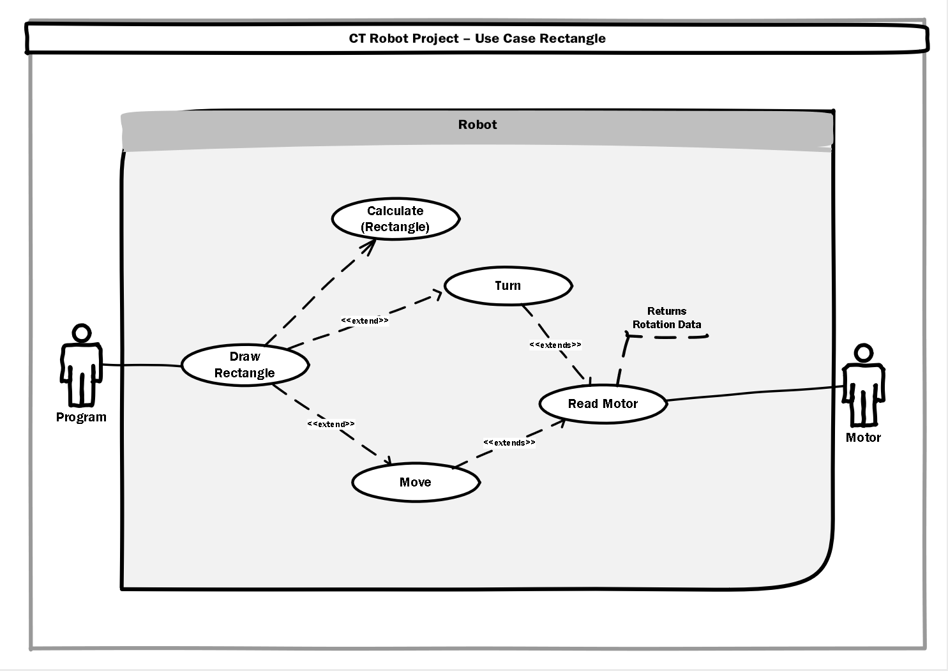
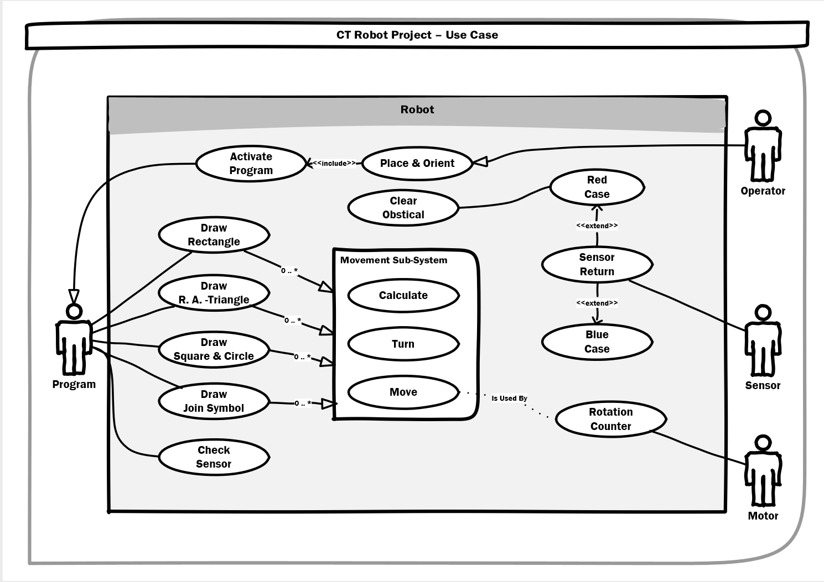

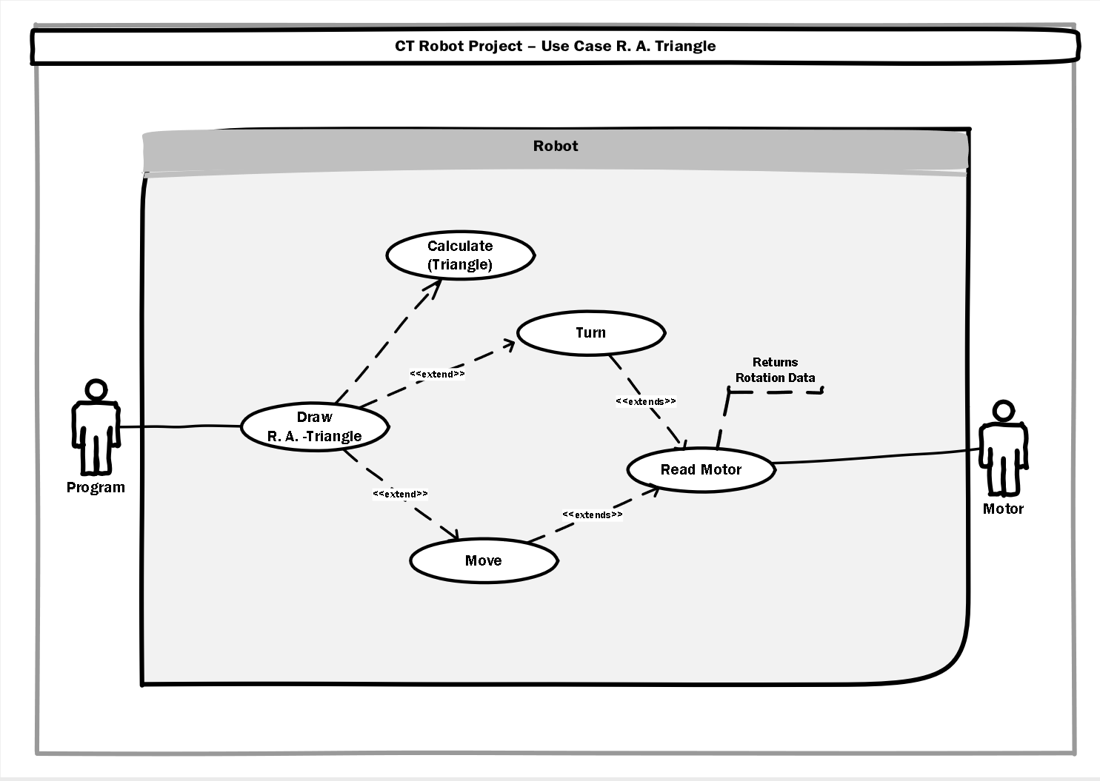
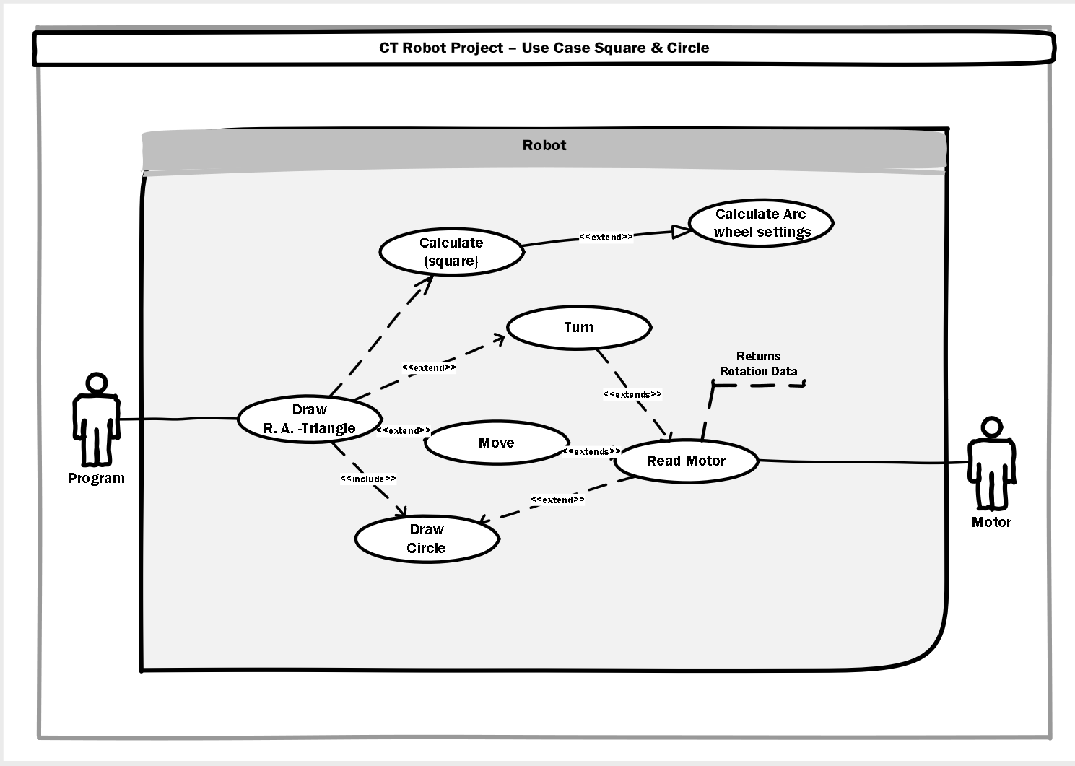
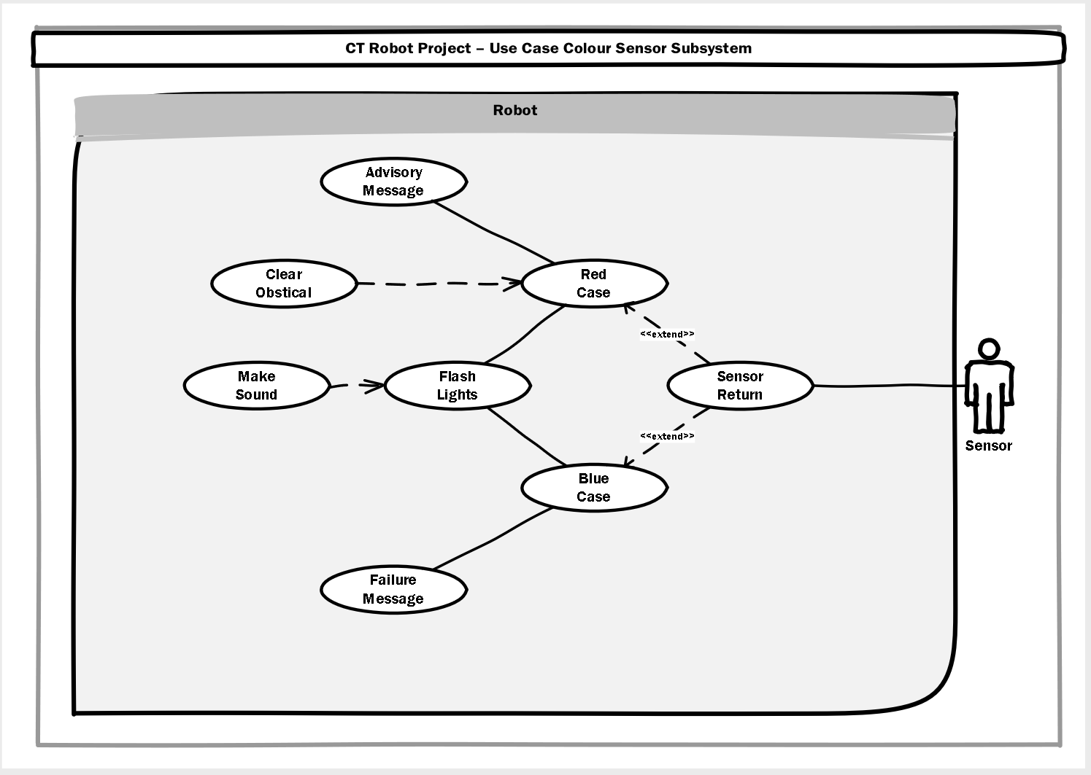
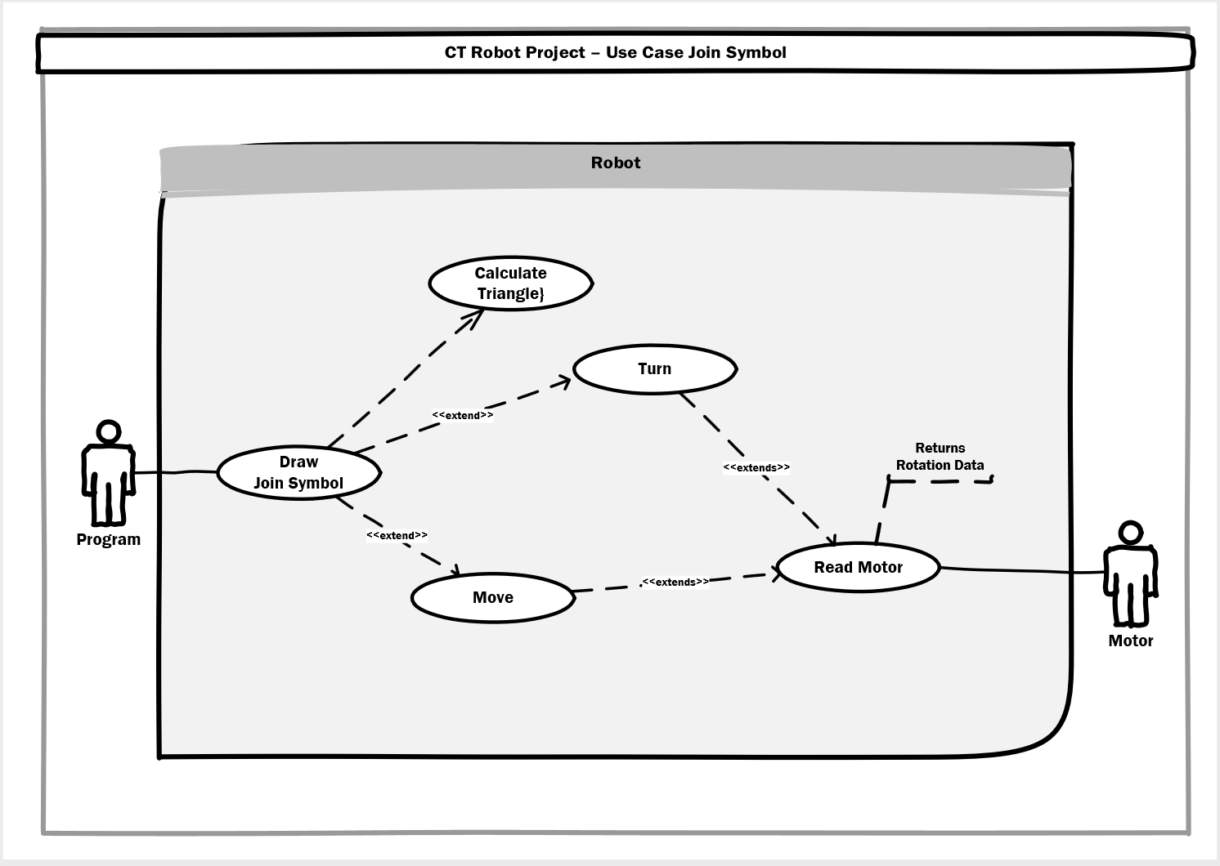

Use Case Documents

System Description
System Name: Mind Storms Robot Demonstration Scenario
Risk Factors
Failure to complete project will result in a module fail.
System Level Use Case Diagram
Actor: User
Case: Place & orientate
Case: Activate Program
Actor: Program
Case: Draw Rectangle
Case: Draw R.A. Triangle
Case: Draw Square & Circle
Case: Draw Join Symbol
Actor: Sensor
Case: Sensor return
Case: Case Blue
Case: Case Red
Case: Remove Obstacle
Actor: Motor
Case: Read Rotation Counter
Architecture Diagram
Three system interfaces that are Program, Sensor and Motor Detection. The robot has an EV3 Brick that houses the processor and a user interaction interface.
Subsystem Descriptions
There are two Main sub systems, these are the sensor detection routine and the movement subsystem that provides functionality for the shape drawing processes

Use Case Descriptions
Use Case Name: Draw Rectangle
Actors: Program, Sensor, Motor
Priority Status level 1
Pre-Conditions: No Required initial conditions
Post-Conditions: Robot to have conducted four turns with two runs at 15CM and two runs as 10cm. Three iterations of the process to be run with side lengths being increased by 10Cm per process. Robot should stop on initial start point. Sensor process will interact if the color sensor detects a coloured strip. At end of run, the robots display should show the calculated area.
Extension Points “Used”
The Processes: Move, turn and calculate are extensions from the calling process.
Use Cases
Draw Rectangle
Calculate(rectangle)
Turn
Move
Read Motor

Use Case Name Color Sensor Subsystem
Actors Sensor
Priority Status Level 2
Pre-Conditions Robot must return to start position for each iteration
Post-Conditions Dependant on color detected. If Blue, Program will be halted with lights, alarm and message. If Red, robot will halt, call the clear obstacle message and then return to calling process. Clear obstacle is dependent on Case Red being run. Sound and light alerts are likewise co-dependant.
Extension Points “Used”
Red Case, Blue Case. Remove Obstacle is dependent on Red Case.
Use Cases
Sensor Return.
Red Case.
Blue Case.
Advisory message.
Clear obstacle.
Make Sound.
Flash Lights.
Failure message.

Use Case Name Draw Right Angle Triangle
Actors Sensor, Motor, Program
Priority Status Level 1
Pre-Conditions Robot must return to start position for each iteration
Post-Conditions Robot should move along three lines to form a right-angled triangle. Initial lengths of the opposite and adjacent sides are 10cm and 15 cm respectively. Distance for these sides will increase by 10cm for each of the three iterations. The sine and cosine angles are to calculated at the start of the process as is the length of the hypotenuse. As with the other cases, the sensor subsystem will activate if the color sensor is triggered. At end of run, the robots display should show the calculated area.
Extension Points “Used”
Move, Turn, read motor
Use Cases
Draw RA Triangle
Move
Turn
Read Motor
Calculate (RA Triangle)

Use Case Name Draw Square & Circle
Actors Motor, Program
Priority Status
Pre-Conditions Robot must return to start position for each iteration
Post-Conditions Robot has to run three times with the dimensions being increased by 10cm for each turn. Robot is to draw a square then after moving half way along the first side, draw a circle to fit inside the square with a radius equal to half the diameter of the square. At end of run, the robots display should show the calculated area.
Extension Points “Used”
Calculate Wheel Arc Settings. Used to set power ratios on the wheels to draw an arc to the proscribed radius.
Use Cases
Draw R.A. Triangle
Calculate (Square)
Turn
Move
Draw Circle
Read Motor
Calculate Arc Wheel Settings

Use Case Name Draw Join Symbol
Actors Program, Motor
Priority Status Level 1
Pre-Conditions Robot must return to start position
Post-Conditions Robot is to draw two horizontal opposing equilateral triangles. At end of run, the robots display should show the calculated area. Initial starting length for the triangles will be 10cm per side with an additional 10cm added per iteration. 3 iterations of the shape are required.
Extension Points “Used”
Read Motor
Use Cases
Draw Join Symbol
Move
Turn
Read Motor

BPMN Diagrams
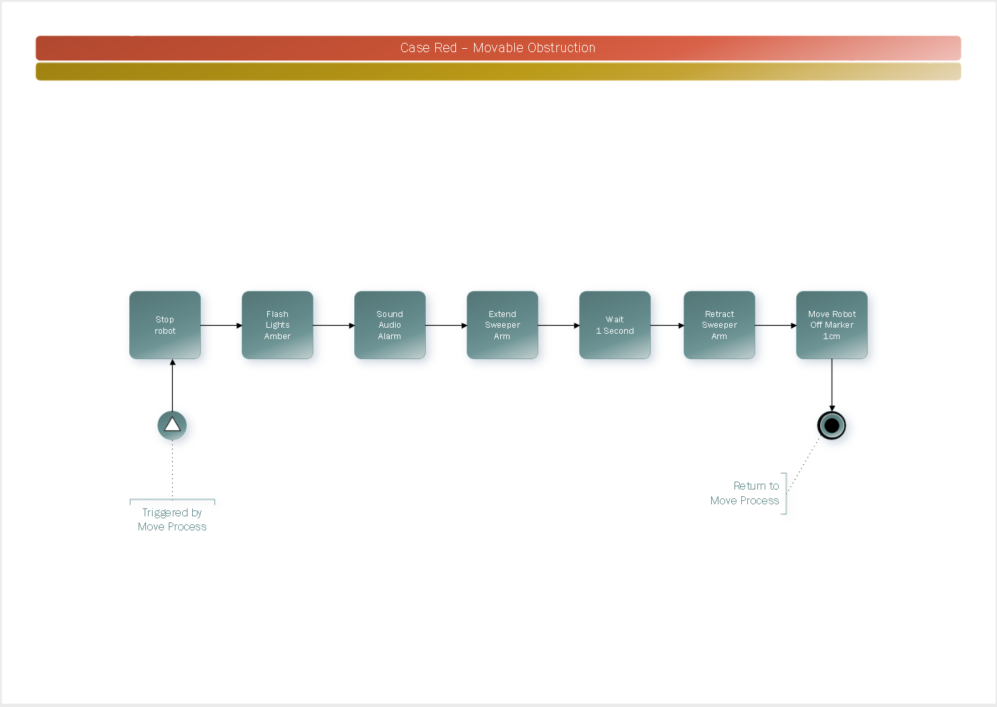
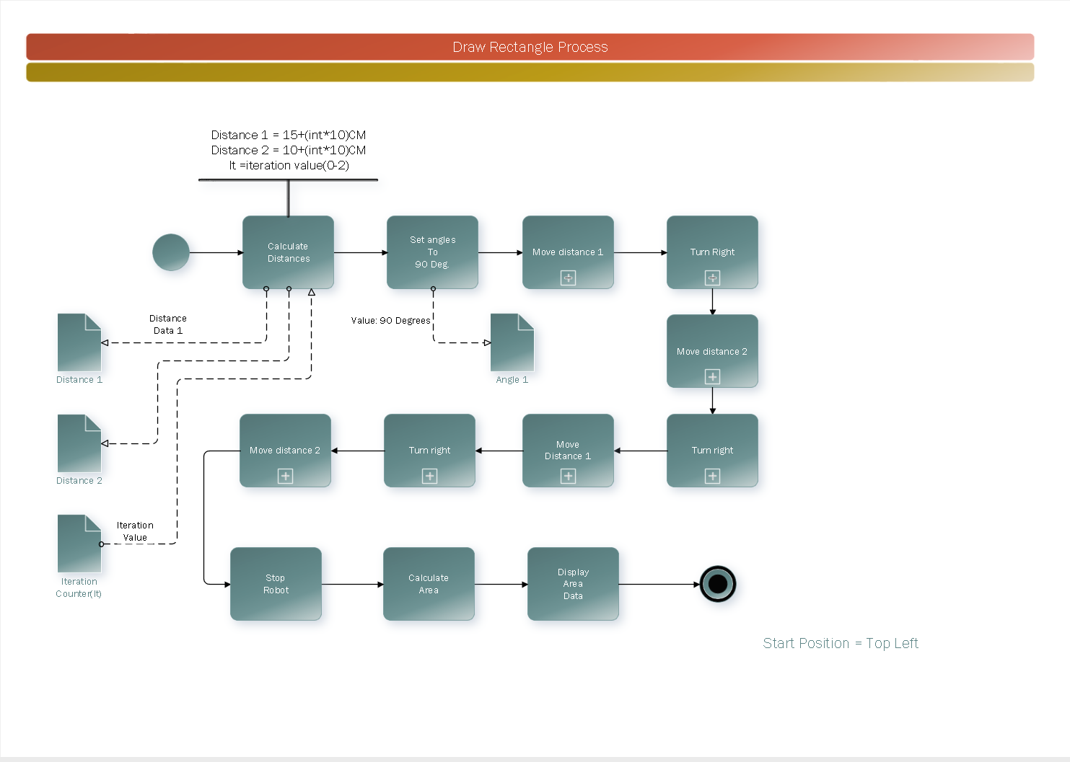
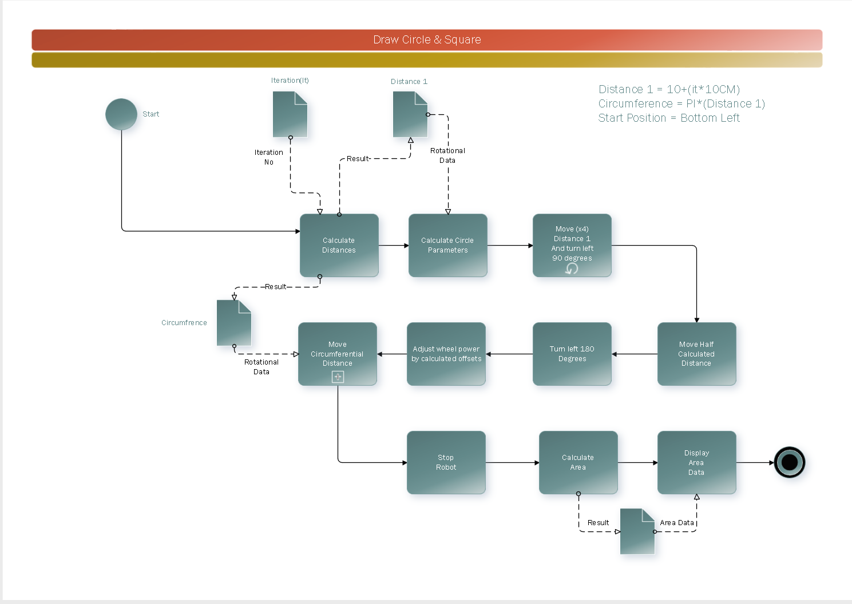
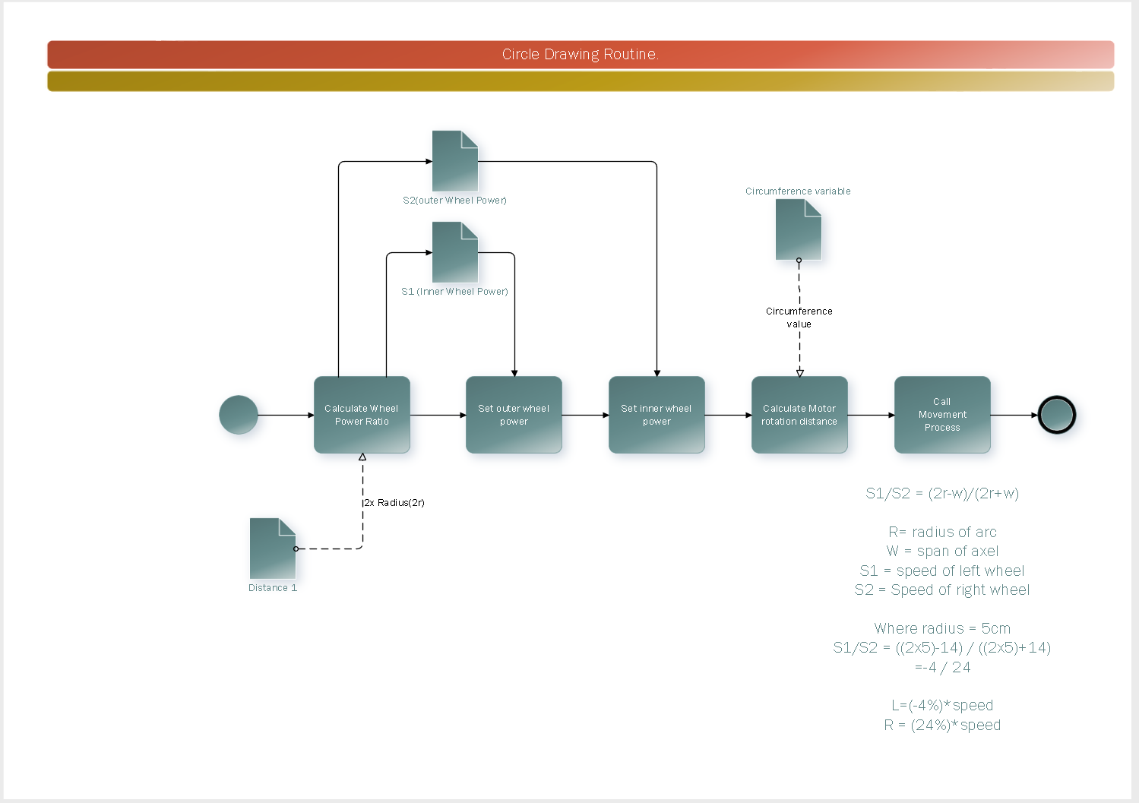
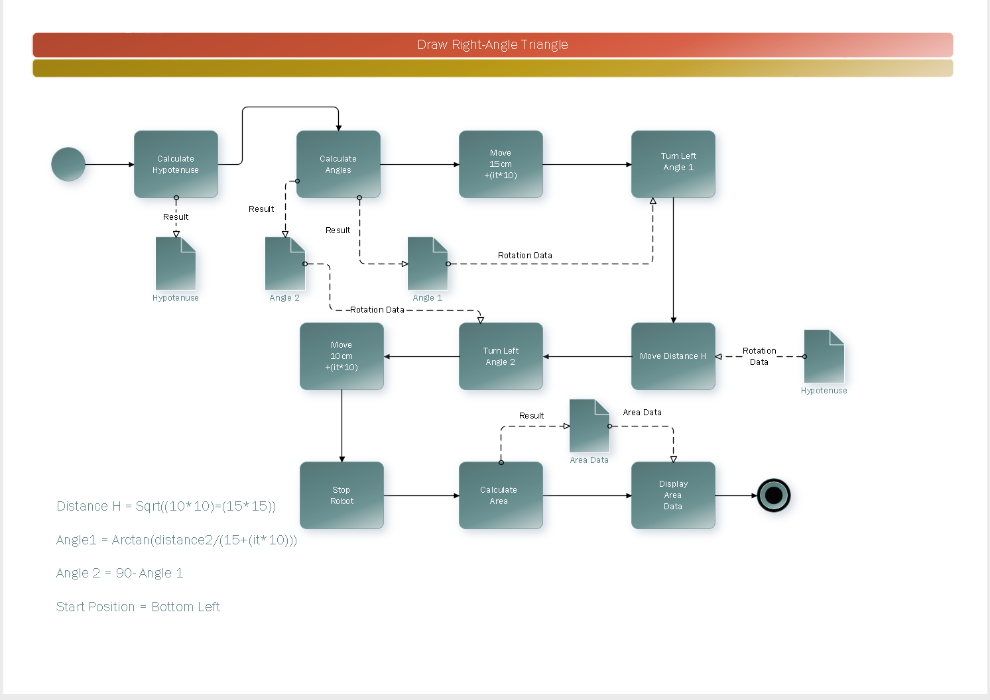
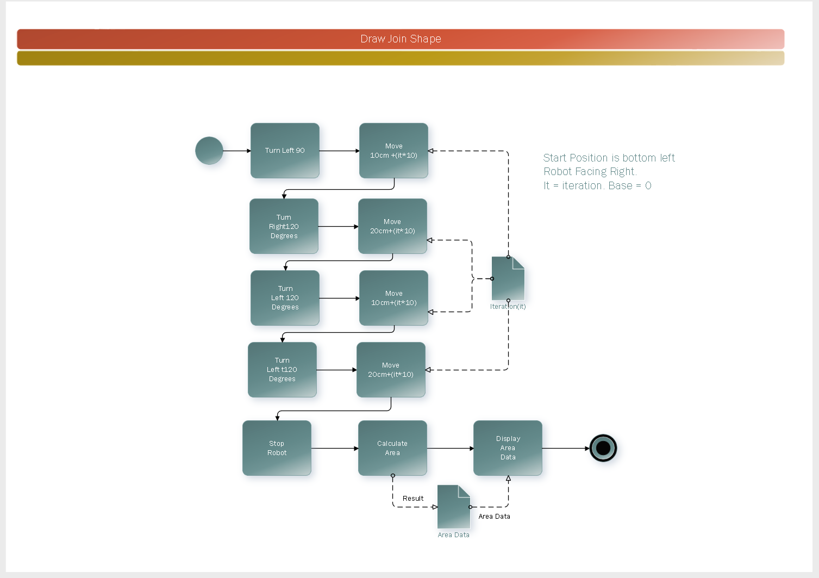

Robot Coding

Sensor Detection Routine
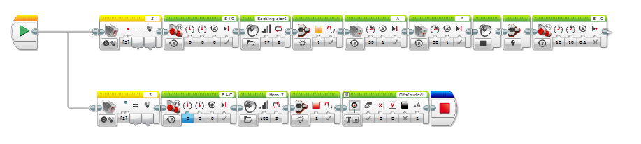

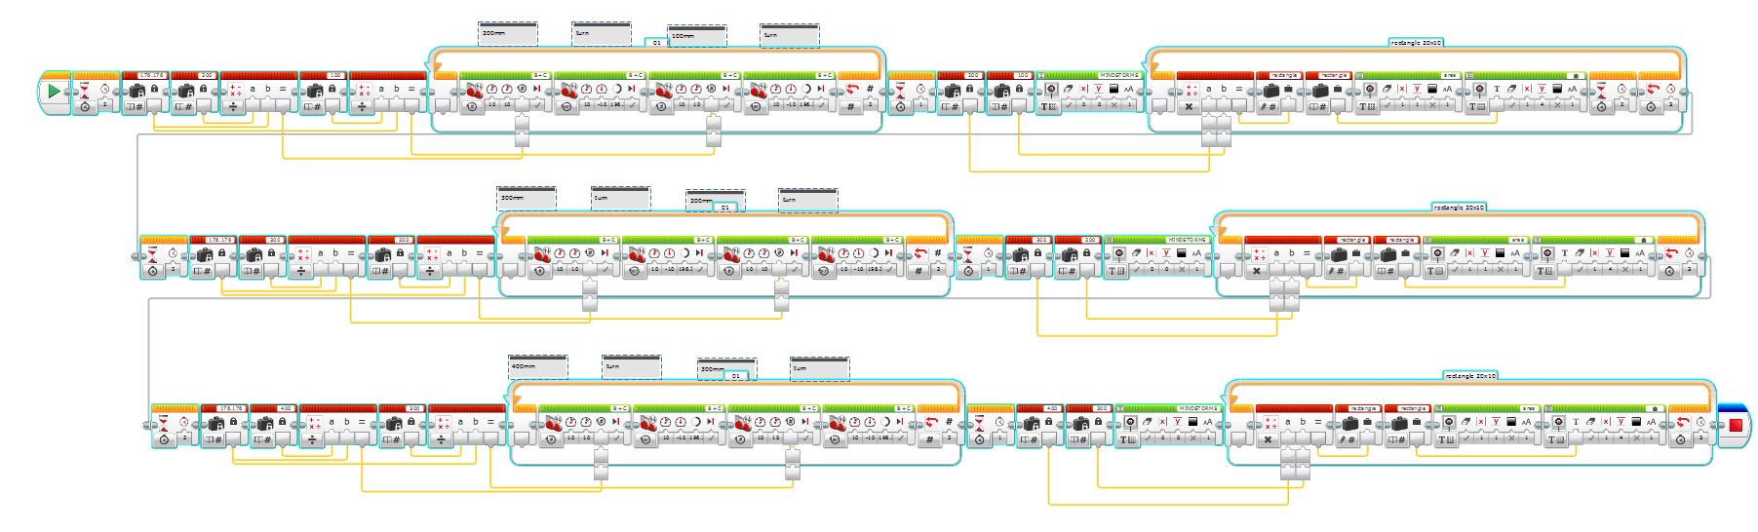
Draw Rectangle

Draw Right Angled Triangle 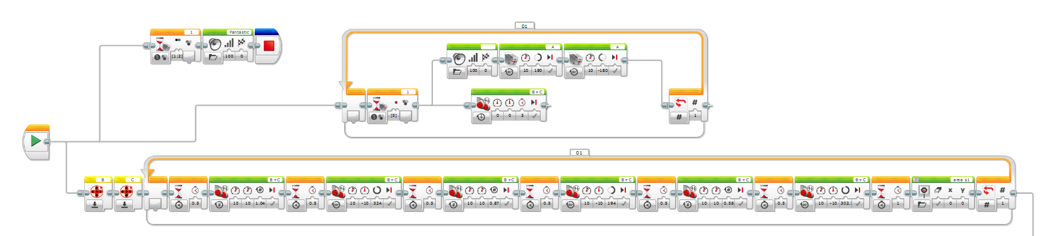
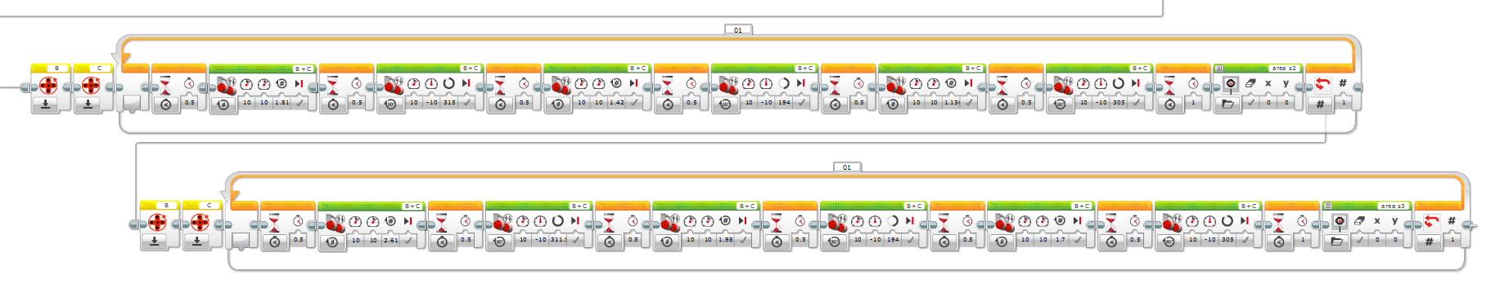

Draw Square & Circle 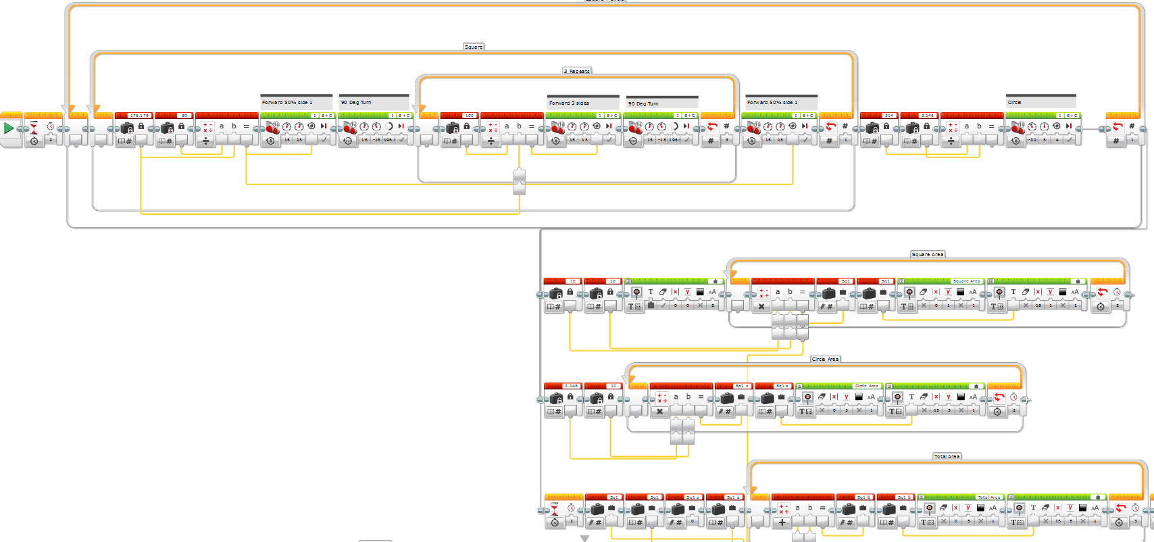
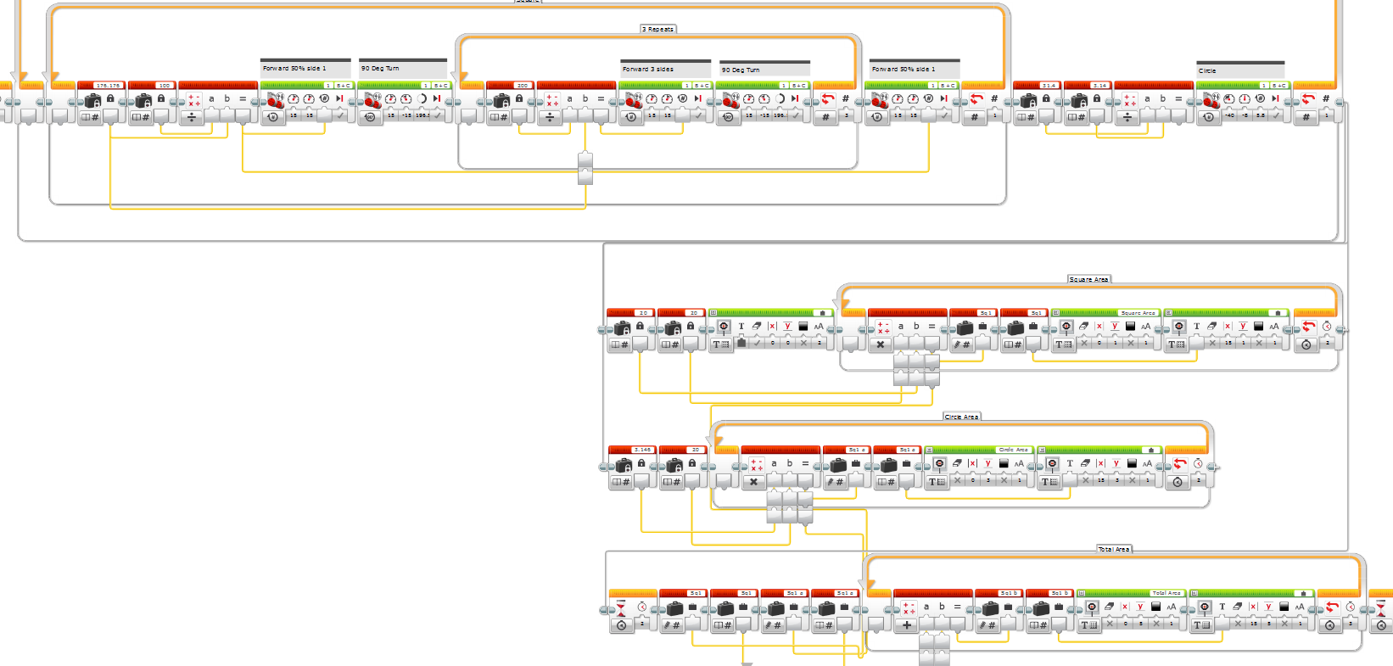
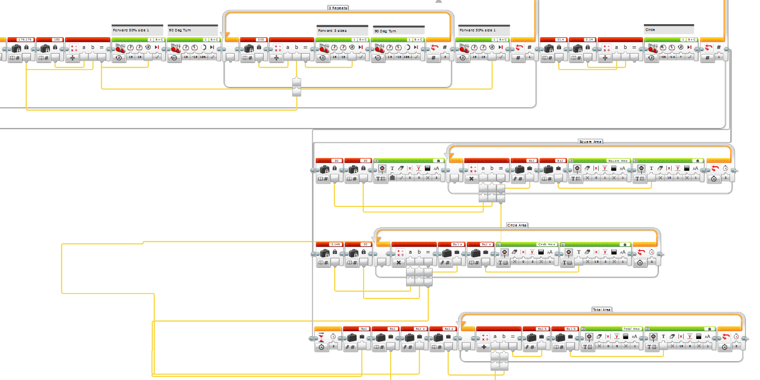

Draw Join Symbol 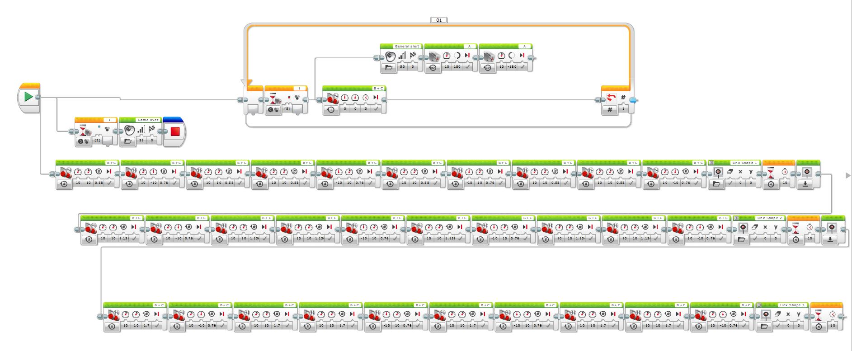

Robot Design Photo’s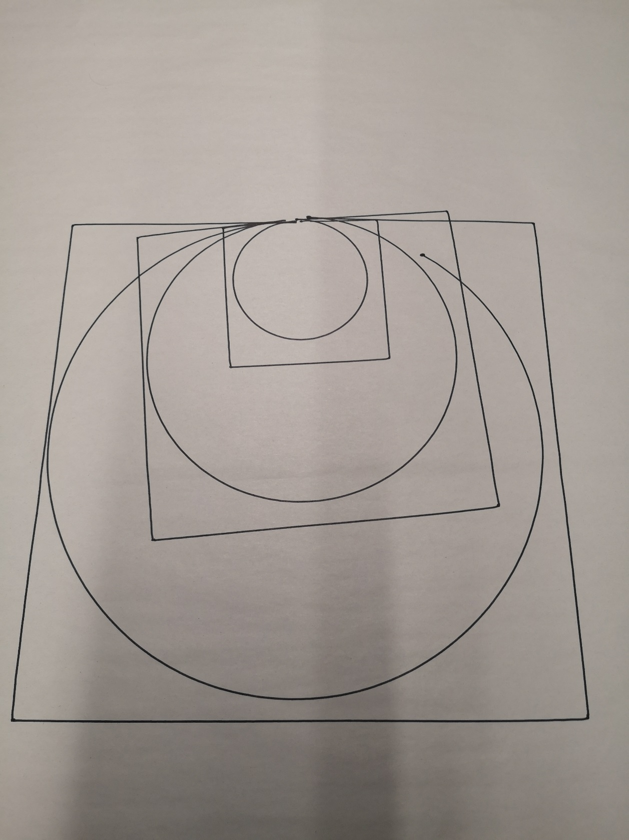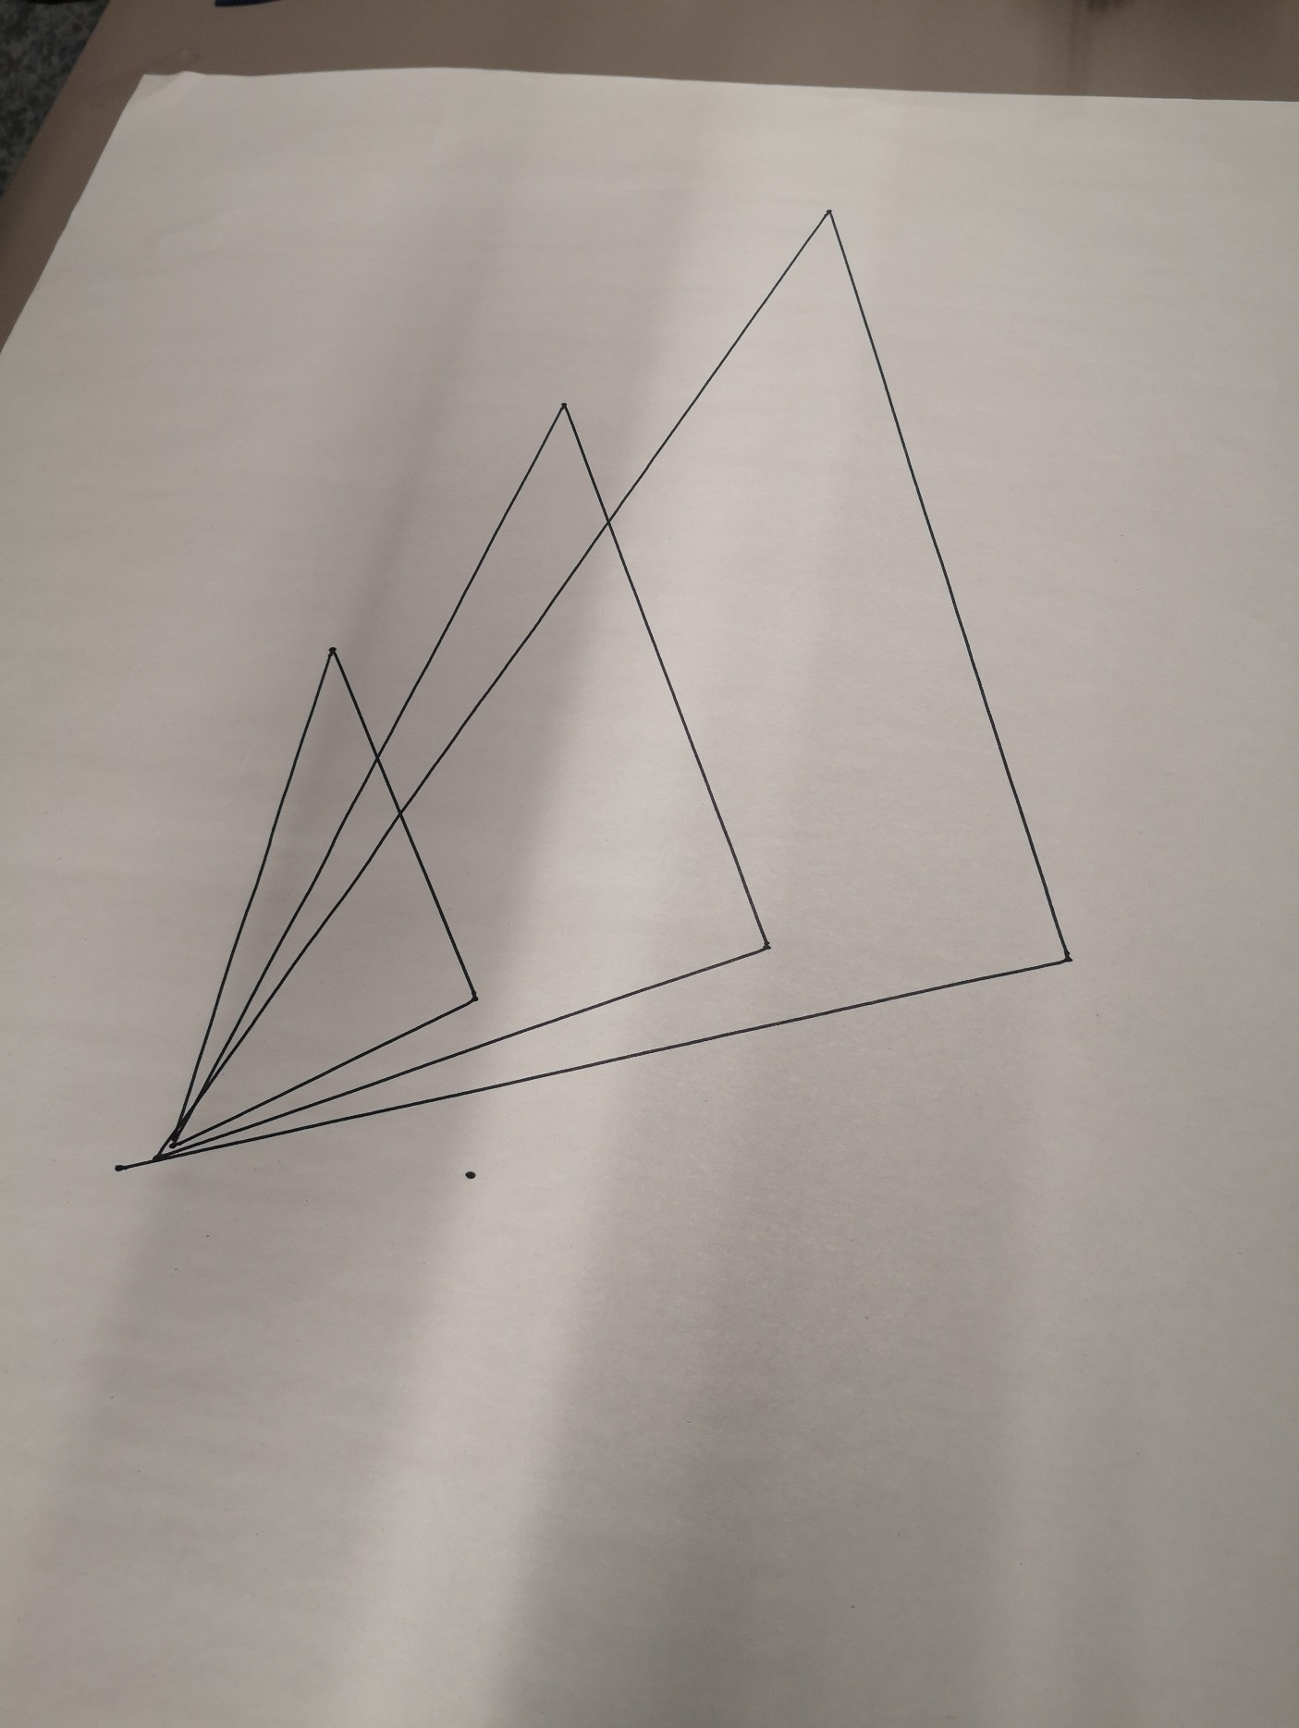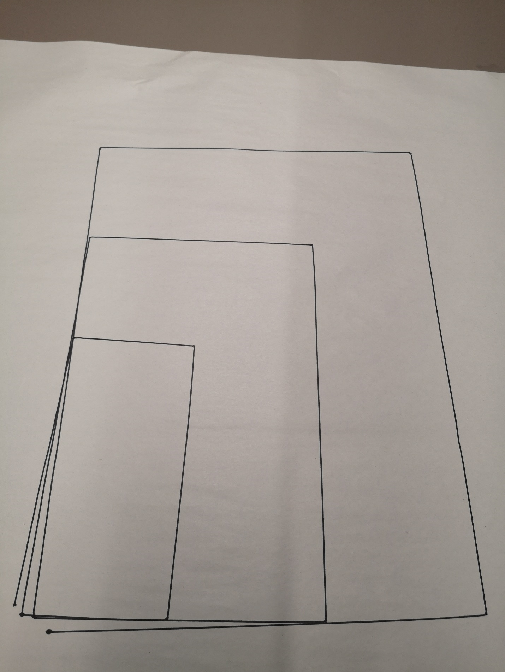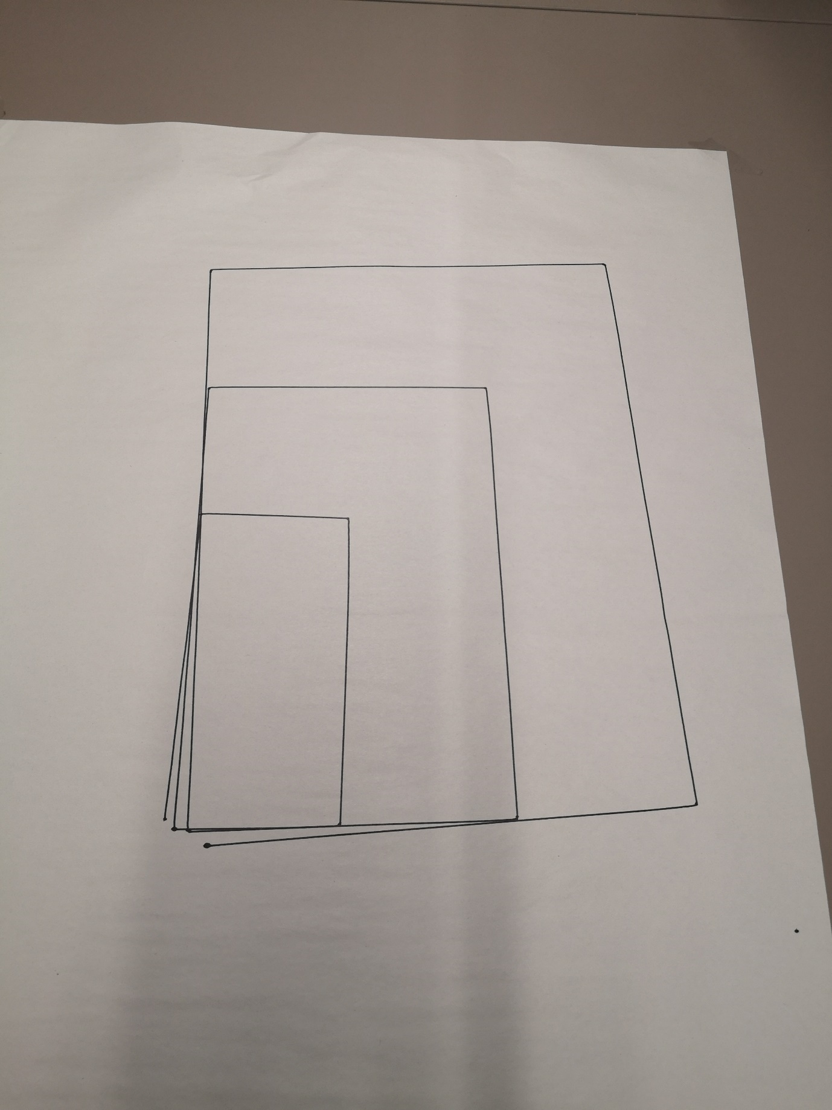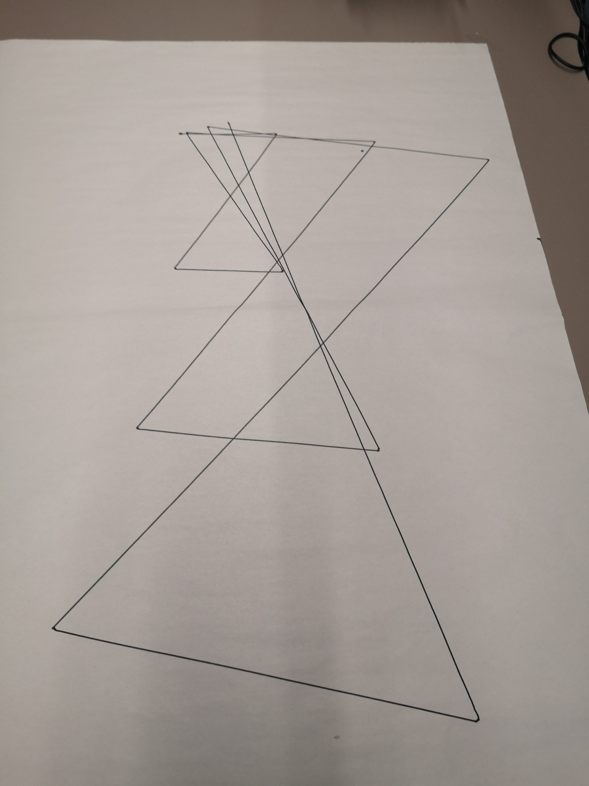
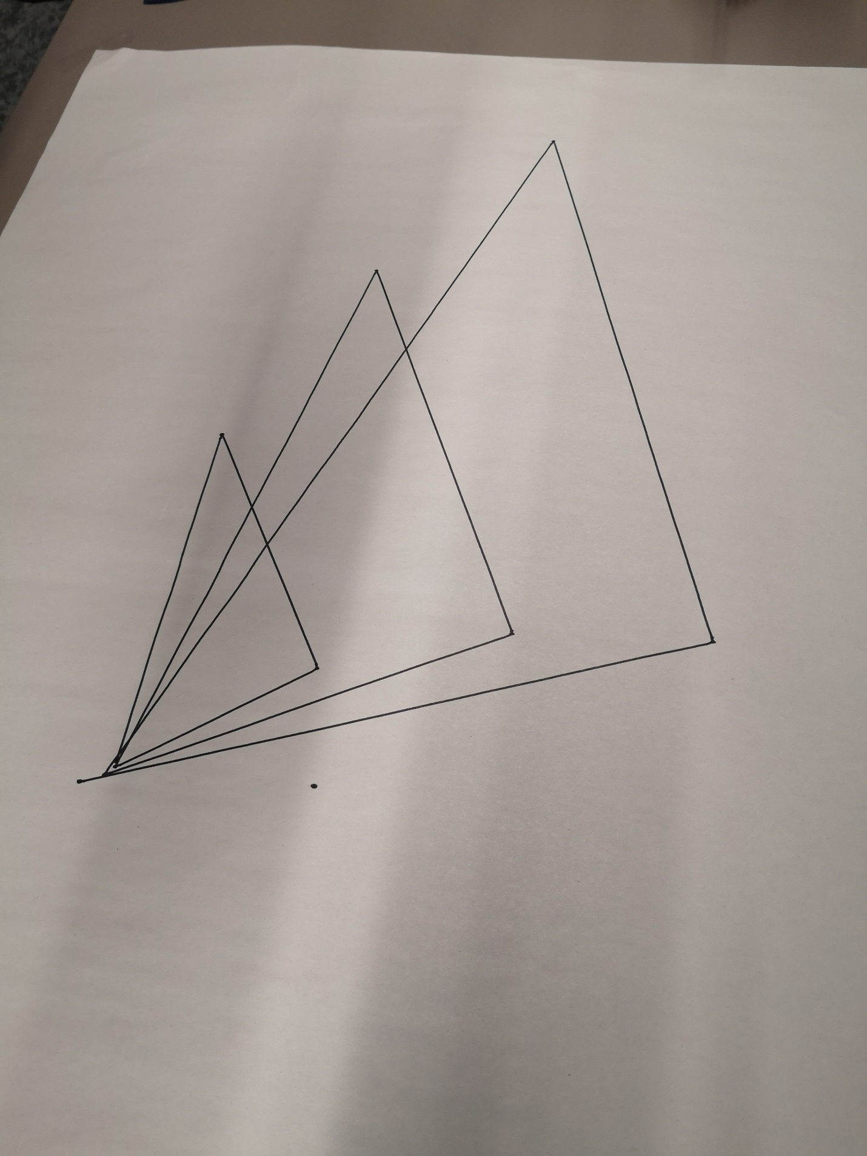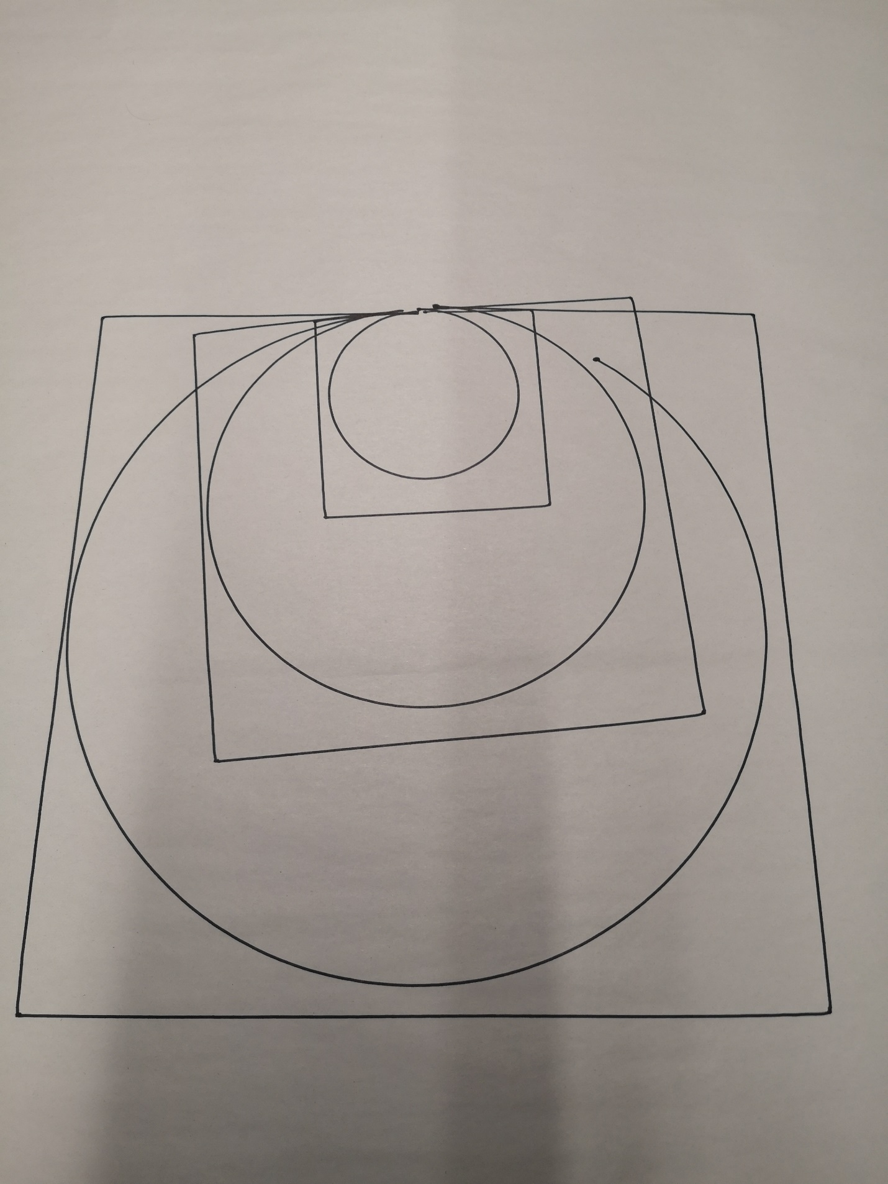

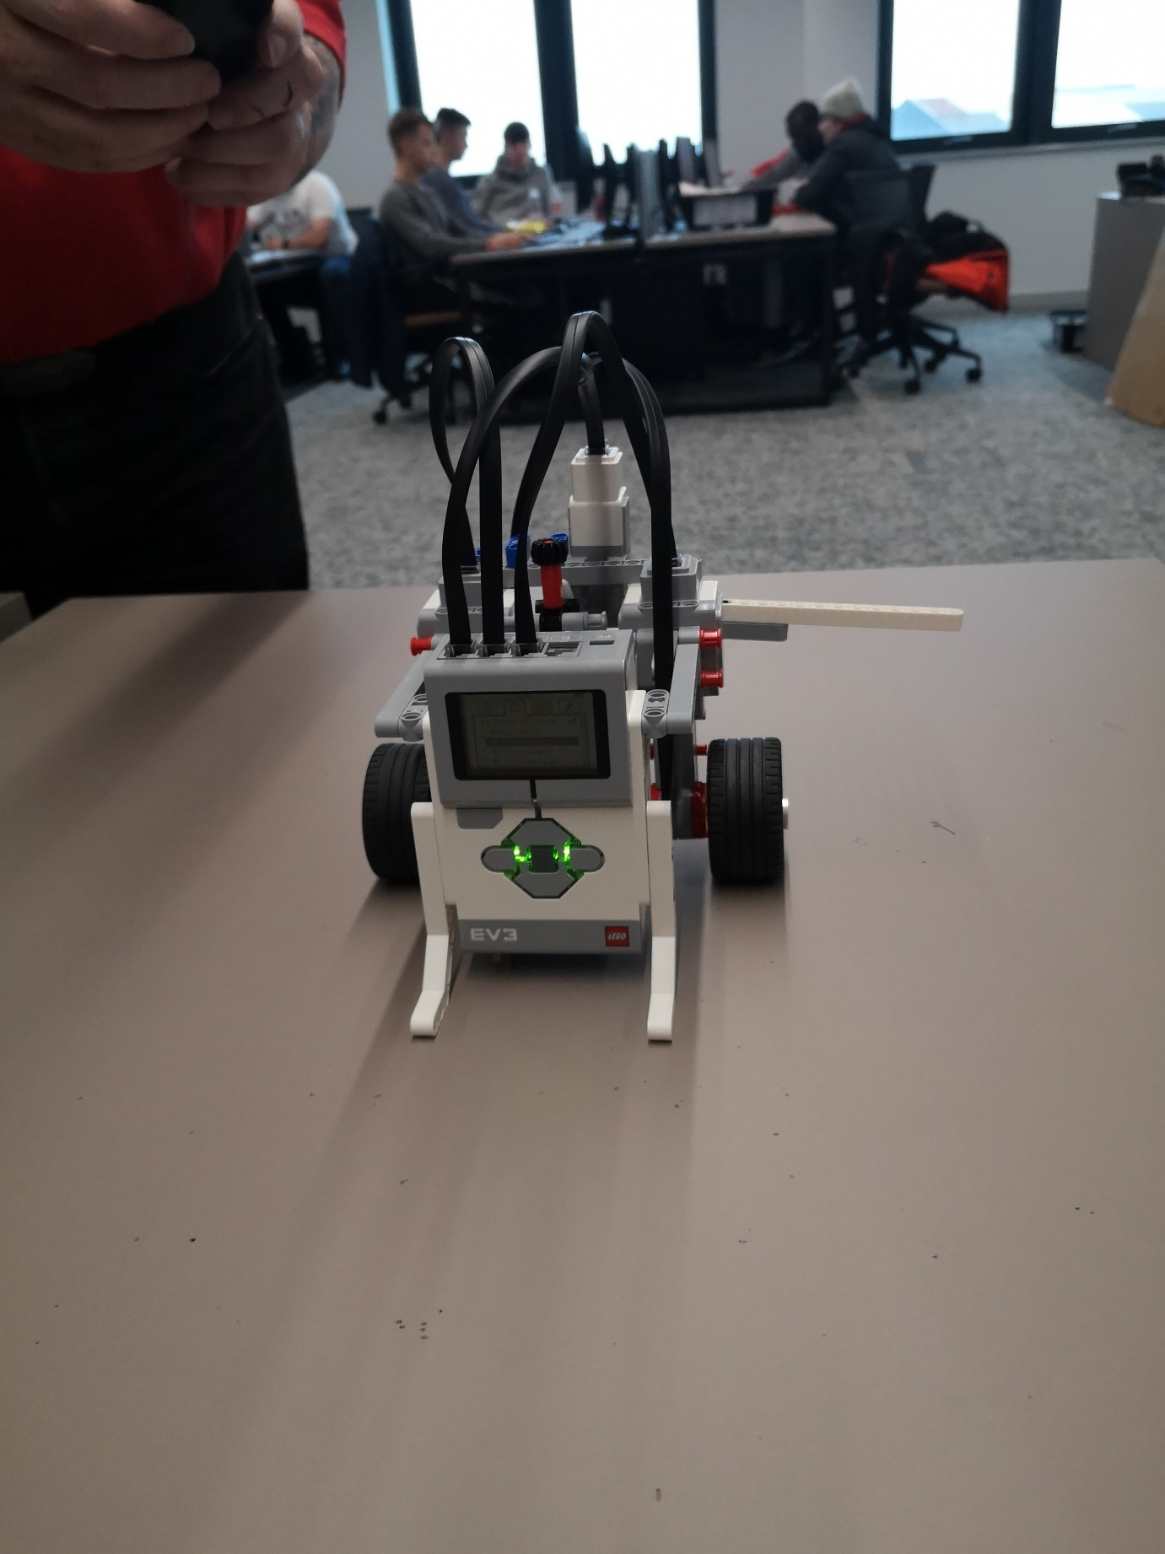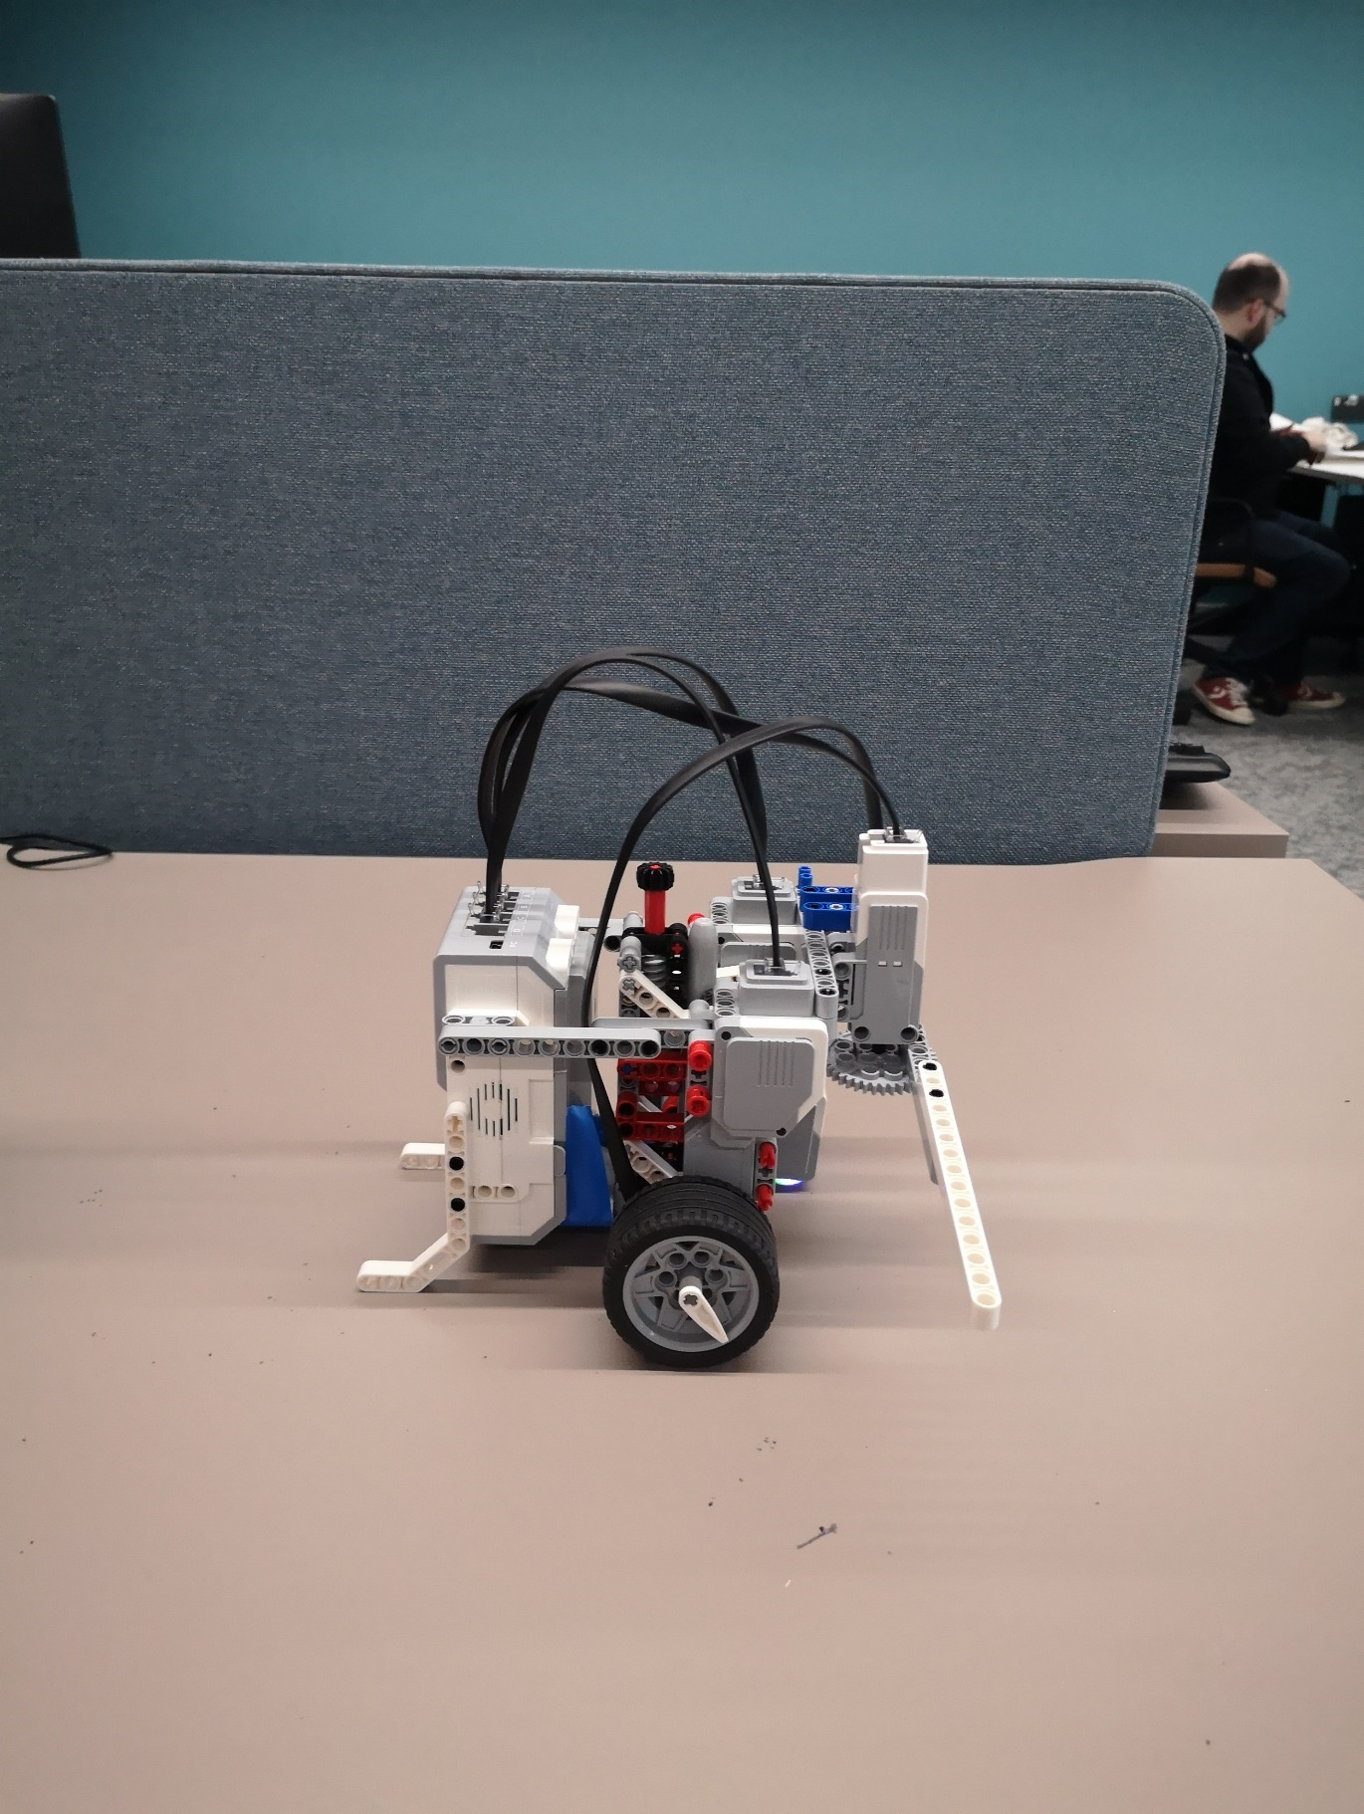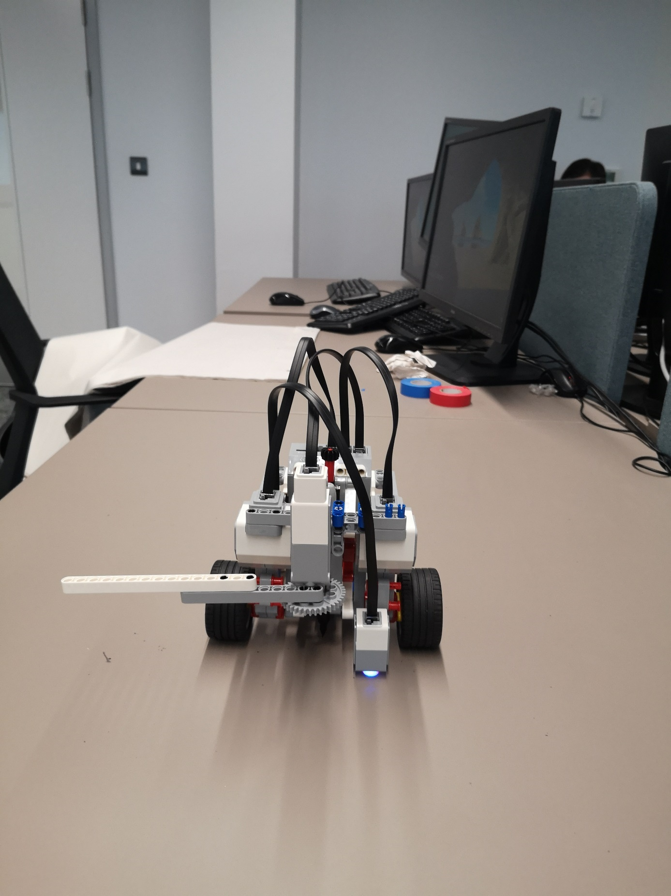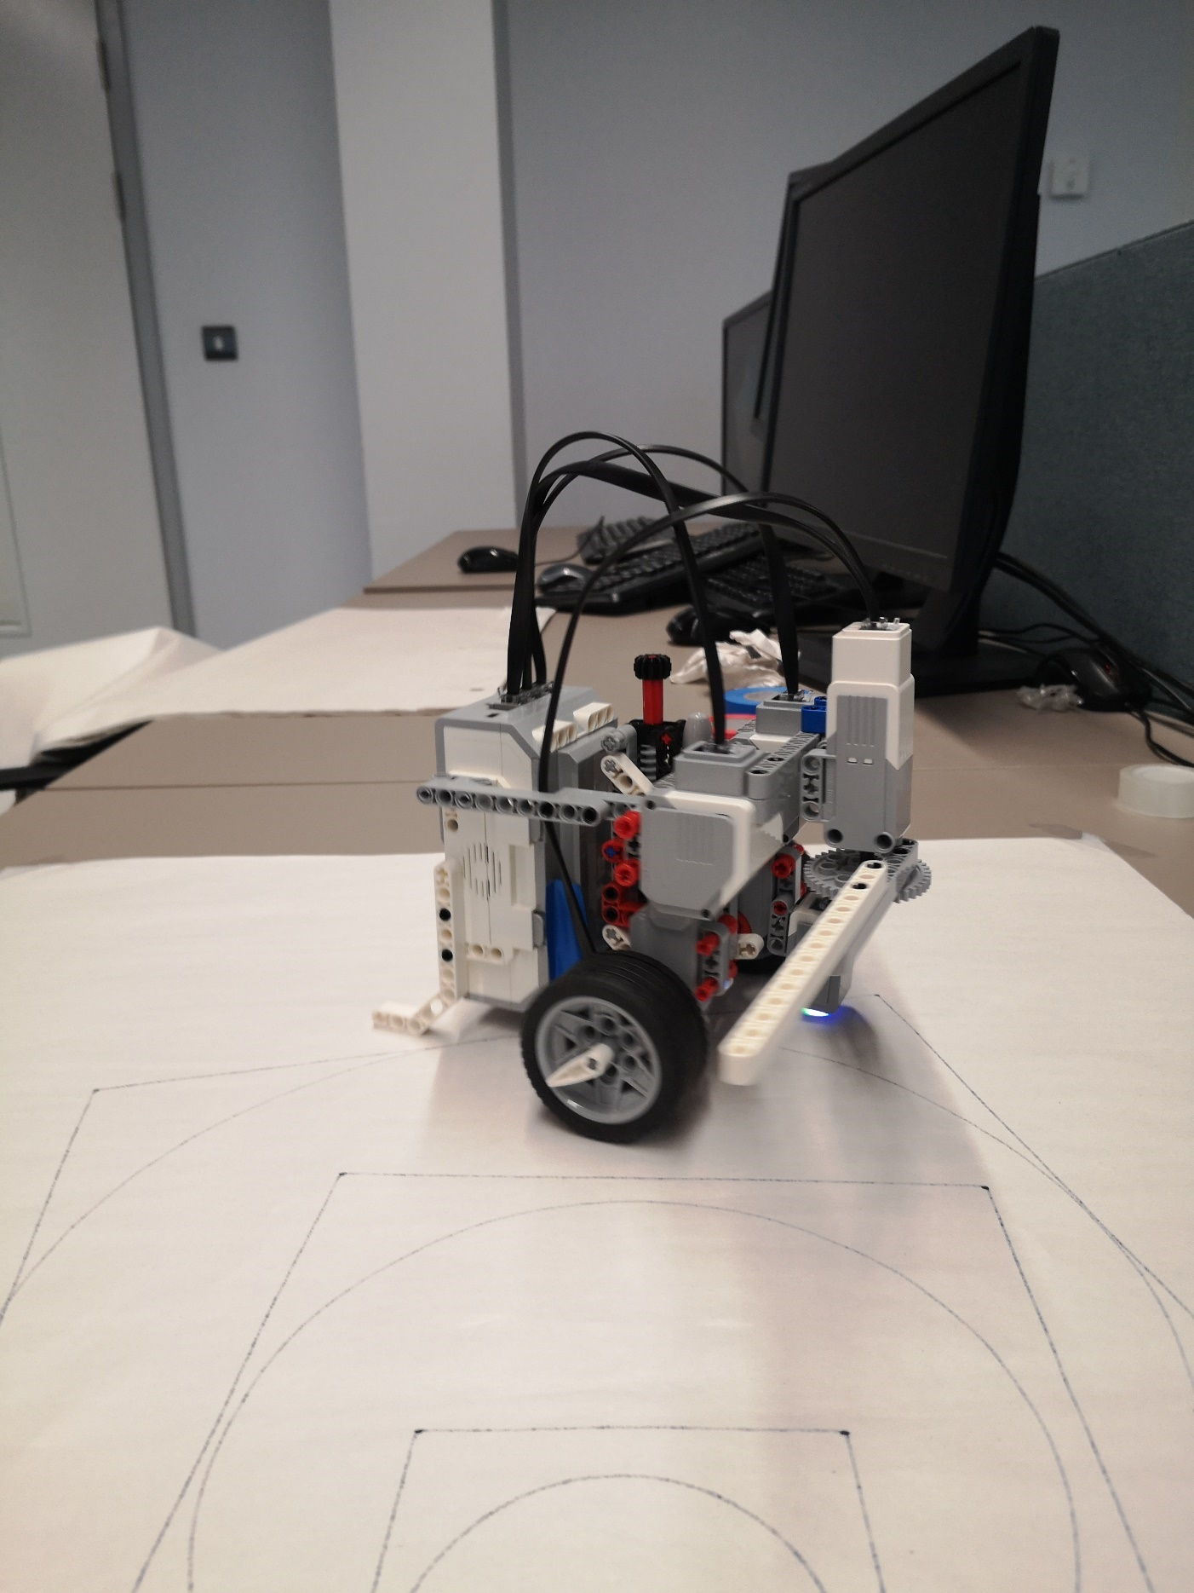

Bibliography
No hard copy was referenced.
On-line resources:
[1] Website: https://sites.google.com/site/ev3basic/ev3-basic-programming/going-further/writerbot-v1/drawing-arcs accessed 20/1/2020
[2] Website: https://www.geeksforgeeks.org/mid-point-circle-drawing-algorithm/ Accessed:19/1/2020
[3]Website: https://bricks.stackexchange.com/questions/6446/ev3-turning-in-circles Accessed 21/1/2020
[4] Website: Lego EV3 Help Page - https://ev3-help-online.api.education.lego.com/Education/en-gb/page.html?Path=editor%2fpage.html%3fPath%3dblocks%252FLEGO%252FCaseSelector.html#Mode_SwitchColorSensorCompareColor Accessed 17/1/2020
[5] Website: BPMN Archives - https://www.businessprocessincubator.com/category/topic/bpmn/ Accessed 17/1/2020
[6] Website: Lego Education - https://education.lego.com/en-us accessed 17-1-2020
[7] Website: Google Scholar -https://books.google.co.uk/books?hl=en&lr=&id=svrlAwAAQBAJ&oi=fnd&pg=PR5&dq=lego+mindstorms+ev3&ots=GpXs3tLFt6&sig=gPHwXGhmnFrWbdtgpZr95JAnO7M&redir_esc=y#v=onepage&q=lego%20mindstorms%20ev3&f=false Accessed 22/1/2020
[8] Website: IBM - https://www.ibm.com/developerworks/rational/library/content/legacy/parttwo/1000/0670/0670_Schneider_Ch07.pdf Accessed 23/1/2020

