

Assignment 2

Continental Hotel Budget Planner

Module: Financial Management for the Hotel Industry

Student: Alexandra Gabriela Atofanei

Student number:2017051

Lecturer: Dale Clarke

- Introduction

This report purpose is to present the budget planner (cash flow forecast) for the Continental Hotel, a 15-room hotel situated in London.
The first part will describe a excel template, where will be attached all the payments done within the hotel for one year period. Also, the excel template will show the budgeted income and expenditure, opening and closing balance in the hotel bank balance. This will be followed by a background in budgeting, where some information will be included regarding budgeting. The second part will include an understanding of traditional based budget and zero-based budget and how this can be implemented will be described for a good understanding. The last part of the assignment will be presented with the ides of the budgeting control and support sustainability. The conclusion will summarise all the information given in the report to clarify the knowledge necessary to be provided to the regional account director. The last part of the report will include the references according to the research found regarding this financial report.

- The Continental Hotel Budget Planner

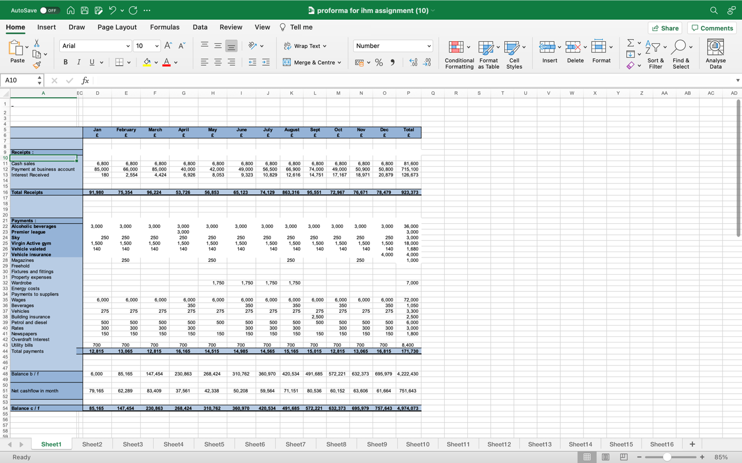

This excel template shows the budget planner for the Continental hotel for over a year period, started from January 2022 and finish in December 2023. This template will help the accounts directors to see and understand the process of the budget and the payments done for this period.

- Budgeting background

According to Garner (1991) budgeting has numerous definitions, but generally refers to the internal approval, external adoption and allocation of funds required in the operation of an organisation.

As the template excel shows for the Continental Hotel , the budgeting is described every month for one year period and shown the payment at the business account. During the one-year period the payments are different for each month and the forecast is done from January 2022 to December 2023.The budget is one of the most important part of the financial planner because describe the essential information which needs to be provided to the accounts directors in order to clarify and analyse the good plan for the hotel forecast.

The budgeting is a process to consider a business estimates income (which are the money comes into the business) from services or selling products and expenditure money that gives out from bills and expenses over a period in the future. This authorize the business to see if they will be able to continue operating at their expected level. The budget is important because help you to notice what money comes in and out of a business ( What is budgeting, nd).

The budget can be classified in four common types: incremental, value proposition, activity based and zero based. Incremental budget is the common type because is easy and simple to understand. The value proposition budget is a mindset about making sure all is included in the budget delivers advantages for the business. The activity based budget is a type of budget that control the amount of inputs required to support outputs or targets regulate by the company, The zero based budgeting, as one of the most common starts with the supposition that all the department’s budget are zero , they must be rebuild from scrape (The four main types of budgets and budgeting methods, nd).

According to Richards ( 2006) the main purpose of budgets is to help implement a firm’s strategy , not just controlling and planning . The changes in the economic environment and business process led to evolutions and budgeting.

- Traditional based budget

Traditional budgeting is one of the methods used for this construction of the budget by the company for a specific period under consideration where the budget of the previous year is considered as the base using a budget of the current year which is prepared and the current year budget is made by making swap in budget of last year (What is traditional budgeting? nd).

Chan (2003) cite that the traditional budget plays an important part in management of public finance sector entitles.

Regarding the traditional budget as can be seen in the excel template for Continental hotel , this method is helps the budget planner preparation started from January and finish in December. As can be observed from the excel, the total receipts are done for every month period for one year time.

Disadvantages of traditional budgeting are the following: inferences-which can lead to data error and difficulty in break-up accurate information, low change responsiveness, disconnection from strategic plan and failure, to motivate advantageous behaviour.

Advantages of traditional budgeting and the following:
-implementation -this saves a lot of time for managers.
-decentralisation.
-stability-financial activities are done with coordination.
-ease of preparations.
-consolidation-help to improve the performance (Advantages and disadvantages of traditional budgeting approach, nd).

Jonsson & Akerlun (2012) cite that traditional budgeting can be called fixed budgeting.
According to Ekholm &Wallin (2000) the most common and foremost alternative to traditional budgeting among organisations is the rolling forecast. In this situation the budgeting is based on a monthly, quarterly on half yearly forecasting.

- Zero-base budgeting (ZBB)

Zero base budgeting is a means of budgeting where all costs must be justified and accepted for each new period (What is zero-based budgeting, nd).

According to Al-Saadi (2015:35) , the zero-base budget requires the administration to conduct a comprehensive and systemic evaluation of the previous and current programs and projects of the administration included in the general budget proposal. It does not give any priority to existing program and projects (under implementation, propsed new projects) when allocating financial budget or cancel projects.

Regarding the excel for Continental hotel, the zero- base budgeting includes all the expenses for the hotel , which are the monthly payments done by the hotel every month. This payments are the following: alcoholic beverage, premier league, sky, virgin active gym, vehicle valeted, vehicle insurance , magazines,, wardrobe, wages, beverages, vehicles, building insurance, petrol and diesel, rates ,newspapers.

Stages of zero-based budgeting are the following: identification and description of decision packages, induction of decision packages, prioritisation of the decision packages and allocation of resources ( Zero-based budgeting, nd).

Hartman (2010) cite that ZBB is an approach of planning and decision making which reverses the working process of traditional budgeting.
Zero-based budgeting advantages are: it prioritizes resource allocation efficiency, it’s built an east benefit analysis, it strengthens strategic growth and promotes optimization ( The Advantages and Disadvantages of Zero-based budgeting,nd).

Disadvantages of zero-based budgeting are the following: detrimental to the long term goals, subjective in nature, skills and managerial conflicts, inflexible ( Advantages and Disadvantages of zero based budgeting, nd).

- The process of zero-based budget and how this can be implemented

The zero-based budget methodology works in contrast with traditional annual budgeting. Zero based budget ask organisations to build their annual budget from zero each year to help verify all the structures of the annual budget.

The fundamentals of zero-based budgeting according to Deloite:
-budgets are not connected to the years spending;
-prevents embedding of existing spending ;
-permit spending levels to be based on the necessary activities.
-require more work than legacy programms.

Five zero-based budgeting best practices:
-identify the quick wins.
-adopt a positive approach.
-don’t do it alone.
-select the right planning platform ( The ultimate guide to zero-based budgeting, nd).

The process of zero-based budget for the Continental hotel is approving all expenses for each period. Everything is started from a zero -based budget and after all the payments are allocated to each expense to pay monthly.
The zero-based budget can be implemented in time with evaluation and planning of the money which enter In the business. Continental hotel planner is monthly and is very well organised to prove the calculation over the periosd.

Hartman (2010) cite that zero-based budgeting is an approach of planning and decision making which reverses the working process of traditional budgeting. Each programme or decisions package has to be justified annually, relating to all costs to system goal and services.

Eight tips for successful zero-based budgeting implementation:
-use enabling technology to drive your zero-based budgeting process;
-be clear about what you want to achieve;
-train your budget holders;
-know your drivers;
-ensure you have management buy-in;
-develop your change management plan;
-consider using one outside advisor ( What is zero-based budgeting, nd).

- Can budgeting control support sustainability

According to Kidd (1992) the concept of sustainability is not new, it has a rather long history, and it has evolved over time. Importantly, this evolution has been affected by different , intellectual and political streams of thought that have moulded concepts of sustainability.

Gray (2010, p53) cite that sustainability is not only a complex and elusive notion but one which is fraught with potential contradictions.

Good budgeting supports financial sustainability and a programme of activities with then three documents: the budget which you need to provide you have money, the actual report, the budget and the cash flow and also you need to show you have enough money to pay the bills ( Good sustainability support financial sustainability , nd).

According to Kamara et.al.,(2006) the concept of sustainability can be traced back to the thirteen century , but in more recent times it appeared to in the environmental literature in the 1970.

According to McCann-Erickson’s (2007) sustainability is a collative term for everything to do with responsibility for the world in which we live. It is about consuming differently and efficiently. It also means sharing between the rich and the poor and protect the global environment.

Sustainability, as can be observed in the excel template for Continental hotel is presented the capacity to maintain a process over a time period as Continental hotel example which is over one year period.
The budget can control an support sustainability, as well as every money goes in the right place , the right time and is not a debt. Everything needs to be calculated from time and analysed all the monthly payments necessary for the business. This is important for the plan of the company to be everything calculated and processed for the best interest and also for a good profit..In the same time , the sustainability is well organised in the report and the connection with the budget helps to give a good overview importance to the calculations done within one year period as is shown in the excel template of the Continental hotel.

The three dynamics of sustainability commutes: economy, ecology and equity. Economy is the management and resources to meet commutes and household needs. Ecology is the pattern of relationship between environment and living things. Equity is fairness. Everyone in a community shares in its well-being (Three dynamics of sustainability commutes: economy, ecology and equity, Nd).

- Conclusion

The overall report presents the understanding of a budgeting background which is followed by a excel template which shows the Continental Hotel budget planner over a year with all the calculations and payments. After this the traditional based budgeting and zero-based budget was presented and analysed for a better understating. The process of zero-based budget and how this can be implemented was described also followed by the budgeting capacity to support sustainability.
This report gives details of the zero-based budgeting technique with a view to implement this type of budgeting in the future for a better approach. The excel template helps to understand the monthly payments for the hotel and to be aware of the forecast which is very essential for a good organisation of the hotel. As in every business, everything must be taken from time and analyse the payments can reassure also a profit during a time period.
This report will help Continental hotel to have a point of start for the future budgeting approach and organisation and to clarify all the methods and calculations essential for the business over a year period which was presented from January 2022 to December 2023.

References:

- Al-Saadi, Abdul Karin Fores Abdul, Amir (2015) Developing government budget;prepearation using the zero budget research to obtain a certificate of legal accounting , the Arab Institute of Accountants and Arab auditors, Baghdad;

- Available at: https://financemanagement.com/budgeting/zero-based/advantages-anddisadvantages-of-zero-based-budgeting/ , Adavantages and Disadavnatges of zero-based budgeting, accessed on 30.06.2022;

- Available at: https://blog.trginternational.com/bid/162036/traditional-budgeting-approach-advantages-and disadvantages/ , Adavantages and Disadvantages of Traditional Budgeting Approach, accessed on 29.06.2022;

- Available at :https://www.wallsteetmojo.com/traditional-budgeting/ What is traditional Budgeting, accessed on 29.06.2022;

- Available at: https://corporatefinanceinstitute.com/resources/knowlegde/accouting/types-of-budgets-budgeting-methods/ , The four main types of budgets and budgeting methods, accessed on 28.06.2022;

- Available at: https://informi.co.uk/finance/what-budgeting/ What is budgeting? Accessed on 28.06.2022;

- Available at:https://www.ala.org/rt/srrt/tfoe/lbsc/librariesbuildsustainablecommunitiesthree, Three Dynamics of sustainability commutes: economy, ecology and equity, accessed on 02.07.2022;

- Available at: https:www.lisamasiello.com/what-is-zero-based-budgeting-trade-show-exhibitor-definition/ , What is zero-based budgeting? Accessed on 29.06.2022;

- Available at: https://businessjargons.com/ Zero-based budgeting, accessed on 29.06.2022;

- Available at: https://planergy.com/blog/adavantages-and-disadavantages-of-zer-based-budgeting/ The Advantages and Disadvantages of zero-based budgeting , accessed on 30.06.2022;

- Available at: https://www.anaplan.com/blog/zbb-zer-based-budgeting-guide/, Zero based budgeting guide, accesed on 1.07.2022;

- Available at: https://blog.board.com/budgeting-planning-forecasting/top-tips-implementing-zero-based-budgeting/644/, What is zero based budgeting?8 tips for successful implementation, accessed on 01.07.2022;

- Available at: https://www.interchargedpd.com/good_budgeting_supports_financial_sustainability, Good budgeting support financial sustainability ,accessed on 02.07.2022;

- Chan, J.L (2003) .Government Accounting: An Assessment of Theory, Purposes and Standards: Public Money and Management ,23(1), pp13-20;

- Ekholm, B-G and Wallin, J. Is the annual budget really dead? The Europe Accounting Review, vol(9) , (2000), 519-539;

- Garner, C.W .(1991), Accounitng and budgeting in public and nonprofit organisations: A manager’s guide , Jossey-Bass Publisher, San Francisco;

- Gray, R (2010) , Is accounting for sustainability actually accounting for sustainability and how we would we know? An exploration of narratives of organisations and the planet. Account Org.Soc, 35:63-80;

- Hartman,W.T (2010) , Secondary Distinct Budgeting Reston , Association of School Business Official International ;

- Jonsson, J and Akerlund , S. ,Budgeting and Business Intelligence, Master Thesis in Business Administration. Management Accounting Spring term, University of Gothenburg, School of Business, Econimics and Law, Sweden, (2012);

- Kamara, M.Ccoff, C and Wynne, B(2006) :GMO’s and sustainability , Available at: www.cesagen/ancs.ac.uk/rrsources/docs/gMOS_and _sustainability_August_2006. ;

- Kidd, CV (1992) :The evaluation of sustainability , J Agr Envnion Ethic , 5(1):1-26;

- McCann-Erickson(2007) :Can sustainability sell? Available at: www.unep.fr/pcsustain/reports/adevertising/can-sustainability-sell/20, ;

- Nnoli, U.F, Adeyemi, S.S &Onuora, O.A. (2016), Zero-based budgeting , Pathaway to Sustainable Budget Implementation ,Nigeria Business Trends, 6(3), 28-35;

- Richards, R (2006) : Beyond budgeting :boon or boondoggle? Investment Management and Financial Innovations, 3(2) , 62-76;

