CERTIFICATE OF HIGHER EDUCATION IN SKILLS FOR THE WORKPLACE.



ERIC WILLY TCHUENTE NOUPIE
STUDENT NUMBER:1910226

PROFESSIONAL CAREER DEVELOPMENT
(BMSW4005)
OLUBUKOLA ADEGBITE

HOW HAS COVID-19 IMPACTED ON
- FLEXIBLE AND
- REMOTE WORKING.

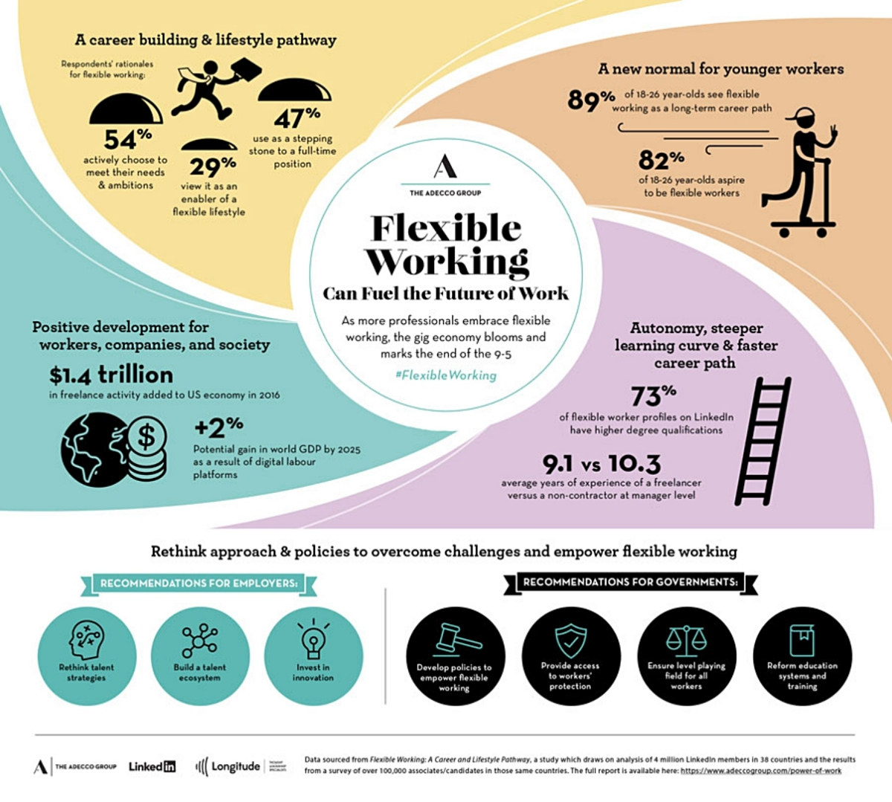

Introduction.

The case study that was submitted to our study is how has covid-19 impacts flexible and remote working. Throughout our work we will respond to these different questions.

- FLEXIBLE WORKING.
Before getting to the heart of the matter, which is flexible work, we will want to define what covid-19 is. A covid-19 is a viral species that has consequences, when it is contracted, this virus affects the respiratory tract and the digestive system, which is responsible for colds and gastroenteritis.
According to who.int.2020 COVID-19 is a disease caused by a new strain of coronavirus. ‘CO’ stands for corona, ‘VI’ for virus, and ‘D’ for disease. Formerly, this disease was referred to as ‘2019 novel coronavirus’ or ‘2019-nCoV.’ The COVID-19 virus is a new virus linked to the same family of viruses as Severe Acute Respiratory Syndrome (SARS) and some types of common cold.
Indeed because of this pandemic it has favoured more flexible work, it is good to know that the flexibility of the work is one of the means allowing a company to adapt to the evolutions of its demand and its environment . This therefore implies calling into question the organization of work within the company or society, in order to adapt to market constraints. In our case, the company is adapting to the covid-19 pandemic, it is right that certain companies have implemented certain rules, namely:
- Different working hours.
- Method of social distancing from each other.
-Sterilization of the workspace before the arrival of the next team.
- Learning new skill.
-The possibility for employees to spontaneously take a day off, or to organize their own breaks.
In this time of covid-19, employers and workers have proven they can be flexible. Flexible in terms of working time and workplace.

- REMOTE WORKING.
Remote work thus puts all workers on an equal footing and emphasizes talent and expertise rather than sartorial presentation.
therefore, in one of the Prime Minister's speeches he said "those who can work from home work at home" which brings us directly to flexible working. However, this allowed the development of new knowledge.
The containment brought about by Covid-19 has become synonymous with teleworking for many people. While some research suggests that working remotely can create a sense of isolation, it also draws attention to the competing priorities workers juggle - sometimes even literally, given the popularity of video calling. The situation allows these workers to feel united in their efforts to find a balance between their professional and personal responsibilities. Whether it is through the unexpected appearance of children or pets on screen during Zoom calls, telecommuting has loosened the traditional rules of professional presentation. As a result, the virtual workplace is not only more flexible, it is also more human-like.

conclusion
This pandemic will have forever changed our lifestyle and especially our work. Many things have changed: employees' view of work, the search for meaning, teleworking, relationships between colleagues and even the workspace. It is the entire organization of the world of work that has been turned upside down while hoping for a return to normal after this long period of confinement seems premature.

References
Who.int. 2020. [online] Available at: <https://www.who.int/docs/default-source/coronaviruse/key-messages-and-actions-for-covid-19-prevention-and-control-in-schools-march-2020.pdf?sfvrsn=baf81d52_4> [Accessed 7 October 2020].

