Emma Haggett (2100501)
Changemakers BMPS5012
Changemakers: Building your Personal Brand for Sustainable Employment

Table of Contents
Task 1 2
Task 2 4
Reference list 6

Task 1

Going into careers week, I had my mind set on becoming a police officer in Gwent Police, however, when attending careers week, I went into it with an open mind. I attended a CV and interview tips talk, a probation service talk, social services talk and a police talk. I found that attending careers week is a great opportunity to find out the skills and experience I need and to gain further insight into a variety of potential jobs and allows myself to get to know individuals on the job and to aim to make a positive impact to try and get myself known to employers. As stated, my current aim is to join the police, however, attending careers week allows me to have more of an open mind and to open myself up to the idea of other job opportunities.

During careers week, the skills and attributes needed were discussed for the different career talks. According to Careers Wales (ND), the skills needed for a Probation Officer are communication, ability to build a relationship with offenders, maintaining authority, organisational skills, and more. The Ministry of Justice (2023) list a variety of different jobs such as probation officers, prison officers, and other jobs associated with prison and probations. HM Prison and Probation Service (2020) states the pay and benefits of a probation officer. Once an individual has completed the recruitment process, they will go on a "PQiP training placement" and the starting salary, once the training is complete is £23, 637. the benefits include annual leave, blue light card, season ticket loans, employee discounts and the government pension scheme (HM Prison and Probation Service (2020), which are all important factors to me when deciding on a future career.

During the social services talk, a list of skills was also discussed, that being: empathy, active listening, communication, problem- solving, and more (Indeed Editorial Team, 2023). The social services talk also discussed the different grades and what qualifications are required for those grades. Rotherham Metropolitan Borough Council (ND) listed the framework for the different levels; Social Worker Band G (Level 1) requires a degree or Maters in Social Work or Social Work Qualifications and the highest band which Social Worker Band J (Level 4) requires a degree or Masters in Social Work or Social Work Qualification and is for the role of a Locality Manager. There are a number of career pathways for social workers such as community social work, medical social work, mental health social work, military social work, school social work, and social work administration (Social Work License Map, 2023).

The talk I was looking forward to the most was that of the police. I felt this talk was extremely helpful and beneficial to me as the talk gave me more information on the application, the different entry routes and what would happen after the recruitment. The talk also discussed the role of a police constable which is to "maintain law and order in local areas" and to protect the public ad their property. Their role is also "preventing crime" and "reducing the fear of crime" (University of Southampton, 2023). The skills needed for the role of a police officer are: honesty and confidence, resilience, the ability to remain calm, communication skills, good fitness levels, and so on (Career Wales, ND). There are a number of routes to join the police such as the Police Constable Degree Apprenticeship, the Degree Holder Entry Programme (DHEP), the Detective Degree holder Entry Programme, and more (Police, 2023). After the police talk during careers week, I found that DHEP was the best route for me as it is the most relevant and beneficial to me as I am currently studying Criminology and Policing. The DHEP is a two- year "work- based training programme" and I will be on probation. As a Police Student Volunteer (PSV), I have found that volunteering has been extremely beneficial to me as it has given me a significant amount of experience and knowledge that will be highly beneficial and useful to me for if I join the Police and could potentially improve my chance of gaining employment. Volunteering has also allowed me to meet police officers and Police Community Support Officers (PCSOs) which could potentially benefit me for the future as I have met a variety of officers. The West Yorkshire Police (2023) stated that there are seven steps to the application process: the application form, the eligibility checks, assessment centre which are reasoning and situational judgemental tests, the interview, the fitness test, the medical assessment, and security vetting.

In conclusion, I felt that careers week was very useful to me. Although I was set on becoming a police officer, and I still am, I thoroughly enjoyed hearing more about the different job opportunities, what is required, and the different routes and pathways. I also enjoyed hearing about the individuals' experiences within their chosen career and why they enjoy it so much. As stated, although I completely set on joining the police as a police officer, I felt it was useful and beneficial to know more about the different careers available within association to the police for the future. If I had another opportunity to attend careers week, I would ask more questions to gain further insight and knowledge because by getting more knowledge, I could better prepare myself for the application process for the police when it comes to applying, especially knowing which entry programme is the most relevant and beneficial to me.

Task 2

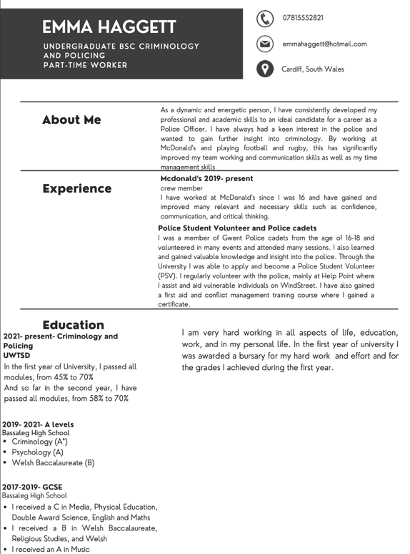


Reference list
- Careers Wales. (ND) "skills and qualities" Careers Wales: Probation Officer. Available at: https://careerswales.gov.wales/job-information/probation-service-officer/skills-and-qualities#:~:text=to%20be%20good%20at%20managing,writing%20skills%2C%20to%20produce%20reports
- Career Wales. (ND) "Skills and qualities" Careers Wales: Police Officer. Available at: https://careerswales.gov.wales/job-information/police-officer/skills-and-qualities
- HM Prison and Probation Service. (2020) "pay and benefits" Probation service. Available at: https://www.traintobeaprobationofficer.com/pay-and-benefits/
- Indeed Editorial Team. (2023) "13 essential social worker skills" Indeed career guide. Available at: https://uk.indeed.com/career-advice/career-development/social-worker-skills
- Ministry of Justice. (2023) "HM Prison and Probation Service" Justice. Gov. UK. Available at: https://jobs.justice.gov.uk/agency/hm-prisons-probations-service/
- Police. (2023) "What's the best route for me?" Joining the Police. Available at: https://www.joiningthepolice.co.uk/application-process/ways-in-to-policing
- Rotherham Metropolitan Borough Council. (ND) "social work progression framework" Rotherham Children's and Young People's Services Procedures Manual. Available at: https://rotherhamcsyp.proceduresonline.com/p_sw_progress_framewk.html
- Social Work License Map. (2023) “career path for social workers: everything you need to know” edX. Available at: https://socialworklicensemap.com/social-work-careers/pathways/
- University of Southampton. (2023) "Police officer and Civil roles in the police" Russel Group: Economic, Social and Political Science. - https://www.southampton.ac.uk/socsci/undergraduate/career_path_police.page
- West Yorkshire Police. (2023) "Recruitment Process" West Yorkshire Police. Available at: https://www.westyorkshire.police.uk/jobs-volunteer/police-officers/recruitment-process

