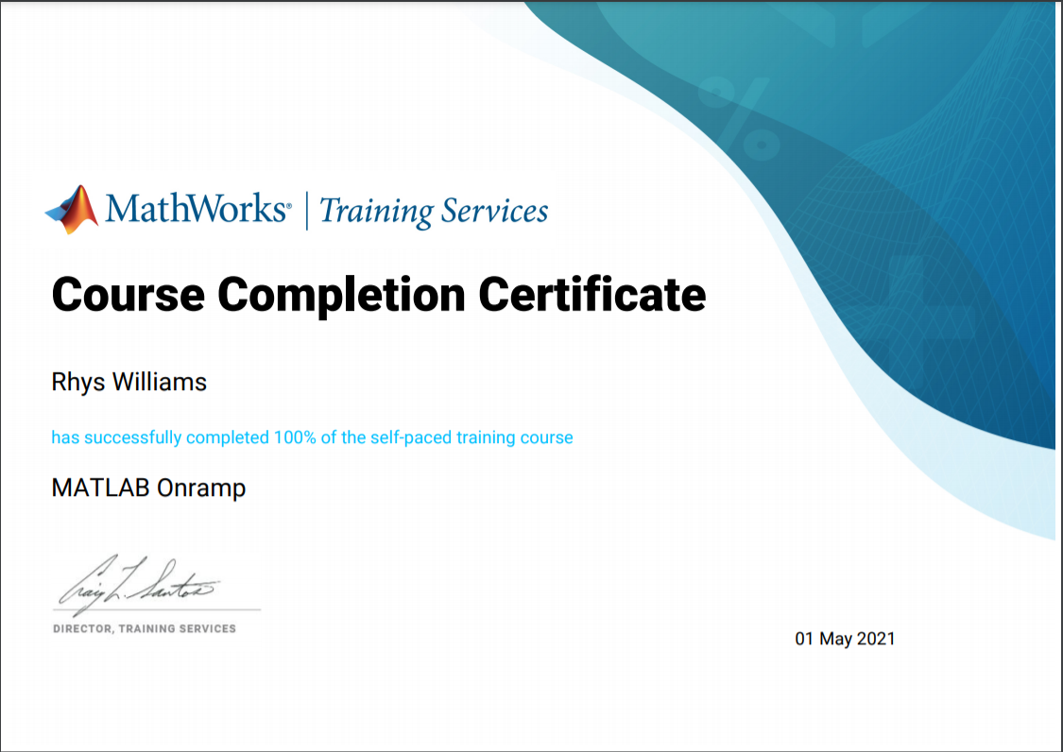I have to write 20 words to submit this, so here is a bunch of random words on the submission form.

