Week three session two tutorial questions
Question one
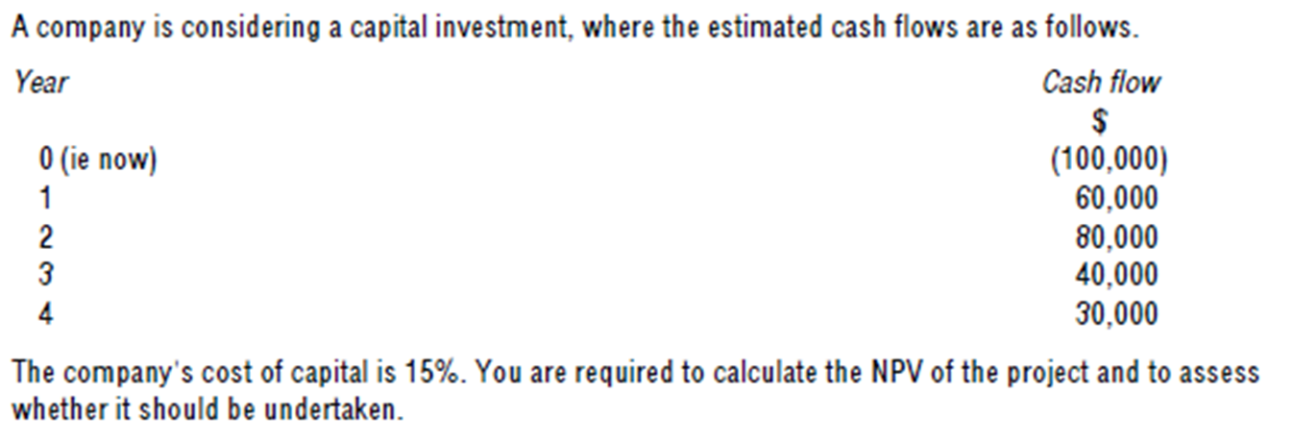
Question two
Gold
Gold is considering a project requiring investment of $100,000 in equipment with a life of five years and a residual value of $15,000. Annual cash earnings will be $25,000, $34,000, $25,000, $15,000 and $8,000 for the five years respectively.
Requirements
(i) Calculate the ARR based on average investment,
(ii) Calculate the ARR based on initial investment,
(iii) Calculate the payback period.

