Student name: Raluca Nicoleta Caruntu

Student number : 2410738

BA (Hons) Leadership and Management Skills for the Workplace

Module: Developing Emotional Intelligence Skills

Module code: LCLM5006

Lecturer: Taonga Kaonga Sobere-Snithers

Assignment Title: Component 2 - Individual written report

Emotional Intelligence and Mindfulness in Contemporary Organisations

Table of Contents
1. Introduction
2. Emotional Intelligence in the Workplace
2.1 Understanding Emotional Intelligence
2.2 Goleman's Emotional Intelligence Framework
2.3 Mayer and Salovey's Ability Model
2.4 Bar-On's Emotional-Social Intelligence Model
2.5 Comparing Emotional Intelligence Models
2.6 Emotional Intelligence and Workplace Performance
2.7 Mindfulness as a Foundation for Emotional Intelligence
3. Managing a Multigenerational Workforce
3.1 Managing a Multigenerational Workforce
3.2 Characteristics of Different Generations
3.3 Impact on Organisational Effectiveness
3.4 Emotional Intelligence and Mindfulness
3.5 Recommendations for Managing a Multigenerational Workforce
3.6 Conclusion
4.Recommendation
5.Reflection
6. Conclusion
Reference List
1. Introduction
In today's rapidly changing business environment, organisations increasingly recognise that organisational success depends not only on technical expertise but also on employees' ability to understand and manage emotions effectively. Emotional intelligence (EI) and mindfulness have become important capabilities that support communication, collaboration, leadership and employee wellbeing (Goleman, 1998; Mayer and Salovey, 1997). Emotional intelligence refers to the ability to recognise, understand and regulate emotions in oneself and others, while mindfulness encourages present-moment awareness and thoughtful responses to workplace challenges (Mayer, Salovey and Caruso, 2016; Kabat-Zinn, 2003).
The importance of these capabilities is reflected in the organisational scenario, where improvements in employee morale, communication and conflict resolution were linked to the successful application of emotional intelligence and mindfulness. Consequently, the Senior Management Team (SMT) has requested this report to support future decisions regarding leadership development, employee wellbeing and recruitment strategies.
This report critically evaluates the role of emotional intelligence and mindfulness in contemporary organisations. The first section examines how emotional intelligence can improve workplace performance, communication, leadership, conflict management and decision-making using Goleman's Emotional Intelligence Framework, Mayer and Salovey's Ability Model and Bar-On's Emotional-Social Intelligence Model. The second section explores the management of a multigenerational workforce, focusing on Generation X, Millennials and Generation Z, and evaluates how emotionally intelligent and mindful leadership can create a more inclusive, productive and psychologically safe workplace. The report concludes with recommendations and a personal reflection on applying these concepts in professional practice.

2.1 Understanding Emotional Intelligence
Emotional intelligence (EI) has become an essential capability in contemporary organisations because workplace success depends on interpersonal skills as well as technical competence. EI refers to the ability to recognise, understand and manage emotions in oneself and others to support effective behaviour and decision-making (Goleman, 1998). The organisational scenario demonstrates its practical value, as improvements in morale, communication and conflict resolution were linked to the application of emotional intelligence and mindfulness. However, EI should not be viewed as a complete solution to organisational problems, as its effectiveness also depends on organisational culture and leadership support (Ashkanasy and Dorris, 2017).
Three influential models explain emotional intelligence from different perspectives: Goleman's Emotional Intelligence Framework, Mayer and Salovey's Ability Model, and Bar-On's Emotional-Social Intelligence Model.
2.2 Goleman's Emotional Intelligence Framework
Goleman's model identifies four key competencies: self-awareness, self-management, social awareness and relationship management (Goleman, Boyatzis and McKee, 2013).

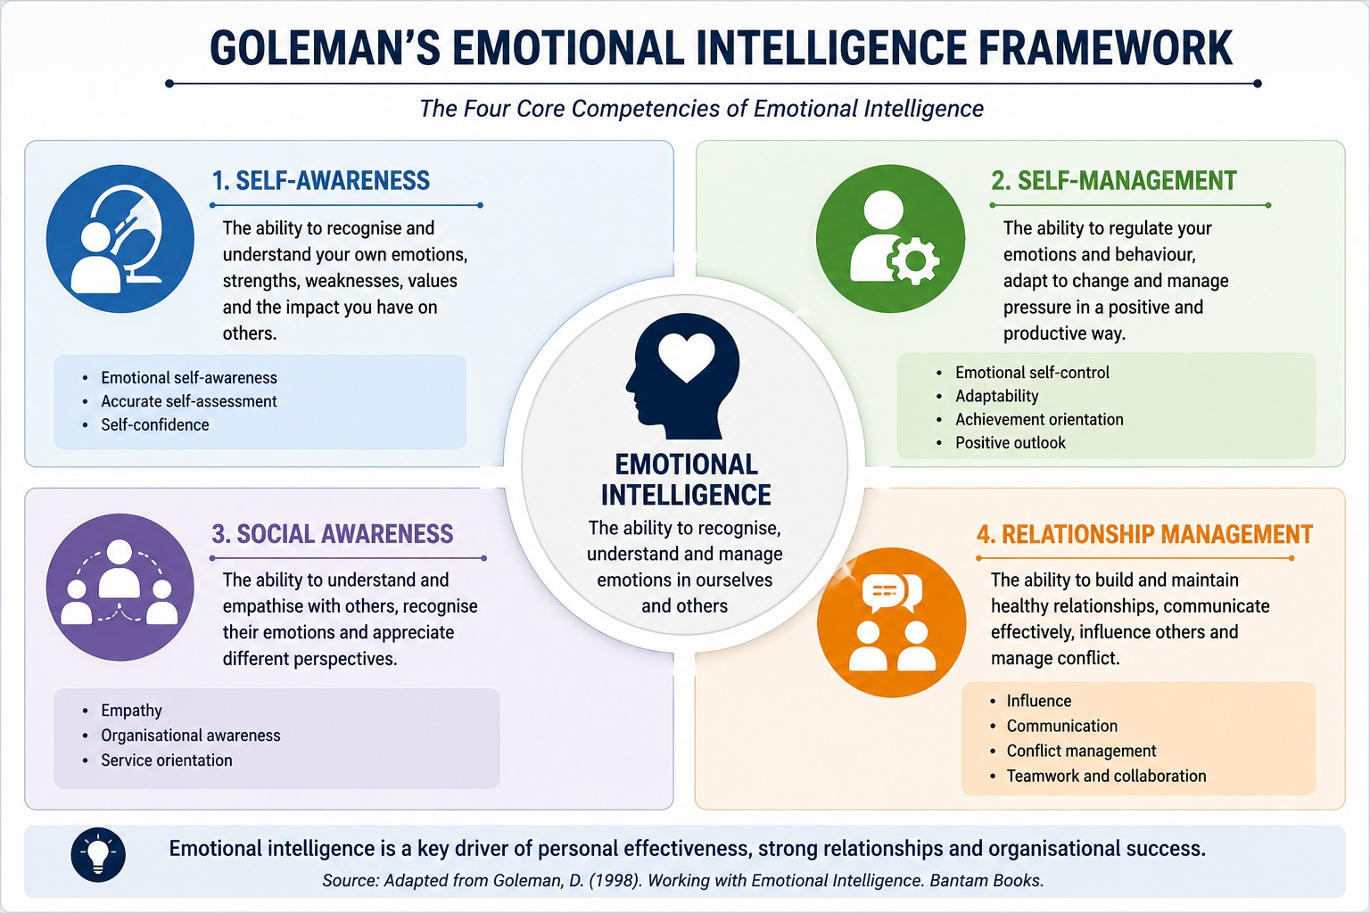

Self-awareness enables employees to recognise emotional triggers, while self-management supports resilience and professionalism under pressure. Social awareness, particularly empathy, helps employees understand colleagues perspectives and contributes to inclusive leadership. Relationship management combines these competencies to improve communication, collaboration and conflict resolution.
The model is widely used in leadership development because it focuses on practical workplace behaviours. However, critics argue that it combines emotional abilities with personality traits, reducing its theoretical precision compared with ability-based approaches (Mayer, Salovey and Caruso, 2008).

2.3 Mayer and Salovey's Ability Model

Mayer and Salovey (1997) define emotional intelligence as a cognitive ability consisting of four branches: perceiving emotions, using emotions to facilitate thinking, understanding emotions and managing emotions.

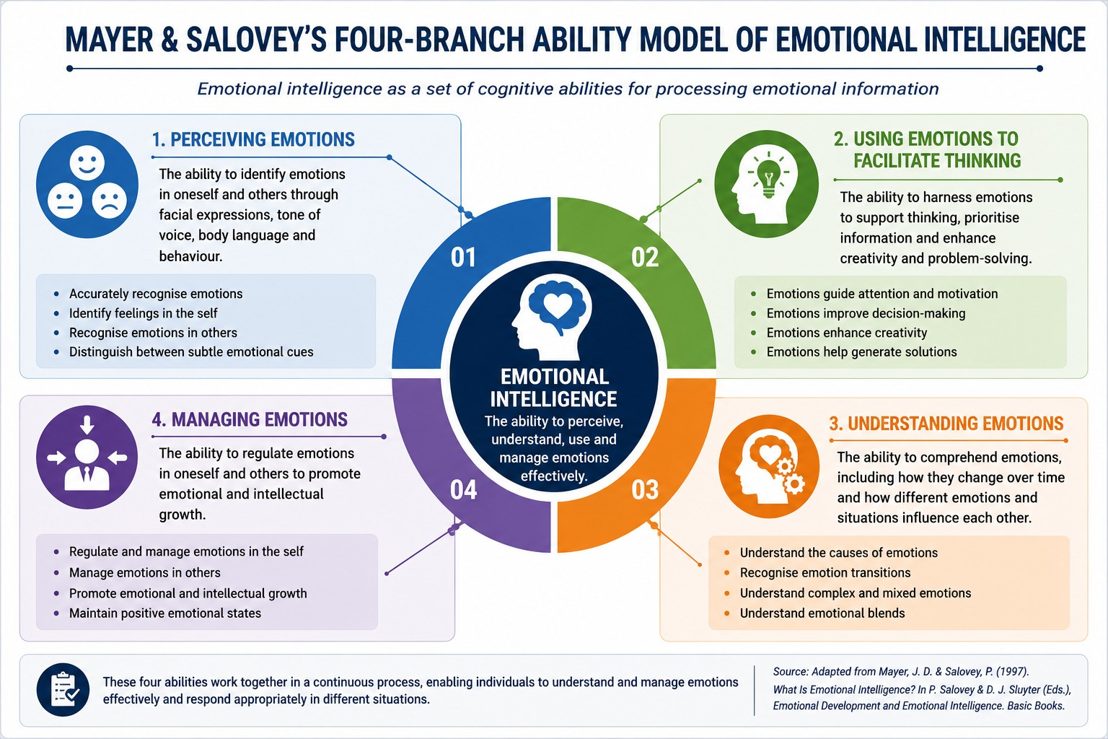

This model suggests that emotions can improve judgement when they are accurately recognised and appropriately regulated. Employees who understand emotional responses are better able to anticipate conflict, adapt communication and make balanced decisions. Its main strength is its strong theoretical foundation and empirical support. However, critics argue that ability-based assessments may measure emotional potential rather than actual workplace performance (Joseph and Newman, 2010), making the model less practical for leadership development.

2.4 Bar-On's Emotional-Social Intelligence Model

Bar-On (2006) views emotional intelligence more broadly by incorporating emotional and social competencies such as self-awareness, interpersonal relationships, stress management, adaptability and optimism.
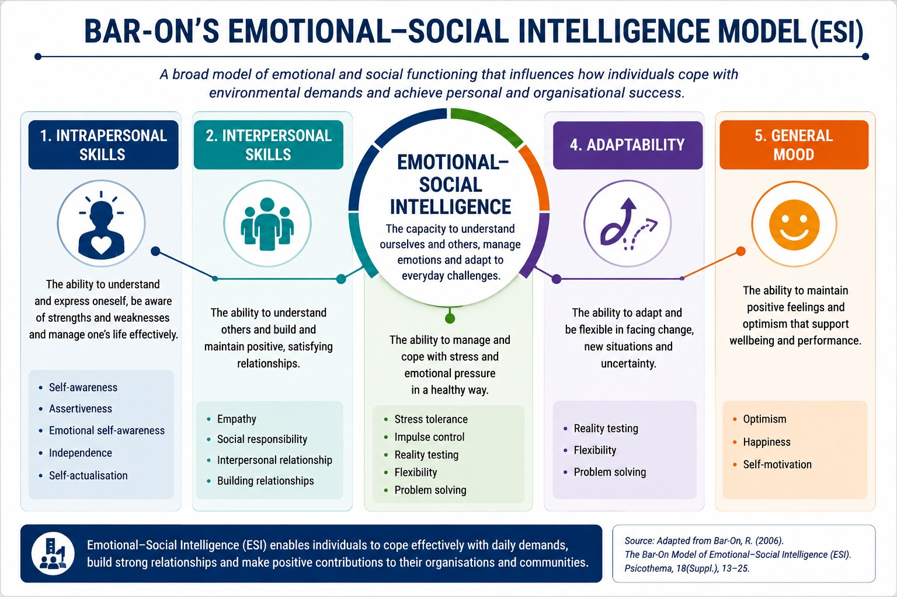

The model is particularly relevant to modern organisations because resilience, flexibility and stress management contribute to employee wellbeing and organisational performance. Nevertheless, some researchers argue that the inclusion of personality characteristics makes it difficult to distinguish emotional intelligence from broader psychological traits (Mayer et al., 2008).
2.5 Comparing the Models

Each model contributes a different perspective. Goleman's framework is practical and widely used in organisations, Mayer and Salovey provide stronger theoretical validity through an ability-based approach, while Bar-On emphasises wellbeing, adaptability and resilience.
Rather than viewing one model as superior, organisations can benefit from combining their strengths. Goleman's competencies support leadership development, Mayer and Salovey strengthen emotional reasoning, and Bar-On highlights the importance of wellbeing and adaptability. This integrated approach provides both academic credibility and practical value.

2.6 Emotional Intelligence in the Workplace

Research demonstrates that emotional intelligence positively influences employee performance, communication and organisational commitment (Miao, Humphrey and Qian, 2017).

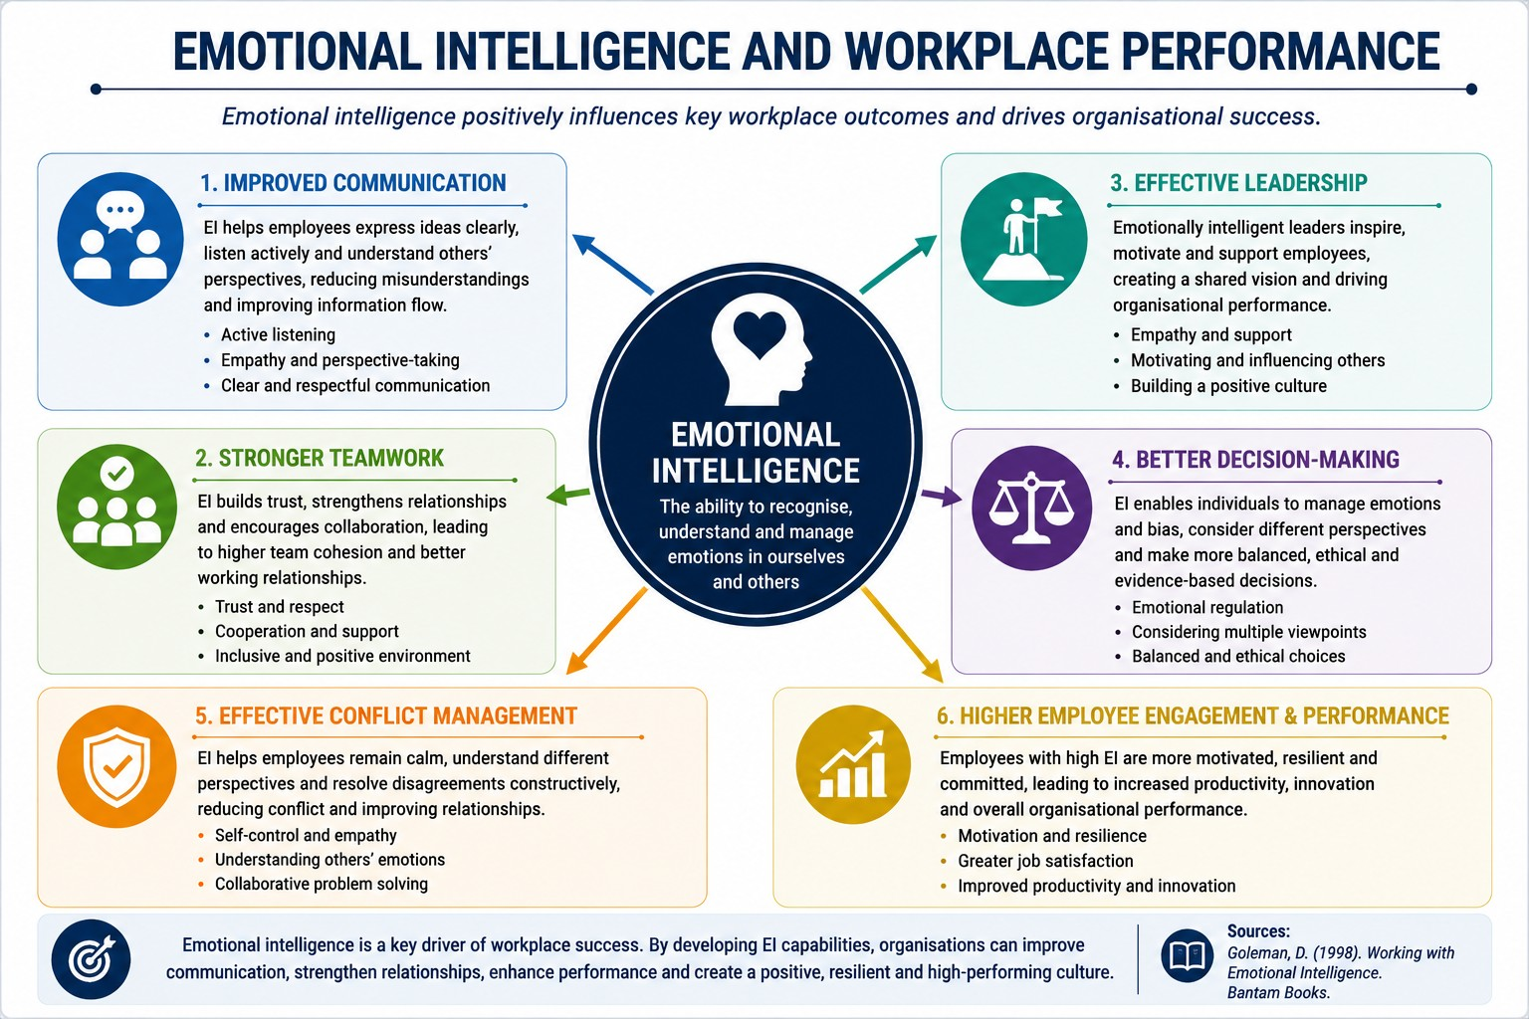

Emotionally intelligent employees communicate more effectively, adapt to change and build stronger workplace relationships.
Emotional intelligence also improves conflict management by encouraging employees to regulate emotions and focus on collaborative solutions rather than personal disagreements. Similarly, emotionally intelligent leaders create psychologically safe workplaces where employees feel confident sharing ideas and learning from mistakes (Edmondson, 1999). Decision-making also benefits because leaders recognise emotional influences while balancing them with objective evidence.

2.7 Mindfulness as a Foundation for Emotional Intelligence

Mindfulness complements emotional intelligence by encouraging present-moment awareness and thoughtful responses rather than impulsive reactions (Kabat-Zinn, 2003). Employees who practise mindfulness are generally better able to regulate emotions, manage stress and communicate effectively.
Research indicates that mindfulness interventions improve emotional regulation and psychological wellbeing (Vonderlin et al., 2020). However, mindfulness should support—not replace—good organisational management. Without fair workloads, supportive leadership and a positive organisational culture, mindfulness alone cannot resolve workplace challenges.
The organisational scenario demonstrates how combining mindfulness with emotional intelligence can improve communication, employee morale and conflict resolution. Embedding these practices into leadership development and organisational culture is therefore likely to support long-term organisational effectiveness.

3.1 Managing a Multigenerational Workforce
Contemporary organisations employ people from different generations, each bringing unique experiences, values and expectations. While generational diversity can encourage innovation and knowledge sharing, it can also create challenges in communication, motivation and leadership. In the organisational scenario, the Senior Management Team (SMT) seeks to understand how emotional intelligence (EI) and mindfulness can strengthen leadership and create a more inclusive workplace. Although generational theory suggests that shared historical experiences influence workplace attitudes (Mannheim, 1952), managers should avoid stereotyping employees, as individual personality and organisational culture often have a greater impact than age alone (Costanza et al., 2012).
3.2 Characteristics of Different Generations
Generation X (1965–1980) is often associated with independence, adaptability and a preference for autonomy. These employees typically value practical leadership, work-life balance and opportunities to use their experience. However, assumptions that they are resistant to technology are not supported by evidence, as technology adoption is influenced more by organisational support than age (CIPD, 2024).
Millennials (Generation Y) generally value collaboration, career development and meaningful work (Twenge, Campbell and Freeman, 2012). They often appreciate regular feedback and opportunities for learning. Although Millennials are sometimes perceived as less loyal, research suggests that retention is influenced more by leadership quality and organisational culture than by generational identity (CIPD, 2024). Emotionally intelligent managers can improve engagement by providing coaching, recognition and development opportunities.
Generation Z has entered employment during a period of rapid digital transformation. Often described as digital natives, they value inclusion, flexibility, wellbeing and authentic leadership (Deloitte, 2025). However, stereotypes suggesting that younger employees lack resilience or commitment should be avoided. Instead, emotionally intelligent leaders recognise individual strengths and encourage mentoring relationships that combine technological confidence with organisational experience.
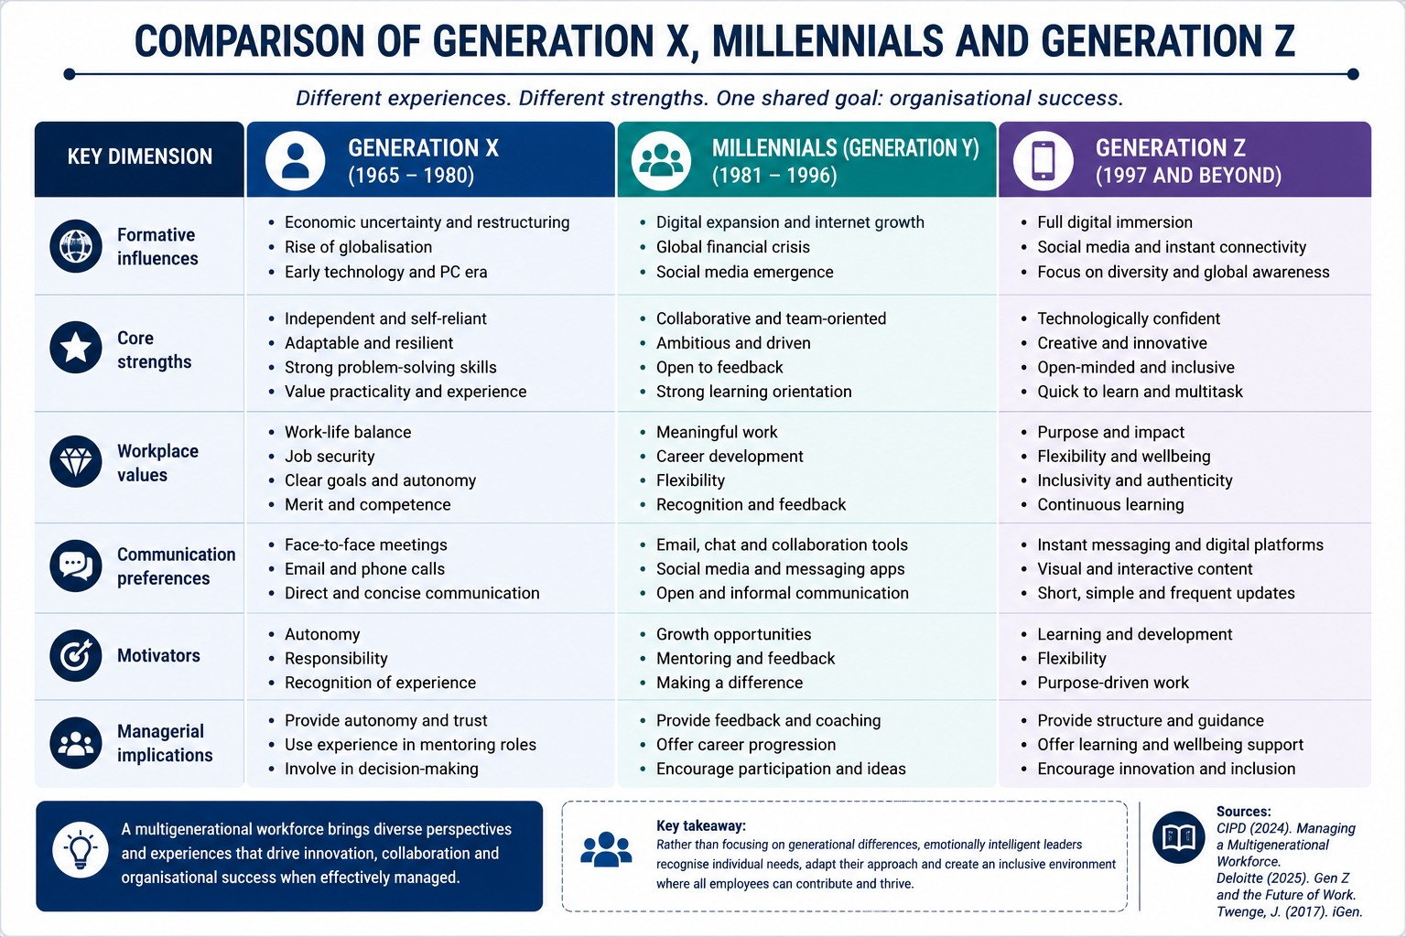

3.3 Impact on Organisational Effectiveness

Generational diversity influences communication, motivation and organisational culture. Different generations may prefer different communication methods, ranging from formal meetings to digital messaging. Similarly, motivational priorities can vary, although Herzberg's Two-Factor Theory suggests that recognition, meaningful work and opportunities for development remain important across all generations.
Rather than allowing these differences to create division, organisations should encourage collaboration through mentoring and knowledge sharing. A workplace that values employees regardless of age is more likely to experience higher engagement, innovation and organisational commitment.

3.4 Emotional Intelligence and Mindfulness

Emotional intelligence enables managers to lead multigenerational teams more effectively by encouraging self-awareness, empathy and adaptive communication.

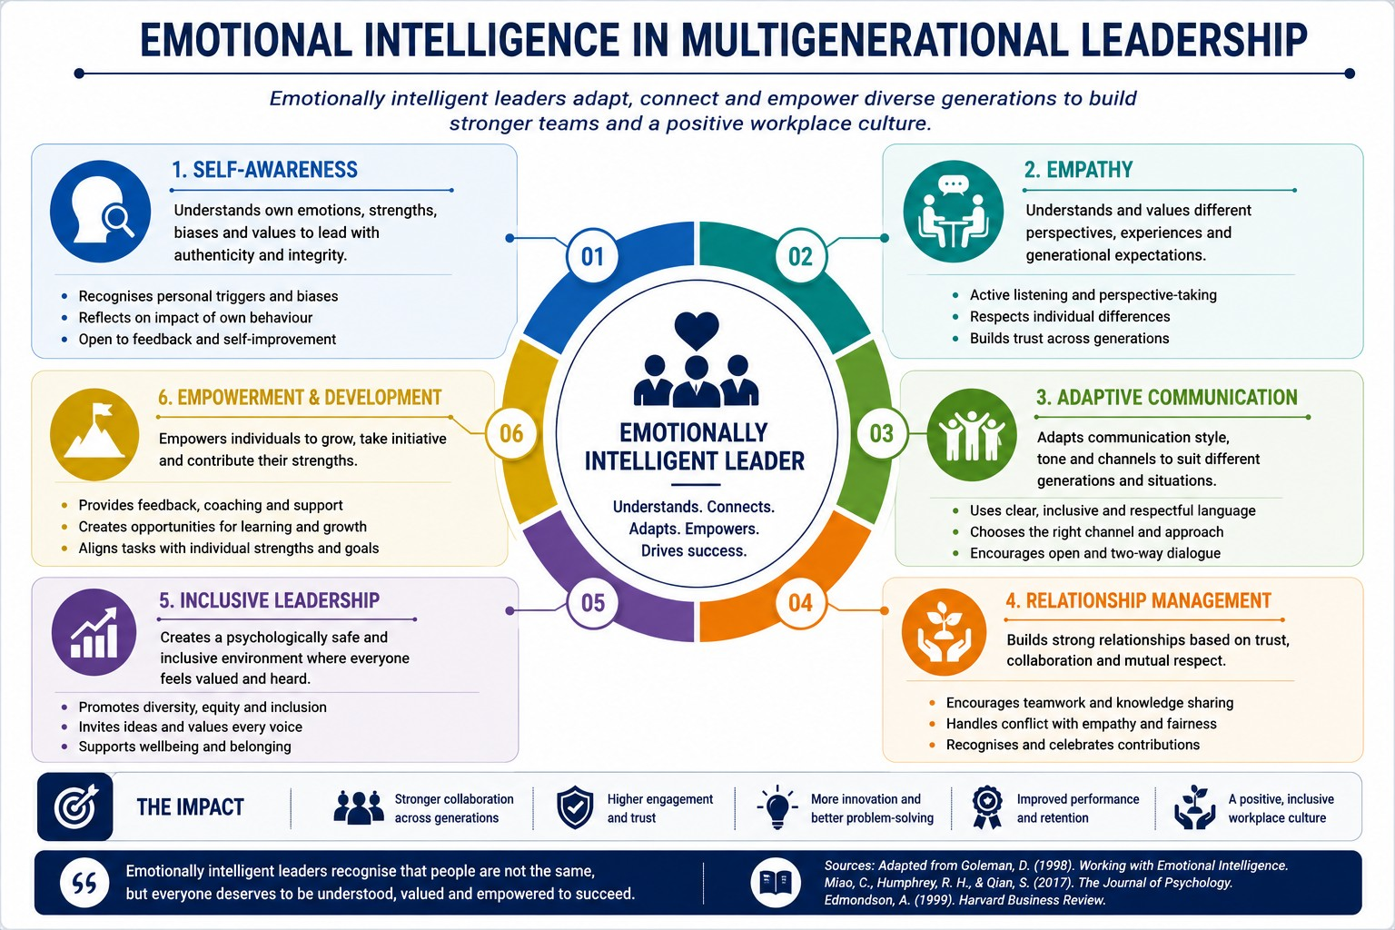

Self-aware leaders recognise their own biases, while empathy helps them understand different employee expectations and communication styles. Relationship management strengthens trust, improves collaboration and reduces workplace conflict (Miao, Humphrey and Qian, 2017).
Mindfulness complements emotional intelligence by encouraging leaders to remain present, listen actively and respond thoughtfully rather than making assumptions (Kabat-Zinn, 2003). It also supports psychological safety by creating an environment where employees feel comfortable expressing ideas and discussing mistakes without fear of criticism (Edmondson, 1999). These outcomes reflect the improvements in communication and morale described in the organisational scenario.

To maximise the benefits of a multigenerational workforce, recruitment should focus on competencies rather than age-related assumptions. Managers should receive emotional intelligence training to strengthen empathy, communication and conflict management, while mentoring and reverse mentoring programmes should encourage knowledge sharing between generations. Mindfulness practices can also be incorporated into leadership development to improve decision-making, wellbeing and employee engagement.
A multigenerational workforce presents significant opportunities when managed effectively. Rather than relying on stereotypes, emotionally intelligent leaders adapt their communication and leadership style to individual needs, creating an inclusive and psychologically safe workplace. By embedding emotional intelligence and mindfulness into recruitment, leadership development and employee wellbeing strategies, organisations can strengthen collaboration, improve retention and support long-term organisational performance.
4.Recommendation
Based on the findings of this report, the Senior Management Team (SMT) should adopt a strategic approach to embedding emotional intelligence (EI) and mindfulness across leadership, employee development and organisational culture.

Develop Emotional Intelligence: The organisation should provide emotional intelligence training for managers and team leaders, focusing on self-awareness, self-management, empathy and relationship management. Practical workshops and coaching can strengthen communication, conflict resolution and decision-making while improving employee engagement and trust (Goleman, 1998; Joseph and Newman, 2010).
Embed Mindfulness into Leadership: Mindfulness should form part of existing leadership and wellbeing programmes. Techniques such as mindful listening and reflective decision-making can improve emotional regulation, reduce stress and support balanced leadership. However, mindfulness should complement effective leadership, manageable workloads and organisational wellbeing initiatives rather than replace them (Kabat-Zinn, 2003; Vonderlin et al., 2020).

Promote Inclusive Leadership: Managers should be trained to lead multigenerational teams without relying on age-related stereotypes. Regular coaching, active listening and constructive feedback will help leaders understand individual employee needs and create a more inclusive workplace (Costanza et al., 2012; CIPD, 2024).

Strengthen Psychological Safety: Leaders should encourage open communication, recognise employee contributions and create an environment where staff feel confident sharing ideas and learning from mistakes. Improving psychological safety is likely to increase collaboration, innovation and employee wellbeing (Edmondson, 1999).

Improve Recruitment and Retention: Recruitment should focus on competencies and organisational values rather than age-related assumptions. Structured onboarding, mentoring, continuous professional development and flexible working opportunities should be used to attract and retain employees from different generations (CIPD, 2025).

Monitor Organisational Impact: The SMT should regularly evaluate the effectiveness of emotional intelligence and mindfulness initiatives using measures such as employee engagement, wellbeing, staff turnover and conflict resolution outcomes. Continuous evaluation will help ensure that these initiatives support both employee wellbeing and organisational performance.

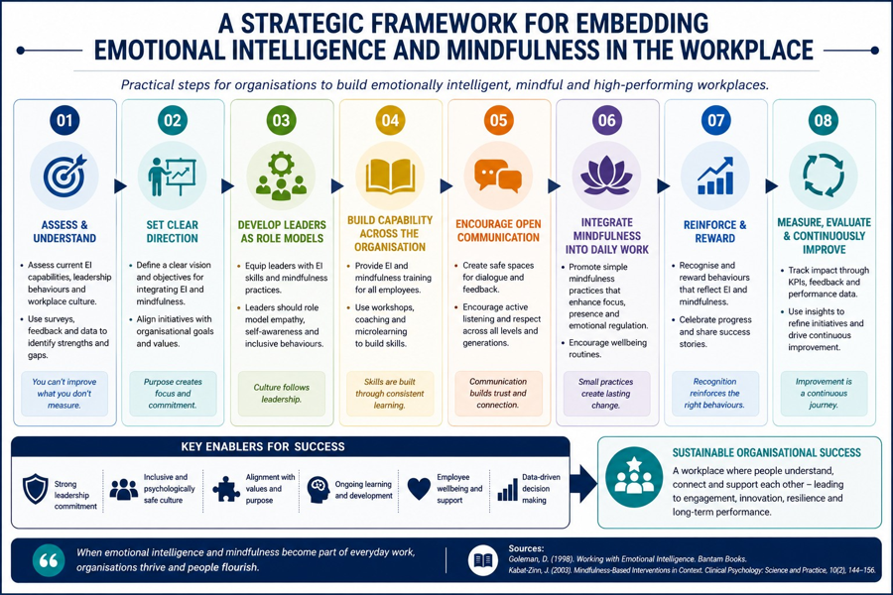

5. Reflection

This report has significantly enhanced my understanding of emotional intelligence (EI) and mindfulness and their contribution to organizational effectiveness. Before undertaking this research, I viewed EI primarily as an interpersonal skill. However, critically examining the work of Goleman (1998), Mayer and Salovey (1997), and Bar-On (2006) demonstrated that emotional intelligence is a multidimensional capability involving emotional awareness, regulation, empathy, relationship management and effective decision-making. I also recognized that mindfulness complements EI by encouraging individuals to pause, reflect and respond thoughtfully rather than reacting impulsively (Kabat-Zinn, 2003).
One of the most important learning outcomes is that emotionally intelligent behavior contributes directly to communication, conflict management and leadership effectiveness. I have learned that technical competence alone is insufficient for modern organizations. Employees and managers who can regulate emotions, demonstrate empathy and adapt their communication style are better equipped to build trust and psychological safety (Edmondson, 1999). Critically, the literature also showed that EI should not be viewed as a universal solution. Poor organizational culture, unrealistic workloads and ineffective leadership cannot be resolved simply through individual emotional skills. This challenged my earlier assumption that personal development alone is enough to improve workplace performance.
Research into multigenerational workforces also changed my perspective. Initially, I assumed that Generation X, Millennials and Generation Z had fixed workplace characteristics. However, the evidence suggests considerable variation within generations and warns managers against stereotyping employees solely because of age (CIPD, 2024). Emotional intelligence enables managers to understand individuals rather than relying on assumptions, while mindfulness encourages reflection before making judgements. This balanced perspective is particularly valuable in increasingly diverse organizations.
I can apply these findings in my own professional career. Working in business development requires building relationships with customers, handling objections and remaining calm under pressure. By improving my self-awareness and emotional regulation, I can communicate more effectively during negotiations, respond constructively to rejection and better understand customers' needs. Empathy will help strengthen long-term client relationships, while mindfulness techniques such as reflective pauses before important meetings can improve my decision-making and reduce stress.
As a future manager, I intend to create psychologically safe environments where employees feel respected and comfortable sharing ideas. I would encourage regular feedback conversations, active listening and inclusive communication. Rather than assuming that employees from different generations require identical management approaches, I would use emotional intelligence to understand individual motivations and adapt my leadership style accordingly. This aligns with contemporary leadership approaches that emphasize coaching, collaboration and employee wellbeing.
Overall, this assignment has reinforced that emotional intelligence and mindfulness are strategic organizational capabilities rather than simply personal qualities. Their value lies not only in improving individual performance but also in creating healthier organizational cultures, stronger collaboration and more sustainable leadership. Going forward, I intend to continue developing these competencies through reflective practice, feedback and continuous learning.
6. Conclusion
Emotional intelligence and mindfulness should be embedded within leadership development, recruitment and organisational culture rather than implemented as isolated initiatives. By adopting this integrated approach, the organisation can improve communication, employee performance, collaboration and psychological safety while creating a more inclusive and resilient workplace capable of supporting long-term organisational success.

Reference list:
Ashkanasy, N.M. and Dorris, A.D. (2017) ‘Emotions in the workplace’, Annual Review of Organizational Psychology and Organizational Behavior, 4, pp. 67–90.
Bar-On, R. (2006) ‘The Bar-On model of emotional-social intelligence (ESI)’, Psicothema, 18(Suppl.), pp. 13–25.
Brackett, M.A., Rivers, S.E. and Salovey, P. (2011) ‘Emotional intelligence: Implications for personal, social, academic, and workplace success’, Social and Personality Psychology Compass, 5(1), pp. 88–103.
Cherniss, C. (2010) Emotional Intelligence: Toward Clarification of a Concept. Industrial and Organizational Psychology, 3(2), pp. 110–126.
Chartered Institute of Personnel and Development (CIPD) (2024) Changing Face of the Youth Labour Market. London: CIPD.
Chartered Institute of Personnel and Development (CIPD) (2025) Health and Wellbeing at Work Survey Report 2025. London: CIPD.
Costanza, D.P., Badger, J.M., Fraser, R.L., Severt, J.B. and Gade, P.A. (2012) ‘Generational differences in work-related attitudes: A meta-analysis’, Journal of Business and Psychology, 27(4), pp. 375–394.
Deloitte (2025) 2025 Gen Z and Millennial Survey. London: Deloitte Insights.
Edmondson, A.C. (1999) ‘Psychological safety and learning behavior in work teams’, Administrative Science Quarterly, 44(2), pp. 350–383.
Edmondson, A.C. (2019) The Fearless Organization: Creating Psychological Safety in the Workplace for Learning, Innovation and Growth. Hoboken, NJ: Wiley.
George, J.M. (2000) ‘Emotions and leadership: The role of emotional intelligence’, Human Relations, 53(8), pp. 1027–1055.
Goleman, D. (1995) Emotional Intelligence: Why It Can Matter More Than IQ. New York: Bantam Books.
Goleman, D. (1998) Working with Emotional Intelligence. London: Bloomsbury Publishing.
Goleman, D., Boyatzis, R. and McKee, A. (2013) Primal Leadership: Unleashing the Power of Emotional Intelligence. Boston: Harvard Business Review Press.
Herzberg, F. (1968) ‘One more time: How do you motivate employees?’, Harvard Business Review, 46(1), pp. 53–62.
Joseph, D.L. and Newman, D.A. (2010) ‘Emotional intelligence: An integrative meta-analysis and cascading model’, Journal of Applied Psychology, 95(1), pp. 54–78.
Kabat-Zinn, J. (2003) ‘Mindfulness-based interventions in context: Past, present and future’, Clinical Psychology: Science and Practice, 10(2), pp. 144–156.
Mannheim, K. (1952) Essays on the Sociology of Knowledge. London: Routledge & Kegan Paul.
Mayer, J.D., Caruso, D.R. and Salovey, P. (2016) ‘The ability model of emotional intelligence: Principles and updates’, Emotion Review, 8(4), pp. 290–300.
Mayer, J.D., Salovey, P. and Caruso, D.R. (2008) ‘Emotional intelligence: New ability or eclectic traits?’, American Psychologist, 63(6), pp. 503–517.
Mayer, J.D. and Salovey, P. (1997) ‘What is emotional intelligence?’, in Salovey, P. and Sluyter, D.J. (eds.) Emotional Development and Emotional Intelligence: Educational Implications. New York: Basic Books, pp. 3–31.
Miao, C., Humphrey, R.H. and Qian, S. (2017) ‘A meta-analysis of emotional intelligence and work attitudes’, Journal of Occupational and Organizational Psychology, 90(2), pp. 177–202.
Miao, C., Humphrey, R.H. and Qian, S. (2017) ‘A meta-analysis of emotional intelligence and employee performance’, Journal of Organizational Behavior, 38(9), pp. 1367–1387.
Northouse, P.G. (2022) Leadership: Theory and Practice. 9th edn. Thousand Oaks, CA: Sage Publications.
Robbins, S.P. and Judge, T.A. (2023) Organizational Behavior. 19th Global edn. Harlow: Pearson.
Schein, E.H. and Schein, P. (2021) Organizational Culture and Leadership. 5th edn. Hoboken, NJ: Wiley.
Twenge, J.M. (2017) iGen: Why Today's Super-Connected Kids Are Growing Up Less Rebellious, More Tolerant, Less Happy—and Completely Unprepared for Adulthood. New York: Atria Books.
Twenge, J.M., Campbell, S.M., Hoffman, B.J. and Lance, C.E. (2010) ‘Generational differences in work values: Leisure and extrinsic values increasing, social and intrinsic values decreasing’, Journal of Management, 36(5), pp. 1117–1142.
Vonderlin, R., Biermann, M., Bohus, M. and Lyssenko, L. (2020) ‘Mindfulness-based programs in the workplace: A meta-analysis of randomized controlled trials’, Mindfulness, 11(7), pp. 1579–1598.
World Health Organization (2022) WHO Guidelines on Mental Health at Work. Geneva: World Health Organization.

