
Module Name: Digital Skills for Personal Development and Business Growth
Module Code: BMSW4008
Assignment Title: Portfolio
Student Name: Sanjeda Akter
Student Number: 2522667
Lecturer: Scott James
Deadline: 23rd March 2026 09.00

AI Acknowledgement Statement:
I confirm that I have not presented any AI generated materials as my own work.
I confirm that I have copies of my drafts, notes, and other resources I used, which I may be asked to provide in evidence.

Contents
Task 1: Assessment of Digital Skills (700 Words) 4
Introduction: Importance of Digital Skills 4
Overview of the JISC Digital Capability Tool 4
Summary of JISC Results 4
Strengths in Digital Skills 4
Areas for Improvement 4
Action Plan Using SMART Goals 4
Reflection and Conclusion 4
Task 1 References (Minimum 5) 4
Task 2: LinkedIn Learning Certificates – Office 365 5
Outlook Essential Training (Microsoft 365) 5
Word Essential Training (Microsoft 365) 5
Excel Essential Training (Microsoft 365) 5
PowerPoint Essential Training (Microsoft 365) 5
Task 3: Relevance and Importance of Microsoft Excel (1,000 Words) 5
Introduction 5
Uses of Microsoft Excel 5
Data Analysis 5
Budgeting and Financial Management 5
Reporting and Decision-Making 5
Practical Spreadsheet Task 5
Reflection and Conclusion 6
Task 3 References (Minimum 5) 6
Task 4: Reflective Presentation Summary (5 Minutes) 6
Overview of Presentation Content 6
Learning and Skill Development 6
Links to Task 1 6
Links to Task 2 6
Links to Task 3 6
Application to Studies and Career 6
Task 3 References (Minimum 5) 7

Task 1: Assessment of Digital Skills (700 Words)

Introduction: Importance of Digital Skills
Digital skills are the knowledge and capability to use technology safely, effectively, confidently and easily while being anywhere whether in an academic setting or in a workplace.
Digital skills are important in higher education as use of technology makes students’ life easier, effective and reliable. In higher education students depend on digital tools as they can use digital skills to explore information related to their academic work. It can also be used to improve research, collaboration, communication and submit assignments (London Metropolitan University, 2025). It can also be used as an online learning platform to expand knowledge while being in the comfort of home. Digital tools are essential for everyone as it has made everyone's life easy and simple. A digital tool can be used to write down rather than doing this in an old-fashioned way.
According to Carabregu-Vokshi et al. (2024) ‘People with strong modern tech skills are invaluable to companies.’ That is why it is important for students to learn digital skills to achieve more in life, enhance their employability skills and increase productivity in the workplace.

Overview of the JISC Digital Capability Tool
The Jisc Digital Capability Tool is a discovery tool, and it is a free online self-assessment service which is designed for individuals, students in college and university and staff, to evaluate their digital capabilities (Jisc, 2026). It uses a series of reflective questions to create a digital capability graph. The Jisc Discovery Capability tool’s questions are like a quiz and non-judgemental. This tool’s aim is to assess someone’s confidence and experience. Just by using this tool participants are going to be familiar with what digital practices they have used previously and get introduced to the new ones which they might use later. Key points of the Jisc discovery tool are purpose, process, feedback and resources, coverage areas and usage.
The Jisc Discovery Capability Tool was used to assess my current digital ability, and it also discovered my strengths, weaknesses and where improvement is needed. During using this discovery tool to do my self-assessment it asked me a whole range of questions, and how confident I was using digital technologies for different tasks. At the end of the self-assessment this discovery tool provided me a visual graph which was showing my capability to use digital skills in various areas.

Summary of JISC Results
The Jisc Discovery Capability Tool results (see figure 1.) show a significant number of areas which need improvement: Digital proficiency, information literacy, media literacy, data literacy, digital collaboration, digital participation digital creation, problem solving, digital innovation, preparing for digital learning, digital learning activities, digital identity management and lastly digital skills for work. These are the areas where I am showing development but there are other areas where the graph is showing I am capable, areas like digital productivity, digital communication also digital wellbeing. This means I am slowly progressing and it also means that I must work towards these skills as they are needed to get successful not only in my academic journey but also in the workplace as well.

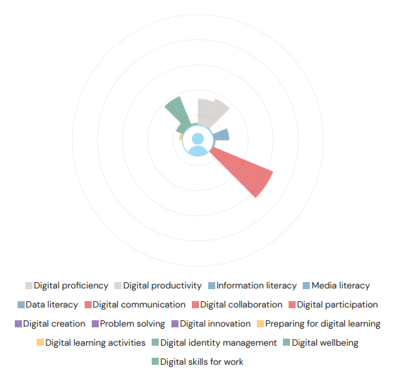
Figure 1. Jisc Discovery Capability Tool results graph

Strengths in Digital Skills
According to the Jisc results, one of the strengths it identified would be preparing for digital learning. Preparing for digital learning means getting ready to use digital tools to support my learning.
The first example would be that I use some of my time to try to work out how to access a useful academic resource or videos which can benefit my education.
Another strength according to the Jisc results is problem solving. Problem solving digitally can build confidence and improve research skills.
For instance, I use google scholar, the university online library and sometime science direct to carry out research and improve my research skills (Cabral and Huet, 2011).

Areas for Improvement
One of the areas for improvement from the Jisc result is digital communication. Digital communication is any type of communication that happens by using a digital media and networks.
One example is I use this digital way of communication with everyone, which can be sometimes through social media, just dropping a simple text or communicating through video chat.
Digital wellbeing is another one that needs improvement according to the Jisc results. Digital wellbeing gets used to figure out how you look after your personal health as well as mental health, maintain your safety, and work life balance.
For instance, I spend a huge amount of time accessing online resources and other resources to work on my assignments without taking a break in between, which then leads to putting pressure on mental health and feeling burned out. I also use digital apps to look after my mental health as well as my physical health. I use them to plan and monitor what I am trying to achieve (Thomas et al., 2022).

Action Plan Using SMART Goals
To make an improvement in my weaker area. I have come up with a Smart goal:
- Specific: Improve my digital communication by practicing more and go through the same thing to understand and get professional advice from a tutor or other students.

- Measurable: Can be done by self-assessment, peer feedback and online tools.

- Achievable: Remind myself to take short breaks during study sessions to avoid getting overwhelmed by information.

- Relevant: This can improve productivity, reduce stress, restore focus, build up confidence, and reduce mental exhaustion.

- Time-bound: Can be achieved in 6/8 weeks' time.

Reflection and Conclusion
Improving my digital skills, will help me not only in my academic journey but also in my personal life as well as in my future career. Developing my skills will also help me manage my academic work efficiently to university standards.

Task 1 References (Minimum 5)
Cabral, A. and Huet, I. (2011) ‘Research in Higher Education: The Role of Teaching and Student Learning’, Procedia - Social and Behavioral Sciences, 29 pp.91 – 97 Available at: https://www.researchgate.net/publication/257714918_Research_In_Higher_Education_The_Role_Of_Teaching_And_Student_Learning (Accessed: 17 March 2026).

Carabregu-Vokshi, M., Ogruk-Maz, G., Yildirim, S., Dedaj, B. and Zeqiri, A. (2024) '21st century digital skills of higher education students during Covid-19-is it possible to enhance digital skills of higher education students through E-Learning?', Education and Information Technologies, 29(1), 103+, Available at: http://dx.doi.org/10.1007/s10639-023-12232-3 (Accessed: 12 March 2026).
JISC (2026) Discovery tool. Available at: https://digitalcapability.jisc.ac.uk/our-service/discovery-tool/. (Accessed: 10 March 2026).
London Metropolitan University (2025) Digital Skills. Available at: https://libguides.londonmet.ac.uk/digital-skills (Accessed: 12 March 2026).
Thomas, N.M., Choudhari, S.G., Gaidhane, A.M. and Quazi Syed, Z. (2022) 'Digital Wellbeing': The Need of the Hour in Today's Digitalized and Technology Driven World!’, Cureus. 7;14(8) doi: 10.7759/cureus.27743. PMID: 36106276; PMCID: PMC9446377 https://doi.org/10.7759/cureus.27743. (Accessed: 17 March 2026).

Task 2: LinkedIn Learning Certificates – Office 365

Outlook Essential Training (Microsoft 365)

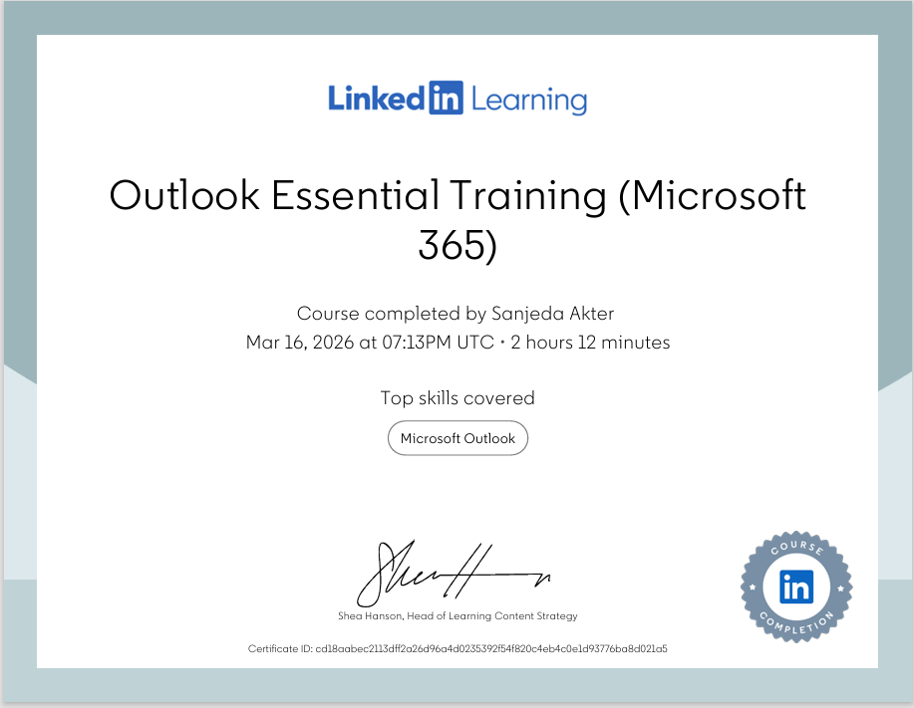

Word Essential Training (Microsoft 365)
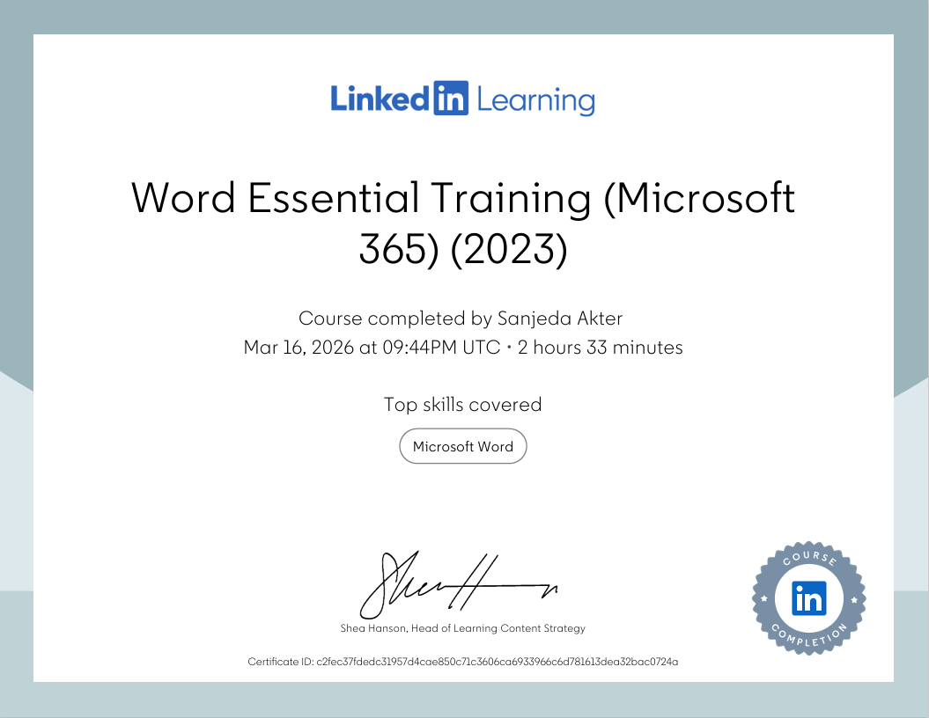

Excel Essential Training (Microsoft 365)
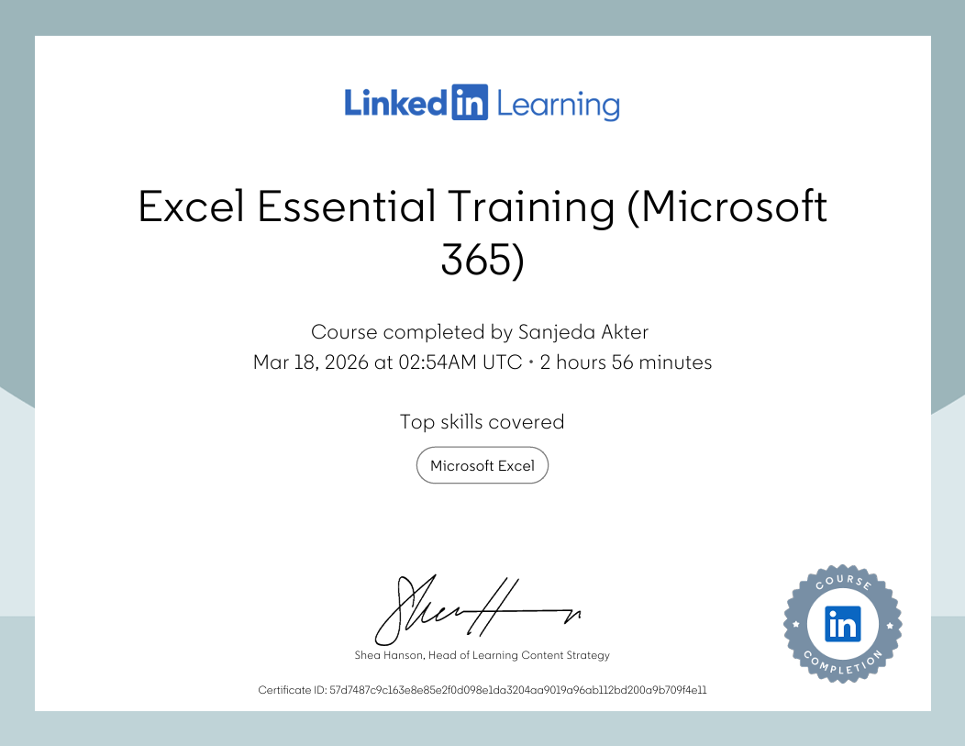

PowerPoint Essential Training (Microsoft 365)
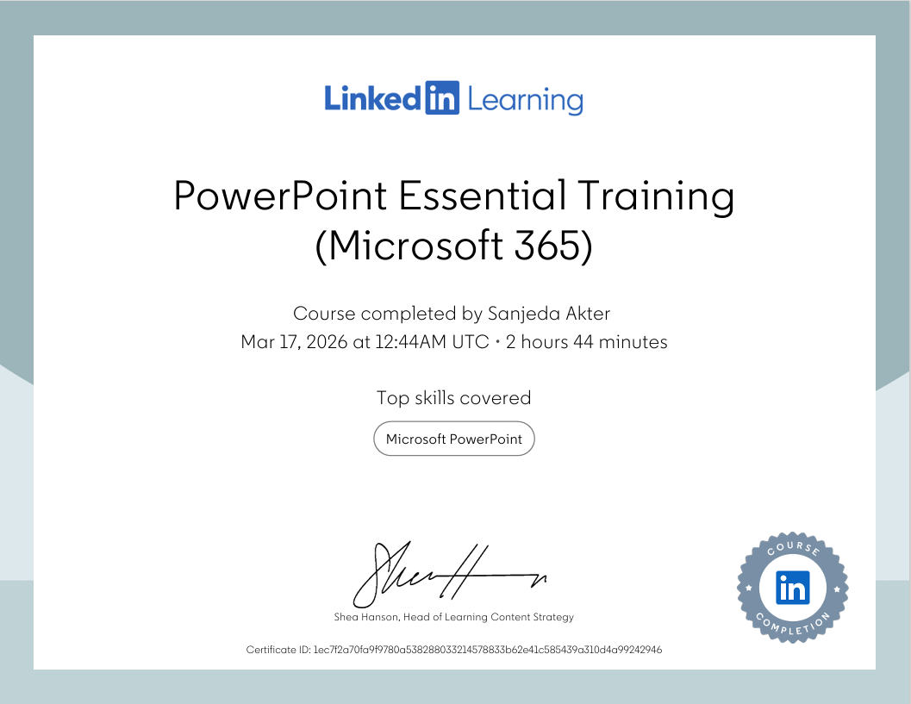

Task 3: Relevance and Importance of Microsoft Excel (1,000 Words)

Microsoft excel is a software spreadsheet application created by Charles Simony and launched in 1985 by the Microsoft corporation (Britannica, 2026).
Microsoft Excel is used for organizing data and representing data visually using rows and columns to structure and organise text or numerical data.
Microsoft excel get used in workplace as well as it a tool for everyday use (Microsoft, 2026). It can also be used to create spreadsheet, analyse data and performing complex calculation using formulas.

Microsoft excel is a powerful and essential tool for in higher education. This tool can help students, teachers and professor to manage and organize information easily and effectively (geeksforgeeks, 2025).
Academic institutes like colleges and universities excel gets widely used by students as well by teachers for data administration, analysis and for organization by using this program students can develop their research skill, complete assignments and work towards personal budgeting. As for teachers and professors Microsoft excel gets used for marking, Visualising data and academic research.
Microsoft Excel is not just a programme which can only be used to do spreadsheet. It is a modern essential tool that gets used modern business is well. Regardless of other various new software which can be found, this is one of the software which gets used for various tasks (Kaplan, 2024).
Business use this sophisticated tool to as it’s a game changer for all types of companies whether the business is big or small. Companies use this tool to organise data, work towards income and balance, project management, make better decision also use it to have a visual report through graph. (School of coding & AI, 2025).
In previous study shows skills like communication and relationship building skills are necessary in the workplace, however it also shows 80% of semi skill level jobs recruited through online requires at least a basic knowledge of understanding how Microsoft excel get used.

Microsoft excel is important as it plays a huge role in many sectors. Using excel can help track expenses or budgeting. It also gets used for its spreadsheet programs not only in businesses, academic institutes and it can also be used to organize personal data (The Importance of MS Excel, 2023). Microsoft Excel can transform unprocessed data into a chart or a visual graph.
Microsoft spreadsheet programs were developed for it to be used by accountant but now it has been embraced by everyone, whether to prepare a budget, sales projection, create profit or loss statement.

Microsoft excel is a great tool which gets used from the comfort of home to workplace for decades. It has powerful features and being easily available makes it a necessary tool for all kind of task. Microsoft excel can be used to manage all types of tasks such as monitoring orders, create budget sheets. (Bloomskillz, 2025).

Uses of Microsoft Excel

Data Analysis
Microsoft Excel can be one of the powerful tools which can manage large data, and it can be used to analyse data formulas simply by selecting a cell in a data range. Excel data can be used to organize data by one or numerous column and sort from highest to lowest form. Microsoft Excel’s data analysis involves organising data, using pivotable to outline and creates graph into visual data.
some of the most important formulas of Microsoft excel which gets used are SUM(), MIN(), MAX(), AVERAGE(), COUNT(), POWER().
Microsoft excel also includes sorting and filtering tools to rapidly display data, which however makes it efficient and easy to be used and manage. Sorting arrangements with Microsoft excel gets done by a specific order such as alphabetically, numerically, by date or can be personalised. Data can also be sorted in ascending (A-Z, 0-9, oldest-newest) or descending (Z-A, 9-0, newest-oldest).
Role of Pivot tables in Microsoft excel program is to summarise, analyse and explore and large datasets without the need of writing any formulas.

Budgeting and Financial Management
Microsoft excel support in budgeting and tracking income and expenditure as it gets used everywhere this day, from academic institute to personal use to track spending.
When it comes to personal finance this tool can be used to track monthly income and expenses towards other things. Such as rent and household bills. This tool can be used to monitor whether there has been any overspending or not. Doing so supports financial awareness.
Microsoft excel hold useful features to track financial performance. Powerful graph and chart tool simplifies and gives a clear view of the financial information. “Dashboards can be created to give a visual overview of key performance indicators (KPIs) like monthly expenses, income, and cash flow”. (Milestone, 2025).

Reporting and Decision-Making
Microsoft excel plays a huge role in reporting and decision making as it can take raw information and transforms them into a structured information. Excel’s visual chart and graph make it simpler and easy to understand and compare performances such as sales monitoring or future targets.

Practical Spreadsheet Task
The household income and expenditure spreadsheet was created to show the practical example of using excel useful features which can be used towards real life finances. Purpose of the spreadsheet is to demonstrates visually of income and expenditure.
By entering data into labelled rows and columns, excel calculates the total income, total expenses towards other things and shows remaining balance left. The formulas that have been used towards this spreadsheet was sum and subtraction to visualise the accurate calculation.
This spreadsheet also represents another pattern where it is showing spending towards other household expenses. Such as rent, council tax, utilities, broadband, phone and towards several other expenses.
This spreadsheet makes it easier to understand and to identify where spending is being more than other areas. By using this tool, it highlights that excel can be used towards professional work, as well as it can also be used in personal life.

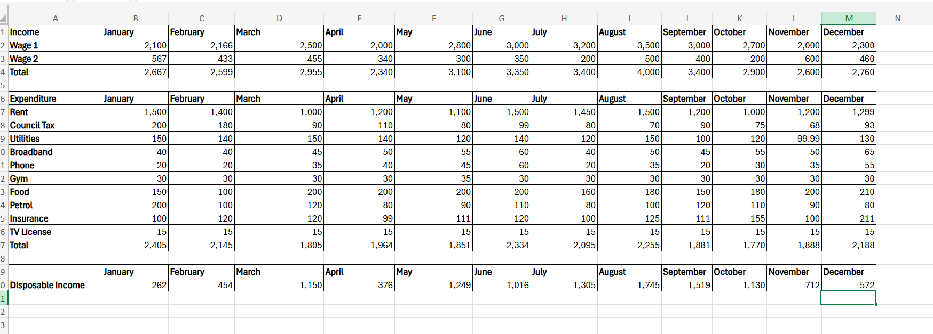

Reflection and Conclusion
Microsoft excel is a useful digital tool which can be used to work towards data analysis, managing finance and can help make decisions. This program can be used not only in academic settings, small or large businesses and towards personal life is well.
Using Microsoft excel in my personal life can help me monitor and give a visual impression of expenses towards my income and expenditure. This program can be used towards my future career as I would like to use this digital tool to store and manage client’s data, tracking progress and use this tool to perform various other tasks.

Task 3 References (Minimum 5)
1Training (n.d.). The Importance of MS Excel. 1Training. Available at: https://www.1training.org/blog/importance-ms-excel/. (Accessed: 17 March 2026).
Awan, A.A. (2022). The 15 Basic Excel Formulas Everyone Needs to Know. Datacamp.com. Available at: https://www.datacamp.com/tutorial/basic-excel-formulas-for-everyone. (Accessed:18 March 2026).
Bloomskillz.com.my. (2025). 10 Reasons Why Microsoft Excel Remains Essential in Today’s Data-Driven World - Bloomskillz - Educational & Training Hub in Malaysia. Available at: https://www.bloomskillz.com.my/blogs/10-reasons-why-microsoft-excel-remains-essential-in-todays-datadriven-world (Accessed: 18 March 2026).
Charlesworth, L. (2024). What is microsoft excel used for and is it still relevant? Kaplan.co.uk. Available at: https://kaplan.co.uk/blog/features/is-microsoft-excel-still-relevant. (Accessed: 18 March 2026).
Excel-easy.com. (2010). Data Analysis in Excel. Available at: https://www.excel-easy.com/data-analysis.html. (Accessed: 18 March 2026).
GeeksforGeeks (2025). Importance of Microsoft Excel in College and Universities. GeeksforGeeks. Available at: https://www.geeksforgeeks.org/excel/importance-microsoft-excel-college/. (Accesses: 18 March 2026).
Microsoft.com. (2015). What is Excel? - Microsoft Support Available at: https://support.microsoft.com/en-gb/office/what-is-excel-94b00f50-5896-479c-b0c5-ff74603b35a3. (Accessed: 18 March 2026).
School of Coding & AI. (2025). Importance of Microsoft Excel in Business: 10 Reasons. Available at: https://schoolofcodinguk.com/blog/importance-of-microsoft-excel-in-business/. (Accessed: 18 March 2026).
The Editors of Encyclopedia Britannica (2019). Microsoft Excel | Description & History. In: Encyclopædia Britannica. Available at: https://www.britannica.com/technology/Microsoft-Excel. (Accessed: 18 March 2026).
Team, T.M. (2025). How Do I Keep Track Of Small Business Expenses In Excel? - Milestone. Milestone. Available at: https://milestone.inc/blog/how-do-i-keep-track-of-small-business-expenses-in-excel. (Accessed: 18 March 2026).

Task 4: Reflective Presentation Summary (5 Minutes)


