Name:Liliana Lorena Buse Student Number:1905867
Module Title:The Global Business Environment
Lectures: Dr. Kenny Tang

The Global Business Environment

Environmental Analysis of an Industry

Table of Contents
Part 1
Introduction 3
PESTEL analysis 3
Porter’s Five Forces analysis 7
Organizational changes and the drive towards electric vehicles 8
Reasons for organizational changes 9
Conclusion 11
References 12

Part 1

Introduction
This report deals with an examination of how the various factors of the external environment can determine the success of an organization and thus are important drivers of change. PESTEL and Porter’s Five Forces analyses have been performed in order to assess the external environment and detect the influence of such factors on an organization like Volvo. Thereafter, a critical evaluation of the organization changes has been performed and the reasons for such changes have been explored.

PESTEL analysis
Analysis of the external forces in the business environment is necessary for assessing the condition of the automotive industry and developing an idea of how the industry has changed in the past in response to these forces. Thus, the PESTEL analysis method is effective in this regard.
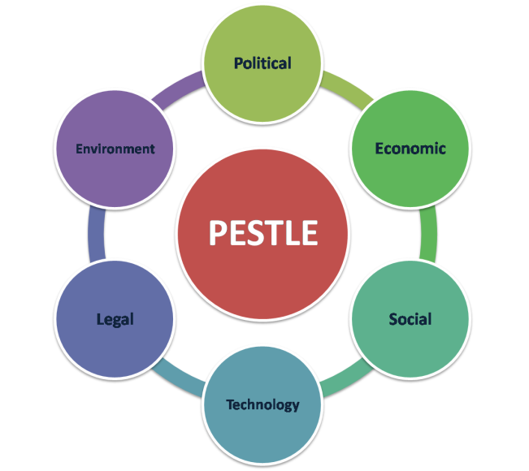
PESTEL
(Source: Story, 2020)

Political
The automotive industry is highly vulnerable to the political scenario in different markets around the world as this directly affects the economic policies and social stability which are important factors driving cars sales. Certain issues are:
Increased taxation – This is one of the main reasons that lead to an increase in the cost of vehicles. The import duties on steel and aluminium have undergone frequent fluctuations and have been hiked several times in some of the major markets in the world (Yang et al. 2019).
Effect of Brexit–The commencement of Brexit continues to have profound influence on the automotive industry with the alteration of trade laws and relations. Since European countries and especially the UK constitute some of the most lucrative markets for automobile manufacturers, political uncertainty in the country caused due to Brexit has adversely affected car sales. This has been compounded by the shortage of skilled labour in the UK caused by the transformation in the political landscape (Bailey and Propris, 2017).

Economic
Fall in demand – this is one of the main concerns affecting the international auto market at the moment. Due to political reasons and over saturation of markets, the demand for new automobiles continues to fall drastically in developed countries in North America and the UK. While new market places like developing countries in the South America and South Asia are opening up, the growth in sales in these markets in not enough to offset the aforementioned fall in demand(Winck, 2019).
Effect of Brexit – Britain being one of the largest automobile markets in the world and also the home of some of the most prestigious automobile manufacturers globally, the economic uncertainty created by Brexit has led to the rise in inflation. It has been estimated that the British economy could suffer further as result of the fallout and this would adversely affect the automobile market (Gowling, 2018).
Trouble in the Chinese market – As discussed before, the Chinese market constitutes a major portion of the international automobile market and is considered as the prime source of growth for the internationals brands. However, a recent slump in the Chinese economy has led to a significant reduction in demand over 2018/19 and some of the largest international automakers have experienced a shrinkage of up to one-fifth in their sales figures(Riley, 2019).

Social
Rise in social consciousness – There is an increasing shift in customer preferences around the world due to the emergence of social consciousness regarding the threat of environmental degradation. However, this poses a problem for car manufactures since achieving environmental sustainability and while maintaining affordability is often difficult.
Decreasing interest in ownership – This has been a constant trend in the developed countries where the establishment of online cab service has seriously affected the way people prefer to travel. The economic efficiency added to the practicality and conveniences of such services are increasingly prompting people to lose interest in owning personal vehicles(Riley, 2019).
Increasing demand of customers for after-sales services – Customer demands and expectations have become more specific and in response to this, some brands have begun to provide added service and round-the-clock assistance. This makes it difficult for other brands to compete without introducing similar services(Thomas, 2019).
Technological
The introduction of AI–Artificial intelligence has caused major changes in the automotive industry and these have also had a direct effect on customer preferences and expectations. The implementation of artificial intelligence in manufacturing and navigation is expected to have an immense influence on the industry in future (Tubaro and Casilli, 2019).
Technological requirements for emission control – with an increasing concentration on the issue of environmental pollution caused by vehicular emissions, the governmental regulations are getting stricter in all countries. Hence, adoption of technology in order to comply with these regulations would be essential for sustenance of car manufacturers in the future (Klebaner, 2018).
Pressure of customer expectations – The growing competition in the automobile industry has led to a significant increase in the expectations and demands of customers in terms of features. Thus, it is expected to get more challenging for car manufacturers in future to provide superior technology at affordable prices(Bloomfield, 2017).

Environmental
The main concern facing the automotive industry is the threat of climate change and environmental degradation. Since traditional cars contribute to the problem in a major way, the industry is witnessing a rapid shift towards more fuel efficient vehicles and growing demands for electric automobiles. The environmental factors will continue to be the most important transformative force in the global automotive industry (Calabrese, 2016).

Legal
The automotive industry is also highly influenced by the legal structure and regulations of the country in which they operate. Change in legal structures and the introduction of strict legislations can be the determinant of success for an automobile company. One of the main issues in recent years has been the change in international trade laws and imposition of taxes and duties in several countries (Kuklinskaet al. 2015).
Element | Specific issues | Ranking
Political | - Increase in taxation  - Chinese domination in the market  - Brexit | Cumulative ranking: High
Economic | - Fall in demand  - Brexit  - Slowing of Chinese economy | Cumulative ranking: High
Social | - Increased social consciousness  - Waning of interest in ownership  - Demand for greater after-sales service | Cumulative ranking: Medium
Technological | - Introduction of AI  - Technological requirements  - Pressure of customer expectations | Cumulative ranking: Medium
Environmental | - Environmental degradation due to vehicular emissions  - Requirement of environmentally conscious practices | Cumulative ranking: Medium
Legal | - Strictness of emission laws  - Proposed EU ban on diesel cars | Cumulative ranking: High

Porter’s Five Forces analysis
Analysis of the different market forces active in the external environment is critical for understanding the nature of the industry. For this, the Five Forces model proposed by Michael Porter can be utilized.
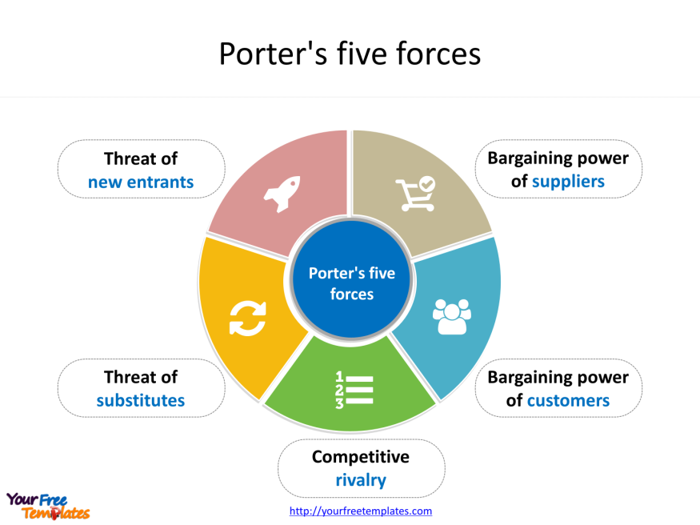
Porter’s Five Forces
(Source: Story, 220)
Threat of new entrants – Since a company like Volvo has constructed their reputation over many years and is highly specialised in terms of its automobiles and other products, the threat posed by any new entrant is fairly low. It would be highly difficult for any new entrant to gain popularity instantly since it involves an enormous financial commitment. Moreover, the current brands (including Volvo) all possess considerable recognition and brand loyalty which is difficult to replace(Garinaet al. 2018).
Bargaining power of suppliers – this is relatively weak force in the automotive industry since there is an abundance of companies manufacturing the machinery and internal parts used in the construction of automobiles. Volvo collaborates with around 51,000 such suppliers worldwide. Since the machinery involved is fairly standardised and generic, replacing suppliers is relatively easy for automobile companies (Manello and Calabrese, 2019).
Bargaining power of buyers – This aspect is highly variable and depends on the general preference and socio-economic condition of the majority. Volvo has never been a mass producer of vehicles like Toyota and General Motors. Thus, the brand has recognition and a unique identity among customers around the world. The bargaining power of buyers is low in certain markets while it is high in others(Schulze et al. 2015).
Threat of substitute products or services – For Volvo, this is definitely a strong force since the competition in the automobile market is high and the positioning of the company does not allow it to be considered a premium car manufacturer. Hence, the company cannot fully capitalize on the unique brand value aspect and has to compete with other manufacturers for market share.
Competition among existing rivals – In the case of Volvo, this force is strong in most markets owing to the presence of a high number of competitors. Volvo is not a mass producer as mentioned earlier. However, the company is also not considered as a luxury car brand like Audi or Mercedes. Thus, Volvo cars have to compete with rival who offer belter pricing with similar or better features (Arbolettiet al. 2014).

Organizational changes and the drive towards electric vehicles
There are several organizational changes that would be necessitated due to Volvo’s decision to completely shift to electrical vehicles as claimed in the given case (McKinsey, 2014).The types of organizational changes would be in two aspects as described below:

Change in organizational structure
The current structure of the organization is essentially a divisional type of structure where the divisions are based on the projects and products. Thus, in Volvo, the different product divisions are headed by certain leaders who ensure proper functioning of the respective divisions and the utilization of resources.
This organizational structure could be altered to a matrix style of culture by which the company could utilize the flexibility of the divisional type of structure along with the clear demarcation of responsibilities androles granted by a hierarchical structure.

Change in organizational culture
The current internal culture of Volvo is claimed to be a combination of means and goal orientations where the implementation of ethical practises is considered equally as important as the achievement of the company’s goals and objectives (Volvo Group, 2019).. The company’s culture is internally driven and the maintenance of discipline is strictly enforced. Moreover, the organization has an open system of organization where considerable flexibility is present along with a clear demarcation and distinction of different tasks (Volvoce.com, 2020).
However, as discussed earlier, one of the main problems of the company in the past has been in regards to its market positioning and branding. Thus, the company has implemented a policy of hiring new talent in order to improve its innovation in terms of production and marketing. This implementation of this strategy could therefore cause certain changes in the internal culture of the organization. The adherence to its values and principles would be maintained but the autocratic system of employee management employed at present could be changed to a more democratic system. This would be crucial for ensuring that the talents of employees are being utilized in the best possible manner and that the company can effectively rediscover its identity in the industry (Harvard business Review, 2018).
Apart from these aspects, all the elements of the business operations would also be drastically altered by the proposed change. The various processes involved in raw material procurement and manufacturing would be transformed and thus, the relationship between the company and its suppliers would also have to change accordingly. Consequently, the interaction and relative strength of the porter’s forces as described previously could also get altered. Hence, the internal and external strategies of the organization would have to be in response to the changes in the market and industry (Musonera and Cagle, 2019).

Reasons for organizational changes
The principal instigator of change in the global automotive industry is the increase in concerns over climate change and environmental degradation. Governments in different countries are attempting to respond to the threat by implementing new environmental regulations and laws. As discussed above, these regulations have been stringent in certain regions like the EU and the UK. Thus, it has become necessary for automobile brands to introduce new technology in order to adhere to the norms. However, this causes a significant rise in prices which makes it difficult to maintain affordability. Governments in the UK and other EU countries have introduced special incentive schemes to assist organizations in adopting sustainable practices. Certain governments also provide tax rebates to owners of such vehicles (Calabrese, 2016).
Moreover, there are concerns regarding an impending energy crisis caused by the depletion of fossil fuel reserves in the world. Hence, this has also prompted the public to actively seek for more environment friendly alternatives (Bloomfield, 2014).
With companies like Tesla showing the way, considerable improvement has been made in battery technology in recent years. This has led to a drastic reduction in the cost of owning and maintaining an electric vehicle which in turn, has increased the demand for such vehicles in the market (Gebert, 2014). Overall, current calculations suggest that electric vehicles are considerably cheaper to maintain than traditional fossil-fuel cars (Buekerset al.2014). China is currently the leading producer of electric vehicles in the world and the concept is growing in popularity steadily in the Europe and the USA (Avciet al. 2015).
Hence, the combined effect of the above reasons has precipitated the change in the automotive industry.

Conclusion
This report deals with an exploration of the different forces in the market environment that directly affects a company like Volvo. An analysis of such forces gives an idea of how the organization could be affected as a result of the proposed change and what the reason for the increase in the popularity of electric vehicles. The complete shift to electrical engines as proposed by the company would necessitate an overhaul of several current processes. The analyses have displayed that the high level of competition in the automotive market is an important motivation for Volvo to respond to customer needs in order to stay relevant and have a competitive edge. The combined influence of multiple factors in the global auto industry has caused the company to take the decision.

References
Arboletti, A., Torresani, G., Palle, N. and Segerberg, P., Accenture Global Services Ltd, 2014. Automotive industry high performance capability assessment.U.S. Patent 8,781,882.
Avci, B., Girotra, K. and Netessine, S., 2015. Electric vehicles with a battery switching station: Adoption and environmental impact. Management Science, 61(4), pp.772-794.
Bailey, D. and De Propris, L., 2017. Brexit and the UK automotive industry. National Institute Economic Review, 242(1), pp.R51-R59.
Bergek, A., Berggren, C. and KITE Research Group, 2014. The impact of environmental policy instruments on innovation: A review of energy and automotive industry studies. Ecological Economics, 106, pp.112-123.
Bloomfield, G.T., 2017. The world automotive industry in transition. In Restructuring the global automobile industry (pp. 19-60). Routledge.
Buekers, J., Van Holderbeke, M., Bierkens, J. and Panis, L.I., 2014. Health and environmental benefits related to electric vehicle introduction in EU countries. Transportation Research Part D: Transport and Environment, 33, pp.26-38.
‌Calabrese, G. ed., 2016. The greening of the automotive industry.Springer.
‌Garina, E.P., Kuznetsov, V.P., Romanovskaya, E.V., Andryashina, N.S. and Efremova, A.D., 2018. Research And Generalization Of Design Practice Of Industrial Product Development (By The Example Of Domestic Automotive Industry). Quality-access to success, 19.
Gebert, M., 2014. COULD TESLA MOTORS BE THE NEW NOKIA FOR THE AUTOMOTIVE INDUSTRY?.
‌Gowling W.L.G. (2018). The potential consequences of Brexit for environmental law and the impact on the automotive industry. [online] Available at: https://gowlingwlg.com/en/insights-resources/articles/2018/brexit-environmental-law-and-automotive-industry/ [Accessed 25 Apr. 2020].
Harvard Business Review. (2018). How Volvo Reinvented Itself Through Hiring. [online] Available at: https://hbr.org/2018/03/how-volvo-reinvented-itself-through-hiring [Accessed 25 Apr. 2020].
Klebaner, S., 2018. Isolated car manufacturers? The political positions of the automotive industry on the real driving emissions regulation. International Journal of Automotive Technology and Management, 18(2), pp.119-141.
Kuklinska, K., Wolska, L. and Namiesnik, J., 2015. Air quality policy in the US and the EU–a review. Atmospheric Pollution Research, 6(1), pp.129-137.
Manello, A. and Calabrese, G., 2019. The influence of reputation on supplier selection: An empirical study of the European automotive industry. Journal of Purchasing and Supply Management, 25(1), pp.69-77.
McKinsey, A.R.F., 2014. EVolution Electric Vehicles in Europe: Gearing up for a New Phase?.
Musonera, E. and Cagle, C., 2019. Electric Car Brand Positioning in the Automotive Industry: Recommendations for Sustainable and Innovative Marketing Strategies. Journal of Strategic Innovation and Sustainability, 14(1).
‌Riley, C. (2019). How Tesla made electric cars sexy. [online] CNN. Available at: https://edition.cnn.com/2019/07/12/business/auto-industry-electric-cars/index.html [Accessed 28 Apr. 2020].
Schulze, A., Paul MacDuffie, J. and Täube, F.A., 2015. Introduction: knowledge generation and innovation diffusion in the global automotive industry—change and stability during turbulent times. Industrial and corporate change, 24(3), pp.603-611.
Story, J. (2020). How to use Porter’s 5 Forces model | Smart Insights. [online] Available at: https://www.smartinsights.com/online-brand-strategy/brand-development/how-to-use-porters-5-forces-model/ [Accessed 28 Apr. 2020].
Story, J. (2020). Using the PESTLE analysis model. [online] Available at: https://www.smartinsights.com/marketing-planning/marketing-models/pestle-analysis-model/ [Accessed 28 Apr. 2020].
Thomas, D. (2019). Five reasons the car industry is struggling. BBC News. [online] 6 Jun. Available at: https://www.bbc.com/news/business-48545733 [Accessed 28 Apr. 2020]‌.
Tubaro, P. and Casilli, A.A., 2019. Micro-work, artificial intelligence and the automotive industry. Journal of Industrial and Business Economics, 46(3), pp.333-345.
Volvo Group presentation Driving prosperity through transport solutions.(2020). [online] Available at: https://www.volvogroup.com/content/dam/volvo/volvo-group/markets/global/en-en/about-us/Volvo-Group-Presentation.pdf [Accessed 25 Apr. 2020].
Volvogroup.com. (2019). Our core values | Company culture | Volvo Group. [online] Available at: https://www.volvogroup.com/en-en/about-us/company-values.html [Accessed 25 Apr. 2020].
Winck, B. (2019). The auto industry is shrinking as the world reaches “peak car” - and it’s dragging down the entire global eco. [online] Business Insider. Available at: https://www.businessinsider.in/stock-market/news/the-auto-industry-is-shrinking-as-the-world-reaches-peak-car-and-its-dragging-down-the-entire-global-economy/articleshow/71825520.cms [Accessed 28 Apr. 2020].
Yang, D.X., Qiu, L.S., Yan, J.J., Chen, Z.Y. and Jiang, M., 2019.The government regulation and market behavior of the new energy automotive industry. Journal of cleaner production, 210, pp.1281-1288.

