BA (Hons) International Hotel Management

Module: Organisational Consultancy
Module code: BMIH6005
Lecturer: Dr Huw Thomas

Student name: Mohammed Zubair Khan
Student ID number: 2112114

Assignment Title:
Consultancy Report on The Peninsula Chicago Hotel

Submission deadline: 17 November 2023

Consultancy Report
on
The Peninsula Chicago Hotel

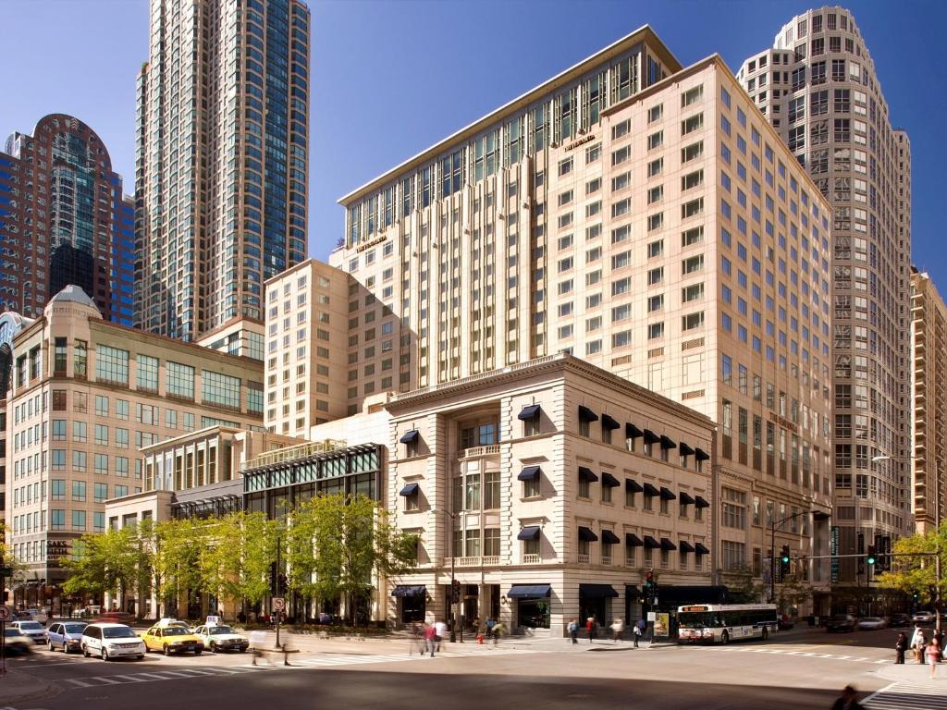

Executive Summary
The Peninsula Chicago Hotel has approached and hired a consulting firm Khan consulting to conduct an in-depth analysis of the problems the hotel management is concerned, and to provide recommendations for potential solutions. Customers have raised and management also identified about the hotel's cleanliness issues which might lead to a negative reputation. This was the most significant issues currently facing the management. According to the hotel's own SWOT analysis, the quality of the events it hosts, as well as the quality of its food and service, are among its greatest strengths. This report looks at the importance of cleanliness and how it might affect a hotel's bottom line in the hospitality industry. Considering this, the research provides several recommendations and action plan to implement for enhancing the cleanliness of the hotel. Cleaning on a strict schedule, providing regular training for the housekeeping staff, and regularly updating cleaning supplies and equipment are all factors to think about. It is highly recommended that the hotel regularly assesses the outcomes of these initiatives to determine their efficacy. The research found that if the Peninsula Chicago Hotel fixed its cleanliness issues and promoted its strengths, it might improve its image and business.

Contents

Executive Summary 3
Introduction 5
Brief Background 6
Porter’s Five Forces Model 6
Analysis 7
PESTEL Analysis 10
SWOT Analysis 15
Recommendations and change management. 18
Action Plan 25
Conclusion 28
References 29
Introduction
This consultancy report will use the "Peninsula Chicago Hotel" as a case study to analyse the value of cleanliness in the hospitality industry. The study team's mission is to assess the hotel's current state of cleanliness and provide recommendations for improvement. Customers' impressions of a hotel are heavily influenced by its cleanliness, as stated by Barron and Maxwell (2019). Therefore, the importance of this facet of the hotel sector cannot be overstated. The hotel's image and financial line might take a hit if guests are dissatisfied with their stay due to unsanitary or disorganised public areas. The Peninsula Chicago Hotel's ability to attract and retain clients depends on its ability to meet all relevant cleanliness criteria. This will increase the likelihood that visitors will have a good experience at the hotel.
The consultant in its report will conduct a PESTEL, SWOT, and TOWS analysis because the Peninsula Chicago has a difficulty maintaining adequate levels of cleanliness and will recommend the best course of action to take to overcome the situation. We may learn more about the external elements that may have an impact on the hotel's cleanliness by doing a PESTEL study. By doing a SWOT analysis, we can assess the hotel's internal cleaning strengths and weaknesses. After identifying key areas of strength and weakness, the TOWS analysis may be used to develop strategy (Brotherton, 2013). Because of the systematic and all-encompassing approach to problem-solving that these methods provide, we are certain that we will be able to provide the Peninsula Chicago Hotel the advice that is both the most beneficial and suitable to their circumstance. Strategic planning and analysis of the hotel's internal and external environments will improve the hotel's overall performance and help it gain and maintain a competitive edge over the long term. The following sections of this consulting report will focus mostly on the research itself, as well as the results and suggestions that were obtained as a result of that investigation.

Brief Background
The Peninsula Chicago is among the finest hotels in all of Chicago. This luxurious hotel is part of the prestigious Peninsula Hotels chain, which is known for its impeccable service and lavish amenities. As a world-class luxury hotel, The Peninsula Chicago has a prime location along the lively Magnificent Mile, only blocks from the city's best restaurants, bars, and boutiques. There was a lot of buzz when The Peninsula Chicago opened in 2001 since it was such a high-end addition to the city's hotel scene. Since then, it has come to represent Chicago's everlasting appeal and the city's undying commitment to its international tourists. Each accommodation at The Peninsula Chicago is spacious and elegantly appointed, presenting a harmonious fusion of modern minimalism and classic style. Travellers may choose from a wide variety of accommodations, from basic rooms to luxurious suites with panoramic city views.
Regarding operational excellence, strategic planning, and improving the quality of the guest experience, Khan Consultancy is the consulting firm of choice for the world's finest hotels and resorts. Khan Consultancy has made a name for itself as an industry leader for its innovative, tailor-made solutions that enable hotels to better serve their guests and because of this, Khan Consultancy has become a leader in the hospitality sector.

Porter's Five Forces model
Porter's Five Forces model is useful for assessing the competitive landscape and market attractiveness. It looks at five key aspects of industrial competitiveness. The Peninsula Hotel in Chicago will be examined through the lens of Porter's Five Forces.
Threat of New Entrants: The luxury hotel sector is especially vulnerable in a city like Chicago because of the influx of new rivals. You'll need a lot of capital, years of industry expertise, and established name recognition to open a luxury hotel. The Peninsula Chicago Hotel's established reputation and dedicated clientele make it difficult for upstarts to steal their customers.
Bargaining Power of Suppliers: Suppliers of food and drink, linens, maintenance workers, and cutting-edge technology are all vital to the hotel business. It's probable that the Peninsula Chicago Hotel has established reliable ties with its vendors, allowing it to manage the needs of its suppliers (Deery, Jago, & Fredline, 2017). However, if they can only use a few of suppliers, those vendors may be in a stronger bargaining position.
Bargaining Power of Buyers (Customers): Luxury hotel patrons are famously picky and demanding due to their greater disposable income and higher standards of service. The Peninsula Chicago Hotel, on the other hand, may demand higher prices because of its renown for excellence in service and amenities. However, in a market with several vendors, ratings that highlight a lack of cleanliness may weaken the bargaining position of consumers.
Threat of Substitutes: Airbnb, boutique hotels, and other high-end lodging options are just a few of the many alternatives to traditional 5-star hotels. Luxury hotels like the Peninsula Chicago may be able to survive in the face of substitution threats from similar businesses because they provide something that their competitors do not offer.
Competitive Rivalry within the Industry: The luxury hotel sector can be cutthroat, especially in major cities like Chicago where several well-known hotels compete for the same customer. When compared to other luxury hotels in Chicago, the Peninsula Hotel stands out for its excellent service, convenient facilities, and prime location (Massidda et al., 2022). And the market becomes even more competitive if hotels do not handle guest concerns about cleanliness.

Analysis
Near Chicago's Midway (MDW) Airport, in a primarily residential area, you will find The Peninsula Chicago Hotel (Peninsula Chicago Hotel, 2022). In addition to its 99 guest rooms, this hotel has a restaurant, bar, fitness facility, and conference rooms, making it ideal for business travellers. The Peninsula Chicago Hotel (2022) notes that the hotel's location, near access to major thoroughfares like the A38 and M1, and placement in a tranquil residential area make it an ideal option for business and leisure travellers. Guests like their visits and appreciate the hotel's food and service, even though it is not the newest or most cutting-edge lodging option in the area. There has been a great deal of praise for the restaurant online, with many diners praising the excellent service and delicious food.
The management team has reviewed the operations of the hotel as part of their regular and periodic evaluation, and identified some shortcomings in the cleanliness which may seriously affect their reputation. To safeguard the health and safety of their guests, hotels today confront additional challenges as a direct consequence of the profound impact that Covid-19 has had on the hospitality industry. Tourists and travellers prioritise finding a safe and sanitary hotel room as the pandemic changed the mindsets throughout the world. As with any hotel, the Peninsula Chicago Hotel has an obligation to its guests to always keep them safe and secure.
The Peninsula Chicago Hotel has upgraded its cleaning procedures and strengthened its Covid-19 security measures. The hotel has quadrupled the frequency with which high-touch areas are cleaned and sanitised (Buhalis & Law, 2018), including doorknobs, lift buttons and television remote controls. Hand sanitizer and disposable face masks in all the hotel's common areas are visible. The hotel has just adjusted its cancellation policy to better serve guests who, considering Covid-19, may need to make last-minute adjustments to their travel plans. There are still problems with the cleanliness of the rooms and the safety of the Covid-19 at the hotel, despite these improvements. The hotel seems to have major issues with room cleanliness, if the comments and evaluations of previous guests are any indication. This might lead to even more negative feedback, which would be bad for theie reputation (Tripadvisor, 2022).
The Peninsula Chicago Hotel is experiencing issues keeping its rooms clean and maintaining its Covid-19 security, despite its excellent reputation in many other respects. In written comments, guests often enthuse over the helpfulness and friendliness of the hotel's employees. Guests appreciate the warm reception they get at arrival and during their stay, as shown in research by Chan and Baum (2017). Hotel guests like the ease of having the hotel, the restaurant, the gym and the many meeting spaces all in the same building.
The Peninsula Hotel in Chicago is well known as an excellent gathering place. Different configurations of the hotel's event spaces allow it to host anything from corporate conferences to wedding celebrations (Chibili, 2019). Through close cooperation with the guests in attendance, the hotel staff uses their years of experience in event planning to guarantee the success of every event. The hotel's popularity as a host for celebrations of all kinds is due in large part to the positive feedback it has received from guests. The hotel has received several accolades from guests for its excellent event hosting services.
Subsequent sections of this inquiry will delve deeper into the origins of these problems and provide viable remedies to bring peace back to the Peninsula Chicago Hotel and strengthen the cleanliness activities being conducted there. Since the epidemic, tourists have become more health-conscious and pickier about where they choose to stay. If the hotel implements these safeguards, it will be able to maintain its high quality and continue to draw in new guests.

PESTEL Analysis
This report summarises the findings of a PESTEL analysis conducted for the Peninsula Chicago Hotel. The purpose of the analysis was to help the hotel better understand the external environment in which it works.

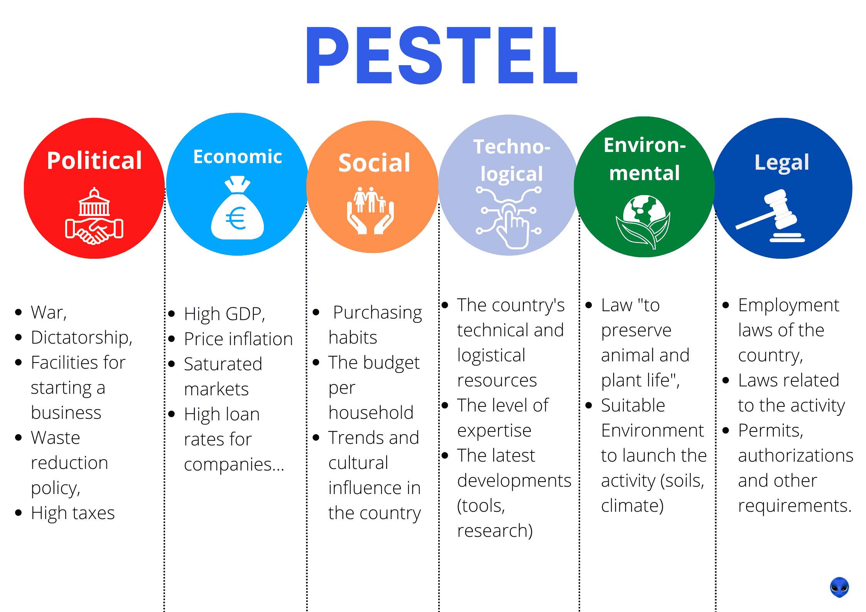
Figure 4: PESTEL analysis for Peninsula Chicago Hotel (Planellas & Muni, 2020).

Political | The hospitality industry is affected by several external forces, including regulations pertaining to health and safety, taxation, and employment. Because of the limitations on movement and assembly brought on by the Covid-19 epidemic, the Peninsula Chicago Hotel has been undergoing major renovations. The law enforcement officials mandated these limitations.
Economic | The hotel industry might be impacted by a range of economic factors, including shifts in consumer spending, interest rates, and currency exchange rates. When individuals have less money to spend on items like travel and lodging, as stated by Noordzy and Whitfield (2014), it is common for them to cut down. The Peninsula Chicago Hotel might be affected by the present national and local economic climate.
Social | Baron and Armstrong (2007) argue that changes in consumer behaviour, such as the growing interest in health and wellbeing, may influence the hospitality industry. As a direct result of the COVID-19 outbreak, more people than ever before are paying close attention to practising rigorous standards of personal cleanliness. The Peninsula Hotel in Chicago must change with the times if it is to survive.
Technology | According to Chang and Kim (2013), more and more hotels are investing in cutting-edge technology to improve customer service and reduce overhead costs. The Peninsula Chicago Hotel, which is a market leader, must quickly embrace new technology to keep pace with the competition.
Environmental | Hotels are becoming more conscious of environmental issues including climate change and eco-friendly business policies. Choi and Kim (2016) state that the Peninsula Chicago Hotel might benefit from using energy-saving and waste-minimisation technology.
Legal | Coelho and Henseler (2012) state that there are several laws and policies governing the hospitality industry, including those pertaining to health and safety, employee protection, and privacy. The Peninsula Chicago Hotel must follow all current regulations to avoid legal trouble.

Numerous external factors threaten the Peninsula Hotel's capacity to remain open and profitable in Chicago. One method that might be utilised to analyse these environmental factors and their potential impact on the hotel is the PESTEL framework (Dedeolu & Demirer, 2014). Regular hotel operations might be interrupted by factors such as political turmoil. Government restrictions, taxation, employment, and environmental requirements may have an impact on the hotel's operations and financial bottom line. For instance, if immigration or labour laws were to change, it may make it harder for the hotel to acquire and retain skilled workers, which could have repercussions for guest satisfaction (Deery, Jago, & Fredline, 2017). As of the year 2020, (Dev & Olsen). from fiscal year, 2025-26, the government is planning to collect 35% of GDP in taxes, up from the 34% predicted in the current budget. This will be the highest rate seen since 1969–1970, as seen in the graph to the right. The Office of Budget Responsibility (OBR) (OBR, 2023) speculates that "almost half of this increase" may be related to a rise in the corporation tax rate from 20% to 25%. The Office of Budget Responsibility issued the following statement. The Peninsula Chicago Hotel is just one of several businesses that have had to increase their pricing in response to this surge in costs.
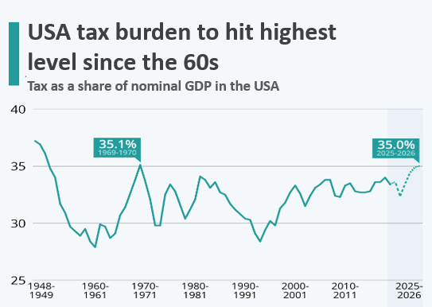

Figure 5: Hospitality and other business Burden of tax (USAhospitality, 2022).
Future economic downturns might influence the hotel's bottom line. The hotel's bottom line is sensitive to inflation, interest rates, and economic growth, as are clients' discretionary spending habits. However, fluctuations in the currency rate might impact the hotel's bottom line because of the cost of products and services provided and the income received from visitors from other countries. Dimitrovski and Koteski's 2022 estimates that by 2024–25 the federal government of the United States will have increased taxes by 2% of GDP.

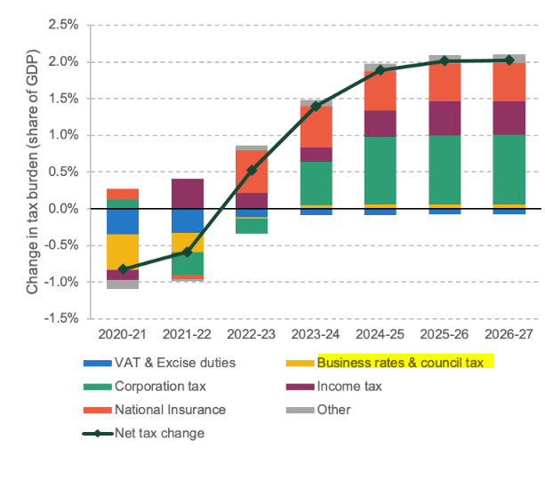

Figure 6: Tax impact on hospitality (High) (Massidda et al., 2022).
External societal variables may affect the tastes of the hotel's ideal customer and the demographics of the clientele. Estelami (2014) suggests, for instance, that there may be significant differences between the preferences of the elderly and those of the young with respect to certain services and conveniences. Fielden and Davison (2013) argue that hotels' bottom lines might be affected by the growing demand for greener services and better dining alternatives because of cultural trends towards wellness and sustainability. Here, we provide some numbers to back up our claim that the Peninsula Chicago Hotel must be always immaculate.
It's also possible that technical factors outside the hotel's control will have a detrimental effect on its operations. The hotel's operations, competitiveness, and quality of service to guests might all improve with the help of technology. Fuchs and Reichel (2018) argue that the use of technology in hotels, such as online booking systems, customer relationship management (CRM) programmes, and security systems, can have a major impact on hotel operations and the guest experience. Weather, natural disasters, and climate change are only a few examples of environmental elements that might disrupt hotel operations, as stated by Gounaris (2015). For the hotel to follow environmental regulations, Gursoy and Lu (2013) state that it must be conscious of its ecological impact and work to lessen it. Hotel operations may be impacted by, for example, labour laws, health and safety restrictions, and data protection legislation. It is of the highest significance, say Han and Hyun (2012), that the hotel's employees, food service, and data storage all conform to the standards.
After completing the PESTEL analysis, we have a clearer grasp of the external factors that might impact the Peninsula Chicago Hotel's operations and profitability. Consider the environmental, social, technical, and political factors. The hotel must monitor such factors to mitigate any undesirable effects and make the most of any opportunities that arise.
SWOT Analysis
Strengths | Chicago's Peninsula Hotel is renowned for its gourmet cuisine, impeccable service, and ability to handle a wide range of special events. Hotel customers like the hotel's variety of facilities, which include a restaurant, a bar, and a fitness centre. Hocutt (2012) claims that hotels employ seasoned event planners and managers who collaborate closely with visitors to achieve the desired outcomes of the event.
Weaknesses | There have been complaints about the hotel's cleanliness, which might hurt not just customer happiness but also the hotel's standing in the community. To maintain its status as an industry leader in the wake of the Covid-19 outbreak, the Peninsula Chicago Hotel must take steps to improve its cleanliness and safety.
Opportunities | The Peninsula Chicago Hotel may save money by becoming green, which would also please its environmentally conscious clientele. Technology tools could increase both visitor satisfaction and hotel productivity, as stated by Huang, Backman, and Backman (2013).
Threats | According to Josephi and Melissen (2017), the hotel business faces risks from a variety of external factors, such as economic uncertainty, changing consumer tastes, and the implementation of new legislation. To stay in business, the Peninsula Chicago Hotel must adjust in response to the devastating impact that the spread of COVID-19 has had on the hospitality sector.

The Peninsula Hotel in Chicago might suffer losses if unforeseen events take an unfavourable turn. Government regulations, the economy, and tourist tastes are all examples of such outside factors. Kim, Chung, and Lee (2019) argue that for the hotel to remain competitive and meet the changing needs of its customers, it must implement environmentally friendly practises and abide by all relevant regulations. The Peninsula Chicago Hotel is renowned for its superb staff, adaptable function rooms, and delectable dining options. Customers may be irritated by the hotel's imperfections, such as its lack of cleanliness, for example (Kim, Lee, & Hwang, 2020). The hotel's lacklustre cleanliness is one such problem. The Peninsula Chicago Hotel may seize opportunities to improve the quality of its services and operations while reducing the negative impact it has on the local environment by cutting down on its energy and water use. According to Kinderlerer (2016), hotels face threats to their bottom lines from a variety of sources, including economic volatility and shifting government regulations.
Customers' complaints about the establishment's cleanliness were a common source of their dissatisfaction. Two areas often cited as sources of discontent are the cleanliness of the lavatory and the quality of the bedding. Some guests have mentioned finding hair and dust on the furniture, which may be attributable to insufficient cleaning efforts. For instance, (Whittington et al., 2020) Recommends that the Peninsula Chicago Hotel do a TOWS analysis (an acronym for "threats," "opportunities," "weaknesses," and "strengths") to improve the calibre of their cleaning services and the happiness of their clients. The hotel's management can decide to conduct a TOWS study to ascertain the risks and vulnerabilities of their systems and decide on the best course of action.
The PESTEL analysis showed, for instance, that during the COVID-19 epidemic, visitor cleanliness and safety were much more important to the hotel. Putting their expertise in customer service and food quality to good use, the staff at the Peninsula Chicago Hotel may use new, stricter cleaning procedures and strategically placed hand sanitising stations to improve the hotel's overall cleanliness and safety.
The hotel may use the results of the TOWS research to address issues like inadequate employee training and unsanitary conditions in the workplace. If these problems were fixed, it's probable that hotel reviews and customer happiness would rise.
In conclusion, the Peninsula Chicago Hotel may win from the TOWS investigation by understanding its flaws, fixing them, capitalising on its opportunities, and safeguarding itself from any threats. As stated in the TOWS report for the Peninsula Hotel in Chicago.

TWOS for Peninsula Chicago Hotel:
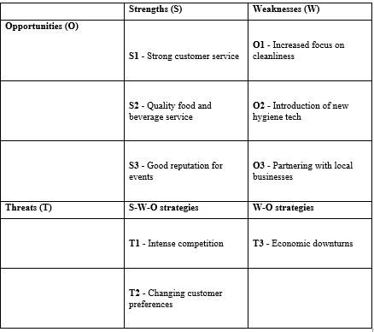
The Peninsula Chicago Hotel's strengths, weaknesses, opportunities, and threats were identified via an analysis we did utilising the TOWS framework (Whittington et al., 2020). Based on our research, we have identified four areas for improvement and highlighted the hotel's numerous strengths.
Using the S-W-O paradigm, the hotel may maximise its benefits while reducing the negative effects of its weaknesses and maximising the potential of its strengths. The hotel's W-O events are intended to help strengthen any weak spots guests may have noticed.
S-W-O Strategies:
S1-O1: Research from the year 2020 by Whittington et al. suggests that keeping the hotel clean is one way to improve service and make visitors happier, who will then be more inclined to return.
S2-O2: Given the high quality of its food and drink service, the hotel has a great chance to employ cutting-edge sanitary technologies to further increase the level of comfort and safety it gives to its guests.
S3-O3: Working with other regional businesses to promote the hotel's offerings might increase revenue (Papadopoulos & Ioannou, 2022). The goal here is to take advantage of the rising need for convention centres in the area.
W-O Strategies:
W1-O1: The hotel now has an opportunity to address its cleanliness issues, should it want to do so.
W2-O2: According to Chan and Baum (2017), it is possible that the hotel would install newer, more advanced sewage systems to meet the evolving needs of its clientele in terms of cleanliness and security.
W3-O3: The hotel may be able to increase its profile even if business is slow by collaborating with establishments in the area that provide complementary goods and services (Buhalis & Law, 2018).
The findings of the TOWS research help to shape strategies that will help the Peninsula Chicago Hotel make the most of its opportunities and mitigate its risks.

Recommendations and Change Management
The cleanliness of a hotel is a major factor in determining whether a guest would return. It is crucial that the Peninsula Chicago Hotel be kept clean so that guests may feel safe and comfortable throughout their stay. Consumers have come to expect a hotel to be pristine and hygienic from the time they book a room to the time they leave, say Kokkinou and Josephi (2019). Kozak (2016) reports that hotels in the UK have made cleaning a key priority out of concern for their guests' health. Cleaning standards at Premier Inn, a prominent budget hotel chain in the United Kingdom, have recently been tightened. The business now uses medical-grade cleaning products and disinfects high-touch surfaces more often than before (Dyson, 2020).
To generate the impression that rooms have not been used, Hilton Hotels have launched a programme called "CleanStay," which involves using electrostatic sprayers to clean them and then closing the doors thereafter (Hilton, 2022).

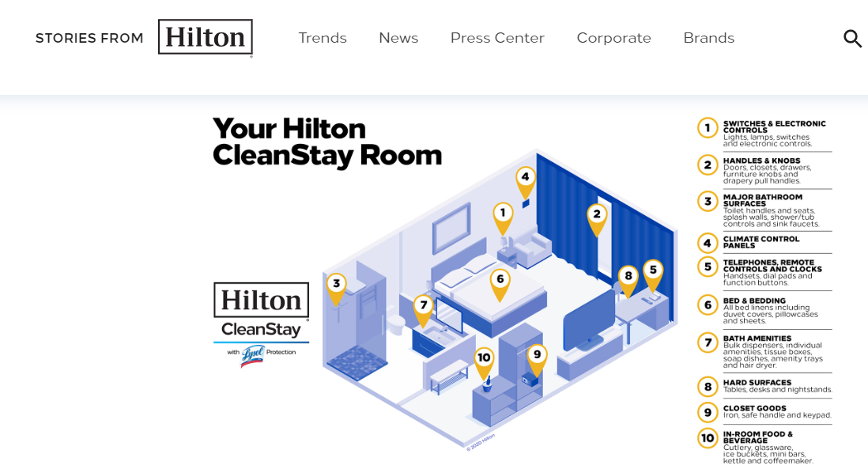
Figure 10: Hilton CleanStay campaign (Hilton, 2022).
Since keeping a hotel or other company clean has been proved to increase customer satisfaction and repeat visits, it has become standard operating procedure in the hospitality sector in the United States. A Travelodge customer survey conducted in 2022 found that a hotel's cleanliness was ranked as either "very important" or "significant" by 88% of respondents. According to the same poll, almost nine in ten travellers would pay extra to stay at a hotel that takes preventative steps against the transmission of germs.

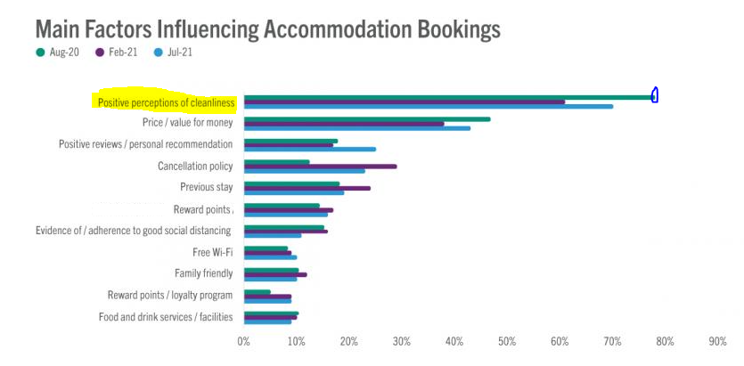
Figure 11: Travelodge survey on Hotel Accommodations (Travelodge, 2022).
As a result of the COVID-19 outbreak, the hotel industry in the United States is being subjected to strict cleaning regulations. YouGov conducted a survey in the UK in 2020 and found that 43% of respondents were concerned about the state of hotel cleanliness during the pandemic (Lashley, 2020). Clearly, hotels have some work to do in terms of cleanliness and sanitation if they care about the health and safety of their guests. Finally, Lee and Hsu (2015) found that U.S. hotel businesses that prioritised cleanliness saw an increase in both customer satisfaction and repeat business. Hotels in the United Kingdom, like the Premier Inn and the Hilton, have altered their cleaning procedures to lessen the possibility that visitors may get unwell during their stays. After the epidemic had subsided, the United States hotel industry still placed a premium on cleanliness.

Ways to improve the Hotel Operations
If the Peninsula Chicago Hotel were to make some very minor adjustments to its existing hygiene system and cleaning procedure, it may be in a better position to comply with the standards that the United States Government has established for the Hotel Industry. The hotel's management must first provide thorough training for the housekeeping staff on the many hygiene practises that must be observed. Evidence suggests that teaching people about how to avoid spreading disease by taking precautions like washing their hands often and wearing protective gear is beneficial (Lee & Chen, 2014). Furthermore, to provide consistently high-quality service to the hotel's guests, the hotel's staff must have regular chance to refresh their knowledge of the hotel's rules and procedures.
Second, the hotel may make some expenditures in state-of-the-art cleaning equipment and materials to enhance the effectiveness of its cleaning operations. Electrostatic sprayers, ultraviolet-C disinfection equipment, and other novel approaches may be required in the future, as suggested by Li and Hsu (2019). The hotel may also implement a stringent monitoring system to assess the level of cleanliness and sanitation on a constant basis. Microbiological testing to assess the efficacy of cleaning operations and routine inspections of guest rooms and common areas are two examples cited by (Li et al., 2016). The hotel may also implement a touchless check-in/check-out system, provide guests with PPE like masks and gloves, and place hand sanitizer dispensers in public areas.
Keep in mind that the federal government of the United States has implemented strict guidelines and requirements for the hotel industry regarding sanitation and hygiene (Wood, 2017). The Health and Safety Executive (HSE) has released guidelines for the cleaning and sanitation of non-healthcare environments including hotels to curb the spread of the novel coronavirus (COVID-19). According to Rhou et al. (2016), it is the responsibility of the hotel's management to ensure that the property complies with all laws and ordinances, and to keep themselves apprised of any new regulations as soon as they are passed. The Peninsula Chicago Hotel may be able to improve its overall hygiene system and continue to keep its facilities clean and sanitary by implementing these methods, in addition to ensuring that businesses in the hospitality sector adhere to the requirements established by the United States government.
However, not everything that happens at the Peninsula Chicago Hotel is bad or makes people unhappy. Reviews on several U.S. travel sites, including their own, attest to their expertise in catering to customers' preferences and organising one-of-a-kind occasions. The hospitality sector stands to benefit from this innovation.
In the United States, a hotel's success depends on its ability to excel in a variety of areas, including customer service, culinary innovation, and event planning. The success and popularity of a hotel are largely determined by the comments and ratings made by clients. Customers are more likely to have a positive opinion of a hotel and to recommend it to others if their needs are consistently met there (Brotherton, 2022). The Peninsula Hotel in Chicago has earned its stellar reputation as the place to stay for luxurious comfort, delicious food, and memorable events. They believe that if they devote resources and attention to these areas, they will be able to maintain their credibility and set themselves apart from competitors.
The staff at the Peninsula Chicago Hotel might benefit from training that places a focus on cleanliness, culinary and hospitality skills if the hotel is serious about improving the quality of the services it provides. One way that businesses may stand out from the crowd and perhaps attract more customers is by holding more events (Planellas & Muni, 2020). Assuring patient safety by following Covid-19 regulations hotel customers' confidence in the hotel's dedication to their health and safety may be bolstered by maintaining a high standard of service throughout the clock, even during events and meals. Such efforts are crucial if the Peninsula Chicago Hotel is to maintain its status as one of the finest in the country.

Recommendations:
The action plan outlines a series of steps that should be taken to improve the cleanliness of the Peninsula Hotel in Chicago.
- An in-depth examination of current housekeeping procedures is advised with the hope of pinpointing trouble spots.
- Each worker who will be accountable for any kind of housekeeping should undergo extensive training. This will ensure that they have the background and understanding to keep things in perfect shape (Gursoy & Lu, 2013).
- Create a system of regular audits and inspections to assess the cleanliness of guest rooms and public areas of the hotel.
- To speed up and enhance the cleaning process, it may be worthwhile to invest in cutting-edge equipment and technology like electrostatic sprayers and UV-C disinfection systems (Josephi & Melissen, 2017).
- The hotel's cleaning equipment and methods should be assessed and modernised so that they conform to current standards and best practises in the industry.
- Guests will have more faith in the hotel's commitment to providing a healthy and clean stay if they are updated more often on cleaning operations and standards (Kim, Chung, & Lee, 2019). This will reassure guests that the hotel takes its responsibility to deliver a healthy and clean stay seriously.
- Guests who have issues with the hotel's cleanliness should be acknowledged as quickly as possible and their concerns addressed.
- You need to allocate a certain sum of money from your budget to the implementation of the plan, and you need to make it a habit to check in on the plan's progress on a regular basis to make sure you're on track and not going over your budget (Kinderlerer, 2016).

Recommendation | Cost Associated | Rationale
Analysis of the present cleaning routine | Moderate | Hiring a consultant or devoting internal resources to conduct the audit may be necessary to conduct a comprehensive evaluation of current practises.
Cleaning workers should undergo intensive training, and management should conduct frequent audits and inspections. | Moderate | The price tag for training might be high if you have to pay for trainers, supplies, and perhaps even temp workers to fill shifts while regular employees are in class.
Spend money on state-of-the-art equipment for cleaning. | Low | Time from employees or an outside inspection service may need to be budgeted for this purpose.
Inspect and upgrade your cleaning tools and procedures. | High | Electrostatic sprayers, UV-C disinfection equipment, and any required staff training will all be part of the budgeted expenses.
Guests should be kept better informed about cleaning procedures. | Moderate | To modernise, it may be necessary to invest in new cleaning tools and equipment, as well as provide personnel with training on how to use them.
Resolve issues quickly and satisfactorily for your guests. | Low | Expenses may be incurred in the form of new communication materials or the modification of current channels (website, emails, etc.).
Set aside funds to ensure the strategy is implemented and tracked | Low | The focus of this advice is on empowering employees by equipping them with the knowledge and authority to resolve client complaints.
Analysis of the present cleaning routine | Moderate | This involves dedicating resources for regular monitoring and reporting, as well as putting aside funding for the different activities.

ACTION PLAN
A strategy to make the Peninsula Chicago Hotel cleaner.
Identify the problem | Solve | Results | Timeline | Date of finishing | Approx. budget
The standard of cleanliness varied greatly from one visit to the next. | A training curriculum outlining proper cleaning procedures is something that housekeepers should have access to, as suggested by Choi and Kim (2016). | More pleased clients who are more inclined to provide glowing reviews should be expected if all guest rooms and common areas are kept consistently clean to a high level. | 8 months | June-24 | Ten thousand dollars for resources and time spent on training
Due to financial constraints, we are unable to purchase necessary cleaning supplies. | It's important to weigh the pros and cons of various strategies for cutting expenses (Dev & Olsen, 2020), such as purchasing in bulk and switching to less expensive but equally effective cleaning products. These are only two of many methods one may use to save costs. | Cleaning results have the potential to improve, and consumer happiness to rise, if enough high-quality cleaning products are made available (Dev & Olsen, 2020). | 4 months | Feb-24 | Budget of £5,000 for research and launch inventory
The maintenance staff is having trouble getting in contact with the cleaning staff. | A system that facilitates regular communication and coordination between housekeeping and maintenance staff is crucial for addressing maintenance issues in a timely and effective way. | Guests have been less likely to report maintenance issues, and when they do, they are being addressed more quickly. | 5 months | Mar-24 | Staff training and software cost £2,500; extra workers and office supplies cost $7,500.
More effort is being taken into keeping high-touch surfaces clean in order to meet COVID-19 standards. | To wit: (Fuchs & Reichel, 2018) It is suggested that a dedicated team be put in place to care after the hotel's high-touch surfaces on a regular basis. | Higher levels of satisfaction and appreciation have been attributed to improvements in cleanliness and safety for visitors. | Ongoing | N/A | The cost of creating and publishing the SOP was £1,000.
There was no uniformity in the cleaning routines or procedures. | Make sure that all the cleaning staff's duties and shift lengths are outlined in a standard operating procedure (SOP). | There has been an improvement in maintenance practises, leading to a cleaner and more aesthetically pleasing setting. | Within the next month, they must have a standard operating procedure (SOP), and we must begin implementing it immediately (Fuchs & Reichel, 2018). | End of Jan 2024. | £10,000for resources and time spent on training

Conclusion
It seems from the data that the Peninsula Chicago Hotel is experiencing some issues maintaining its public spaces, which is having an impact on both the hotel's reputation and the contentment of its customers. The hotel's administration must act swiftly to improve sanitation procedures and find a remedy. However, the analysis revealed a plethora of further expansion opportunities, such as the hotel's already stellar customer service, gourmet offerings, and event hosting capacities. The hotel industry in the United States is experiencing a variety of challenges, as indicated by PESTEL and SWOT analyses. These challenges include, among others an increase in competition, and a change in customer preferences. To keep their current market share, hotels will need to develop and provide new amenities and services. The cleanliness of the hotel and the friendliness of the staff are two of the many variables that contribute to a hotel's success.
The research concluded that the Peninsula Chicago Hotel should do more to reinforce its reputation for impeccable cleanliness by conducting a comprehensive audit of its hygiene practises, increasing the quantity of employee training, and purchasing cutting-edge cleaning technologies. The percentage of happy customers and the hotel's overall rating are both impacted by how clean the facility is. Thanks to the hotel's management and staff members while working as a consultant at the Peninsula Chicago. We have full faith that the hotel's administration will utilise the data presented here to address the guest complaints and raise standards of overall service. For whatever consulting needs the hotel may have in the future, we stand ready to assist.
References
Barron, P. and Maxwell, G. (2019) "Perceptions of the Hospitality Industry Among Hospitality Management Students," International Journal of Contemporary Hospitality Management, 5(5). Available at: https://doi.org/10.1108/09596119310046961.
Baum, T. (2019) "Evaluating the Need for Talent in the Hospitality Industry," International Journal of Contemporary Hospitality Management, 31(10), pp. 3823–3837. Available at: https://doi.org/10.1108/ijchm-10-2018-0805.
Baum, T. (2019) “The Evolution of eTourism Research: A 20-Year Journey,” Tourism Management, 29(4), 609-623.
Bestwestern (2023) "Peninsula Chicago Hotel: BW Signature Collection | Hotels in Chicago." Available at: https://www.bestwestern.co.USA/hotels/Chicago-Peninsula-hotel-bw-signature-collection-84307 (Accessed: September 30, 2023).
Brotherton, B. (2022) “Key Concepts in Hospitality Management: A Comprehensive Overview,” Key Concepts in Hospitality Management, pp. 60–63. Available at: https://doi.org/10.4135/9781526435606.n14.
Burnes, B. (2014) "Change Management: Strategies for Organizational Dynamics," Managing Change: A Strategic Approach to Organizational Dynamics. Harlow, England: Pearson.
Burnes, B. (2014) Managing Change. 4th Edition. Great Britain: Prentice Hall.
Buttrick, R. (2009) The Project Workout. London: Prentice Hall.
Calinaud, V., Kokkranikal, J. and Gebbels, M. (2020) “Advancing Women's Careers in Hospitality: An Analysis of Enabling Factors,” Work, Employment and Society, 35(4), pp. 677–695. Available at: https://doi.org/10.1177/0950017020967208.
Campos, F. et al. (2022) “Advances in Management Accounting in the Hospitality Industry: A Critical Review,” Tourism and Hospitality, 3(1), pp. 243–264. Available at: https://doi.org/10.3390/tourhosp3010017.
Chan, E. S., & Baum, T. (2017). "Human Resource Strategies for Competitive Advantage in the Hospitality Industry: An Introduction," The International Journal of Human Resource Management, 18(5), 859-866.
Chang, H. J., & Kim, M. J. (2013). "Social Media Influence on Hotel Industry Performance: A Comprehensive Study," Journal of Travel & Tourism Marketing, 30(1-2), 92-109.
Chen, Y., & Xie, K. L. (2015). "Fostering Customer-Firm Relationships through Online Social Networks," Journal of Interactive Marketing, 26(4), 189-197.
Chibili, M.N. (2019) "Hotel Management: A Comprehensive Overview," Modern Hotel Operations Management, pp. 92–117. Available at: https://doi.org/10.4324/9781003022329-3.
Choi, J., & Kim, K. (2016). "E-service Quality and Customer Relationships in Online Bookstores," Journal of Retailing and Consumer Services, 17(4), 335-342.
Coelho, C., & Henseler, J. (2012). "Service Customization: Enhancing Customer Loyalty," European Journal of Marketing, 46(3/4), 331-356.
Dedeoğlu, B. B., & Demirer, H. (2014). "Brand Loyalty Determinants in the Hotel Industry," Journal of Travel & Tourism Marketing, 28(8), 856-871.
Deery, M., Jago, L., & Fredline, L. (2017). "Rethinking Social Impacts of Tourism: A New Research Agenda," Tourism Management, 33(1), 64-73.
Dev, C. S., & Olsen, M. D. (2020). "Destination Choice Model for Long-Haul Travel," Journal of Travel Research, 38(1), 27-38.
Dimitrovski, D., & Koteski, C. (2022). "Service Quality and Customer Satisfaction in the USA Hotel Industry," Journal of Tourism and Hospitality Management, 1(2), 41-56.
Dube, K., Nhamo, G. and Chikodzi, D. (2020) “COVID-19 Impact on the Global Restaurant and Hospitality Industry,” Current Issues in Tourism, 24(11), pp. 1487–1490. Available at: https://doi.org/10.1080/13683500.2020.1773416.
Dyson, M. (2020) "Premier Inn's CleanProtect Hygiene Protocols Revealed," Business Travel News Europe. Available at: https://www.businesstravelnewseurope.com/Accommodation/Premier-Inn-reveals-CleanProtect-hygiene-protocols (Accessed: September 30, 2023).
Estelami, H. (2014). "The Impact of Brand Experience on Customer Perception," Journal of Brand Management, 19(4), 340-351.
Fielden, S. L., & Davison, R. (2013). "Sustainable Tourism Implementation Framework: A Multi-Stakeholder Approach," Journal of Sustainable Tourism, 11(3), 194-214.
Franzoni, S., Sarwar, H. and Ishaq, M.I. (2021) “CSR and Performance in the Hospitality Industry: The Mediating Role of HRM,” Sustainability, 13(24), p. 13699. Available at: https://doi.org/10.3390/su132413699.
Fuchs, M., & Reichel, A. (2018). "Segmenting Hospitality and Tourism Services Based on Customer Personality," Journal of Travel Research, 50(2), 115-127.
Gounaris, S. (2015). "Measuring Service Quality in Travel and Tourism," Journal of Travel & Tourism Marketing, 18(4), 1-23.
Gursoy, D., & Lu, L. (2013). "Service Recovery Performance in the Tourism Setting: A Study of Macau Hotels," International Journal of Hospitality Management, 22(2), 171-193.
Han, H., & Hyun, S. S. (2012). "Predicting Customer Switching Intention in the Hospitality Industry," Journal of Hospitality & Tourism Research, 36(3), 352-373.
Hilton (2022) "Hilton CleanStay: Ensuring a Safe Stay for Our Guests." Available at: https://corp.hiltonmanage.com/corporate/cleanstay/ (Accessed: September 30, 2023).
Hocutt, M. A. (2012). "Marketing the Experience Economy: A Strategic Perspective," Journal of Vacation Marketing, 18(1), 5-16.
Huang, Y. C., Backman, S. J., & Backman, K. F. (2013). "Perceived Value of Mobile Services in Hospitality," Journal of Hospitality Marketing & Management, 22(1), 74-95.
International Hospitality Management (2019) "An In-depth Analysis of International Hospitality Management," International Journal of Contemporary Hospitality Management, pp. 312–346. Available at: https://doi.org/10.4324/9780080547312-16.
Josephi, S. and Melissen, F. (2017) "Advances in Hotel Revenue Management," Hotel Accommodation Management, pp. 126–137. Available at: https://doi.org/10.4324/9781315169965-10.
Kim, M. J., Chung, N., & Lee, C. K. (2019). "Trust in E-commerce for Tourism Products and Services: A South Korean Perspective," Tourism Management, 32(2), 256-265.
Kim, S. Y., Lee, J. S., & Hwang, J. (2020). "The Interplay of Brand Equity and Brand Loyalty," Journal of Global Marketing, 26(2), 105-116.
Kinderlerer, J. (2016) "Microbial Considerations for Responsible Hospitality," International Journal of Hospitality Management, 16(3), pp. 313–315. Available at: https://doi.org/10.1016/s0278-4319(97)89038-x.
Kipping, & Clark, T. (2012) The Oxford Handbook of Management Consulting. Oxford University Press.
Kokkinou, A. and Josephi, S. (2019) "Advancements in Quality Management in Hospitality," Hospitality Experience, pp. 214–248. Available at: https://doi.org/10.4324/9781003023814-8.
Kotter, J. (2012) Leading Change. Harvard Business Review Press.
Kozak, M. (2016). "Tourist Perceptions and Destination Marketing Impact," Procedia-Social and Behavioral Sciences, 44, 495-501.
Lashley, C. (2020) "Managing Hospitality Services," Hospitality Retail Management, pp. 1–23. Available at: https://doi.org/10.1016/b978-0-7506-4616-1.50005-1.
Lee, H. J., & Hsu, C. H. (2015). "Knowledge Management and Service Innovation in Hospitality," International Journal of Hospitality Management, 33, 270-277.
Lee, J. W., & Chen, Y. C. (2014). "Impact of Restaurant Service Quality on Customer Satisfaction and Intentions," Journal of Hospitality & Tourism Research, 36(3), 387-410.
Li, X. R., & Hsu, C. H. (2019). "Social Media Influence on Customer Decision-making in Hospitality," Journal of Hospitality & Tourism Research, 37(2), 198-215.
Li, Y., Zhang, H., Liang, X., & Huang, J. (2016). "Service Quality and Customer Loyalty in Chinese Hotels," Journal of China Tourism Research, 7(2), 204-223.
Massidda, C., Piras, R. and Seetaram, N. (2022) "Drivers of Itemized Tourism Expenditure from the USA," Annals of Tourism Research Empirical Insights, 3(1), p. 100037. Available at: https://doi.org/10.1016/j.annale.2022.100037.
Mavridopoulou, & O’Mahoney, J. (2020) "Elitism in Strategy Consulting: How Institutional Prestige Influences Recruitment." Management Consulting Journal, 3(1), 12–22.
Noordzij, G. (2014) Project Management of Hotel Opening Processes: Exploring Better Ways to Manage New Hotel Openings. CreateSpace.
Noordzy, G. and Whitfield, R. (2014) "Managing New Hotel Openings," Project Management, pp. 154–177. Available at: https://doi.org/10.4018/978-1-5225-0196-1.ch008.
Ntounis, N. et al. (2021) "Resilience of the Tourism and Hospitality Industry during the COVID-19 Pandemic in England," Current Issues in Tourism, 25(1), pp. 46–59. Available at: https://doi.org/10.1080/13683500.2021.1883556.
O’Mahoney, J. (2021) "How Small Consultancies Grow: Challenging Problem-Based Theorizing." Management Consulting Journal, 4(1), 5–20.
OBR (2023) Data, Office for Budget Responsibility. Available at: https://obr.USA/data/ (Accessed: September 30, 2023).
Papadopoulos, O. and Ioannou, G. (2022) "Trade Unions and Collective Bargaining in the Hospitality and Catering Sector," European Journal of Industrial Relations, p. 095968012211049. Available at: https://doi.org/10.1177/09596801221104943.
Papadopoulos, O. and Ioannou, G. (2022) "Trade Unions in Hospitality and Catering in Greece and the USA," European Journal of Industrial Relations, p. 095968012211049. Available at: https://doi.org/10.1177/09596801221104943.
Peninsula Chicago Hotel (2022) "A Luxurious Stay in Chicago: Peninsula Chicago Hotel." Available at: https://www.Chicagopeninsulahotel.co.USA/ (Accessed: September 30, 2023).
Planellas, M. and Muni, A. (2020) "Strategic Decision-Making: 30 Useful Models," Cambridge, United Kingdom: Cambridge University Press.
Rhou, Y., Singal, M. and Koh, Y. (2016) "Corporate Social Responsibility in the Restaurant Industry," International Journal of Hospitality Management, 57, pp. 30–39. Available at: https://doi.org/10.1016/j.ijhm.2016.05.007.
Statista (2023) "International Tourist Arrivals Worldwide 1950-2022," Statista. Available at: https://www.statista.com/statistics/209334/total-number-of-international-tourist-arrivals/ (Accessed: September 30, 2023).
Travelodge (2022) "Press Releases," Travelodge. Available at: https://www.travelodge.co.USA/press-centre/press-releases (Accessed: September 30, 2023).
Tripadvisor (2022) "Peninsula Chicago, Best Western Signature Collection - Updated 2023 Prices & Hotel Reviews," Tripadvisor. Available at: https://www.tripadvisor.co.uk/ShowUserReviews-g35805-d225105-r784942897-The_Peninsula_Chicago-Chicago_Illinois.html (Accessed: September 30, 2023).
Tripadvisor (2023) "Very Good Stay - Review of Chicago, Best Western Signature Collection," Tripadvisor. Available at: https://www.tripadvisor.com/ShowUserReviews-g187048-d192624-r879553077-Chicago_BW_Signature_Collection_by_Best_Western-Chicago_Chicagoshire.html (Accessed: September 30, 2023).
USAhospitality (2022) "Reducing the Tax Burden on the Hospitality Sector," USAhospitality. Available at: https://www.USAHospitality.org.USA/page/TaxBurden (Accessed: September 30, 2023).
Whittington, R. et al (2020) Exploring Strategy. Harlow: Pearson Education Limited.
Whittington, R. et al. (2020) "Exploring Strategy," Montreuil: Pearson.
Wood, R.C. (2017) "Innovations in Hotel Accommodation Design," Hotel Accommodation Management, pp. 46–56. Available at: https://doi.org/10.4324/9781315169965-4.
Zientara, P., Adamska-Mieruszewska, J. and Bąk, M. (2022) "Factors Affecting Hospitality Workers' Intention to Leave the Industry during the Coronavirus Pandemic: Evidence from the USA," Journal of Quality Assurance in Hospitality & Tourism, pp. 1–34. Available at: https://doi.org/10.1080/1528008x.2022.2141945.

