Student name  Peter Nguty Acha | Student number  2018019
Programme | BSc Health and Social Care
Module | Creativity and value Creation
Module code | -  BMHP5014_BIRM
lecturer | Robert Nartowski
Assessment title | Evaluation

Introduction
According to Godin, B. (2008) Society has grown with the application of projects that have sum up to give birth to answers to issues or advancements to existing structures, procedures, items or attempted solutions. I will be writing a reflective report on some of the four topics I have chosen from among others which I have learned about in this module. I have even gone further to do more research on these topics to get a sound knowledge on creativity and value creation. The topics I will be reflecting on are:
- In unit 1 I have chosen “Innovation”
- In unit 2 I have chosen “Who and what are changemakers”
- In unit 3 I have chosen supportive network
- In unit 4 I have chosen “what is success”.
In unit 1 I learned about Innovation, how innovation have changed the world from prehistoric times to this 21st century we are now and how it will continue to change the future. Before I go ahead, I would like to define the meaning of “innovation”.
According to Twiss (1989) innovation is a process that brings together science, technology, economics and management, as it is to attend newness and expand from the unfolding of the idea to its commercialization in the structure of product. According to Bhat (2010) innovation comes from the lattin word Innovare meaning to renew. There are many things I never to so important or never asked question about like the printing press. I learned that Before the coming into existence of the internet the printing press developed in Mainz in Germany by Johannes Gutenberg, was one of the most important machines that helps for the spread of knowledge. Gutenberg’s printing press was so important because books were affordable even for the lower class and this helped spark the Age of Enlightenment. It was so important because it also helped spread news and sometimes disputable ideas. “The Ninety-Five Theses” which Jumpstarted the Protestant Reformation and instigated conflict for the thirty years war (1618-48) because followers of a German monk by name Martin Luther used the printing press to spread his seminal work. Some other great innovation discoveries were the compas, paper currency, the electricity, transistors, the magnifying lenses, the telegraph.
The telegraph was one of the most important innovation discoveries of all times. I learned how the American president used it to stop the American civil war in 1862. According to H. Stone (2020) Abraham Lincoln telegraphed a colonel in the field during civil war Battle of Second Manassas (Bull Run) in 1862 and the civil war ended.
I also learned how in 1928 Antibiotic (penicillin) was accidentally discovered by Alexander Fleming. This innovatory discover was a big breakthrough in the field of medicine as millions of lives were saved especially soldiers who were in the battlefield during World War 1. One other important discovery was the steam engine perfected by James Watt in the 1700s that later sparked one of the big technological jumps in human existence during the Industrial Revolution. I learned how the external combustion allowed for exponential improvement in agriculture, transportation and manufacturing. This also propelled the rise of very powerful and influential nations like Great Britain and the United States.
I have learned how innovation has helped enhance companies' development and evolution and have also helped improved production qualitatively and quantitatively to meet up markets demand.
As maintained by Yalabik et al (2012) Innovation could also be defined as business process that improves company’s growth and improvement.
I have learned that for any business or company whether it is a big scale or small scale to grow or boost its production and profit they must embrace innovation. We can see how Amazon and other millions of companies are using innovation to boost their productions and services. AS maintained by Fuertes-Callen and Cuellar-Fernandez (2014) innovation is one of the important strategic tools for firms to be successful. To conclude, I would like to say I have learned that innovation is strongly connected to technology, and the speedy changes attached with technology also pave ways for companies, businesses, and establishments to innovate. Innovation is beneficial both for the producers and the consumers because it helps to meet the customers' demands and on the other hand helps it helps companies to meet up with customers' demands both qualitatively and quantitatively. Innovation has helped the society to create clean spaces. The society 5.0 a human-centred society that balances economy and technological advancements to solve the society’s problems with super-smart AI data systems could only be possible because of innovation.
In unit 2 I will be reflecting on what I have learned about change makers. Who is a change maker, what could possibly be another word for a change maker, the role of a change maker, the values change makers create, the characteristics of a change maker, what are the skills of a change maker etc. It will be recalled that this word was often used by the one-time president of the United States of America Bill Clinton, who always referred to his wife H. Clinton as a change maker. Before I proceed, I would like to define a change maker as someone who longs for change in a particular area or areas of life and by putting knowledge and resources, makes that change to become a reality. I can say there is a very huge connection between a change maker and innovation. I also learned that every change maker is out to create a value, to do things differently from the normal ways things are always done. According to R. McNamara, Abraham Lincoln in 1862, used the telegraph to stop the American civil war. In this case he made change happened by stopping the war with the telegraph because it was the first time the telegraph was ever used to stop a war. I learned that Change makers most predominant gold is to create value.
What is value? This is a very difficult word to define, but however I learned about five types of values namely enjoyment, social, economic, influence and harmony values.
- Enjoyment value. These are people who create values by making enjoy what they do.
- Social value. These are people who make people happy or relief suffering in some way or another.
- Economic value. These are people creating values for themselves
- Influence value. These are people who create values by trying to influence other people and later use this influence to make power somewhere else.
- Harmony value. These are people who try to create sense of community.

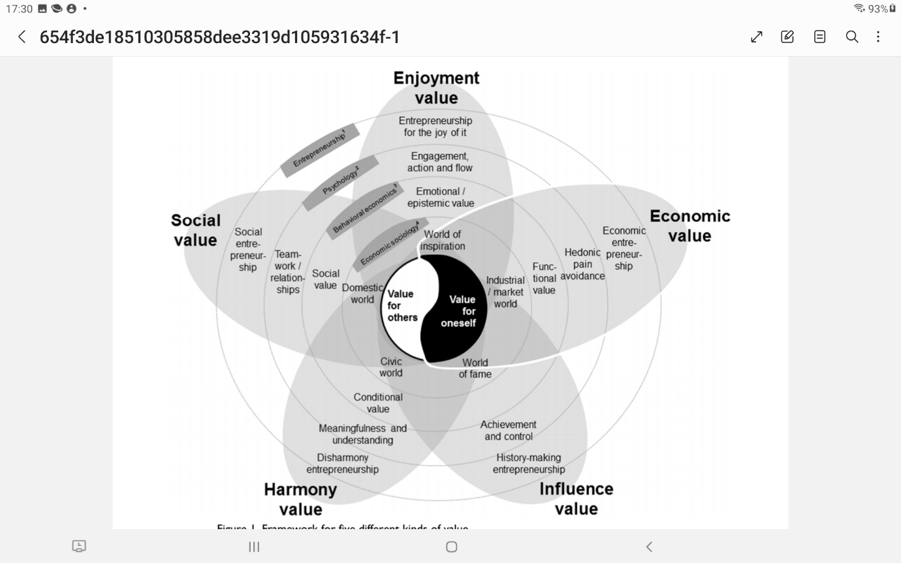
Figure 1A structure for five different types of values. Notes: 1: Korsgaard & Anderson, 2011; Goss, 2005; Tan et al., 2005; Blenker et al., 2012; Spinosa et al., 1999. 2: Fiske, 2008; Seligman, 2012; Frankl, 1985. 3: Sheth et al., 1991. 4: Boltanski & Thévenot, 1991.
I learned that to be a change maker doesn't just come in a golden plate. A change make is someone who has a vision. Someone who is committed, someone who is honest, someone who knows how to connect with people and most of all must be resilience that is someone who can withstand criticism someone who is ready to persist. I also learned that change makers are thought leaders, and they always have the growth mindset to be successful. I learned that other words for a changer maker are disruptor, agitator, influencer, intrapreneur, entrepreneur, innovator, change agent etc.

I can conclude by saying that that when we talk of a change maker we talk of innovation.
In unit 3 I learned how to establish a supportive network, understanding how other people’s contribution contributes to the success of a project. A support network simple describe your team. The people in your life that you can turn to them to seek for encouragement, advise, financial support and own growth. As a matter of fact, having a good network is an important element to maintain your mental sanity and well-being. I have learned that building Personal Contact Network can include relatives, friends, neighbours, work mates and professional contacts and financial lenders. Personal connections can play a very important character in the development of ideas and the favourable outcome of a new venture by paving way to potentially important resources. These resources may include financial assets, important suppliers or customers, new ideas, advice and information. The network should be able to give emotional support. I also learned about two types of networks namely active network and Latent network.
Figure AA bellow show the structure of an Active network.
 | Active Networks
Reciprocity | Mostly is a give and take, the relationship is mutually profitable for example a co-worker in another unit who depends on you and you on him.
Trust/ intimacy | Total trust. A friend who you have confidence in concerning work and personal issues
Frequency | Regular or ongoing contact for some time. a manager who has remain a good mentor and you talk every few times

Figure AB bellow shows how a Latent network looks like
 | Latent Networks
Reciprocity | Basic or no give and take, relationship is just one-sided. Example: A company worker who gives you information on current movements
Intimacy/Trust | Basic level of trust and disclosure. Loose commitment. Example: An employee of a competitor that you become friendly with at industry meeting
Frequency | Sporadic contact. For about half a year ago. Example: A former manager you check in with seldomly
I have learned that a good network most have the following qualities. It must be open, diverse and deep. According to Willburn and Cullen (2014) a good network must be diverse, open and deep.

Unit 4 I will be reflecting on what I learned about success.
According to Oxford English Dictionary (1971) success originally referred to any positive outcome, but most of the times it is attached with wealth and prestige. Although this definition of success may not mean the same to everybody especially when we are talking about what success may mean to a woman and a man. This may sound preposterous, but it is real. According to Deutschendorf (1996) and Doyle (1983) this definition of success is seen to be mostly constant with male socialization.
Success could also be defined as getting or attaining wealth, respect, or fame. It could also be defined as acquiring a wished result of a venture. At individual level success may mean attaining what a person long for. Organisational level success may mean to attain its projected goals. The word success could be seen and define differently depending on what field or domain it may be referring to. I also learn that success sometimes mean doing things you love must. I learned that success has its characteristics. According to L. Siegel (2006) some characteristics of success are:
- Optimism. Being optimistic means not expecting any failures always expecting positive outcomes.
- Creativity. Being creative means doing thigs differently. Always sorting different ways to resolve issues. Always coming up with new and innovative ideas.
- Resilience. The ability of perseverance and never give up even when confronted with a difficult situation.
- Self-control. The ability to control one's action or feelings of anger or unwanted comportment
- Emotional Awareness. This is knowing when feelings are present in us, and other people. As suggested by Larsen et al (2017) our ability to reason about our emotions contributes an important role in interreacting and relating to one another.
- Sociability. To be successful requires to be friendly. Associable and ready to make new friends
To conclude, in my reflective essay I have talked about innovation. The history of innovation and how it has changed our lives and the world in diverse ways. I also talked about who and what are change makers and how change makers are great innovators and how they create different values. I also talk about supportive networks, the qualities of a good network, types of networks, its composition and its characteristics etc. Lastly, I talked about success, its characteristics, how and what it means to different people and what it means to different domains.
Reference list
- Godin, B. (2008) Innovation: The History of a Category. Montreal: Project of the Intellectual History of Innovation, Working Paper No. 1, p. 26.
- Twiss, B. (1989). Goodridge M., Managing Technology for Competitive Advantage: Integrating Technological and Organisational Development: From Strategy to Action. Trans-Atlantic Publications.
- Bhat, J. S. a. (2010). Managing innovation: Understanding how continuity and change are interlinked. Global Journal of Flexible Systems Management, 11, 63–74. Retrieved from http://search.proquest.com
- https://www.history.com/this-day-in-history/lincoln-delivers-gettysburg-address?cmpid=email-hist-tdih-2020-1119-
- Yalabik, B., Howard, M., & Roden, S. (2012). The innovation game: Lessons in strategy and managing operations. International Journal of Operations & Production Management, 32(12), 1441–1459. doi:1
- Fuertes-Callén, Y., & Cuéllar-Fernández, B. (2014). What is the role of commercialisation and reputation in product innovation success? Innovation: Management, Policy & Practice, 16(1), 96–105. doi:10.5172/impp.2014.16.1.96
- McNamara, Robert. "Abraham Lincoln and the Telegraph." ThoughtCo, Aug. 26, 2020, thoughtco.com/abraham-lincoln-and-the-telegraph-1773568
- Korsgaard, S., & Anderson, A. R. (2011). Enacting entrepreneurship as social value creation. International Small Business Journal, 29(2), 135–151. DOI: http://dx.doi.org/10.1177/0266242610391936.
- Cullen, K., Willburn, P., Chrobot-Mason, D., & Palus, C. (2014). Networks: How Collective Leadership Works (pp. 13-16). Greensboro, NC: Center for Creative Leadership.
- Oxford English Dictionary (Compact ed.), Volume 1. (1971). Glasgow, Scotland: Oxford University Press.
- Doyle, J. A. (1983). The male experience. Dubuque, Iowa: Brown
- Deutschendorf, H. (1996). Of work and men: How men can become more than their careers. Minneapolis, Minnesota: Fairview
- The Psychologist from "The Apprentice’ Reveals What It Really Takes to Excel—in the Boardroom and in Life, by Liza Siegel, Ph.D. (AMACOM, 2006)
- Larsen, R., Buss, D., Wismeijer, A., & Song, J. (2017). Personality psychology: Domains of knowledge about human nature. McGraw-Hill Education

