DS 1 Assignment

My Screenshots/Photos

Screenshot/Photo 1
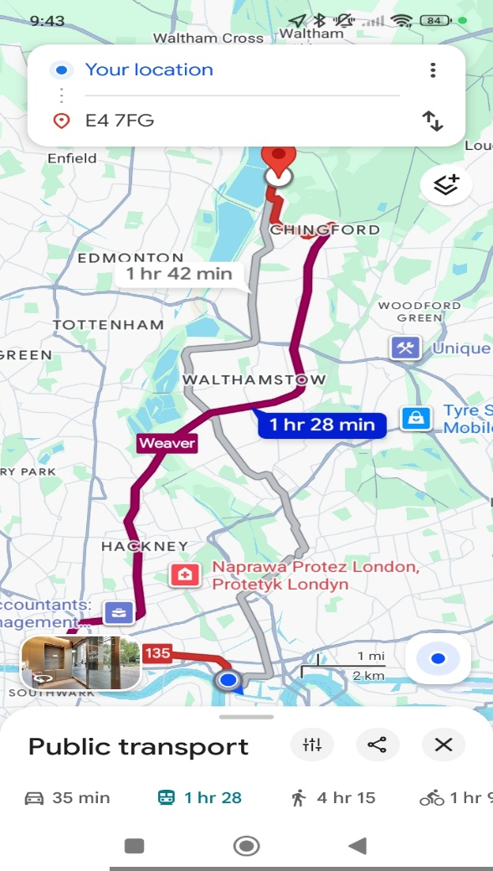
This screenshot from google maps shows how I plan my journey from home to university. I use digital technology to compare different travel options, check journey times and costs, and choose the most suitable route. I also check traffic conditions, accidents and possible delays to make sure I arrive at university on time. That help me make better decisions, manage my time effectively and organise my daily responsibilities. I can also compare public transport with other options, such as uber or bolt, to find a quicker or more affordable way to travel.

Screenshot/Photo 2
Destination Search for Holidays

I used the internet to search for a place in Poland for my winter holiday. O looked at different locations and explored photos of the mountains and lakes to find a suitable destination. Digital technology helped me discover beautiful places, compare holiday options and decide where I would like to go. B using online resources, I could research the location, check the scenery and plan my trip before travelling.

Screenshot/Photo 3
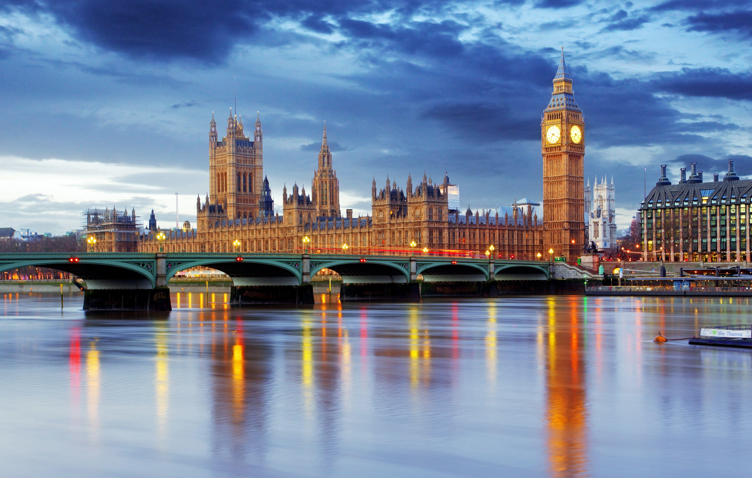
This photo represents a family trip to central London. I enjoy spending time with my family and visiting famous places such as Big Ben, the Houses of Parliament and Westminster Bridge. I use my phone and technology to explore places to visit, find directions using google maps, check public transport options and plan our journey. I can also use the internet to discover attractions and find useful information before our trip.

Screenshot/Photo 4

One of my main hobbies is motoring, especially classic American cars. Last week, I visited a car show where I saw a 1969 Ford Mustang, a car I have dreamed of owning for many years. It was a special experience because I could see this iconic car in person. I also use digital technology to explore my interests, search for information about classic cars, watch videos and discover car shows and automotive events. The internet allows me to learn more about different models, their history and technical specifications.

Screenshot/Photo 5
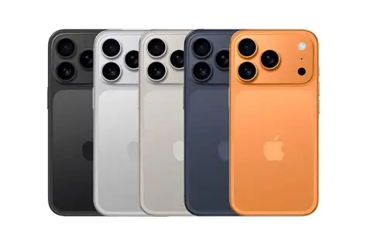
Last week I was looking for new phone for myself. One of my friends recommended I phone 17 which I checked and decided to take with great offer soon. I phone 17 with 6.3 inch 120Hz ProMotion display and A19 chip with Apple Intelligence, and a 48MP Dual Fusion camera system. All those functions will be really helpfully with my daily checking ( Maps, websites, relax, music, games, movies, education, photos, videos, etc ). Hopefully I will receive my new mobile phone soon.

Screenshot/Photo 6
[Insert Photo/Screenshot below]


My Short Reflection

- I use digital tools to plan my journeys, search for information and organise my daily life
- I feel confident when I use google maps, browse websites an search for information online.
- I want to improve my digital skills to help me with my university studies and future career in business management.
- I offend use these tools: google maps, internet search engines, websites and mobile applications.
- I sometimes feel nervous about finding reliable information online and knowing which sources I can trust.
- I hope this module will help me become more confident with technology, improve my research skills and complete my university work successfully.
- Digital skills are important for me because they help me with my university studies, everyday tasks and future career in business management,

