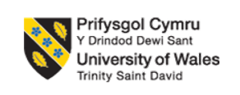

Managing Projects in Organisations

Student name:Catalina Maties
Student number:1905775

BLOG 1: The Value of Work Breakdown Structures (WBS) in Project Planning
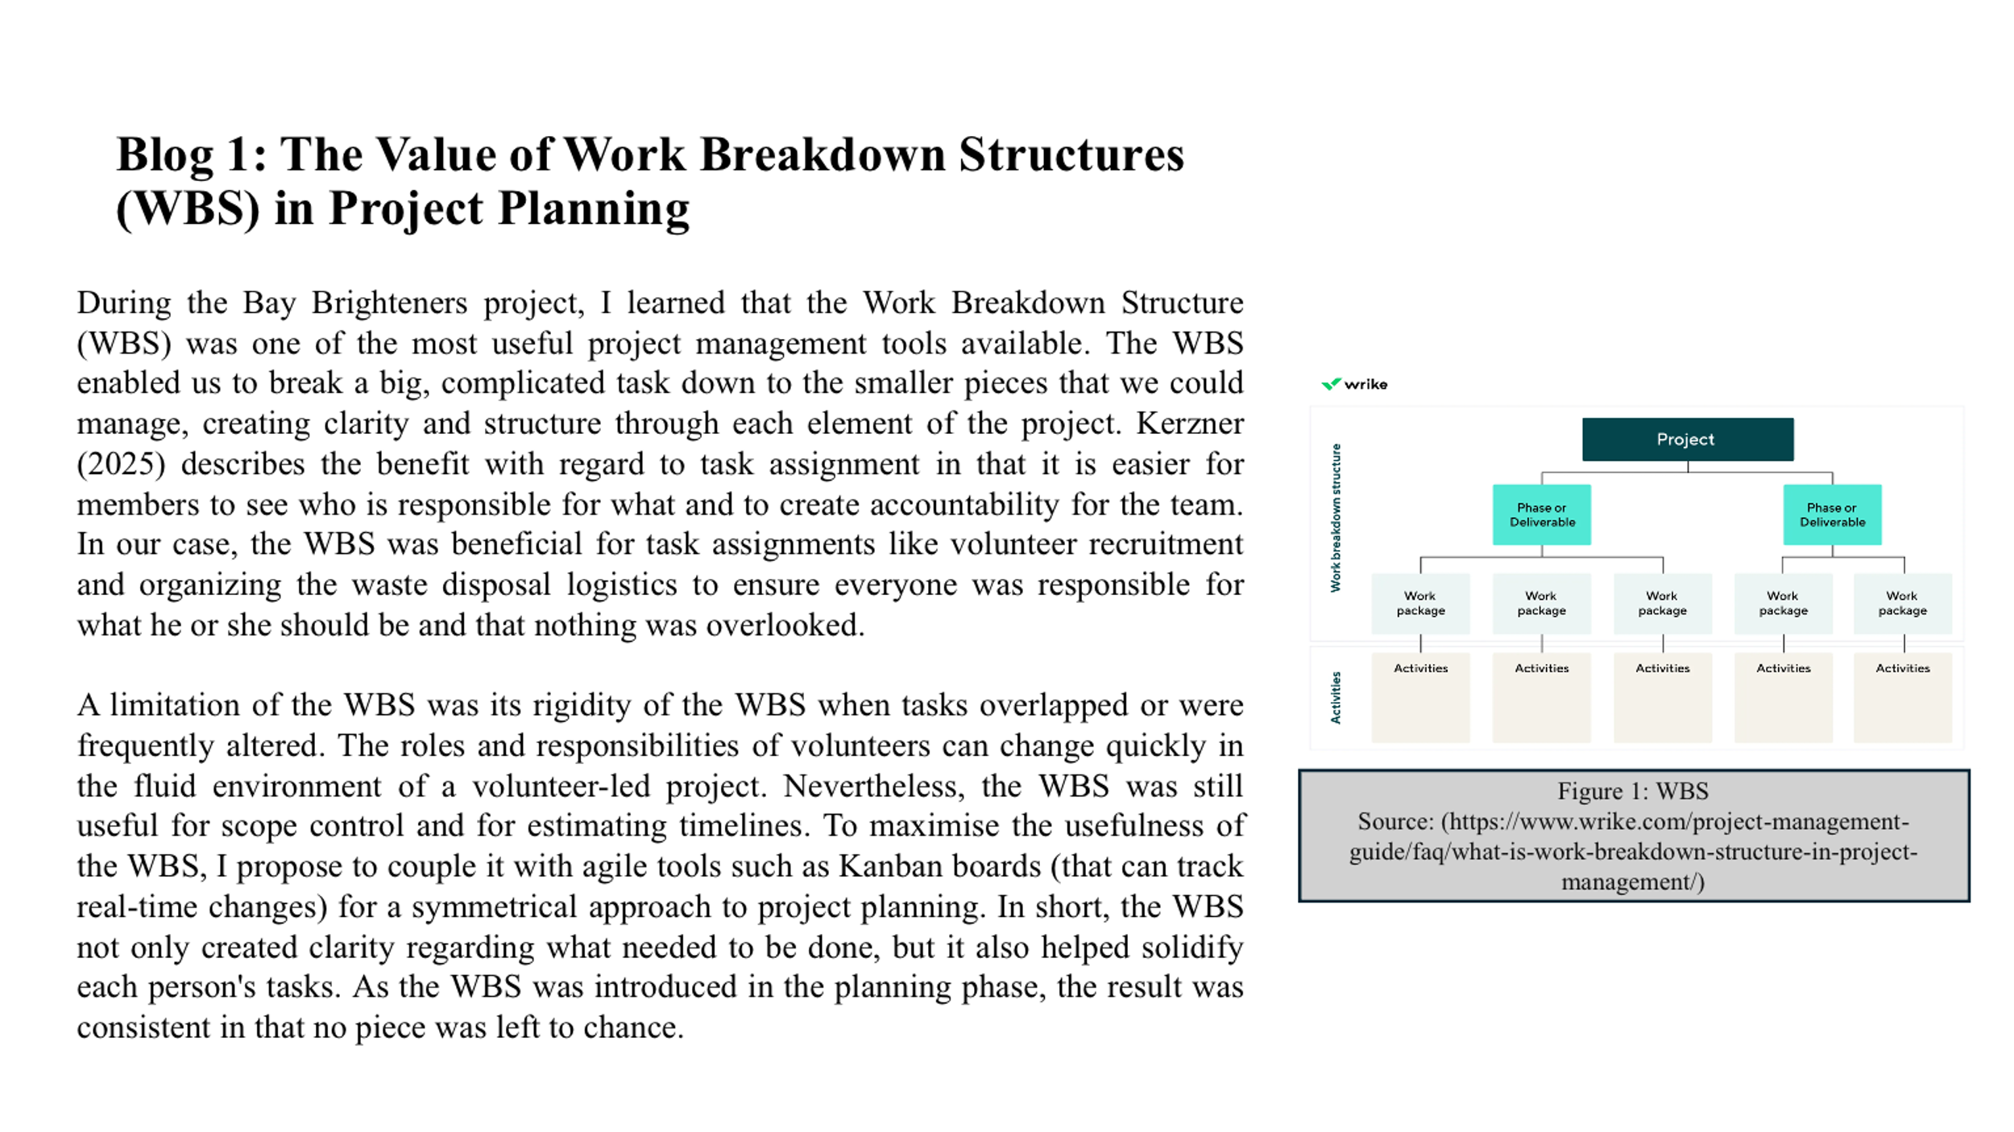
During the Bay Brighteners project, I learned that the Work Breakdown Structure (WBS) was one of the most useful project management tools available. The WBS enabled us to break a big, complicated task down to the smaller pieces that we could manage, creating clarity and structure through each element of the project. Kerzner (2025) describes the benefit with regard to task assignment in that it is easier for members to see who is responsible for what and to create accountability for the team. In our case, the WBS was beneficial for task assignments like volunteer recruitment and organising the waste disposal logistics to ensure everyone was responsible for what he or she should be and that nothing was overlooked.
A limitation of the WBS was its rigidity of the WBS when tasks overlapped or were frequently altered. The roles and responsibilities of volunteers can change quickly in the fluid environment of a volunteer-led project. Nevertheless, the WBS was still useful for scope control and for estimating timelines. To maximise the usefulness of the WBS, I propose to couple it with agile tools such as Kanban boards (that can track real-time changes) for a symmetrical approach to project planning. In short, the WBS not only created clarity regarding what needed to be done, but it also helped solidify each person's tasks. As the WBS was introduced in the planning phase, the result was consistent in that no piece was left to chance.

BLOG 2: Using Risk Assessments to Safeguard Project Success
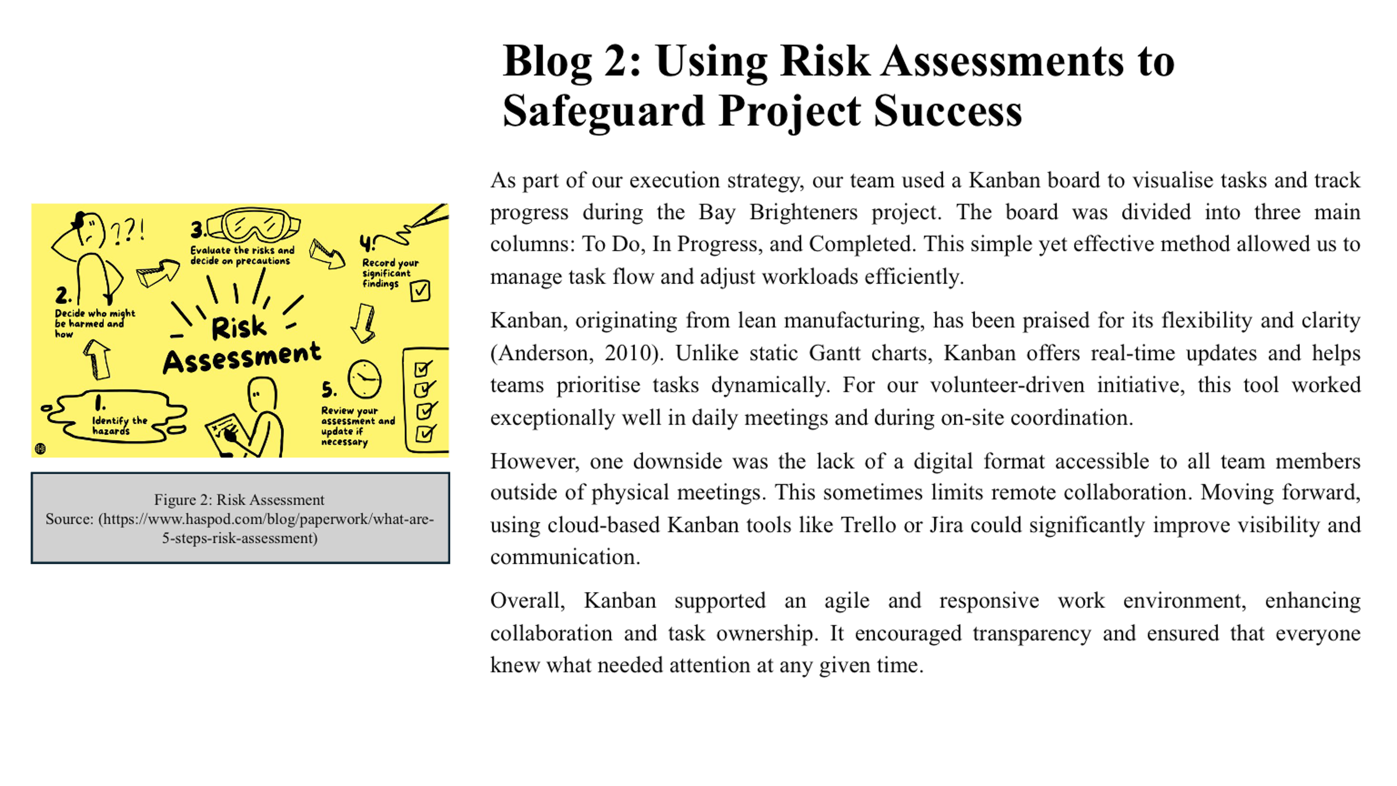
Risk management is a critical component of project delivery. During the Bay Brighteners project, we undertook a systematic approach to risk assessment for a litter picking activity at Swansea Bay Beach. The identified risks included sharp objects, weather, lone working, and the public. A severity-likelihood matrix was used to score each identified hazard and outline mitigation measures. This follows Hillson and Simon (2020), who believe that the best risk assessments are proactive, rather than reactive.
The benefits were apparent, with volunteers feeling reassured about their hazards, and, moreover, we had no serious incidents as we had the correct equipment and properly briefed the safety requirements. That said, we still did not have a clear ability to predict environmental hazards such as tide patterns, and if it suddenly rained, it was a challenge to manage in real time.
An important takeaway was that risk assessments cannot be static documents; they have to be updated regularly, and if possible, altered in light of new circumstances. In future projects, I would encourage the use of digital risk registers that could be updated as required and could be visibly consulted by everyone involved.
In conclusion, risk analysis gave us the ability to make our litter picking activity safe, while also demonstrating added assurance and credibility to our project with stakeholders, and in particular, Swansea Council supported our activity based upon our quality risk planning.

BLOG 3: Stakeholder Analysis: Managing Interests and Expectations
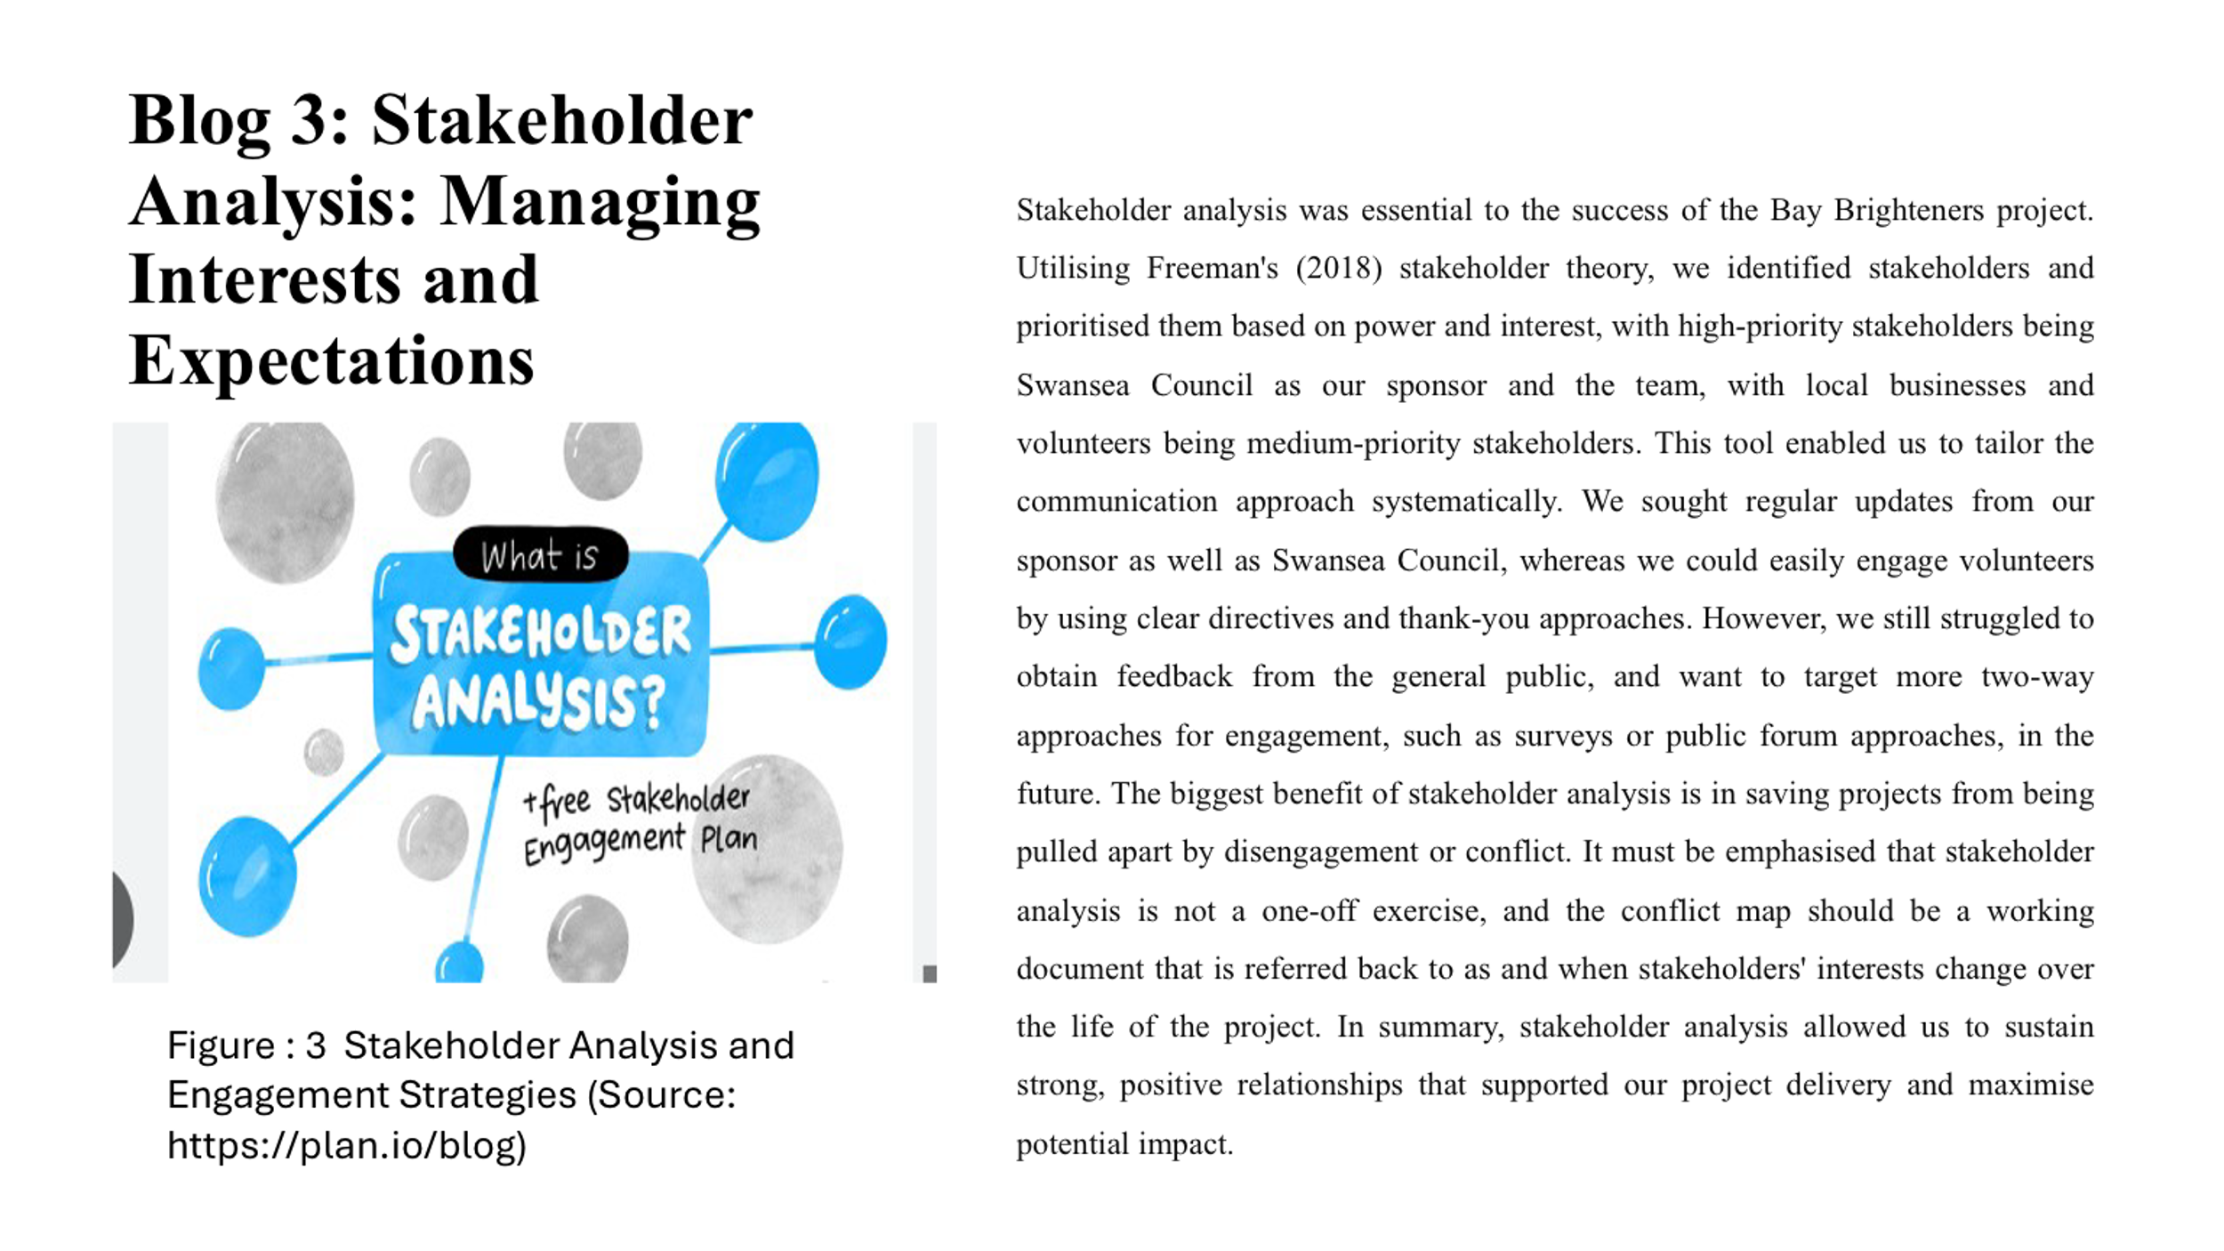
Stakeholder analysis was essential to the success of the Bay Brighteners project. Utilising Freeman's (2018) stakeholder theory, we identified stakeholders and prioritised them based on power and interest, with high-priority stakeholders being Swansea Council as our sponsor and the team, with local businesses and volunteers being medium-priority stakeholders. This tool enabled us to tailor the communication approach systematically. We sought regular updates from our sponsor as well as Swansea Council, whereas we could easily engage volunteers by using clear directives and thank-you approaches. However, we still struggled to obtain feedback from the general public, and want to target more two-way approaches for engagement, such as surveys or public forum approaches, in the future. The biggest benefit of stakeholder analysis is in saving projects from being pulled apart by disengagement or conflict. It must be emphasised that stakeholder analysis is not a one-off exercise, and the conflict map should be a working document that is referred back to as and when stakeholders' interests change over the life of the project. In summary, stakeholder analysis allowed us to sustain strong, positive relationships that supported our project delivery and maximise potential impact.

BLOG 4: Kanban Boards and Agile Task Management
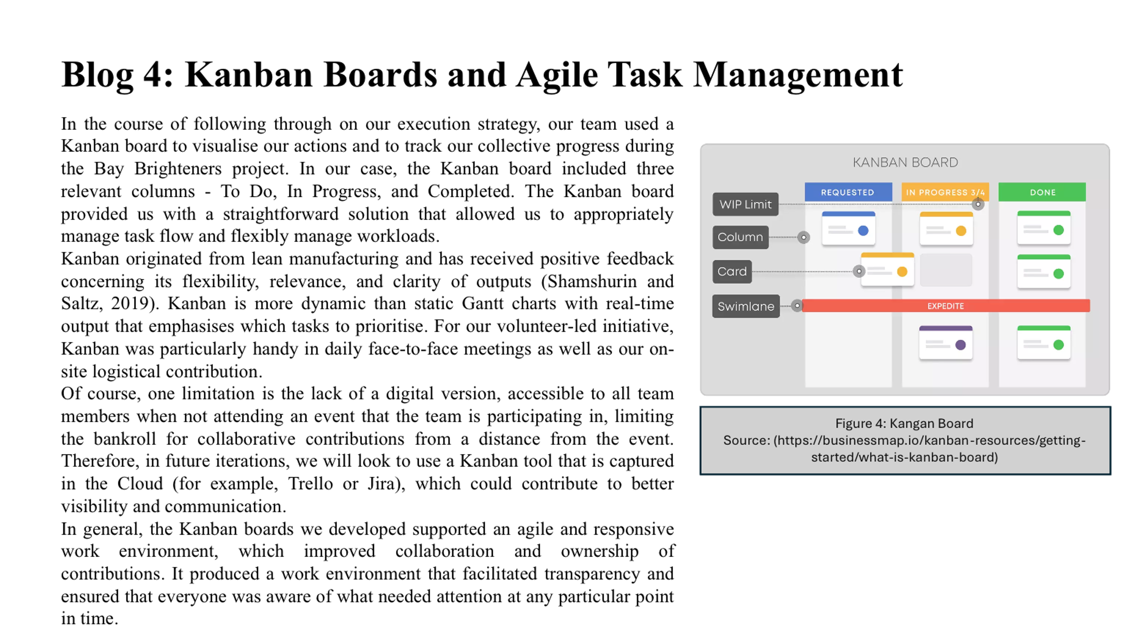
In the course of following through on our execution strategy, our team used a Kanban board to visualise our actions and to track our collective progress during the Bay Brighteners project. In our case, the Kanban board included three relevant columns - To Do, In Progress, and Completed. The Kanban board provided us with a straightforward solution that allowed us to appropriately manage task flow and flexibly manage workloads.
Kanban originated from lean manufacturing and has received positive feedback concerning its flexibility, relevance, and clarity of outputs (Shamshurin and Saltz, 2019). Kanban is more dynamic than static Gantt charts with real-time output that emphasises which tasks to prioritise. For our volunteer-led initiative, Kanban was particularly handy in daily face-to-face meetings as well as our on-site logistical contribution.
Of course, one limitation is the lack of a digital version, accessible to all team members when not attending an event that the team is participating in, limiting the bankroll for collaborative contributions from a distance from the event. Therefore, in future iterations, we will look to use a Kanban tool that is captured in the Cloud (for example, Trello or Jira), which could contribute to better visibility and communication.
In general, the Kanban boards we developed supported an agile and responsive work environment, which improved collaboration and ownership of contributions. It produced a work environment that facilitated transparency and ensured that everyone was aware of what needed attention at any particular point in time.

BLOG 5: Self-Reflection and Development Plan
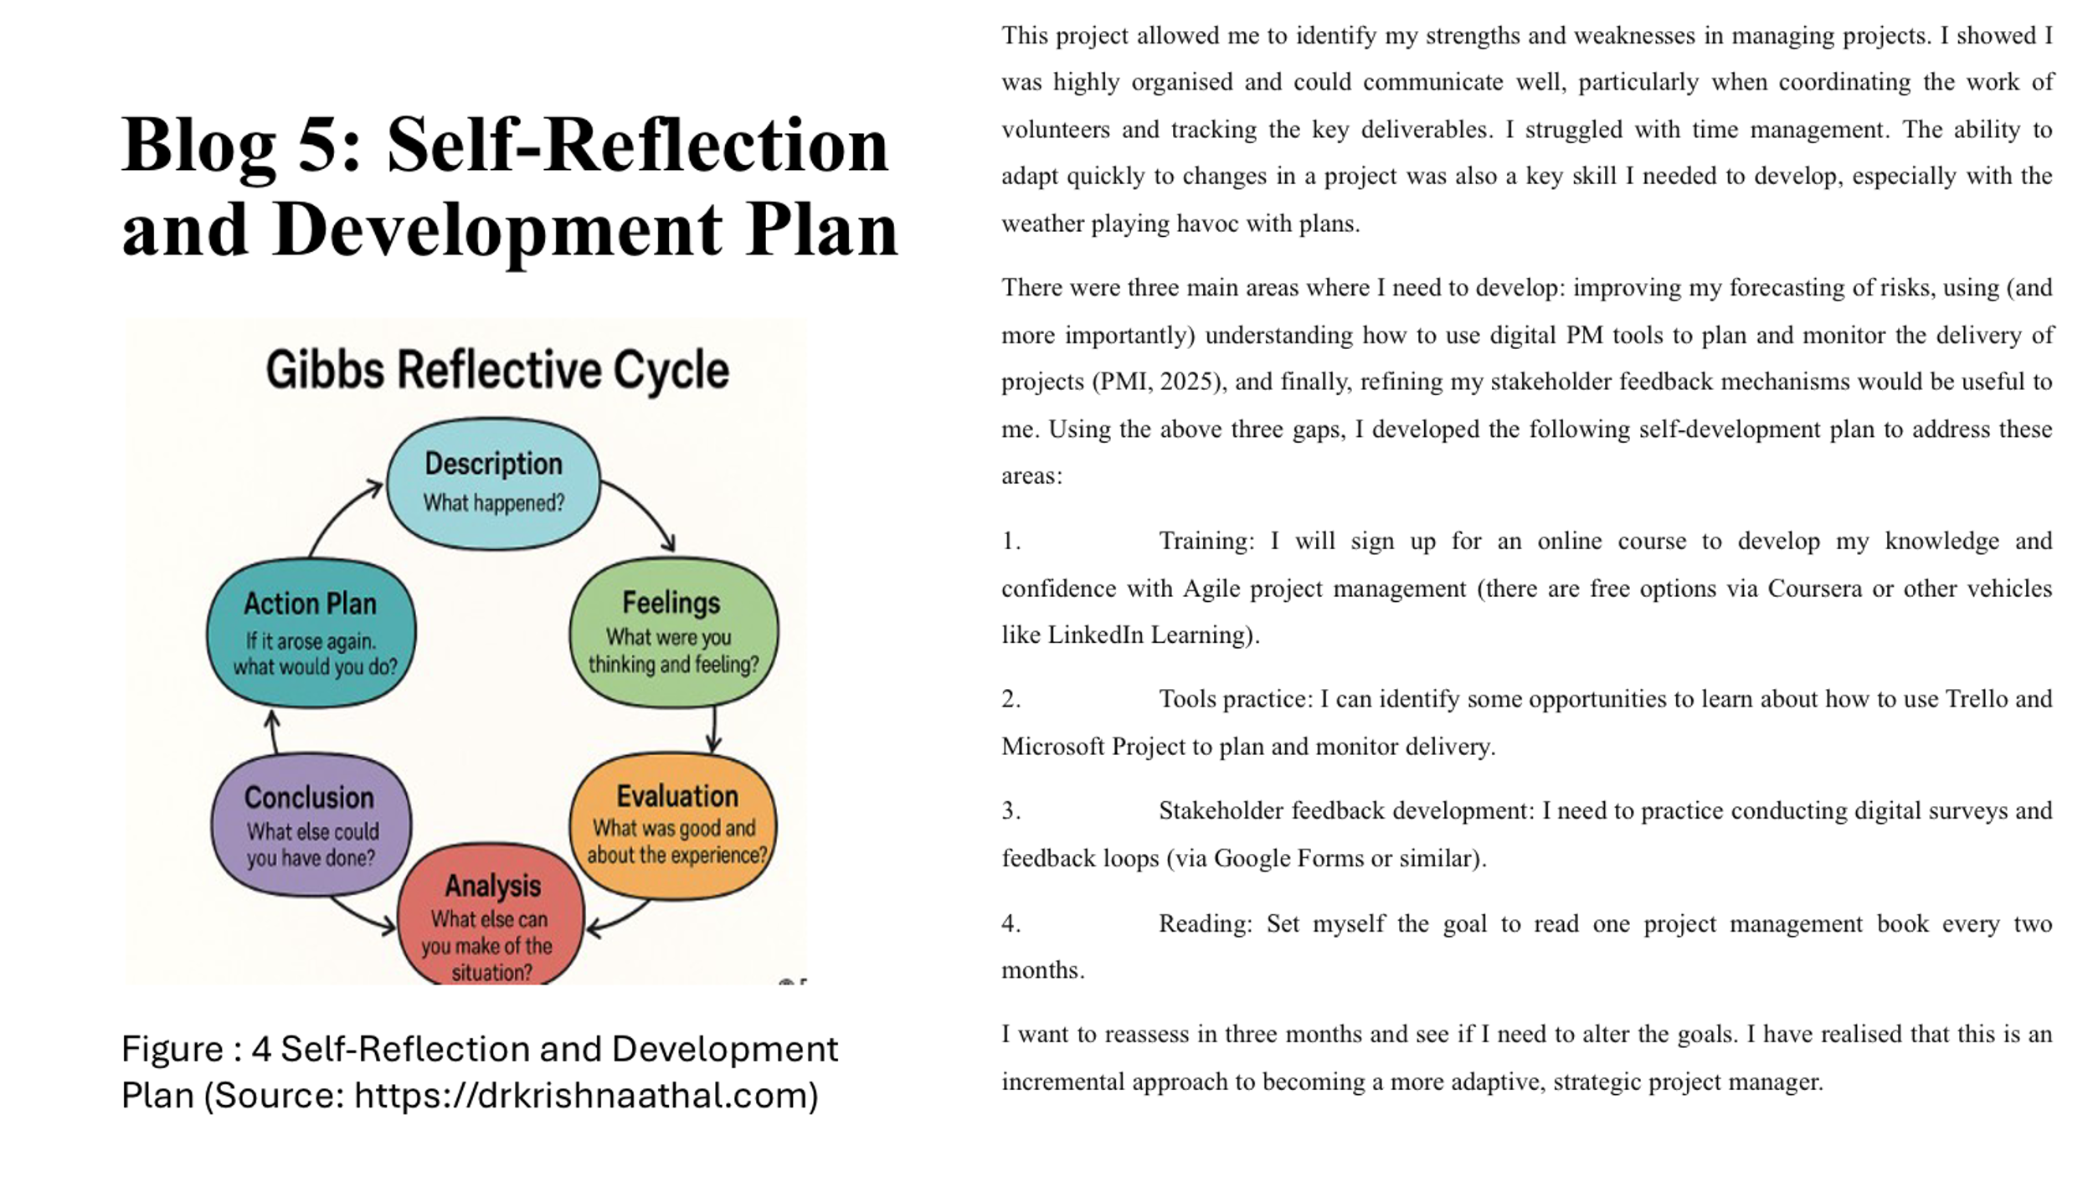
This project allowed me to identify my strengths and weaknesses in managing projects. I showed I was highly organised and could communicate well, particularly when coordinating the work of volunteers and tracking the key deliverables. I struggled with time management. The ability to adapt quickly to changes in a project was also a key skill I needed to develop, especially with the weather playing havoc with plans.
There were three main areas where I need to develop: improving my forecasting of risks, using (and more importantly) understanding how to use digital PM tools to plan and monitor the delivery of projects (PMI, 2025), and finally, refining my stakeholder feedback mechanisms would be useful to me. Using the above three gaps, I developed the following self-development plan to address these areas:
1. Training: I will sign up for an online course to develop my knowledge and confidence with Agile project management (there are free options via Coursera or other vehicles like LinkedIn Learning).
2. Tools practice: I can identify some opportunities to learn about how to use Trello and Microsoft Project to plan and monitor delivery.
3. Stakeholder feedback development: I need to practice conducting digital surveys and feedback loops (via Google Forms or similar).
4. Reading: Set myself the goal to read one project management book every two months.
I want to reassess in three months and see if I need to alter the goals. I have realised that this is an incremental approach to becoming a more adaptive, strategic project manager.

References
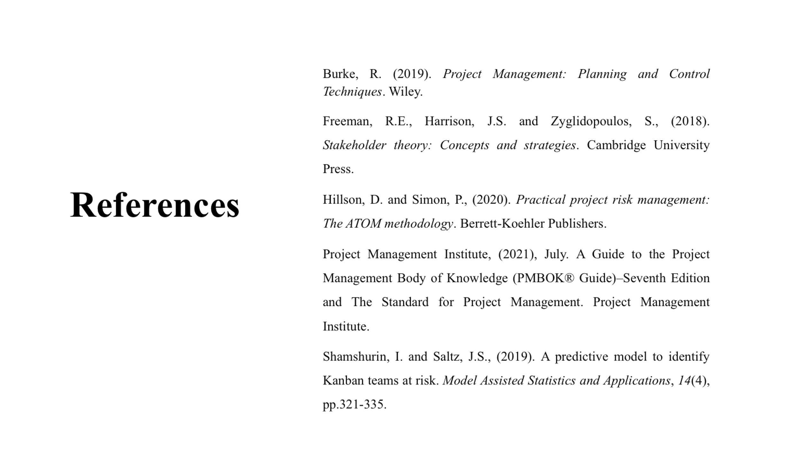
Burke, R. (2019). Project Management: Planning and Control Techniques. Wiley.
Freeman, R.E., Harrison, J.S. and Zyglidopoulos, S., (2018). Stakeholder theory: Concepts and strategies. Cambridge University Press.
Hillson, D. and Simon, P., (2020). Practical project risk management: The ATOM methodology. Berrett-Koehler Publishers.
Project Management Institute, (2021), July. A Guide to the Project Management Body of Knowledge (PMBOK® Guide)–Seventh Edition and The Standard for Project Management. Project Management Institute.
Shamshurin, I. and Saltz, J.S., (2019). A predictive model to identify Kanban teams at risk. Model Assisted Statistics and Applications, 14(4), pp.321-335.

