
BMIH6003
Managing Guest Service Operations
Student Learning Log

Student name: Madalina Floriana Popescu
Student ID:2024553

Table of Contents
1. Introduction 3
2. Description of the overall placement 3
3. Learning log development through Gibb’s reflective cycle 3
3.1 Description 4
3.2 Feelings 4
3.3 Evaluation 4
3.4 Analysis 5
3.5 Conclusion 5
3.6 Action plan 6
4. Summary of the learning 6
5. References 8

1. Introduction
The following student-learning log is focused on my placement development record while working at Marriott Cardiff Hotel as housekeeping staff and in back-of-house areas. In this way, I have developed potential learning and skills alongside identified loss of opportunities and skill gaps, which I need to improve further.

2. Description of the overall placement
At Marriott Cardiff Hotel, I have served my service as a housekeeping and back-of-house staff for two weeks. In this way, I had to maintain the overall room service, guest accommodation maintenance, documentation keeping and other functions, which are directly linked with the guest service. However, key issues that I have noticed while working as a housekeeping service are poor guest service and issues in the performance management of the hotel. The staff could not provide better service to the guests and there was a lack of cleaning practices in the hotel rooms, which created major guest dissatisfaction at that time.

3. Learning log development through Gibb’s reflective cycle
Considering the key issues faced at Marriott Cardiff, I would like to develop my placement record with the help of Gibb’s reflective cycle, which considers six consecutive stages (The University of Edinburgh, 2020).
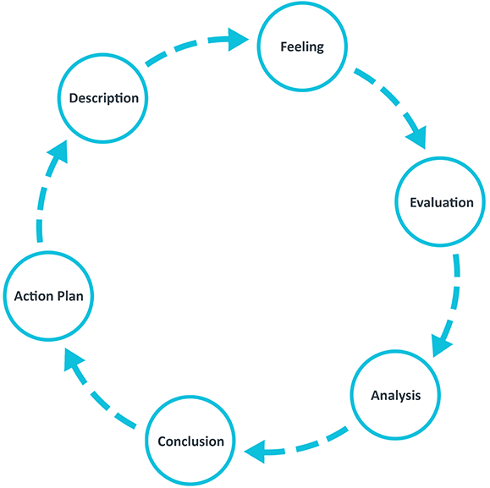
Figure 1: Gibb’s reflective model
(Source: The University of Edinburgh, 2020)

3.1 Description
While working as a housekeeping staff at Marriott Cardiff Hotel I found that the hotel guests are frequently complaining about the key housekeeping services and room accommodations. It has been identified that housekeeping management in the hotel could not provide proper cleaning and accommodation service towards the guests, which include laundry, linen, rubbish cleaning inside the rooms and bathrooms, proper vacuuming, and pest control practices. In this way, the lack of operational management and performance evaluation of the housekeeping could be the potential result of this. Additionally, I observed that the staff could not track the documentation related to the guests and their preferences, which has further affected the poor guest service practice at Marriott Cardiff as well. In this context, I would analyse the three-factor theory of customer satisfaction in the context of the issue for better evaluating my placement record.

3.2 Feelings
Considering my placement at Marriott Cardiff as a housekeeping staff, I have experienced a range of interpersonal and professional skills. I could state that customer satisfaction plays a vital role in the hotels and thus, housekeeping services could help in developing a better satisfaction rate among the hotel guests. Additionally, while addressing the key issue at the hotel, my vocational, self, and academic skill development became ensured, which motivated me to perform my responsibility better as well as my professional learning outcomes become improved. In addition, I felt that without proper customer service, the key objective of the hotel could not be achieved and thus, it would affect the brand value of the hotel. In this way, the performance management and housekeeping service should be properly analysed for hindering these issues.

3.3 Evaluation
According to the opinion of Daoust (2021), customer satisfaction is the key responsibility of the hotel business and in this aspect, better housekeeping and customer service delivery are necessary for better outcomes. In the context of my placement in Marriott Cardiff, the issues related to guest service and accommodation have reduced the guest satisfaction rate. The theory of three factors for customer satisfaction ensures necessary factors, performance factors and excitement factors (Nag, 2017). The necessary factor would focus on the key product or service delivery by the business while the excitement focuses on customer satisfaction or dissatisfaction (Füller and Matzler, 2023). Consequently, the performance factor highlights the way that should be provided by the business by focusing on key strategies (Nag, 2017). In this way, due to a lack of performance management, proper guest service through housekeeping could not be possible in Marriott Cardiff, which led to a great problem during my placement scenario.
However, while dealing with the problem, I had to interact with my team members frequently for generating a solution through which my vocational and self-development through the placement became developed. I understood the way to deal with a business crisis and resolve it properly, which would support me in future professional areas. Meanwhile, I found a skill gap in my academic knowledge development through this placement due to dealing with this problem. In addition, I was not able to provide a proper solution to the guests initially based on which I had to rely on my seniors in the housekeeping department. This aspect can be considered a loss of opportunity for me to ensure my potential as a staff in the hotel.

3.4 Analysis
Considering the placement in Marriott Cardiff, I have experienced the importance of customer service and other amenities in the hotel business. It has been stated that high customer engagement in the hotel could result in high brand value and competitive advantage (Chen et al., 2022). Due to the issues that I have experienced in the organisation, I understood the importance of guest service through housekeeping, which has improved my interpersonal skills. Additionally, I interacted with my peers, seniors, and guests in the context of the problem based on which my communication skills became generated. In addition, I have applied my knowledge of hotel management study in dealing with guests through which my task management and knowledge development on hotel business become nurtured.
Khalimova (2020) reported that proper situational analysis in the hospitality business is necessary, as it could lead to effective mitigation of any significant problem. However, due to a lack of proper performance management and lack of skills among the housekeeping staff, the housekeeping issues regarding the hotel room could not be properly resolved. I have further noticed my lack of skills regarding time management, situational analysis and lack of working experience has limited my academic skill development through the placement as well.

3.5 Conclusion
At the end of the placement record, I could state that the hotel management at Marriott Cardiff should focus on the housekeeping service better. In this way, proper training, skill development programs and employee motivation for the housekeeping team should be provided. Additionally, regular checking and monitoring of the housekeeping service thrice a day could be recommended for avoiding this issue in future.

3.6 Action plan
Considering the overall learning development in Marriott Cardiff placement as housekeeping staff, I should focus on my learning agreement depending on the lack of skills. In this way, the below action plan would help in generating those skills based on which I could handle similar situations while working in a hotel as well.
Key actions | Resources | Outcomes | Timeline
Improving situational analysis through problem-solving and decision-making skill development | Attending training and coursework on those skills, group activity, accessing secondary journal articles, online webinar | In this way, I could develop my problem-solving and decision-making skills through which the housekeeping or similar issues in future hotel placement would be avoided | Within the next 8 months
Develop time management skills for the future | Use of time management tools, developing a goal and timeline for each task and self-management practice | Timely delivery and resolving the issues faced by guests would be possible through time management skill | Within the next 10 months
Table 1: Action plan development on learning agreement

4. Summary of the learning
The above study was focused on the development of my learning log based on my placement at Marriott Cardiff Hotel in housekeeping and back-of-house staff. In this way, I have identified the lack of proper guest room service and accommodation delivery by the hotel, which made the guests dissatisfied. In this way, I have developed some important skills and learning, which influenced my vocational, academic and self-development. Additionally, with the help of my learning development, I was able to provide suggestions for the hotel for mitigating the issues alongside generating an action plan for me to improve my lack of skills as well. In this way, my future professional and personal growth could be possible.

5. References
Chen, X. et al. (2022) ‘The Impact of Hotel Customer Engagement and Service Evaluation on Customer Behavior Intention: The Mediating Effect of Brand Trust’, Frontiers in Psychology, 13. doi: https://doi.org/10.3389/fpsyg.2022.852336.
Daoust, C. (2021) The importance of customer service in the hospitality industry, Hotello. Available at: https://hotello.com/en/customer-service-hotels/#:~:text=Indeed%2C%20an%20excellent%20customer%20service (Accessed: 20 October 2023).
Füller, J. and Matzler, K. (2023) ‘Customer delight and market segmentation: An application of the three-factor theory of customer satisfaction on life style groups’, Tourism Management, 29(1), pp. 116–126. doi: https://doi.org/10.1016/j.tourman.2007.03.021.
Khalimova, N.J., (2020). Analysis of foreign experience in hotel career enhancement programs. Central Asian Problems of Modern Science and Education, 2020(2), pp.3-14.
Nag, R. (2017) Customer satisfaction-Three factor theory, www.linkedin.com. Available at: https://www.linkedin.com/pulse/customer-satisfaction-three-factor-theory-ram-n/ (Accessed: 20 October 2023).
The University of Edinburgh (2020) Gibbs’ Reflective Cycle, The University of Edinburgh. Available at: https://www.ed.ac.uk/reflection/reflectors-toolkit/reflecting-on-experience/gibbs-reflective-cycle (Accessed: 20 October 2023).

