Qualification: CIPD Diploma in Applied Human Resources

Module Name: Understanding Employee Engagement

On the job training

Word Count: Activity 1: 718
Activity 2: 421
Activity 3: 318

Student Name: Maria Mellen Jimenez
Student Number: 2005457
CIPD Membership Number: 57501591

By signing below, I confirm that the work/evidence presented is my own, unaided work. I understand the regulations pertaining to candidate malpractice and the action that may be taken as a result.

Signed: 
Date: 07/02/22.
EVALUATION OF MY ORGANISATION’S APPROACH TO EMPLOYEE ENGAGEMENT
I worked as a manager for a multinational high street fashion retailer in Swansea since 2009. Going back to when I first joined the company in 2008 as cashier, the company values have not changed. It is still the main priority to offer the best for the customers and to achieve the sales targets, the company believes that internal promotion is the key to this success (Inditex, 2022). There have been improvements in the staff training and development programs, but there is room for improvement in this aspect.
When I have analysed the enablers of employee engagement established by MacLeod and Clarke (2009), I can see the strategic vision is clear on the website. However, when a new starter joins the company, there is no mention of the company values in their induction, apart from the task to be completed by the manager, who is expected to know this. The main issue I find is that when an employee is in the development program to become a manager, ‘Company Values’ is not even mentioned in any of the booklets to be completed. It is assumed that this employee in training knows them, but they should be at least shown where to find the information on the website.
The onboarding process has been recently updated, making it a four-week process, but, once again, a guide has been sent to the managers with no explanation or training on how to follow it, so, unless we have engaged managers who would like to spend their free time looking into this to find out more information, the new process will not be followed by the management team.
Talking about engaging managers, experience has taught me that it is vital when goals must be achieved as a team. In this aspect, the organisation provides training to the managers in how to develop their teams through coaching and mentoring activities and conversations. In small workplaces like the store where I used to work, with a team of 30 staff, the management team were always promoting good working relationships, offering the employees our support beyond our working hours and organising activities outside the workplace to get to know each other as individuals, not as members of a retail business.
Another enabler I consider key is employee voice. This is definitely something that does not happen at all. The only feedback the Head Office team is interested in is regarding the product that we sell in the stores. When it comes to introducing new initiatives, no feedback is requested from senior managers. Still, when constructive feedback about issues is shared with the regional without being requested, it is not taken as a way of trying to improve a situation, but as a way of labelling that specific manager as ‘the one who always find an issue’. There is not any interest from the Head Office in hearing from the employees’ well-being either, especially after the lockdowns and issues we have had to encounter due to Covid.
Integrity is the fourth enabler of engagement cited in the MacLeod Report. At the moment, the general feeling in the store is that the organisation is focused on profits by allowing the customers not only to ignore the policies when it comes to refunds and exchanges, but also to disrespect the staff. There has been requests to the customer service team to provide us with signage that shows zero tolerance to abusive behaviour, but this has been disregarded. This has contributed to a high level of employee disengagement, including from the management team, where the levels of absenteeism have increased in comparison to the last two years, the majority due to anxiety, and their performance has decreased considerably.
This reflects some of the trends established by Quantum Workplace (2022) such as loss of trust in leadership and less opportunities for career growth. This retailer must start by listening to the employees, showing that their opinions count, at least once a year, or following up any leaver processes with exit interviews. The employer brand has clearly been damaged and needs to be looked at. Reports in Indeed.com (2022) show that, although the organisation scores at 3.7 out of 5, there are a lot of negative comments regarding how hard it is requesting time off, management, mentally draining, or no private life.

ANALYSIS OF EMPLOYEE HANDBOOK AND STAFF BULLETINGS TO FIND OUT WHETHER THE CONTENT ENGAGES EMPLOYEES WITH TOPICS THAT MATTER TO THEM
After examining all the company policies, nothing has been found regarding employee engagement as a term. However, there are a few initiatives which are related to employee engagement and performance:
- Monthly Incentive Scheme: Each employee receives an incentive if the monthly sales targets have been achieved in the store. The issue we find here is that this amount is around £40 if the employee works 40 hours per week. Considering that 75% of the store staff work 20 hours on average, the feedback we get in the store from the employees is that the effort is not worth it, or that a monetary reward is not what they need to be motivated at work.

- Holiday allowance: Employees who have worked in the company for 3-5 years will receive one extra holiday day, 5-10 years will receive two and those who have been working for more than 10 years will get three.

- Length of service award: Employees who have worked in the organisation for at least one year will receive £10 extra every month, increasing to a maximum of £50 per month. This does not apply to senior managers, though.

- Bank holiday pay: Double pay if working on a bank holiday, or lieu day if the employee is a senior manager.

On the employees’ mobile app, there are some resources to support employees with well-being and mental health issues. As we can see below, there are some videos to help keep active:
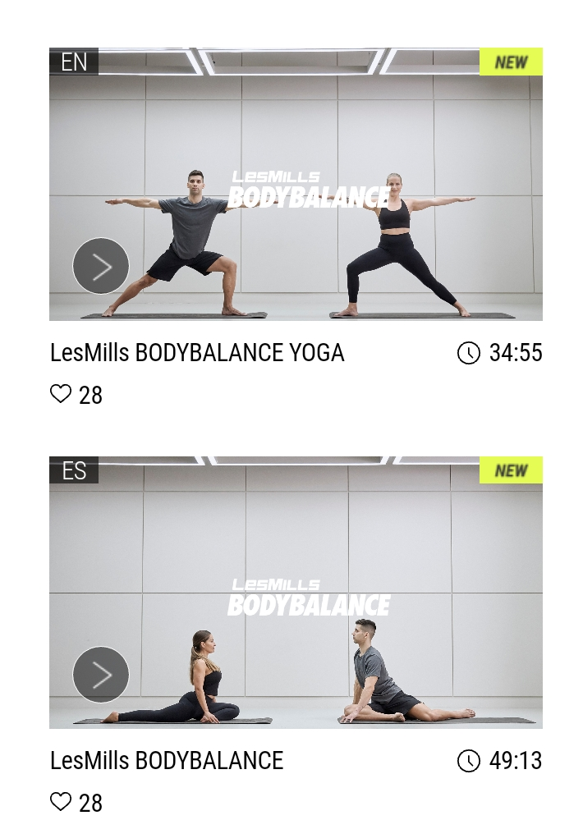

And at the beginning of the year, a post was published with 50 different new year resolutions, in order to help with mental health.

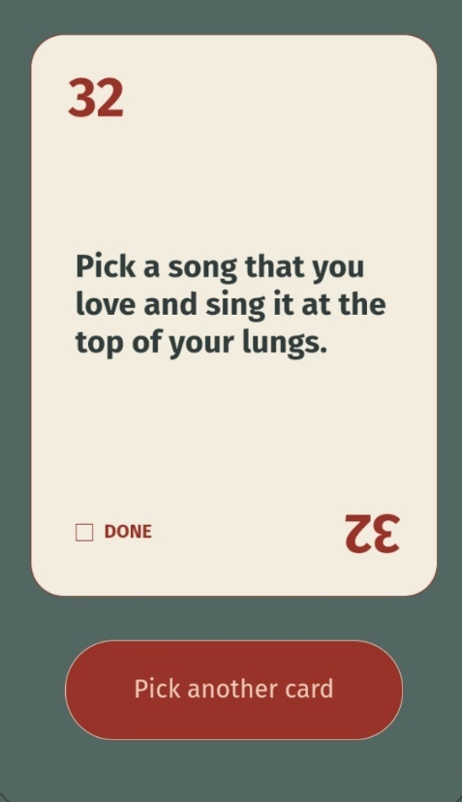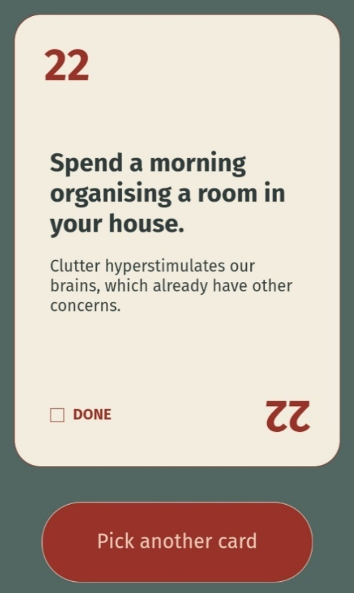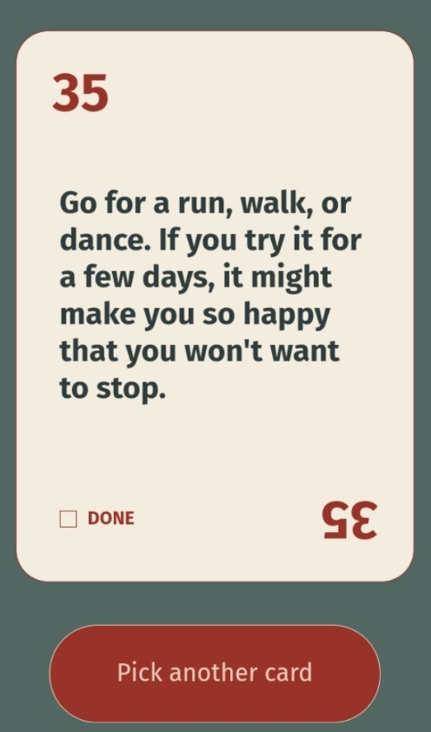

There is also different type of content on the app such learning magazines, with articles like the qualities of organic cotton, featured in the picture below.


The organisation is working on different ways of keeping the employees informed about different matters that may or may not have an impact on their performance. The only issue is that employees are not allowed to use their phone during working hours, so anything that is published on the app will have to be accessed before or after work. This brings up the question on which communication channel should be chosen for content that might influence the employees’ performance and, ultimately, the organisation’s one too. We should not expect employees to be disturbed by any work-related matters in their free time. Perhaps some online seminars should be organised to be attended by all employees during working hours to ensure they get the knowledge to be more engaged with their job.

MY DEVELOPMENT NEEDS AGAINST THE CIPD PROFESSION MAP
After analysing the CIPD standards established in the CIPD Profession Map regarding Employee Experience (CIPD, 2022), I would class myself in the Foundation Level, as there are some areas I need to develop. I understand the approach that my organisation has regarding employee engagement, but I need to develop my knowledge on the tools to drive the engagement.
As I have explained before, it is clear that my organisation does not have an approach in terms of employee voice. I have researched different ways of collecting data and the type of data generated, for the purposes of this module.
I have a vast experience on working relationships, both positive and negative, and I have learnt to turn a negative relationship into a positive one, by listening to the employees and following up with a two-way communication. This is key to achieve high levels of both performance and engagement.
When it comes to the onboarding process of an employee, I have been involved in it for nearly thirteen years. When I had to do my research report last year, I based it on my organisation’s onboarding process, as it was a different one to the recent one. In this specific aspect, I would consider myself to be on the Chartered Member level as I put together a few recommendations to improve the onboarding process and I believe I could design the process to adapt it to the stores.
In terms of employer brand, I understand the impact this might have on absenteeism and recruitment, but I must work on the techniques to improve the employer brand.
I have examined the people policies in the employee handbook. Related to employee engagement, I have found some that are purely linked to their performance by being monetary rewarded. However, for those who will not buy in by it, the organisation offers other ways of rewarding long service or working during bank holidays.

REFERENCES
- CIPD (2022) Employee experience. Available at: https://peopleprofession.cipd.org/profession-map/specialist-knowledge/employee-experience. Accessed on 06/02/22.

- Indeed.com (2022) Zara employee reviews. Available at: https://uk.indeed.com/cmp/Zara/reviews#:~:text=Great%20place%20to%20work.,Employer%20paid%20very%20well. Accessed on 06/02/22.

- Inditex (2022) Professional Development. Available at: https://www.inditex.com/our-commitment-to-people/our-employees/employee-development. Accessed on 05/02/22.

- MacLeod, D. and Clarke, N. (2009) Engaging for Success: enhancing performance through employee engagement. Available at: https://engageforsuccess.org/wp-content/uploads/2021/02/Engaging-for-Success.pdf. Accessed on 30/01/22.

