

Managing Enterprise in the 21st Century

Business Plan

Agim Jata
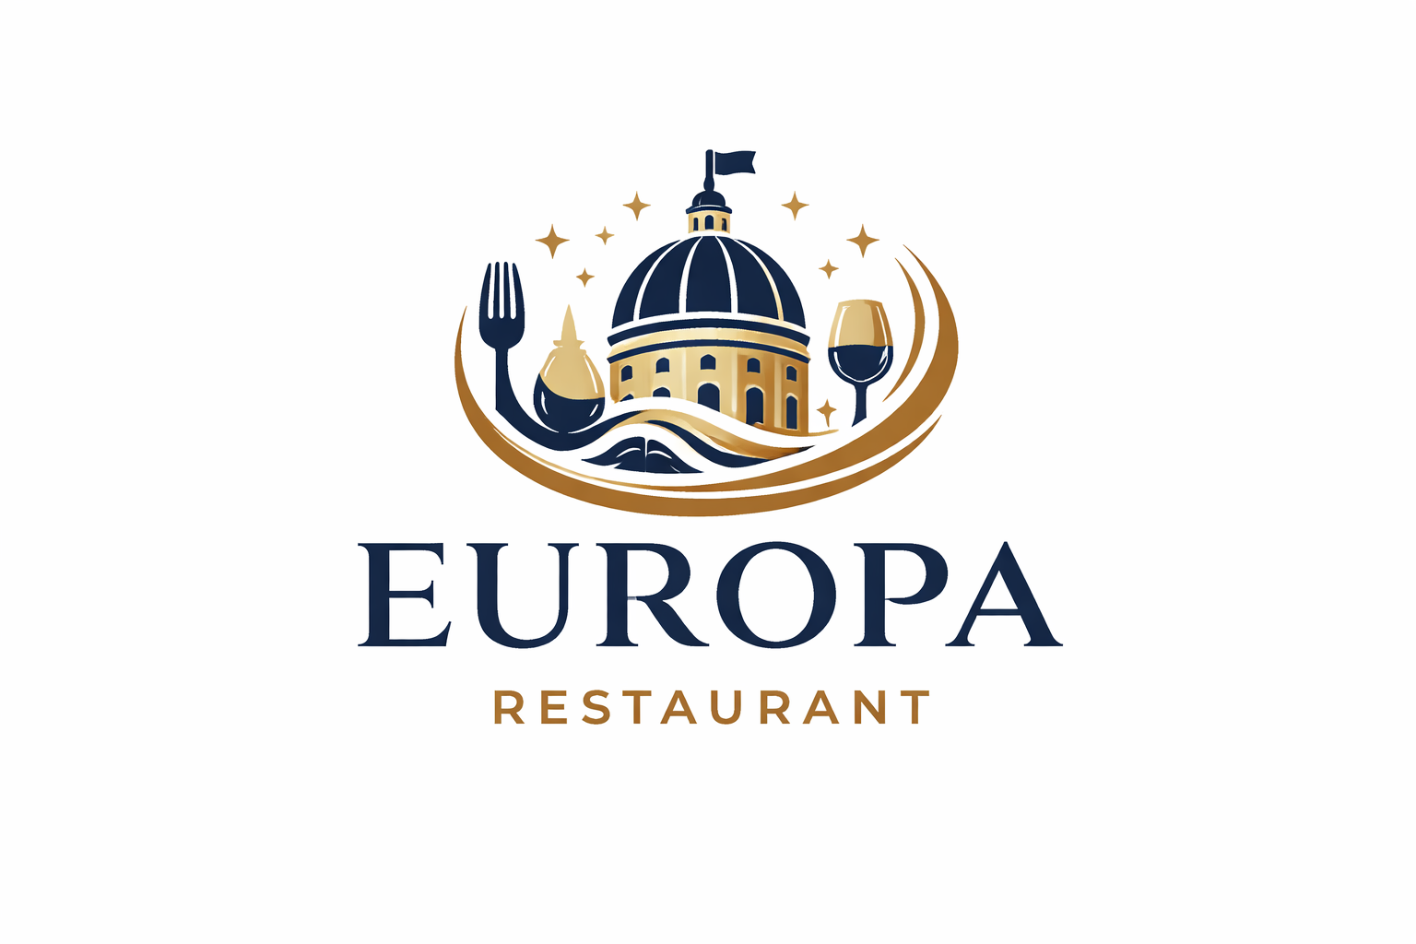
Europa Bar & Restaurant

Submission Date:

Lecturer: Konstantina Mari

Executive Summary

Europa restaurant is a European inspired restaurant designed to execute refined dining experience and approachable. Europa typically covers the atmosphere, cuisine style and unique selling point. Europa restaurant offers an intimate dining destination offering refined seasonal plates in a sophisticated setting with local sourced ingredients paired with a conspicuous set of wines.

Business Concept

Europa is a modern European dinning experience that brings together the flavours, cultures and lifestyle of Europe comprehensively. The idea is built around the concept of a journey around Europe where guests can explore a variety of iconic dishes and drinks in a single cohesive modern setting. The restaurant creates an experience where food, design and atmosphere work together to transport guests across different European regions.

Business Description

Europa is a restaurant that using an immersive dinning experience by bringing together the diverse flavours and cultures of Europe in to one contemporary setting. The restaurant specialises in a curated menu of European fusion cuisine combining classic dishes from regions such as Italy , France , Spain , Poland , Greece and Great Britain with modern culinary techniques and presentation. Europa operates as a full restaurant offering breakfast, lunch, dinner and a selection of premium beverages including wine and signature cocktails. The business is positioned to cater to young professionals, couples, families and social groups making it suitable for casual dining, business meetings and special occasions.

Product Description

The core product for Europa is a diverse menu that brings together signature flavours from across Europe. The food offering includes a combination of small plates, sharing dishes and main courses inspired by the main European cuisine. Also on a weekend basis to offer special dishes from each and every country in Europe using local ingredients.

Business Objectives (SMART Objectives)

The first main business objective is to calculate and thoroughly plan until breaking even point, using the SMART objectives and description. Breaking even = fixed costs / ( selling price per unit – the variable cost per unit)
Understanding the breaking even point will work out the budget we need to cover the start up costs, operational costs and fixed costs.

Specific: Cover all start up and operational costs.
Measurable: Monthly revenue to cover the expenses.
Achievable: Based on pricing and costumer volume.
Relevant: Driving commercial success.
Time bound: Within 16 months.

Market Analysis and Marketing Plan

Market Analysis (Competitors, Customers, Target Groups)

Europa conducts business with competitive UK casual dining market particularly in the urban areas where there is a high demand for high end experience managed restaurants.

Target market
- Young professionals (age 25-40)
- Couples and social dinners.
- Families seeking premium casual dinning.
- Food lovers overrated in European cuisine.

PESTEL Analysis

- Political factors:
- Food safety and hygiene regulations
- Licensing laws for selling alcohol
- Employment laws
- Post-Brexit laws for trade policies

- Economic Factors
- Inflation increasing food and energy prices
- Cost of living crisis effecting dining out habits
- Minimum wage increasing effecting staffing costs

- Social Factors
- Growing interest in dinning experiences not just food
- Popularity for European cuisine
- Increased use of social media for restaurant discovery

- Technological Factors
- Online booking system
- Free delivery platforms
- Digital payments
- Social media and marketing tools

- Legal factors
- Health & safety laws
- Food hygiene ratings
- Employment & equality laws
- Allergen information regulations
- Liability insurance

- Environmental
- Reducing food waste
- Energy efficiency
- Eco-friendly packaging
- Demand for sustainable sourcing

SWOT Analysis

- Strengths
- Prime location
- Ambience & décor
- Operational efficiency
- Strong brand reputation
- Experienced staff & chefs

- Weaknesses
- High operating costs
- Dependency on key staff
- Inconsistent service
- Limited parking

- Opportunities
- Increasing delivery & takeout services
- Local tourism growth
- Collaboration & events
- Loyalty programmes & digital marketing

- Threats
- High intense competition
- Supply chain disruptions
- Economic downturns
- Health & Safety regulations

Marketing Mix (4Ps)

Marketing the Europa restaurant, we will be in need for a mix of online and offline marketing strategies to attract costumers and build loyalty to connect with the customer satisfaction, so they keep coming back. First, we need to be active daily with updates on menus, specials and events the restaurant will undertake on the most active social media apps nowadays for example:
- Instagram & Tik Tok
- Creation of a Google business profile so it shows up to local searches from the community
- Happy hour deals, which will help to connect with the alcohol lovers
- Food Delivery apps like Deliveroo and Uber eats
- Branding & unique identity, creating a memorable logo, theme & atmosphere.

Financial Plan (One Year)

The break down of the financial plan for the Europa restaurant that will open in Romford town centre is based on research online of compared start up costs. (Rightbiz.co.uk)
Start up costs
- £130.000 Lease for already running restaurant.
- £2.000 Rent per month
- £50.000 Renovation & interior designs
- £2.000 Licenses & permits
- £2.000 Marketing & Branding
- £2.000 Staff recruitment & training
Total: £188.000

Operational Fixed costs & variable / month
- £2.000 Rent
- £10.000 Salaries
- £300 Insurance
- £1.000 Utilities
- £2.000 Ingredients and food supplies
- £500 Delivery fees
Total: £15.800

Sources of Finance

The budget needed for the start up and running of this business is £205.000.
£50.000 will come from savings and another £50.000 will come from a bank loan.
The other £105.000 will come from an investing partner that is experienced in the hospitality industry.

Cost of Production Forecast

- Average price for meal £20
- Costumers per day 75
- Daily revenue £20 x 75 = £1.500
- Monthly revenue £45.000

Break Even Analysis
Break-even is the point where a business’s total revenue equals its total costs.

Revenue for the month: £45.000
Operational costs for the month: £15.800

Break even formula:

Fixed costs £15.800 / (selling price £20 – variable cost £5
£15.800 / £15
= 1.055 meals per month up to Break even point

Cash Flow Financial forecast

Month | Cash In (£) | Cash Out (£) | Net Cash Flow (£) | Closing Balance (£)
Jan | 30,000 | 28,000 | +2,000 | 2,000
Feb | 32,000 | 28,500 | +3,500 | 5,500
Mar | 35,000 | 29,000 | +6,000 | 11,500
Apr | 36,000 | 30,000 | +6,000 | 17,500
May | 38,000 | 31,000 | +7,000 | 24,500
Jun | 40,000 | 32,000 | +8,000 | 32,500
Jul | 42,000 | 33,000 | +9,000 | 41,500
Aug | 43,000 | 34,000 | +9,000 | 50,500
Sep | 41,000 | 33,000 | +8,000 | 58,500
Oct | 39,000 | 32,000 | +7,000 | 65,500
Nov | 37,000 | 31,000 | +6,000 | 71,500
Dec | 45,000 | 35,000 | +10,000 | 81,500

- Cash In → Sales from food, drinks, delivery, events
- Cash Out → Rent, wages, food supplies, bills
- Net Cash Flow → Cash In – Cash Out
- Closing Balance → Running total of money left

Reference List

Rightbiz,(2026) Albz Bar & Restaurant. Available at: https://www.rightbiz.co.uk/buy_business/for_sale/645344_london.html Accessed: 30th of March

